Supplementary data

Cluster analysis
The data collected for the 3,596 words was analyzed to determine whether or not there were subgroups of concepts. It could be reasonably expected to find concepts typically visual and others typically auditory, but there may also exist concepts strongly or on the contrary weakly grounded in these two modalities. To this aim, a cluster analysis was conducted with the ratings on visual and auditory perceptual strength, using R (v3.4, R core team, 2018) with the “NbClust” (v3.0, Charrad, Ghazzali, Boiteau, & Niknafs, 2014) and “cluster” (v2.0.7, Maechler, Rousseeuw, Struyf, Hubert, & Hornik, 2018) libraries.

The optimal number of clusters was determined according to the “NbClust” function from the “NbClust” library using euclidean distance and the K-means method. Most of the 23 different methods (14 on 23) used by the function converge to 3 as the best number of clusters. The data were then analyzed with the “pam” function from the “cluster” library which partitions the data into clusters around medoids (a more robust version of K-means, see Kaufman & Rousseeuw, 1990) to define the composition of the 3 clusters.

The results are represented in Figure A. Among the three clusters, cluster 1 regroups 774 concepts that are highly experienced in both visual and auditory modalities, cluster 2 is formed of 1,468 concepts that are weakly experienced in these two modalities and finally the 3d cluster is made of 1,354 concepts strongly grounded in visual properties but not very grounded in auditory properties.

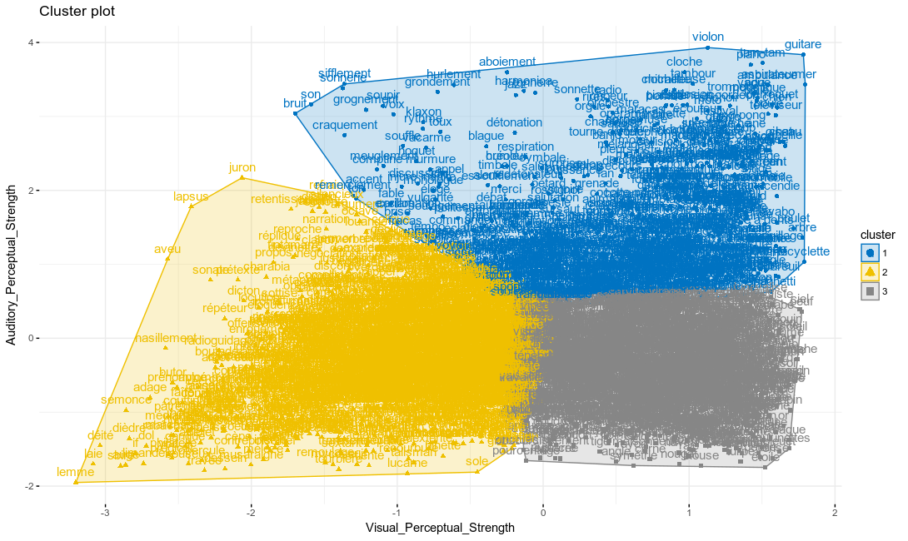
Figure A. Results of the cluster analysis on the visual and auditory perceptual strength for the 3,596 words into 3 different clusters.

For instance, the words “airport”, “eagle”, “car”, or “eruption” belong to the cluster 1, whereas the words “abstraction”, “ambiguity”, “distortion” or “feeling” were in the cluster 2 and finally the cluster 3 includes words such as “zebra”, “turtle”, “mountain”, or “apricot”. As logically expected, cluster 2 regroups most of the abstract concepts that were tested in our study. However, the analysis did not differentiate a subgroup of words strongly grounded in auditory modalities alone. One might argue that most of auditory concepts are also experienced in the visual modalities (such as music instruments or birds). Purely auditory are still imaginable but they are probably very uncommon (e.g., siren, music) whereas the opposite is more frequent (bugs or furniture).

References

R Core Team (2018). R: A language and environment for statistical computing. R Foundation for

Statistical Computing, Vienna, Austria. URL https://www.R-project.org/.

Malika Charrad, Nadia Ghazzali, Veronique Boiteau, Azam Niknafs (2014). NbClust: An R Package
for Determining the Relevant Number of Clusters in a Data Set. Journal of Statistical

Software, 61(6), 1-36. URL http://www.jstatsoft.org/v61/i06/.

Maechler, M., Rousseeuw, P., Struyf, A., Hubert, M., Hornik, K.(2018). cluster: Cluster
Analysis Basics and Extensions. R package version 2.0.7-1.
Kaufman, L., & Rousseeuw, P. J. (1990). Partitioning around medoids (program pam). Finding groups in data: an
introduction to cluster analysis, 68-125.

