*. Page 1*

Software Requirements Specification

For

Freelancer

Prepared by

* Radwa Mostafa
* Aya Ashraf
* Adel Hosny
* Erine Ehab
* Tasneem Adel

Helwan university

* December 2021

***Software Requirements Specification for Freelancer***

**Table of Contents**

**Table of Contents.......................................................................................................... ii**

**Revision History.......................................................................................................... iiii**

**1. Introduction...................................................................................... 1**

1.1 Purpose..................................................................................................................................1

1.2 Document Conventions ..........................................................................................................1

1.3 Intended Audience and Reading Suggestions........................................................................1

1.4 Product Scope........................................................................................................................1

1.5 References .............................................................................................................................1

**2. Overall Description.............................................................................3**

2.1 Product Perspective ...............................................................................................................3

2.2 Product Functions...................................................................................................................3

2.3 User Classes and Characteristics...........................................................................................7

2.4 Operating Environment...........................................................................................................8

2.5 Design and Implementation Constraints .................................................................................8

2.6 User Documentation...............................................................................................................8

2.7 Assumptions and Dependencies ............................................................................................9

**3. External Interface Requirements....................................................... 10**

3.1 User Interfaces .....................................................................................................................10

3.2 Hardware Interfaces .............................................................................................................18

3.3 Software Interfaces...............................................................................................................19

3.4 Communications Interfaces ..................................................................................................19

**4. System Features ............................................................................... 19**

4.1 Graph Visualization...............................................................................................................19

4.2 Graph Layout........................................................................................................................22

***Software Requirements Specification for Freelancer***

**5.OtherNonfunctionalRequirement……....................................................4**

5.1 Performance Requirements..................................................................................................4

5.2 Safety Requirements ............................................................................................................4

5.3 Security Requirements .........................................................................................................30

5.4 Software Quality Attributes ...................................................................................................30

**6. Other Requirments……………………………………………………………………….5**

**Appendix A : Glossary………………………………………………………………………5**

**Appendix B : Analysis Models ……………………………………………………………5**

**Appendix C : To Be Determined List……………………………………………………6**

**Revision History**

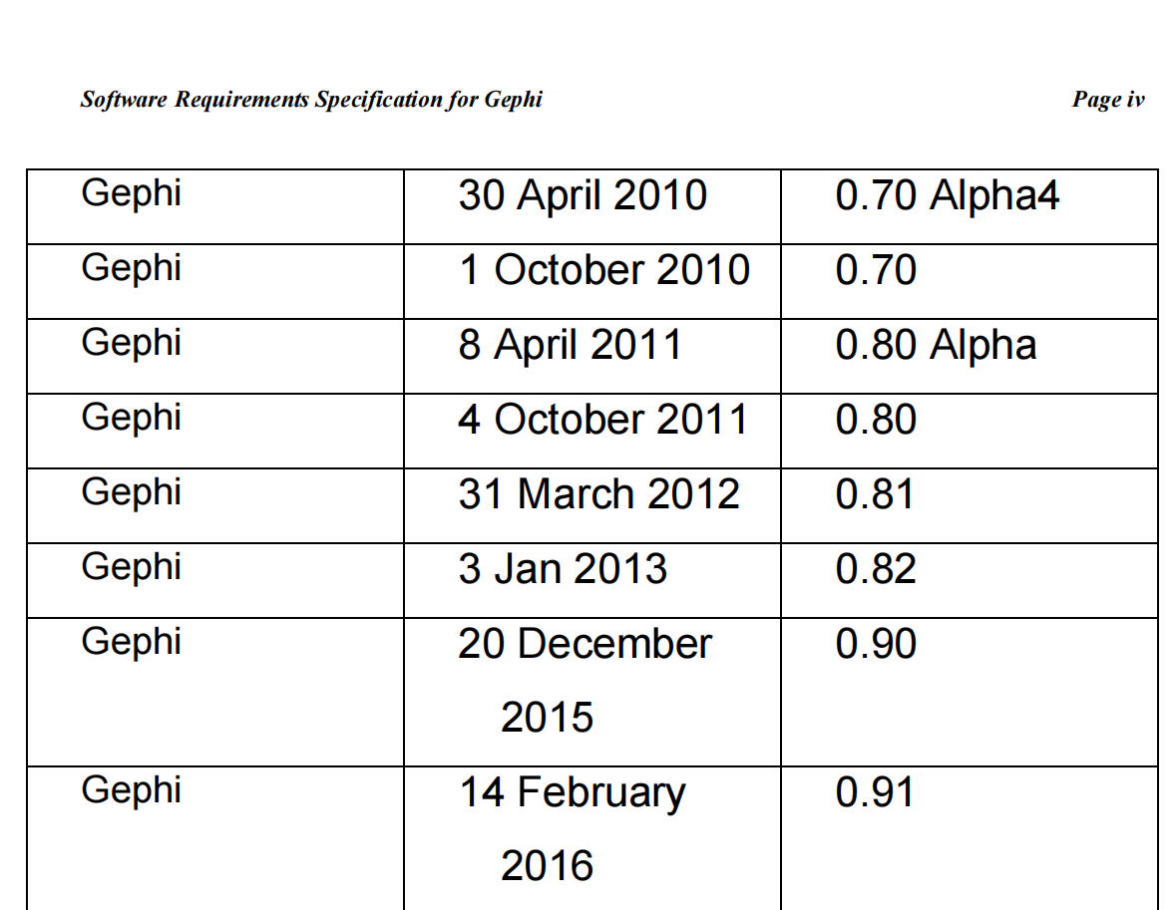

**1.Introduction**

**1.1Purpose**

The purpose of this document is to present a detailed description of how clients post their tasks which needed to be done and how freelancers do this tasks in cooperation with each other .

It will explain the features and profits of this software , what the software will do and the constraints under which it must operate.

* 1. **Intended Audience and Reading Suggestions**
* Typical Users , such as clients who want to use freelance

Management systems for improving their tasks and analyzing them.

* Advanced/Professional Users, such as freelancers who can get a job from this site and do tasks according to their experience.
* Programmers who are interested in working on the project by further developing it or fix existing bugs.

**1.3 Product Scope**

**A Freelancer Management System standardizes the process by making all the intel on your freelancer available on a single platform so that you have complete knowledge of the projects they have worked on, contracts they have signed, time they are available at, invoices created, payments made to them and more.**

1. **Overall Description** 
   1. **product perspective**

Freelance Management Systems are developed for everyone who wants to get an online job and create an account to know all the tasks the clients are shared and for everyone who wants to post tasks.

* 1. **Product functions**
* Open the site and login if the user (admin , client , freelancer) has an existing account
* If the user has not an account will sign up to create a new one
* The clients will post the needed tasks on the page
* The admin has the ability to accept or refuse the post
* If the admin accepts the posts they will appear int the wall page
* The admin updates the posts after accepting them
* If the admin refuses the posts they will be deleted from the site
* The freelancer will login the site and the accepted posts will show in the wall page
* The freelancer can search about job post by date , title , client name
* The freelancer will send proposal to the clients to request to do the task
* The client will accept/refuse the proposal
* If the client accepts the proposal the particular post will be deleted
* The freelancer will save the particular post
* And then the task will be done and deleted from the site
  1. **Operating Environment**
* Windows 7
* Windows 8
* Windows 10
* Mac OS X
* Linux

**2.4 User Classes and Characteristics**

* Typical Users , such as clients who want to use freelance

Management systems for improving their tasks and analyzing them.

* Advanced/Professional Users, such as freelancers who can get a job from this site and do tasks according to their experience.
* Admins who can accept, refuse and update posts
* Programmers who are interested in working on the project by further developing it or fix existing bugs.
  1. **Assumptions and Dependencies**
* The freelancer may send a proposal to client to do a particular task but he may be not qualified enough to do it so that this task will not be done efficiently.
* The added task may be not real so if this happened

The freelancer may lose his time and effort.

* The client and freelancer may differ on the fee

All of the above if happened this will threat the credibility of the site…

1. **External Interface Requirements**
   1. **user interface**
   2. **Software interface**

Freelance Management Systems can be connected to MySQL ,SQLite database toimport the list of data

*Functional requirements

|  |  |  |  |  |  |
| --- | --- | --- | --- | --- | --- |
| Pages | Sign up | Login | Profile | Posts | admin |
| Freelancer | If the freelancer has not an account will sign up to create a new Account as freelancer to enter his first name ,last .username , password ,confirm password  Email, enter SSN and profile photo,  Graduation year , university , experience, mobile , choose country and select that he is freelancer  And click submit to get into the profile page | If he has already account  That enter his email &password and click on login as freelancer to get into to post page to show the client’s tasks and he has ability to send to client his offer | In this  The freelancer will save the particular post  And can edit this info | Freelancer in this page he can search about a certain task and send to client proposal and tell him about his offer | He can access and page and update and delete any info about freelancer  And he can see all data about freelancer |
| Client | If the client has not an account will sign up to create a new Account as client to enter his first name ,last .username , telephone, password ,confirm password  Email, enter SSN and profile photo and select that he is client  And click submit to get into the post  page | If he has already account  That enter his email &password and click on login as client to get into to post page to can add tasks to find freelance can do this task and he has ability to accept and refuse the offer that freelancer send to him |  | Client has ability to add tasks in this page to get a freelancer that can do this task | The admin has the ability to accept or refuse the post  If the admin accepts the posts they will appear int the wall page  The admin updates the posts after accepting them  If the admin refuses the posts they will be deleted from the site |
|  |  |  |  |  |  |