CSCI-2020 Database Fundamentals

Erin Lorelle

Final Exam Project, Fall 2017

December 2, 2017



**“PassBase”**

## Credential Manager Database

## for

## Renkcub Software Solutions

# **Table of Contents**

Phase #1: CONCEPTUAL DESIGN 3

1. Entity relationship diagram (ERD) 3

Phase #2: Logical Design Section 4

1. Table relations 4

Phase #3: Physical Design Section 5

1. Data dictionary 5

Phase #4: Database Implementation Section 6

1. Part I: SQL DDL statements 6
2. Part II: SQL DML statements 7

Phase #5: Database Maintenance Section 10

1. Part I: Create specified view 10
2. Part II: Create specified indexes 11

# Phase #1: Conceptual Design

## Purpose

“Credential Manager” for Renkcub Software Solutions to store user credentials. The database will also track previously used passwords. The below ERD is based on the specific business needs requested. Note: All and any assumptions are noted on the diagram.

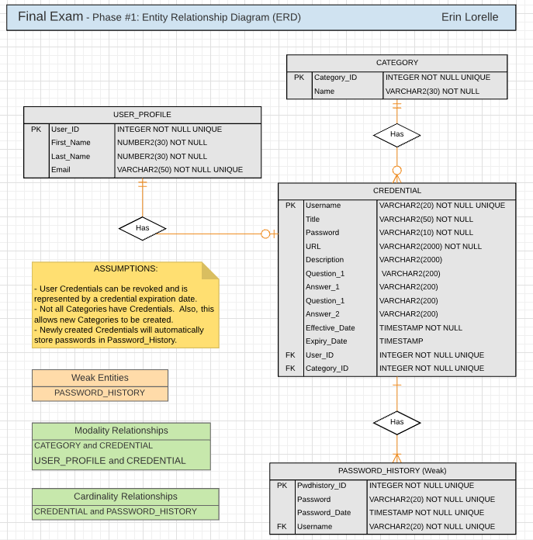Table of Contents>>

# Phase #2: Logical Design

## Normalized through 3NF

***ATTRIBUTES/FIELDS LIST***

Category

Category ID

Category Name

Credential

Credential Title

Username

Password

Password Date

URL

Credential Description

Security Questions & Answers

Credential Effective Date

Credential Expiration Date

User ID

User Name

User Email

***3NF***

*Note: Includes separate PASSWORD_HISTORY entity to accommodate multiple passwords tracked individually by date created.*

CATEGORY (Category_ID, Name)

CREDENTIAL (Username, Title, Password, URL, Description, Question_1, Answer_1, Question_2,

Answer_2, Effective_Date, Expiry_Date, User_ID, Category_ID)

PASSWORD_HISTORY (Pwdhistory_ID, Password, Password_Date, Username)

USER_PROFILE (User_ID, First_Name, Last_Name, Email)

Table of Contents>>

# Phase #3: Physical Design

## Data Dictionary

|  |  |  |
| --- | --- | --- |
| **Column Name** | **Data Type** | **Constraints (PK, FK, NOT NULL, UNIQUE)** |
| **Category_ID** | Integer | PK, FK, NOT NULL, UNIQUE |
| Name | Varchar2(30) | NOT NULL |
| **Username** | Varchar2(20) | PK, FK, NOT NULL, UNIQUE |
| Title | Varchar2(50) | NOT NULL |
| Password | Varchar2(20) | NOT NULL |
| URL | Varchar2(200) | NOT NULL |
| Description | Varchar2(2000) |  |
| Question_1 | Varchar2(2000) |  |
| Answer_1 | Varchar2(2000) |  |
| Question_2 | Varchar2(2000) |  |
| Answer_2 | Varchar2(2000) |  |
| Effective_Date | Timestamp | NOT NULL |
| Expiry_Date | Timestamp |  |
| **Pwdhistory_ID** | Integer | PK, NOT NULL, UNIQUE |
| Password_Date | Timestamp | PK, NOT NULL, UNIQUE |
| Password | Varchar2(20) | NOT NULL |
| **User_ID** | Integer | PK, FK, NOT NULL, UNIQUE |
| First_Name | Varchar2(30) | NOT NULL |
| Last_Name | Varchar2(30) | NOT NULL |
| Email | Varchar2(200) | NOT NULL |

Table of Contents>>

# Phase #4: Database Implementation

## **PART I:** SQL Data Definition Language (DDL) statements

-- Create USER_PROFILE table

CREATE TABLE user_profile(

user_id INTEGER NOT NULL,

first_name VARCHAR2(30) NOT NULL,

last_name VARCHAR2(30) NOT NULL,

email VARCHAR(50) NOT NULL UNIQUE,

CONSTRAINT pk_user_profile PRIMARY KEY (user_id)

);

-- Create CATEGORY table

CREATE TABLE category(

category_id INTEGER NOT NULL,

name VARCHAR2(30) NOT NULL,

CONSTRAINT pk_category PRIMARY KEY (category_id)

);

-- Create CREDENTIAL table

CREATE TABLE credential(

username VARCHAR2(50) NOT NULL,

title VARCHAR2(50) NOT NULL,

password VARCHAR2(20) NOT NULL,

url VARCHAR2(200),

description VARCHAR2(200),

question_1 VARCHAR2(200),

answer_1 VARCHAR2(200),

question_2 VARCHAR2(200),

answer_2 VARCHAR2(200),

effective_date TIMESTAMP WITH TIME ZONE NOT NULL,

expiry_date TIMESTAMP WITH TIME ZONE,

user_id INTEGER NOT NULL,

category_id INTEGER NOT NULL,

CONSTRAINT pk_credential PRIMARY KEY (username)

);

Table of Contents>>

-- Create PASSWORD_HISTORY table

CREATE TABLE password_history(

pwdhistory_id INTEGER NOT NULL,

password_date TIMESTAMP WITH TIME ZONE NOT NULL,

username VARCHAR2(50) NOT NULL,

CONSTRAINT pk_password_history

PRIMARY KEY (pwdhistory_id)

);

-- Add foreign key constraints to tables

ALTER TABLE credential ADD CONSTRAINT fk_credential_user_id

FOREIGN KEY (user_id) REFERENCES user_profile(user_id);

ALTER TABLE credential ADD CONSTRAINT fk_credential_category_id

FOREIGN KEY (category_id) REFERENCES category(category_id);

ALTER TABLE password_history ADD CONSTRAINT fk_password_history_username

FOREIGN KEY (username) REFERENCES credential(username);

## **PART II:** SQL Data Manipulation Language (DDL) statements

--Add six rows to CATEGORY table

INSERT INTO category (category_id, name) VALUES (1001, 'Web');

INSERT INTO category (category_id, name) VALUES (2001, 'Software');

INSERT INTO category (category_id, name) VALUES (3001, 'Hardware');

INSERT INTO category (category_id, name) VALUES (4001, 'Sales');

INSERT INTO category (category_id, name) VALUES (5001, 'Operations');

INSERT INTO category (category_id, name) VALUES (6001, 'Marketing');

--Add five rows to USER_PROFILE table

INSERT INTO user_profile (user_id, first_name, last_name, email)

VALUES (12345, 'Bugs', 'Bunny', 'bugs@myfuzzysite.com');

Table of Contents>>

INSERT INTO user_profile (user_id, first_name, last_name, email)

VALUES (678910, 'Weird Al', 'Yankovic', 'al@rekcubsoftware.com');

INSERT INTO user_profile (user_id, first_name, last_name, email)

VALUES (246810, 'Bilbo', 'Baggins', 'bilbo@rekcubsoftware.com');

INSERT INTO user_profile (user_id, first_name, last_name, email)

VALUES (36972, 'Harry', 'Dresden', ‘harry@rekcubsoftware.com');

INSERT INTO user_profile (user_id, first_name, last_name, email)

VALUES (48121, 'Marty', 'McFly','marty@rekcubsoftware.com');

--Add five rows to CREDENTIAL table

INSERT INTO credential (username, title, password, url,

description, question_1, answer_1, question_2, answer_2,

effective_date, expiry_date, user_id, category_id)

VALUES ('duckseason', 'Manager', 'carr0ts_42', 'www.renkcubsoftware.com', 'Sales Manager', 'What is your favorite color', 'blue', 'What is the name of your first grade teacher?', 'Ms Broomstick', CURRENT_TIMESTAMP, null, 12345, 4001);

INSERT INTO credential (username, title, password, url,

description, question_1, answer_1, question_2, answer_2,

effective_date, expiry_date, user_id, category_id)

VALUES ('pancreas', 'Owner', 'Franks2000inchTV', 'www.renkcubsoftware.com', 'Owner and CEO', 'What is your favorite color', 'hawaiian red', 'What is the name of your first grade teacher?', 'Mr Nye the Science Guy', CURRENT_TIMESTAMP, null, 678910, 6001);

INSERT INTO credential (username, title, password, url,

description, question_1, answer_1, question_2, answer_2, effective_date, expiry_date, user_id, category_id)

VALUES ('myprecious', 'Dept Manager', 'Sting111', 'www.renkcubsoftware.com', 'Department Manager and Head Web Designer', 'What is your favorite color', 'earthy brown', 'What is the name of your first grade teacher?', 'Mr. Gandalf the Grey', CURRENT_TIMESTAMP, null, 246810, 1001);

Table of Contents>>

INSERT INTO credential (username, title, password, url,

description, question_1, answer_1, question_2, answer_2, effective_date, expiry_date, user_id, category_id)

VALUES ('mrmister', 'Asst Manager', 'blueb3@tle', 'www.renkcubsoftware.com', ‘Assistant Manager and Director of Hardware and Such', 'What is your favorite color', 'black', 'What is the name of your first grade teacher?', 'Mr. Bob', CURRENT_TIMESTAMP, null, 36972, 3001);

INSERT INTO credential (username, title, password, url,

description, question_1, answer_1, question_2, answer_2, effective_date, expiry_date, user_id, category_id)

VALUES ('gigawatt', 'Associate', '88mph', 'www.renkcubsoftware.com', 'Administrative Assistant', 'What is your favorite color', 'delorean gray', 'What is the name of your first grade teacher?', 'Doc Brown', CURRENT_TIMESTAMP, null, 48121, 5001);

--Add five rows to PASSWORD_HISTORY table

INSERT INTO password_history VALUES (32, CURRENT_TIMESTAMP, 'duckseason');

INSERT INTO password_history VALUES (64, CURRENT_TIMESTAMP, 'pancreas');

INSERT INTO password_history VALUES (19, CURRENT_TIMESTAMP, 'myprecious');

INSERT INTO password_history VALUES (28, CURRENT_TIMESTAMP, 'mrmister');

INSERT INTO password_history VALUES (95, CURRENT_TIMESTAMP, 'gigawatt');

--Update first USER_PROFILE record to my first and last name

UPDATE user_profile SET first_name = 'Erin', last_name = 'Lorelle'

WHERE (user_id = 12345);

Table of Contents>>

# Phase #5: Database Maintenance

## **PART I:** Create a view

CREATE VIEW All_User_Credentials(User_ID, Last_Name, First_Name, Email,

Username, Title, Password, URL, Job_Credential_Description, Security_Question_1,

Answer_1, Security_Question_2, Answer_2, Credential_Effective_Date,

Expiry_Date, Category_id, Category_Name, PasswordHistory_ID,

Old_Password, OldPassword_Date) AS

SELECT user_id, last_name, first_name, email, username, title, password, url,

description, question_1, answer_1, question_2, answer_2, effective_date,

expiry_date, category_id, name, pwdhistory_id, password, password_date

FROM credential

JOIN user_profile USING (user_id)

JOIN category USING (category_ID)

JOIN password_history USING (username)

ORDER BY user_id, last_name;

SELECT*

FROM All_User_Credentials;

Table of Contents>>

## **PART II:** Create specified indexes

-- Test index

SELECT last_name, first_name

FROM user_profile

ORDER BY last_name;

--Cost: 4

CREATE INDEX idx_last_name ON user_profile(last_name, first_name);

--Cost: 2

***MISC:*** *Notes*

*I attempted to create the below trigger based on research I found online. I wasn’t able to get it to function properly but thought I would include it in my submission. I am curious if this is close to something that would actually be used.*

--Attempt to add trigger to PASSWORD_HISTORY table

CREATE OR REPLACE TRIGGER "PASSWORD_CHANGE"

BEFORE UPDATE ON credential

FOR EACH ROW

BEGIN

IF :new.password <> :old.password THEN

DELETE password_history h WHERE h.pwdhistory_id = :old.pwdhistory_id AND h.TIMESTAMP =

(select min(TIMESTAMP) FROM password_history u WHERE u.pwdhistory_id = :old.username

HAVING COUNT(*) >= 20);

INSERT INTO password_history (pwdhistory_id, TIMESTAMP, PASSWORD) VALUES

(:old.pwdhistory_id, password_date, :old.PASSWORD);

END IF;

END;

-- Added UNIQUE constraint to PASSWORD_HISTORY table to insure password

wasn't previously used.

ALTER TABLE password_history ADD CONSTRAINT pwd_is_not_reused UNIQUE (pwdhistory_id, password);

Table of Contents>>