Erin Johnston
CSC 202
Lab 4 Write-Up

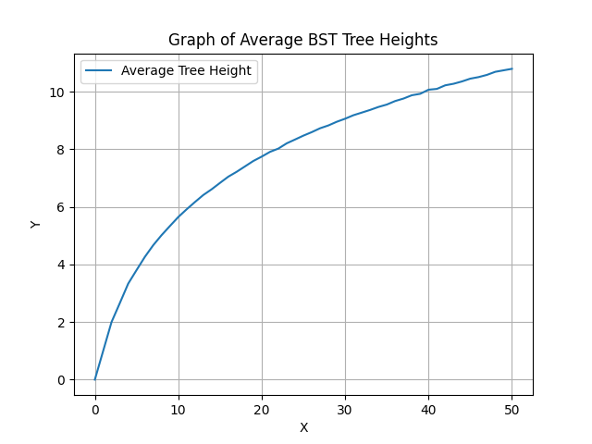
Figure 1
The graph increases quickly at a low value of N (x-axis) and then starts to decrease. It has a roughly logN shape, which is expected because if you have a super balanced BST, it will be logN height (more common) because best case O(logN) and if you have a completely unbalanced tree it will be N height (less common) so the average would have more of a logN shape. It is smooth because it is an average of all the randomly generated trees.

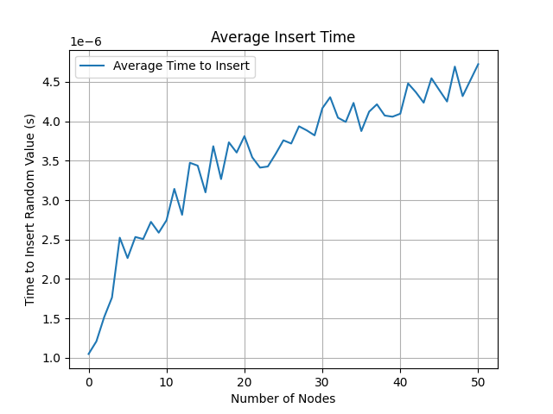
Figure 2.
This graph also has a roughly logN shape, which is expected for similar reasons to the last graph because the time it takes to randomly insert a value into a BST scales with the height of the BST (on average). While this is also an average, I think the reason it jitters has to do with my computers ability to perform the function. I think it would likely look different if I were running some other programs in the background because this function is measuring time. I think fig 1 would still look the same no matter how much of my disc space was being used at the time.

