ENSO Diversity and Tropical Cyclone Activity in the Eastern and Central Pacific (1979–2023)
Erin C. Welch
University of Illinois Urbana-Champaign, Champaign, Illinois
1. Introduction
Tropical cyclones (TCs) in the eastern and central North Pacific represent a major source of natural hazard, influencing coastal communities, marine ecosystems, and economic activity across the Pacific basin. These storms contribute substantially to seasonal rainfall, flooding, and coastal impacts, while also posing risks to shipping, fisheries, and offshore infrastructure. Interannual variability in Pacific TC activity is large, and understanding the climate processes that modulate this variability is critical for improving seasonal prediction, hazard preparedness, and long-term risk assessment.
One of the dominant drivers of interannual climate variability in the tropical Pacific is the El Niño–Southern Oscillation (ENSO). ENSO is characterized by coupled ocean–atmosphere fluctuations that alter sea surface temperature (SST) patterns, atmospheric circulation, and convection across the tropical Pacific and beyond (Vecchi and Wittenberg, 2010). These large-scale changes strongly influence TC environments by modifying vertical wind shear, thermodynamic instability, mid-tropospheric moisture, and upper-level divergence, all of which play central roles in TC formation and development. As a result, ENSO has long been recognized as a key modulator of TC activity in multiple ocean basins, including the Pacific and Atlantic (Chan, 2000; Lander, 1994; Bove et al., 1998).
Early studies documented that El Niño conditions tend to enhance TC activity in the eastern and central North Pacific while suppressing activity in the western North Pacific and Atlantic basins, with opposite tendencies during La Niña (Bove et al., 1998). Subsequent work expanded this framework by quantifying ENSO impacts on storm frequency, intensity, and tracks, often using basin-integrated metrics such as accumulated cyclone energy (ACE) or storm counts (Camargo et al., 2007; Bell et al., 2000). These studies established ENSO as a primary control on Pacific TC climatology, but they typically treated El Niño as a single, spatially uniform phenomenon.
More recent research has demonstrated that El Niño events are not spatially homogeneous and that their impacts depend strongly on the longitudinal structure of SST anomalies. A growing body of literature distinguishes between Eastern Pacific (EP), or “canonical,” El Niño events, characterized by maximum SST anomalies in the eastern equatorial Pacific near the Niño1+2 region, and Central Pacific (CP), or “Modoki,” El Niño events, in which peak warming is displaced westward toward the Niño4 region (Ashok et al., 2007; Kao and Yu, 2009; Kug et al., 2009; Capotondi et al., 2015). These ENSO “flavors” are associated with distinct atmospheric teleconnection patterns, including differences in Walker circulation anomalies, upper-level divergence, and regional wind shear, leading to differing climate impacts across the Pacific basin.
Several studies suggest that ENSO diversity may play an important role in shaping TC behavior. EP El Niño events have been linked to enhanced eastern Pacific TC activity, potentially through reduced vertical wind shear and increased ocean heat content near the Central American coast (Boucharel et al., 2016). In contrast, CP El Niño events have been associated with a westward displacement of favorable TC environments, influencing genesis locations and activity in the central Pacific while exerting weaker or more variable impacts farther east (Kim et al., 2011; Song et al., 2022). Despite these advances, relatively few studies have systematically quantified how ENSO flavor modulates energy-based intensity metrics, spatial genesis characteristics, and extreme seasonal behavior across both the eastern and central North Pacific.
In particular, many ENSO–TC studies focus on storm counts or regional frequency, while fewer examine basin-wide energetics such as ACE or evaluate whether ENSO diversity influences the likelihood of extreme TC seasons. Energy-based metrics integrate storm frequency, intensity, and duration and are therefore more directly linked to seasonal hazard potential. Moreover, many existing studies focus on a single basin or do not explicitly separate eastern and central Pacific responses (Chu, 2004; Jien et al., 2014), limiting insight into how ENSO flavor affects the broader Pacific TC system. Addressing these gaps is increasingly important given growing interest in ENSO diversity and its implications for regional climate extremes (Capotondi et al., 2015).
This study builds on prior ENSO–TC research and extends earlier basin-wide analyses by explicitly distinguishing between EP and CP El Niño events and quantifying their impacts on TC activity in the eastern and central North Pacific during the satellite era (1979–2023). ENSO types are identified using SST anomalies in the Niño1+2 and Niño4 regions, allowing El Niño events to be classified based on the longitudinal structure of Pacific warming rather than magnitude alone. TC activity is assessed using multiple complementary metrics, including seasonal accumulated cyclone energy (ACE), seasonal mean maximum sustained wind speed (MaxWind), spatial genesis distributions, and the frequency of extreme seasons.
The primary objectives of this study are to quantify how EP and CP El Niño events differentially modulate basin-wide and regional TC energetics in the eastern and central North Pacific, assess whether ENSO flavor influences seasonal peak intensity as distinct from storm frequency and persistence, examine how ENSO diversity affects TC genesis locations and spatial density patterns, and evaluate whether extreme TC seasons occur preferentially during specific ENSO states. Based on prior literature, it is hypothesized that EP El Niño events will be associated with significantly enhanced basin-wide ACE and a higher frequency of extreme seasons relative to CP El Niño, Neutral, and La Niña conditions, while CP El Niño events will exhibit weaker and more spatially heterogeneous impacts. It is further hypothesized that ENSO flavor primarily modulates TC energetics through changes in storm frequency and duration rather than systematic increases in peak storm intensity.
By integrating ENSO diversity with energy-based TC metrics and spatial analyses, this study provides a comprehensive observational assessment of how different El Niño types shape TC behavior in the eastern and central North Pacific. The results contribute to a more nuanced understanding of ENSO–TC relationships and have implications for seasonal forecasting, regional hazard assessment, and future climate projections in a region highly sensitive to TC variability.
2. Methods
a. Data Sources and Computational Environment
Monthly sea surface temperature (SST) data are obtained from the Extended Reconstructed Sea Surface Temperature version 5 (ERSSTv5) product provided by NOAA National Centers for Environmental Information. ERSSTv5 supplies spatially complete monthly mean SSTs on a 2° × 2° grid and is widely used for analyses of large-scale climate variability. SST fields are downloaded from NOAA Physical Sciences Laboratory servers in NetCDF format and processed using the xarray Python library for subsequent analysis.
Tropical cyclone data are obtained from the International Best Track Archive for Climate Stewardship version 4 (IBTrACSv4), which provides globally consistent 6-hourly storm position and intensity records synthesized from multiple operational forecasting agencies. Best track files are retrieved directly from the NOAA IBTrACS data repository using automated file downloads with urllib.request.urlretrieve. The downloaded NetCDF files are read into Python using xarray and converted to tabular format for analysis. For each storm, the storm identifier, time, latitude, longitude, and maximum sustained wind speed are retained. Storms that reach at least tropical storm (TS) strength, defined as maximum sustained winds of at least 34 kt at some point during their lifetime, are included in analyses involving ACE, while all storms with valid wind observations are retained for maximum wind speed analyses, consistent with standard TC climatology practices.
All analyses are conducted using Python version 3.13.5. Code development and execution are performed within Visual Studio Code, and all scripts and figures are tracked using GitHub for version control and reproducibility. Core scientific libraries used throughout analysis include numpy, pandas, xarray, scipy, statsmodels, matplotlib, and cartopy. All data processing, analysis, and visualization steps are performed programmatically to ensure a transparent and fully reproducible workflow.
b. SST Processing and ENSO Index Computation
Monthly SSTs are subset to the analysis period from January 1979 through December 2023. All longitudes are converted to a 0-360° coordinate system to ensure consistency across datasets. SST anomalies are computed by removing the monthly climatological mean calculated over the standard 30-year base period from 1981 through 2010. This climatology is computed separately for each calendar month, and anomalies are obtained by subtracting the appropriate monthly mean from each SST field. This procedure removes the seasonal cycle while retaining interannual and longer variability.
Two ENSO indices are constructed directly from the SST anomaly fields. The Niño1+2 index is defined as the area-weighted mean SST anomaly averaged over 10°S-0° latitude and 90°W-80°W longitude. The Niño4 index is defined as the area-weighted mean SST anomaly averaged over 5°S-5°N latitude and 160°E-150°W longitude (Fig. 1). Area weighting is applied using the cosine of latitude to account for grid-cell convergence toward the poles.
Monthly ENSO indices are averaged over June through October (JJASO) to create seasonal mean indices corresponding to the peak TC season in the eastern and central North Pacific. These JJASO means are computed for each year and used for both classification and statistical analysis.
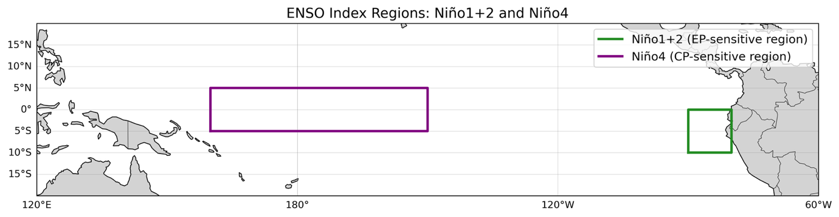
Fig. 1. Geographic boundaries of the Niño1+2 and Niño4 regions used to quantify eastern-Pacific and central-Pacific SST anomalies. These standardized index regions form the basis for identifying ENSO types (EP El Niño, CP El Niño) throughout the analysis.
c. ENSO Event Classification
Each year is classified into one of four ENSO categories based on the JJASO mean Niño indices. Years are classified as Eastern Pacific (EP) El Niño when the Niño1+2 index exceeds +0.5°C and is greater than the Niño4 index. Years are classified as Central Pacific (CP) El Niño when the Niño4 index exceeds +0.5°C and is greater than the Niño1+2 index. Years are classified as La Niña when either index is less than -0.5°C. All remaining years are classified as Neutral (Table 1). This classification scheme follows established ENSO diversity literature and ensures that EP and CP El Niño events are distinguished based on the spatial structure of SST anomalies rather than magnitude alone.
Year | 197x | 198x | 199x | 200x | 201x | 202x
0 | n/a | Neutral | Neutral | Niña | Niña | Niña
1 | n/a | Niña | CP Niño | Niña | Niña | Neutral
2 | n/a | EP Niño | Neutral | CP Niño | Neutral | Niña
3 | n/a | EP Niño | EP Niño | Neutral | Niña | EP Niño
4 | n/a | Niña | CP Niño | CP Niño | EP Niño | n/a
5 | n/a | Niña | Neutral | Niña | EP Niño | n/a
6 | n/a | Neutral | Niña | EP Niño | Neutral | n/a
7 | n/a | EP Niño | EP Niño | Niña | Neutral | n/a
8 | n/a | Niña | Niña | Niña | CP Niño | n/a
9 | Neutral | Niña | Niña | CP Niño | Niña | n/a
Table 1. ENSO classification for JJASO seasons from 1979-2023 based on Niño1+2 and Niño4 SST anomalies. The column indicates the decade, and the row indicates the year. Each year is categorized as Eastern Pacific El Niño (EP Niño), Central Pacific El Niño (CP Niño), La Niña (Niña), or Neutral following the threshold-based classification described in section 2c. Years not included in analyses are marked as n/a. This classification is used consistently across all analyses in the study.
d. TC Data Processing and Basin Definition
TC data are restricted to the period 1979–2023 and to the June–October (JJASO) season, which encompasses the climatological peak of TC activity in the eastern and central North Pacific. This restriction excludes early- and late-season storms that are relatively infrequent and often governed by different environmental controls, thereby ensuring a more homogeneous sample of peak-season TC behavior. Although ENSO events typically peak during boreal winter, ENSO-related SST anomalies and large-scale circulation patterns are well established by boreal summer and persist through the JJASO season. As a result, JJASO-mean ENSO indices are appropriate for examining ENSO influences on peak-season TC activity without conflating fundamentally different storm regimes.
Storm genesis is defined as the first 6-hourly record for each storm identifier. Genesis locations are used to assign each storm to a basin based on NOAA operational boundaries. Storms are classified as Central North Pacific (CNP) genesis storms if their genesis latitude lies between 0° and 40°N and their genesis longitude lies between 180°W and 140°W. Storms are classified as Eastern North Pacific (ENP) genesis storms if their latitude lies between 0° and 40°N and their genesis longitude lies between 140°W and 60°W. To ensure the ENP longitude window does not inadvertently include Atlantic storms, storms identified as North Atlantic (basin_main = NA in IBTrACS) are excluded prior to applying the genesis longitude–latitude masks (Fig. 2). All 6-hourly fixes associated with storms whose genesis occurs in either basin are retained, regardless of subsequent storm motion. This ensures that basin classification is based solely on formation location and not influenced by later track behavior or intensification.
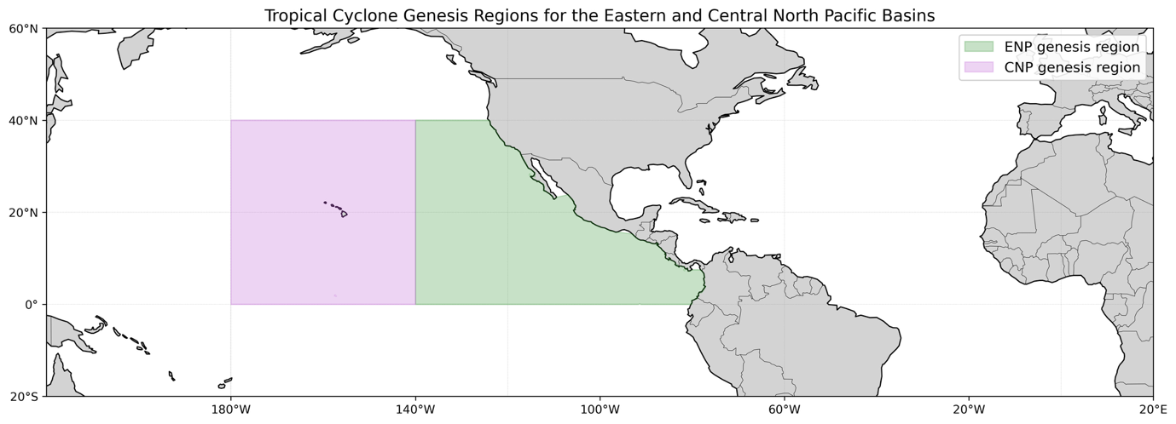
Fig. 2. Genesis regions used to classify Eastern North Pacific (ENP) and Central North Pacific (CNP) tropical cyclones. The ENP region spans 0°-40°N and 140°W-60°W on the Pacific side of the Americas only. The CNP region spans 0°-40°N and 180°W-140°W. These boundaries follow NOAA conventions and determine basin assignment for each storm’s observed fix.
e. TC Intensity Metrics
Two intensity metrics are computed. Accumulated Cyclone Energy (ACE) is calculated following the standard NOAA definition as the sum over all 6-hourly periods of the square of the maximum sustained wind speed, multiplied by 10⁻⁴. Only 6-hourly periods during which the maximum sustained wind speed equals or exceeds 34 kt contribute to ACE. Weaker periods are retained in the dataset but contribute zero to the seasonal total.
Maximum wind speed (MaxWind) is defined for each storm as the maximum 6-hourly sustained wind observed during that storm within a given season. All storms are included in the MaxWind analysis regardless of whether they contribute to ACE. Storm-level ACE and MaxWind are aggregated to basin-year values by summing ACE across storms and averaging storm-level MaxWind within each basin and season. Seasonal mean MaxWind therefore represents the mean of storm-maximum sustained winds (one value per storm) for all storms forming in a given basin and season, including storms that do not reach tropical storm strength. This formulation allows ENSO impacts on peak storm intensity to be evaluated independently of storm frequency and duration.
f. Statistical Analyses
Statistical analyses are used to quantify the relationship between ENSO variability and TC activity and to assess uncertainty across ENSO categories. Linear associations between seasonal ENSO indices and basin-wide ACE are evaluated using Pearson correlation coefficients. Ordinary least squares regression is applied using a binary indicator variable representing EP El Niño years to estimate the magnitude and statistical significance of ENSO type effects on seasonal ACE and mean MaxWind. Analyses focusing on uncertainty and pairwise differences emphasize ACE rather than MaxWind because seasonal mean MaxWind exhibits substantial overlap across ENSO categories and provides limited additional discriminatory power at the basin scale.
Uncertainty in mean seasonal ACE for each ENSO category is quantified using nonparametric bootstrap resampling. Bootstrap samples are generated by resampling seasonal values with replacement within each ENSO category, and 95 percent confidence intervals are estimated from the resulting distributions. Pairwise differences between ENSO categories are evaluated using Welch two-sample t-tests to account for unequal variances and sample sizes. Multiple-comparison adjustments are applied using both the Bonferroni and false discovery rate (FDR) methods.
Extreme seasons are identified independently for ACE and MaxWind using the 90th percentile of the full seasonal distribution as a threshold. The frequency of extreme seasons within each ENSO category is computed to assess whether certain ENSO states are associated with an increased likelihood of unusually energetic or intense seasons.
g. TC Genesis Location and Density Analysis
TC genesis is defined as the first recorded 6-hourly fix for each storm. Genesis locations are examined by ENSO category to assess whether ENSO flavor influences preferred storm formation regions. Spatial distributions of genesis points are evaluated using scatter plots and gridded density analyses.
Genesis density is computed on a 2° by 2° latitude-longitude grid across the eastern and central North Pacific domain. For each ENSO category, the number of genesis events within each grid cell is counted and normalized by the number of years in that category to yield genesis density expressed as events per year. Difference fields between EP and CP El Niño years are computed to highlight spatial contrasts in genesis frequency.
h. Basin-Separated Analyses
To assess whether basin-aggregated results mask region-specific ENSO responses, intensity metrics are additionally analyzed for storms forming in the Eastern North Pacific (ENP) only. Seasonal ACE and seasonal mean MaxWind are computed using ENP-genesis storms and stratified by ENSO category. Bootstrap confidence intervals, regression analyses, and extreme-season diagnostics are applied using the same methods as in the basin-combined analysis. ENP-only results are presented because this basin contains the majority of storms and provides sufficient sample sizes for statistically robust comparisons across ENSO types. In contrast, the Central North Pacific (CNP) contains relatively few storms, leading to large uncertainty and unstable statistical estimates when analyzed separately. CNP-only results are therefore not shown to avoid overinterpretation of noise-driven differences.
i. SST Anomaly Composites
SST anomaly composites are constructed to provide physical context for observed differences in TC activity across ENSO categories. JJASO SST anomaly fields are averaged separately for EP El Niño, CP El Niño, and La Niña years. Composite differences between EP and CP El Niño years are also computed to highlight zonal contrasts in SST forcing. All composites are derived from the same SST anomaly fields and spatial domain used for ENSO index computation, ensuring consistency between the classification methodology and physical interpretation.
3. Results
a. TC Track and Fix Distributions
Figure 3 shows the spatial distribution of all 6-hourly TC fixes occurring during JJASO from 1979-2023 for storms forming in the Eastern North Pacific (ENP) and Central North Pacific (CNP) basins. Fixes are colored according to the basin of storm genesis, with ENP-origin storms shown in green and CNP-origin storms shown in purple. The figure illustrates the spatial extent of TC activity included in the analysis and highlights systematic differences in track density and longitudinal reach between basins. All subsequent basin-separated analyses are based on the genesis classification shown here, with basin assignment determined solely by formation location.
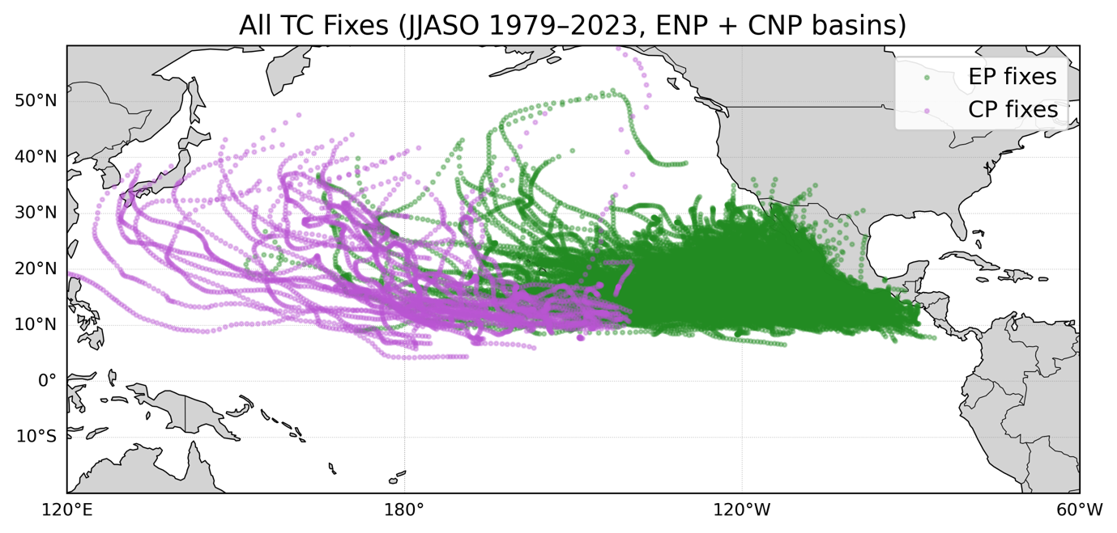
Fig. 3. Spatial distribution of all 6-hourly TC best-track fixes during the JJASO season for the period 1979–2023 across the Eastern and Central North Pacific. Points show individual 6-hourly positions from the IBTrACS v4 dataset. Storms are colored by basin of genesis, with systems forming in the Eastern North Pacific (ENP; n = 783 storms, 41,955 fixes) shown in green and those forming in the Central North Pacific (CNP; n = 68 storms, 4324 fixes) shown in purple. Basin assignment is determined solely by the location of the first recorded TC fix, and all subsequent 6-hourly fixes are retained regardless of later track evolution. The figure defines the spatial domain and basin classification used in all subsequent basin-aggregated and basin-separated analyses.
b. ENSO Variability and Event Classification
Seasonal JJASO Niño1+2 and Niño4 anomalies from 1979 to 2023 exhibit substantial interannual variability, with distinct periods associated with enhanced eastern-Pacific or central-Pacific warming. The two indices often evolve independently, resulting in years where SST anomalies are concentrated preferentially in either the Niño1+2 or Niño4 region rather than uniformly across the equatorial Pacific.
Figure 4 shows the JJASO Niño1+2 and Niño4 time series with background shading indicating the ENSO classification applied in this study. EP El Niño years are characterized by elevated Niño1+2 anomalies relative to Niño4, while CP El Niño years are characterized by elevated Niño4 anomalies relative to Niño1+2. La Niña years show negative anomalies in one or both regions, and Neutral years cluster near zero anomaly in both regions. The classification produces a balanced distribution of ENSO states across the record, with all four types of events occurring throughout the analysis period rather than being confined to a specific decade.
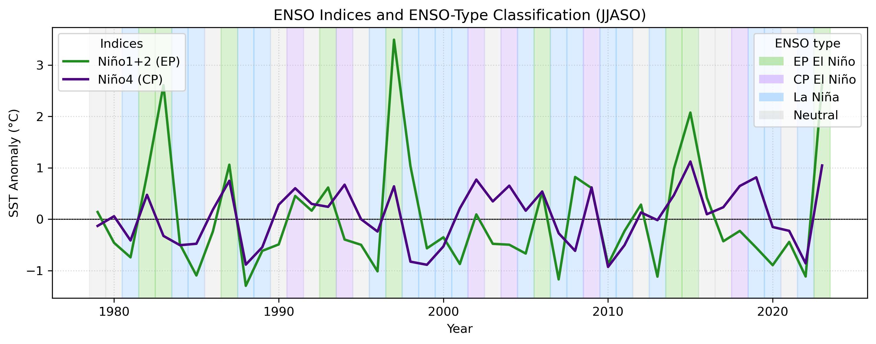
Fig. 4. Seasonal (JJASO) SST anomalies for the Niño1+2 (eastern Pacific; green line) and Niño4 (central Pacific; purple line) regions from 1979–2023. Background shading denotes the ENSO event classification applied in this study: Eastern Pacific (EP) El Niño (n = 9 seasons), Central Pacific (CP) El Niño (n = 6 seasons), La Niña (n = 19 seasons), and Neutral (n = 11 seasons). SST anomalies are shown relative to the 1981–2010 climatology. The figure illustrates the interannual variability and differing temporal evolution of eastern- and central-Pacific SST anomalies and provides the visual basis for the categorical ENSO groupings used in subsequent analyses.
c. Basin-Wide TC Activity and Interannual Variability
Seasonal ACE for the combined eastern and central North Pacific basins shows large year-to-year variability during JJASO from 1979 to 2023. Figure 5 displays the basin-wide seasonal ACE time series. Several seasons exceed 400 (10⁻⁴ kt²), while other seasons exhibit suppressed activity with ACE near 100 (10⁻⁴ kt²). Periods of elevated activity and suppression occur intermittently throughout the record, and no monotonic trend is evident over the analysis period. The large interannual spread in seasonal ACE motivates subsequent grouping by ENSO state to assess whether systematic differences emerge when seasons are grouped by large-scale climate conditions.
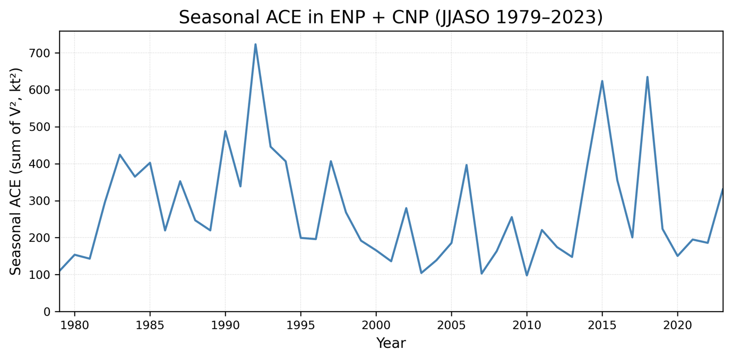
Fig. 5. Seasonal ACE for all TCs forming in the combined ENP and CNP basins during JJASO from 1979–2023 (n = 45 seasons). ACE is computed following the standard NOAA definition as the sum of the squared 6-hourly maximum sustained wind speeds (in knots) for all tropical storms and hurricanes within each season and is reported in units of 10⁻⁴ kt². The time series exhibits substantial interannual variability, with seasons of both enhanced and suppressed basin-wide TC activity, motivating subsequent stratification and statistical analysis by ENSO type.
d. Tropical Cyclone Intensity by ENSO Type
Figure 6 presents boxplots of seasonal ACE and seasonal mean maximum sustained wind speed (MaxWind) stratified by ENSO type for the combined Eastern and Central North Pacific (ENP + CNP) basins during JJASO from 1979–2023. Each box represents the distribution of basin-integrated seasonal values, with one value per season.
Seasonal ACE exhibits clear differences across ENSO categories (Fig. 6a). EP El Niño seasons show the highest median ACE (≈397 (10⁻⁴ kt²)) and the highest mean ACE (≈408 (10⁻⁴ kt²)), indicating enhanced basin-wide cyclone energetics during these years (Table 2). CP El Niño seasons also exhibit elevated ACE, though with a lower median and greater dispersion. Neutral seasons span a broad range of ACE values, while La Niña seasons consistently show the lowest median and mean ACE and reduced variability relative to other ENSO states.
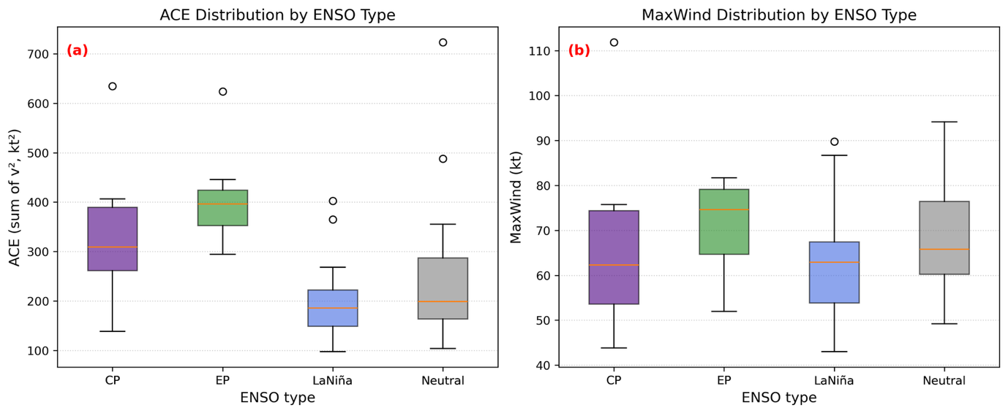
Fig. 6. Boxplots of (a) seasonal ACE and (b) seasonal mean maximum sustained wind speed (MaxWind) for TCs forming in the combined Eastern and Central North Pacific (ENP + CNP) basins during JJASO (1979–2023), stratified by ENSO type. Each box summarizes the distribution of basin-integrated seasonal values, with one value per JJASO season. ACE is computed following the standard NOAA definition as the sum of squared 6-hourly maximum sustained wind speeds (kt²) for all storms within a season and is reported in units of 10⁻⁴ kt². MaxWind is computed as the seasonal mean of storm-maximum 6-hourly sustained winds (one maximum per storm), including storms that do not reach tropical storm strength. Sample sizes are CP El Niño (n = 6), EP El Niño (n = 9), La Niña (n = 19), and Neutral (n = 11) (Table 2). Boxes denote the interquartile range, horizontal lines indicate the median, whiskers extend to 1.5×IQR, and points denote outliers.

ENSO Category | n (seasons) | Mean ACE | Std. Dev. | Min | 25th pct | Mdn | 75th pct | Max
EP El Niño | 9 | 407.59 | 93.87 | 294.65 | 352.58 | 396.50 | 424.24 | 623.69
CP El Niño | 6 | 342.33 | 168.83 | 138.75 | 261.59 | 309.25 | 389.55 | 634.72
Neutral | 11 | 265.76 | 188.05 | 104.33 | 164.05 | 199.30 | 287.42 | 723.10
La Niña | 19 | 200.64 | 78.84 | 97.79 | 149.06 | 185.83 | 222.11 | 402.45
Table 2. Descriptive statistics of seasonal Accumulated Cyclone Energy (ACE; 10⁻⁴ kt²) for TCs forming in the combined ENP + CNP basins during JJASO (1979–2023), stratified by ENSO type. Statistics are computed from one basin-integrated seasonal ACE value per year.
Seasonal mean MaxWind distributions show substantially greater overlap across ENSO categories (Fig. 6b) (Table 3). EP El Niño seasons exhibit the highest median MaxWind (≈75 kt), followed by Neutral and CP El Niño seasons, while La Niña seasons show the lowest median values. However, the interquartile ranges overlap considerably among all ENSO types, indicating that differences in peak seasonal intensity are smaller and less systematic than differences in basin-wide energetics demonstrated by ACE.
ENSO Category | n (seasons) | Mean MaxWind (kt) | Std. Dev. | Min | 25th pct | Mdn | 75th pct | Max
EP El Niño | 9 | 71.56 | 9.82 | 51.95 | 64.63 | 74.64 | 79.09 | 81.68
CP El Niño | 6 | 68.23 | 24.38 | 43.83 | 53.62 | 62.30 | 70.09 | 81.68
Neutral | 11 | 68.82 | 12.62 | 49.22 | 60.23 | 65.79 | 76.42 | 94.17
La Niña | 19 | 62.26 | 12.95 | 43.00 | 53.85 | 62.94 | 67.39 | 89.78
Table 3. Descriptive statistics of seasonal mean maximum sustained wind speed (MaxWind; kt) for TCs forming in the combined Eastern and Central North Pacific (ENP + CNP) basins during JJASO (1979–2023), stratified by ENSO type. Seasonal mean MaxWind is computed as the mean of storm-maximum 6-hourly sustained wind speeds (one maximum per storm) within each season, yielding one value per year. All storms are included regardless of whether they reach tropical storm strength (≥34 kt). Reported values include sample size (n), mean, standard deviation, minimum, interquartile range, median, and maximum.
e. Relationship Between ENSO SST Anomalies and Seasonal ACE
Figure 7 shows scatterplots of basin-wide seasonal ACE versus JJASO Niño1+2 and Niño4 SST anomalies for the combined Eastern and Central North Pacific (ENP + CNP) basins from 1979–2023 (n = 45 seasons). Each point represents one JJASO season.
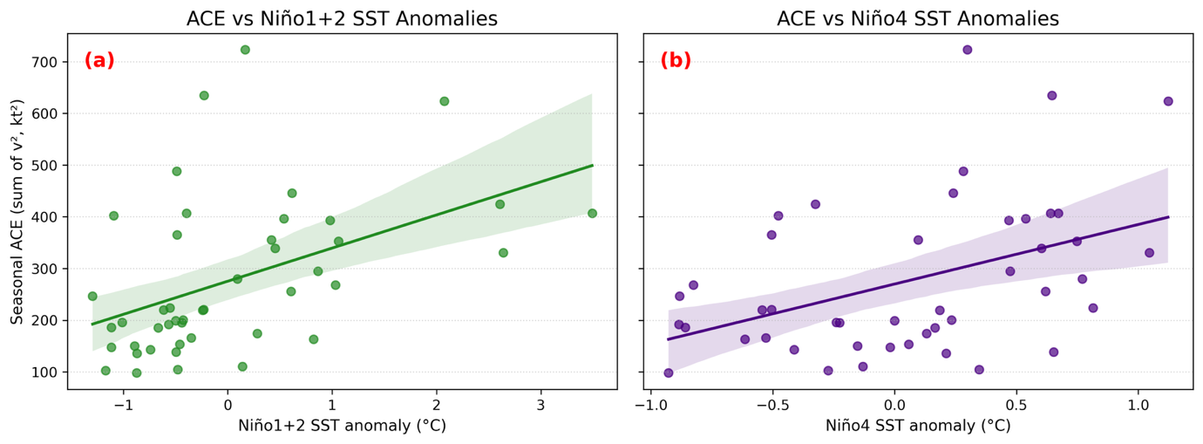
Fig. 7. Scatterplots showing the relationship between basin-wide seasonal ACE and JJASO SST anomalies in (a) the Niño1+2 region and (b) the Niño4 region for the combined Eastern and Central North Pacific (ENP + CNP) basins during 1979–2023 (n = 45 seasons, df = 43). Each point represents one JJASO season. Solid lines indicate least-squares linear fits, and shaded envelopes denote the 95% confidence intervals. Pearson correlation coefficients are r = 0.46 (p = 0.001) for Niño1+2 and r = 0.43 (p = 0.003) for Niño4. Seasonal ACE is reported in units of 10⁻⁴ kt² following the standard NOAA definition.
Seasonal ACE exhibits a statistically significant positive linear association with SST anomalies in both ENSO regions. The Pearson correlation between Niño1+2 SST anomalies and seasonal ACE is r = 0.46 (p = 0.001), while the correlation between Niño4 SST anomalies and seasonal ACE is r = 0.43 (p = 0.003). Seasons characterized by stronger positive SST anomalies in either the eastern or central equatorial Pacific tend to be associated with higher basin-wide ACE. Despite these positive relationships, substantial scatter is evident in both panels, with high and low ACE seasons occurring across a wide range of SST anomaly magnitudes. This indicates that while ENSO-related SST variability is significantly associated with seasonal ACE, it explains only a portion of the total interannual variability in basin-wide TC energetics.
f. ENSO-Type Regression Analysis of Seasonal TC Intensity
Ordinary least squares (OLS) regression is used to quantify the association between ENSO type and basin-wide seasonal TC intensity using a binary indicator for EP El Niño years. Seasonal metrics are aggregated to one value per year for the combined ENP+CNP basin, yielding 45 seasonal observations spanning 1979-2023. Separate regressions are performed with seasonal ACE and seasonal mean maximum sustained wind speed (MaxWind) as response variables.
For seasonal ACE, the regression model explains a substantial fraction of the total interannual variance (R² = 0.198). The EP El Niño indicator is associated with a positive regression coefficient of 163.4 (10⁻⁴ kt²), indicating markedly higher basin-wide seasonal ACE during EP El Niño years relative to all non-EP years (Table 4). This effect is statistically significant at the 5% level (p = 0.002), providing strong evidence that EP El Niño conditions are associated with enhanced seasonal TC ACE in the ENP + CNP basins. Residual diagnostics indicate positive skewness and non-normality, consistent with the episodic nature of extreme ACE seasons and the influence of a small number of highly energetic years.
For seasonal mean MaxWind, the regression explains little variance (R² = 0.032). The EP El Niño coefficient is positive (6.3 kt) but not statistically significant (p = 0.242), indicating no detectable linear relationship between ENSO type and basin-wide seasonal mean storm-maximum intensity. As with ACE, residual diagnostics show departures from normality, reflecting the influence of individual intense storms on seasonal mean values.
Response Variable | n | df (residual) | Coefficient | Std. Error | t | p | R²
ACE | 45 | 43 | 163.44 | 50.11 | 3.26 | 0.002* | 0.198
MaxWind | 45 | 43 | 6.30 | 5.31 | 1.19 | 0.242 | 0.032
Table 4. OLS regression results relating ENSO type to basin-wide seasonal TC intensity metrics for the combined ENP + CNP basins during JJASO 1979-2023. ENSO type is represented by a binary indicator for EP El Niño years. Reported values include regression coefficients, standard errors, test statistics, p-values, and model R². Asterisks denote significance at α = 0.05.
Overall, the regression results indicate that ENSO type, expressed as a binary EP El Niño indicator, is strongly and statistically significantly associated with basin-wide seasonal TC energetics (ACE), while exhibiting no statistically significant relationship with seasonal mean storm intensity (MaxWind). All regressions are based on 45 seasonal observations, yielding 43 residual degrees of freedom for each model.
g. Uncertainty and Statistical Comparisons Across ENSO Categories
Uncertainty in basin-wide TC energetics across ENSO categories is quantified using nonparametric bootstrap resampling and formal pairwise statistical tests applied to seasonal ACE for the combined Eastern and Central North Pacific (ENP + CNP) basins during JJASO (1979–2023; n = 45 seasons). Nonparametric bootstrap confidence intervals were additionally computed for seasonal mean maximum sustained wind speed (MaxWind) but are not shown because bootstrap distributions exhibit substantial overlap across ENSO categories and provide limited insight beyond the descriptive statistics and regression results.
Bootstrap distributions of mean seasonal ACE for each ENSO category are shown in Figure 8. Each distribution represents 3,000 bootstrap resamples of seasonal ACE values within a given ENSO category, providing an empirical estimate of sampling uncertainty in the category mean. EP El Niño seasons exhibit the highest bootstrap distribution, with a median and interquartile range shifted toward larger ACE values relative to all other ENSO types. The EP El Niño distribution is comparatively narrow, indicating relatively consistent enhancement of basin-wide ACE during these seasons. In contrast, La Niña seasons show the lowest bootstrap distribution, with both median and spread well below other categories. CP El Niño and Neutral seasons occupy intermediate ACE ranges and exhibit substantial overlap with all ENSO types, reflecting larger interannual variability and weaker separation.
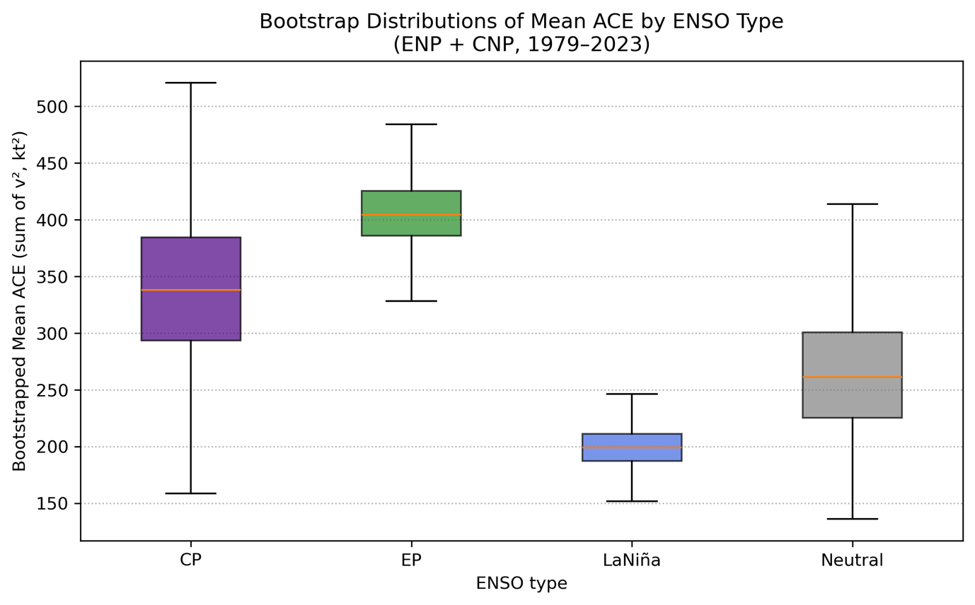
Fig. 8. Bootstrap distributions of mean seasonal ACE for each ENSO category for the combined ENP + CNP basins during JJASO (1979–2023). Distributions are derived from 3,000 nonparametric bootstrap resamples of basin-integrated seasonal ACE values within each ENSO category. Boxes indicate the interquartile range, orange horizontal lines denote the median, and whiskers represent the full range of the resampled distributions. Sample sizes are CP El Niño (n = 6), EP El Niño (n = 9), La Niña (n = 19), and Neutral (n = 11).
Uncertainty in mean seasonal ACE is summarized using 95% bootstrap confidence intervals (Table 5). EP El Niño seasons have the highest mean ACE (≈408 (10⁻⁴ kt²)) with confidence intervals that lie largely above those of La Niña seasons. La Niña seasons exhibit the lowest mean ACE (≈201 (10⁻⁴ kt²)) and the narrowest confidence interval, indicating suppressed basin-wide ACE. CP El Niño and Neutral seasons show wider confidence intervals that overlap with both EP El Niño and La Niña.
ENSO Category | n (seasons) | Mean ACE | 2.5% CI | 97.5% CI
EP El Niño | 9 | 407.59 | 353.99 | 474.65
CP El Niño | 6 | 342.33 | 216.60 | 493.13
Neutral | 11 | 265.76 | 169.24 | 388.83
La Niña | 19 | 200.64 | 167.98 | 235.76
Table 5. 95% bootstrap confidence intervals for mean seasonal ACE by ENSO category for the combined ENP + CNP basins during JJASO (1979–2023). Confidence intervals are derived from 3,000 nonparametric bootstrap resamples of one basin-integrated seasonal ACE value per year.
Pairwise statistical differences in seasonal ACE between ENSO categories are evaluated using Welch two-sample t-tests, which account for unequal sample sizes and variances (Table 6). After applying multiple-comparison adjustments, only the contrast between EP El Niño and La Niña seasons remains statistically significant (t = 5.73, p < 0.001), indicating substantially higher ACE during EP El Niño relative to La Niña. Comparisons involving CP El Niño and Neutral seasons show moderate differences in mean ACE but do not reach statistical significance after correction, consistent with the overlapping bootstrap distributions. Pairwise statistical comparisons were also computed for seasonal mean maximum sustained wind speed (MaxWind); however, these results are not shown because distributions overlap strongly across ENSO categories and no contrasts remain statistically significant after multiple-comparison correction.
Comparison | n₁ | n₂ | Mean ACE₁ | Mean ACE₂ | Difference (ACE₁ – ACE₂) | t (Welch) | p (raw) | p (FDR) | p (Bonf.)
CP – EP | 6 | 9 | 342.33 | 407.59 | -65.26 | -0.86 | 0.417 | 0.417 | 1.00
CP – La Niña | 6 | 19 | 342.33 | 200.64 | 141.69 | 1.99 | 0.096 | 0.193 | 0.578
CP - Neutral | 6 | 11 | 342.33 | 265.76 | 75.57 | 0.86 | 0.409 | 0.417 | 1.000
EP – La Niña | 9 | 19 | 407.59 | 200.64 | 206.95 | 5.73 | <0.001* | <0.001* | <0.001*
EP - Neutral | 9 | 11 | 407.59 | 265.76 | 141.83 | 2.19 | 0.044* | 0.133 | 0.267
La Niña - Neutral | 19 | 11 | 200.64 | 265.76 | -65.12 | -1.09 | 0.295 | 0.417 | 1.000
Table 6. Pairwise Welch t-test results for seasonal ACE across ENSO categories for the combined ENP + CNP basins during JJASO (1979–2023). Reported values include sample sizes, group means, mean differences (ACE₁ − ACE₂), raw p-values, and adjusted p-values using false discovery rate (FDR) and Bonferroni corrections. Asterisks denote significance at α = 0.05.
In addition to mean differences, the frequency of extreme TC seasons is evaluated using a percentile-based threshold approach. Extreme seasons are defined as those exceeding the 90th percentile of basin-wide seasonal ACE or seasonal mean maximum sustained wind speed (MaxWind) across the full 1979–2023 record. This approach isolates the upper tail of the seasonal intensity distribution while remaining independent of absolute magnitude assumptions. Extreme-year frequencies by ENSO category are summarized in Table 7. Extreme ACE seasons occur most frequently during EP El Niño (22.2%) and Neutral (18.2%) years, with CP El Niño exhibiting intermediate frequencies (16.7%). No La Niña seasons exceed the 90th percentile threshold for ACE. For seasonal mean MaxWind, extreme seasons occur most frequently during Neutral (18.2%) and CP El Niño years (16.7%), while La Niña shows a lower frequency (10.5%) and no EP El Niño seasons exceed the extreme MaxWind threshold.
ENSO Type | n (seasons) | Extreme ACE (%) | Extreme MaxWind (%)
CP El Niño | 6 | 16.7 | 16.7
EP El Niño | 9 | 22.2 | 0.0
La Niña | 19 | 0.0 | 10.5
Neutral | 11 | 18.2 | 18.2
Table 7. Frequency of extreme TC seasons by ENSO category for the combined ENP + CNP basins during JJASO (1979–2023). Extreme seasons are defined as those exceeding the 90th percentile of basin-wide seasonal ACE or seasonal mean maximum sustained wind speed (MaxWind) across all years. Percentages represent the fraction of seasons within each ENSO category classified as extreme, based on one basin-integrated seasonal value per year.
h. ENP-Only Basin-Separated TC Intensity by ENSO Type
To assess whether basin-aggregated analyses obscure region-specific ENSO responses, TC intensity metrics were analyzed separately for the Eastern North Pacific (ENP) basin. All analyses in this section use ENP-genesis storms only, aggregated to one seasonal value per year. Figure 9 presents boxplots of seasonal ACE and seasonal mean maximum sustained wind speed (MaxWind) for ENP storms during JJASO (1979–2023), stratified by ENSO type.
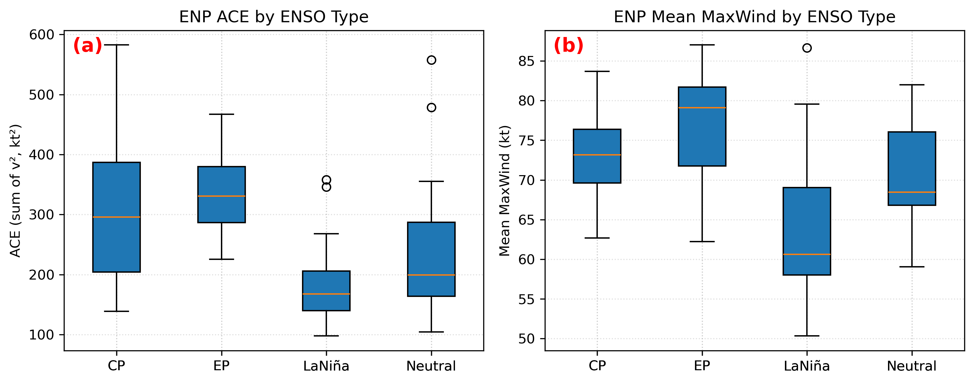
Fig. 9. Boxplots of (a) seasonal ACE and (b) seasonal mean maximum sustained wind speed (MaxWind) for ENP-only TCs during JJASO (1979–2023), stratified by ENSO type. Seasonal metrics are computed from storms whose genesis occurred in the ENP and then aggregated to one value per season. Sample sizes are n = 6 (CP El Niño), 9 (EP El Niño), 19 (La Niña), and 11 (Neutral) seasons. Boxes denote the interquartile range with median shown as the center line and outliers shown as points.
Seasonal ACE in the ENP exhibits differences across ENSO categories (Fig. 9a). EP El Niño years have the highest mean seasonal ACE (≈333 (10⁻⁴ kt²)), followed closely by CP El Niño years (≈317 (10⁻⁴ kt²)). Neutral seasons span a broad range of ACE values, while La Niña seasons consistently exhibit lower ACE with reduced variability, indicating persistent suppression of ENP activity under La Niña conditions.
Descriptive statistics for ENP seasonal ACE by ENSO type are summarized in Table 8. Mean seasonal ACE during EP El Niño years exceeds that of La Niña years by approximately 147 (10⁻⁴ kt²), while CP El Niño and Neutral years occupy intermediate ranges. Variability is largest during CP El Niño and Neutral years, reflecting occasional highly energetic seasons interspersed with relatively quiet years.
ENSO Type | n (seasons) | Mean ACE | Std. Dev. | Min | 25th pct | Median | 75th pct | Max
CP El Niño | 6 | 317.38 | 161.77 | 138.75 | 204.20 | 296.06 | 387.07 | 582.40
EP El Niño | 9 | 332.51 | 78.60 | 225.57 | 286.77 | 330.56 | 379.68 | 467.27
La Niña | 19 | 185.55 | 72.75 | 97.79 | 140.17 | 168.01 | 205.77 | 358.24
Neutral | 11 | 249.32 | 149.37 | 104.33 | 164.05 | 199.30 | 287.42 | 557.41
Table 8. Seasonal ACE statistics for ENP TC during JJASO (1979-2023), stratified by ENSO type. Statistics are computed for basin-restricted seasonal ACE totals.
Seasonal mean MaxWind in the ENP shows weaker separation across ENSO categories than ACE (Fig. 9b). EP El Niño seasons exhibit the highest mean MaxWind (76.8 kt), followed by CP El Niño (73.1 kt) and Neutral years (71.1 kt), while La Niña seasons show the lowest mean values (63.7 kt) (Table 9). However, interquartile ranges overlap substantially across ENSO types, indicating that differences in peak storm intensity are smaller and less consistent than differences in basin-wide energetics.
ENSO Type | n (seasons) | Mean MaxWind (kt) | Std. Dev. | Min | 25th pct | Median | 75th pct | Max
CP El Niño | 6 | 73.09 | 7.22 | 62.7 | 69.6 | 73.2 | 76.4 | 83.7
EP El Niño | 9 | 76.79 | 8.20 | 62.2 | 71.8 | 79.1 | 81.7 | 87.0
La Niña | 19 | 63.72 | 9.24 | 50.3 | 58.0 | 60.6 | 69.0 | 86.7
Neutral | 11 | 71.05 | 6.82 | 59.1 | 66.8 | 68.4 | 76.1 | 82.0
Table 9. Seasonal mean MaxWind for ENP TC during JJASO (1979-2023), stratified by ENSO type. Statistics are computed from basin-restricted seasonal mean MaxWind values.
Uncertainty in ENP mean seasonal ACE is quantified using nonparametric bootstrap resampling (3,000 resamples). EP El Niño seasons exhibit the highest mean ENP ACE (332.5 (10⁻⁴ kt²)), with a 95% bootstrap confidence interval of ([282.4, 384.1] (10⁻⁴ kt²)) (Table 10). This interval lies entirely above the La Niña confidence interval ([154.3, 218.3] (10⁻⁴ kt²)), indicating a robust separation between EP El Niño and La Niña conditions in the ENP. CP El Niño seasons have a mean ENP ACE of 317.4 (10⁻⁴ kt²) with a wide confidence interval ([193.3, 460.6] (10⁻⁴ kt²)), reflecting substantial interannual variability and overlap with both EP El Niño and Neutral seasons. Neutral seasons exhibit an intermediate mean ACE (249.3 (10⁻⁴ kt²)) and a broad confidence interval ([168.5, 342.2] (10⁻⁴ kt²)) that overlaps all ENSO categories except the upper tail of EP El Niño.
ENSO Type | n (seasons) | Mean ACE | 2.5% CI | 97.5%CI
CP El Niño | 6 | 317.38 | 193.32 | 460.55
EP El Niño | 9 | 332.51 | 282.41 | 384.11
La Niña | 19 | 185.55 | 154.32 | 218.29
Neutral | 11 | 249.32 | 168.45 | 342.17
Table 10. Nonparametric bootstrap 95% confidence intervals for mean seasonal ACE in the ENP by ENSO type. Confidence intervals are derived from 3,000 nonparametric bootstrap resamples of seasonal ACE within each ENSO category.
Nonparametric bootstrap confidence intervals were additionally computed for seasonal mean maximum sustained wind speed (MaxWind) in the ENP but are not shown because bootstrap distributions exhibit substantial overlap across ENSO categories and provide limited insight beyond the descriptive statistics and regression results.
An OLS regression applied to the ENP seasonal ACE further quantifies the influence of EP El Niño conditions. EP El Niño years are represented using a binary indicator variable. The regression explains approximately 12% of the variance in ENP seasonal ACE (R² = 0.12) across 45 seasons (df=43). The EP El Niño coefficient is positive and statistically significant (β = +105.5 (10⁻⁴ kt²), t = 2.43, p = 0.020), indicating that EP El Niño seasons are associated with an average increase of approximately 105.5 (10⁻⁴ kt²) in ENP seasonal ACE relative to all other ENSO states. Regression coefficients and diagnostics are summarized in Table 11.
Term | Coefficient | Std. Error | t | p | 95% CI
Intercept | 227.01 | 19.45 | 11.67 | <0.001* | [187.78, 266.24]
EP El Niño (dummy) | 105.50 | 43.50 | 2.43 | 0.020* | [17.78, 193.22]
Table 11. Ordinary least squares (OLS) regression results for ENP seasonal ACE during JJASO (1979–2023) using a binary indicator for EP El Niño years. The regression is based on 45 seasonal observations (df = 43). Reported values include regression coefficients, standard errors, t-statistics, p-values, and 95% confidence intervals. The model explains 12% of the interannual variance in ENP seasonal ACE (R² = 0.12), indicating a statistically significant but modest association between EP El Niño conditions and enhanced ENP TC energetics. Asterisks denote significance at α = 0.05.
The frequency of extreme seasons in the ENP is evaluated using a 90th-percentile threshold applied to the full ENP seasonal distribution. Extreme ACE seasons occur most frequently during CP El Niño years (33.3 %), followed by Neutral (18.2 %) and EP El Niño years (11.1 %), while no extreme ACE seasons occur during La Niña years (Table 12). Extreme MaxWind seasons occur across all ENSO categories, with modest differences between groups.
ENSO Type | n (seasons) | Extreme ACE (%) | Extreme MaxWind (%)
CP El Niño | 6 | 33.3 | 16.7
EP El Niño | 9 | 11.1 | 22.2
La Niña | 19 | 0.0 | 5.3
Neutral | 11 | 18.2 | 9.1
Table 12. Percentage of ENP seasons classified as extreme based in the 90th percentile threshold of the full ENP seasonal distribution. Extreme ACE and extreme MaxWind seasons are identified independently.
i. TC Genesis Locations and Spatial Density
Figure 10 shows TC genesis locations during JJASO seasons classified as Eastern Pacific (EP) and Central Pacific (CP) El Niño years over the combined ENP and CNP domain for 1979-2023. Each point represents the first 6-hourly best-track fix for an individual storm whose genesis occurred within the ENP+CNP. Genesis locations for both EP and CP El Niño years are concentrated primarily between approximately 8°N and 15°N latitude, with the highest density of points occurring in the eastern portion of the Pacific near the Pacific coast of Central America. Genesis locations extend westward across the central Pacific for both ENSO types, with substantial spatial overlap throughout much of the basin.
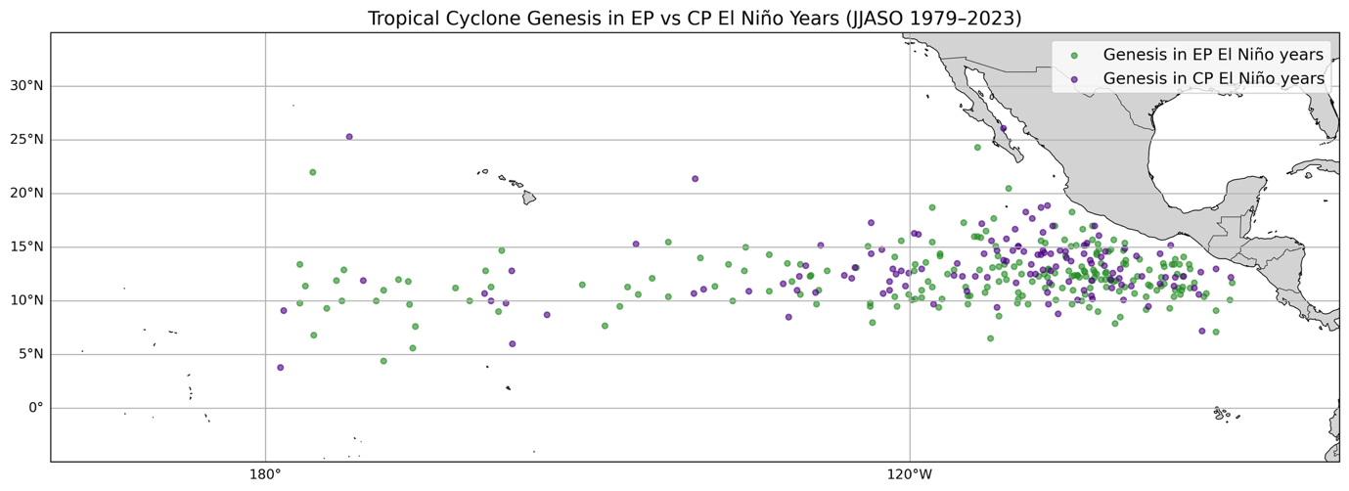
Fig. 10. TC genesis locations during JJASO seasons classified as Eastern Pacific (EP) El Niño years (green) and Central Pacific (CP) El Niño years (purple), 1979–2023. Each point denotes the first 6-hourly IBTrACS fix genesis for an individual storm whose genesis occurred within the study area. Sample sizes are n = 218 EP El Niño storms and n = 127 CP El Niño storm genesis points (one per storm).
Gridded genesis density fields for EP El Niño years, CP El Niño years, and their difference are shown in Figure 11. Genesis density is expressed as the mean number of genesis events per year within 2° x 2° grid cells, normalized by the number of years in each ENSO category. During EP El Niño years (Fig. 11a), the highest genesis densities are concentrated between approximately 100°W and 130°W and 8°-15°N, with lower densities extending westward toward the dateline. CP El Niño years (Fig. 11b) exhibit a broadly similar spatial structure, with genesis maxima occurring in comparable latitude bands and longitudinal ranges, though local differences in magnitude are evident.
The EP minus CP genesis density difference field (Fig. 11c) shows localized differences rather than a basin-wide shift in genesis location. Higher genesis frequency during EP El Niño years occurs mainly in the eastern basin near 110°–125°W, while lower frequencies appear sporadically farther west. Overall, EP and CP El Niño years exhibit broadly similar large-scale genesis patterns, with only modest regional differences.
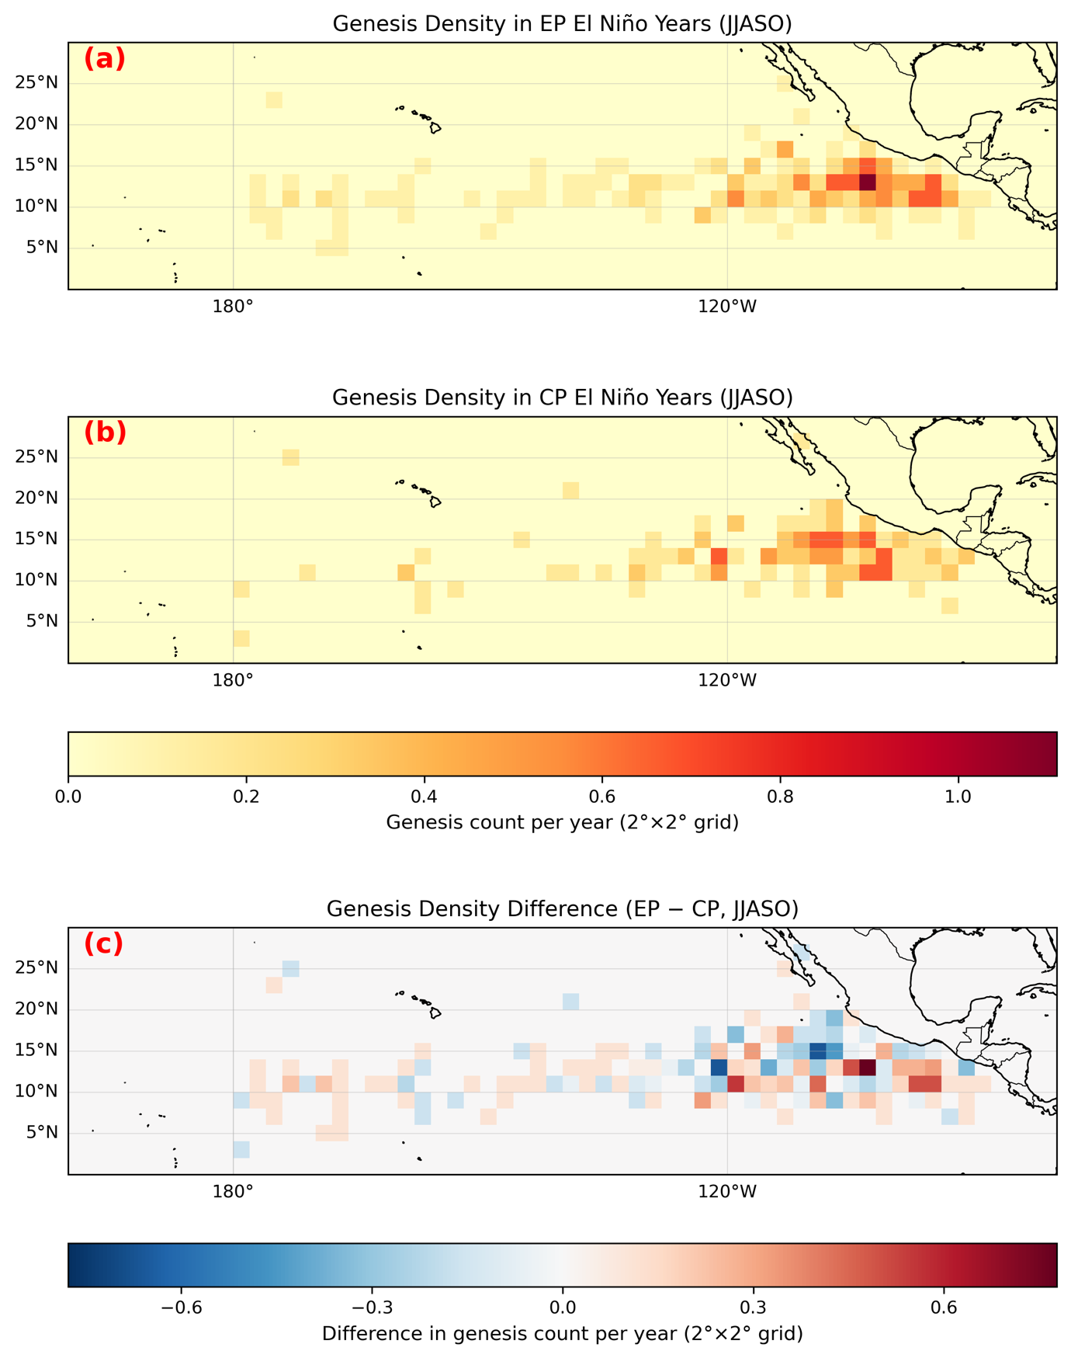
Fig. 11. Gridded TC genesis density during JJASO El Niño seasons for (a) Eastern Pacific (EP) El Niño years and (b) Central Pacific (CP) El Niño years, expressed as the mean number of genesis events per year within 2°×2° grid cells over the ENP+CNP domain. Densities are computed by binning storm genesis points (one per storm) and normalizing by the number of seasons in each category (EP: n = 9 seasons; CP: n = 6 seasons). Panel (c) shows the difference (EP − CP). Panels (a–b) share a common sequential color scale; panel (c) uses a diverging color scale.
j. SST Anomaly Composites by ENSO Type
Seasonal JJASO SST anomaly composites for EP El Niño, CP El Niño, and La Niña years are shown in Figure 12, along with the difference between EP and CP El Niño composites. All composites are calculated from ERSSTv5 SST anomalies relative to the 1981-2010 climatology and averaged over the JJASO season. These SST composites are constructed independently of TC occurrence and provide a basin-scale physical context for the ENSO classifications used throughout this study.
The EP El Niño composite (Fig. 12a) exhibits pronounced positive SST anomalies extending across the eastern equatorial Pacific, with maximum warming concentrated near the South American coast and along the Niño1+2 region. Positive anomalies also extend westward along the equator, though with descending magnitude toward the central Pacific. The CP El Niño composite (Fig. 12b) displays positive SST anomalies centered farther west, with peak warming located in the central equatorial Pacific near the Niño4 region. SST anomalies in the eastern Pacific are weaker than in EP El Niño years, and coastal warming near South America is reduced relative to the EP composite. The La Niña composite (Fig. 12c) is characterized by negative SST anomalies across much of the central and eastern equatorial Pacific, with the strongest cooling along the equator and near the eastern Pacific cold tongue. Weak positive anomalies appear in portions of the western Pacific. The EP minus CP difference field (Fig. 12d) highlights enhanced warming in the eastern equatorial Pacific during EP El Niño years relative to CP El Niño years, with positive differences extending from the South American coast westward along the equator. Negative differences in the central Pacific indicate regions where SST anomalies are stronger during CP El Niño events.
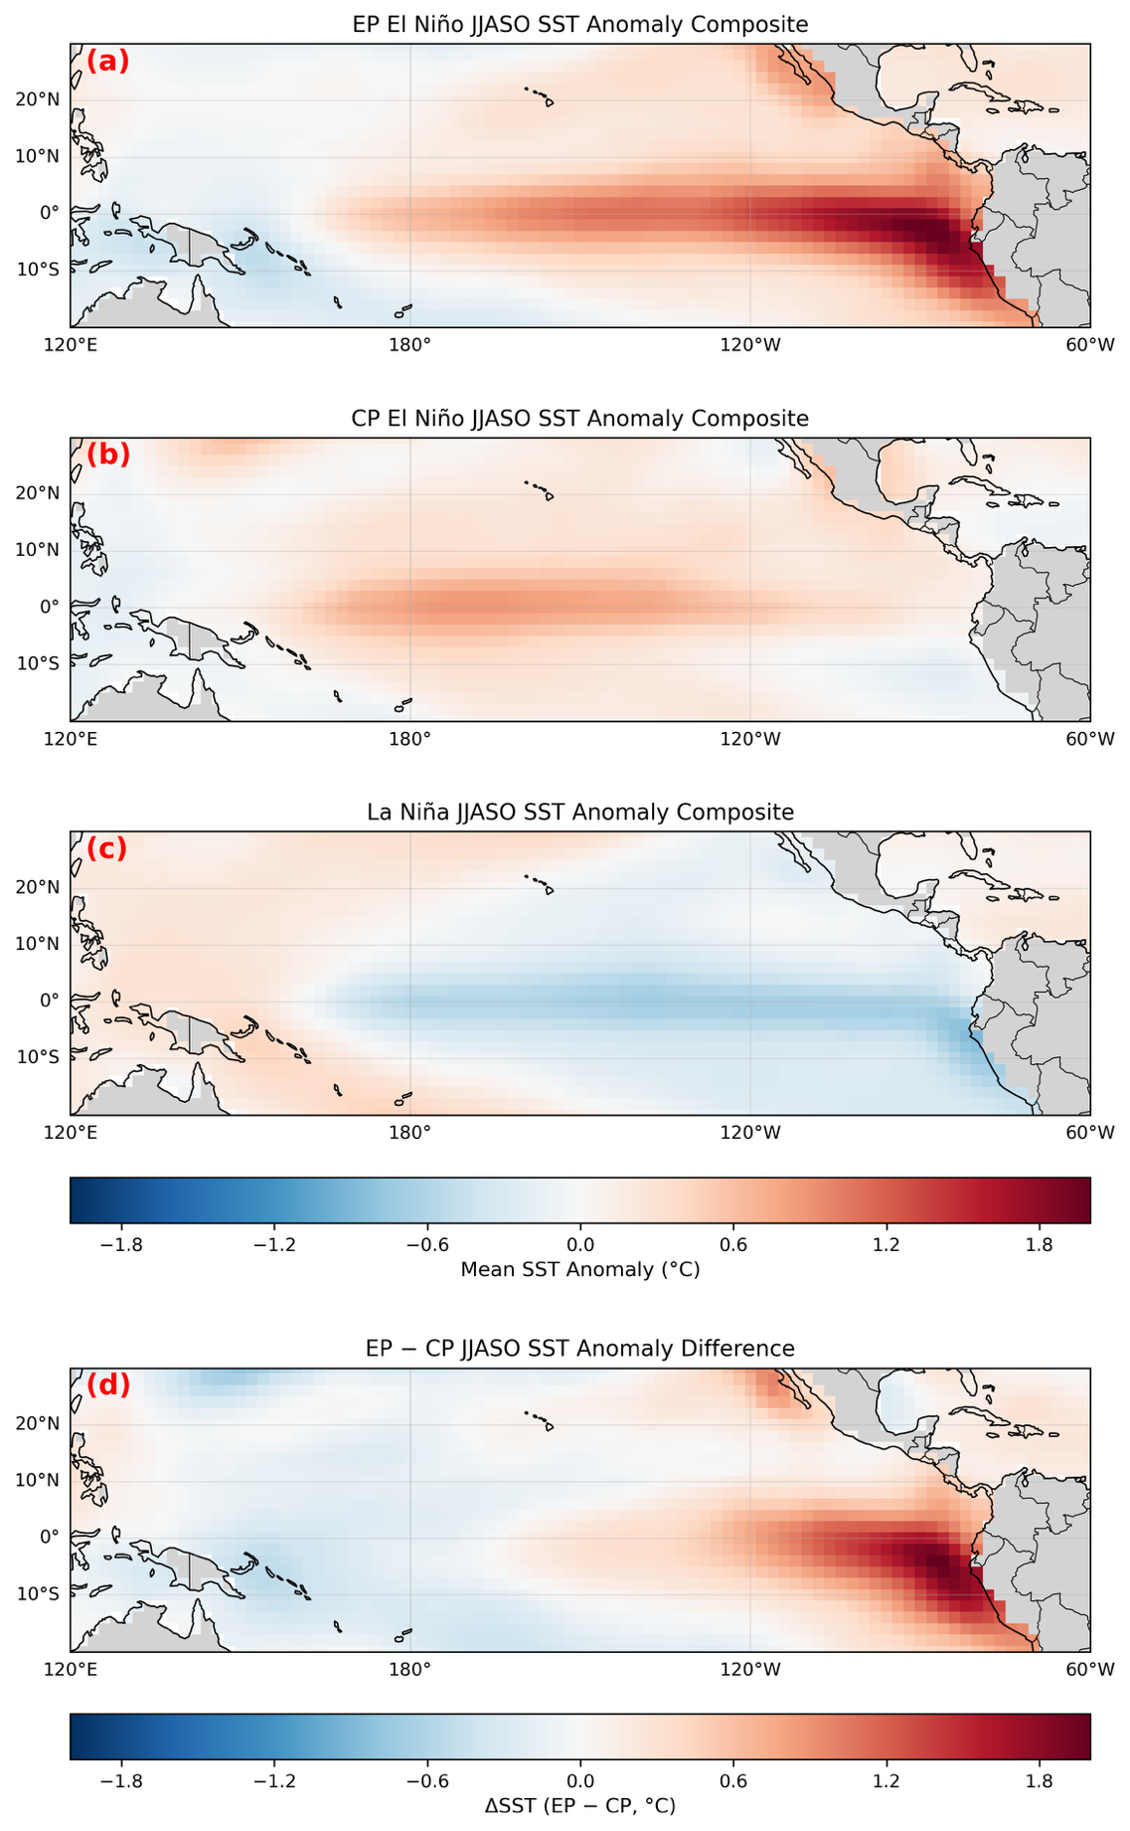
Fig. 12. JJASO SST anomaly composites derived from ERSSTv5 for (a) Eastern Pacific (EP) El Niño years, (b) Central Pacific (CP) El Niño years, and (c) La Niña years during 1979-2023. Composites are based on 9 EP El Niño years, 6 CP El Niño years, and 19 La Niña years. Anomalies are shown relative to the 1981-2010 climatology and share a common color scale. Panel (d) shows the difference between EP and CP El Niño composites (EP – CP), highlighting spatial contrasts in SST anomalies between ENSO flavors.
4. Discussion
This study examined how ENSO diversity modulates TC activity in the eastern and central North Pacific during the JJASO season from 1979–2023. ENSO is a dominant mode of interannual climate variability, but El Niño events are not spatially uniform; some events feature maximum SST anomalies in the eastern equatorial Pacific near the Niño1+2 region (Eastern Pacific, or EP El Niño), while others exhibit peak warming in the central equatorial Pacific near the Niño4 region (Central Pacific, or CP El Niño). These ENSO “flavors” are associated with distinct atmospheric circulation responses and have been shown to produce different impacts on global precipitation, winds, and TC behavior (Ashok et al., 2007; Kao and Yu, 2009; Kug et al., 2009; Capotondi et al., 2015). Despite growing recognition of ENSO diversity, the extent to which EP and CP El Niño events differentially influence TC energetics, intensity, and genesis characteristics in the eastern and central North Pacific remains incompletely quantified. This study addresses that gap by systematically comparing basin-wide and basin-separated TC metrics across ENSO types using multiple complementary statistical approaches.
Across the combined ENP + CNP basin, seasonal ACE exhibits clear and statistically robust differences by ENSO type. EP El Niño seasons show the highest mean and median ACE (mean ≈ 408 (10⁻⁴ kt²)), significantly exceeding La Niña seasons (mean ≈ 201 (10⁻⁴ kt²)), with this contrast remaining statistically significant after both false discovery rate and Bonferroni correction (Welch t = 5.73, p < 0.001). Bootstrap confidence intervals further demonstrate that EP El Niño ACE lies above the La Niña range, indicating a significant separation. In contrast, CP El Niño and Neutral seasons occupy intermediate ACE ranges with wide confidence intervals that overlap both EP El Niño and La Niña, indicating weaker and more uncertain separation. These results are consistent with prior studies showing enhanced eastern Pacific TC activity during strong EP El Niño events and suppressed activity during La Niña, driven by reduced vertical wind shear and enhanced convective instability during EP warming (Camargo et al., 2010).
Despite large differences in basin-wide energetics, seasonal mean maximum sustained wind speed (MaxWind) shows much weaker ENSO dependence. Although EP El Niño seasons exhibit slightly higher mean MaxWind than other ENSO categories, interquartile ranges overlap substantially across all ENSO states, and neither regression nor pairwise tests identify statistically significant differences after correction. This contrast between strong ENSO modulation of ACE and weak modulation of MaxWind indicates that ENSO primarily influences the number, duration, and persistence of storms rather than systematically altering peak storm intensity. This finding aligns with previous work suggesting that ENSO impacts on ACE largely arise from changes in storm frequency and lifespan rather than intensity alone (Klotzbach, 2011).
Regression analysis further supports this interpretation. A basin-wide OLS regression using a binary EP El Niño indicator explains approximately 20% of the interannual variance in seasonal ACE (R² = 0.198, p = 0.002), indicating a strong and statistically significant association between EP El Niño conditions and enhanced seasonal TC energetics. In contrast, the same regression framework explains little variance in seasonal mean MaxWind (R² = 0.032), reinforcing the conclusion that ENSO flavor exerts limited control on peak storm intensity at the seasonal scale. The modest R² values also emphasize that ENSO is an important but incomplete driver of TC variability, with additional influences from intraseasonal variability, background climate state, and stochastic atmospheric processes (Barrett and Leslie, 2009; Emanuel et al., 2004; Li et al., 2015; Vitart et al., 2010).
Extreme-season analysis provides additional insight into ENSO modulation of the upper tail of TC activity. Extreme ACE seasons, defined using the 90th percentile threshold, occur most frequently during EP El Niño (22.2%) and Neutral years (18.2%), while no La Niña seasons exceed the extreme ACE threshold. This result indicates that ENSO flavor influences not only mean activity but also the likelihood of exceptionally energetic seasons. In contrast, extreme MaxWind seasons occur across most ENSO categories, further underscoring that ENSO exerts stronger control over basin-wide energetics than over seasonal peak intensity.
When analyses are restricted to storms forming in the Eastern North Pacific (ENP) basin only, the ENSO-flavor signal remains evident. Mean ENP seasonal ACE during EP El Niño years (≈333 (10⁻⁴ kt²)) is substantially higher than during La Niña years (≈186 (10⁻⁴ kt²)), with non-overlapping bootstrap confidence intervals. An ENP-only regression using an EP El Niño indicator explains approximately 12% of ENP ACE variance (R² ≈ 0.12, p = 0.020), confirming that the basin-combined ENSO signal is not a result of spatial aggregation. As in the basin-combined analysis, ENP seasonal mean MaxWind shows substantial overlap across ENSO categories and no statistically significant relationships, indicating that ENSO primarily modulates ENP activity through storm frequency and persistence rather than intensity.
Genesis locations during EP and CP El Niño years show substantial spatial overlap across the ENP–CNP domain, indicating that ENSO flavor does not fundamentally shift where storms form. Instead, differences between EP and CP El Niño years are expressed as localized changes in genesis frequency, with EP El Niño years showing higher genesis density in parts of the eastern basin. CP El Niño years exhibit a broadly similar spatial pattern but with weaker or more diffuse genesis maxima. These results suggest that ENSO flavor modulates the intensity and frequency of storm formation within established genesis regions rather than reorganizing the large-scale spatial structure of TC genesis.
JJASO SST anomaly composites confirm that these spatial differences are consistent with the expected ENSO forcing. EP El Niño years are characterized by stronger eastern-equatorial Pacific warming, while CP El Niño years show maximum warming displaced westward into the central Pacific. The EP–CP composite difference highlights enhanced eastern-Pacific SST anomalies during EP El Niño years, providing physical context for the higher ENP activity observed in those seasons. This consistency between SST structure and TC response supports the interpretation that eastern-Pacific warming during EP El Niño events more effectively enhances environmental conditions for ENP TC development than CP El Niño forcing (Kao and Yu, 2009).
Several limitations of this study should be acknowledged. The analysis is restricted to the JJASO season from June through October, which captures the climatological peak of tropical cyclone activity in the eastern and central North Pacific but excludes early and late season storms and does not coincide with the typical boreal winter peak of ENSO sea surface temperature anomalies. As a result, JJASO mean ENSO indices represent a developing or evolving ENSO state rather than its mature phase, which may weaken some ENSO-TC relationships. ENSO classification is based on Niño1+2 and Niño4 threshold exceedance, such that a season may be classified as La Niña if one region exhibits sufficiently negative anomalies even when the other region differs in sign or magnitude, introducing ambiguity in transitional or mixed seasons. In addition, small sample sizes, particularly for Central Pacific El Niño years, limit statistical power and increase uncertainty in bootstrap and pairwise comparisons (Chu and Wang, 1997). Finally, this study focuses on observed TC metrics and does not explicitly diagnose environmental mediators such as vertical wind shear, thermodynamic instability, or intraseasonal variability, which likely influence the observed ENSO tropical cyclone relationships and warrant further investigation (Emanuel et al., 2004).
Despite these limitations, this study provides clear observational evidence that distinguishing between EP and CP El Niño events is essential for understanding ENSO modulation of TC activity in the eastern and central North Pacific. EP El Niño events, characterized by strong eastern-Pacific warming and associated large-scale circulation changes, consistently enhance basin-wide TC energetics, while CP El Niño events exert weaker and more variable influences. These findings have implications for seasonal TC prediction, hazard assessment, and future climate projections, highlighting the importance of representing ENSO diversity rather than treating El Niño as a single, uniform phenomenon.

Acknowledgments.
Thank you, Dr. Jewett, for your continued mentorship throughout research, analytical, and interpretive stages. Thank you as well to Dr. Klees and the rest of the University of Illinois Urbana-Champaign Weather and Climate Risk and Data Analytics team for your support, teamwork, and guidance.

Data Availability Statement.
The Sea Surface Temperature data used in this study is free and publicly accessible without restriction though NOAA PSL via the following links:
https://psl.noaa.gov/data/gridded/data.noaa.ersst.v5.html
DOI: https://doi.org/10.1175/JCLI-D-16-0836.1

The TC data used in this project is free and publicly accessible without restriction through NOAA NCEI via the following links:
https://www.ncei.noaa.gov/products/international-best-track-archive
DOI: https://doi.org/10.1175/2009BAMS2755.1

The data and code that support the findings of this study are openly available for reference and collaboration on GitHub: https://github.com/erinsatmosphere/ATMS_596_Final

REFERENCES
Ashok, K., S. K. Behera, S. A. Rao, H. Weng, and T. Yamagata, 2007: El Niño Modoki and its possible teleconnection. J. Geophys. Res., 112, C11007, doi:10.1029/2006JC003798.
Barrett, B. S., and L. M. Leslie, 2009: Links between Tropical Cyclone Activity and Madden–Julian Oscillation Phase in the North Atlantic and Northeast Pacific Basins. Mon. Wea. Rev., 137, 727–744, https://doi.org/10.1175/2008MWR2602.1.
Bell, G. D., and Coauthors, 2000: Climate Assessment for 1999. Bull. Amer. Meteor. Soc., 81, S1–S50, https://doi.org/10.1175/1520-0477(2000)81[s1:CAF]2.0.CO;2.
Boucharel, J., F.-F. Jin, I. I. Lin, H.-C. Huang, and M. H. England, 2016: Different controls of tropical cyclone activity in the Eastern Pacific for two types of El Niño. Geophys. Res. Lett., 43, 1679–1686, doi:10.1002/2016GL067728.
Bove, M. C., J. B. Elsner, C. W. Landsea, X. Niu, and J. J. O'Brien, 1998: Effect of El Niño on U.S. Landfalling Hurricanes, Revisited. Bull. Amer. Meteor. Soc., 79, 2477–2482, https://doi.org/10.1175/1520-0477(1998)079<2477:EOENOO>2.0.CO;2.
Camargo, S. J., K. A. Emanuel, and A. H. Sobel, 2007: Use of a Genesis Potential Index to Diagnose ENSO Effects on Tropical Cyclone Genesis. J. Climate, 20, 4819–4834, https://doi.org/10.1175/JCLI4282.1.
Camargo, S. J., A. H. Sobel, A. G. Barnston, and P. K. Klotzbach, 2010: The Influence of Natural Climate Variability on Tropical Cyclones, and Seasonal Forecasts of Tropical Cyclone Activity. https://doi.org/10.1142/9789814293488_0011
Capotondi, A., and Coauthors, 2015: Understanding ENSO Diversity. Bull. Amer. Meteor. Soc., 96, 921–938, https://doi.org/10.1175/BAMS-D-13-00117.1.
Chan, J. C. L., 2000: Tropical Cyclone Activity over the Western North Pacific Associated with El Niño and La Niña Events. J. Climate, 13, 2960-2972,
https://doi.org/10.1175/1520-0442(2000)013<2960:TCAOTW>2.0.CO;2.
Chu, P. S., 2004: ENSO and tropical cyclone activity. Hurricanes and typhoons: Past, present, and potential, 297-332
Chu, P. S., and J. Wang, 1997: Tropical Cyclone Occurrences in the Vicinity of Hawaii: Are the differences between El Nino and non-El Nino years Significant?. Journal of Climate, 10, 10, 2683-2689
Emanuel, K., C. DesAutels, C. Holloway, and R. Korty, 2004: Environmental Control of Tropical Cyclone Intensity. J. Atmos. Sci., 61, 843–858, https://doi.org/10.1175/1520-0469(2004)061<0843:ECOTCI>2.0.CO;2.
Jien, J. Y., W. A. Gough, and K. Butler, 2015: The Influence of El Niño–Southern Oscillation on Tropical Cyclone Activity in the Eastern North Pacific Basin. J. Climate, 28, 2459–2474, https://doi.org/10.1175/JCLI-D-14-00248.1.
Kao, H., and J. Yu, 2009: Contrasting Eastern-Pacific and Central-Pacific Types of ENSO. J. Climate, 22, 615–632, https://doi.org/10.1175/2008JCLI2309.1.
Kim, H., P. J. Webster, and J. A. Curry, 2011: Modulation of North Pacific Tropical Cyclone Activity by Three Phases of ENSO. J. Climate, 24, 1839–1849, https://doi.org/10.1175/2010JCLI3939.1.
Klotzbach, P. J., 2011: The Influence of El Niño–Southern Oscillation and the Atlantic Multidecadal Oscillation on Caribbean Tropical Cyclone Activity. J. Climate, 24, 721–731, https://doi.org/10.1175/2010JCLI3705.1.
Li, W., L. Li, & Y. Deng, 2015: Impact of the Interdecadal Pacific Oscillation on Tropical Cyclone Activity in the North Atlantic and Eastern North Pacific. Sci Rep, 5, https://doi.org/10.1038/srep12358
Kug, J., F. Jin, and S. An, 2009: Two Types of El Niño Events: Cold Tongue El Niño and Warm Pool El Niño. J. Climate, 22, 1499–1515, https://doi.org/10.1175/2008JCLI2624.1.
Lander, M. A., 1994: An Exploratory Analysis of the Relationship between Tropical Storm Formation in the Western North Pacific and ENSO. Mon. Wea. Rev., 122, 636-651 https://doi.org/10.1175/1520-0493(1994)122<0636:AEAOTR>2.0.CO;2.
Song, J., P. J. Klotzbach, N. Wei, & Y. Duan, 2023: Modulation of western North Pacific tropical cyclone formation by central Pacific El Niño–Southern Oscillation on decadal and interannual timescales. International Journal of Climatology, 43, 426–437. https://doi.org/10.1002/joc.7777
Vecchi, G.A. and A. T. Wittenberg, 2010: El Niño and our future climate: where do we stand?. WIREs Clim Chg, 1, 260-270. https://doi.org/10.1002/wcc.33
Vitart, F., A. Leroy, and M. C. Wheeler, 2010: A Comparison of Dynamical and Statistical Predictions of Weekly Tropical Cyclone Activity in the Southern Hemisphere. Mon. Wea. Rev., 138, 3671–3682, https://doi.org/10.1175/2010MWR3343.1.

