
UNIVERSITY OF BATANGAS - LIPA CAMPUS
COLLEGE OF ENGINEERING AND ARCHITECTURE
COMPUTER ENGINEERING

FACE FOLLOWER ROBOT
Camera-Based Face Tracking and Mobile Robot Control Using
ESP32-CAM, MediaPipe, and L298N

PROJECT DOCUMENTATION
Digital Signal Processing / Embedded Systems

Bonaobra, Carl Jayson Eli B.
2320601
CPE4A

Submitted to:
Engr. Oscar Bryan Magtibay

September 25, 2026

1. Project Description
1.1 Introduction
The Face Follower Robot is a camera-based mobile robot that follows the horizontal position of a detected human face. The system combines an ESP32-CAM, an OV5640 camera sensor, an L298N motor driver, two DC geared motors, Wi-Fi communication, and laptop-based image processing. The robot captures live video through the ESP32-CAM and streams the frames to a laptop, where Python, OpenCV, and MediaPipe process the image and determine the appropriate movement command.
The project uses a distributed architecture. The ESP32-CAM handles embedded tasks such as camera capture, Wi-Fi connectivity, HTTP communication, and GPIO motor control. The laptop handles the heavier vision-processing task. After the face position is determined, the laptop sends an HTTP command back to the ESP32-CAM, which controls the L298N and the two motors.
The final system uses closed-loop visual feedback with discrete directional correction. The robot repeatedly observes the target face, evaluates its position, performs a movement or steering correction, and then observes the updated position again. The final build documented here is the result of several development versions and manual motor-direction calibration.
1.2 Project Purpose
The purpose of the project is to demonstrate how digital image processing and embedded control can be integrated into a practical robot. The camera data acts as the input signal, the laptop extracts the face position, the control logic converts the detected position into a direction decision, and the embedded controller produces physical motor movement.
1.3 Scope and Limitations
- The system detects the location of a human face; it does not identify or recognize the person.
- When multiple faces are visible, the laptop selects the largest detected face as the target.
- The ESP32-CAM and laptop must be connected through the same reachable Wi-Fi network.
- The face detector runs on the laptop, not directly on the ESP32-CAM.
- The apparent face width is used only as a relative proximity estimate; it is not a true distance measurement in centimeters.
- ENA and ENB of the L298N are tied HIGH to 5 V, so the final build does not use PWM speed control.
- Quantitative measurements such as maximum tracking distance, detection accuracy, and end-to-end control latency were not formally measured in this project submission.
1.4 Relevance to Digital Signal Processing and Embedded Systems
For Digital Signal Processing, the project processes a continuous sequence of camera frames, converts color format for MediaPipe, extracts a face bounding box, computes position information, and applies temporal smoothing to reduce frame-to-frame detection noise. The smoothing function is an exponential moving average, which behaves like a simple temporal low-pass filter on the detected bounding-box coordinates.
For Embedded Systems, the project uses an ESP32-CAM as the embedded controller, configures camera and GPIO peripherals, hosts HTTP services, communicates over Wi-Fi, and controls an external motor driver. This separation of real-time embedded I/O from laptop-side vision processing demonstrates hardware-software integration across two computing platforms.
1.5 Development Versions
Version | Main Development Focus | Key Changes
Version 1 | Initial prototype | Established the basic camera-based face-following concept and the motor-command workflow used as the baseline for later improvements.
Version 2 | Face detection stability | Used MediaPipe Face Detection on the laptop, selected the largest face, added face-box smoothing, two-frame direction confirmation, a no-face safety stop, a 3-second HTTP timeout, and request control to reduce command pile-up.
Version 3 | Motion tuning | Focused on weak forward movement and right-turn overshoot. Forward was kept continuous, the center deadzone was increased to 18%, command confirmation increased to three frames, and asymmetric turn pulses were introduced: 120 ms for left and 65 ms for right.
Version 3.1 / Final Calibration | Physical motor-direction correction | Manual HTTP tests showed that the original forward and backward motor states were physically reversed. The firmware mapping was corrected while the verified left and right directions were retained. The shorter right-turn pulse remained in the laptop control logic to reduce overshoot.

2. Objectives
2.1 General Objective
To develop a camera-based face follower robot that uses an ESP32-CAM for video streaming and embedded motor control while using laptop-based MediaPipe processing to detect a face and generate movement commands.
2.2 Specific Objectives
- Capture and stream live video from the ESP32-CAM through Wi-Fi.
- Detect human faces using MediaPipe Face Detection on the laptop.
- Determine the horizontal position of the detected face relative to the center of the image.
- Generate forward, left, right, and stop decisions based on face position and apparent face size.
- Reduce unstable steering through face-position smoothing, a center deadzone, and multi-frame command confirmation.
- Control two DC motors through the L298N motor driver using ESP32-CAM GPIO outputs.
- Provide safe stop behavior when the target is close, when no face is detected for several frames, or when the program exits.
- Calibrate the physical motor directions and turning response through direct HTTP motor tests.
3. Equipment and Materials
3.1 Hardware Components
Component | Quantity / Specification | Purpose
ESP32-CAM | 1, AI-Thinker pin configuration | Camera interface, Wi-Fi communication, HTTP servers, and motor-control GPIO.
OV5640 camera sensor | 1 | Captures the live image used for face detection.
L298N motor driver | 1 | H-bridge motor interface for the two DC motors.
DC geared motors | 2 | Provide left and right wheel motion.
Robot chassis / wheels | 1 set | Mechanical platform for the mobile robot.
Power bank | 5 V / 2 A | Main 5 V source used in the prototype.
USB Type-C charging / power module | 1 | Provides the Type-C power connection used before the motor-side boost converter.
5 V-to-12 V boost converter | 1 | Raises the motor-side supply used by the L298N.
Breadboard | 2 x 400-point | Used to organize and distribute prototype connections.
Jumper wires | As required | Signal and power connections.
Laptop / PC | 1 | Runs Jupyter Notebook, OpenCV, MediaPipe, and the control algorithm.

3.2 Software and Libraries
Software / Library | Purpose
Arduino IDE + ESP32 Arduino core | Compiles and uploads the ESP32-CAM .ino firmware.
Jupyter Notebook (.ipynb) | Organizes and runs the laptop-side face detection and robot-control program.
Python 3.11 | Execution environment used by the notebook.
OpenCV | Connects to the MJPEG stream, reads frames, converts image color format, and displays the annotated video window.
MediaPipe 0.10.21 | Detects faces and returns normalized face bounding boxes.
NumPy 1.26.x | Supports numerical operations used in face-box smoothing.
requests | Sends HTTP GET motor commands to the ESP32-CAM.
threading | Keeps motor HTTP requests from blocking the real-time video-processing loop.

4. System Features and Requirements
4.1 Functional Features
Feature | Description
Live camera streaming | The ESP32-CAM provides an MJPEG stream through port 81.
Face detection | MediaPipe detects faces from the incoming video frames on the laptop.
Largest-face target selection | When multiple faces are detected, the system selects the largest face as the active target.
Position-based steering | The system compares the face center with the frame center to choose left, right, or forward.
Proximity stop | The robot stops when the face width exceeds 35% of the image width.
No-face safety stop | The robot stops after five consecutive frames without a detected face.
HTTP motor interface | The ESP32-CAM accepts forward, backward, left, right, and stop commands through /motor?dir=... .
Safe program exit | The notebook sends STOP when the program is closed or interrupted.

4.2 Non-Functional Requirements
- Stability: temporary face-detection noise should not immediately change motor direction.
- Safety: loss of target or program exit should result in a stop command.
- Responsiveness: motor commands should be transmitted without blocking the continuous camera-processing loop.
- Maintainability: camera/motor firmware and vision/control logic are separated into .ino and .ipynb files.
- Network dependency: reliable operation depends on reachable Wi-Fi communication between the laptop and ESP32-CAM.
5. System Design and Method
5.1 Overall System Architecture
The Face Follower Robot uses a distributed closed-loop architecture. The ESP32-CAM captures images and exposes both a video-stream endpoint and a motor-control endpoint. The laptop reads the video stream, detects the face, calculates the target position, and sends a new motor command. Physical robot movement changes the camera view, creating the feedback needed for the next decision cycle.
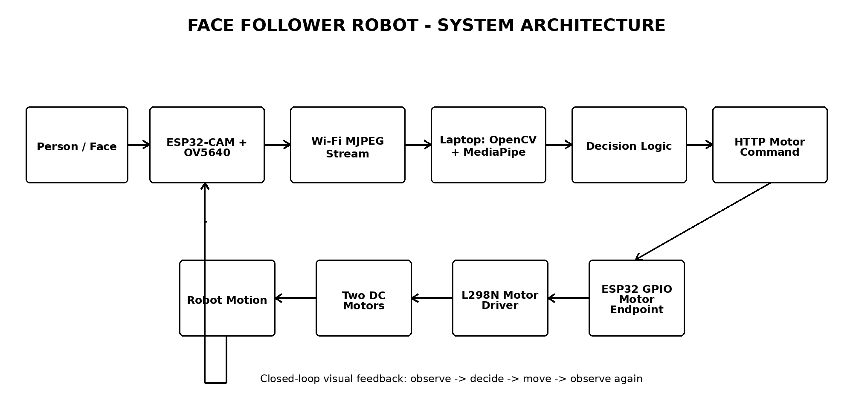
Figure 1: Face Follower Robot system architecture
5.2 ESP32-CAM Firmware (.ino)
The Arduino firmware is responsible for the embedded side of the system. It initializes the camera and the four L298N direction pins, connects to Wi-Fi, starts the HTTP servers, and converts incoming direction strings into GPIO states.
- Camera stream endpoint: http://<ESP32_IP>:81/stream
- Motor endpoint: http://<ESP32_IP>/motor?dir=forward|backward|left|right|stop
- Camera output: JPEG / MJPEG stream, QVGA frame size, JPEG quality 15, one frame buffer.
- Camera XCLK configuration: 10 MHz in the V3 firmware for a conservative camera configuration.
- Motor pins: IN1 = GPIO 13, IN2 = GPIO 12, IN3 = GPIO 14, IN4 = GPIO 15.
- ENA and ENB are tied directly to 5 V, so motor channels remain enabled at full ON/OFF drive.
5.3 Laptop-Side Jupyter Notebook (.ipynb)
The Jupyter Notebook performs the vision and decision-making tasks. OpenCV opens the ESP32-CAM MJPEG stream, MediaPipe detects the face, NumPy supports bounding-box smoothing, and the requests library sends HTTP movement commands. The motor-sending function uses worker threads so network requests do not block the continuous image-processing loop.
Parameter | Final V3 Value | Function
CENTER_DEADZONE | 0.18 | Creates an 18% normalized center region where the robot continues forward instead of making small steering corrections.
CLOSE_FACE_RATIO | 0.35 | Stops when face width is greater than 35% of frame width.
MIN_DETECTION_CONFIDENCE | 0.55 | Minimum MediaPipe face-detection confidence.
MODEL_SELECTION | 0 | Uses the short-range MediaPipe face detector.
FACE_SMOOTHING_ALPHA | 0.30 | Weight applied to the newest face box in exponential moving-average smoothing.
DIRECTION_CONFIRM_FRAMES | 3 | Requires the same candidate direction for three frames before accepting a new stable direction.
NO_FACE_STOP_FRAMES | 5 | Stops after five consecutive frames without a detected face.
MOTOR_REQUEST_TIMEOUT | 3.0 s | Limits how long a motor HTTP request may wait.
SAME_COMMAND_HEARTBEAT | 1.5 s | Periodically refreshes an unchanged state command.
LEFT_TURN_PULSE_MS | 120 ms | Left correction pulse duration.
RIGHT_TURN_PULSE_MS | 65 ms | Shorter right correction pulse used to reduce overshoot.
TURN_COOLDOWN_MS | 90 ms | Minimum interval before another turn correction is allowed.

5.4 Face Detection, Target Selection, and Smoothing
MediaPipe returns normalized bounding-box coordinates for every detected face. The notebook converts each detected box to pixel coordinates and selects the face with the largest area. Confidence is used only as a tie-breaker when necessary. This method makes the most visually dominant face the active target.
To reduce frame-to-frame jitter, the selected face box is smoothed using an exponential moving average. For each bounding-box coordinate, the new smoothed value is calculated using:
Smoothed = (1 - α) × Previous + α × Current, where α = 0.30
Because only 30% of the new measurement is applied at each update, sudden small changes in the detected box are reduced before the position is used for steering.
5.5 Direction Decision Logic
The horizontal center of the face is compared with the horizontal center of the video frame. The normalized horizontal offset is computed as:
offset = (face_center_x - frame_center_x) / frame_width
The decision rules are:
- If face_width / frame_width > 0.35, command STOP because the target is considered close.
- If offset < -0.18, generate a LEFT correction.
- If offset > +0.18, generate a RIGHT correction.
- If the offset is inside the ±0.18 deadzone, command FORWARD.
- The same candidate decision must persist for three frames before becoming the stable command.
5.6 Final Motor Direction Mapping
Direct HTTP testing showed that the original forward and backward definitions were physically reversed by the installed motor orientation. Rather than rewiring the motors, the final mapping was corrected in software. The left and right directions were separately tested and preserved.
Command | IN1 | IN2 | IN3 | IN4 | Physical Result
STOP | LOW | LOW | LOW | LOW | Both motors stopped
FORWARD | LOW | HIGH | LOW | HIGH | Robot moves forward
BACKWARD | HIGH | LOW | HIGH | LOW | Robot moves backward
LEFT | LOW | HIGH | HIGH | LOW | Robot turns left
RIGHT | HIGH | LOW | LOW | HIGH | Robot turns right

In the final control method, FORWARD and STOP behave as continuous state commands. LEFT and RIGHT are short correction pulses. The notebook sends the turn command, waits for the calibrated pulse duration, sends STOP, and then waits for the next camera decision. This approach reduces continuous turning and limits overshoot without requiring PWM rewiring.
5.7 Power and Motor Interface
The ESP32-CAM is powered from the 5 V source, while the L298N motor-side supply receives boosted voltage from the 5 V-to-12 V converter. The Type-C power module is connected in the motor-side power path before the converter. A common ground is required between the ESP32-CAM and the L298N so the GPIO logic levels use the same electrical reference.
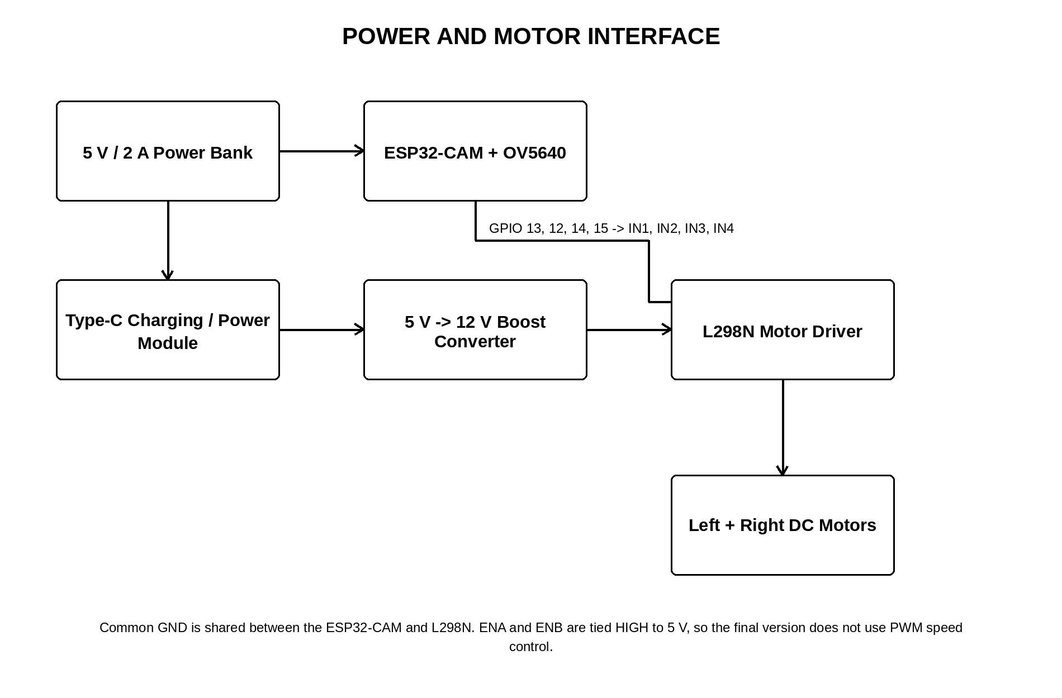
Figure 2: Power and motor interface used in the prototype
6. Procedure
6.1 Hardware Assembly
1. Mount the two DC geared motors and wheels on the robot chassis.
2. Connect the motors to the two output channels of the L298N motor driver.
3. Connect L298N IN1, IN2, IN3, and IN4 to ESP32-CAM GPIO 13, 12, 14, and 15 respectively.
4. Keep ENA and ENB enabled by connecting them to 5 V as used in the final prototype.
5. Connect the Type-C charging/power module to the 5 V-to-12 V boost-converter path used for the L298N motor supply.
6. Provide the ESP32-CAM with a separate 5 V supply from the power source and connect a common ground between the ESP32-CAM and L298N.
7. Use the two 400-point breadboards to organize the prototype power and signal connections.
6.2 ESP32-CAM Firmware Setup
1. Open the final corrected ESP32-CAM firmware in the Arduino IDE.
2. Select the AI Thinker ESP32-CAM board configuration, or a compatible ESP32 Wrover configuration with PSRAM enabled.
3. Enter the current Wi-Fi credentials in the local sketch. Credentials are intentionally omitted from this documentation.
4. Upload the firmware and open Serial Monitor at 115200 baud.
5. Confirm camera initialization, PSRAM status, Wi-Fi connection, and the assigned ESP32 IP address.
6. Open http://<ESP32_IP>:81/stream in a browser to confirm that the camera stream is available.
6.3 Motor Calibration
1. Before running face detection, send direct HTTP motor commands to test FORWARD, BACKWARD, LEFT, RIGHT, and STOP independently.
2. Observe the physical direction of both wheels and the whole robot.
3. If a command is physically reversed, correct the direction mapping in the firmware rather than assuming a motor or driver failure.
4. After calibration, verify that forward, backward, left, and right each match their intended physical direction.
6.4 Laptop-Side Face Follower Setup
1. Install MediaPipe 0.10.21, NumPy below version 2, OpenCV Contrib below version 5, and requests in the Python environment.
2. Set ESP32_IP in the notebook to the IP address printed by the Serial Monitor.
3. Run the import, configuration, MediaPipe detector, motor sender, helper, direction logic, and main-loop cells in order.
4. Start the system using run_face_follower(show_window=True).
5. Stand in front of the camera and move left or right to verify steering corrections.
6. Press Q to stop the notebook. The program also sends a STOP command during program exit for safety.
7. How It Works
1. The OV5640 camera captures the scene through the ESP32-CAM.
2. The ESP32-CAM sends JPEG frames as an MJPEG stream over Wi-Fi.
3. OpenCV on the laptop reads the video stream and converts each frame from BGR to RGB for MediaPipe.
4. MediaPipe detects visible faces and returns their normalized bounding boxes.
5. The notebook selects the largest detected face and smooths its bounding box using an exponential moving average.
6. The face center is compared with the center of the camera frame, and the face width is compared with the proximity threshold.
7. The same candidate movement must remain consistent for three frames before it becomes the stable decision.
8. If the face is centered, the laptop sends FORWARD. If the face is left or right, the notebook sends a short correction pulse. If the face is close or lost for five frames, it sends STOP.
9. The ESP32-CAM receives the HTTP direction string, sets GPIO 13, 12, 14, and 15, and the L298N drives the two motors.
10. The resulting robot motion changes the camera view, and the process repeats as closed-loop visual feedback.
8. Flow Chart
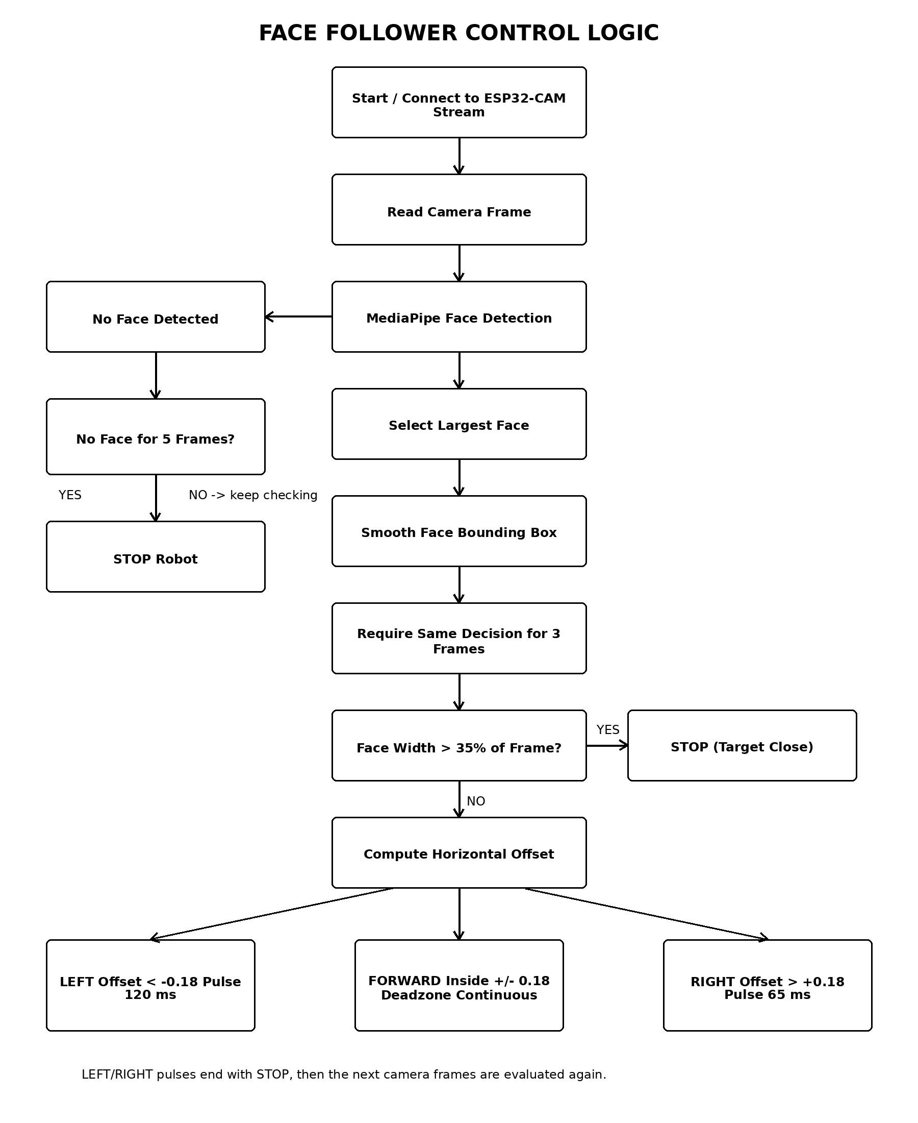
Figure 3: Face detection and movement-decision flow chart
9. Testing and Results
9.1 Manual Motor-Direction Test
The motor subsystem was tested independently from the face-detection program using direct HTTP requests. This isolated the motor and wiring behavior from the computer-vision logic and helped identify the actual direction mapping.
Test Command | Observed Result Before Final Correction | Interpretation / Action
forward | Both wheels rotated, but the robot moved backward. | Both motor channels were active; the forward mapping was physically reversed.
backward | Both wheels rotated and the robot moved forward. | Confirmed that the motor-direction states for forward/backward needed to be swapped.
left | Robot moved toward the left. | Left command mapping was correct.
right | Robot moved toward the right. | Right command mapping was correct.
Final corrected firmware | Forward, backward, left, and right matched the intended robot motion. | Final direction mapping accepted for the project.

9.2 Power and Driver Checks
Measurement / Observation | Approximate Result | Meaning
L298N motor supply at idle | ~12.10 V | The boost-converter path was providing the intended motor-side supply.
L298N supply while motor was running | Approximately 11-12 V, fluctuating with load | The motor supply showed load-related voltage variation but did not collapse completely.
ENA to GND | ~5.06 V | The tested enable input was HIGH, enabling the associated L298N channel.
Both wheels during direct command tests | Both motors responded | Helped rule out a permanently dead motor or completely inactive L298N channel.

9.3 Functional Verification
- The ESP32-CAM motor HTTP endpoint accepted direct commands during testing.
- Both motors were able to respond to direct motor commands.
- The original physical reversal of forward and backward was identified and corrected in software.
- Left and right physical directions were verified separately.
- The V3 notebook implements MediaPipe face detection, largest-face selection, smoothing, deadzone control, three-frame confirmation, no-face stopping, and asymmetric steering pulses.
- Formal measurements of maximum tracking distance, face-detection accuracy, and total system latency were not completed before submission.

10. Results and Discussion
The project demonstrated that the ESP32-CAM can be used as a networked embedded camera and motor-control interface while a laptop performs the more computationally intensive face-detection task. This division of work made it possible to use MediaPipe face detection without attempting to run the full vision workload on the ESP32-CAM.
The development process also showed the importance of separating software problems from hardware problems. At one stage, forward movement appeared incorrect and one side was suspected to be weak. Direct HTTP motor testing later showed that both motors and both driver channels could respond, while the original forward and backward logic were physically reversed. Swapping the command mapping in software corrected the problem without changing the motor wiring.
Steering stability was improved in Version 3 by combining several techniques rather than relying on a single threshold. Face-box smoothing reduces detection noise, the 18% deadzone prevents unnecessary corrections near the center, three-frame confirmation rejects short one-frame changes, and left/right pulse control limits how long the robot continues turning before it re-evaluates the camera image. The shorter 65 ms right pulse was selected because the robot had shown stronger right-turn overshoot than left-turn overshoot.
The current project results are primarily functional and qualitative. A future evaluation should record quantitative measures such as detection range, command response time, tracking success rate, and turning error under different lighting and network conditions.

11. Conclusion
The Face Follower Robot successfully integrates camera-based image processing, Wi-Fi communication, embedded motor control, and a two-motor mobile platform. The ESP32-CAM captures and streams the camera image while the laptop performs MediaPipe face detection and determines the target position. The laptop then sends HTTP commands back to the ESP32-CAM, which controls the L298N motor driver and the two DC motors.
The final version improves stability through exponential face-box smoothing, an 18% center deadzone, three-frame decision confirmation, a five-frame no-face stop, asynchronous motor requests, and short calibrated turn pulses. Manual testing also identified and corrected the reversed physical forward/backward mapping. The project therefore demonstrates a practical combination of Digital Signal Processing concepts and Embedded Systems implementation in a working mobile-robot prototype.

12. Future Improvements
- Migrate the camera controller to an ESP32-S3 camera board with additional usable GPIO pins.
- Connect ENA and ENB to PWM-capable GPIO pins to allow independent left and right motor-speed control.
- Replace fixed turn pulses with proportional differential steering based on the measured face offset.
- Perform formal tests for maximum detection distance, tracking accuracy, response latency, and performance under different lighting conditions.
- Improve the motor power system to reduce voltage drop and improve startup torque under load.
- Add structured logging of camera decisions and motor commands to support performance analysis and tuning.

13. Appendices
13.1 Source Code / Repository
Source code repository URL: https://github.com/erinxcs/ESP32-Camera
13.2 Project Photographs and Screenshots

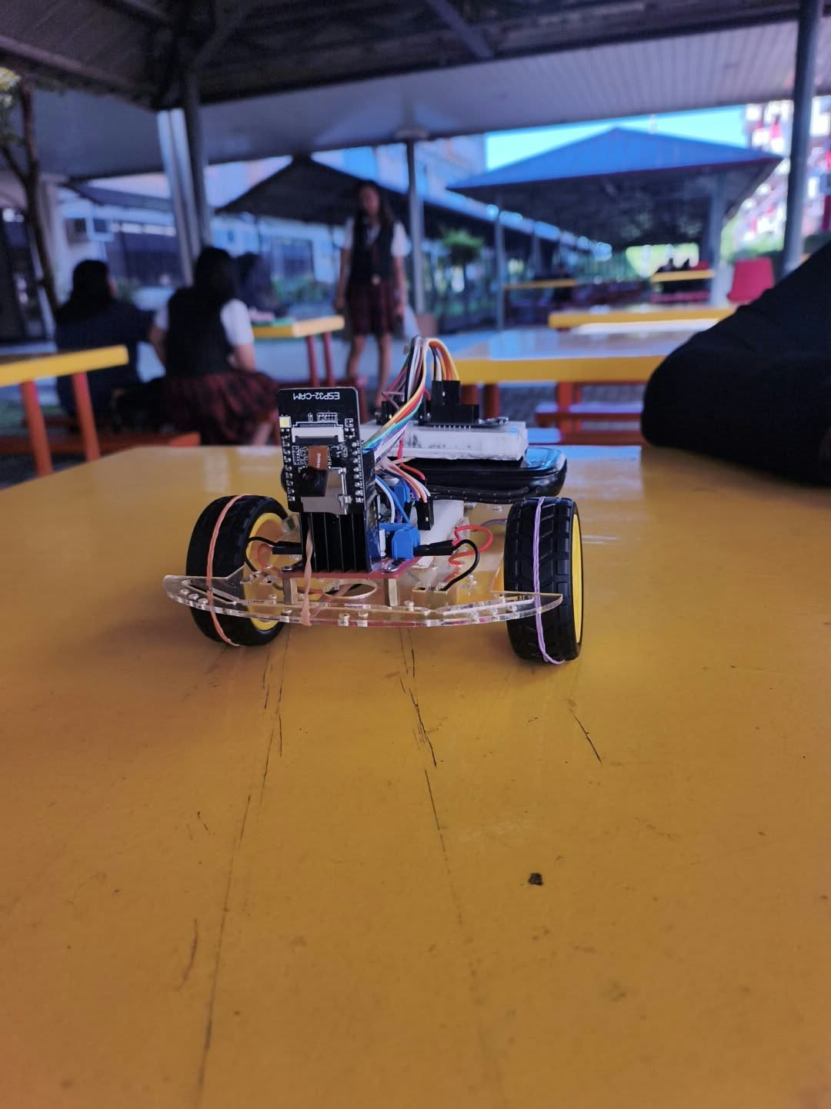
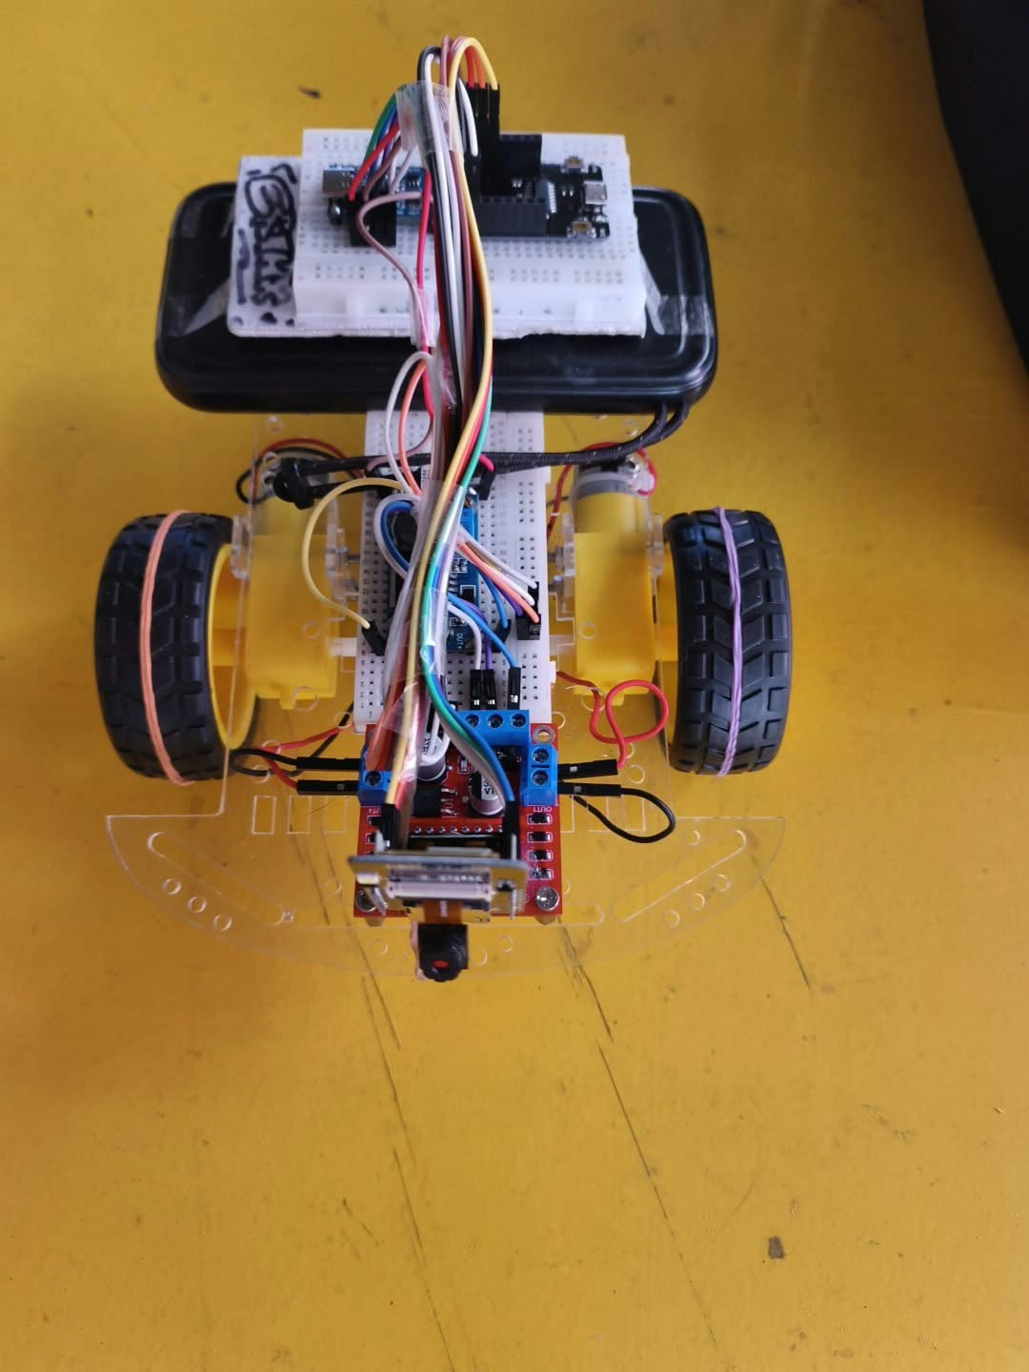

Figure 4: Complete Face Follower Robot prototype

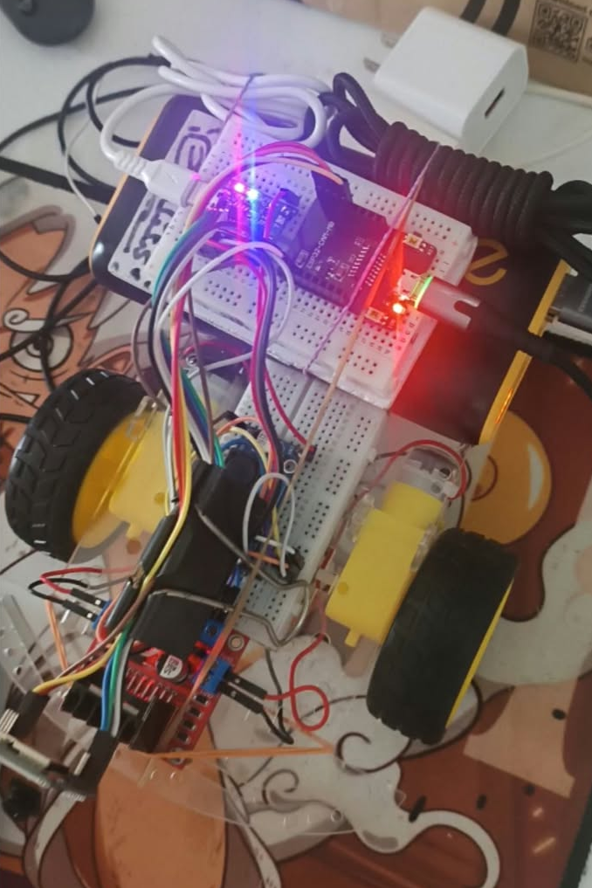
Figure 5: Hardware wiring and motor-driver connections

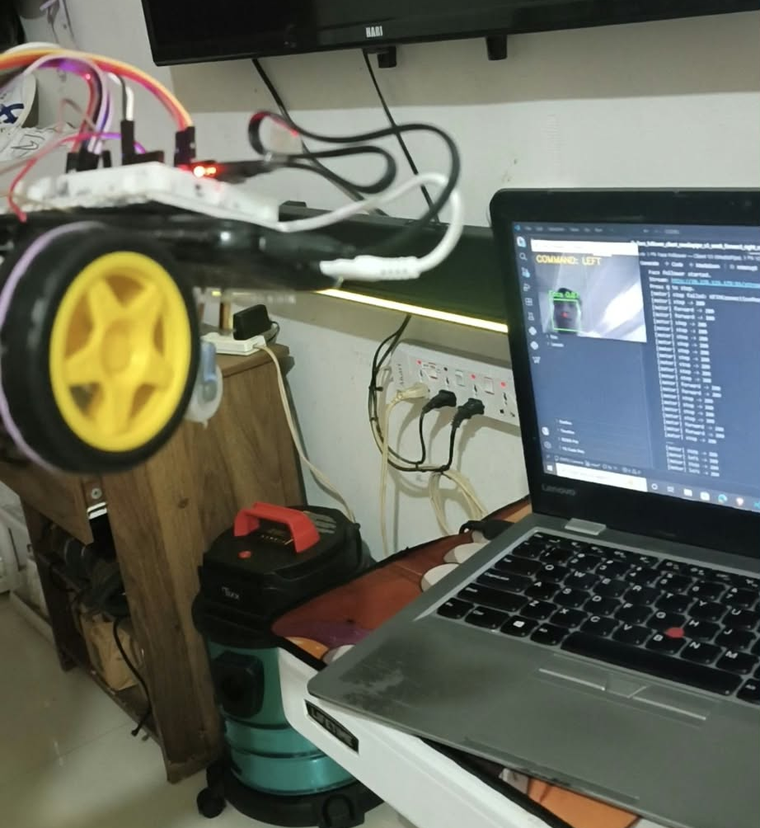
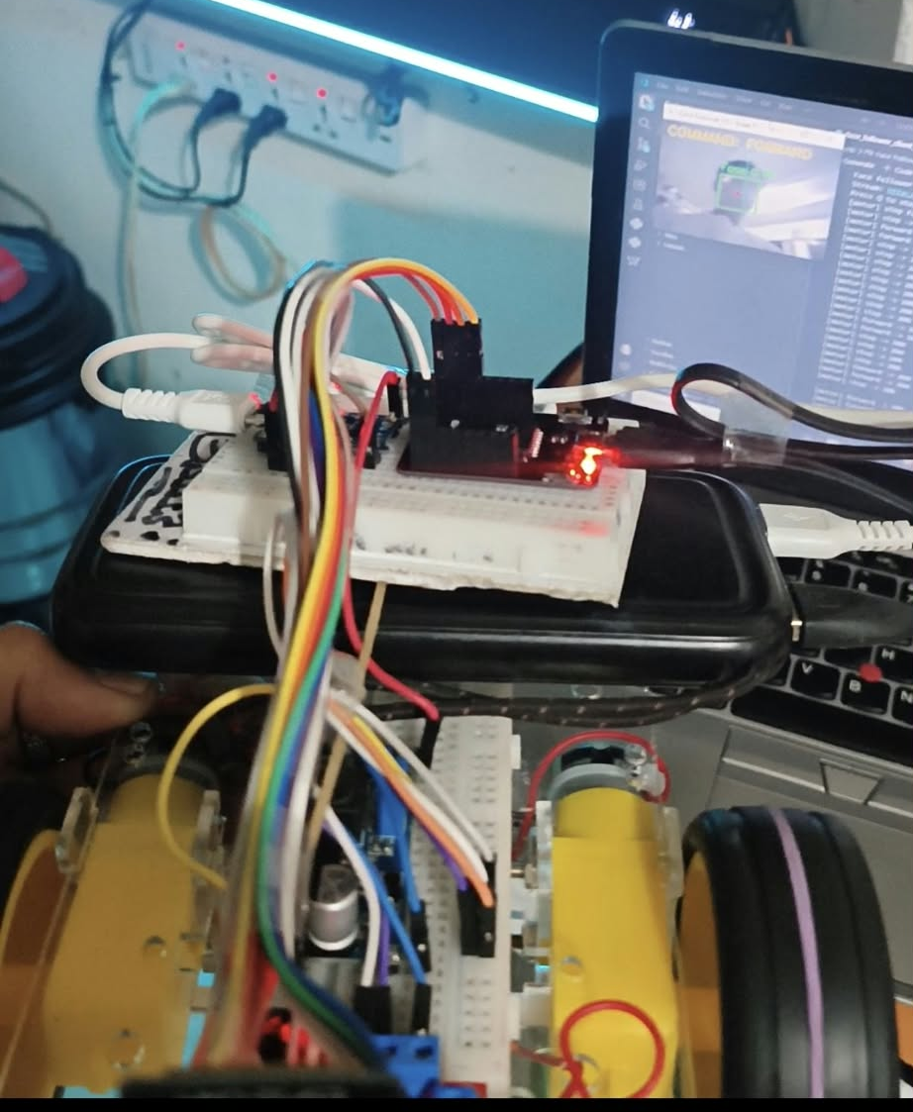

Figure 6: Laptop-side face detection and movement command display
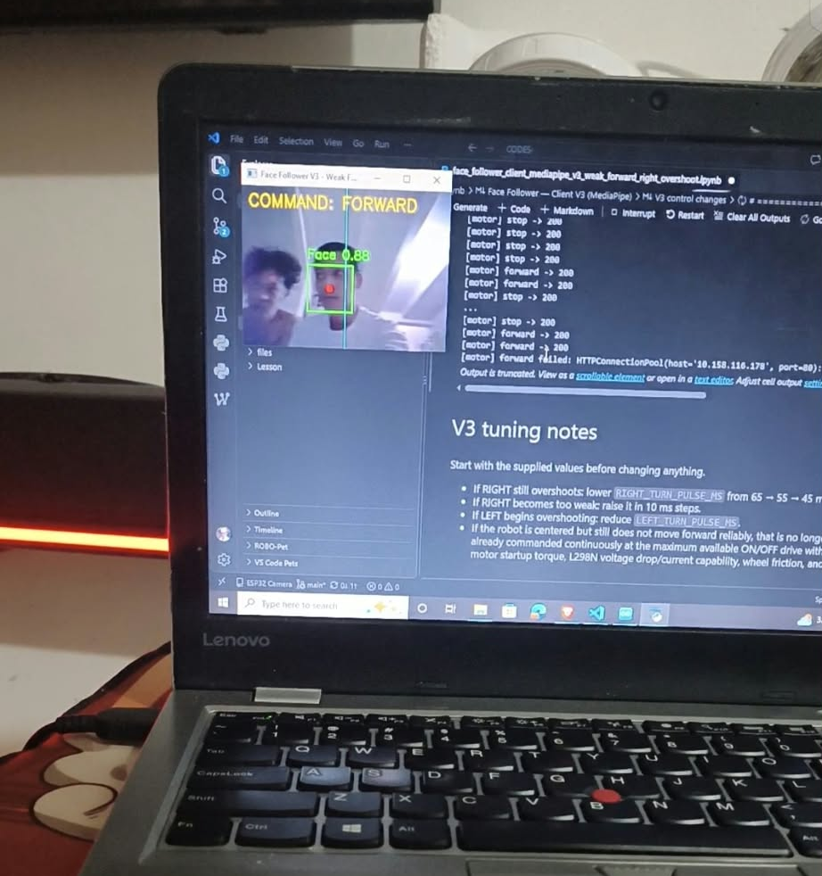
Figure 7: ESP32-CAM or Jupyter execution evidence
13.3 Final Demonstration Sequence
1. Power the ESP32-CAM and motor system.
2. Confirm the ESP32-CAM IP address and open the video stream.
3. Run the V3 face-follower notebook.
4. Stand in front of the camera and demonstrate centered forward movement.
5. Move to the left and right to demonstrate correction pulses.
6. Move closer to the camera to demonstrate the face-size stop condition.
7. Press Q to stop the program safely.

