CCT College Dublin

Assessment Cover Page

Module Title: | Programming for DA  Stats for Data Analytics  ML for Data Analysis  Data Prep & Vis
Assessment Title: | MSC_DA_CA2
Lecturer Name: | Taufique Ahmed/Cristiani Eccher  Kayoum Khbuli  Muhammad Iqbal  David McQuaid
Student Full Name: | Erick Eduardo Rios Trevino
Student Number: | 2024488
Assessment Due Date: | 29th December 2024
Date of Submission: | 28th December 2024

Declaration

By submitting this assessment, I confirm that I have read the CCT policy on Academic Misconduct and understand the implications of submitting work that is not my own or does not appropriately reference material taken from a third party or other source. I declare it to be my own work and that all material from third parties has been appropriately referenced. I further confirm that this work has not previously been submitted for assessment by myself or someone else in CCT College Dublin or any other higher education institution.

Abstract
This project focuses on analyzing Ireland's agricultural industry, with a particular emphasis on the dairy sector. Additionally, the Irish Agri-sector is compared to other countries worldwide to identify trends and patterns. Various statistical techniques were employed to explore and analyze the data, including the investigation of central tendencies and the assessment of statistical distributions to determine their suitability for describing the data. Complementing the statistical analysis, machine learning techniques—such as linear regression, random forests, and K-means clustering—were applied to predict, classify, and cluster the data. The integration of these methodologies provides a comprehensive understanding of the agricultural sector, with actionable insights for both local and global contexts.

Introduction
This project investigates three datasets to uncover meaningful insights about the global agricultural sector, with a particular focus on Ireland. The analysis aims to address key questions surrounding various aspects of agriculture, including farming practices and export dynamics. The primary areas of exploration include:

- Farms in Ireland and the European Union:
This section examines farms across the European Union, focusing on key metrics such as the number of farms, the workforce involved in agriculture, and the land area utilized for farming activities.
- Exported Products from Ireland:
A detailed analysis of Ireland's most exported agricultural products, evaluating metrics such as trade value (in EUR or USD) and weight (in kilograms). Comparisons are made with other countries worldwide to contextualize Ireland’s agricultural exports in the global market.

Through these analyses, this project aims to provide a comprehensive understanding of Ireland’s agricultural sector and its global standing, supported by data-driven insights.

Contents
Abstract 1
Introduction 1
Data Preparation & Visualization 3
Acquiring Data 3
Exploratory Data Analysis 4
Data Understanding 4
Data Preparation 5
Anomalies 6
Feature Relationship 6
Data Visualization 7
Dataset 1: European Farm Agriculture Structure Indicators 7
Dataset 2: Irish Agricultural Exportation 14
Dataset 3: Commodity Trade Statistics Dataset 20
Interactive Dashboard 23
Statistics 24
Descriptive Statistics 24
Measures of the Central Tendency of Data 25
Measures of Dispersion of Data 25
Dataset 1: European Agriculture Farm Structure Indicators 26
Dataset 2: Irish Agricultural Exportation 32
Dataset 3: Commodity Trade Statistics Dataset 35
Inferential Statistics 36
Hypothesis 38
Deeper Research 41
Machine Learning 44
Scenario 1: Regression 44
Scenario 2: Classification 46
Scenario 3: Clustering 47
Comparison of Regression Models with Cross-Validation 48
Comparison of Regression Models with Hyperparameter Tuning and Cross-Validation 50
Sentimental Analysis 51
Supervised Learning 55
Unsupervised Learning 57
Comparison of Machine Learning Models 60
Programing 61
References 62

Data Preparation & Visualization

Acquiring Data
The data collection process for the Agricultural Analysis had several positive aspects. One notable advantage was the ease of access to a wide range of datasets comprising thousands of data points from diverse sources. However, a significant challenge was that many of these datasets were subject to restrictive No Derivates (ND) License, limiting their use in derivative analyses.
For my project, I utilized three datasets obtained from different sources. Each dataset was carefully selected to ensure compliance with licensing terms, specifically focusing on those that explicitly permitted reuse for analysis purposes.
- European Agriculture Farm Structure Indicators Eurostat 2016
License: Unless otherwise indicated, content owned by the EU on this website is licensed under the Creative Commons Attribution 4.0 International (CC BY 4.0) licence. This means that reuse is allowed, provided appropriate credit is given and changes are indicated.
Source: europa.eu/eurostat
- Irish Agricultural Exportation
License: : Unless otherwise indicated, content owned by the EU on this website is licensed under the Creative Commons Attribution 4.0 International (CC BY 4.0) licence. This means that reuse is allowed, provided appropriate credit is given and changes are indicated.
Source: data.gov.ie
- Commodity Trade Statistics
License: all data and metadata provided on UNdata’s website are available free of charge and may be copied freely, duplicated and further distributed provided that UNdata is cited as the reference.
Source: data.un.org

Exploratory Data Analysis
"Procedures for analyzing data, techniques for interpreting the results of such procedures, ways of planning the gathering of data to make its analysis easier, more precise or more accurate, and all the machinery and results of (mathematical) statistics which apply to analyzing data." (Tukey, 1961)

Data Understanding
In this section, the dataset is explored to gain a foundational understanding of the raw data, which is critical for an effective analysis.
The following steps were performed:
- Shape of the Dataset. The .shape command was used to determine the number of rows and columns in the dataset. This provides insight into the dataset's size and scope.

- Columns Using the .columns command, a complete list of column names was generated. This allows for an overview of all available features and facilitates easy copying for future references.

- Data Types (Dtypes). The .dtypes command was executed to display the data type of each column. It is crucial to verify that all columns have the correct data types to ensure accurate analysis.

- Summary Statistics: The .describe() method was used to generate key statistical metrics, such as count, mean, standard deviation, minimum, maximum, and percentiles. This step provides an overview of the data distribution and highlights potential issues, such as wide ranges or outliers that may indicate missing or anomalous values.

Data Preparation
Data preparation is the process of preparing raw data so that it is suitable for further processing and analysis. Key steps include collecting, cleaning, and labeling raw data into a form suitable for machine learning (ML) algorithms and then exploring and visualizing the data. (Kaufmann, 1999)
After gaining a basic understanding of the dataset, the next step was to prepare the data for analysis. This involved the following actions
- Removing Irrelevant Columns: The .drop() command was executed on each dataset to eliminate columns deemed irrelevant to the analysis.
- Identifying Missing Values: The dataset was inspected for missing values across all features using the .isnull().sum() command.
- Filling Missing Values: Missing values were addressed by using the .fillna(method='pad') command, ensuring a continuous and logical progression of values in the dataset.
- Checking for Duplicates: The .duplicated() command was applied to confirm that no duplicate rows existed in the dataset, thus maintaining data integrity.

Anomalies
An outlier is a datum that is far from other data points in which it occurs. It can have a considerable impact on the output. Therefore, removing or resolving it before the analysis is essential to prevent skewing. Outliers in a survey sampling can have a significant outcome on statistical results. (Ch. Sanjeev Kumar Dash, 2023)

Outlier Detection
Different methods are used to detect outliers. One of the methods is visualization, which is similar to Boxplot, Histogram, Scatter Plot, IQR methods. (Wang H., 2019)
For a visualization of possible features with outliers .boxplot from seaborn library was utilised.
Boxplots are a popular and easy method for identifying outliers. There are two categories of outlier: (1) outliers and (2) extreme points. Values above Q3 + 1.5xIQR or below Q1 - 1.5xIQR are considered as outliers. Values above Q3 + 3xIQR or below Q1 - 3xIQR are considered as extreme points (or extreme outliers). (Tukey, 1977)

Handling Outliers
There are three main methods of dealing with outliers, apart from removing them from the dataset (Grubbs, 1969):
1) reducing the weights of outliers (trimming weight)
2) changing the values of outliers (Winsorisation, trimming, imputation)
3) using robust estimation techniques (M-estimation).

Removing Outliers
An optional DataFrame was created for each dataset with outliers removed. This process involved identifying and erasing all detected outliers to ensure a clean and consistent dataset. The optional dataset serves as a fallback option, particularly for cases where certain Machine Learning models may exhibit inconsistency or sensitivity to outliers.

Feature Relationship

Scatter Plot
An easy method to see correlation between features is using a Scatter plot.
“A scatterplot shows the relationship between two quantitative variables measured for the same individuals. The values of one variable appear on the horizontal axis, and the values of the other variable appear on the vertical axis. Each individual in the data appears as a point on the graph.” (Moore, 2013)

Heatmap Correlation Matrix
One of the simplest ways to assess variable relationships is Correlation Matrix. A correlation matrix is simply a table that displays the correlation coefficients for different variables. The matrix depicts the correlation between all the possible pairs of values in a table. It is a powerful tool to summarize a large dataset and to identify and visualize patterns in the given data. (Robert Nisbet, 2009)

Data Visualization
Effective visual communication relies on six key principles: Comparison, Causality, Multivariate Analysis, Integration, Documentation, and Context (Tufte, 1983).
These principles were applied throughout the analysis to gain a comprehensive understanding of the significance of the agricultural economy within the European Union. By leveraging these principles, the visualizations effectively highlighted relationships, trends, and insights that are crucial for interpreting the agricultural landscape in this region.

Dataset 1: European Farm Agriculture Structure Indicators
For a detailed explanation of the process and code used please refer to ‘Dataset 1: European Agriculture Farm Structure Indicators’ in the accompanying Jupyter Notebook.

Data Understanding
The dataset consists of 27 rows and 24 columns. All data types are in correct order.

Data Preparation
The United Kingdom row was dropped in order to analyze countries in the European union. 18 irrelevant columns were removed.

One missing value was identified in the standard_output_EUR feature for Czechia. Given the limited size of the dataset, it is recommended to retain Czechia for a more comprehensive analysis. The missing value was handled using the fillna() method, with an estimation based on sorting the countries by area.

Anomalies (outliears)
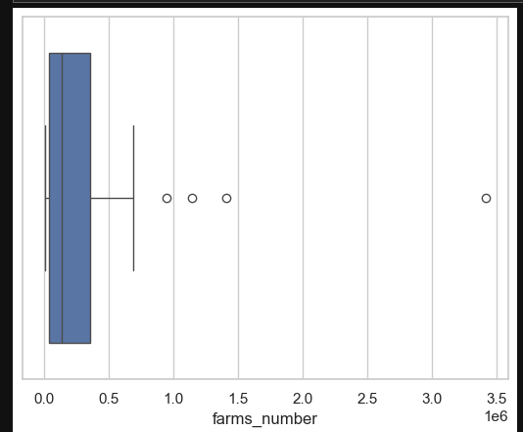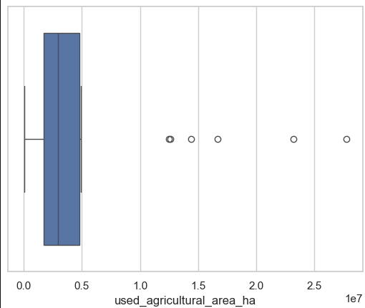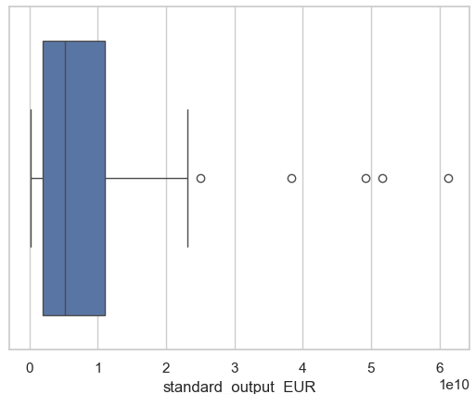
Figure 1. Boxplot of ‘farms_number’ feature. Figure 2. Boxplot of ‘used_agricultura_area_ha’ . Figure 3. Boxplot of 'standard_output_EUR’.
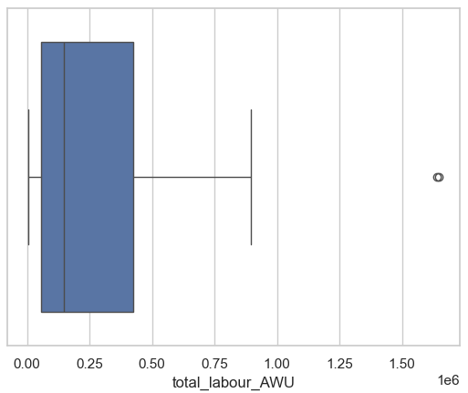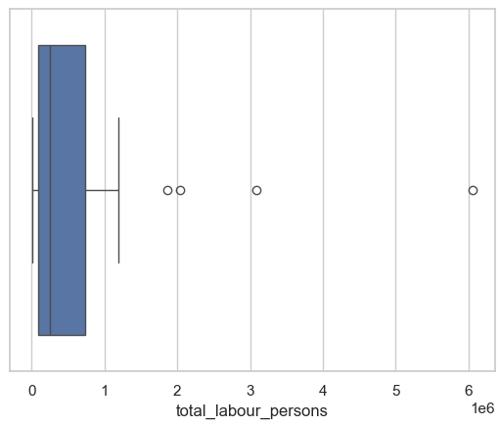
Figure 4. Boxplot of 'total_labour_AWU’ Figure 5. Boxplot of 'total_labour_persons’
Observations:
- The boxplot shows possible outliers
- farm_no_outliers dataset was created as an option with no outliers.

Feature Relationship
Scatter plot
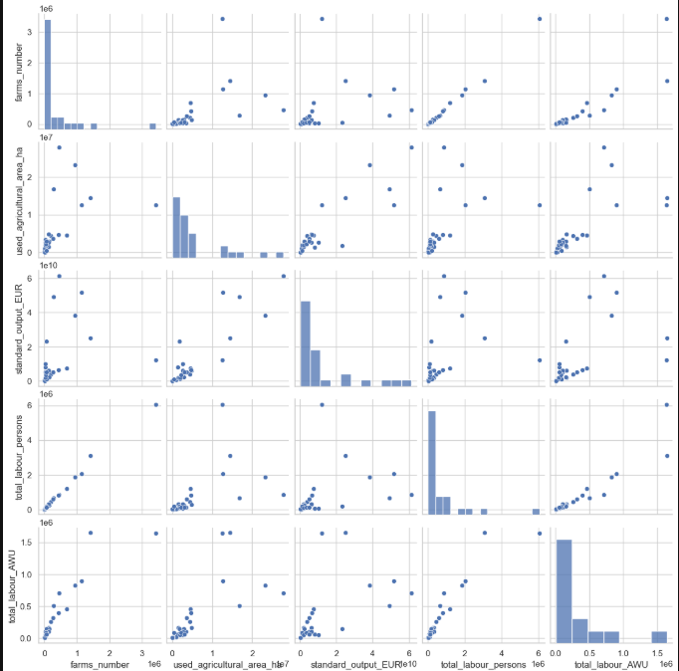
Figure 6. Scatter plot of dataset 1

Heatmap
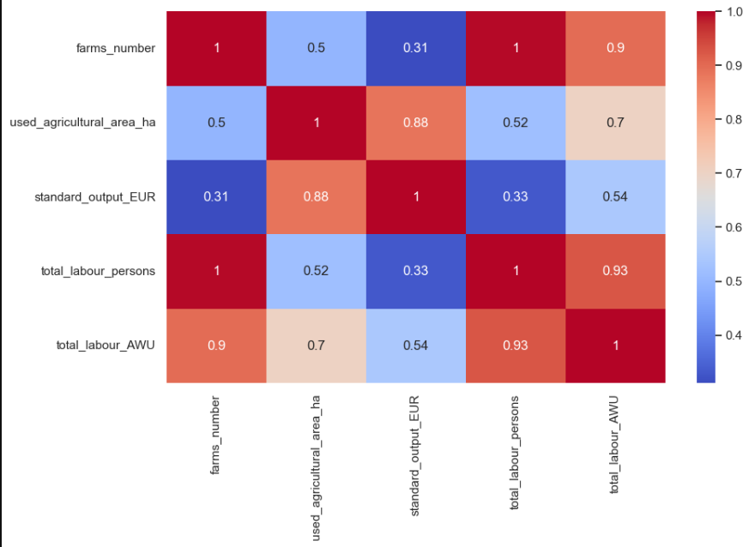
Figure 7. Heatmap of dataset 1
Relationships Found:
- 'total_labor_persons' and ' farms_number',
- 'total_labour_AWU' and 'farms_number'
- ' total_labour_AWU' and 'total_lobour_persons'
- 'standard_output' and 'used_agricultural_area_ha'

Data Visualization
Number of Farms in the European Union
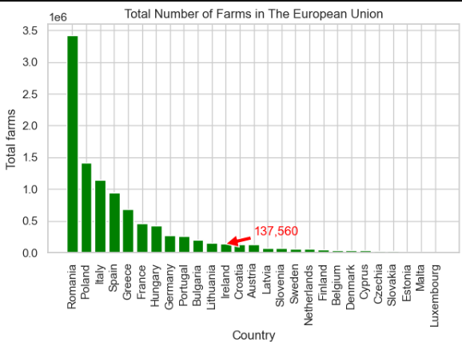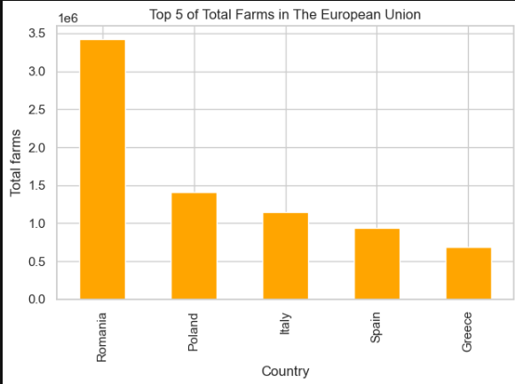
Figure 8. Histogram of number of farms. Figure 9. Top 5 countries with farm’s number.
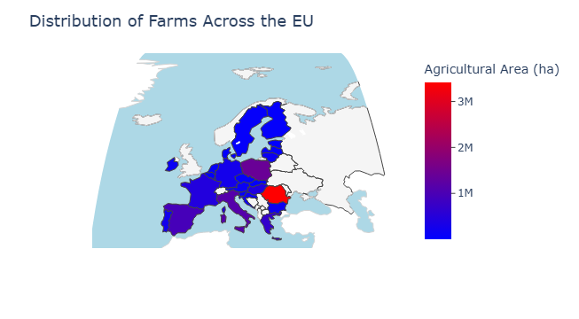
Figure 10. Interactive map of farm’s number.
Farm Workers in the European Union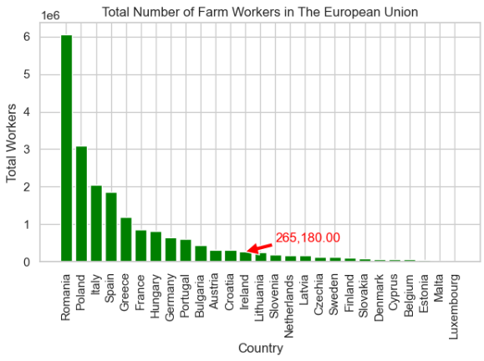
Figure 11. Histogram of farm workers
Annual Work Unit (AWU) by Country in the European Union
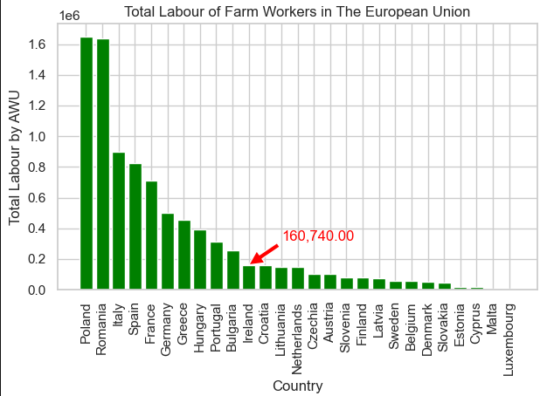
Figure 11. Histogram of labour of farm workers.

Standard Output(EUR) of Each Country in the European Union

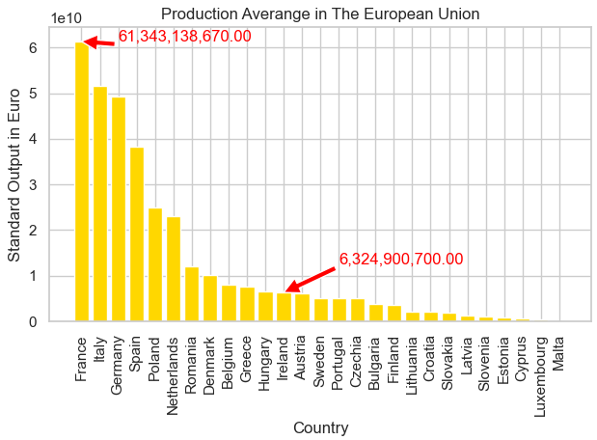
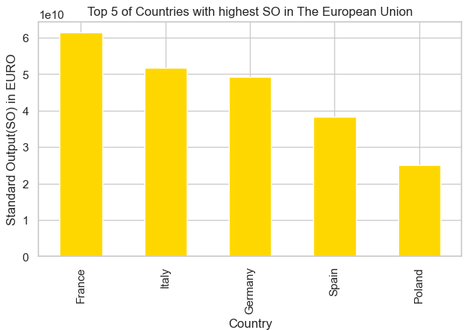
Figure 12. Histogram of standard output in the EU. Figure 13. Top 5 countries with highest standard output in the EU.
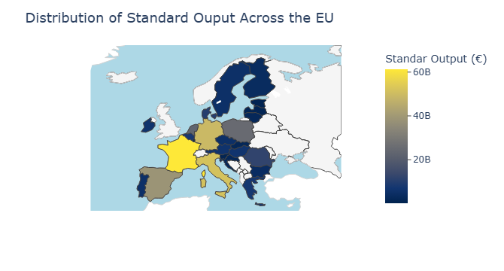
Figure 14. Interactive map showing standard output in the EU.

Agricultural Area Used by Country in The European Union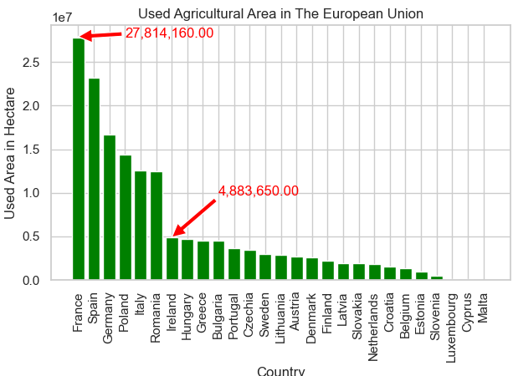 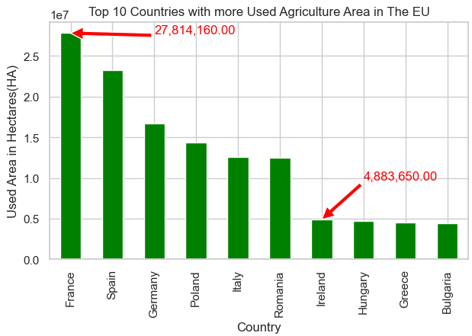
Figure 15. Histogram of used agricultural area in the EU. Figure 16. Top 10 countries with biggest used agricultural area in the EU.

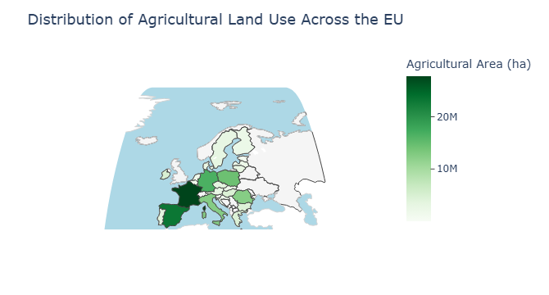
Figure 17. Interactive map of used agricultural area in the EU.

Conclusion:
Based on the characteristics of the dataset, including the limited number of observations, it is recommended to employ robust machine learning models for analysis. Robust models, such as ensemble methods or algorithms designed to handle small and imbalanced datasets, are better suited to provide reliable results under this condition.

Dataset 2: Irish Agricultural Exportation
For a detailed explanation of the process and code used please refer to ‘Data Preparation & visualization/Dataset 2: Irish Agricultural Exportation’ in the accompanying Jupyter Notebook.

Data Understanding
The dataset consists of 110 rows and 5 columns. All data types are correct. nunique() command shows 5 years and 22 categories.
Data Preparation
One irrelevant row was removed. No missing values were found as well as no duplicated columns. The Columns were renamed for an easier access.

Anomalies (outliers)
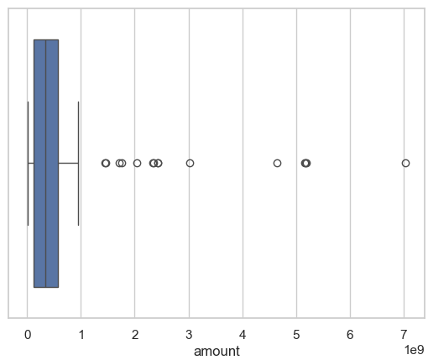
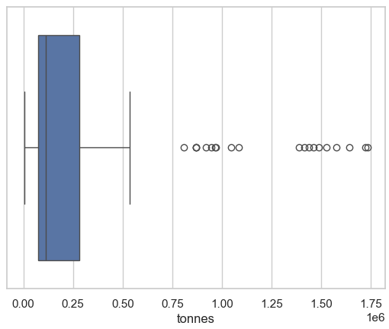
Figure 18. Boxplot of ‘amount’. Figure 19. Boxplot of ‘tonnes’.
Observations:
- The boxplot shows possible outliers
- df2_no_outliers dataset was created as an option with no outliers.

Feature Relationship
Scatter Plot
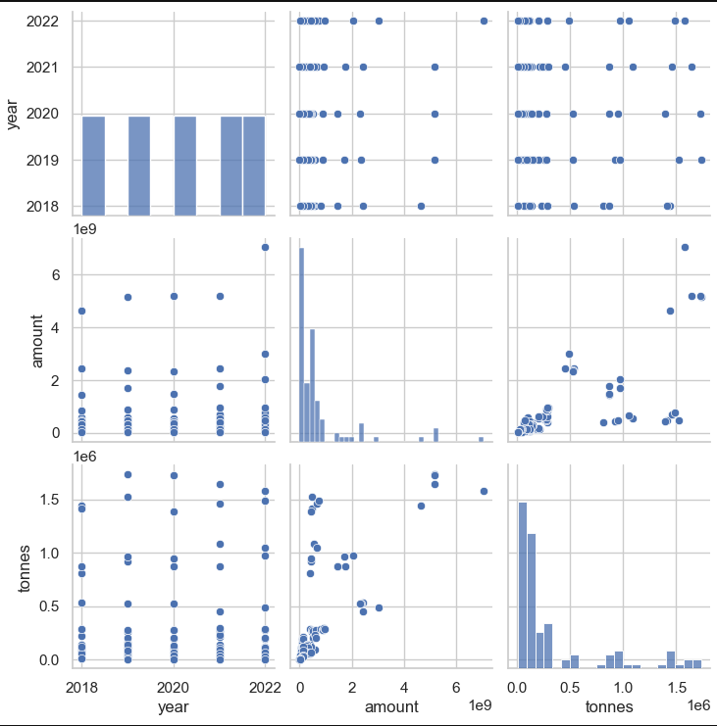
Figure 20. Scatter plot of dataset 2.
Heatmap Correlation Matrix
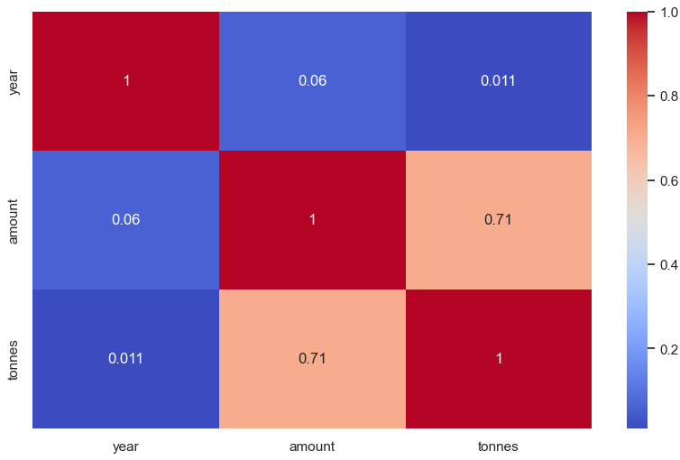
Figure 21. Heatmap of dataset 2.

Relationships found:
- ‘amount’ and ‘tonnes’ presented a strong relationship

Data Visualization
Ireland’s income form Agriculture between 2018 to 2022
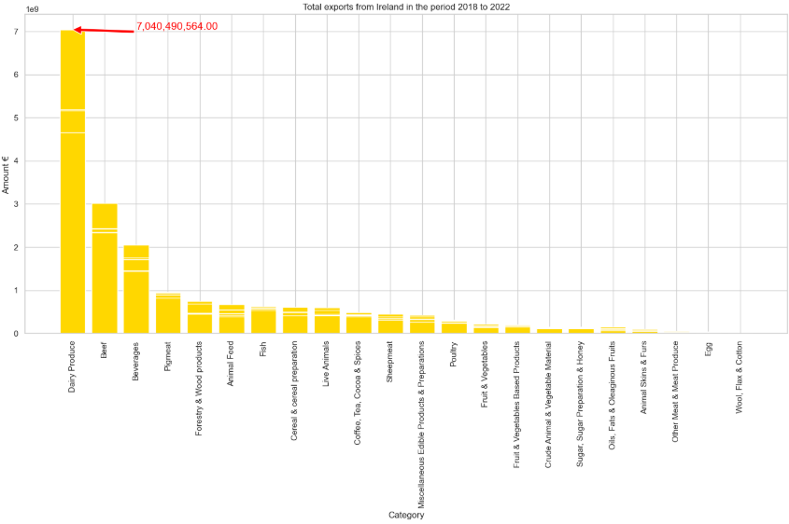
Figure 22. Ireland’s income form Agriculture between 2018 to 2022

Total Export from Ireland by Amount (€) over the years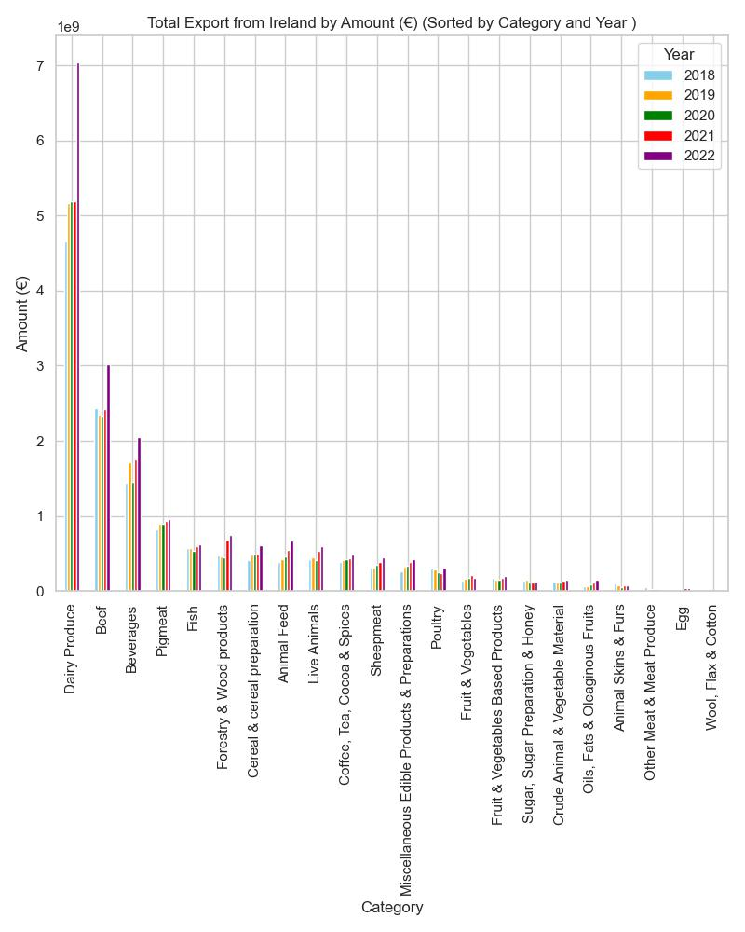
Figure 23. Total Export from Ireland by Amount (€) over the years.
Top 5 Exported Agricultural products from Ireland
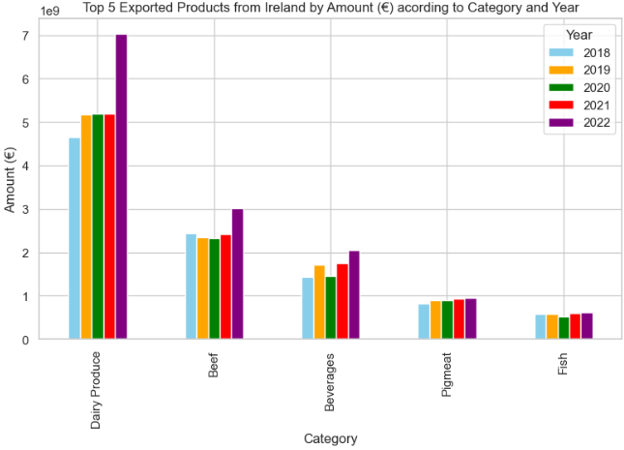
Figure 24. Top 5 Exported Agricultural products from Ireland.

Agricultura Exports Sorted by Tonnes over the years
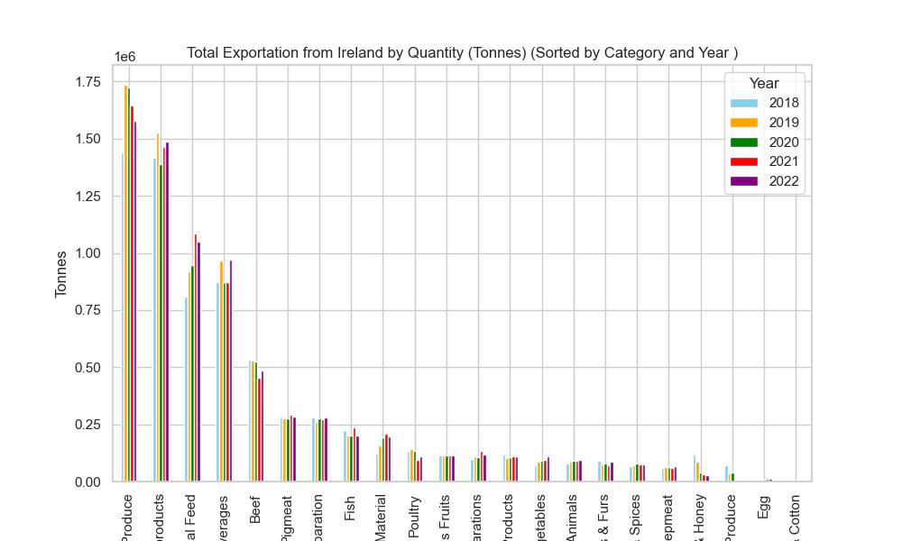
Figure 25. Agricultura Exports Sorted by Tonnes over the years.

Top 5 Agricultural Exported Products form Ireland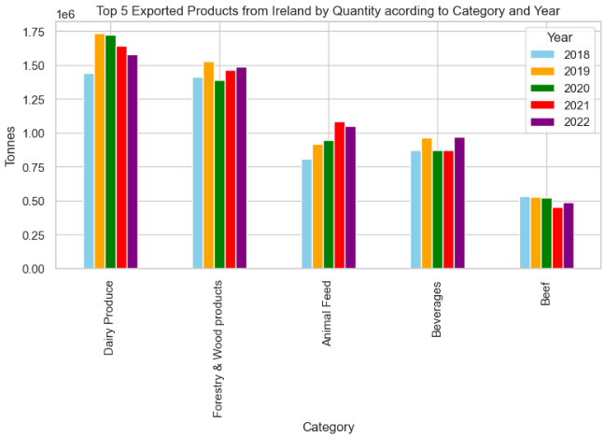
Figure 26. Top 5 Agricultural Exported Products form Ireland.

Conclusion:
Dairy products have been identified as the most exported category from Ireland, highlighting their importance for future analyses. The dataset contains outliers, suggesting the need to consider robust machine learning models for analysis. Additionally, the possibility of using a version of the dataset without outliers will be explored to ensure accurate and reliable insights.

Dataset 3: Commodity Trade Statistics Dataset
For a detailed explanation of the process and code used please refer to ‘Data Preparation & visualization/Dataset 3:Commodity Trade Statistics Dataset’ in the accompanying Jupyter Notebook.
Data Understanding
This dataset contains import and export volumes for 5,000 commodities across most countries worldwide over the last 30 years. It consists of more than 8 million rows and 10 columns, providing a comprehensive view of global trade patterns.
Data Preparation
Missing Values:
- Over 100,000 values are missing in the weight_kg column.
- Over 300,000 values are missing in the quantity column.
Using the code .isnull().sum() / trade.shape[0] * 100, we determined that the missing values represent a small percentage of the total dataset:
- weight_kg has 1.5% missing values.
- quantity has 3.7% missing values.
Given that these percentages are well below 15%, the missing values were removed. This decision will not significantly impact the analysis.
Dataframes
From the dataset, multiple dataframes were created to facilitate future analysis and enable meaningful comparisons against Ireland. These dataframes will support targeted insights and specific evaluations tailored to the scope of the analysis.
Anomalies (outliers)
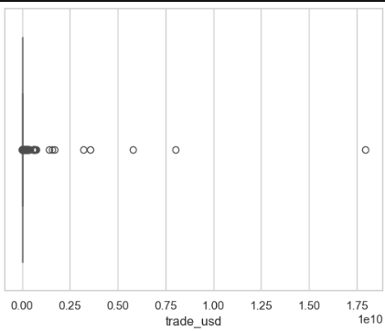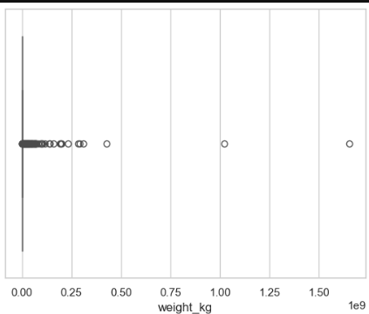
Figure 27. Boxplot of trade_usd. Figure 28. Boxplot of weight_kg.

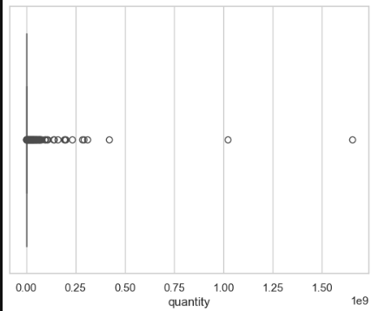
Figure 29. Boxplot of quantity.
The presence of outliers is detected.

Feature Relationship
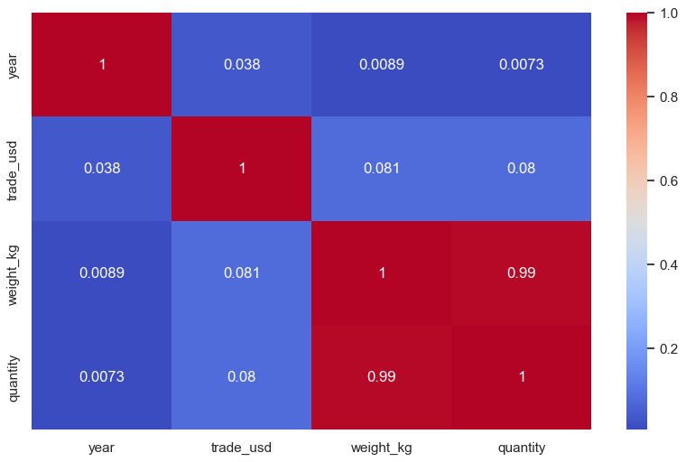
Figure 30. Heatmap of dataset 3.

Observations:
- strong realtionship between weight_kg and quantity
- also weight_kg and trade_usd
  - Data Visualization

Agricultural Product Exported from Ireland in 2016
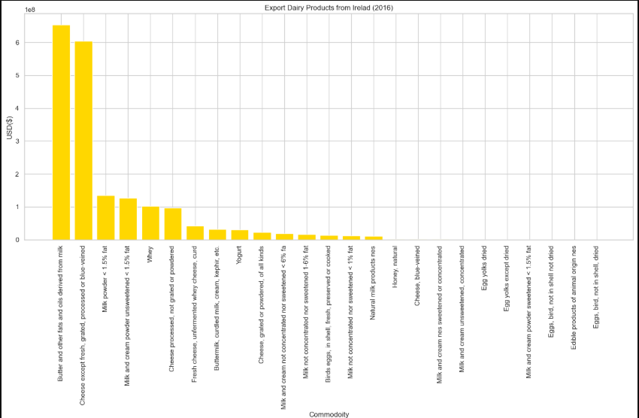

Figure 31. Agricultural Product Exported from Ireland in 2016.
Butter, Fat and oil from Milk Exported from Ireland over the years

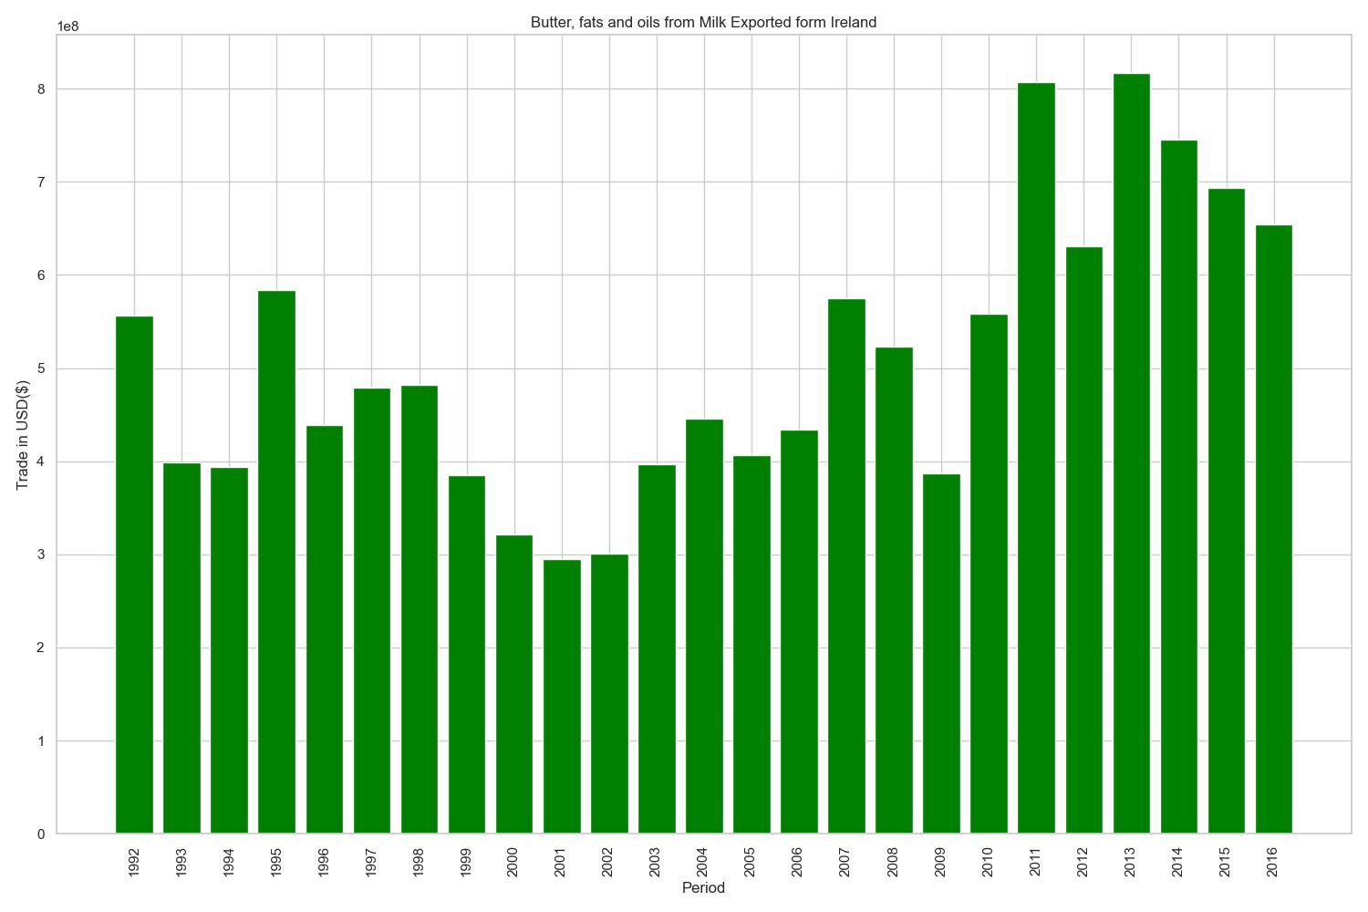
Figure 32. Butter, Fat and oil from Milk Exported from Ireland over the years.

Interactive Dashboard
To enhance the understanding and analysis of Ireland's exported and imported products, an interactive dashboard was developed. This dashboard provides a dynamic visualization of export and import commodities, categorized and sortable by year. Hosted on Streamlit, it offers an intuitive platform for exploring trade data efficiently and effectively.
Link to the dashboard: https://app-8mynamj5uzbm22fnrpvndq.streamlit.app/

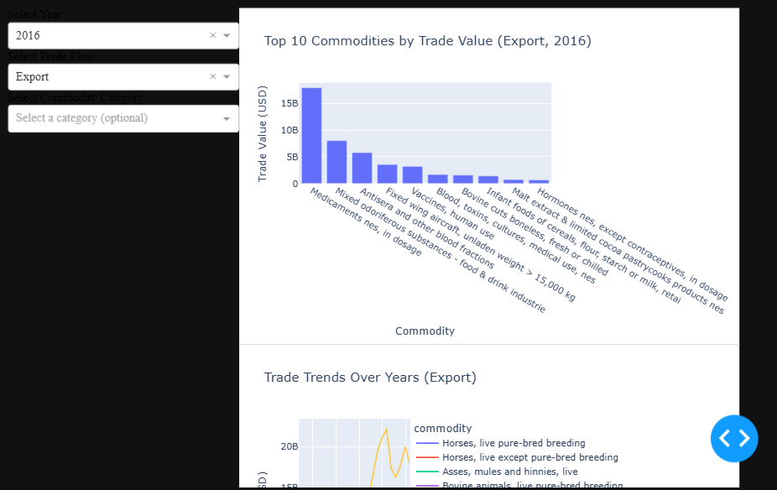
Figure 33. Interactive Dashboard.
For a detailed explanation of the process and code used please refer to ‘Data Preparation & Visualization/ Interactive DashBoard on Streamlit’ in the accompanying Jupyter Notebook.

Statistics

Descriptive Statistics
Descriptive statistics are specific methods basically used to calculate, describe, and summarize collected research data in a logical, meaningful, and efficient way. Descriptive statistics are reported numerically in the manuscript text and/or in its tables, or graphically in its figures. (Salkind, 2016)
Summary Statistics
The .describe() function was used in each dataset to compute and visualize key metrics such as mean, standard deviation, minimum, maximum, and percentiles.

Measures of the Central Tendency of Data
The mean, median, and mode are 3 measures of the center or central tendency of a set of data. When a set of data is truly normally distributed, its distribution forms or follows a bell-shaped curve, and its mean, median, and mode are all at the same point, at the center of the distribution. (Urdan, 2017)
A custom function was implemented in each dataset to calculate the mean, median, and mode for every feature in the dataset.

Measures of Dispersion of Data
In addition to a measure of its central tendency (mean, median, or mode), another important characteristic of a research data set is its variability or dispersion. In simplest terms, variability is how much the individual recorded scores or observed values differ from one another. (Salkind, 2016)
The most general measure of variability is the total range, namely, the absolute difference between the minimum (lowest, smallest) and the maximum (highest, largest) recorded values. (W Mendenhall, 2013)
The standard deviation (SD) represents the average amount of variability in a set of values or scores, and practically or roughly speaking, the SD is the average distance from the mean. (Urdan, 2017)
The following steps were performed on each dataset to calculate detailed statistical measures:
- Min, Max, Range, and Variance: A for loop was implemented to compute these values for every feature.
- Standard Deviation: The standard deviation for each feature was calculated using a function within a for loop.
- Percentiles and IQR: The .percentile function was utilized within a for loop to determine percentiles and the interquartile range (IQR) for all features.
- Kurtosis: The kurtosis command was used to measure the tail-heaviness of the data distribution.
- Skewness: The skew command was used to evaluate the asymmetry in the data distribution.
- Distribution Visualization: A Histogram plot was created for each feature to visually assess the dataset's distribution and identify potential outliers.

Dataset 1: European Agriculture Farm Structure Indicators
For a detailed explanation of the process and code used please refer to ‘Statistics/Dataset 1:European Agriculture Farm Structure Indicators’ in the accompanying Jupyter Notebook.

Descriptive Statistics
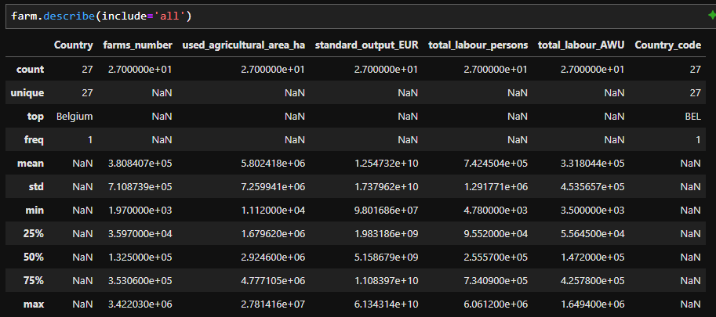
Figure 34. Descriptive statistics of dataset 1.
Observations:
- 27 countries
- Min and max have a significant difference in of features
- The high standard deviation reflects significant variability in each feature

Measures of Central Tendency of Data

--- farms_number ---
Mean: 380840.74074074073
Median: 132500
Mode: None

--- used_agricultural_area_ha ---
Mean: 5802417.777777778
Median: 2924600
Mode: None

--- standard_output_EUR ---
Mean: 12547320210.74074
Median: 5158678850.0
Mode: 5144206850.0

--- total_labour_persons ---
Mean: 742450.3703703703
Median: 255570
Mode: None

--- total_labour_AWU ---
Mean: 331804.44444444444
Median: 147200
Mode: None

Observations:
- Farms Number Observations: The mean is significantly higher than the median, indicating a right-skewed distribution.
- Used Agricultural Area (ha) Observations: The mean is much larger than the median, which again indicates a right-skewed distribution.
- Standard Output (EUR) Observations: The mean is more than double the median, indicating a strong right skew.
- Total Labour Persons Observations: The mean is nearly three times the median, pointing to a right-skewed distribution.
- Total Labour AWU (Annual Work Units) Observations: The mean is more than double the median, again showing a right-skewed distribution.

Measures of Dispersion

--- farms_number ---
Min: 1970
Max: 3422030
Range: 3420060
Variance: 505341764960.9687
--- used_agricultural_area_ha ---
Min: 11120
Max: 27814160
Range: 27803040
Variance: 52706740793248.72
--- standard_output_EUR ---
Min: 98016860.0

Max: 61343138670.0
Range: 61245121810.0
Variance: 3.020510431869074e+20
--- total_labour_persons ---
Min: 4780
Max: 6061200
Range: 6056420
Variance: 1668673461372.935
--- total_labour_AWU ---
Min: 3500
Max: 1649400
Range: 1645900
Variance: 205721872848.71793

Observations:
- Farms Number
- There is a huge range in the number of farms across regions, with some regions having only a few thousand farms while others have millions.
- The variance is exceptionally high, indicating substantial variability in farm counts between regions.
- Used Agricultural Area (ha):
- The range is vast, with some regions having minimal agricultural land and others having extensive area.
- The extremely high variance highlights significant disparities in land usage.
- Standard Output (EUR):
- The range and variance show an extreme concentration of economic output in a few regions.
- Smaller regions with low outputs contribute minimally to the total, while some regions dominate with billions of euros in output.
- Total Labour Persons:
- The range suggests that some regions are highly labored , while others likely rely on mechanization or have smaller farming operations.
- The large variance implies an uneven distribution of labor across regions.
- Total Labour AWU (Annual Work Units):
- The range reflects disparities in labor effort, possibly influenced by farm size or mechanization.
- The high variance highlights significant differences in labor intensity across regions.
Potential Skewness:
- The presence of very high maximum values suggests that these metrics are likely right-skewed, with a small number of outliers.

Standard Deviation

--- farms_number ---
Standard Deviation: 697585.4093197102

--- used_agricultural_area_ha ---
Standard Deviation: 7124229.030736425
--- standard_output_EUR ---
Standard Deviation: 17054734460.35787
--- total_labour_persons ---
Standard Deviation: 1267624.053330223
--- total_labour_AWU ---
Standard Deviation: 445087.11981441494

- Farms Number
Observations: The high standard deviation reflects significant variability in the number of farms across regions.
- Used Agricultural Area (ha)
Observations: The substantial standard deviation emphasizes the disparity in agricultural land usage, consistent with the observed range.
- Standard Output (EUR)
Observations: This is a massive standard deviation, indicating some regions contribute far more to total output than others.
- Total Labour Persons
Observations: High variability shows that labor force size differs significantly between regions.
- Total Labour AWU (Annual Work Units)
Observations: The lower standard deviation compared to other metrics suggests less extreme variability in labor effort than in absolute labor numbers.

Percentiles and IQR

-- farms_number ---
25th Percentile: 35970.0
75th Percentile: 353060.0
IQR: 317090.0
--- used_agricultural_area_ha ---
25th Percentile: 1679620.0
75th Percentile: 4777105.0
IQR: 3097485.0
--- standard_output_EUR ---
25th Percentile: 1983186330.0
75th Percentile: 11083966920.0
IQR: 9100780590.0
--- total_labour_persons ---
25th Percentile: 95520.0
75th Percentile: 734090.0
IQR: 638570.0
--- total_labour_AWU ---
25th Percentile: 55645.0
75th Percentile: 425780.0
IQR: 370135.0

Observations:
- Wide disparities across metrics, indicating a regional difference.
- Upper quartile Dominance, regions in the upper quartiles outperform those in the lower quartiles in all metrics

Kurtosis

--- farms_number ---
Kurtosis: 10.656653858597014
--- used_agricultural_area_ha ---
Kurtosis: 2.1375084956234858
--- standard_output_EUR ---
Kurtosis: 1.593889453870867

--- total_labour_persons ---
Kurtosis: 9.014970748009462
--- total_labour_AWU ---
Kurtosis: 2.8636648161202682

Interpretation:
- High Kurtosis (> 3): Indicates that the dataset has heavy tails or outliers. This is the case of : "farms_number", and "total_labour_persons". The presence of fewer extreme values or outliers is expected
- Low Kurtosis (< 3): Indicates that the dataset has lighter tails than a normal distribution. This is the case of: "used_agricultural_area_ha","standard_output_EUR", "total_labour_AWU"

Skewness

--- farms_number ---
Skewness: 3.194621227454298
--- used_agricultural_area_ha ---
Skewness: 1.75734330730258
--- standard_output_EUR ---
Skewness: 1.7090064584206577

--- total_labour_persons ---
Skewness: 2.9657959382325862
--- total_labour_AWU ---
Skewness: 1.920617283372104

Observations:
All metrics are positively skewed, showing that most regions are on the lower side of the distributions, with a few regions acting as outliers on the higher end.

Distribution
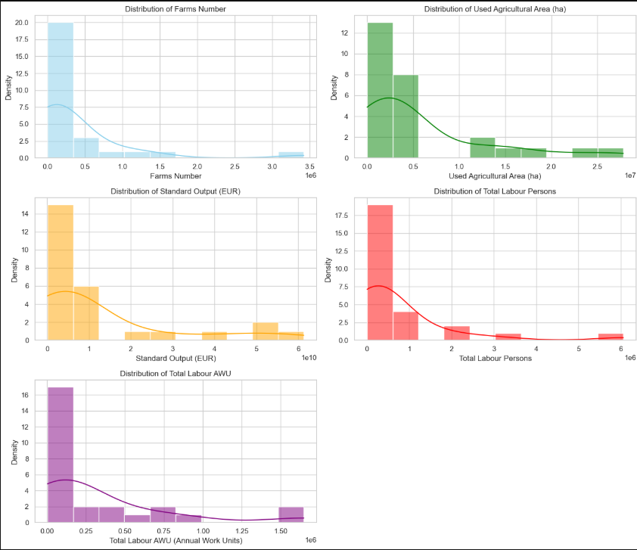
Figure 35. Distributions of dataset 1.

Dataset 2: Irish Agricultural Exportation
For a detailed explanation of the process and code used please refer to ‘Statistics/Dataset 2: Irish Agricultural Exportation dataset’ in the accompanying Jupyter Notebook.
Descriptive Statistics
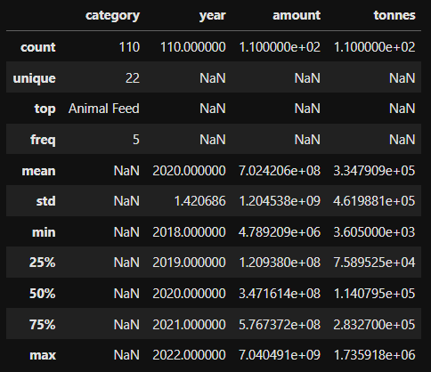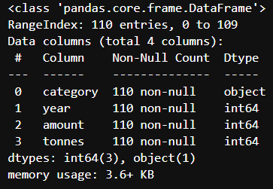
Figure 36. describe() of dataset 2. Figure 37. info of dataset 2.

Observations:
- 22 categories, 5 years
- 110 rows, 4 columns
- category" variable is an object data type as expected
- the rest of the variables are integer data type

Measures of Dispersion

Percentiles and IQR

--- amount ---
25th Percentile: 120937987.5
75th Percentile: 576737179.25
IQR: 455799191.75

--- tonnes ---
25th Percentile: 75895.25
75th Percentile: 283270.0
IQR: 207374.75

Skewness and Kurtosis

--- amount ---
Skewness: 3.222071638993855
Kurtosis: 10.796046221992095

--- tonnes ---
Skewness: 1.783973641359184
Kurtosis: 1.918750799471998

Interpretation:
- High Kurtosis (> 3): Indicates that the dataset has heavy tails or outliers. This is the case of : 'amount'.
- low Kurtosis (< 3): Indicates that the dataset has lighter tails than a normal distribution. This is the case of: 'tonnes'
- Skew value More than 1.5 indicates High Skewed distribution, which is the case of both features .

Distributions

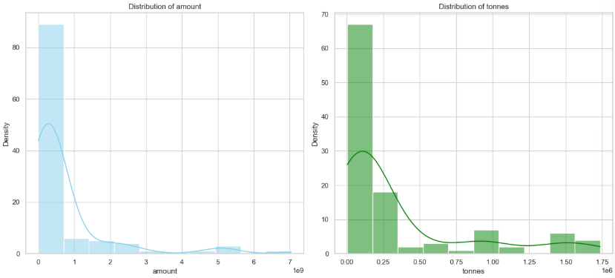
Figure 38. Distributions of dataset 2.

Dataset 3: Commodity Trade Statistics Dataset
For a detailed explanation of the process and code used please refer to ‘Statistics/Dataset 3: Commodity Statistics Dataset’ in the accompanying Jupyter Notebook.

Descriptive Statistics
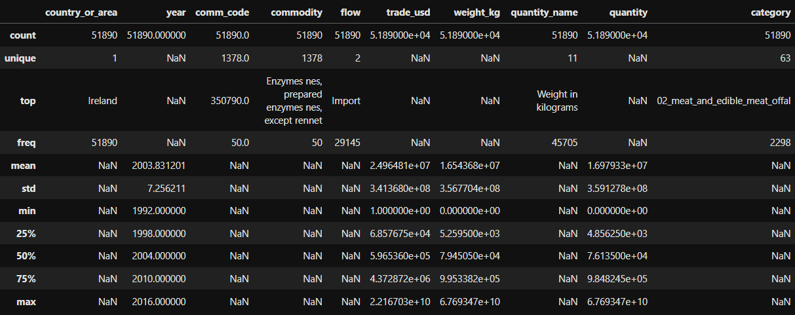
Figure 39. Descriptive statistics of dataset 3.

Observations:
- 209 countries in total
- 5047 commodities in total
- 98 categories

Measures of Dispersion of Data

--- trade_usd ---
25th Percentile: 11072.0
75th Percentile: 1895476.5
IQR: 1884404.5

--- weight_kg ---
25th Percentile: 1089.0
75th Percentile: 447443.25
IQR: 446354.25

Skewness and Kurtosis

--- trade_usd ---
Skewness: 196.28507814406026
Kurtosis: 49870.27592499017

--- weight_kg ---
Skewness: 275.87143486419706
Kurtosis: 107639.40203272442

Interpretation:
- High Kurtosis in both features (> 3): Indicates that the dataset has heavy tails or outliers.
- Skew value More than 1.5 indicates High Skewed distribution, which is the case of both featues.

Distribution
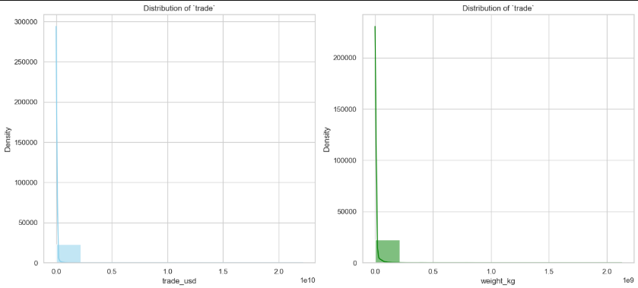
Figure 40. Distributions statistics of dataset 3.

Inferential Statistics
“After the preceding experiment is completed and the data are described and summa-rized, we hope to be able to draw a conclusion about which teaching method is superior. This part of statistics, concerned with the drawing of conclusions, is called inferential statistics. To be able to draw a conclusion from the data, we must take into account the possibility of chance.” (Ross, 2009)
Inferential statistical techniques include:
- Hypothesis tests, or tests of significance: These involve confirming whether certain results are significant and not simply by chance
- Correlation analysis: This helps determine the relationship or correlation between variables
- Logistic or linear regression analysis: These methods enable inferring and predicting causality and other relationships between variables
- Confidence intervals: These helps identify the probability an estimated outcome will occur

Irish_data_export DataFrame
This data frame was generated in order to take samples of exportation trades from Ireland.
Distribution
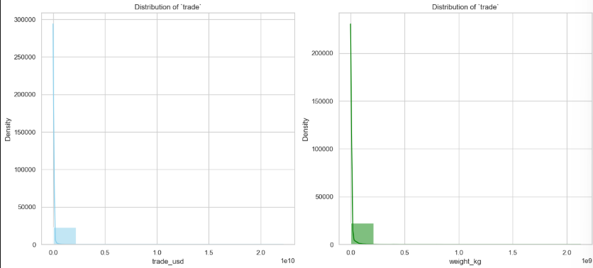
Figure 41. Distributions statistics of irhis_data_export dataset.
Additionally, samples of Hungary and Mexico about Dairy products Export were created from Dataset 3: Commodity Trade Statistics.

Hypothesis
For a detailed explanation of the process and code used please refer to ‘Statistics/Hypothesis’ in the accompanying Jupyter Notebook.
Conventional statistical hypothesis testing validates whether a hypothesis about a quantity of interest (a parameter) is true or false based on the likelihood that the observed data could have been generated if the hypothesis were true.
Statistical hypothesis testing has a long history (Fisher, 1925). Hypothesis testing begins with a question about a parameter or parameters of interest that describe aspects of a population of interest. The parameters define the probability of distribution for generating data from the population. In order to test a hypothesis about a parameter, a sample of data is taken from the population, and a test statistic is calculated from the data (E L Lehmann, 2005).

Techniques Used

- T-Test: A statistical test used to compare the means of two groups.
- Z-Test: A method for comparing two means, typically applied to population data or when the sample size exceeds 30.
- Chi-Squared Test: Assesses the magnitude of discrepancies between expected results and actual results.
- Wilcoxon Signed-Rank Test: A non-parametric test that requires fewer assumptions compared to its parametric counterpart, used to analyze paired data.
- Mann-Whitney U Test: A non-parametric test to compare two sample means from the same population, used to determine if the means are equal.
- ANOVA (Analysis of Variance): A statistical test used to identify differences among three or more unrelated groups or samples.

Hypothesis 1:

- Null Hypothesis (H₀): The Export Trade (USD) Average from Dairy Products of Ireland and Hungary distributions are equal.
- Alternative Hypothesis (H₁):The Export Trade (USD) Average of Dairy Products from Ireland and Hungary distributions are Not equal.
To address this hypothesis, both T-tests and Z-tests were applied.
Decision for T-test:
Reject the null hypothesis: There is a significant difference in the average trade (USD) of Dairy Export between Ireland and Hungary.
Decision for Z-test:
Reject the null hypothesis: There is a significant difference in the average Dairy Trade USD between Ireland and Hungary.

Hypothesis 2:

- Null Hypothesis (H₀): The Export Trade (USD) Average of Dairy Products from Ireland and Hungary in 2016 are equal.
- Alternative Hypothesis (H₁): The Export Trade (USD) Average of Dairy Products from Ireland and Hungary in 2016 are Not equal.
To address this hypothesis, both T-tests and Z-tests were applied.
Decision for T-test:
Fail to reject the null hypothesis: There was no significant difference in Dairy Export between Ireland and Hungary in 2016.
Decision for Z-Test:
Fail to reject the null hypothesis: There was no significant difference in Dairy Export between Ireland and Hungary in 2016.

Hypothesis 3:
Do certain flow values("Export", "Import") of Ireland depend on the category of goods?
Hypothesis:
- Null Hypothesis (H₀): There is relationship between "flow" and "category".
- Alternative Hypothesis (H₁): There is not relationship between "flow" and "category".
To address this hypothesis Chi-Squared Test was applied.
Decision by Chi-Squared Test:
There is a significant association between the variables (reject null hypothesis).

Hypothesis 4:

- Null Hypothesis (H₀): The Export Weight (kg) Average of Dairy Products from Ireland and Hungary are equal.
- Alternative Hypothesis (H₁): The Export Weight (kg) Average of Dairy Products from Ireland and Hungary are Not equal.
To address this hypothesis Wilcoxon Signed-Rank Test was applied.
Decision by Wilcoxon Signed-Rank Test:
Significant difference between Ireland and Hungary weight distributions (reject null hypothesis).

Hypothesis 5:
Comparison of Export Dairy Products Trade (USD) between Ireland and Mexico.
Hypothesis:
- Null Hypothesis (H₀): The Trade (USD) Average of Dairy Products from Ireland and Mexico are equal.
- Alternative Hypothesis (H₁): The Export Trade (USD) Average of Dairy Products from Ireland and Mexico are Not equal.
To address this hypothesis Mann-Whitney U Test was applied.
Decision by Mann-Whitney U Test:
Reject null hypothesis: Significant difference between Ireland and Mexico trade usd distributions.

Hypothesis 6:
Comparison between Ireland, Hungary and Mexico Export Dairy Products Trade (usd)
Hypothesis:
- Null Hypothesis (H₀): The Trade (USD) Average of Dairy Products from Ireland, Hungary and Mexico are equal.
- Alternative Hypothesis (H₁): The Export Trade (USD) Average of Dairy Products from Ireland, Hungary and Mexico are Not equal.

ANOVA was applied to address this hypothesis.

Decision by ANOVA:
Reject null hypothesis: Significant difference between Ireland, Hungary and Mexico trade usd distributions.

Deeper Research
For a detailed explanation of the process and code used please refer to ‘Statistics/Dairy Export in the World’ in the accompanying Jupyter Notebook.

Dairy products are the most exported commodities from Ireland, with butter, fats, and other oils derived from milk leading the category. To extend the analysis, I retrieved global export data for butter, fats, and other milk-based oils for further examination.
Process:
- Step 1: filter the data by commodity
- Step 2: filter the data by flow
- Step 3: sort the data by trading
- Step 4 : visualization
Results:

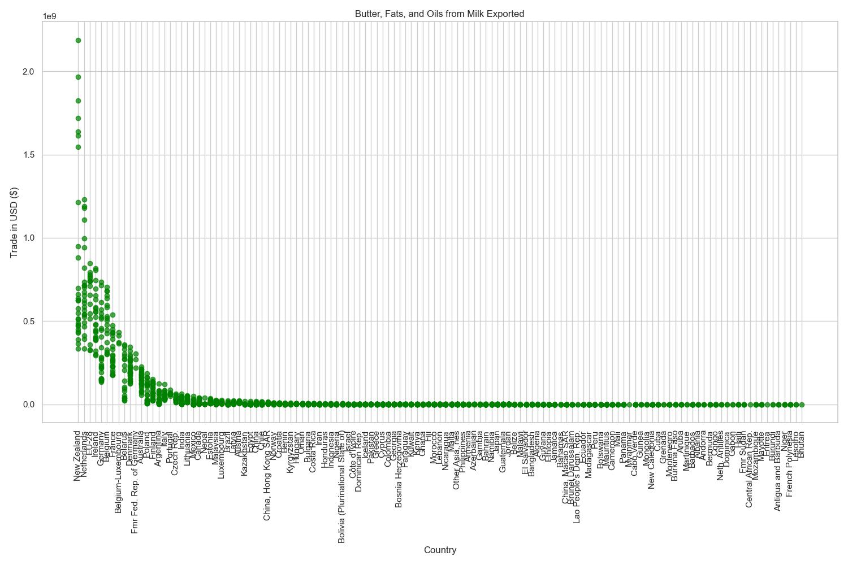
Figure 42. Butter export in the world.
Ireland ranks 4th globally in the export of butter, fats, and oils derived from milk. This is particularly impressive considering the country's relatively small size.
  - Interactive Map of Dairy export products in the world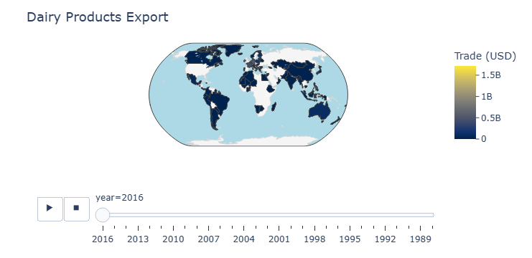
Figure 43. Interactive Map of Dairy export products in the world.
  - An interactive map was developed, it shows the Trade in USD of Dairy Products in the world through the years.

Mean ,Median and Mode

Calculation of the mean, median and mode of Dairy Products all over the world.
--- trade_usd ---
- Mean: 59874184.80589431
- Median: 455856.0
- Mode: 564

--- weight_kg ---
- Mean: 19055069.669720102
- Median: 185035.0
- Mode: 0.0

--- quantity ---
- Mean: 19055069.669720102
- Median: 185035.0
- Mode: 0.0

Visualization of Distributions
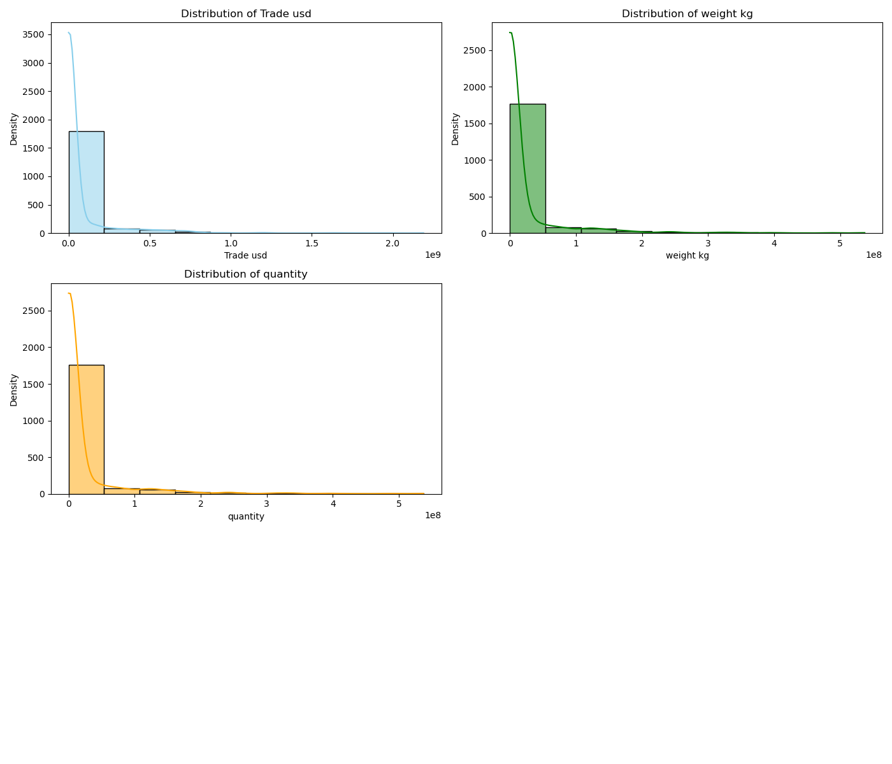
Figure 44.Distributions of Dairy export products in the world.

Machine Learning
For a detailed explanation of the process and code used please refer to ‘Machine Learning’ in the accompanying Jupyter Notebook.
Three scenarios were proposed, Regression, Classification and Clustering.

Scenario 1: Regression
Goal: Predict Export Dairy Trade(USD) form Ireland.
For this scenario I developed two models. Feature importance technique was applied to both models. GridSearchCV was applied to Model 2.
Model 1 : Linear Regression
Linear regression is a supervised algorithm, that learns from the labelled datasets and maps the data points to the most optimized linear functions that can be used for prediction on new datasets. (Anon., 2018).
Model 2: Random Forest
Random forests are a combination of tree predictors such that each tree depends on the values of a random vector sampled independently and with the same distribution for all trees in the forest. Using a random selection of features to split each node yields error rates that compare favorably but are more robust with respect to noise. (Breiman, 2001)
Feature importance
Feature importance refers to a class of techniques for assigning scores to input features to a predictive model that indicates the relative importance of each feature when making a prediction.
“Often, we desire to quantify the strength of the relationship between the predictors and the outcome. […] Ranking predictors in this manner can be very useful when sifting through large amounts of data.” (Max Kuhn, 2013)
Grid search cv
GridSearchCV acts as a valuable tool for identifying the optimal parameters for a machine learning model.

Results on Model 1:
The feature importance technique suggests that features ‘year’ and ‘quantity’ are relevant for Linear Regression.
Model 1 predicts Trade (USD) based on ‘quantity’ and ‘year’, but the accuracy obtained is 58%.
Results on Model 2:
The technique of feature importance suggests that all numerical features are relevant to Random Forest Regressor.
Model 2 predicts Trade (USD) based on ‘quantity’, ‘weight’, and ‘year. The accuracy obtained is 48%
Conclusion:
Despite using GridSearchCV, the models demonstrated low accuracy. To improve performance, I propose exploring more robust models, applying normalization techniques, or removing outliers from the dataset.

Scenario 2: Classification
Goal: To classify the Irelan’s flow (import/export).
For this scenario I developed two models. Feature importance technique was applied to both models. GridSearchCV was applied to Model 2.

Model 1: Logistic Regression
Logistic regression is a supervised algorithm widely used for binary classification tasks, this approach utilizes the logistic (or sigmoid) function to transform a linear combination of input features into a probability value ranging between 0 and 1. (Harrell, 2015)
Model 2: Random Forest Classifier with GridSearchCV
For classification tasks, the output of the random forest is the class selected by most trees. (Ho, 1995). Random forests correct for decision tree’s habit of overfitting to their training set. (Trevor Hastie, 2008)
Results of Model1:
- The feature importance technique identified weight_kg and year as the most relevant features. However, after experimenting with different feature combinations, the highest accuracy was achieved using weight_kg and trade_usd.
- Model 1 demonstrated the ability to classify the flow of a commodity based on weight and trade value, but the accuracy achieved was only 56%.
Results of Model 2:
- Feature importance analysis suggested that all numerical features are relevant to the Random Forest Classifier.
- GridSearchCV was applied to optimize Model 2's parameters.
- Model 2 classified the flow of a commodity based on weight_kg, trade_usd, and year, achieving an improved accuracy of 61%.
Conclusion:
The Random Forest Classifier is a robust model and currently the best option among those tested. However, further improvements could be made by exploring additional techniques such as normalization, feature engineering, or addressing outliers in the dataset.

Scenario 3: Clustering
Goal: Cluster Dairy Commodities based on Trade Patterns.
In this Scenario a K-means Clustering model was developed. k-means clustering is a method of vector quantization, that aims to partition n observations into k clusters in which each observation belongs to the cluster with the nearest mean (cluster centers or cluster centroid), serving as a prototype of the cluster. This results in a partitioning of the data space into Voronoi cells. (Lloyd, 1957)
StandardScaler was used as a data preparation method standardizing features by removing the mean and scaling to unit variance (The scikit-learn developers, 2024).
The elbow method was applied to find the optimum number of clusters. In cluster analysis, the elbow method is a heuristic used in determining the number of clusters in a data set. The method consists of plotting the explained variation as a function of the number of clusters and picking the elbow of the curve as the number of clusters to use. (Thorndike, 1953)
The silhouette score was utilized to calculate the goodness of the clustering method used. The silhouette score is specialized for measuring cluster quality when the clusters are convex-shaped. The silhouette can be calculated with any distance metric, such as the Euclidean distance or the Manhattan distance. (Monshizadeh, et al., 2022)
Results of Model 1 K-means Clustering:
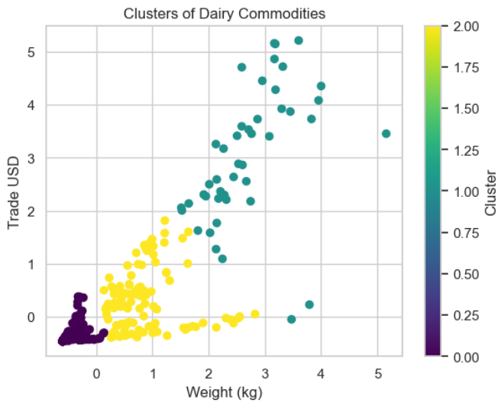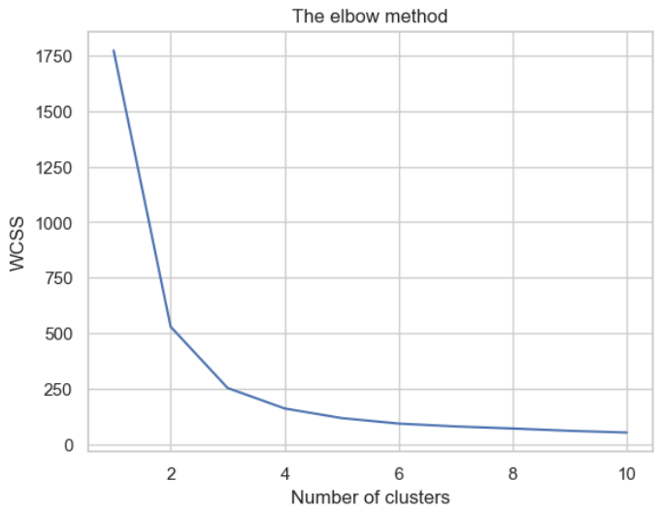
Figure 45. Clustering of dairy commodities. Figure 46. Elbow method plot.

Silhouette Score: 0.754

Conclusion:
The model demonstrated strong performance, achieving a silhouette score of 0.75 following data preprocessing with feature standardization. The optimal number of clusters, determined using the elbow method, was three.

Comparison of Regression Models with Cross-Validation
In order to discover the optimum method, a comparison of Regression Models was developed.
Cross-Validation was applied, it offers a more reliable estimate of how a model will perform on new data. By testing the model on multiple data subsets, you avoid overestimating its performance based on just one train-test split. (Allen, 1974)
Results:
Model | MAE | MSE | RMSE | R² Score | Cross-Validation for R² Score
Linear Regression | 4.216007e+07 | 7.804555e+15 | 8.834339e+07 | 0.581063 | 0.705942
Lasso | 4.183558e+07 | 7.761343e+15 | 7.761343e+15 | 0.583382 | 0.705978
Decision Tree | 4.292418e+07 | 1.231538e+16 | 1.109747e+08 | 0.338928 | 0.532600
Random Forest | 3.850624e+07 | 9.470300e+15 | 9.731547e+07 | 0.491648 | 0.712833
k-Nearest Neighbour | 3.910385e+07 | 9.567392e+15 | 9.567392e+15 | 0.486436 | 0.709132
Support Vector Machine | 6.716069e+07 | 2.244214e+16 | 1.498070e+08 | -0.204662 | -0.164807
Ridge Regression | 4.215903e+07 | 7.804491e+15 | 8.834303e+07 | 0.581066 | 0.705947
RANSAC Regressor | 3.650312e+07 | 7.115957e+15 | 8.435613e+07 | 0.618025 | 0.711129
Table 1.Comparison of regression models.

Conclusion:
The RANSAC Regressor is identified as the optimal model, demonstrating robust performance with an accuracy of 61%.

For a detailed explanation of the process and code used please refer to ‘Machine Learning/ Comparison of Regression Models’ in the accompanying Jupyter Notebook.

Comparison of Regression Models with Hyperparameter Tuning and Cross-Validation
In this section another comparison of models was developed, this time adding GindSearchCV in order to find the best parameters for optimal efficiency.

Model | Best Parameters | Best CV R² Score | Cross-Validation for R² Score
Lasso | {'alpha': 0.01} | 0.700638 | 0.705978
Decision Tree | {'max_depth': 5} | 0.622600 | 0.532600
Random Forest | {'n_estimators': 200} | 0.693469 | 0.712833
KNN | {'metric': 'minkowski', 'n_neighbors': 12, 'p'... | 0.745151 | 0.713317
SVR | {'C': 50000, 'gamma': 0.01, 'kernel': 'rbf'} | -0.160328 | -0.164807
Ridge | {'alpha': 0.01, 'solver': 'auto'} | 0.682893 | 0.705942
RANSAC | {'max_trials': 1000, 'min_samples': 0.01, 'res... | 0.393456 | 0.705513
Table 2. comparison of regression models with best parameters.

Conclusion:
Using GridSearchCV to identify the optimal parameters, the best-performing models were KNN with an accuracy of 74% and Lasso with an accuracy of 70%.
I considered this table to continue with the analysis and development of a Supervised and unsupervised Model.
For a detailed explanation of the process and code used please refer to ‘Machine Learning/ Hyperparameter Tuning using GridSearchCV’ in the accompanying Jupyter Notebook.

Sentimental Analysis

Continuing the analysis of agriculture in Ireland, the focus shifted to dairy products. Kerrygold emerged as the most widely consumed and exported butter brand from Ireland.

Collecting Data
Data from reddit were collected using PRAW, an acronym for “Python Reddit API Wrapper”, is a Python package that allows for simple access to Reddit’s API. (Mellor, 2010)

Analyzing the Data
SentimentIntensityAnalyzer() was applied, it provides a method called polarity_scores() that takes a piece of text as input and returns a dictionary containing the sentiment scores for the text. The dictionary contains four keys: neg, neu, pos, and compound. (Hutto & Gilbert, 2014)
Result:
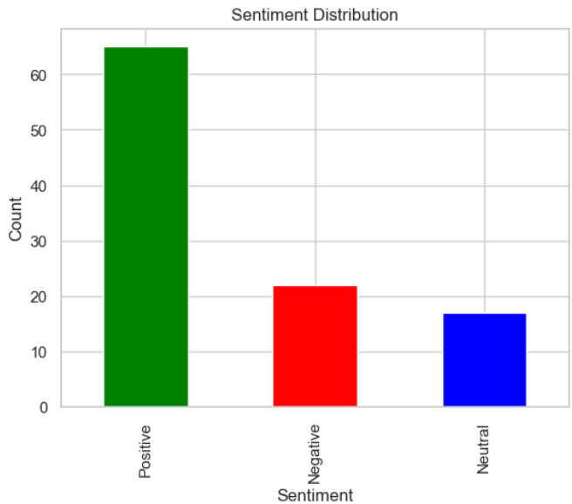
Figure 47. Histogram of sentiment analysis.
The results tell us that the majority of the comments about Kerrygold are positive.

Random Fores Classifier for Predictions

A Random Fores Classifier model which can predict sentiment labels based on text was developed.
Vectorization method was applied. Scikit-learn’s Tfidftransformer aim to do the same thing, which is to convert a collection of raw documents to a matrix of TF-IDF features. (Ganesan, 2022)
Results:
 | precision | recall f1 | f1-score | support
Negative | 0.00 | 0.00 | 0.00 | 6
Neutral | 0.00 | 0.00 | 0.00 | 2
Positive | 0.62 | 1.00 | 0.76 | 13
accuracy |  |  | 0.62 | 21
macro avg | 0.21 | 0.33 | 0.25 | 21
weighted avg | 0.38 | 0.62 | 0.47 | 21
Table 3. Results of random forest classifier.

Keyboard Analysis
The Keyboard analysis consist in discover the most frequent word in the comments.
Processing the text
Stopwords was imported from nltk.corpus for processing the text.
The reason why stop words are critical to many applications is that, if we remove the words that are very commonly used in a given language, we can focus on the important words instead (Ganesan, 2022).
The Vectorization was by CountVectorizer, it is a class in scikit-learn that transforms a collection of text documents into a numerical matrix of word or token counts.

Results:
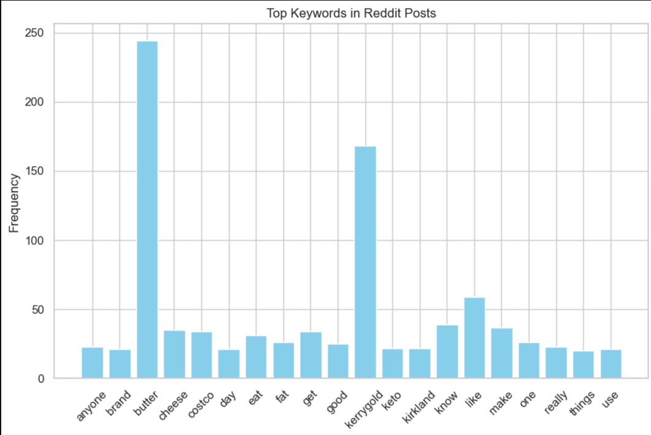
Figure 48. Histogram of keyboard analysis.

Word Cloud Analysis
Word clouds or tag clouds are graphical representations of word frequency that give greater prominence to words that appear more frequently in a source text. (Oesper, 2011)
Result:
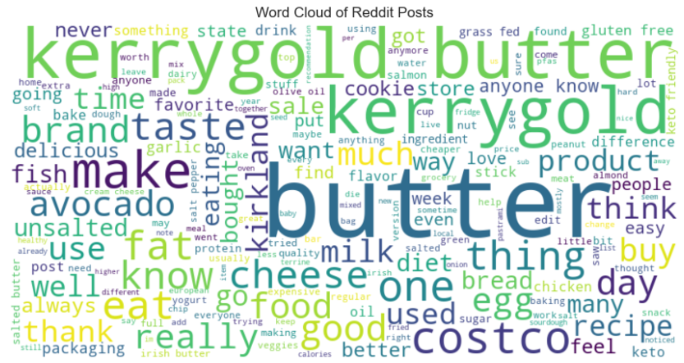
Figure 49. Word cloud result.

Topic Modelling
A topic modelling was developed using Latent Dirichlet allocation .
Latent Dirichlet allocation is a topic modeling technique for uncovering the central topics and their distributions across a set of documents. (Blei, et al., 2003)
Results:
- Topic 1:
eat com http imgur jpg keto oil fish avocado tastes
- Topic 2:
https com www went baking using dough cooking bake better
- Topic 3:
leave didn products milk need grocery edit time diet stick
- Topic 4:
irish unsalted chicken garlic salt die sauce mix dough products
- Topic 5:
difference butters better quality european taste flavor extra cheaper expensive
- Topic 6:
want day things salmon week water new eating saw states
- Topic 7:
post food people worth stuff dairy great products right keto
- Topic 8:
sale saw day time delicious little unsalted edit keto eat
- Topic 9:
kirkland free gluten packaging bread pfas chicken regular version states
- Topic 10:
- sugar way diet cookie new tried maybe people help drink

Conclusion of Sentiment Analysis:
The analysis revealed that positive comments and words were most prominent, indicating that the Kerrygold brand is highly regarded and well-received by consumers.

For a detailed explanation of the process and code used please refer to ‘Machine Learning/Sentimental Analysis’ in the accompanying Jupyter Notebook.

Supervised Learning
In this section of the project, a K-Nearest Neighbors (KNN) model was developed utilizing dimensionality reduction through Principal Component Analysis (PCA) and standardized data using StandardScaler. The best parameters were given by GrindSearchCV. The model's performance was evaluated through Cross-Validation to ensure robustness and reliability.
Goal: Predict the Trade Value in USD of export from ireland.

Step 1: Features and Target
- Independent Features (X): weight_kg and year
- Target Feature (y): trade_usd
Step 2: Standardizing the Data
The features were standardized using StandardScaler() to normalize the dataset, ensuring equal weighting across features.
Step 3: Train-Test Split
25% of the dataset was allocated for testing, while the remaining data was used for training.
Step 4: Dimensionality Reduction
Principal Component Analysis (PCA) was applied to the data. PCA reduces the number of dimensions in large datasets to principal components that retain most of the original information. PCA with KNN that can not only reduce the data dimensionality to speed up the calculation of KNN, but also reduce redundancy information while remaining effective information improves the performance of KNN prediction (Jenkins & Box, 1970).
Step 5: Parameters for GridSearchCV
Optimal hyperparameters for the KNN model with PCA were determined using the GridSearchCV technique.
Step 6: Model Evaluation with Cross-Validation
The model's performance was validated through Cross-Validation using the best parameters identified by GridSearchCV.
Results:
- Best Parameters for KNN with PCA:
{'knn__metric': 'minkowski', 'knn__n_neighbors': 12, 'knn__p': 1, 'pca__n_components': 2}
- KNN with PCA Performance Metrics:
  - Mean Squared Error: 7,152,862,110,480,163.0
  - R² Score: 0.6739
- Cross-Validation R² Scores:
[0.7997, 0.6118, 0.7482, 0.6757, 0.7471]
- Average Cross-Validation R² Score:
0.7165

The KNN model can predict Trade USD of a Commodity based on weight and year.
Conclusion:
The KNN model, enhanced by PCA and GridSearchCV for parameter optimization, demonstrates a strong ability to predict the trade value in USD of commodities based on weight_kg and year. The combination of PCA for dimensionality reduction and standardized data processing contributes to the model's robust predictive performance.

For a detailed explanation of the process and code used please refer to ‘Machine Learning/Supervised Learning’ in the accompanying Jupyter Notebook.

Unsupervised Learning

In this section of the project, a K-Means Clustering model was developed utilizing dimensionality reduction through Principal Component Analysis (PCA) and standardized data using StandardScaler. The model's performance was evaluated through Cross-Validation to ensure robustness and reliability.
Goal: Cluster Farms of the European Union by Used Agricultural Area and Standard Output.
Step 1: Numerical Feature selection
X = 'used_agricultural_area_ha','standard_output_EUR'
Step 2: Standardizing the Data
The features were standardized using StandardScaler() to normalize the data, ensuring that both features contribute equally to the clustering process by eliminating any potential bias due to differing scales.
Step 3: Dimensionality Reduction
Principal Component Analysis (PCA) was applied to reduce the dimensionality of the dataset. PCA transforms the data into principal components that retain the most variance, improving the performance and efficiency of the clustering process.
Step 4: Perform K-Means Clustering
The K-Means algorithm was applied to the dataset to partition the farms into clusters based on their agricultural area and standard output. The K-Means method attempts to group the farms into clusters that minimize variance within the groups.
Step 5: Model Evaluation with Cross-Validation using silhouette score
The performance of the clustering model was validated using Cross-Validation with the Silhouette Score, which measures how similar an object is to its own cluster compared to other clusters. A higher silhouette score indicates better-defined and more distinct clusters.
Silhouette Scores (Cross-Validation):
- [0.7135, 0.4392, 0.7228, 0.7430, 0.7396]
Average Silhouette Score:
- 0.6716

Step 6: Visualization
Visualization of the clusters was created to provide a clear graphical representation of how the farms are grouped
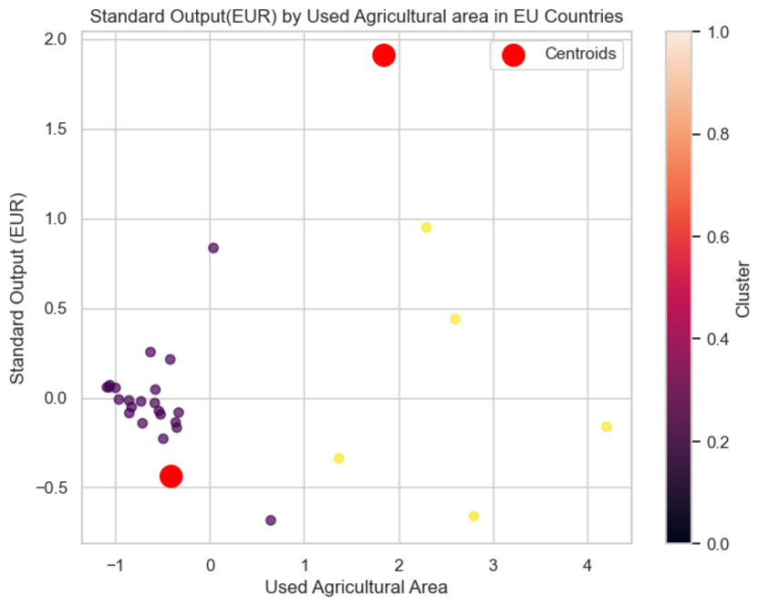
Figure 50. Clustering result performed by k-means.

Step 7: elbow method
The Elbow Method indicated that the optimal number of clusters is 2, as shown by the plot.
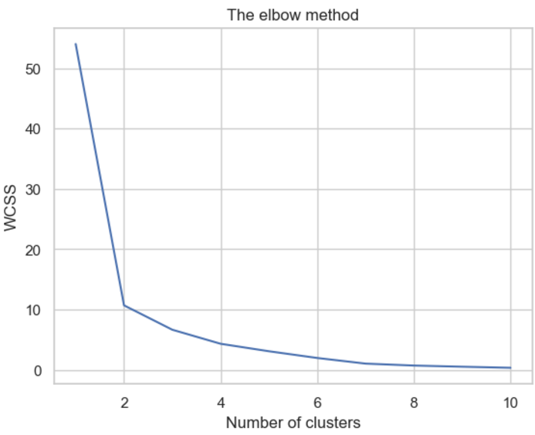
Figure 51. elbow method plot.
Conclusion:
The K-Means clustering model successfully grouped farms based on their used agricultural area and standard output, with a reasonable silhouette score average of 0.6716, indicating well-defined clusters. The application of PCA and standardization helped in reducing dimensionality and normalizing the data for more efficient clustering. The final visualization effectively illustrates these clusters, aiding in the understanding of farm categorization within the European Union.
For a detailed explanation of the process and code used please refer to ‘Machine Learning/Unsupervised Learning’ in the accompanying Jupyter Notebook.

Comparison of Machine Learning Models

Model | Metric Used | Value
K-Nearest Neighbors | Average Cross-Validation R² Score: | 71%
K-Means Clustering | Silhouette Scores (Cross-Validation): | 67%
Table 4. comparison of machine learning methods.
Conclusion:
Both models performed successfully with reasonable scoring metrics, demonstrating the effectiveness of preprocessing and parameter optimization in improving model performance.

Programing

Data From Diverse Sources:
Three datasets were obtained from different sources, a big number of libraries were imported and utilized in order to analyze the agriculture in Ireland. Continuously, I will disclose the most relevant for the project.
The library to manipulate the data was pandas. Pandas is a Python library used for working with data sets. It has functions for analyzing, cleaning, exploring, and manipulating data. The name "Pandas" has a reference to both "Panel Data", and "Python Data Analysis" (McKinney, 2008).
Seaborn was used as a generation of graphs. Seaborn is a Python data visualization library based on matplotlib. It provides a high-level interface for drawing attractive and informative statistical graphics (Waskom, 2021).
To work with arrays, NumPy was the library utilized. NumPy is a Python library used for working with arrays. It also has functions for working in domain of linear algebra, Fourier transform, and matrices (Harris, et al., 2020).
For visualization of the data the library used was Matplotlib. Matplotlib is a comprehensive library for creating static, animated, and interactive visualizations in Python. Matplotlib makes easy things easy and hard things possible (Hunter, 2007).
These three libraries were essential to explore the data, allowing to read, erase, handling large datasets and plot graphs.
Data manipulation
The groupby method from the pandas library was employed as the primary aggregation technique. This method allowed for the grouping and summarization of specific columns in the dataset, providing a structured way to derive meaningful insights. Additionally, it was utilized as a filter to create new datasets with targeted information.
Optimization
The third dataset, which contained trade information for the entire world, was classified as big data due to its size and complexity. The initial attempts to manipulate this dataset consumed significant RAM and CPU resources, resulting in slower processing times and potential system performance issues.
To address these challenges, an optimization strategy was implemented to improve data manipulation efficiency and reduce resource usage.

References
Allen, D., 1974. The Relationship between Variable Selection and Data Agumentation and a Method for Prediction. Technometrics.
Anon., 2018. GreeksforGreeks. [Online]
Available at: https://www.geeksforgeeks.org/ml-linear-regression/
[Accessed 15 12 2024].
Blei, D., Ng, A. & Jordan, M. I., 2003. Latent Dirichlet Allocation. Journal of Machine Learning Research.
Breiman, L., 2001. Random Forests. [Online]
Available at: https://doi.org/10.1023/A:1010933404324
[Accessed 12 2024].
Ch. Sanjeev Kumar Dash, A. K. B. S. D. A. G., 2023. An outliers detection and elimination framework in classification task of data mining. Decision Analytics Journal, Volume 6.
Documentation, P. D. A. L., n.d. Python Data Analysis Library Documentation. [Online]
Available at: https://pandas.pydata.org/pandas-docs/stable/reference/index.html
[Accessed 15 12 2024].
E L Lehmann, J. P. R., 2005. Testing statistical hypotheses. 3 ed. New York: s.n.
Fisher, R. A., 1925. Statistical methods for research workers. Edinburgh: Oliver and Boyd.
Ganesan, K., 2022. The Business Case for AI. s.l.:Opinosis Analytics.
Grubbs, F. E., 1969. Procedures for detecting outlying observations in samples. s.l.:Technometrics.
Harrell, F., 2015. Regression Modeling Strategies. 2 ed. New York: s.n.
Harris, C., Millman, K. & Walt, S. J. v. d., 2020. Array programming with NumPy. Nature.
Ho, T. K., 1995. Random Decision Forest. 2016 ed. s.l.:s.n.
Hunter, J. D., 2007. Matplotlib: A 2D Graphics Environment", Computing in Science & Engineering. s.l.:s.n.
Hutto, C. J. & Gilbert, E. E., 2014. VADER: A Parsimonious Rule-based Model for Sentiment Analysis of Social Media Text. s.l., Eighth International Conference on Weblogs and Social Media (ICWSM-14).
Jenkins, G. & Box, G., 1970. Time Series Analysis: Forecasting and Control. San Francisco: s.n.
Kaufmann, M., 1999. Data preparation for data mining. s.l.:s.n.
Lloyd, S., 1957. Least squares quantization in PCM, s.l.: Bell Lab.
Max Kuhn, K. J., 2013. Applied Predicitve Modelin. 2013 ed. s.l.:‎ Springer.
McKinney, W., 2008. pandas.pydata.org. [Online]
Available at: https://pandas.pydata.org/docs/reference/index.html
[Accessed 12 2024].
Mellor, T., 2010. github. [Online]
Available at: https://github.com/praw-dev/praw/commit/efef08a4a713fcfd7dfddf992097cf89426586ae
[Accessed 12 2024].
Monshizadeh, M., Khatri, V., Kantola, R. & Yan, Z., 2022. A deep density based and self-determining clustering approach to label unknown traffic. Journal of Network and Computer Applications, Issue 1084-8045, p. 207.
Moore, D. S. N. W. I. &. F. M. A., 2013. The basic practice of statistics. New York: Freeman and Company.
Oesper, L., 2011. WordCloud: a Cytoscape plugin to create a visual semantic summary of networks. Source code for biology and medicine.
Robert Nisbet, G. M., 2009. Handbook of Statistical Analysis and Data Mining Applications. s.l.:s.n.
Ross, S. M., 2009. Introduction to Probability and Statistics for Engineers and Scientists. 4 ed. s.l.:s.n.
Salkind, N. J., 2016. Statistics for People who (think they) hate statistics. 6th ed. s.l.:s.n.
The scikit-learn developers, 2024. github. [Online]
Available at: https://github.com/scikit-learn/scikit-learn/blob/6e9039160/sklearn/preprocessing/_data.py#L696
[Accessed 12 2024].
Thorndike, R. L., 1953. Who Belongs in the Family?. Psychometrika.
Trevor Hastie, R. T. J. F., 2008. The Elements of Statistical Learning. 2 ed. s.l.:s.n.
Tufte, E., 1983. The Visual Display of Quantitative Information. s.l.:s.n.
Tukey, J., 1961. The future of Data Analysis. In: s.l.:s.n.
Tukey, J. W., 1977. Exploratory Data Analysis. s.l.: Addison-Wesley.
Urdan, T., 2017. Measures of central tendecy. New York: s.n.
W Mendenhall, R. J. B., 2013. Describing data with numerical measures. Boston: s.n.
Wang H., B. M. H. M., 2019. Progress in outlier detection techniques: A survey. 7(Article 107964-108000).
Waskom, M., 2021. seaborn: statistical data visualization.. Journal of Open Source Software.

