Confidence Intervals for Run Composition of Returning Salmonids

Kirk Steinhorst, Tim Copeland, Mike Ackerman, Bill Schrader, and Eric Anderson

-------------------------------

\footnote{Kirk Steinhorst is Professor Emeritus, Department of Statistical Science, University of Idaho, Moscow, ID 83844-1104 (E-mail: mailto:kirk@uidaho.edu). Tim Copeland is Senior Fishery Research Biologist, Idaho Fish and Game, Nampa, ID 83686. Mike Ackerman is Fishery Research Biologist, Pacific States Marine Fisheries Commission \& Idaho Department of Fish and Game, Eagle Fish Genetics Lab, Eagle, ID 83616. Bill Schrader is Principal Fishery Research Biologist, Idaho Fish and Game, Nampa, ID 83686. Eric Anderson is Research Molecular Geneticist, Fisheries Ecology Division, Southwest Fisheries Science Center, Santa Cruz, CA 95060}

ABSTRACT

We propose weighted estimators of fish composition for wild steelhead and Chinook salmon returning to a single point in a river system. Using data on overall fish numbers derived from counts at an observation window, trap data providing separation of wild and hatchery fish, and data on sex, age, and genetic stock of wild fish, we propose one-at-a-time and simultaneous confidence intervals for numbers by sex or age or stock based on parametric bootstraps of both the wild/hatchery data and the sex/age/stock data. Using two simulations, we show that the estimators are generally unbiased with confidence intervals that have good coverage. We define precision for large, intermediate, and small groups. Within these categories, we know the true numbers within 10%, 25%, and 50%.

Keywords: Bootstrap, Stratified Sampling, Salmonid Escapement, Simultaneous Inference

Introduction

Migratory life histories are important in fisheries management and conservation (Hilborn1992,McDowall1999). Given migratory characteristics, the spatial distribution of a stock or population is predictable, which facilitates exploitation and also sampling for research and management. Sampling may be conducted by test fisheries (e.g., Flynn2004, Beacham2012), hydroacoustics (e.g., Tarbox1996, Pritt2013), or by other means. A highly controlled sampling regime can be instituted by counting or sampling fish as they move past barriers such as weirs or dams (e.g., Wagner2007). In all of these sampling scenarios it is typical to subdivide overall abundance into groups of management interest by applying compositional data (e.g., species, stock, age, and sex) derived either from the primary sampling gear or by a secondary sampling gear (e.g., using gill net samples to allocate hydroacoustic counts to species, Rudstam2012). The complexities of fisheries sampling programs and the relevant groups into which the fish are parsed present difficulties for estimating precision about the point estimates generated.

There are two approaches to determining run composition ( Starr1988): 1) Direct identification of fish from tags, scales, genetic analysis, and/or morphology and 2) Reconstruction of the run from catch data, adult escapement numbers (numbers of fish returning from the ocean to a given point), and migration paths (Prevost2005, Flynn2006, Buckland2007, Chasco2007, Newman2009, Branch2010). Run reconstruction uses maximum likelihood estimation of a product of probability density functions describing arrivals, escapement, harvest, and ages or it uses state-space models and Bayesian estimation via MCMC or related techniques. Run reconstruction methods have been widely applied for mixed stock fisheries in coastal fisheries although they have been applied to riverine settings as well (Eggers2011,Pritt2013). Bayesian intervals provide information on precision of estimates.

There is no statistical literature on properties of estimators and confidence intervals for composition determined from direct identification. This paper provides a statistical evaluation of estimators derived via direct identification methods. We observe adult steelhead and Chinook salmon as they migrate past Lower Granite Dam (LGD) on the Snake River 695 kilometers from the ocean. Adults returning from the Pacific Ocean to spawn in tributaries of the Snake River must ascend fish ladders at eight dams during their migration including four on the Columbia River and four on the Snake River. LGD is the final dam they encounter on the Snake River; fish migrating past LGD then disperse to tributaries throughout the Snake River basin to spawn. An observation window on the LGD fish ladder allows us to count fish by species as they migrate upstream. A trapping facility located above the observation window allows us to intercept fish as they migrate past and collect data and obtain biological samples. The counting and sampling of returning adult steelhead and Chinook salmon at the dam provides direct data for calculating composition.

Raymond88 documented a decrease in survival of juvenile Snake River steelhead trout *Oncorhynchus mykiss* (hereafter steelhead)and spring-summer Chinook salmon *O. tshawytscha* (hereafter Chinook salmon) populations in the Snake River basin of Idaho, NE Oregon, and SE Washington following the construction of hydroelectric dams in the Snake and Columbia rivers during the late 1960s and early 1970s. Snake River spring-summer Chinook salmon were classified as threatened in 1992 under the Endangered Species Act (ESA). Survival improved and adult abundance rebounded slightly in the early 1980s, but then escapements over Lower Granite Dam into the Snake River basin declined again (Busby1996). Steelhead were listed as threatened under the ESA in 1997. In recent years, abundances in the Snake River basin have increased slightly. However, the increase has been dominated by fish produced in hatcheries (intended to mitigate for lost fisheries and to supplement natural populations), while the returns of steelhead and Chinook salmon born in the natural environment remain critically low (Busby1996).

Fisheries biologists need to know how many wild versus hatchery steelhead and salmon return in order to properly manage fisheries as well as to assess the conservation status of wild populations. In our study, we are particularly interested in the number of wild fish returning for status and trends monitoring of ESA-listed steelhead and salmon. Further, for wild fish, we want to know numbers of fish returning by sex, age, and genetic stock.

McElhany2000 in a document published by the National Oceanic and Atmospheric Administration (NOAA), provides guidance for status and trends monitoring of ESA-listed Pacific salmon populations based on Viable Salmonid Population (VSP) indicators. The VSP indicators include adult spawner abundance, productivity, spatial distribution, and diversity. McElhany2000 highlights the need for reliable population information to provide merit to regulatory and conservation decisions based on that information. As a result, NOAA suggests unbiased estimates with a coefficient of variation (CV) of 15% or less (Crawford2011). Thus for a 90% asymptotic confidence interval, we have  or  NOAA requires us to know the truth within 25% of the estimate. Researchers often set a goal of estimating the truth within 10%. For small groups, both of these sampling criteria may be too stringent. If there are only a few fish in a category, one would probably be happy with a more lenient rule. For example, if our estimate is 50 and the confidence interval is (20, 80) then the percent half width is 60% of the estimate. Knowing that the true number is between 20 and 80 might be sufficient especially if the numbers of fish in other groups are decidedly larger.

We examine the properties of estimators of composition and their confidence intervals derived from weightings of window counts, wild/hatchery data obtained from the trap samples, and sex/age/genetic stock data collected on wild fish subsampled at the trap. We consider counts at the observational window to be a census of fish passing the dam. Thus the total number of fish returning to LGD is known. One-at-a-time and simultaneous confidence intervals for subgroups are derived via a combination of bootstrap sampling of both the wild/hatchery trap data set and the sex/age/genetic stock data set produced by sampling wild fish. We are particularly interested in knowing if the estimators are unbiased and what precision can be expected as measured by half the confidence interval as a percentage of the estimate.

In section 2, we describe the setting and the data collection and processing methods. In section 3, we present the estimators and methods for obtaining the bootstrap confidence intervals. In section 4, we give the results for 2011 steelhead and salmon runs. Section 5 contains the results of simulations examining the properties of the estimators and confidence intervals.

Data Collection

This paper summarizes the abundance and composition of wild adult steelhead and spring/summer Chinook salmon migrating past LGD during spawn year (SY) 2011. For steelhead, the SY2011 run is operationally defined as adults migrating past LGD between 07/01/10 and 06/30/11. Most steelhead migrate past LGD during the fall although a small proportion migrate the following spring; all steelhead spawn during the spring. For spring/summer Chinook salmon, the SY2011 is operationally defined as adults migrating past LGD during the 2011 calendar year prior to 08/17/11. Spring/summer Chinook begin arriving at the dam in April. Chinook migrating past LGD after 08/17/11 are considered fall Chinook, a separate lineage of Chinook salmon occurring within the Columbia River basin.

Adult steelhead and Chinook salmon returning from the ocean to the Snake River basin must pass LGD during their spawning migration; adults enter a fish ladder bypass system to ascend past the dam. An observation window, located on the fish ladder, allows United States Army Corps of Engineers (COE) personnel to tally and record the number of fish for each species that ascend the fish ladder daily. Snake River fisheries management agencies may assume the daily fish counts are recorded without error and represent the total escapement to LGD. Live window counts are conducted throughout a majority of the year and occur from 0400 to 2000 Pacific Time. Video counts are used in lieu of window counts in November, December, and March and occur from 0600-1600. Most fish pass the window during the 10 to 16 daylight hours when counts are made (Cassinelli2012). The ladder is closed in January and February. Count data were downloaded from the COE website: http://www.nwp.usace.army.mil/Missions/Environment/Fish/Data.aspx. The steelhead count consists of all fish > 12'' identified as *O. mykiss*. For Chinook salmon, adults (≥56 cm) and jacks (males that return after only one year of saltwater residency, 30-–56 cm) are counted separately; we combined the adult and jack counts to get total counts on a daily basis. Daily counts were aggregated on a weekly basis. Early and late in the season weeks were collapsed into longer strata if few fish were passing.

The fish ladder bypass system also contains a trapping facility, located above the observation window, designed to intercept adult steelhead and salmon at a predetermined sampling rate (Harmon 2003; Ogden 2010, 2011; Schrader et al. 2012, 2013). Trap sampling rates are determined by a committee of co-managers in an attempt to achieve sample requirements for multiple projects and to balance fish handling concerns; sample rates are typically 10-–20%. The sample rate determines how long a trap gate remains open four times per hour; the trap is operational 24 hours per day. Additional details on the adult trap can be found in Harmon2003 and Steinhorst2010.

Trapped fish are anesthetized and examined to determine whether they are of hatchery or wild origin. All wild fish have an intact adipose fin (a small, fleshy fin on the back posterior of the dorsal fin and anterior of the caudal fin) because they spend their entire life-cycle in the natural environment. Most hatchery origin fish have a clipped adipose fin so they can be identified for mark selective fisheries (i.e. recreational anglers may only keep fish with a clipped adipose fin). However, some hatchery fish may be released with an intact adipose fin to supplement natural populations or to bolster tribal harvest opportunities. Thus, fish with an intact adipose fin are further examined for a coded wire tag (CWT) or a passive integrated transponder (PIT) tag that were implanted into fish at the hatchery as juveniles. For adipose intact steelhead, hatchery origin may also be determined by the presence of dorsal and/or ventral fin erosion, which is assumed to occur only in hatchery-reared steelhead (Latremouille2003). We also used the presence of a ventral fin clip to determine if an unclipped fish was of hatchery origin. For unclipped Chinook salmon, hatchery origin was determined solely by the presence of a CWT or ventral fin clip.

Scale and tissue samples are taken from a subsample of trapped fish determined to be wild. Scale samples are used to determine age based on visual examination of scale annuli (Schrader2013). Scale samples were taken from above the lateral line and posterior to the dorsal fin. Samples were stored in coin envelopes for transport to the IDFG aging laboratory in Nampa, Idaho. Scales were mounted between two glass microscope slides and two technicians independently viewed each scale to assign ages without reference to fish length. If there was no age consensus among readers, a third reader viewed the image and all readers collectively examined the image to resolve their differences before a final age was assigned. If a consensus age was not attained, the sample was excluded from further age-specific analyses. Readers estimate both freshwater-age (time spent in freshwater prior to entering the ocean as juveniles) and saltwater-age (time spent in the ocean prior to upriver spawning migration as adults) for each fish. Ocean-age determination for steelhead is 98.8% accurate and for Chinook salmon is 98.1% accurate based on comparisons with known-age individuals. Currently, freshwater-age determination accuracy cannot be validated, but precision estimates based on the coefficient of variation between experienced readers were 11.9% for steelhead and 3.3% for Chinook (Schrader2013). Age data collected at LGD are used to assign returning adults back to specific brood years.

Tissue samples for DNA extraction and single nucleotide polymorphism (SNP) genotyping were taken from a small clip of the anal fin. Tissues were stored in a vial with 200-proof nondenatured ethyl alcohol for transport to the IDFG genetics laboratory in Eagle, Idaho. Tissue samples are used to determine sex and estimate genetic stock of origin. Sex determination is not based on phenotypic characteristics observed at the LGD adult trap; rather sex is determined post hoc using a sex-specific allelic discrimination assay (Campbell2012) that is screened during genetic analysis (described below). The sex-determination assay for steelhead is 99.3% accurate and for Chinook salmon is 99.0% accurate based on comparisons with known-sex individuals (C. Steele and J. McCane, Pacific States Marine Fisheries Commission, pers. comm.).

The genetic stock of each fish is estimated using IA, a type of genetic stock identification (GSI; Pella1987, Shaklee1999), using multi-locus SNP genotype data. IA allocates each fish to the population and genetic stock in which the probability of its genotype occurring is the greatest. Two sets of data are required for IA: 1) allele frequency estimates from multi-locus genotypes obtained from samples taken from all potentially contributing stocks (the baseline), and 2) corresponding multi-locus genotype data from unknown origin individuals whose stock is to be estimated (Koljonen2005). Ackerman2014 present the Snake River SNP baselines for both steelhead and Chinook salmon used for this study; unknown stock fish trapped at LGD were genotyped using the same SNP loci presented in that study. Each individual's population was estimated and then summed into genetic stock estimates (allocate-sum procedure; Wood1987). Genetic stocks (reporting groups) are assemblages of reference (baseline) populations grouped primarily by genetic and geographic similarities and secondarily by political boundaries and/or management units (Ackerman2011). IA was performed using the Bayesian version of the program gsi_sim (Anderson2008,Anderson2010). The Bayesian gsi_sim uses Markov chain Monte Carlo (MCMC) to compute posterior probabilities of stock membership conditional on the allele frequencies estimated from the baseline. The likelihood that a fish originates from a stock is computed using the compound Dirichlet-multinomial formulation of Rannala1997 conditional on the baseline samples and these likelihoods remain fixed throughout the MCMC simulation. To perform the MCMC, gsi_sim uses a Gibbs sampler (Casella1992) in which alternately: 1) the stock assignments of the fish in the mixture are updated as a multinomial draw from their posterior probabilities given the current estimate of the stock proportions and the stock-likelihoods of the fish; and 2) the stock proportions are updated as a draw from a Dirichlet distribution given a unit-information prior and the current values of the stock assignments of all the fish in the mixture.

Ackerman2014 defined the genetic stocks used for IA at LGD. Ten genetic stocks were defined for steelhead. Genetic stocks include: 1) UPSALM: the upper Salmon River; 2) MFSALM: Middle Fork Salmon River (including Chamberlain and Bargamin creeks); 3) SFSALM: South Fork Salmon River; 4) LOSALM: lower Salmon River; 5) UPCLWR: upper Clearwater River (Lochsa and Selway rivers); 6) SFCLWR: South Fork Clearwater River (including Clear Creek); 7) LOCLWR: lower Clearwater River; 8) IMNAHA: Imnaha River; 9) GRROND: Grande Ronde River; and 10) LSNAKE: Tucannon River, Asotin Creek and tributaries to the Snake River downstream of the Clearwater River confluence.

Seven genetic stocks were defined for Chinook salmon. Genetic stocks include: 1) UPSALM: upper Salmon River; 2) MFSALM: Middle Fork Salmon River; 3) CHMBLN: Chamberlain Creek; 4) SFSALM: South Fork Salmon River; 5) HELLSC: an aggregate stock that includes the Little Salmon, Clearwater, Grande Ronde, and Imnaha rivers and small tributaries of the Lower Snake River; 6) TUCANO: Tucannon River, and 7) FALL: Snake River fall Chinook salmon. The FALL genetic stock represents a separate lineage of Chinook salmon in the Snake River basin and is managed as a separate species under the ESA. Fall Chinook are genetically highly differentiated from spring/summer Chinook salmon and can be identified using IA with 100% accuracy (Ackerman2014). Genomic DNA extraction and amplification and SNP genotyping using multiplex 5’-nuclease reactions follow methods described in Seeb2009. DNA was extracted using nexttecTM Genomic DNA Isolation Kits from XpressBio (Thurmont, Maryland) or QIAGEN DNeasy Tissue Kits (Valencia, California). Ackerman2014 fully describes DNA amplification and SNP genotyping protocols; SNP genotyping was performed using the Fluidigm EP1TM platform. All adults queued for genotyping were screened at 191 SNPs and the sex-specific allelic discrimination assay Campbell2012. Samples were processed at either the IDFG genetics laboratory in Eagle, Idaho, or the Columbia River Inter-Tribal Fish Commission genetics laboratory in Hagerman, Idaho.

The above sampling design produces three datasets: 1) a census of fish numbers returning to and migrating past the dam (window counts), 2) a hatchery versus wild dataset for all trapped fish, and 3) a dataset containing sex, age, and stock for a subsample of wild fish that were trapped. These three data sets are used to produce the size of the run and estimates and confidence intervals for number of fish by sex or age or genetic stock.

Estimates and Confidence Intervals

The proportions of wild and hatchery steelhead or salmon changes over the season, but within a week are relatively constant. Given weekly counts,  , the number of wild steelhead or salmon is estimated as



where  are estimates of proportion wild by week from the trap data. Since the window counts are assumed to be fixed, we find a confidence interval for the number of wild fish using a parametric bootstrap to produce B bootstrap sets of  yielding . That is, for week h we assume the bootstrap number of wild fish has a binomial distribution,  where  is the number of fish trapped for that week and . The  and  percentiles of  give us the  confidence interval for the true number of wild steelhead or Chinook passing LGD for the year.

Define . Then we have  as the conditional probabilities for wild females and males for weeks . Similarly for A ages, we have conditional probabilities . For g stocks, we have conditional probabilities . Given estimates of these probabilities from wild fish examined in the trap, we obtain



and



and



That is, the number of wild females or males is a weighted sum of the weekly window counts where the weights are estimates of the probability of being wild and female (or male). Likewise for ages  or origins , the estimate is a weighted sum of the weekly counts with weights that are an estimate of the probability of being wild of that age or genetic stock.

To find confidence intervals for these estimates we have to account for the variability of both the trap data and the wild fish sample data. We do this by extending the parametric bootstrap process used above for obtaining the confidence interval for number wild by adding a conditional parametric bootstrap based on the sex/age/stock of wild fish in the trap.

For sex, define pseudoreplicates using



where  is the number of wild fish sexed. Bootstrap values for the number of wild females,  follow from . The percentile bootstrap confidence interval for true number of wild females,  , is given by finding the  percentiles. Similarly, we find a bootstrap confidence interval for the number of wild males. Changing the binomial above to a multinomial, we generate B sets of  to obtain bootstrap confidence intervals for the true number of wild fish of ages 1,..., A. We follow the same procedure for genetic stocks 1,..., g.

Simultaneous confidence intervals for numbers of wild fish by sex or age or genetic origin are found using the methods of Mandel2008.

Results for spawn year 2011

We consider two empirical examples to illustrate the methods outlined in section 3 –-- steelhead and Chinook salmon returning to spawn in 2011. This provides two differing examples. A total of 208,296 steelhead returned during SY2011. Of these, we estimate that 44,452 were wild (21.3%, Table 1). Based on B = 5,000 bootstrap iterations, the 90% confidence interval is (43454,45473). We found 90% one-at-a-time and simultaneous confidence intervals on the numbers of each sex, on numbers by age (brood year), and numbers by genetic stock. The simultaneous confidence intervals were found separately for sex, age, and stock. In addition to female and male, there are five ages, and ten genetic stocks for steelhead. The simultaneous confidence intervals are proportionally wider for age and stock than for sex. Columns P1 and Psim give half the width of the confidence interval as a percentage of the estimate. If the estimate is near the center of the confidence interval then we are 90% confident that we know the truth within this percentage of the estimate. Confidence intervals for total wild, sex, BY05, BY06, BY07, GRROND, LSNAKE, and UPSALM meet our 10% goal for confidence interval width. BY04 and BY08 have percent half widths of 26.4% and 33.1% respectively. The other genetic stocks are reasonably well estimated; the percent half widths fall in the range 10.4 to 15.2%.

The percent half widths for the simultaneous confidence intervals for sex are under 10%. The percent half widths for BY04 and BY08 32.3% and 39.1% respectively. The remaining percent half widths are 21.9% or less.

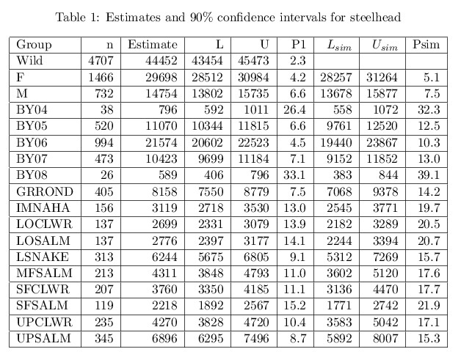

A total of 134,594 Chinook were counted at the observation window at the dam. Of those, 26,673 were estimated to be wild (19.8%, Table 2). We obtained a 90% confidence interval of (25937, 27400). In addition to female and male, there are five ages, and seven genetic stocks. Note that one of the genetic stocks identified is FALL Chinook (4.2%) which are managed as a different species under the ESA. If more than 1,129 spring/summer Chinook arrived after August 17th, then our window count is an underestimate of spring/summer Chinook salmon escapement. For total wild, the truth should be within 2.7% of the estimate. Confidence intervals for total wild, sex, BY06, BY07, BY08, and 4 of 7 genetic stocks (UPSALM, MFSALM, SFSALM, HELLSC) meet our 10% goal for confidence interval width. CHMBLN and FALL stocks had percent half widths less than 25%. When the groups are quite small like BY05, BY09, and the TUCANO stock, then the truth might be as much as 35-50% away from the estimate. Note that the TUCANO stock (Tucannon River) is actually located below LGD; the TUCANO estimate represents fish that strayed above LGD or ascended LGD and fell back to the Tucannon River later.

If you compare the P1 and Psim columns, you see that the widths of the simultaneous confidence intervals for female and male are not markedly wider than the one-at-a-time intervals. For age and genetic stock the simultaneous confidence intervals can be double the width of the one-at-a-time confidence intervals.

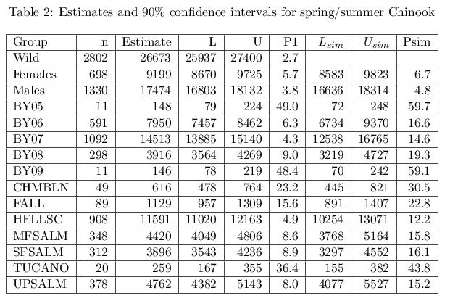

For steelhead, there were twice as many females as males. For Chinook salmon, the reverse was true. These sex ratios vary annually, but the ratios seen for both species in 2011 are typical. For both steelhead and Chinook the middle age groups had more fish returning than the younger and older age groups. Steelhead genetic stocks are fairly evenly represented, although the GRROND stock has almost four times the number as the SFSALM stock (Table 1). For Chinook, the HELLSC stock (Little Salmon, Clearwater, Grande Ronde, and Imnaha rivers and small tributaries of the Lower Snake River) was more abundant than any other stock. For stocks within the Salmon River, CHMBLN produced 616 spring/summer Chinook summer and the remaining 3 (UPSALM, MFSALM, SFSALM) all produced between 3,800 and 4,800 (Table 2).

Simulations

We used a parametric bootstrap for finding confidence intervals because the variables in both the trap dataset and the wild dataset follow binomial or multinomial distributions. Using the observed weekly proportions, we generated bootstrap proportions for both hatchery/wild and categories of wild (sex, age, stock). We then combined these bootstrap proportions with the window counts to produce pseudovalues and then percentile confidence intervals. While our estimators and confidence intervals (Section 3) are intuitive, we do not know their statistical properties.

We set up two simulations; one similar to the steelhead and one similar to the Chinook salmon empirical scenarios presented above. We established parameter values for all binomial and multinomial distributions that are similar to weekly estimates obtained from the SY2011 datasets (Tables 3, 4, 6, 7). We also set trap sample rates (PTrp) and wild subsampling rates (PWhandled) similar to those used in practice at LGD. We simulated 500 data sets as follows. Simulate the number of fish trapped each week  by generating binomial samples for each time stratum (weeks) with the number of binomial trials equal to population size SimPop and probabilities PTrp. Simulate the number of trapped fish that are wild for each stratum by generating binomial samples with the number of trials equal to the simulated number of trapped fish and with probabilities equal to PWild. The remaining trapped fish are hatchery. From these numbers, we can generate a simulated data set for trapped fish with 2 columns: time stratum and wild/hatchery. The length of this data set is the sum of the numbers of wild fish trapped across the time strata, .

We now calculate the random number of wild fish sexed, aged, and genotyped for stock for each week by multiplying the simulated number of wild fish trapped by PWhandled. These numbers by stratum are the number of binomial or multinomial trials for sex or age or genetic stock, . For example, we can find the random number of wild/handled fish that are female by generating binomial trials of size  with probabilities Pfemale. The remainder each week is male. Knowing the random number of wild females and males each week, we can put together a simulated data set for sexed fish by forming a data set with columns equal to stratum and female/male. The length of this data set is equal to the sum across time strata of the numbers of handled fish,  . Similar data sets are simulated for age and stock.

For steelhead, the trapping rate, PTrp, ranges from 3 to 14% (Table 3); for Chinook salmon PTrp ranges from 7 to 11% (Table 6). The trapping data set will have about 20,000 lines for steelhead (10% of 200,000) and about 13,500 lines for Chinook salmon (10% of 135,000). Depending on the week (time stratum) 20 to 50% of steelhead and 10 to 55% of Chinook will be wild (Pwild). Approximately 50% of wild steelhead and 75% of wild Chinook salmon will be handled (PWhandled) so the sex or age or genetic stock data set will be approximately 2,500 lines long for both species.

Now we have two random data sets: 1) a randomly generated trap data set with a random number of wild and hatchery fish, and 2) a randomly generated wild fish data set with randomly generated numbers of female/male or fish of various ages or fish of various genetic stocks. We use the window counts (SIMPOP) and the trap and wild data sets to obtain estimates and bootstrap confidence intervals for each iteration. We save the estimates and confidence intervals for subsequent analysis. We used B = 500 bootstrap iterations for finding the confidence intervals. After 500 simulation iterations, we have 500 estimates of total wild, female/male wild, wild by age, and wild by genetic stock. We also have 500 one-at-a-time and simultaneous confidence intervals for each estimate. Since we know the true number of wild fish and numbers of females/males and fish of different ages and different stocks, we compute the bias as the mean of the estimates minus the truth. We also compute variances of the estimates and standard errors.

We compute the coverage of any one-at-a-time confidence interval by tallying the number of times the true population number falls inside the confidence interval. We get the simultaneous coverage by tallying the number of times the all true population numbers fall within the joint confidence hypercube. For example, for steelhead we know the true number of females is 28,972 and the true number of males is 14,784. The joint coverage is the proportion of times that the simultaneous female confidence interval contains 28,972 AND the simultaneous male confidence interval contains 18,375.

Steelhead

For the steelhead simulation, we set the total adult escapement to LGD as 200,000. For our known population, 43,756 (22%) of the total escapement was wild.

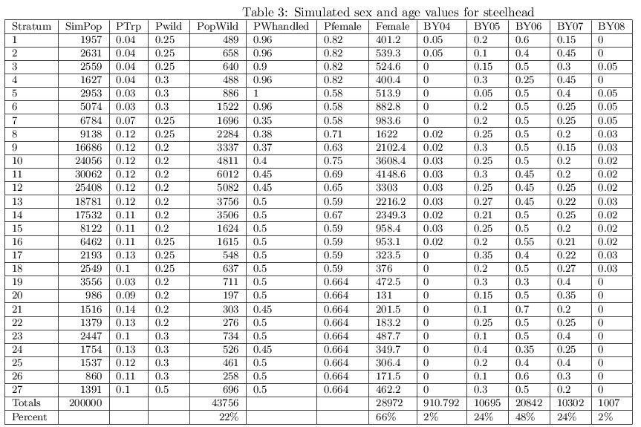

The numbers of female fish by stratum are found by multiplying the number wild (PopWild) column by the proportion of females (Pfemale) for that stratum. Summing the number of females across strata gives us the true number of females. Of the wild steelhead, 28,972 were female (66%). The remaining fish were males. The numbers of fish of each age (brood year) were found by multiplying the number wild (PopWild) column by the corresponding age column proportions (BY04…BY08). Summing those numbers by age over strata (weeks) gives the true numbers of fish of each age. True numbers by age were: BY04 = 911 (2%), BY05 = 10,695 (24%), BY06 = 20,842 (48%), BY07 = 10,302 (24%), BY08 = 1,007 (2%). Similarly, the numbers of wild fish of each genetic stock by stratum were found by multiplying the number of wild (PopWild) by the corresponding genetic stock proportion columns and summing over strata giving the true numbers of fish of each genetic stock. True numbers by genetic stock were: UPSALM = 6,624 (15.1%), MFSALM = 3,872 (8.8%), SFSALM = 2,324 (5.3%), LOSALM = 1,551 (3.5%), UPCLWR = 4,123 (9.4%), SFCLWR = 4,315 (9.9%), LOCLWR = 1,779 (4.1%), IMNAHA = 2,455 (5.6%), GRROND = 7,106 (16.2%), LSNAKE = 9,607 (22.0%).

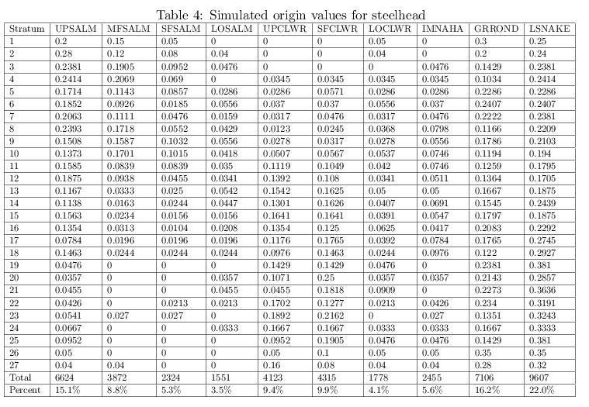

For the steelhead simulation, we find that all estimates are essentially unbiased (Table 5). The largest percent bias is for the Imnaha stock (2.6%). The coverage for the confidence interval for number wild is 0.87. The coverage of one-at-a-time confidence intervals for females and males were 89.4% and 88%, respectively. The joint coverage for females and males was 90.2%. The expected half widths as a percentage of the truth (P1) were 3.4% and 5.4% respectively. The expected widths for the joint confidence intervals for females and males were 1.3 and 1.2 times the expected widths for the one-at-a-time confidence intervals (WidthRatio). The one-at-a-time coverages for BY04, BY05, BY06, BY07, and BY08 were all very near the nominal 90%. The joint coverage for ages was 90%. The expected half widths as a percentage of the truth were less than 10% for BY05, BY06, and BY07, but were 24.5% and 23.8% for BY04 and BY08, respectively. The expected widths of the simultaneous confidence intervals for ages were 1.2 to 2.2 times the expected widths of the one-at-a-time confidence intervals.

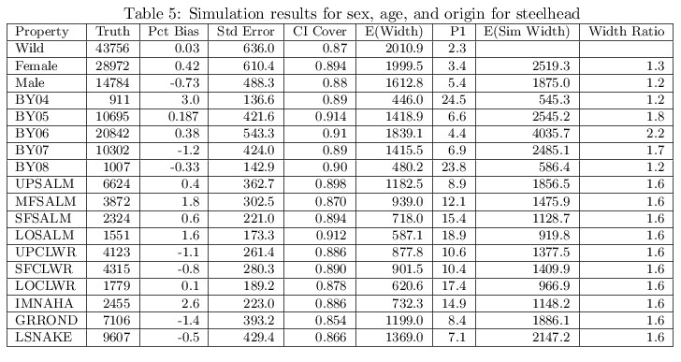

The one-at-a-time coverages for stock were close to 90% except for the GRROND stock (85.5%). The expected half widths as a percentage of the truth for the three most abundant genetic stocks (UPSALM, GRROND, LSNAKE) are less than 10%. The percent half-width for the least abundant stock, LOSALM, is 18.9%. The joint confidence interval widths are 1.6 times the one-at-a-time widths. We do a very good job of estimating numbers of females and males and a modestly good job of estimating numbers by age and stock.

Chinook salmon

For the Chinook salmon simulation, we set the total adult escapement at LGD as 135,000. 27243 (20.2%) are wild. Of the wild Chinook salmon, the true number of females was 8,867 (33%). True numbers by age were: BY05 = 184 (0.7%), BY06 = 8,271 (30.4%), BY07 = 14,660 (53.8%), BY08 = 3,975 (14.6%), BY09 = 153 (0.6%).

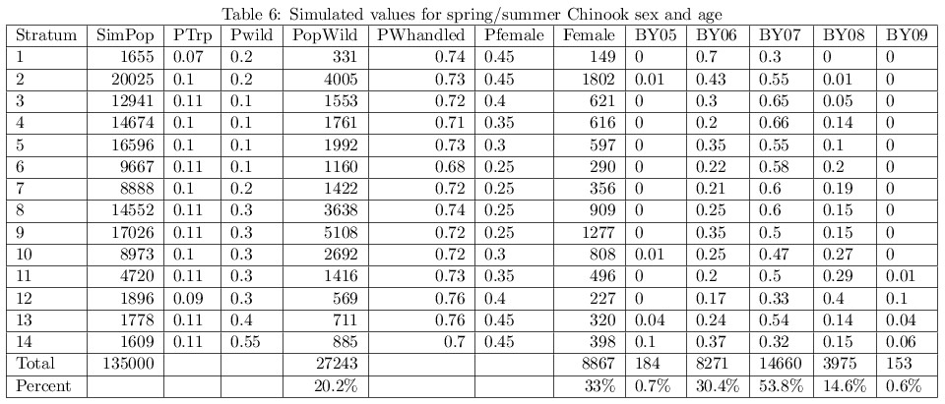

True numbers by genetic stock were: UPSALM = 4,833 (17.7%), MFSALM = 4,519 (16.6%), CHMBLN = 623 (2.3%), SFSALM = 3,944 (14.5%), HELLSC = 11,937 (43.8%), TUCANO = 272 (1.0%), FALL = 1,114 (4.1%).

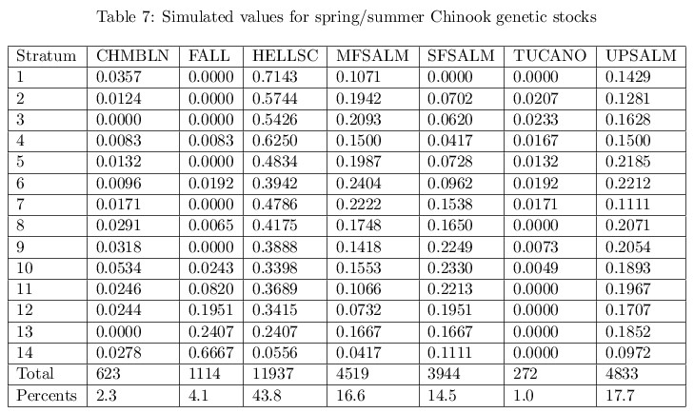

Results for Chinook salmon were similar to results for steelhead. For the Chinook salmon simulation, we find that all estimates except BY05 and BY09 are essentially unbiased (Table 8). The coverages of the one-at-a-time confidence intervals are very close to the nominal 90%. For females and males, our goal of estimating true numbers within 10% with 90% confidence was met (column P1). The expected half widths as a percentage of the truth were 5.8% and 3.6%, respectively. The coverage of the joint confidence intervals for numbers of females and males was 93%. For ages, the bias in estimating the least abundant ages BY05 and BY09 are 3.5% and -2.0% respectively. For the three most abundant ages (BY06, BY07, BY08) our goal of estimating true numbers within 10% with 90% confidence was met; the half widths as a percentage of the truth were 8.9% or smaller. The percent half width for BY05 was 44.0% and for BY09 was 45.7%. The coverage of the one-at-a-time confidence interval for BY09 was 85.6%. The joint coverage for the age simultaneous confidence intervals was slightly below nominal (87%). The simultaneous confidence intervals were 1.2 to 3.3 times the corresponding one-at-a-time confidence intervals.

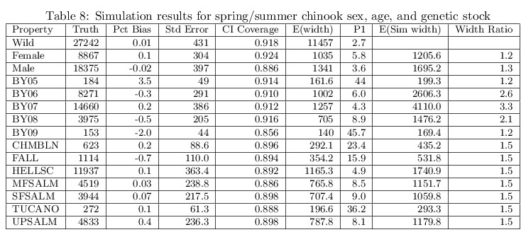

The one-at-a-time coverages for stocks were very close to 0.9. The coverage of the joint confidence interval was 0.872. The expected half-widths as a percentage of the truth for the four most abundant stocks (UPSALM, MFSALM, SFSALM, HELLSC) were less than 10%. The percent half-width for the least abundant stock, TUCANO, was 36.2%. The percent half width for CHMBLN and FALL were less than 25%.

DISCUSSION

The simulations show that our estimators are nearly unbiased (Tables 5, 8) . The largest biases are for the youngest and oldest age groups for Chinook (3.5% and -2.0% respectively). The simulations show that the one-at-a-time and simultaneous confidence intervals have coverages very near the nominal 0.9. Two steelhead stocks (GRROND and LSNAKE) had coverages of 0.854 and 0.866 respectively. The youngest Chinook group (BY09) had a coverage of 0.856.

Precision as measured by the percent half confidence width (P1) shows that for large groups we generally meet the research goal of knowing the truth within 10% with 90% confidence. For intermediate groups, we meet the NOAA goal of knowing the truth within 25% with 90% confidence. For steelhead, of 18 confidence intervals reported 9 met the research sampling criteria, 7 met the NOAA sampling criteria, and 2 groups of size 796 and 589 had precision estimates of 26.4% and 33.1% respectively (Table 1). The steelhead simulation shows similar results except ALL measures of precision are less than 25% (Table 5). For Chinook, of 15 confidence intervals reported 10 met the research sampling criteria, 2 met the NOAA sampling criteria, and 3 groups of size 148, 146, and 259 had precision estimates of 49%, 48.4%, and 36.4% respectively (Table 2). The Chinook simulation (Table 8) gave identical results (10, 2, and 3).

Steinhorst2010 in a study of Fall Chinook recommend that group sizes should be at least 300 to be confident in the estimates. In this study, if you define steelhead groups of size 589 and 796 and Chinook groups of size 146, 148, and 259 as ``small'', then adequate precision is obtained in all cases.

The Mandel/Betensky simultaneous confidence intervals for sex were not much wider than the one-at-a-time confidence intervals. For stocks they were about 1 1/2 times as wide. Given the number of stocks (10 and 7), we are not paying a large penalty for computing simultaneous intervals. For age, the simultaneous confidence intervals were sometimes 2 to 3 times wider than the one-at-a-time confidence intervals. Given that there were only 5 ages in each example, it is surprising that the simultaneous confidence intervals for age were relatively wider than for stocks.

When the numbers for a group are small, then we worry about the distribution of the pseudovalues being skewed. If so, the estimate may not be near the middle of the confidence interval. For the Chinook salmon data set, the estimate of number of fish from BY05 is 148. We captured 5,000 pseudovalues for this case and looked at the distribution (Figure 1). Even though this group is small, the distribution of pseudovalues is pretty symmetric. The midpoint of the confidence interval (68, 240) is 154. Given that our estimators are relatively unbiased and the confidence interval coverages are close to nominal, we are confident in our estimates and their corresponding confidence intervals.

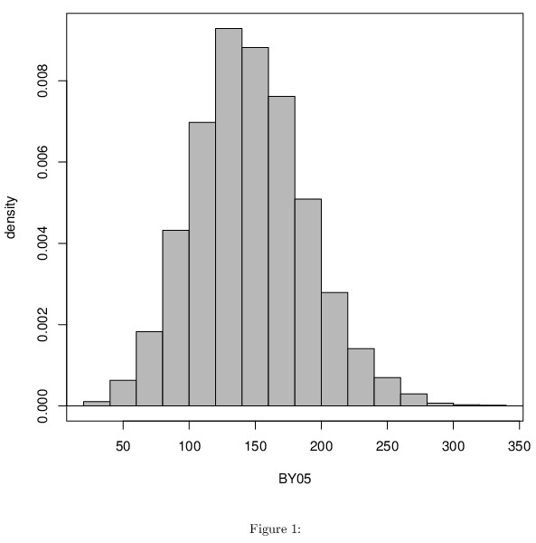

Our results have implications for how fish populations are monitored. If the interest is on the relative composition of the total (Tim, I am lost here), then most sampling programs will yield sufficient results. However, weak stocks are frequently a problem in conservation and fisheries management (CITE). We should make some positive statements about how to sample and to analyze monitoring data. Obviously there is a tradeoff between sample size and number of subdivisions that can be supported. Previous work (Gerritsen) shows this but the criteria for success is on overall (average) coverage. Thompson1987 found that a sample size of 510 should suffice under a worst case scenario for alpha=0.05 (even proportions among groups but number of groups doesn’t matter). Our results show something else. What can we recommend?

In our scenario, sample size is a function of 1) total fish escapement, 2) trap sample rate, and 3) handling rate. Total fish escapement is out of our hands, but sample size can effectively be increase by increasing the trap sample rate or the handling rate. For SY2011 steelhead, the trap rate averaged 10% and the handling rate was slightly over 50%. For Chinook salmon, the trap rate also averaged 10% and the handling rate was about 75%. We reran both the steelhead and Chinook salmon simulations increasing trap rates to 20% and the handling rate to 100%. This doubles the number of fish trapped in both cases. For steelhead, the number of fish for which sex, age, and stock was determined is 4 times the original simulation. For Chinook salmon, the number for which sex, age, and stock was determined is 2 2/3 times the original simulation. In practice, it is possible that this level of sampling would swamp the trapping crew (which can generally handle up to 800 fish a day due to logistical constraints), but we wanted to examine the effects of increasing sample sizes to this level. For both species, the percent half widths relative to the true population sizes were reduced in proportion to the reciprocal of the square root of the increase in sample size:  for steelhead and  for Chinook salmon. That is, the reduction in confidence interval width is a simple function of the increase in sample size.

Estimates of abundance by sex and by age within a stock of fish allow biologists to generate brood tables for given stocks. Brood tables summarize the number of offspring that return as adults (or recruit to the population) in subsequent years for a given spawn or brood year (recruits per female or recruits per spawner) and provide a metric of productivity. Time-series estimates of recruits per spawner allow us to fit stock-recruitment curves to the data. Stock-recruitment curves are an important tool in fisheries management and conservation (Ricker1973, Hilborn2003). Estimates of productivity also facilitate extinction risk analysis. Reasonable estimates of stock-sex and stock-age combinations for genetic stocks at LGR would allow us to generate brood tables for genetic stocks and facilitate stock-recruitment and productivity monitoring at a scale and coverage recently unavailable to managers. Further research is needed to determine whether or not we can reasonably estimate combinations of stock-sex or stock-age.

Although our case study is characterized by a high degree of sampling control (near census of fish numbers with systematic compositional samples), there are lessons for other fisheries applications. Certainly SY2011 had more control than other years at Lower Granite Dam (cite some Schrader reports) in that the run was as expected and there were no unexpected gaps in sampling. Frequently, sampling rate changes due to logistical concerns (e.g., more fish than expected can overwhelm trap and processing capacity) or environmental issues such as high summer water temperatures which can prohibit fish handling due to stress concerns. These types of problems will be greater in other cases where total abundance estimates have considerable variance or the sampling rate of the population for compositional data is small or unknown. The value of our case study is that is provides a best-case scenario to illustrate some basic statistical issues.

In short, the two data set bootstrap method for finding confidence intervals worked well. Our method for estimating numbers of steelhead and spring/summer Chinook salmon in compositional groups provides unbiased estimators and confidence intervals with good coverages.

References

@Article{Ackerman2011,

author = "M W Ackerman and Habicht, C. and Seeb, L W",

year = "2011",

title = "Single-nucleotide polymorphisms (SNPs) under diversifying selection provide increased accuracy and precision in mixed-stock analyses of sockeye salmon from the Copper River, Alaska",

journal = "Transactions of the American Fisheries Society",

volume = "140",

number = "3",

pages = "865-881",

note = "DOI: 10.1080/00028487.2011.588137"

}

@TECHREPORT{Ackerman2012,

author = "M Ackerman",

year = "2012",

title = "Some title here",

institution = "Idaho Department of Fish and Game Report",

number = "NNN11-113",

note = "Annual report 2012, XXXBPA Project 2010-026-00"}

@TechReport{Ackerman2014,

author = "M W Ackerman and Vu, N and McCane, J and Steele, C A and Campbell, M R and Matala, A P and Hess, J E and Narum, S R",

year = "2014",

title = "Chinook and Steelhead Genotyping for Genetic Stock Identification at Lower Granite Dam",

institution = "Idaho Department of Fish and Game",

number = "14-01",

OPTnote = " Available at: https://collaboration.idfg.idaho.gov/FisheriesTechnicalReports/Res14-01Ackerman2014%20Chinook%20and%20Steelhead%20Genotyping%20for%20G SI%20at%20LGR.pdf"

}

@article{Anderson2008,

author = "E C Anderson and Waples, R S and Kalinowski, S T",

year = "2008",

title = "An improved method for predicting the accuracy of genetic stock identification",

journal = "Canadian Journal of Fisheries and Aquatic Sciences",

volume = "65",

number = "",

pages = "1475-1486",

}

@article{Anderson2010,

author = "E C Anderson",

year = "2010",

title = "Assessing the power of informative subsets of loci for population assignment: standard methods are upwardly biased",

journal = "Molecular Ecology Resources",

volume = "10",

number = "4",

pages = "701-710"

}

@ARTICLE {Baumetal1970,

AUTHOR = "L E Baum and Petrie, T and Soules, G and Weiss, N",

YEAR = "1970",

TITLE = "A maximization technique occurring in the statistical analysis of

probabilistic functions on (M)arkov chains",

JOURNAL = "Annals of Mathematical Statistics",

VOLUME = "41",

PAGES = "164--171" }

@ARTICLE {Beacham2012,

AUTHOR = "A Beacham",

YEAR = "2012",

TITLE = "I dont know what it is",

JOURNAL = "Canadian Journal of Fisheries and Aquatic Science",

VOLUME = "61",

PAGES = "80--92" }

@Article{boggs2004,

author = "C T Boggs and Keefer, M L and Peery, C A and Bjornn, T C and Stuehrenberg, L C",

year = "2004",

title = "Fallback, reascension, and adjusted fishway escapement estimates for adult Chinook salmon and steelhead at Columbia and Snake River dams",

journal = "Transactions of the American Fisheries Society",

volume = "133",

pages = "932-949"}

@ARTICLE {Branch2010,

AUTHOR = "T A Branch and R Hilborn",

YEAR = "2010",

TITLE = "A general model for reconstructing salmon runs",

JOURNAL = "Canadian Journal of Fisheries and Aquatic Sciences",

VOLUME = "67",

PAGES = "886--904" }

@ARTICLE {Buckland2007,

AUTHOR = "S T Buckland and K B Newman and C Fernandez and L Thomas and J Harwood",

YEAR = "2007",

TITLE = "Embedding population dynamics models in inference",

JOURNAL = "Statistical Science",

VOLUME = "22",

PAGES = "44--58" }

@TECHREPORT{Busby1996,

author = "P J Busby and Wainwright, T C and Bryant, G J and Lierheimer, L J and Waples, R S and Wauneta, F W and

Lagomarsino, I V",

year = "1996",

title = "Status review of West Coast steelhead from Washington, Idaho, Oregon, and California",

institution = "NOAA",

number = "NMFS-NWFSC-27",

note = "Technical Memorandum"}

@Article{Campbell2012,

author = "M R Campbell and Kozfkay, C C and Copeland, T and Schrader, W C and Ackerman, M W and Narum, S R",

year = "2012",

title = "Estimating Abundance and Life History Characteristics of Threatened Wild Snake River Steelhead Stocks by Using Genetic Stock Identification",

journal = "Transactions of the American Fisheries Society",

volume = "141",

number = "5",

pages = "1310-1327",

note = "DOI: 10.1080/00028487.2012.690816"

}

@Article{Casella1992,

author = "G Casella and George, E I",

year = "1992",

title = "Explaining the Gibbs Sampler",

journal = "The American Statistician",

volume = "46",

number = "3",

pages = "167-174"

}

@TechReport{Cassinelli2012,

author = "J Cassinelli and Rosenberger, S and Bohlen, F",

year = "2012",

title = "2011 Calendar Year Hatchery Chinook Salmon Report: IPC and LSRCP Monitoring and Evaluation Programs in the State of Idaho",

institution = "Idaho Department of Fish and Game",

number = "Report Number 12-02",

note = "https://collaboration.idfg.idaho.gov/FisheriesTechnicalReports/Res12-02Cassinelli2011%20Calendar%20Year%20Hatchery%20Chinook.pdf"

}

@ARTICLE {Chasco2007,

AUTHOR = "B Chasco and R Hilborn and A E Punt",

YEAR = "2007",

TITLE = "Run reconstruction of mixed-stock salmon fisheries using age-composition data",

JOURNAL = "Canadian Journal of Fisheries and Aquatic Sciences",

VOLUME = "64",

PAGES = "1479--1490" }

@ARTICLE {Crawford2011,

AUTHOR = "Crawford",

YEAR = "2011",

TITLE = "I dont know what it is",

JOURNAL = "Some Journal of Something",

VOLUME = "53",

PAGES = "397--401" }

@Techreport{Eggers2011,

AUTHOR = "D M Eggers and D R Bernard",

YEAR = "2011",

TITLE = "Run reconstruction and escapement goals for Alsek River sockeye salmon",

institution = "Alaska Department of Fish and Game",

number = "11-01",

PAGES = "1--69" }

@ARTICLE{Flynn2004,

AUTHOR = "L Flynn and Hilborn, R",

YEAR = "2004",

TITLE = "Test fishery indices for sockeye salmon as affected by age

composition and environmental variables",

JOURNAL = "Canadian Journal of Fisheries and Aquatic Sciences",

VOLUME = "61",

PAGES = "80--92" }

@ARTICLE {Flynn2006,

AUTHOR = "L Flynn and A E Punt and R Hilborn",

YEAR = "2006",

TITLE = "A hierarchical model for salmon run reconstruction and application to the Bristol Bay sockeye salmon

(\textit{Oncorhynchus nerka}) fishery",

JOURNAL = "Canadian Journal of Fisheries and Aquatic Sciences",

VOLUME = "63",

PAGES = "1564--1577" }

@ARTICLE {Gerritsen,

AUTHOR = "H D Gerritsen and D Mcgrath",

YEAR = "2006",

TITLE = "Precision estimates and suggested sample sizes for length-frequency data",

JOURNAL = "Fishery Bulletin",

VOLUME = "106",

PAGES = "116--120" }

@ARTICLE{Harmon2003,

author = "J R Harmon",

year = "2003",

title = "A trap for handling adult anadromous salmonids at Lower Granite Dam on

the Snake River, Washington",

JOURNAL = "North American Journal of Fisheries Management",

VOLUME = "23",

PAGES = "989--992"}

@BOOK{Hilborn1992,

AUTHOR = "R Hilborn and Walters, C J",

YEAR = "1992",

TITLE = "Quantitative Fisheries Stock Assessment: Choice, Dynamics and Uncertainty",

PUBLISHER = "Chapman and Hall",

ADDRESS = "New York" }

@BOOK{Hilborn2003,

AUTHOR = "R Hilborn",

YEAR = "2003",

TITLE = "Quantitative Fisheries Stock Assessment: Choice, Dynamics and Uncertainty",

PUBLISHER = "Chapman and Hall",

ADDRESS = "New York" }

@Article{Koljonen2005,

author = "Koljonen, M.L. and J.J. Pella and M. Masuda",

title = "Classical individual assignments versus mixture modeling to estimate stock proportions in Atlantic salmon (Salmo salar) catches from DNA microsatellite data",

journal = "Canadian Journal of Fisheries and Aquatic Sciences",

year = "2005",

volume = "62",

pages = "2143-2158"

}

@ARTICLE{Latremouille2003,

author = "D N Latremouille",

title = "Fin erosion in aquaculture and natural environments",

JOURNAL = "Reviews in Fisheries Science",

year = "2003",

VOLUME = "11",

PAGES = "315--335" }

@Article{Mandel2008,

author = "M Mandel and R Betensky",

pages = "2158-2165",

title = "Simultaneous Confidence Intervals Based on the Percentile Bootstrap Approach",

journal = "Computational Statistics and Data Analysis",

year = "2008",

volume = "52",

number = "4"

}

@Article{Matala2014,

author = "A P Matala and M W Ackerman and M R Campbell and S R Narum",

pages = "1000---2000",

title = "Simultaneous Confidence Intervals Based on the Percentile Bootstrap Approach",

journal = "Comput Stat Data Anal",

year = "2014",

volume = "1",

number = "1"

}

@ARTICLE{McDowall1999,

AUTHOR = "R M McDowall",

YEAR = "1999",

TITLE = "Tim I need the ref here",

JOURNAL = "I dont know",

VOLUME = "99",

PAGES = "1--999" }

@Techreport{McElhany2000,

AUTHOR = "P McElhany and M H Ruckelshaus and M J Ford and T C Wainwright and E P Bjorkstedt",

YEAR = "2000",

TITLE = "Viable salmonids populations and the recovery of evolutionarily significant units",

institution = "National Oceanic and Atmospheric Administration",

number = "NMFS-NWFSC-42"

}

@ARTICLE {Newman2009,

AUTHOR = "K B Newman and C Fernandez and L Thomas and S T Buckland",

YEAR = "2009",

TITLE = "Monte Carlo inference for state-space models of wild animal populations",

JOURNAL = "Biometrics",

VOLUME = "65",

PAGES = "572--583" }

@TECHREPORT{NMFS2005,

author = "NMFS",

title = "BPA project: Lower Granite Dam Adult Trap Operations",

institution = "NMFS",

number = "2005-002-00",

year = "2005",

note = "Technical Memorandum"}

@TECHREPORT{Ogden2010,

author = "D A Ogden",

title = "BPA project: Operation of the Lower Granite Dam adult trap",

institution = "National Marine Fisheries Service",

number = "2005-002-00",

year = "2009",

note = "Annual Report"}

@TECHREPORT{Ogden2011,

author = "D A Ogden",

title = "What is it",

institution = "gogogo",

number = "20112345",

year = "2011",

note = "Technical Memorandum"}

@InBook{Pella1987,

author = "J.J. Pella and G.B. Milner",

year = "1987",

editor = "N. Ryman and F. Utter",

title = "Population genetics and fisheries management",

chapter = "Use of genetic marks in stock composition analysis",

publisher = "University of Washington Press, Seattle",

pages = "274-276"

}

@ARTICLE {Prevost2005,

AUTHOR = "Prevost and Crozier and Schon",

YEAR = "2005",

TITLE = "I dont know

what it is",

JOURNAL = "Some Journal of Something",

VOLUME = "53",

PAGES = "397--401" }

@ARTICLE {Pritt2013,

AUTHOR = "J J Pritt and M R DuFour and C M Mayer and P M Kocovsky and J T Tyson and E J Weimer and C S Vandergroot",

YEAR = "2013",

TITLE = "Including independent estimates and uncertainty to quantify total

abundance of fish migrating in a large river system: walleye (\textit{Sander vitreus}) in the Maumee River, Ohio",

JOURNAL = "Canadian Journal of Fisheries and Aquatic Sciences",

VOLUME = "70",

PAGES = "803--814" }

@Article{Rannala1997,

author = "Rannala, B. and J. L. Mountain",

year = "1997",

title = "Detecting immigration by using multilocus genotypes",

journal = "Proceedings of the National Academy of Sciences of the USA",

volume = "94",

pages = "9197-9201"

}

@ARTICLE {Raymond88,

AUTHOR = "H L Raymond",

YEAR = "1988",

TITLE = "Effects of hydroelectric development and fisheries enhancement on

spring and summer Chinook salmon and steelhead in the Columba River basin",

JOURNAL = "North American Journal of Fisheries Management",

VOLUME = "8",

PAGES = "1--24" }

@ARTICLE {Ricker1973,

AUTHOR = "Ricker",

YEAR = "1973",

TITLE = "Richer curves ref here",

JOURNAL = "North American Journal of Fisheries Management",

VOLUME = "8",

PAGES = "1--24" }

@ARTICLE {Rudstam2012,

AUTHOR = "Rudstam",

YEAR = "2012",

TITLE = "I dont know what it is",

JOURNAL = "Some Journal of Something",

VOLUME = "53",

PAGES = "397--401" }

@TechReport{Schrader2010,

author = "W Schrader",

year = "1919",

title = "title",

institution = "institution"

}

@TechReport{Schrader2012,

author = "W Schrader",

title = "title"

}

@TechReport{Schrader2013,

author = "W. Schrader and M. P. Corsi and P. Kennedy and M. W. Ackerman and M. R. Campbell and K. K. Wright and T. Copeland",

year = "2013",

title = "Wild adult steelhead and Chinook salmon abundance and composition at Lower Granite Dam, spawn year 2011",

institution = "Idaho Department of Fish and Game",

type = "Annual Report",

number = "13-15",

note = "BPA Projects 1990-055-00, 1991-073-00, 2010-026-00"

}

@InBook{Seeb2009,

author = "Seeb, J. E. and C. E. Pascal and R. Ramakrishnan and L. W. Seeb",

year = "2009",

editor = "A. Komar",

title = " Methods in molecular biology: single-nucleotide polymorphisms",

chapter = "SNP genotyping by the 5’-nuclease reaction: advances in high-throughput genotyping with nonmodel organisms",

publisher = " Humana Press, Totowa, New Jersey",

edition = "2nd edition",

pages = "277-292",

}

@Article{Shaklee1999,

author = "J B Shaklee and Beacham, T D and Seeb, L and White, B A",

year = "1999",

title = "Managing fisheries using genetic data: case studies from four species of Pacific salmon",

journal = "Fisheries Research",

volume = "43",

pages = "45-78"

}

@ARTICLE {Starr1988,

AUTHOR = "P Starr and R Hilborn",

YEAR = "1988",

TITLE = "Reconstruction of harvest rates and stock contribution in gauntlet salmon fisheries: application to British

Columbia and Washington sockeye (\textit{Oncorhynchus nerka})",

JOURNAL = "Canadian Journal of Fisheries and Aquatic Sciences",

VOLUME = "45",

PAGES = "2216--2229" }

@Article{Steele2014,

author = "C Steele",

year = "1918",

title = "title",

journal = "journal"

}

@ARTICLE {Steinhorst2010,

AUTHOR = "K Steinhorst and Milks, D and Naughton, G P and Schuck, M and Arnsberg, B",

YEAR = "2010",

TITLE = "Use of statistical bootstrapping to calculate confidence intervals for the fall Chinook salmon run

reconstruction to Lower Granite Dam",

JOURNAL = "Transactions of the American Fisheries Society",

VOLUME = "139",

PAGES = "1792--1801"}

@ARTICLE {Tarbox1996,

AUTHOR = "K E Tarbox and Thorne, R E",

YEAR = "1996",

TITLE = "Assessment of adult salmon in near-surface waters of Cook Inlet, Alaska",

JOURNAL = "ICES Journal of Marine Science",

VOLUME = "53",

PAGES = "397--401" }

@ARTICLE {Thompson1987,

AUTHOR = "S K Thompson",

YEAR = "1987",

TITLE = "Sample Size for Estimating Multinomial Proportions",

JOURNAL = "The American Statistician",

VOLUME = "41",

PAGES = "42---46" }

@ARTICLE {Wagner2007,

AUTHOR = "Wagner",

YEAR = "2007",

TITLE = "I dont know what it is",

JOURNAL = "Some Journal of Something",

VOLUME = "53",

PAGES = "397--401" }

@Article{Wood1987,

author = "Wood, C. C. and S. McKinnell and T. J. Mulligan and D. A. Fournier",

year = "1987",

title = "Stock identification with the maximum-likelihood mixture model: sensitivity analysis and application to complex problems",

journal = "Canadian Journal of Fisheries and Aquatic Sciences",

volume = "44",

pages = "866-881"

}