# User Scenarios

Scenario 1 - Receptionist Login:

* The shift receptionist will enter their username and password credentials in the system.
* If the data they entered is incorrect, they will be prompted to enter the data again.
* After a successful login, they will be redirected to the system’s main page for receptionists.

Scenario 2 - Receptionist’s Registering Patients Actions:

* A new patient will approach the reception, asking for a visit.
* The receptionist will confirm if this patient is already registered.
* If this patient is already registered, the receptionist will proceed with the verbal interrogation and the room assignment procedure.
* Otherwise the receptionist will register this patient, using their health card or other relevant identification document to fill out the patient form.

Scenario 3 - Receptionist’s Room Assignment Actions:

* After confirming the registration, the receptionist will conduct a verbal interrogation with the patient.
* After the interrogation, the receptionist will go to the room assignment page and look up the proper hospital room for this patient, based on the patient’s description of their condition.
* If there are any vacant rooms, the patient will be reserved that room.
* The receptionist will direct the patient to this room.
* Then the receptionist will look up the appropriate doctor and send a notification to this doctor, signaling them that a patient is awaiting their treatment.

Scenario 4 - Receptionist’s Patient Allocation:

* The receptionist will be notified of an allocation of a patient to a new room.
* Then the receptionist will press the reallocate button and will be shown the layout of the hospital.
* The receptionist will select the room the patient will be allocated to.

Scenario 5 - Doctor Login:

* The doctor will enter their username and password credentials in the system from their office computer.
* If the data they entered is incorrect, the doctor will be prompted to enter the data again.
* After a successful login, she will be redirected to the system’s main page for doctors.

Scenario 6 – Doctor’s Notifications Check:

* The doctor will check his notifications feed.
* The doctor will spot a notification about a patient waiting in the specific room for his treatment.
* The doctor will close this request, and he will head to the room to perform the consultation or checkup.

Scenario 7 – Doctor’s Diagnosis Update:

* After the checkup the doctor will go back on his computer and finalize the appointment.
* After this the doctor will update the patient’s medical history with the results of the checkup by reporting the diagnosis, documenting the prescription that might have been given and the visit data.

Scenario 8 – Doctor’s Symptoms Checker:

* The doctor will click on the symptoms checker button.
* They will provide any number of symptoms.
* A list of possible diseases that cause the symptoms will be shown on the screen.

Scenario 9 – Patient Login :

* The patient will enter their username and password credentials in the system.
* If the data they entered is incorrect, they will be prompted to enter the data again.
* After a successful login, she will be redirected to the system’s main page for patients.

Scenario 10 – Patient Actions:

* The patient can access their medical history.
* The patient can check their visit reports.
* The patient can check their previous prescriptions.

Scenario 11 – Medicine Stock Manager Login:

* The stock handler will enter their username and password credentials in the system.
* If the data they entered is incorrect, they will be prompted to enter the data again.
* After a successful login, the manager will be redirected to the system’s main page for patients.

Scenario 12 – Medicine Stock Manager Actions:

* The manager of the stock can look up all the medicine and supplies in the stock.
* If a nurse or doctor has requested and taken an item, they will remove this item from the stock.
* If supplies have arrived, the manager can add these supplies to the stock.

Scenario 11 – HR Manager Login:

* The HR manager will enter their username and password credentials in the system.
* If the data they entered is incorrect, they will be prompted to enter the data again.
* After a successful login, the manager will be redirected to the system’s main page for patients.

Scenario 12 – HR Manager Employee Edit:

* The HR manager will look up the hired medical and supplementary staff.
* The HR manager will edit the employee data from the table.

Scenario 13 – HR Manager Shift Organizing:

* The HR manager will bring up the various staff schedules.
* The HR manager will select an employee and rearrange their schedules

Scenario 14 – HR Manager New Employee:

* The HR manager will click the Add Employee button.
* The manager will fill out the Employee form, mainly specifying the type of Employee.
* Then the manager will be redirected to the timetable page to arrange this employee into the proper schedule.

Scenario 15 – HR Manager Leaving Employee:

* The HR manager will click the Remove Employee button.
* Then the employee profile will be considered inactive
* The schedule will be removed from the active schedules.

**2. User Stories**

|  |  |  |
| --- | --- | --- |
| **ID** | **Actor** | **Action** |
| UC-01 | The patient... | ..will login in the system by providing their username or ID and password |
| UC-02 | The patient... | ..will be provided the entirety of his medical history and visit records, along with the previous prescriptions. |
| UC-03 | The patient... | ..will be able to download his medical profile and previous prescriptions |
| UC-04 | The patient... | ..will logout |
| UC-05 | The receptionist... | ..will login in the system by providing their username or ID and password |
| UC-06 | The receptionist... | ...will look up the patient information. |
| UC-07 | The receptionist... | ...will register new patient in the system if he is new. |
| UC-08 | The receptionist... | ... will check the room status and to whom they are assigned if not free |
| UC-09 | The receptionist... | ..will assign room to a new patient |
| UC-10 | The receptionist... | ..will notify the doctor on the patient submission to a now busy room. |
| UC-11 | The receptionist... | ..will vacate room after the patient goes out of the hospital |
| UC-12 | The receptionist... | ..will reallocate patient if the order is given by a nurse or doctor |
| UC-13 | The receptionist... | ..will logout of the system |
| UC-14 | The Nurse... | ..will login in the system |
| UC-15 | The Nurse... | ..will update dosage amounts and the necessary update in the medical section |
| UC-16 | The Nurse... | ..will logout |
| UC-17 | The doctor... | ..will login in the system by providing their username or ID and password |
| UC-18 | The doctor... | ..can check their schedule for any changes |
| UC-19 | The doctor... | ..can check the profile of a patient |
| UC-20 | The doctor... | ..will accept an appointment with a patient |
| UC-21 | The doctor... | ..will finalize the appointment after the visit |
| UC-22 | The doctor... | ..can change the medical profile and family medical history of a patient after a visit |
| UC-23 | The doctor... | ..can consult the symptoms checker |
| UC-24 | The doctor... | ..will logout |
| UC-25 | The stock manager... | ..will login in the system by providing their username or ID and password |
| UC-26 | The stock manager... | ..can check their schedule for any changes |
| UC-27 | The stock manager... | ..can add an item in the stock by providing the necessary data |
| UC-28 | The stock manager... | ..can change the data of any item in the stock |
| UC-29 | The stock manager... | ..can remove an item from the stock |
| UC-30 | The stock manager... | ..will logout |
| UC-31 | The HR Manager... | ..will login in the system by providing their username or ID and password |
| UC-32 | The HR Manager... | ..can check their schedule for any changes |
| UC-33 | The HR Manager... | ..will register a new employee by providing data such as name, salary and role |
| UC-34 | The HR Manager... | ..will create an appropriate schedule after registering a new employee |
| UC-35 | The HR Manager... | ..can edit an employee’s data such as salary, role |
| UC-36 | The HR Manager... | ..can change an employee’s schedule |
| UC-37 | The HR Manager... | ..can remove an employee from active duty |
| UC-38 | The HR Manager... | ..will logout |

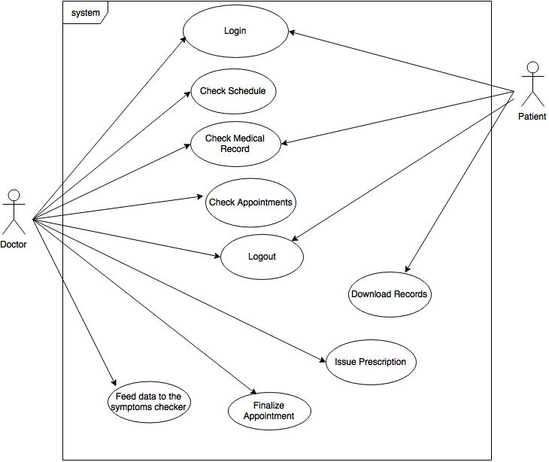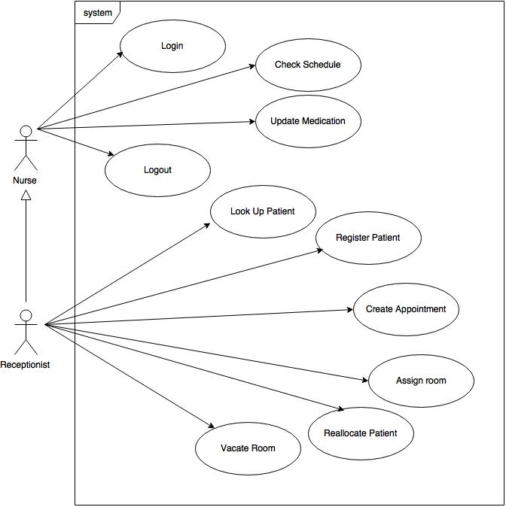

***Use cases of the doctor and the patient***

***Use cases of the nurse and the receptionist***

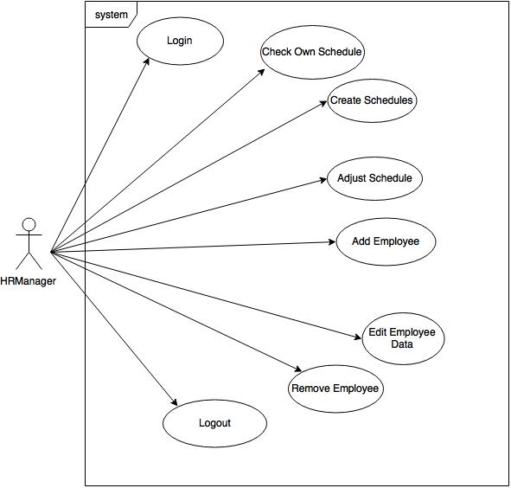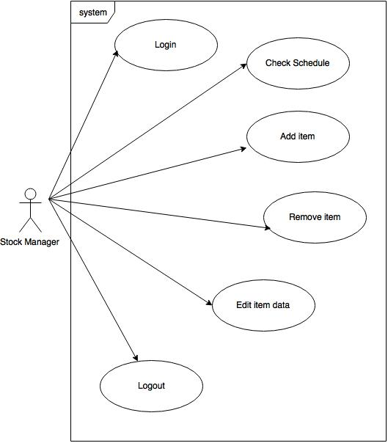

***Use cases of the Human Relations Manager***

***Use cases of the Stock Manager***

***Data Flow Diagram of the patient visit and the doctor’s actions***

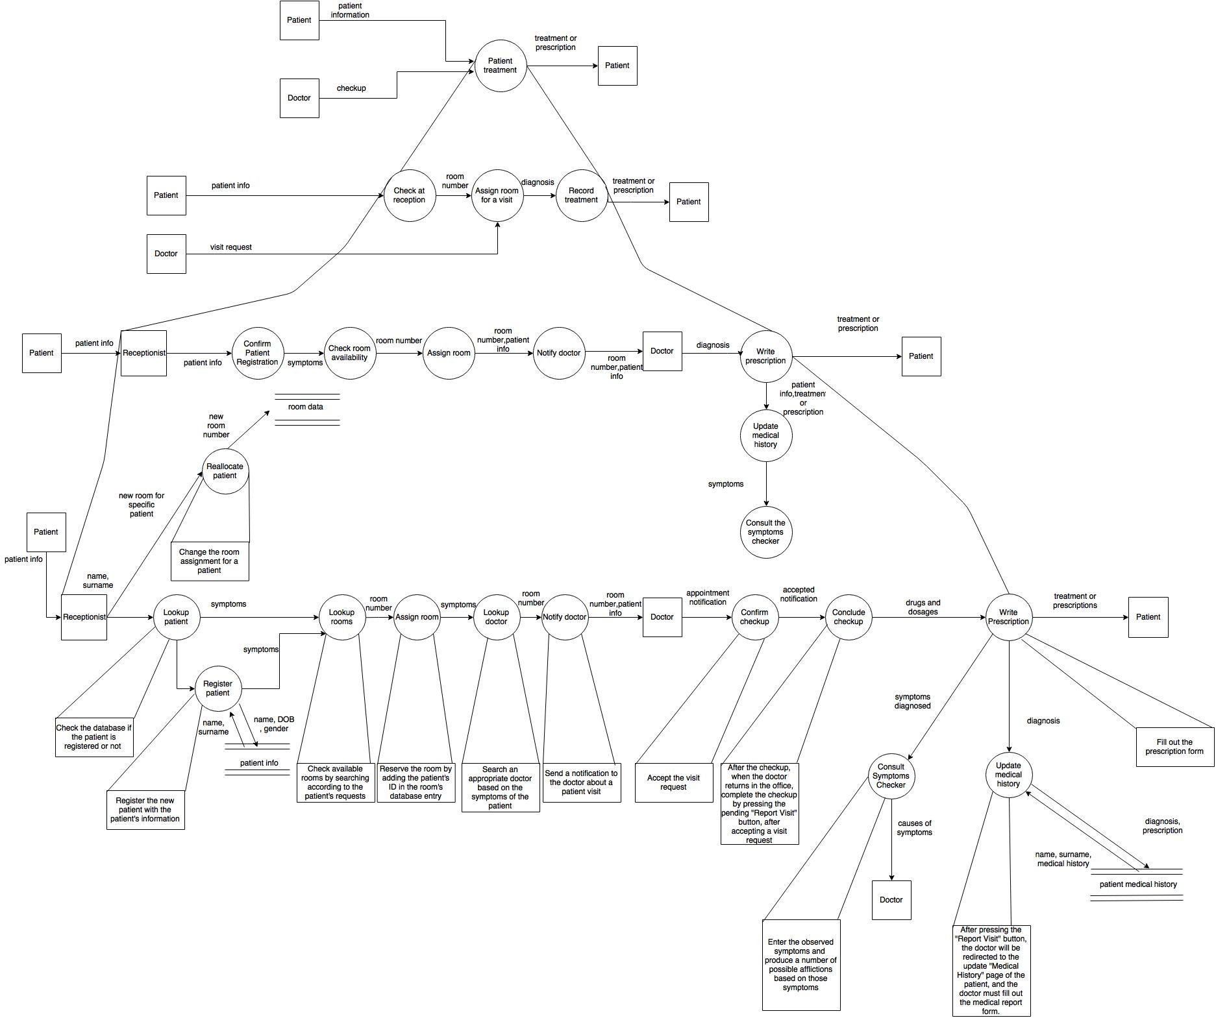

***Data Flow Diagram of the patient visit and the doctor’s actions***

# C:\Users\Dante\Dropbox\Apps\drawio\InvDFD.jpg

***Data Flow Diagram of the stock manager actions***

# C:\Users\Dante\Dropbox\Apps\drawio\HRManagerDFD.jpg

***Data Flow Diagram of the Human Relations Manager actions***

# C:\Users\Dante\Desktop\SE\Today\ERDApp.jpg

***Entity Relationship Diagram of the doctor, receptionist, nurse and patients.***

# C:\Users\Dante\Desktop\SE\Today\ERDHR.jpg

***Entity Relationship Diagram of the HR Manager, Schedule and Services Staff entities***

# C:\Users\Dante\Desktop\SE\Today\ERDInv.jpg

***Entity Relationship Diagram of the Inventory and Inventory Manager entities***

# C:\Users\Dante\Desktop\SE\Today\DBStruct.JPG

***Database Structure***

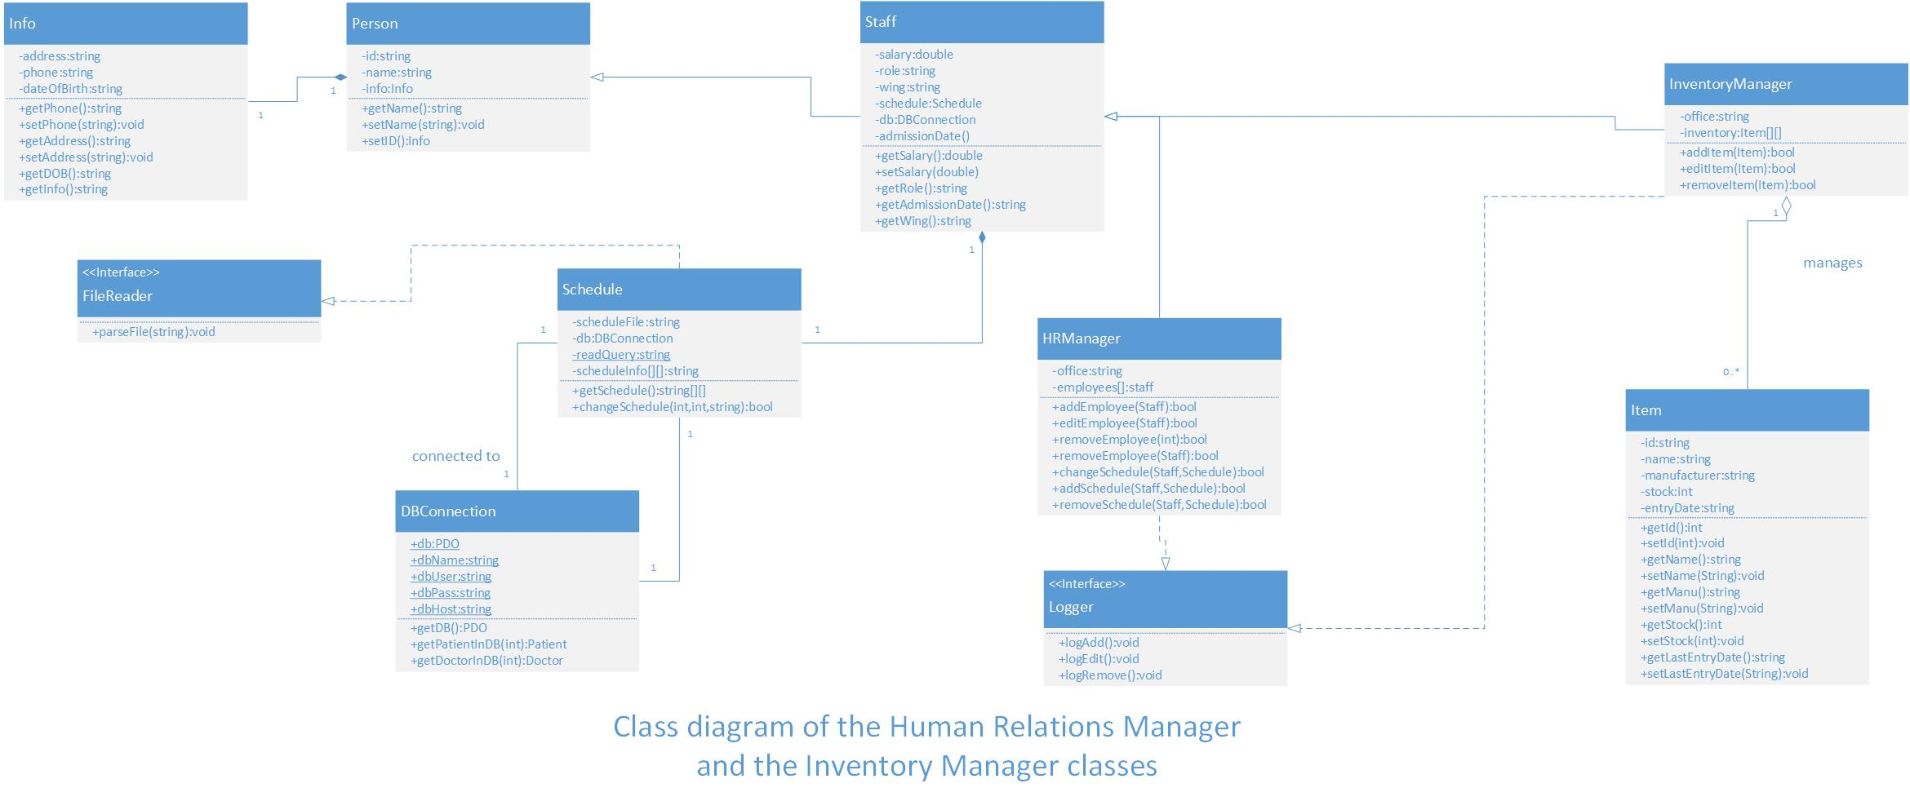

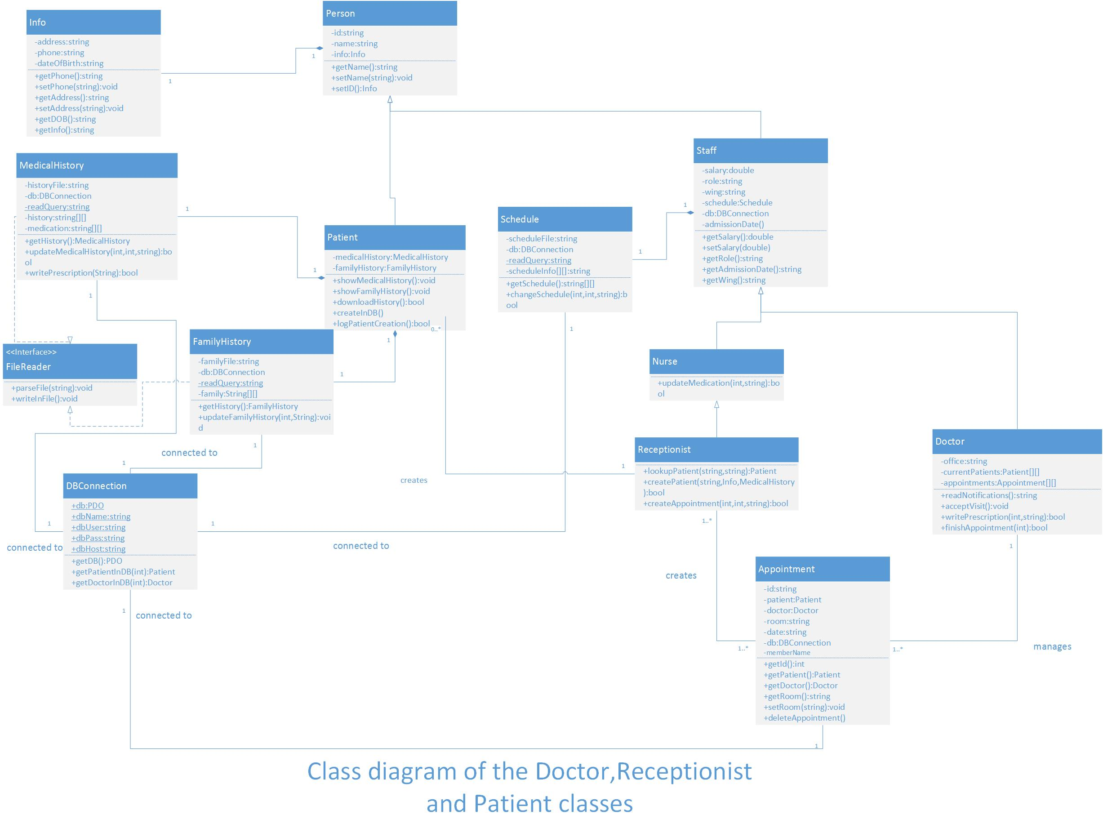

# C:\Users\Dante\Desktop\SE\Today\ObjDiaApp.jpg

# C:\Users\Dante\Desktop\SE\Today\ObjHR.jpg

# 3. Research

**Why we have chosen PHP?**

Among the members we had several options to consider in picking the platform that we would be developing our project, such as Java Server Pages, Python as CGI, using PHP in Symfony, and even developing the project as a mobile application in Android. However we settled on object-oriented PHP for several reasons:

- Group Experience

Perhaps the most deciding factor was the group’s experience with the scripting language. The group confessed that they are much more comfortable developing in vanilla object-oriented PHP, which meant that almost no time would be spent on first getting familiar with a platform or framework that most of us are inexperienced in.

- Platform-Independent

PHP is highly regarded as a platform-independent scripting language. This implies that no additional software or specific OS is required to install the system in the hospital’s data servers. It can support all the major web servers and all the major databases. PHP’s greatest appeal in our opinion is PDO, a very useful tool to handle the frequent database transactions present in out project.

- Lightweight

PHP is highly optimized, reducing the delay to perform the different types of actions that out project incurs: robust web pages, frequent database transactions, file management.

**Bootstrap**

Bootstrap as a frontend framework was an immediate choice for us. It is a very robust framework that will greatly facilitate the creation of the web pages, while also providing us with different templates that will let us create a web application that will be intuitive and enjoyable for all the project’s users.