**Revision History**

|  |  |  |  |
| --- | --- | --- | --- |
| Revision number | Revision Date | Summary of Changes | Author |
| 0.1 | 2015/05/29 | * Initial Version |  |

**Content Summary**

1 Introduction to ELSA System 3

1.1 General description of ELSA 3

1.2 Application Architecture 3

1.3 Customization Interface - PP 3

2 Preparing the Installation 4

3 Install ELSA Web Management System 4

4 Function Descriptions 4

4.1 Association of Tags and Products 4

4.1.1 Associate Tags from Web Page 4

4.1.2 Associate Tags from BC page using Handheld 6

4.1.3 Associate Tags with SARA 6

4.1.4 Import/Export Associations from a file 6

4.1.5 De-association 6

4.2 ESL Tag Update and Job Control 6

4.2.1 Update Tag from Web Page 7

4.2.2 Update Tag with Image 7

4.2.3 Job Status and Retry Mechanism 7

4.3 Management of the Tags 7

4.3.1 Device connection status 7

4.3.2 Device Information 7

4.4 Management of the Inventory 7

4.5 Management of the Layout 7

4.6 System Inspection and Diagnostic 7

5 Customization – PP 7

6 Trouble Shooting 7

7 Web Page Illustration(Map) 7

8 Contact Information 7

# Introduction to ELSA System

## General description of ELSA

Building Blocks, ex AP/RT/ED/SARA?

System limitations, Latency Design principal

## Application Architecture

PP/Image Creator/Layout

## Customization Interface - PP

SQL/File change

PP/Layout/Daemon Control or combined in Introduction?

# Preparing the Installation

PC and OS Reqruirements

location of ethernet plug, power plug..

Configuration of AP Ethernet MAC

Interference Check, etc

# Install ELSA Web Management System

# Function Descriptions

After the system is installed, there would be a list of on-line tags shown from Web. The tags are not

## Association of Tags and Products

In ELSA 1.0, each ESL Tags must be associated to one Product before it could be updated. There are several methods to associate the ESL Tag to a product, listed below. In any case of the association method, the Tags should be automatically updated with associated image:

Example:

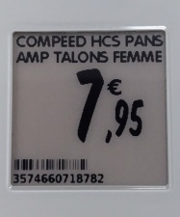

### Associate Tags from Web Page

Click on the ESL Management Page and follow the steps:

1. Double click one of the tags from the list. Only “TAG” can be associated.

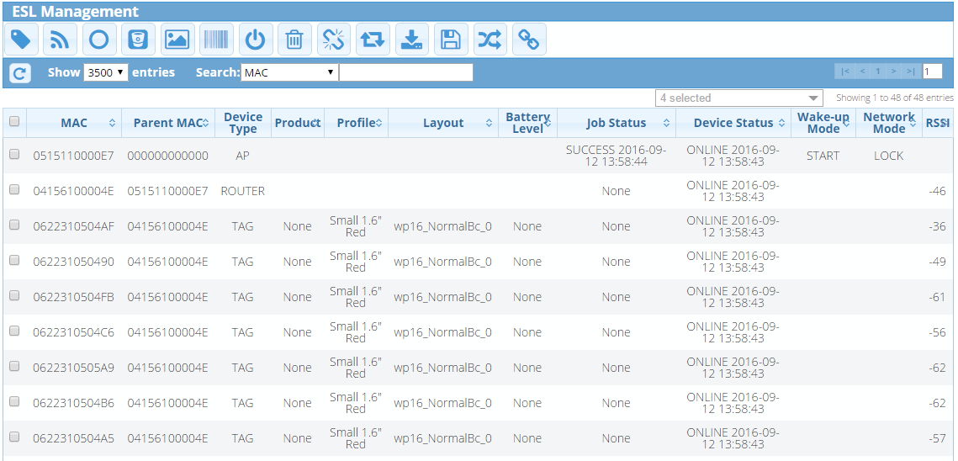

1. The window like below will appear. Click on the pencil icon to choose the product.

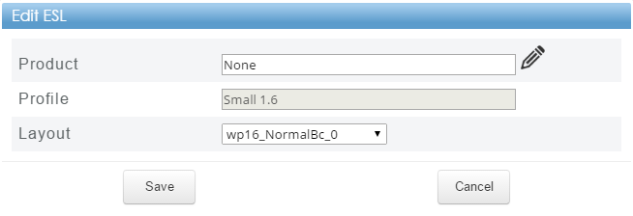

1. After the list of product like below appears, you can choose the product and click “Select”.

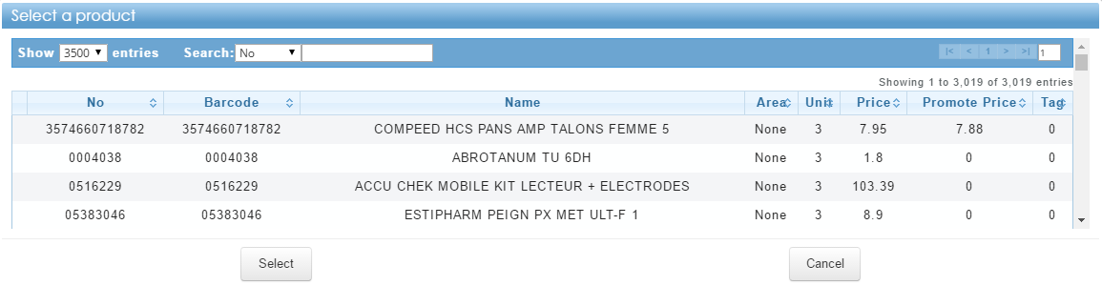

1. After choosing the product, the window like below will appear. You also can change the layout in this step. If everything has been chosen correctly you can click “Save” and the tag will update its information with the newest data.

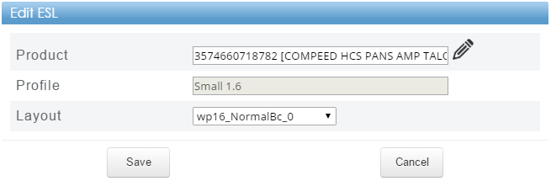

1. From the list, you can notice the product has been changed

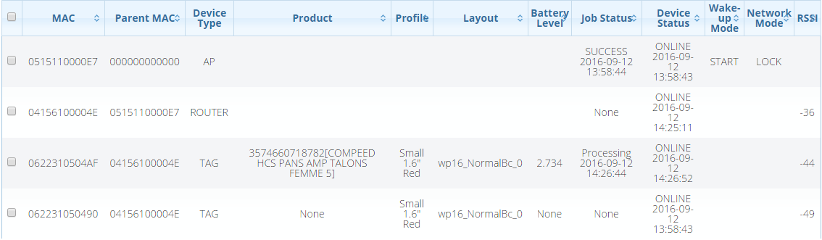

### Associate Tags from BC page using Handheld

The BC page is a specific page designed for limited resolution devices

### Associate Tags with SARA

### Import/Export Associations from a file

### De-association

## ESL Tag Update and Job Control

The Tags information update from PP is not included here, refer to customization.

### Update Tag from Web Page

### Update Tag with Image

### Job Status and Retry Mechanism

## Management of the Tags

### Device connection status

Query/Reboot/Wakeup

### Device Information

BAT/RSSI/Budget?

## Management of the Inventory

## Management of the Layout

## System Inspection and Diagnostic

Tag Histroy/Daily Email/…

# Customization – PP

# Trouble Shooting

# Web Page Illustration(Map)

# Contact Information

|  |
| --- |
| **M2Communication, Inc. (M2C)**  4F-3, No. 32, Gaotie 2nd Rd,  Zhubei City, Hsinchu County, Taiwan  Tel: +886-3-657-8939  Fax: +886-3-657-6909  Email: support@m2comm.com |
|  |
| This document contains confidential information and is subject to the terms and conditions set forth in the Non-Disclosure Agreement between the Recipient Entity and M2Communication, Inc. (M2C) The information in this document is believed to be accurate in all respects at the time of publication but is subject to change without notice. M2Communication, Inc. assumes no responsibility for errors and omissions, and disclaims responsibility for any consequences resulting from the use of information included herein. Additionally, M2Communication, Inc. assumes no responsibility for the functioning of un-described features or parameters. M2Communication, Inc. reserves the right to make changes without further notice. M2Communication, Inc. makes no warranty, representation or guarantee regarding the suitability of its products for any particular purpose, nor does M2Communication, Inc. assume any liability arising out of the application or use of any product or circuit, and specifically disclaims any and all liability, including without limitation consequential or incidental damages. M2Communication, Inc. products are not designed, intended, or authorized for use in applications intended to support or sustain life, or for any other application in which the failure of the M2Communication, Inc. product could create a situation where personal injury or death may occur. Should Buyer purchase or use M2Communication, Inc. products for any such unintended or unauthorized application, Buyer shall indemnify and hold M2Communication, Inc. harmless against all claims and damages. |