

Background on SAS





# Background

* SAS (Statistical Analysis Software) was

developed at North Carolina State

University from 1966 until 1976, when

SAS Institute was incorporated.

* SAS Institute, Cary, NC, is always among

the top ten on Fortune list of Best

Companies to Work For in the US

because of award- winning workplace

culture (on-site child care, swimming

pools, medical clinics, fitness centers, car

detailings, nail salons, shoe repairs,

massages, art classes, etc.).





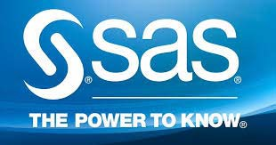



# SAS Advantages

* SAS is developed by statisticians and for

statisticians

* Uses standard formulas and methods to

analyze data

* Uses common-sense default values in

calculations

* Easy to program from scratch
* Allows possibility to program any non-

standard computation



# SAS Disadvantages

* Expensive ($75,000/year for site license)
* A new version comes out every so often

resulting in lots of bugs and compatibility

issues

* Not for Macintosh, only if Windows are

installed



# Where to Get SAS?

* CSULB has university-wide license
* SAS should be available in all computer labs on campus (not really)
* Can be downloaded from Software Depot

(Be warned: installation takes hours)

* Use Student Virtual Lab (SVL)



HOW TO INSTALL SAS

* SAS Download Manager, once fully extracted,

requires approximately 150 MB of space to

run

* SAS installation checklist is provided on the

course website

# SAS Certification Exams



# SAS Base Programmer

# SAS Advanced Programmer

# SAS Clinical Trials Programmer

# SAS Predictive Modeler

# SAS Statistical Business Analyst

# Students are eligible for a 50% discount on exam fees.