Chapter 5 GETTING DATA INTO SAS

Reference

SAS Certification Prep Guide: Base Programming for SAS 9, SAS Publishing Inc., 3rd ed., 2011, ISBN: 978-1607649243

There are several ways to input data into SAS:

(1) Entering data directly into SAS code (called **reading instream data**).

(2) Referencing a SAS data file stored on external drive.

(3) Importing a spread sheet file into SAS library.

(4) Creating dataset inside SAS code using the DO statement.

Example 1 (Entering data directly into SAS code).

Suppose we are given the following data

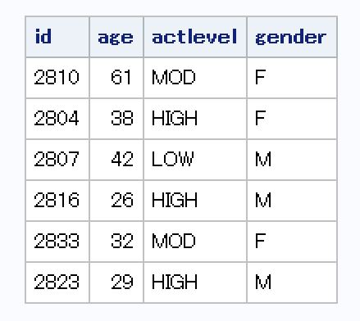

To enter the data into SAS, type

data method1;

input id $ age actlevel $ gender $;

cards;

2810 61 MOD F

2804 38 HIGH F

2807 42 LOW M

2816 26 HIGH M

2833 32 MOD F

2823 29 HIGH M

;

proc print data=method1;

run;

Example 2 (Referencing a SAS data file stored on external drive).

Suppose we have a data file named exercise.dat stored on G drive. If you open this file in Notepad, it looks like this:

2810 61 MOD F

2804 38 HIGH F

2807 42 LOW M

2816 26 HIGH M

2833 32 MOD F

2823 29 HIGH M

To reference this data file in SAS, type

data method2;

infile 'C:\Users\mstudent\Desktop\exercise.dat';

input id $ age actlevel $ gender $;

run;

proc print data=method2;

run;

Example 3 (Importing a spread sheet file into SAS library).

Suppose we have an Excel file exercise.xlsx stored on the desktop (C:\Users\mstudent\Desktop). We can import that file into SAS as follows:

proc import out=method3

datafile="C:\Users\mstudent\Desktop\exercise.xlsx"

dbms=xlsx replace;

run;

proc print data=method3;

run;

or

proc import out=method3a

datafile="C:\Users\mstudent\Desktop\exercise.csv"

dbms=csv replace;

run;

proc print data=method3a;

run;

proc

Example 4 (Creating dataset inside SAS code using the DO statement).

Suppose we are given the following data



To enter the data into SAS, type

data method4;

do counter=1 to 6;

actlevel='HIGH';

gender='M';

output;

end;

do counter=1 to 3;

actlevel='MOD';

gender='M';

output;

end;

do counter=1 to 1;

actlevel='LOW';

gender='M';

output;

end;

do counter=1 to 5;

actlevel='HIGH';

gender='F';

output;

end;

do counter=1 to 4;

actlevel='MOD';

gender='F';

output;

end;

do counter=1 to 3;

actlevel='LOW';

gender='F';

output;

end;

run;

proc print data=method4;

run;