# «MVP в Cursor → улучшение через GitHub (ветки + PR)»

1.init login

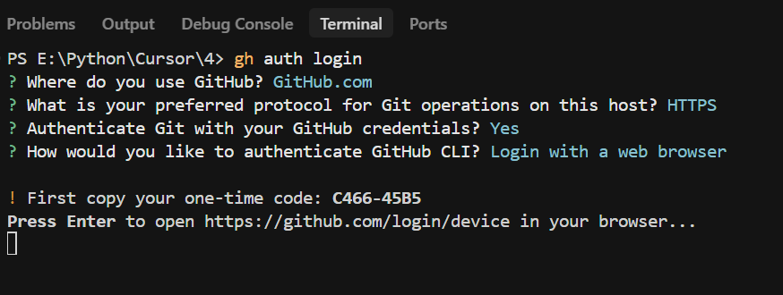

2. authorize on web

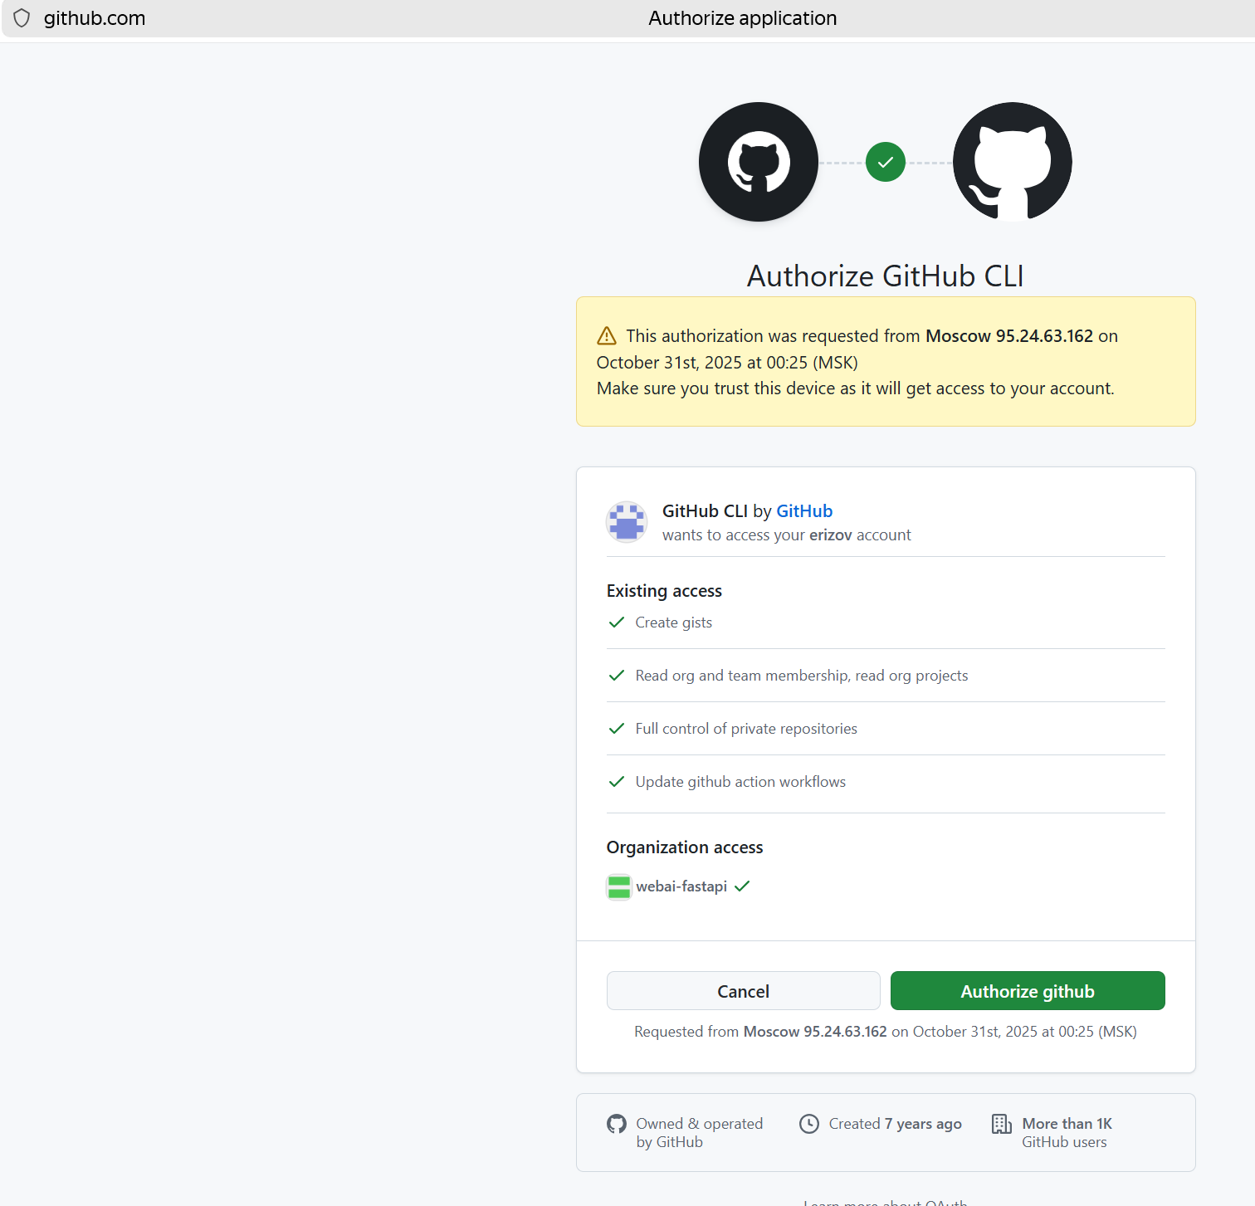

3. authenticate with passkey

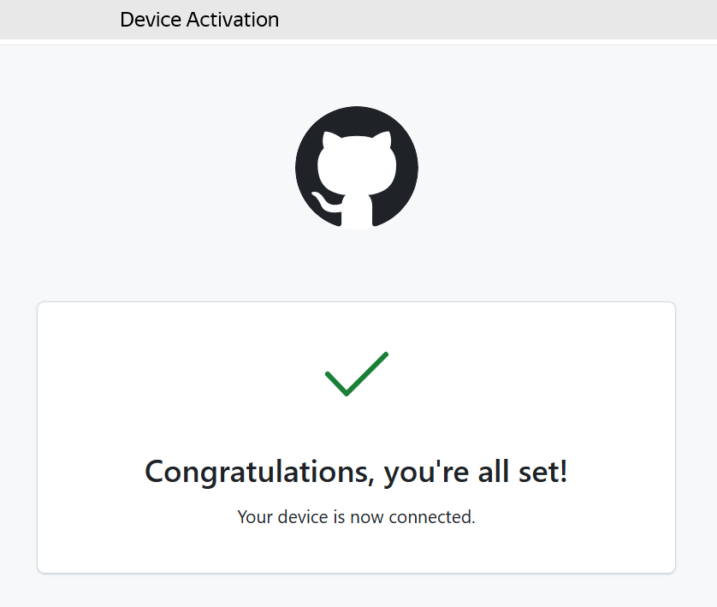

4. git init

Initialized empty Git repository in E:/Python/Cursor/4/.git/

git config user.name "erizov"

git config user.email "erizov@yahoo.com"

5. Commit  
git add .   
git commit -m "Initial commit"

git remote add origin <https://github.com/erizov/cursor-github-mvp.git>

git status

On branch master

nothing to commit, working tree clean

6. change to feature branch  
PS E:\Python\Cursor\4> git status

On branch feature/add-docker

nothing to commit, working tree clean

7. added docker ci:

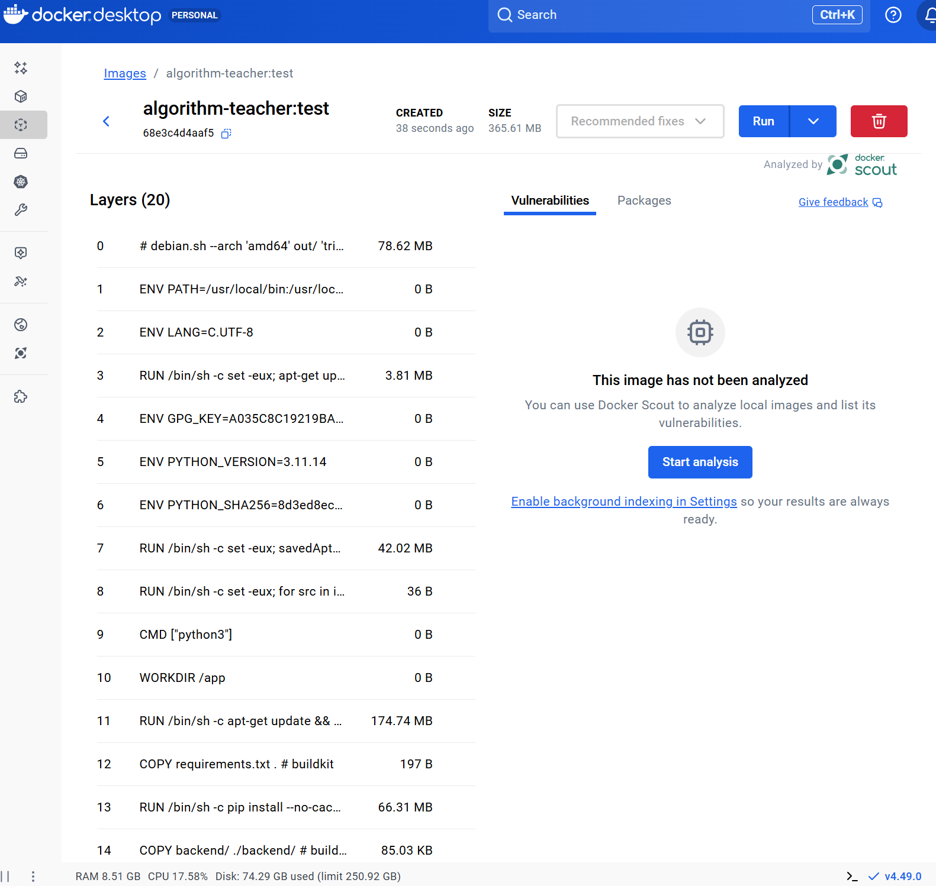

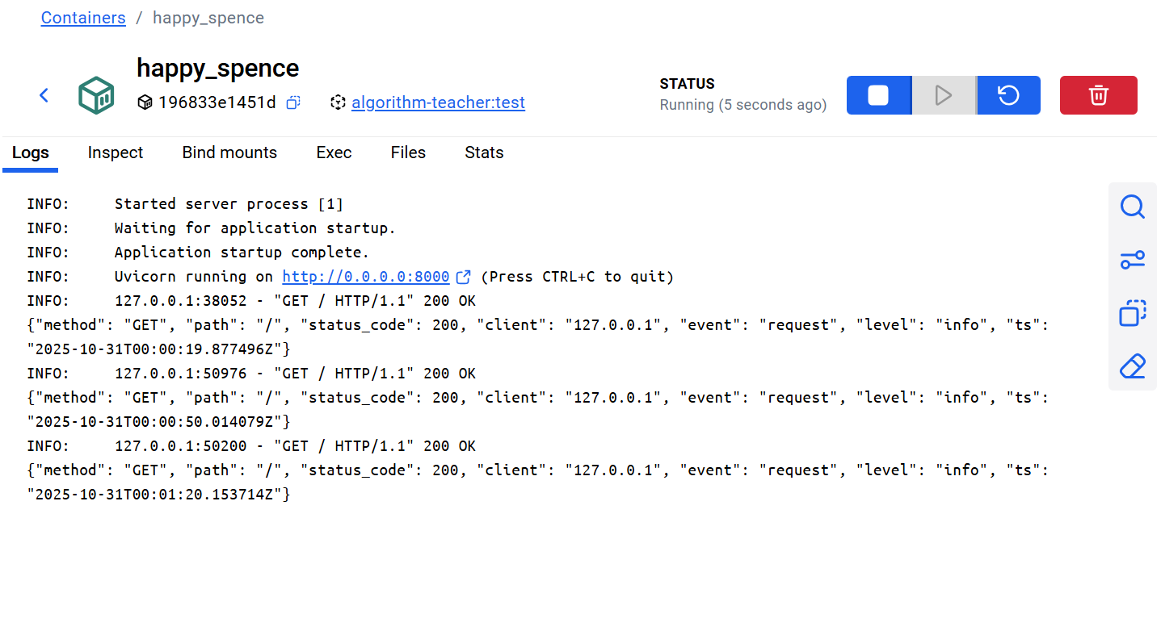

8.

9.