Hi Client ,

We have analyzed the data set against the standardized quality assessment and discovered following issues.

 | Transactions | New Customer List | Customer Demographic | Customer Address
Accuracy | - product_first_sold_date is in ordinal format  - one of the product_id is zero, which doesn’t make sense | - There is an entry ‘U’ for gender, is that valid?
Completeness | - Null values are present in order_online, brand, product_line, product_class, product_size, standardize cost and product_first_sold_date  - it seems most of the missing values are in same data points which can be dropped | - Null values are present in last_name, DOB, job_title, job_industry_category | - Null values are present in last_name, DOB, job_title, job_industry_category, default and tenure
Consistency |  | - Invalid entries in DOB | - Invalid entries in DOB
Currency
Relevancy
Validity
Uniqueness

Detailed Analysis

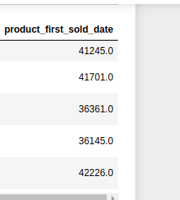
Transactions Table

product_first_sold_date is in ordinal format, we have to convert it into date-time format.

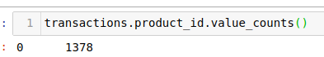
product_id is zero for 1378 items which is invalid

null values are depicted as follows, it can be observed many columns have null values for same data points
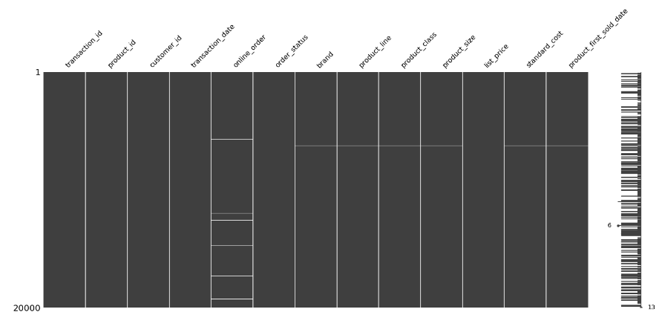

New Customer List

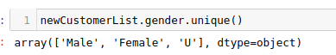
gender has ‘U’ entry, which is invalid

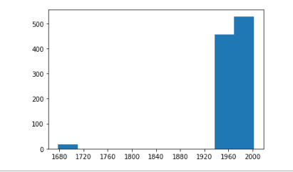
DOB has some unrealistic entries

Null values are depicted as follows, job_title and job_industry category has multiple null values
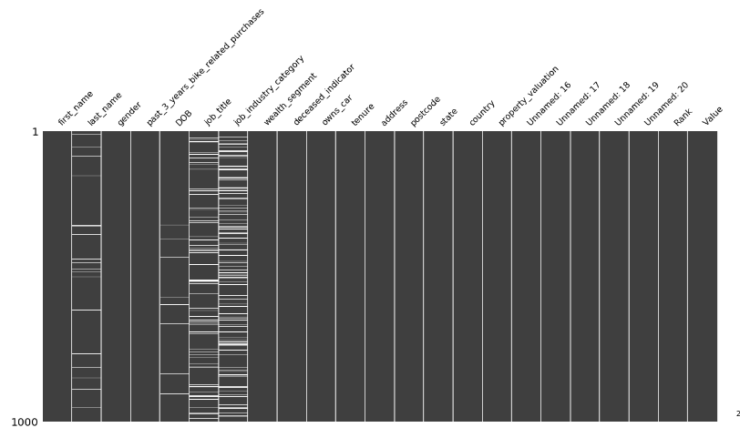

Customer Demographic

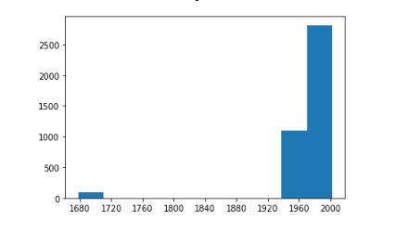
invalid entries in DOB

Null values are depicted as follows, job_title and job_industry_category have most null values.

