WORK INTEGRATED LEARNING PROGRAMME

Microservices Development and Deployment
QuickBite — Online Food Ordering System
Course: SEZG583 – Scalable Services | Submission date: 12 November 2026 | Total: 20 marks
Student name | [ENTER NAME]
Student ID | [ENTER BITS ID]
Group members | [ENTER NAMES / IDs OR SOLO]
GitHub repositories | [ENTER FOUR REAL REPO URLS AFTER PUSH]
Status: Implementation package prepared. Actual Docker/Minikube screenshots, repository URLs and demo-video link must be filled after execution.

Assignment alignment
Section | Weight | What this report demonstrates
Part 1 — Design | 6 | Use case, commands/queries, capabilities, architectural boundaries and collaboration
Part 2 — Implementation | 7 | Independent FastAPI services, validation, REST integration and database isolation
Part 3 — Deployment | 7 | Docker containers, Kubernetes/Minikube instructions, dashboard and autoscaling

Note: This document is a detailed academic report template, not a claim that Kubernetes has been executed. All runtime screenshots must be generated during the student demonstration.

1. Application overview and objectives
QuickBite is a sample online food-ordering application. A customer discovers restaurants, opens a menu, selects food items, submits an order, and creates a delivery request. To meet scalable-services principles, the application separates business capabilities into independently deployable FastAPI services, fronted by a single API Gateway.

1.1 Functional use case — placing and delivering an order
- Customer requests the list of restaurants and an individual restaurant menu.
- Customer selects menu items and quantities.
- Orders validates items with Catalog, calculates a trusted server-side total and persists the order.
- Delivery verifies that the order exists and creates a delivery job.
- Customer can retrieve the order and delivery details by identifier.

1.2 Non-functional objectives
- Independent service development and testing, via four separate code roots and GitHub repositories.
- Container-based deployment and discoverable internal HTTP endpoints.
- Horizontally scalable stateless application tier and separate persistence boundaries.
- Availability monitoring via health, liveness and readiness checks; bounded upstream timeouts.
- Demonstrable behavior, documented API operations and reproducible test commands.

1.3 Technology selection
Layer | Technology | Reason
API services | Python 3.12, FastAPI, Pydantic | Typed REST endpoints and request validation
Service communication | HTTP/REST + JSON, httpx | Simple synchronous collaboration
Persistence | SQLite (local); PostgreSQL 16 (Docker/K8s) | Easy local run; isolated data per business service
Gateway/frontend | FastAPI + HTML/CSS/JS | One ingress point with a working web UI
Container platform | Docker + Docker Compose | Independent image and container per service
Orchestration | Minikube + Kubernetes | Deployments, Services, StatefulSets, HPA, PDB and Dashboard
Tests | pytest + automated HTTP smoke script + Postman | Repeatable local/cluster API evidence

2. Part 1 — Scalable service design (6 marks)

2.1 Architecture diagram
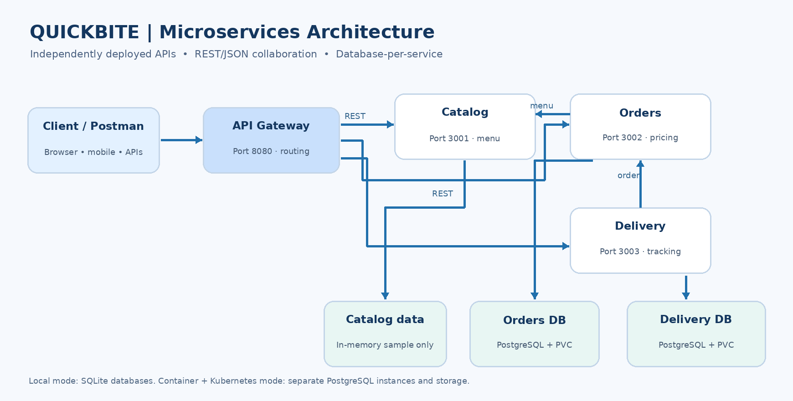
Figure 1. Logical QuickBite architecture. Service-to-service communication uses internal HTTP. Each persistent service owns its own database. Catalog uses in-memory demonstration data.

2.2 Business capabilities mapped to services
Capability | Service owner | Owned data / responsibility
Restaurant/menu discovery | Catalog | Restaurant, cuisine and sample menu prices
Order management | Orders | Price validation, order records and listing
Delivery tracking | Delivery | Delivery creation, status and orderId uniqueness
API entry/routing | Gateway | Public routes and web page; no business database

2.3 System operations: commands and queries
Type | Operation / route | Owner | Purpose
Query | GET /restaurants | Catalog | List restaurants
Query | GET /restaurants/{id}/menu | Catalog | Retrieve menu & authoritative prices
Command | POST /orders | Orders | Validate and create priced order
Query | GET /orders | Orders | List recent orders with pagination
Query | GET /orders/{id} | Orders | Get a specific order
Command | POST /deliveries | Delivery | Validate existing order and create delivery
Query | GET /deliveries/{id} | Delivery | Get delivery and status
Query | GET /health, GET /live | Each service | Readiness and process liveness

The gateway exposes these through prefixes `/api/catalog/…`, `/api/orders/…`, and `/api/deliveries/…`.

2.4 Collaboration and end-to-end sequence
- Browser/Postman sends an API request to Gateway :8080.
- Gateway forwards to the owning service using its internal service name.
- For POST /orders, Orders calls GET Catalog menu; it never trusts a client-submitted price.
- Orders calculates totalCents, writes its own DB record, and returns HTTP 201 with orderId.
- For POST /deliveries, Delivery calls Orders to validate the order, then writes to its separate DB.
- Repeated delivery for one order results in HTTP 409; service request errors result in 502/503 as appropriate.

2.5 Scalability, limitations and tradeoffs
Stateless application processes can run multiple replicas behind Kubernetes Services. HPA definitions request 2–10 application replicas at a 70% CPU utilization target, dependent on metrics server and sustained workload. PostgreSQL instances are single-replica StatefulSets, so they are not database high-availability systems. Requests are synchronous and may experience upstream latency; production extensions would add authentication, durable event messaging, tracing, network policies, managed HA databases and an external ingress/TLS.

3. Part 2 — Microservices implementation (7 marks)

3.1 Independent service repositories
The assignment requires at least two implemented services and explicitly requires one independent code repository per service. This solution implements four services as isolated source roots, each with its own main.py, requirements.txt, Dockerfile, .dockerignore, .gitignore, and README.md. Publish them as FOUR separate GitHub repos; folders alone are not sufficient.
Proposed GitHub repository | Local path | Default port
quickbite-catalog | services/catalog/ | 3001
quickbite-orders | services/orders/ | 3002
quickbite-delivery | services/delivery/ | 3003
quickbite-gateway | services/gateway/ | 8080

3.2 Catalog service
Provides two seeded restaurants (Green Garden and Corner Pizza) and six fixed-price products. REST GET endpoints return restaurant listings and menus. Health/liveness endpoints support deployment checks. Catalog intentionally uses in-memory data in this educational sample.

3.3 Orders service
Pydantic models validate customerId, restaurantId, menuItemId and positive quantity. Orders calls Catalog using httpx, derives trusted prices, stores a UUID order in a dedicated database, and exposes create/get/list APIs. SQLite is used in no-Docker local mode; PostgreSQL is used for Docker and Kubernetes.

3.4 Delivery service
Delivery validates orderId with Orders via REST, stores delivery status queued, prevents multiple deliveries for the same order through a database uniqueness constraint, and retrieves deliveries by UUID. Errors such as a missing order and duplicate delivery are handled explicitly.

3.5 Gateway, database isolation and testability
Gateway supplies a single localhost:8080 interface for all client requests and serves the browser user interface. The shared schema is *not* a shared database: only Orders accesses Orders DB, and only Delivery accesses Delivery DB. Each service has its own dependencies and can be tested or packaged independently.

3.6 Core example: order API
POST http://127.0.0.1:8080/api/orders/orders
{"customerId":"student-101","restaurantId":"r1","items":[{"menuItemId":"m1","quantity":2},{"menuItemId":"m3","quantity":1}]}
Expected: HTTP 201; the returned order has a generated UUID, status “placed”, and totalCents = 2×1299+399 = 2997. The exact UUID and createdAt timestamp vary each run.

3.7 Verification and negative cases
Test | Expected response | Why it matters
GET restaurants / menu | 200 OK | Catalog discovery and API query
POST valid order | 201 Created | Command and server-side pricing
POST unknown menu item | 422 | Input/business validation
GET newly created order | 200 OK | Order persistence and retrieval
POST delivery using order ID | 201 Created | HTTP collaboration across services
GET newly created delivery | 200 OK | Delivery persistence and retrieval
POST duplicate delivery | 409 Conflict | Integrity constraint

Ten supplied `pytest` unit/contract checks and `scripts/smoke_test.py` have been run successfully in Python/SQLite local mode in the packaging environment. They do not demonstrate Docker or Minikube execution.

4. Part 3 — Deployment (7 marks)

4.1 Docker: separate containers
Each of the four FastAPI services has its own Dockerfile based on python:3.12-slim. Docker Compose additionally provisions two PostgreSQL 16 containers and separate persisted volumes, creating six containers total.
docker compose config
docker compose up --build -d
docker compose ps
python scripts/smoke_test.py
Evidence E09 — insert actual screenshot here: `docker compose ps` with all service containers and health statuses. No container execution is claimed in this report draft.

4.2 Minikube preparation and image builds
minikube start --driver=docker --cpus=4 --memory=6144
minikube addons enable metrics-server
Build each image into Minikube with `minikube image build`; the exact four commands are in docs/STEP_BY_STEP_EXECUTION.md. These commands cannot succeed until Docker Desktop/driver and Minikube are installed and available.

4.3 Kubernetes deployment
kubectl apply -f deploy/kubernetes/00-namespace.yaml
kubectl apply -f deploy/kubernetes/01-secret-demo.yaml
kubectl apply -f deploy/kubernetes/02-databases.yaml
kubectl apply -f deploy/kubernetes/03-catalog.yaml
kubectl apply -f deploy/kubernetes/04-orders.yaml
kubectl apply -f deploy/kubernetes/05-delivery.yaml
kubectl apply -f deploy/kubernetes/06-gateway.yaml
kubectl apply -f deploy/kubernetes/07-hpa.yaml
kubectl apply -f deploy/kubernetes/08-pdb.yaml
Kubernetes uses one namespace (food-delivery), two database StatefulSets with per-instance persistent volume claims, four Deployments with initial replicas=2, four HTTP ClusterIP Services, HPA rules and disruption budgets. This is an application-tier scaling demonstration; single-instance databases remain a bottleneck.

4.4 Access, Dashboard and observed scalability
kubectl -n food-delivery get deploy,statefulset,pods,svc,pvc,hpa,pdb
kubectl -n food-delivery port-forward service/gateway 8080:8080
minikube addons enable dashboard
minikube dashboard
Set dashboard namespace to food-delivery. Capture actual Kubernetes dashboard Workloads/Pods/Deployments and HPA. Optional: `python scripts/load_test.py --requests 2000 --concurrency 60` while watching HPA; scale-out is only “observed” if actual replica counts change. Metrics Server must be enabled, and CPU utilization may stay too low to cause scaling.

4.5 Availability, safety and deployment limitations
- Application replicas use liveness/readiness probes and Kubernetes Services for request routing.
- Database PVCs persist data; PostgreSQL instance count remains one and has no automatic failover.
- HPA targets are configuration, not measured proof of elasticity. Capture outputs and performance metrics if reported.
- A demonstration secret contains local-dev-only credentials. Replace it using real Kubernetes Secrets or managed secret provisioning before any real deployment.
- Kubernetes dashboard screenshots and actual deployment state must come from the student laptop.

4.6 Optional CI/CD pipeline
Each independently maintained service directory includes `.github/workflows/ci.yml`. When its corresponding GitHub repository receives a push or pull request, GitHub Actions installs that service dependencies, runs its own pytest tests and builds its Docker image. This demonstrates a CI design. It is not evidence of a successful GitHub Actions run or automated cluster deployment until the repositories are pushed and workflows executed.

5. Execution plan, evidence and submission

5.1 Step-by-step student execution
- Install dependencies and run `python run_local.py`; verify localhost:8080 and Swagger.
- Run `pytest -q` and `python scripts/smoke_test.py`; capture output.
- Import supplied Postman collection and execute all calls in sequence.
- Start Docker Desktop; use `docker compose up --build -d`; capture the six containers.
- Start Minikube, build all four images, apply 00–08 Kubernetes manifests.
- Check deployments/statefulsets/pods and access Gateway with port-forward.
- Open Minikube Dashboard and capture deployment, pods and HPA views.
- Create and push four independent GitHub repositories; insert their links below.
- Record demo video showing architecture, code, API calls, Docker, Kubernetes and GitHub.
- Fill member information/evidence and zip all deliverables for submission.

5.2 Evidence placeholders
Figure | Required screenshot from your live environment
E03–E04 | Postman GET restaurants/menu and JSON results
E05–E07 | Postman order / order GET / delivery / duplicate 409
E08 | pytest + smoke_test command output
E09 | Docker Compose six-container status
E10 | kubectl pods, deployments, StatefulSets, Services, PVCs
E11 | Minikube dashboard with food-delivery namespace
E12 | HPA / metrics / observed replica count
E13 | Four separate GitHub repositories

Screenshots E03–E13 are intentionally not fabricated or inserted here; attach real evidence in the final university copy.

5.3 GitHub repository links — populate after push
- Catalog: https://github.com/<YOUR_USERNAME>/quickbite-catalog
- Orders: https://github.com/<YOUR_USERNAME>/quickbite-orders
- Delivery: https://github.com/<YOUR_USERNAME>/quickbite-delivery
- Gateway: https://github.com/<YOUR_USERNAME>/quickbite-gateway

5.4 Submission package
Per assignment instructions, submit **one ZIP** named `<StudentID>_QuickBite.zip` with the completed report, source code, GitHub links and a screen-recorded demo video. The LMS deadline is 12 November 2026. The report and video are required even if the video is separately transferred using the instructor’s permitted option. Include actual names/IDs of all group members or state individual work.
Academic honesty: understand, test, adapt, and document this implementation in your own words. Submission is subject to the institution’s independent-work and plagiarism requirements.

6. Conclusion and future improvements
The QuickBite solution demonstrates service boundary design, command/query assignment, independent FastAPI components, REST collaboration, database-per-service persistence and reproducible local execution. The included Docker and Kubernetes configuration is a deployment blueprint. Final Part 3 credit depends on executing it in Minikube, opening the dashboard and submitting genuine results. Planned future work: persistent catalog management, authentication, observability/tracing, resilient asynchronous workflows, external ingress with TLS and managed HA databases.

