Izmir Institute of Technology

Probability and Statistic

Homework 1

Erkan Şahin

240201053

Calculations:

E(A) = 1/6x(1+2+3+4+5+6) = 3.5

E(B) = 1/4x(1+2+3+4) = 2.5

E(C) = 1/2x (1+ (-1)) = 0

E(X) = E (A)+E(B)x E(C)

E(X) = 3, 5 + (2.5) x 0 = 3.5

Var(X) = E(X\*\*2)-(E(X) \*\*2)

E(X\*\*2) = 1/6 x (1+4+9+16+25+36)+1 x (1/4)x(1+4+9+16)

E(X\*\*2) = 15.166+7.5=22.67

Var(x) = E[x \*\*2]-(E[x]) \*\* 2 = 10.42

Probability Mass Function:

C = 1,

B=1

A=1, X=2

A=2, X=3

A=3, X=4

A=4, X=5

A=5, X=6

A=6, X=7

B=2

A=1, X=3

A=2, X=4

A=3, X=5

A=4, X=6

A=5, X=7

A=6, X=8

B=3

A=1, X=4

A=2, X=5

A=3, X=6

A=4, X=7

A=5, X=8

A=6, X=9

B=4

A=1, X=5

A=2, X=6

A=3, X=7

A=4, X=8

A=5, X=8

A=6, X=9

C = -1

B=1

A=1, X=0

A=2, X=1

A=3, X=2

A=4, X=3

A=5, X=4

A=6, X=5

B=2

A=1, X=-1

A=2, X=0

A=3, X=1

A=4, X=2

A=5, X=3

A=6, X=4

B=3

A=1, X=-2

A=2, X=-1

A=3, X=0

A=4, X=1

A=5, X=2

A=6, X=3

B=4

A=1, X =-3

A=2, X=-2

A=3, X=-1

A=4, X=0

A=5, X=1

A=6, X=2

1/48 -> -3

2/48 -> -2

3/48 -> -1

4/48 -> 0

4/48 -> 1

5/48 -> 2

5/48 -> 3

5/48 -> 4

5/48 -> 5

4/48 -> 6

4/48 -> 7

3/48 -> 8

2/48 -> 9

1/48 -> 10

Cumulative Distribution Function:

1/48 -> -3

3/48 -> -2

6/48 -> -1

10/48 -> 0

14/48 -> 1

19/48 -> 2

24/48 -> 3

29/48 -> 4

34/48 ->5

38/48 -> 6

42/48 -> 7

45/48 -> 8

47/48 -> 9

48/48 = 1 -> 10

Graphs:

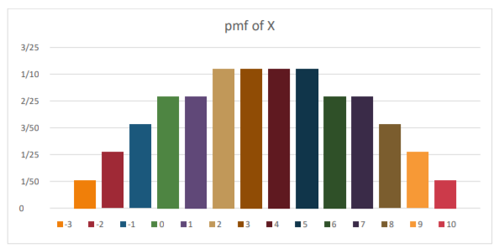

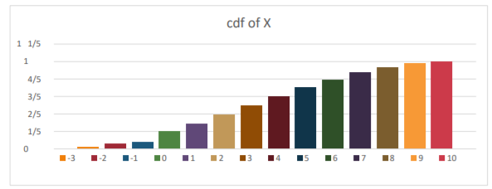

Comparing Calculations with the simulations:

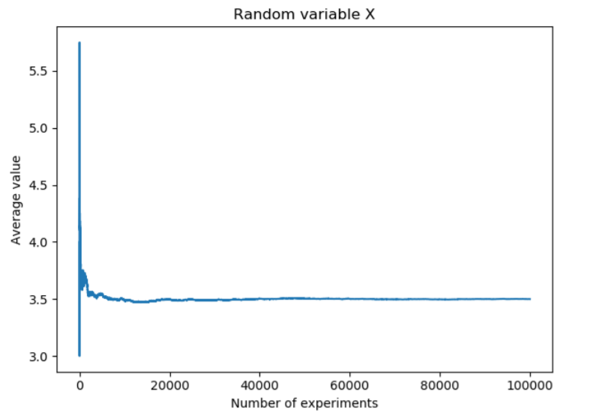

It seems that the value in the simulations converges to 3.5 which is the same as we calculated. If we make infinite experiment, it will eventually become 3.5.

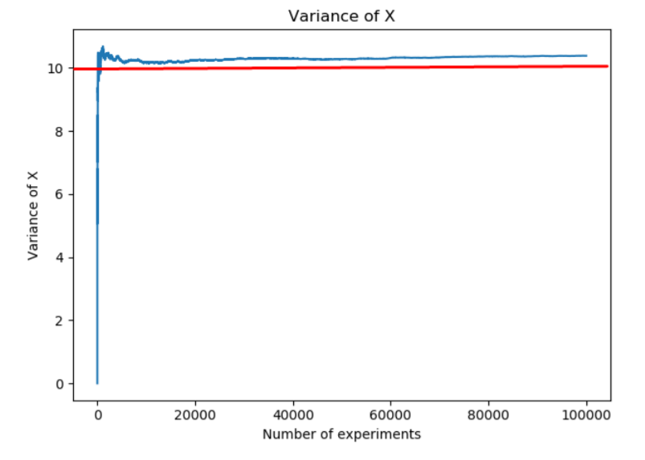

We calculated variance of X as 10,42.The results that we get from the simulation is similar. The value seems to converge 10.42.

Conclusion

To sum up, in this experiment, we observed that as we increased the number of experiments we converge theoretical values. This experiment helped us to understand the probability theory.