Izmir Institute of Technology

Probability and Statistic

Homework 2

Erkan Şahin

240201053

Part A:

Figure 1

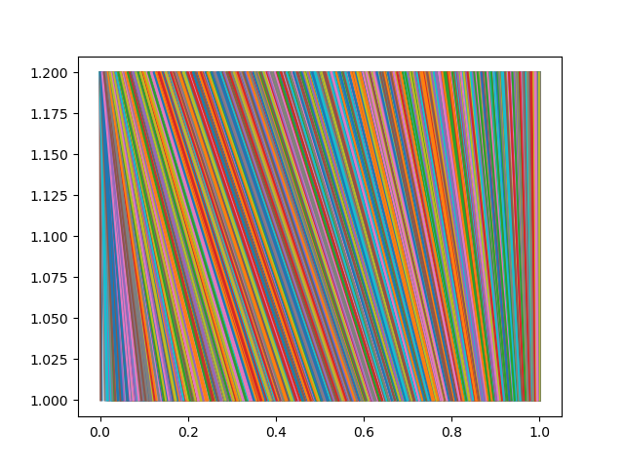

This figure illustrates the relationship between U and xA. As approaching 0 and 1 the lines are getting perpendicular to x-axis.

Figure 2

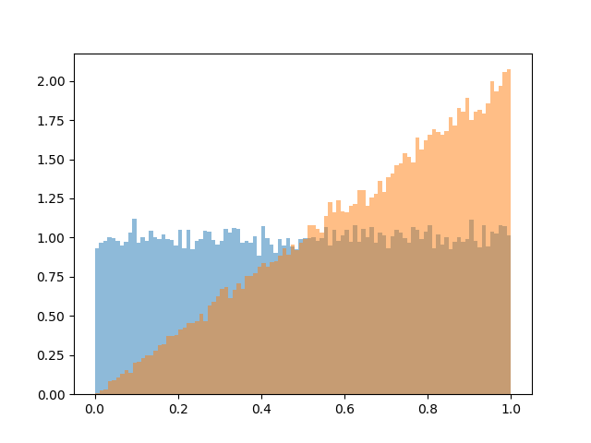

This figure demonstrates the histograms of generated U and X samples. Histogram illustrates the quantity of samples per bin. To cut a long story short, this histogram shows probability density functions of U and X.

Figure 3

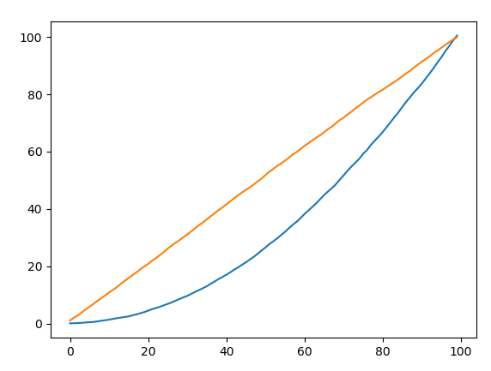

This graph shows cumulative distribution function of U and X which is created by using probability density function in the figure given above.

Figure 4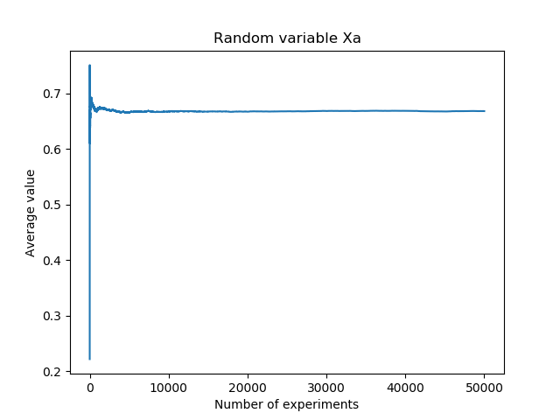

This graph shows the mean of random variable Xa which is calculated using the formula given below:

C:\Users\Erkan\AppData\Local\Microsoft\Windows\INetCache\Content.Word\cont_expectation.gif

The value converges to 0.66 As it is expected, the mean of Xa and Xb are equal.

Calculation:

 ∫ F(X)\*x dx =  ∫ (2\*x)\*(x)dx = 0.66

Figure 5

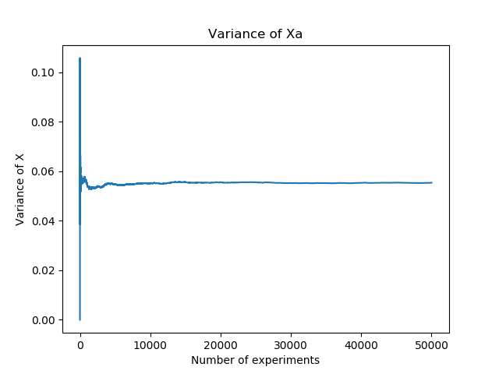

This graph gives variance of Xa which is calculated using the formula given below:

Var(X)=\left [ \int_{-\infty }^{\infty }x^2\: f(x)dx \right ]-\mu^2

Calculation:

 ∫ f(x)\*x dx =  ∫ (2\*x)\*(x\*\*2)dx = 0.055

It can be clearly realized that the value converges to 0.055. As it is expected, the variance of Xa and Xb are equal.

Figure 6

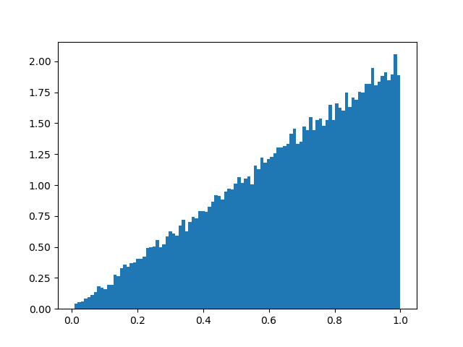

This histogram illustrates derivative of the cumulative distribution function F(x) = x\*\*2.

Part B:

Figure 7

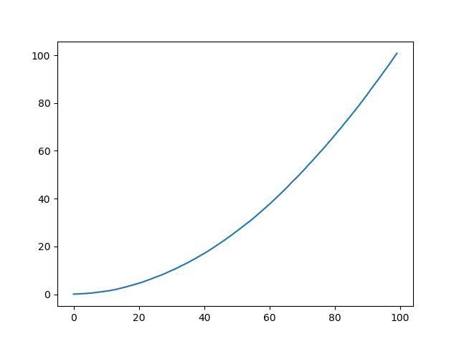

This graph shows us the cumulative distribution function F(X) = x\*\*2.

Figure 8This graph shows average values of random variable Xb which is calculated using the formula given below:

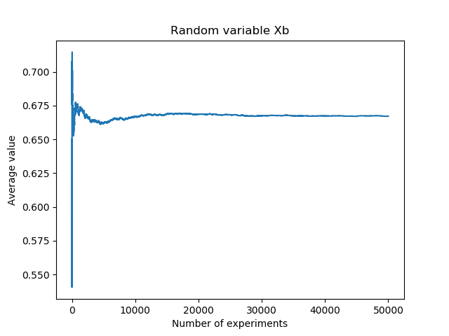

C:\Users\Erkan\AppData\Local\Microsoft\Windows\INetCache\Content.Word\cont_expectation.gif

It is obvious that the value converges to 0.66. As it is expected, the expected value of Xa and Xb are equal.

Calculation:

 ∫ f(x)\*x dx =  ∫ (2\*x)\*(x)dx = 0.66

Figure 9

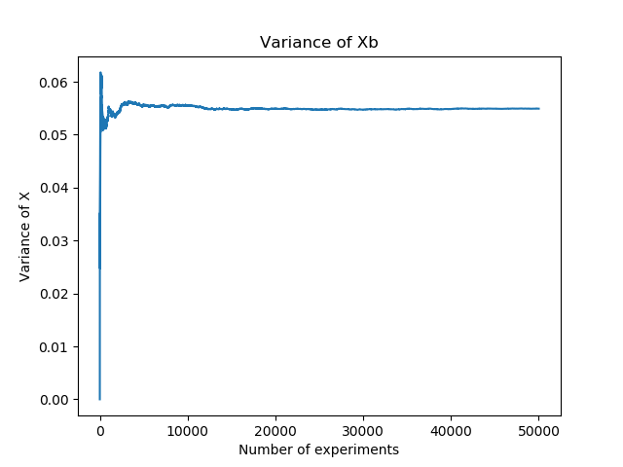

This graph gives variance of Xb which is calculated using the formula given below:

Var(X)=\left [ \int_{-\infty }^{\infty }x^2\: f(x)dx \right ]-\mu^2

Calculation:

 ∫ f(x)\*x dx =  ∫ (2\*x)\*(x\*\*2)dx = 0.055

It can be easily seen that the value converges to 0.055. As it is expected, the variance of Xa and Xb are equal.

To sum up, we used two different methods to generate samples which are Inverse Transformation Method and Rejection Method. Although these are distinct methods, we observed that the expectation and variance of these samples are the same. It is observed that the expected values and variances that are generated in simulations are converging to the values that are calculated by hand.