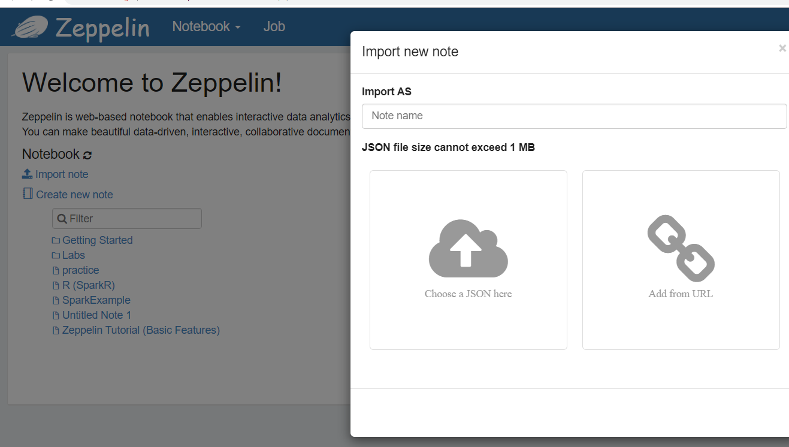

Click Import note and select your .json extended notebook file