Eric Kearney
CS 390S – Digital Image Processing
Professor Feng Jiang
16, November 2018

Project 1 – Face Recognition
As with my previous projects, I used Python with OpenCV in lieu of MatLab. I found this project extremely challenging, in part because I had little to no previous experience with Linear Algebra, so I had absolutely no idea what an Eigen Vector was prior to beginning this project, which is why I spend the first week or so familiarizing myself with them. 3Blue1Browns’ Essence of Linear Algebra playlist was enormously helpful to me during this process.
Once I had some semblance of an idea what was going on in the two provided papers, I began writing the code. I decided to create a Person object, upon creation of which creates its own array of flattened images. The Person object also has a compute_mean() method, which returns the average of all the vectorized images associated with that person, and the compute_deviation() method, which will compute the difference between that persons’ average vector and the average vector across all persons in the data set. In my main() method, I created a people array of Person objects, where each index in the people array represents one of the people in the training data set. From there, I simply followed the instructions in the “day 16” slides.
One thing I found particularly challenging was OpenCV’s strange imwrite() and imshow() methods, in the sense that these two methods work completely differently from one another. In the end, this resulted in some very dark looking eigen faces, though these eigen faces still seem to do what they’re supposed to.
I also have to give a shout-out to Tovio (Andrew) for pointing the difference between numpy.linalg.eig() and numpy.linalg.eigh(), the former returns imaginary numbers, the latter does not. He saved me many headaches with that!

References
3Blue1Brown Essence of Linear Algebra Playlist: https://www.youtube.com/playlist?list=PLZHQObOWTQDPD3MizzM2xVFitgF8hE_ab
NumPy documentation: https://docs.scipy.org/doc/numpy-1.15.1/reference/index.html

Results

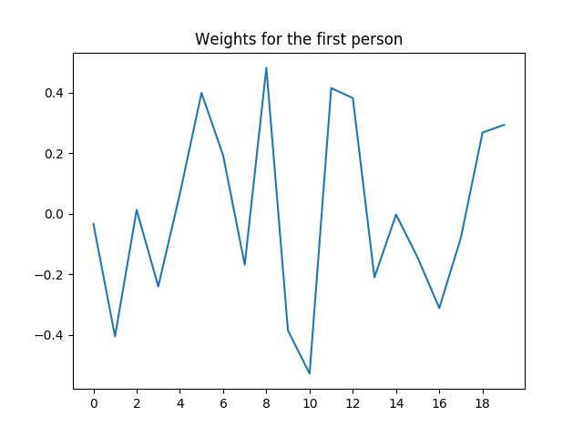
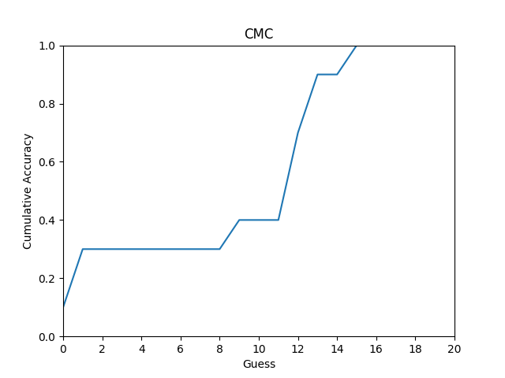
Sample Eigen Face

