Eric Kearney
CS 390S – Digital Image Processing
Professor Feng Jiang
27, October 2018

Assignment 5 – Face Detection

I didn’t quite follow the steps outlined for this assignment, instead I chose to simply detect skin, then remove everything except the largest contour, which will often be the face, then perform a simple dilation and erosion. Similar to the skin correction assignment, my script converts the image to hsv color space, then it uses hard-coded values found to be decent for human skin detection. Then I use OpenCV’s findCountour method, grab the largest of the found contours, then use OpenCV’s drawCountours method to created a mask. The drawContours method conveniently fills in any holes within the contour. Then I performed a dilation and an erosion, and got rid of everything from the original image that was outside of the mask.

I’ve included two additional images, both of the same person. The first, ‘chris_hemsworth_pass.jpg’, is another example of an image this script works on. The second, ‘chris_hemsworth_fail.jpg’ is an example of an image this script fails on. In this image, the subject is dressed in such a way that his entire arm is showing, to the point where there is more ‘arm skin’ than ‘face skin’ on display, making the arm the largest contour.

To test these images yourself, use:
python3 5assignment.py --image chris_hemsorth_pass/fail.jpg.

To see a step-by-step demonstration of how the facial detection is done, add the steps flag:
python3 5assignment.py –steps

Results

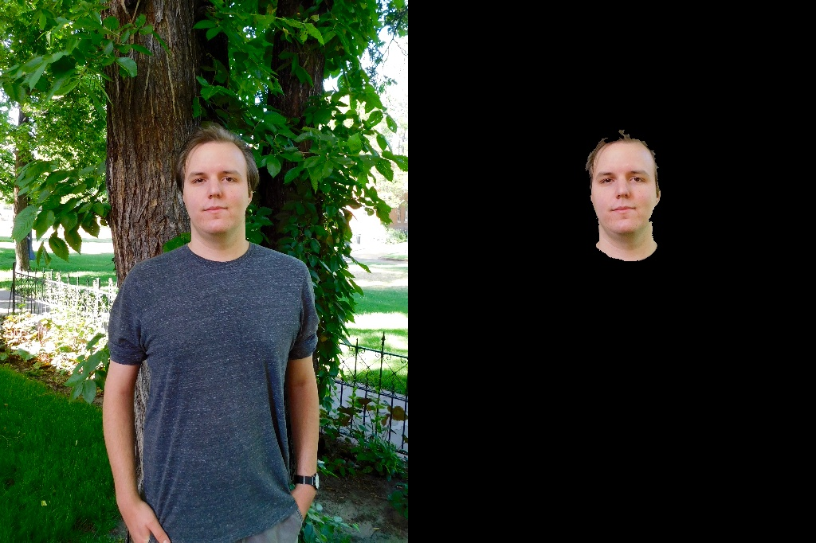


portrait.jpg
chris_hemsworth_pass.jpg
chris_hemsworth_fail.jpg

