Eric Kearney
CS 390S – Digital Image Processing
20, October 2018
Professor Feng Jiang

Assignment 4 – Noise generation and correction

The first part of this assignment was to generate 3 types of noise, Gaussian, uniform, and salt and pepper noise. I made use of numPys’ numpy.random.uniform(low, high, size) routine for the Gaussian and uniform noise generation. For Gaussian noise, we start by finding sigma by taking the square root (i.e., raising it to the 0.5 power) of the variance, which is provided as a parameter. We then use sigma as the high value and the mean as the low value in the numpy.random.uniform() method, we then use the size of the original image for the size parameter. In other words, we generate a uniform distribution of size (rows * columns) of values which are greater than or equal to the mean and less than or equal to sigma. Finally, we reshape the values we just generated and add them to the original image. The process for generating uniform noise was very similar.

Generating salt and pepper noise was a little different. The method I created takes three inputs, the image to generate noise for, s_vs_p, and amount. s_vs_p represents how much salt vs. pepper there should be. A value of 1 would generate only salt, and a value of 0 would generate only pepper, a value of 0.5 (which is what I used) will generate equal amounts of salt and pepper. The amount parameter dictates how much of the image should be ‘salted/peppered’. A value of 1 would mean ‘salt/pepper the entire image’. I used a value of 0.004, so 0.4% of the image will be affected.

As it turns out, removing the noise from the images was simpler than generating the noise. For both the Gaussian noise and the salt and pepper noise, I used an averaging filter. For the Gaussian noise I actually performed an averaging filter 3 times. The result is pretty blurry, but the noise is all-but gone. To remove the salt and pepper noise, I used a median filter, which I also repeated three times. The results on this one were pretty good!

Original
Gaussian
Uniform
Salt and Pepper

Original

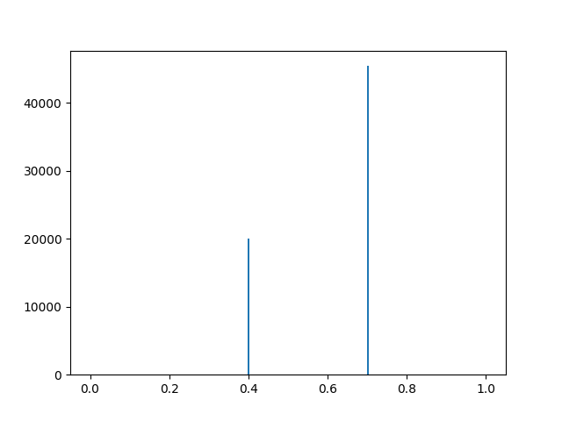
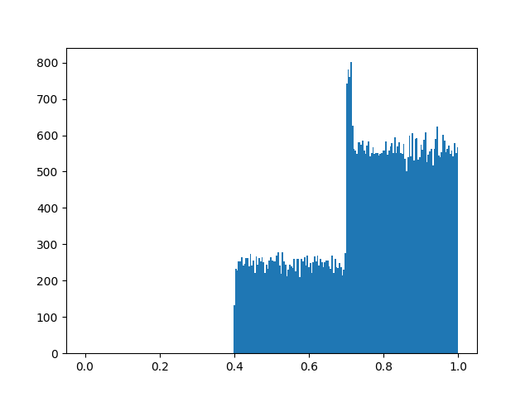
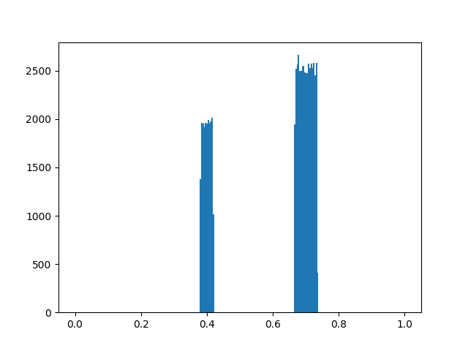
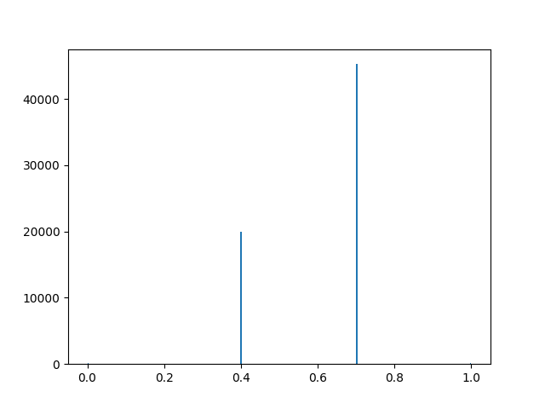
Histogram
Corrected

