Automated Non-Contact Assessment of Bread Size and Shape from RGB Images Using Computer Vision

Abstract
Manual dimensional inspection is difficult to scale in bakery quality control. This study developed a fully automated and reproducible pipeline for estimating bread width and height and for describing shape from ordinary RGB images. Mendeley Data version 1 (DOI 10.17632/f663p7c89m.1) was audited before modelling. Of 173 CSV rows, 171 uniquely mapped samples were eligible after excluding conflicting or unmatched records, and a deterministic grouped 70/15/15 split protected the final test set. Bread was segmented with Gaussian smoothing, Otsu thresholding, morphology, and contour validation. Validation-stage train-only pixel calibration was compared with linear, ridge, random-forest, and histogram-gradient-boosting regression on morphological features. The method selected on validation data was hist_gradient_boosting. On 26 untouched test samples it achieved width MAE 2.10, height MAE 2.40, width RMSE 3.12, height RMSE 3.02, and R² values of 0.694 and 0.847, respectively, in the dataset's nominal millimetre unit. Classical processing required 4.3 ms/image on CPU. The results establish a transparent low-cost baseline while exposing metadata, calibration, and external-validity limitations.
Keywords: computer vision; bread quality; non-destructive measurement; image processing; machine learning; measurement agreement; quality control

1. Introduction
Dimensions and visible shape are practical indicators of process consistency in bakery production, yet manual caliper measurements are intermittent, labour-intensive, and difficult to trace. RGB imaging offers inexpensive, non-contact acquisition and can run at line speed when the view, illumination, and scale are controlled. Reviews of imaging for baked goods describe broad use of colour, texture, size, and shape features, but also identify inconsistent acquisition and limited reproducibility [16,17]. Recent bread studies already use Gaussian filtering, Otsu thresholding, morphology, and OpenCV contours [2,5]; these operations are therefore a baseline, not the claimed novelty.
Existing work ranges from sliced-bread dimensional analysis [2] and baguette geometry [3] to sensory-trait prediction [4] and crumb-texture fingerprints [8]. Accuracy from those systems cannot be transferred because bread type, camera geometry, labels, and reference scales differ. The present contribution is an auditable batch workflow that links each image to instrument measurements, freezes a group-safe test set, compares simple and learned physical calibration, quantifies agreement, and reports CPU cost. The research question is whether this low-cost RGB pipeline can estimate width and height with useful accuracy and whether morphology-based learning reduces error relative to one-dimensional pixel calibration.
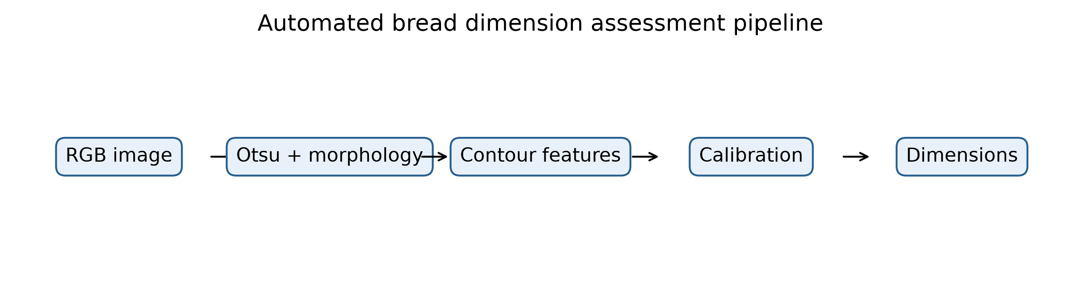
Figure 1. End-to-end workflow from the versioned dataset audit and group-safe split to segmentation, feature extraction, model selection, final-test evaluation, and generated research artifacts. The diagram emphasises that the test set is opened only after validation selection.

2. Materials and Methods

2.1 Dataset and audit
Quantity | Value
Archive images | 2211
Measurement rows | 173
Eligible samples | 171
Train / validation / test | 119 / 26 / 26
Segmentation failures | 0
The public CC BY 4.0 dataset by Mora [1] was downloaded from its official versioned record and kept outside Git. It contains texture, color, and size directories plus a semicolon-delimited CSV using decimal commas. The published total of 1,635 images was not treated as the dimensional sample count. The CSV has 173 rows and links one width/height view and one thickness view to each record. A repeated filename carries conflicting labels; both conflicting rows were excluded rather than silently corrected. This left 171 eligible physical sample identifiers. Source colour crops and texture images were not mixed into the dimension experiment. The CSV does not state the unit explicitly; values are treated as nominal millimetres and this uncertainty is preserved as a limitation.

2.2 Segmentation and shape features
Each RGB image was converted to grayscale, smoothed with a Gaussian kernel, and thresholded by Otsu's method [12]. Both threshold polarities were evaluated deterministically; morphological opening and closing removed small artefacts, after which the largest valid contour was retained. The implementation recorded failures, border contact, polarity, and processing time. Extracted features were bounding-box width and height, contour area, perimeter, aspect ratio, circularity, solidity, extent, equivalent diameter, and ellipse axes/eccentricity when defined. They are quantitative descriptors; no unsupported good/bad shape class was created.
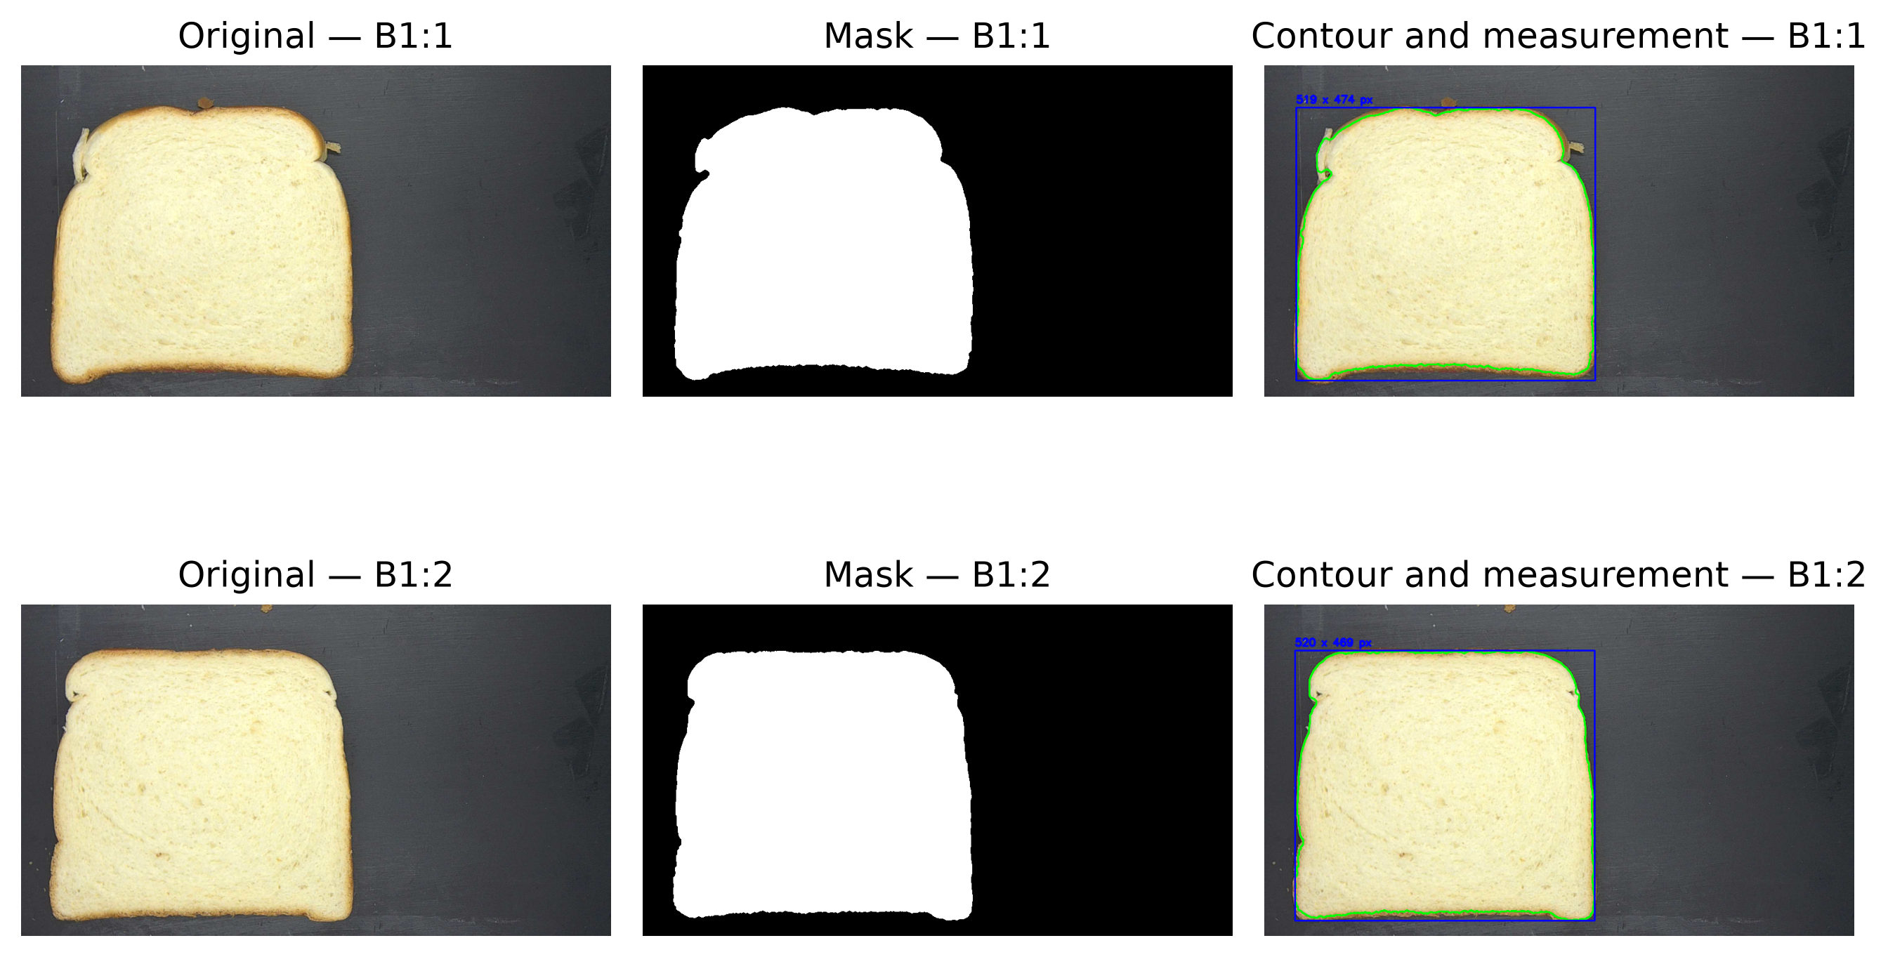
Figure 2. Representative source photographs from the size subset, automatically generated binary masks, and the retained bread contours with axis-aligned width and height measurements. The examples show that crust irregularities are retained instead of being replaced by an idealised geometric template.

2.3 Splitting and models
Sample identifiers, rather than images, were assigned to 70% training, 15% validation, and 15% test partitions with seed 42. Assertions require zero identifier overlap. Segmentation parameters and method selection did not use test outcomes. Method A fitted separate linear transforms from pixel width and height to physical targets using training data only. Method B compared ordinary linear regression, ridge regression, Random Forests [15], and histogram gradient boosting on the full morphology vector. A pre-specified ablation compared only width/height pixels against the full feature set. Preprocessing and imputation were fitted inside each training pipeline.

2.4 Evaluation
Models were selected by mean validation MAE and then fitted on training plus validation data for a single final-test evaluation. Width and height were scored separately using MAE, RMSE, MAPE where defined, and R². MAE confidence intervals used deterministic bootstrap resampling. Absolute errors were compared with paired Wilcoxon tests on identical samples. Because association is not agreement, the selected method was also assessed using Bland--Altman mean bias and 95% limits of agreement [13]. CPU timing includes segmentation and feature extraction after image loading.

3. Results and Discussion
Target | MAE | RMSE | R²
Width | 2.103 | 3.122 | 0.694
Height | 2.400 | 3.016 | 0.847
The validation-selected method was hist_gradient_boosting. On 26 untouched test samples, width MAE and RMSE were 2.10 and 3.12; height MAE and RMSE were 2.40 and 3.02. The corresponding R² values were 0.694 for width and 0.847 for height. Full per-method metrics, bootstrap intervals, predictions, ablation results, paired tests, and Bland--Altman limits are generated from the same run in reports/results.md and results/. Classical image processing averaged 4.3 ms/image on the recorded CPU environment. The lightweight image regression status for this run was completed; no missing CNN result is represented as a successful comparison.
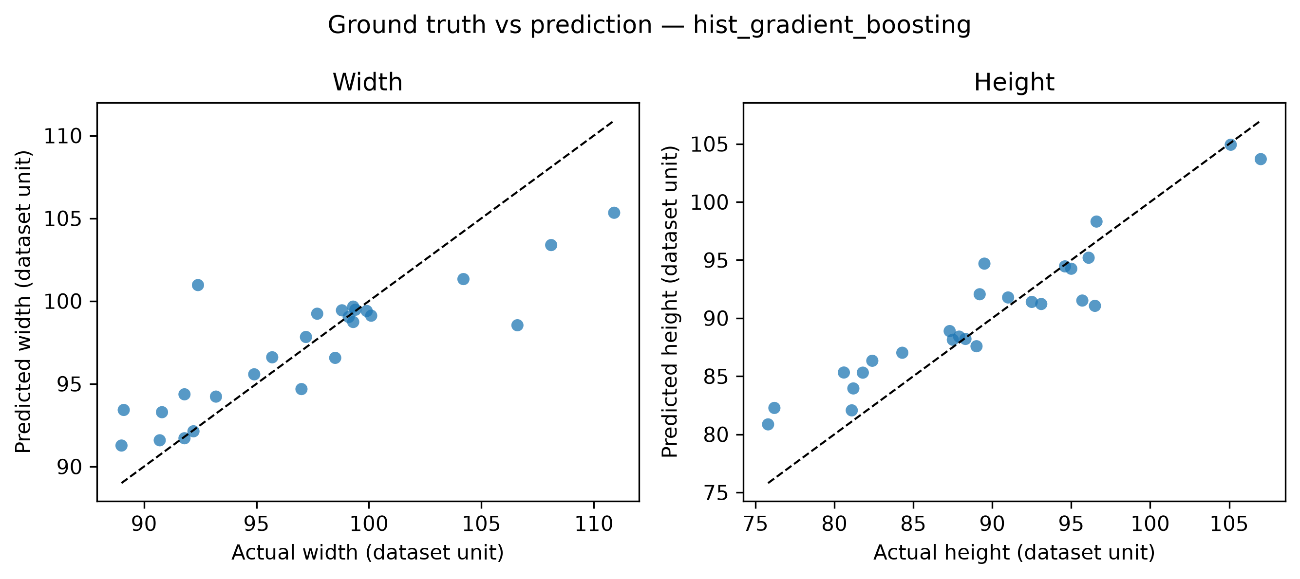
Figure 3. Ground truth versus predictions of the validation-selected model on the untouched test set. The dashed identity line makes systematic compression at the extremes visible, especially for large widths, even when the overall coefficient of determination remains positive.
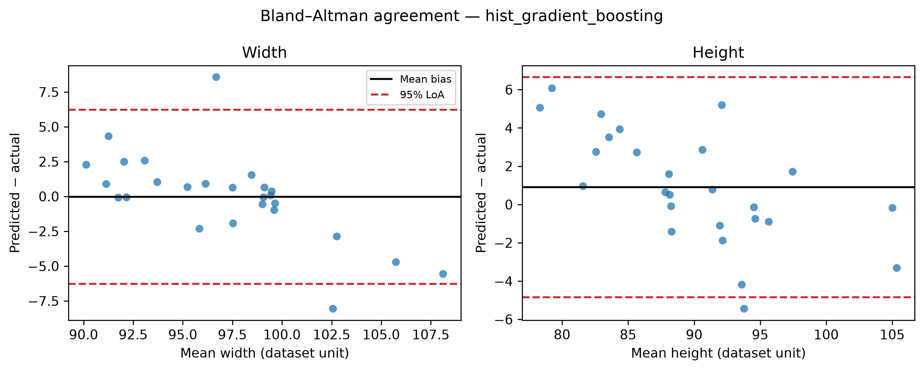
Figure 4. Bland--Altman agreement analysis for width and height. The central line represents mean bias and the outer lines the empirical 95% limits of agreement. This view complements R² by showing the magnitude and spread of pairwise measurement differences.
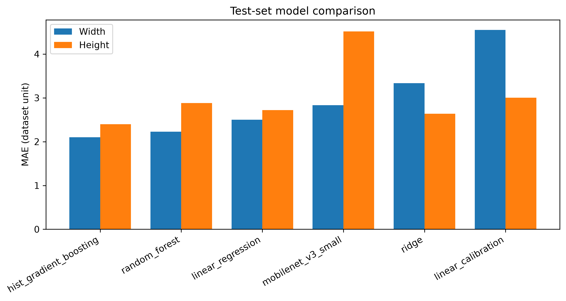
Figure 5. Final-test MAE comparison for linear calibration, morphology-based regressors, and MobileNetV3-Small. The CNN result is retained as a negative comparison rather than selectively omitted; on this sample size the compact morphology model performs better.
Differences between width and height errors can arise from irregular crust boundaries, orientation, and the fact that an axis-aligned bounding box responds to pose. Learned morphology can capture area and compactness relationships that a one-dimensional calibration omits, but it also remains tied to the acquisition booth and the observed bread families. Direct numerical comparison with prior work would be misleading: the sliced-bread study [2], baguette system [3], and RGB-D food systems [11] use different geometries and targets. The relevant advance is the fully traced evaluation rather than an unsupported claim of universal superiority.

4. Conclusion
The study delivered a reproducible RGB workflow connecting dataset audit, automatic contour measurement, leakage-safe calibration, compact regressors, agreement analysis, and CPU benchmarking. The validation-selected hist_gradient_boosting model obtained test MAE of 2.10 for width and 2.40 for height in the nominal dataset unit. Practical deployment remains conditional on external validation under new cameras, products, poses, and lighting; explicit reference geometry would also remove ambiguity in physical units. Future work should validate the pipeline prospectively, quantify instrument uncertainty, evaluate rotated geometries or learned segmentation, and test a lightweight CNN only when effective sample size and compute support a defensible experiment.

References
- Mora J. A dataset containing images of bread crumb and crust, along with measurements of size, color, and hardness. Mendeley Data, version 1, 2025. doi:10.17632/f663p7c89m.1.
- Martínez-Lara N.-D., Garzón-Castro C. L., Filomena-Ambrosio A. Analysis of physical properties in white and whole wheat sliced bread using digital image processing. Discover Food, 5, 261, 2025. doi:10.1007/s44187-025-00568-3.
- Dong C., Huang L., Xiong C., Li M., Tang J. Evaluation of quality of baguette bread using image analysis technique. Journal of Food Composition and Analysis, 140, 107222, 2025. doi:10.1016/j.jfca.2025.107222.
- Azmat M. et al. Assessing traits in bread using image analysis and machine learning. Food Research International, 235, 119131, 2026. doi:10.1016/j.foodres.2026.119131.
- Lee J., Kim Y., Kim S. The Study of an Adaptive Bread Maker Using Machine Learning. Foods, 12(22), 4160, 2023. doi:10.3390/foods12224160.
- Gonzalez Viejo C., Harris N. M., Fuentes S. Quality Traits of Sourdough Bread Obtained by Novel Digital Technologies and Machine Learning Modelling. Fermentation, 8(10), 516, 2022. doi:10.3390/fermentation8100516.
- Olakanmi S. J. et al. Quality Characterization of Fava Bean-Fortified Bread Using Hyperspectral Imaging. Foods, 13(2), 231, 2024. doi:10.3390/foods13020231.
- Ruderman M., Howell K. A., Appels R. Digital image analysis to assess the texture of bread products. Applied Food Research, 5(2), 101447, 2025. doi:10.1016/j.afres.2025.101447.
- Torres J. D. et al. Non-invasive microstructural characterization and in vivo glycemic response of white bread formulated with soluble dietary fiber. Food Bioscience, 61, 104505, 2024. doi:10.1016/j.fbio.2024.104505.
- Nallan Chakravartula S. S. et al. Computer vision-based smart monitoring and control system for food drying: A study on carrot slices. Computers and Electronics in Agriculture, 206, 107654, 2023. doi:10.1016/j.compag.2023.107654.
- Gonzalez B. et al. Automated Food Weight and Content Estimation Using Computer Vision and AI Algorithms. Sensors, 24(23), 7660, 2024. doi:10.3390/s24237660.
- Otsu N. A Threshold Selection Method from Gray-Level Histograms. IEEE Transactions on Systems, Man, and Cybernetics, 9(1), 62–66, 1979. doi:10.1109/TSMC.1979.4310076.
- Bland J. M., Altman D. G. Statistical methods for assessing agreement between two methods of clinical measurement. The Lancet, 327(8476), 307–310, 1986. doi:10.1016/S0140-6736(86)90837-8.
- Howard A. et al. Searching for MobileNetV3. Proceedings of the IEEE/CVF International Conference on Computer Vision, 1314–1324, 2019. doi:10.1109/ICCV.2019.00140.
- Breiman L. Random Forests. Machine Learning, 45, 5–32, 2001. doi:10.1023/A:1010933404324.
- Olakanmi S. J., Jayas D. S., Paliwal J. Applications of imaging systems for the assessment of quality characteristics of bread and other baked goods: A review. Comprehensive Reviews in Food Science and Food Safety, 22(3), 1817–1838, 2023. doi:10.1111/1541-4337.13131.
- Martínez-Lara N.-D., Filomena-Ambrosio A., Garzón-Castro C. L. Use of computer vision systems in baked products: potential tool for measuring physical properties. Journal of Food Measurement and Characterization, 20, 6925–6947, 2026. doi:10.1007/s11694-026-04154-8.
The same verified records are also available in machine-readable BibTeX form in references.bib.

