UI/UX DESIGN
SPECIFICATION
Professional Consulting Organization Website
and Digital Engagement Platform
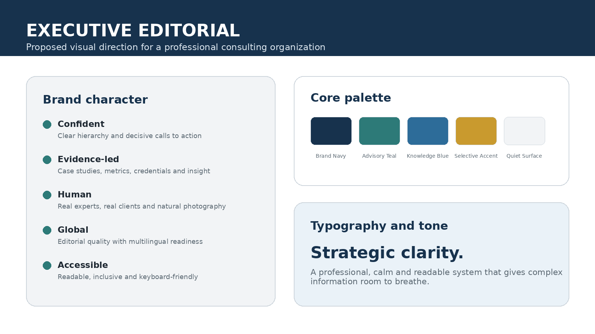
Document type | UI/UX Design Specification and Visual Design System
Version | 1.0
Date | 26 July 2026
Status | Design baseline for review and implementation
CONFIDENTIAL - FOR PROJECT, DESIGN AND PROCUREMENT USE

Document Control

Revision History
Version | Date | Prepared by | Summary
0.1 | 26 July 2026 | Solution Design Team | Initial UI/UX design baseline
1.0 | 26 July 2026 | Solution Design Team | Approved issue for design, implementation and acceptance

Approval Record
Role | Name | Decision | Date
Project Sponsor | ________________ | Approve / Reject | ____________
Business Owner | ________________ | Approve / Reject | ____________
UI/UX Lead | ________________ | Approve / Reject | ____________
Technical Lead | ________________ | Approve / Reject | ____________
Accessibility Reviewer | ________________ | Approve / Reject | ____________

Document authority
This document defines the intended visual, interaction and content experience for the approved platform. It complements the SRS, SDD and LLD. Where a conflict exists, the approved change-control process shall resolve the inconsistency before implementation.

Executive Summary
The website should feel like a credible international consulting organization rather than a generic corporate template. The proposed design direction is premium but restrained: strong editorial typography, generous whitespace, disciplined use of navy and teal, authentic expert-led imagery, visible evidence of impact, and clear paths to request advice.
The public experience is designed around trust and task completion. Visitors must quickly understand what the organization does, identify a relevant service or industry, evaluate expertise and results, and contact the right team without unnecessary friction. The administration experience is intentionally more functional, compact and workflow-driven while retaining the same visual language.

Design Baseline at a Glance
Dimension | Approved direction
Visual direction | Executive editorial: confident, calm, evidence-led and human
Primary audiences | Decision-makers, procurement teams, partners, job candidates, researchers and media
Primary conversions | Consultation requests, RFP submissions, contact messages, newsletter subscriptions and applications
Launch languages | English and Amharic, with layouts capable of supporting additional locales
Accessibility | WCAG 2.2 Level AA target across public and administrative journeys
Responsive model | Mobile-first, four-column mobile, eight-column tablet and twelve-column desktop grid
Technology alignment | Laravel 12, Blade/Tailwind/Alpine, progressive enhancement and server-rendered core journeys
Design governance | Token-based component system with documented states and acceptance criteria

Figure 1. Proposed executive editorial visual direction.

Table of Contents
The table below lists the principal controlled sections. Detailed subsections use Word heading styles for navigation and future automated updates.
Section | Page
1. Introduction | 6
2. Experience Strategy | 8
3. Audience and User Journeys | 10
4. Information Architecture and Navigation | 12
5. Visual Design System | 14
6. Responsive and Adaptive Design | 17
7. UI Component Library | 19
8. Public Website Page Specifications | 22
9. Consultation, Contact and Application Experiences | 26
10. CMS and Administration Experience | 28
11. Accessibility and Inclusive Design | 31
12. Content Design and Localization | 33
13. Interaction, Motion and Feedback | 35
14. Performance, SEO and Trust Experience | 36
15. Analytics, Consent and Privacy UX | 37
16. Design QA and Acceptance Criteria | 38
17. Design Handoff and Governance | 40
Appendix A. Design Tokens | 41
Appendix B. Page Inventory | 43
Appendix C. UI/UX Requirement Register | 45
Appendix D. Pre-Launch Checklist | 54

1. Introduction

1.1 Purpose
This UI/UX Design Specification defines how the Professional Consulting Organization Website and Digital Engagement Platform shall look, behave and communicate. It converts the approved business, software and technical baselines into a consistent experience that designers, developers, content teams, reviewers and testers can implement and verify.

1.2 Scope
• Public corporate website, knowledge center and structured professional content.
• Service, industry, expert, case study, insight, event and career discovery journeys.
• Consultation, contact, RFP, newsletter and job-application interactions.
• Multilingual behavior for English and Amharic content.
• Authenticated content-management and administration screens.
• Responsive, accessible, performance-conscious and trust-building design rules.
• Reusable design tokens, components, interaction states and quality criteria.

1.3 Out of Scope
• Final brand logo artwork where the organization has not supplied an approved identity.
• Pixel-perfect high-fidelity designs for every content variation; this document defines the system and required patterns.
• Future client portal, online payment and complete CRM workflows beyond interface placeholders and extensibility rules.
• Marketing campaign microsites that require separate approval and brand treatment.

1.4 Related Deliverables
Document | Relationship
Software Requirements Specification | Defines functional, non-functional and acceptance requirements.
Software Design Description | Defines architecture, modules, interfaces, security and deployment design.
Low-Level Design | Defines classes, routes, schemas, validation, permissions, jobs and tests.
This UI/UX Specification | Defines visual language, content hierarchy, responsive behavior and interaction quality.

1.5 Design Assumptions
• The organization provides or approves its logo, official name, legal details and brand assets before final visual sign-off.
• The platform launches with enough real content to demonstrate expertise, impact and leadership; placeholder content is not acceptable for production.
• English and Amharic content may differ in length; layouts must expand naturally without clipping or forced truncation.
• Core journeys remain usable when non-essential JavaScript fails or is disabled.

2. Experience Strategy

2.1 Experience Vision
Experience statement
A visitor should feel that the organization understands complex institutional problems, can explain them clearly, has credible experts and evidence, and is easy to engage.

2.2 Brand Personality
Attribute | Design interpretation
Confident, not loud | Use decisive language, strong headings and uncluttered layouts; avoid oversized promotional claims.
Expert, not academic | Present evidence and methodology in understandable language; avoid unnecessary jargon.
Premium, not decorative | Create quality through typography, spacing, photography and restraint rather than visual effects.
Human, not anonymous | Show identifiable experts, real collaboration and authentic project environments.
Global, not generic | Meet international quality expectations while respecting local institutional context and multilingual needs.
Accessible, not simplified | Provide sophisticated information through inclusive, readable and navigable patterns.

2.3 Core UX Principles
Principle | Required behavior
Clarity before persuasion | The visitor must understand the offer before being asked to act.
Evidence before claims | Support positioning with outcomes, case studies, credentials and named expertise.
One primary action per context | Each page should present a clearly dominant next step and a limited number of secondary actions.
Progressive disclosure | Show the essential message first, then allow users to explore detail without overwhelming the page.
Consistency creates trust | Use the same components, labels, spacing and state behavior across the platform.
Accessibility is a design input | Keyboard access, contrast, focus, language and content order are designed from the beginning.
Mobile is a primary experience | Do not treat mobile as a compressed desktop layout.
Performance is visible quality | Pages should feel immediate, stable and responsive even on slower connections.

2.4 Desired Emotional Response
• “This organization is credible and experienced.”
• “They understand challenges like ours.”
• “I can see how they work and what results they achieve.”
• “I can identify the right expert or service quickly.”
• “It is safe and straightforward to share my inquiry.”

2.5 UX Success Indicators
Indicator | Target interpretation | Evidence
Comprehension | A first-time visitor can explain the organization and core services after viewing the hero and first content section. | Moderated usability testing
Findability | A visitor reaches a relevant service, industry, expert or insight within three primary navigation actions. | Task test and analytics
Conversion clarity | Users understand what happens after a consultation, contact or application submission. | Post-task interview
Accessibility | Critical journeys pass keyboard, screen-reader and contrast verification. | Accessibility test report
Perceived quality | Users describe the interface as professional, trustworthy, clear and modern. | Qualitative research

3. Audience and User Journeys

3.1 Primary Audience Segments
Audience | Primary need | Priority destinations
Executive decision-maker | Needs rapid understanding of strategic relevance, credibility and likely outcomes. | Services, industries, impact, leadership, consultation
Procurement or program lead | Needs scope, methodology, credentials, delivery evidence and a safe RFP channel. | Case studies, experts, documents, RFP submission
Technical or functional specialist | Needs detailed capability descriptions, publications and expert profiles. | Service detail, insights, expert search
Partner or development organization | Needs institutional profile, sectors, locations, governance and collaboration evidence. | About, projects, partners, contact
Job candidate or consultant | Needs culture, opportunities, requirements and a reliable application experience. | Careers, vacancy detail, application
Researcher, media or public visitor | Needs authoritative information, reports, announcements and contacts. | Search, insights, press, contact
Content editor or approver | Needs efficient, safe and auditable content creation and publishing. | CMS dashboard, editor, workflow, preview

3.2 Priority User Journeys
Journey | Expected path
Discover a service | Home -> Services -> Service detail -> Related case study -> Consultation request
Evaluate sector experience | Industries -> Industry detail -> Case studies -> Experts -> Contact
Assess organizational credibility | About -> Leadership -> Methodology -> Clients/partners -> Consultation
Find a specialist | Experts -> Filter -> Profile -> Related insights/case studies -> Contact
Download a report | Insights -> Search/filter -> Report detail -> Consent if required -> Download
Submit an RFP | Request consultation -> Select RFP -> Organization/project details -> Upload -> Review -> Confirmation
Apply for a vacancy | Careers -> Vacancy -> Requirements -> Application -> Upload -> Confirmation
Publish content | CMS login/MFA -> Create/edit -> Validate -> Preview -> Submit for review -> Approve -> Publish

3.3 Journey Design Rules
• Every primary journey shall expose a clear current location, next step and exit or recovery route.
• The system shall preserve user-entered data when validation fails and where technically safe during short interruptions.
• Cross-links shall be contextual: service pages link to relevant industries, experts, case studies and insights rather than generic lists.
• The user shall never need to understand the internal organizational structure to contact the correct team.
• Confirmation screens shall state what was received, provide a reference where applicable and explain the expected response process.

4. Information Architecture and Navigation

4.1 Sitemap
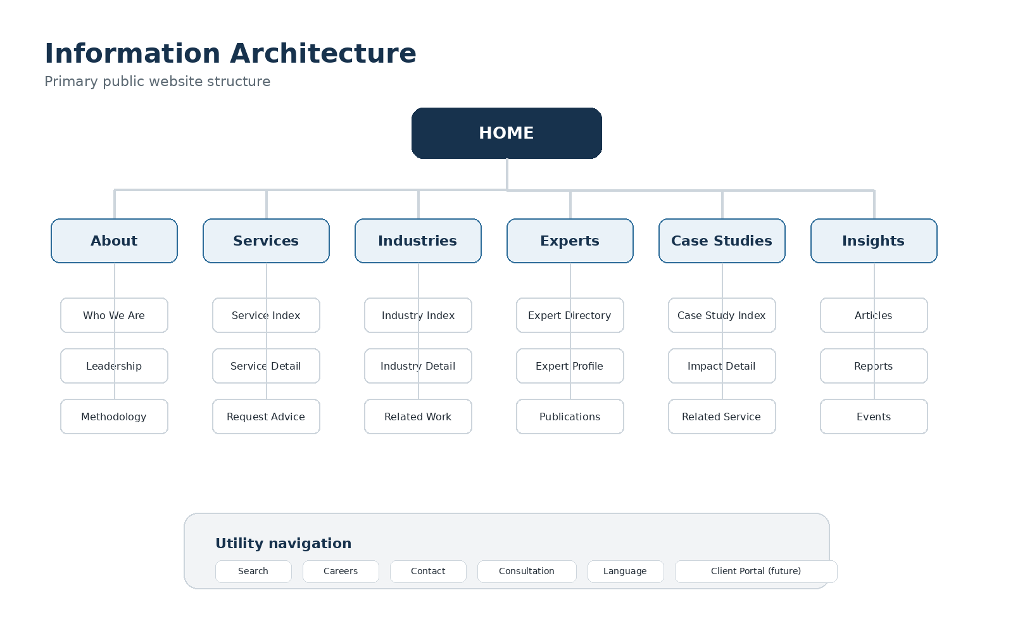
Figure 2. Recommended public information architecture.

4.2 Global Header
• Desktop header: organization logo/name at left; primary navigation in the center; search, language and consultation action at right.
• The header may be sticky after the user scrolls beyond the hero, but it shall not consume excessive vertical space.
• The primary consultation action shall remain visible on desktop and accessible within the first mobile navigation level.
• The active navigation item shall be visually distinguishable without relying only on color.
• The header shall provide a skip link as the first keyboard-focusable element.

4.3 Mega Menu
Menu | Recommended structure | Behavior
Services | Capability categories, featured services, short explanatory text and consultation action. | Open on click and keyboard activation; do not depend on hover.
Industries | Sector categories, featured industries and selected impact story. | Use a concise list; avoid exposing every page at once.
Insights | Article, report, event and media categories with featured content. | Allow direct access to the full knowledge center.
About | Who we are, leadership, approach, offices, partners and careers. | Keep institutional information grouped and understandable.

4.4 Mobile Navigation
• Use a full-height navigation panel or sheet with a visible close control and trapped keyboard focus.
• Top-level items expand as accordions; only one or a small number should remain open to reduce scrolling.
• Search, language and consultation actions remain visible without scrolling to the bottom of the menu.
• Closing the menu returns focus to the menu trigger.

4.5 Breadcrumbs and Local Navigation
• Breadcrumbs appear on detail pages deeper than one level and use descriptive labels rather than URLs.
• Long detail pages may use a sticky in-page section navigation on desktop and a compact jump menu on mobile.
• The current breadcrumb item is plain text and is not linked to itself.

4.6 Search and Filtering
Area | Required UX
Global search | Predictive suggestions may be used, but a standard results page must always be available.
Results | Group or label results by content type and show title, summary, type, date and relevant metadata.
Filters | Use visible filter chips or a filter panel; show result count and active filters; provide Clear all.
Mobile filters | Open in a modal/sheet with Apply and Clear controls; retain selections when closed.
No results | Explain the query, suggest corrections or broader categories and provide a contact route.

5. Visual Design System

5.1 Approved Design Concept
The approved concept is “Executive Editorial.” It combines the confidence and reading quality of a premium business publication with the clarity and task focus of a modern digital service. The interface should feel composed rather than crowded, structured rather than boxed, and professional rather than promotional.
Avoid
Generic template sections, excessive gradients, background video, auto-rotating carousels, glassmorphism, decorative animation, crowded icon grids, stock-photo clichés and unsupported claims.

5.2 Color System
Token | Hex | Primary use | Accessibility rule
Brand Navy | #17324D | Primary headings, header, footer, high-trust surfaces | Use on white; white text on navy
Advisory Teal | #2D7A78 | Primary action, active navigation, links, focus emphasis | White text for large controls; test small text
Knowledge Blue | #2D6C99 | Information, insight categories, secondary emphasis | Use with white or pale blue surfaces
Selective Gold | #C99A2E | Awards, metrics, premium detail and limited highlights | Never use as body-text color on white
Ink | #1F2933 | Primary body copy | Default text color
Muted | #5D6A74 | Secondary copy, metadata and captions | Do not use below AA contrast
Quiet Surface | #F2F4F6 | Section backgrounds, table alternation and skeleton states | Pair with ink/navy text
Danger | #C0392B | Validation errors and destructive actions | Never communicate by color alone

5.3 Typography
Role | Recommended specification | Usage
Display / hero | 48-64 px desktop; 36-44 px mobile; bold; tight but readable line height | One decisive message, normally not more than three lines
Page title | 40-52 px desktop; 32-40 px mobile | Detail-page identity and primary topic
Section heading | 28-36 px desktop; 24-30 px mobile | Clear editorial separation between page sections
Card title | 18-24 px | Service, insight, expert and case-study cards
Body | 16-18 px public website; 15-16 px admin | Primary reading content; line length approximately 55-75 characters
Metadata | 13-15 px | Dates, types, reading time, tags and supporting labels
Font families | English: Inter, Arial or approved sans-serif. Amharic: Noto Sans Ethiopic or approved Ethiopic typeface. | Use a consistent fall-back stack and verify glyph coverage

5.4 Spacing and Layout Rhythm
• Use a base spacing unit of 4 px and preferred increments of 8, 12, 16, 24, 32, 48, 64, 80 and 96 px.
• Public-page sections normally use 64-96 px vertical padding on desktop and 40-64 px on mobile.
• Text blocks should not touch card edges; standard card padding is 24-32 px desktop and 20-24 px mobile.
• Separate unrelated content with whitespace before adding borders or background colors.
• Maintain a maximum reading width even when the page container is wide.

5.5 Grid and Containers
Viewport | Grid | Container | Gutter
Large desktop | 12 columns | Maximum 1200-1280 px | 24-32 px
Desktop | 12 columns | Fluid with 48-64 px outer margin | 24 px
Tablet | 8 columns | Fluid with 32 px outer margin | 20-24 px
Mobile | 4 columns | Fluid with 16-20 px outer margin | 16 px

5.6 Iconography
• Use one coherent outline icon set with consistent stroke weight and optical size.
• Icons support labels; they do not replace critical text unless the control is universally understood and has an accessible name.
• Avoid mixing filled, outline, 3D and illustration styles within the same interface.
• Country flags shall not represent language selection.

5.7 Photography and Illustration
• Prioritize real experts, workshops, client environments, public-service settings, infrastructure, technology and field work.
• Images should communicate collaboration and expertise, not staged handshakes or generic office smiles.
• Use natural color grading and consistent aspect ratios; avoid heavy filters and text embedded inside images.
• Every informative image requires meaningful alternative text; decorative images use empty alternative text.
• Illustrations may explain frameworks or processes but should be simple, brand-aligned and secondary to real evidence.

5.8 Shape, Borders and Elevation
Element | Rule
Corners | Use a restrained 8-16 px radius; cards should not look excessively rounded or playful.
Borders | Use light neutral borders to define structure; avoid heavy boxes around every section.
Shadows | Use subtle shadows only for overlays, menus, sticky elements or elevated interactive cards.
Section backgrounds | Alternate white and quiet neutral surfaces to create rhythm; use navy for strategic emphasis.
Decorative lines | Use thin rules and small accent bars to support editorial hierarchy.

6. Responsive and Adaptive Design
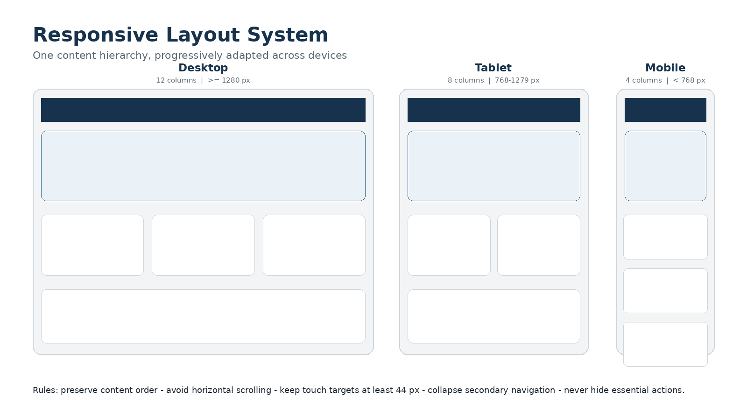
Figure 3. Responsive grid and layout adaptation rules.

6.1 Breakpoint Strategy
Breakpoints shall be selected according to content behavior rather than device names. The baseline categories below support implementation and testing but components may adapt earlier where content becomes constrained.
Category | Indicative width | Primary behavior
Mobile | < 768 px | Single-column reading, four-column layout system, collapsed navigation and full-width primary actions
Tablet | 768-1279 px | Eight-column grid, two-column cards where appropriate, simplified mega menu and reduced section spacing
Desktop | >= 1280 px | Twelve-column grid, full navigation, multi-column editorial layouts and sticky local navigation

6.2 Responsive Content Priority
• Preserve the same semantic content order across viewport sizes.
• Do not hide essential information or primary actions on mobile.
• Reorder purely decorative media only where reading order and accessibility remain correct.
• Long tables should transform into stacked records, enable controlled horizontal scroll with clear affordance, or use a purpose-built mobile summary.
• Cards should become full-width before text becomes narrow or typography is reduced below approved sizes.

6.3 Touch and Pointer Input
• Interactive targets shall be at least 44 by 44 CSS pixels where practical.
• Adjacent touch targets shall include sufficient separation to avoid accidental activation.
• Hover may enhance an interaction but shall never be the only method of revealing essential information.
• Swipe gestures require visible alternatives and shall not be used for critical actions without confirmation.

6.4 Mobile Homepage
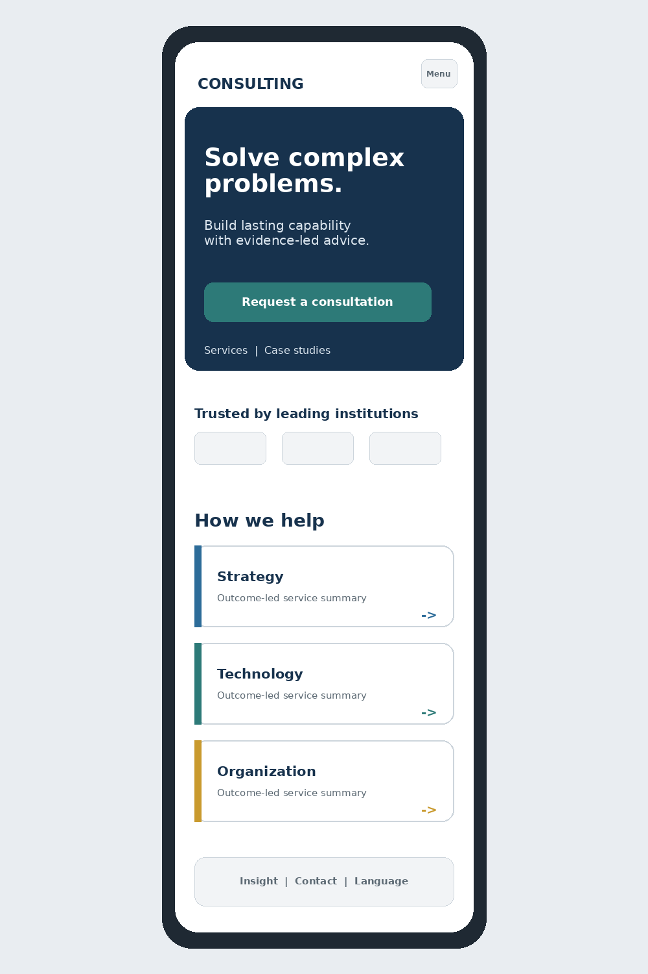
Figure 4. Conceptual mobile homepage hierarchy.

7. UI Component Library

7.1 Component Governance
All screens shall be assembled from a documented component library. Components are semantic, accessible, responsive and state-complete. New one-off patterns require design review before implementation.

7.2 Buttons and Links
Variant | Use | Rules
Primary | One dominant action in a page section or form step | Filled teal; clear verb; avoid more than one competing primary action in the same visual group
Secondary | Alternative or supporting action | Outlined or quiet treatment; visually subordinate to primary
Tertiary / text | Low-emphasis navigation or inline action | Use descriptive link text; preserve clear focus state
Destructive | Delete, revoke or irreversible action | Use danger color, confirmation and explicit consequence
Icon button | Compact action with recognized icon | Provide accessible name, tooltip where helpful and 44 px target

7.3 Form Controls
• Labels remain visible above fields and are programmatically associated with controls.
• Placeholder text may provide an example but shall not replace the label or instructions.
• Required fields are identified in text; avoid relying only on an asterisk without explanation.
• Help text appears before errors and remains available after validation.
• Inline errors identify the problem and how to correct it; a summary links to all invalid fields for long forms.
• Date, phone and numeric formats shall support the active locale without preventing valid international input.

7.4 Cards
Card type | Required content | Interaction
Service | Service name, outcome-led summary, category and link | Entire card may be clickable if link semantics and focus are correct
Industry | Industry name, contextual image/graphic and short relevance statement | Link to industry detail
Expert | Portrait, name, role, specialisms and location/language where relevant | Link to profile; image not the only clickable target
Case study | Challenge/outcome title, industry, service, key metric and image | Emphasize measurable impact
Insight | Type, title, summary, author/date, reading time and image where useful | Support bookmark/share only if implemented consistently
Vacancy | Title, location, type, closing date and status | Closing date and application action must be prominent

7.5 Navigation Components
• Breadcrumb, tabs, pagination, in-page navigation and filter chips shall expose selected and focus states.
• Tabs are used only when content is closely related and users do not need to compare panels simultaneously.
• Accordions use buttons with expanded state and do not contain hidden critical information by default.
• Pagination uses Previous, Next and meaningful page labels; infinite scroll is not the default for knowledge content.

7.6 Feedback and System Status
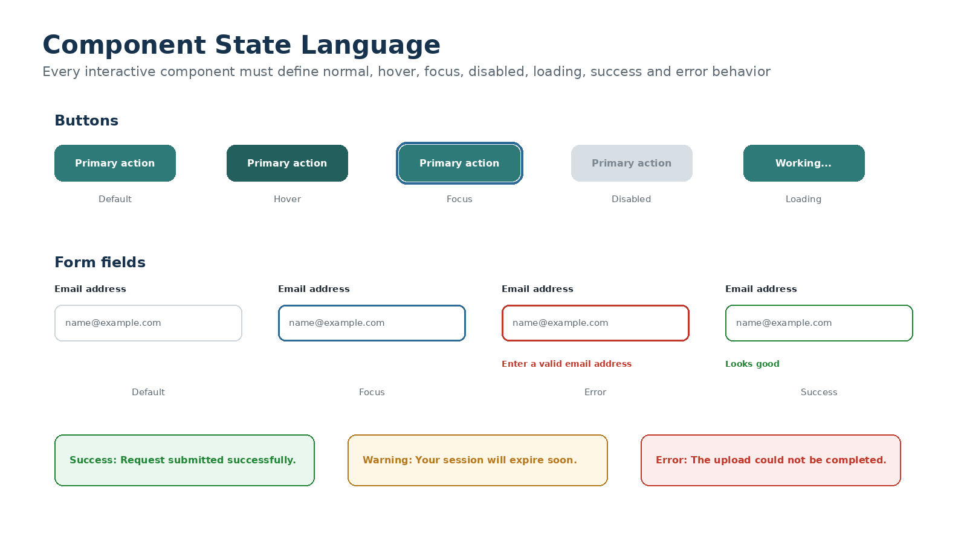
Figure 5. Required component and feedback states.
• Success messages confirm the completed action and the next step.
• Warning messages explain risk before the user commits an action.
• Error messages do not blame the user and preserve entered information where safe.
• Loading indicators appear when an action is not immediate; use skeletons for predictable content layouts.
• Toast notifications supplement, but do not replace, persistent confirmation for important actions.

7.7 Tables and Data Lists
• Administrative tables use clear column labels, sorting indicators, filtering, pagination and row actions.
• Row actions should be grouped and not require precise pointer movement.
• Bulk actions remain disabled until rows are selected and show the selection count.
• Status uses text plus color/icon, and date columns display a consistent locale-aware format.
• On small screens, prioritize essential columns and provide a structured record view rather than shrinking text excessively.

7.8 Modals, Drawers and Overlays
• Use a modal only when the user must respond before continuing; use a drawer for contextual editing or filters.
• Focus moves into the overlay, remains contained, and returns to the trigger after closure.
• The Escape key closes non-destructive overlays unless doing so would lose unsaved work without warning.
• Destructive confirmation names the affected item and consequence; avoid generic “Are you sure?” messages.

8. Public Website Page Specifications

8.1 Homepage
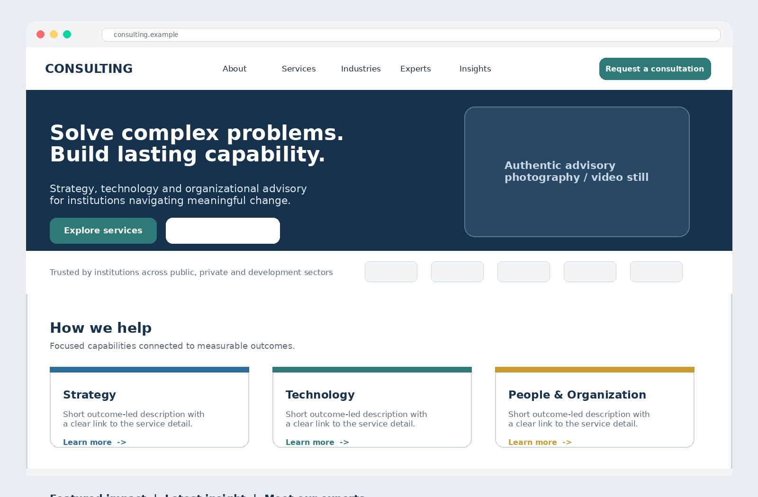
Figure 6. Conceptual desktop homepage hierarchy.
Section | Purpose | Required content
Header | Orient and enable immediate action | Logo, primary navigation, search, language and consultation action
Hero | Explain the organization in seconds | Outcome-led headline, supporting statement, primary CTA, secondary CTA and authentic media
Credibility strip | Provide immediate trust signals | Selected clients/partners, certifications or quantified reach, subject to permission
Services | Expose the main capability areas | Three to six priority service cards and route to all services
Featured impact | Demonstrate results | Case study with challenge, intervention and measurable outcome
Industries | Show sector relevance | Priority sectors with concise context
Experts | Humanize the organization | Selected experts and link to directory
Insights | Demonstrate thought leadership | Recent or featured report/article/event
Final CTA | Convert informed visitors | Consultation invitation with expectations and contact alternative
Footer | Provide utility and legal access | Contact, offices, sitemap groups, social links, legal, accessibility and language

Homepage rule
The homepage is a decision path, not a complete company brochure. It should prioritize understanding, credibility and next action rather than display every available content type.

8.2 About and Institutional Pages
• Use a strong organizational narrative: purpose, history, values, leadership, approach and locations.
• Replace generic mission language with evidence, timelines, governance or capability indicators where available.
• Leadership profiles shall link to full expert pages where those people provide advisory services.
• Client and partner logos require permission and meaningful grouping; they shall not appear as an unexplained wall of logos.

8.3 Services Index
• Open with a concise explanation of how service categories relate to client outcomes.
• Support browsing by category and keyword where the catalogue is large.
• Service cards use outcome language rather than internal department names.
• Provide a cross-cutting consultation call to action after the catalogue and within relevant groups.

8.4 Service Detail
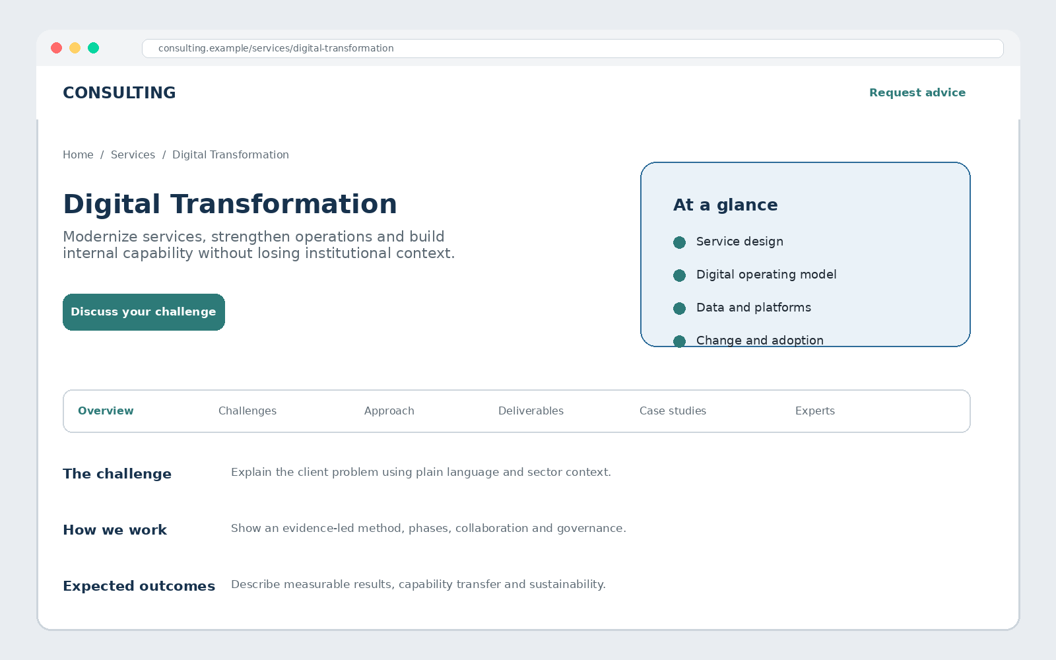
Figure 7. Conceptual service-detail page.
Section | Design requirement
Hero | Service name, concise value statement, primary consultation action and optional at-a-glance capability list
Client challenges | Recognizable problems written from the client perspective
Approach | Phases, methods, collaboration model and differentiators
Deliverables/outcomes | Concrete outputs and expected measurable benefits
Related experience | Case studies relevant to the service
Experts | Named specialists with profiles
Insights | Relevant reports or articles
CTA | Service-specific consultation prompt with preselected service context

8.5 Industry Index and Detail
• Industry pages should demonstrate understanding of sector context, not merely repeat service descriptions.
• Use sector challenges, regulatory or operating context, relevant services, case studies, experts and insights.
• The hero image or visual should be specific to the sector and not rely on generic corporate photography.

8.6 Expert Directory and Profile
Screen | Required UX
Directory | Search and filters for expertise, service, industry, location and language where data is available; clear reset action
Expert card | Consistent portrait, name, role, two or three specialisms and location/language metadata
Profile hero | Portrait, name, role, expertise, short biography and appropriate professional contact/link
Profile body | Experience, credentials, selected projects, publications, languages and related services
Privacy | Do not expose personal contact information without approval; route inquiries through controlled channels

8.7 Case Studies
• Index cards foreground outcomes, not only project titles.
• Detail pages use a clear narrative: context, challenge, approach, implementation, results and lessons.
• Quantified metrics identify the time period or basis where needed and avoid misleading precision.
• Confidential engagements may anonymize the client while retaining sector, challenge and result credibility.
• Related service, industry and experts are visible without interrupting the case-study narrative.

8.8 Insights and Knowledge Center
Area | Design requirement
Index | Featured content plus searchable/filterable list by type, topic, service, industry and date
Article | Readable editorial width, author/date, share controls, related content and optional table of contents
Report | Executive summary, publication metadata, preview/image, download action and data-use notice where applicable
Events | Date/time/timezone, format/location, agenda, speakers, registration state and accessibility information
Media | Video/audio controls, captions/transcripts and no autoplay with sound

8.9 Careers and Vacancy Pages
• The careers page explains culture, values, working model, opportunities and recruitment process with authentic employee content.
• Vacancy detail pages make location, employment type, closing date, responsibilities, requirements and application action easy to scan.
• Expired vacancies remain clearly marked and do not display an active application button.
• Application forms explain required documents, privacy, save/return behavior if available and expected next steps.

8.10 Contact, Offices and Legal Pages
• Contact options are organized by user need; do not present a long undifferentiated list of email addresses.
• Office pages include accessible address text, phone, working hours, directions and map as an enhancement rather than the sole source.
• Privacy, terms, cookies, accessibility, complaints and ethics pages use readable layouts and plain-language summaries.
• The accessibility statement provides a contact route for reporting barriers.

9. Consultation, Contact and Application Experiences

9.1 Consultation and RFP Flow
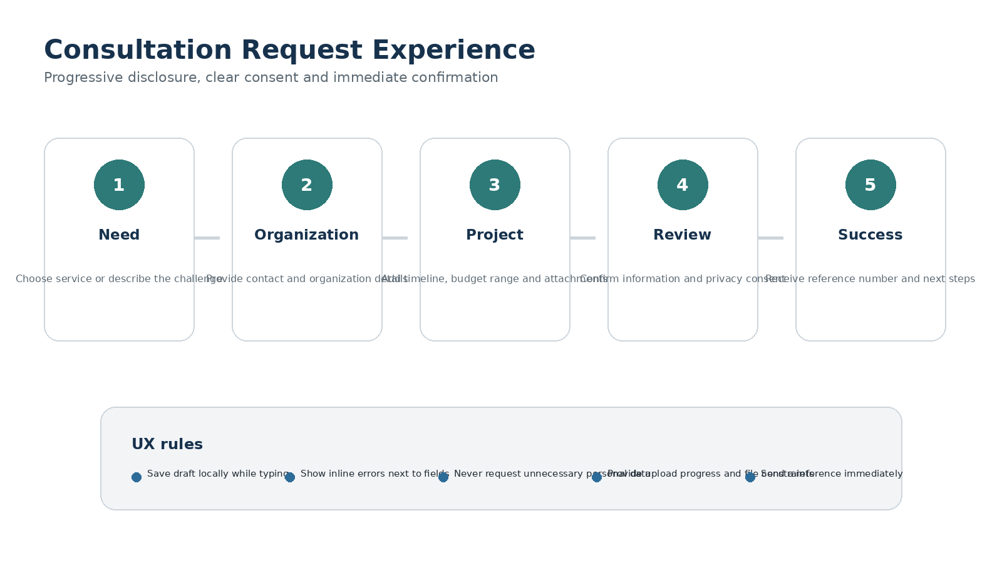
Figure 8. Recommended consultation and RFP experience.

9.2 Form Structure
Step | Information | UX rule
Need | Service/topic, inquiry type and challenge summary | Allow “I am not sure” and route without forcing internal terminology
Organization | Name, organization, role, email, phone and location | Request only data needed for routing and response
Project | Objectives, timing, budget range and supporting documents | Use optional ranges and clear file constraints
Review | Summary of entered information and privacy consent | Allow edit by section without losing data
Confirmation | Reference, submitted summary, response expectation and contact route | Send acknowledgement and provide printable/downloadable confirmation where required

9.3 Validation and Error Recovery
• Validate after meaningful interaction or submission, not on every keystroke where it creates distraction.
• Place error text beside the relevant field and provide an error summary for multi-section forms.
• Preserve valid values when other fields fail.
• Differentiate client-side format guidance from server-side or security rejection.
• For a network failure, explain that submission was not completed and offer a safe retry without duplicate creation.

9.4 File Upload
• Display allowed file types, maximum size and maximum file count before selection.
• Show file name, size, upload/scan status, progress and remove action.
• Do not imply successful submission until server validation and security scanning complete or are safely queued.
• Provide an alternative contact route when the user cannot upload an essential document.

9.5 Newsletter and Lightweight Forms
• Newsletter subscription should require minimal data and clearly state content frequency and unsubscribe behavior.
• Contact and event registration forms use the same label, validation, consent and confirmation patterns as consultation forms.
• Spam-prevention challenges shall be accessible and should not be shown unless risk signals justify them.

10. CMS and Administration Experience

10.1 Design Direction
The CMS should feel related to the public brand but prioritize speed, clarity and operational safety. It uses denser spacing, smaller typography and more tables than the public website, while maintaining the same colors, status language, focus states and accessibility rules.
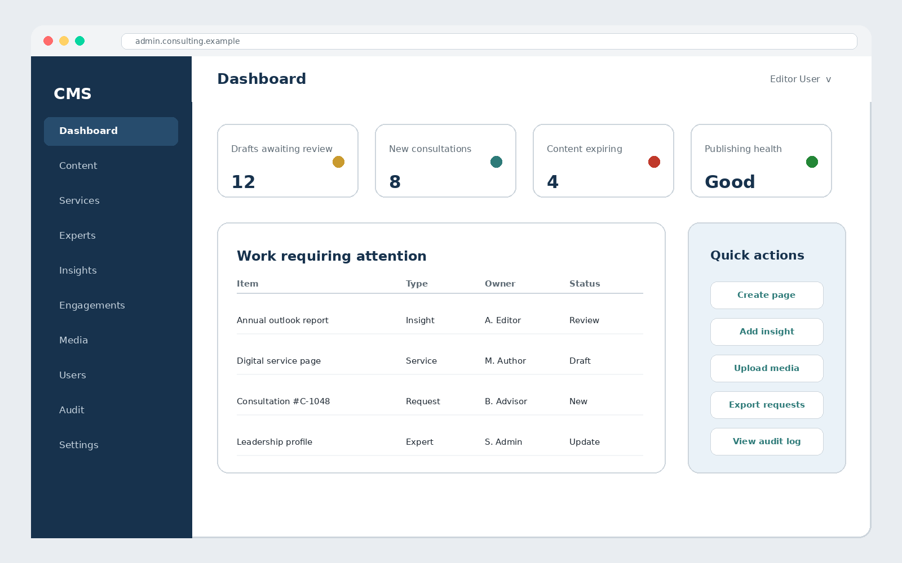
Figure 9. Conceptual CMS dashboard.

10.2 Login and MFA
• Use a focused, single-purpose login screen with organization identity, clear labels and password visibility control.
• MFA screens explain the requested factor, recovery route and security consequence without exposing sensitive system detail.
• Authentication errors remain generic enough to prevent account enumeration while still guiding legitimate users.
• Session-expiry warnings give the user an opportunity to continue safely and preserve unsaved work where practical.

10.3 Dashboard
Area | Required content
Attention summary | Drafts awaiting review, new engagements, failed jobs, expiring content and unresolved accessibility/SEO issues
Recent work | Items recently edited, assigned or submitted for review
Quick actions | Create page/insight, add expert, upload media, review requests and view audit log according to permission
System status | Publishing, search, email/queue and storage health at a level appropriate for the user role

10.4 Content Lists
• Display content title, type, locale, owner, status, updated date and scheduled/published date as appropriate.
• Support search, filters, sorting, saved views where valuable and explicit Clear filters.
• Row actions shall be permission-aware and use descriptive labels.
• Bulk actions require confirmation and show affected item count.
• Empty lists explain why no items are present and how authorized users can create the first item.

10.5 Content Editor
Region | Required behavior
Main canvas | Structured fields and approved rich-text blocks; avoid an unrestricted page builder for core content types
Status panel | Owner, workflow state, locale, visibility, publication schedule and validation status
Preview | Desktop/mobile preview for the selected locale using production-like rendering
Autosave/draft | Show last saved time and distinguish local changes from server-saved state
Validation | Provide field-level and document-level issues before review or publication
Relationships | Searchable selectors for related services, industries, experts, case studies and insights
SEO/social | Title, description, canonical, indexing, social image and preview with guidance

10.6 Publishing Workflow
1. Author creates or updates content in Draft state.
2. The system validates required content, locale completeness, media, links and applicable SEO/accessibility checks.
3. Author previews and submits for review with an optional note.
4. Reviewer compares, comments, returns for changes or approves according to permission.
5. Authorized publisher publishes immediately or schedules a future date.
6. The system confirms publication, invalidates caches, updates search and records the audit event.

10.7 Media Library
• Provide upload, security-scan state, image dimensions, file size, crop/focal point, alternative text, caption, rights/source and usage references.
• Warn before deleting an asset that is in use and show where it is referenced.
• Support responsive renditions without requiring editors to upload multiple files manually.
• Do not allow decorative filenames or missing alternative-text decisions to pass silently for published informative images.

10.8 Engagement Inbox
• Consultation, RFP, contact and application records use separate or clearly labeled queues.
• Lists show reference, submitter/organization, category, received time, assignee, status and priority where applicable.
• The detail view separates submitted data, attachments, internal notes, assignment and audit timeline.
• Sensitive records and attachments remain permission-restricted and are not exposed in general search or dashboard summaries.

10.9 Users, Roles, Audit and Settings
• Role and permission screens explain access in business language and show affected scope.
• High-risk permission changes require confirmation and appear in the audit trail.
• Audit views support actor, action, object, date and result filters without enabling log alteration.
• Settings group related controls, display safe defaults and identify changes requiring deployment or restart.

11. Accessibility and Inclusive Design

11.1 Conformance Target
The baseline target is WCAG 2.2 Level AA for public and authenticated experiences. Compliance shall be verified through automated checks, keyboard testing, screen-reader testing, contrast review and representative user testing; automated tools alone are not sufficient.

11.2 Keyboard and Focus
• Every interactive element is reachable and operable by keyboard in a logical sequence.
• Focus indicators are clearly visible on light and dark surfaces and are never removed without an equivalent replacement.
• Skip links, landmarks and headings support efficient navigation.
• Mega menus, accordions, tabs, modals and drawers follow established keyboard patterns.
• Focus is managed after route changes, validation failures, overlay closure and dynamic updates.

11.3 Color and Contrast
• Text and essential interface elements meet the applicable contrast ratio for their size and function.
• Color is never the only indicator of status, selection, error or required information.
• Charts and diagrams use labels, patterns or direct values in addition to color.
• High-contrast mode and browser color overrides shall not make core journeys unusable.

11.4 Structure and Semantics
• Each page has one clear H1 and a logical heading hierarchy without skipped levels for visual styling.
• Landmarks, lists, tables, buttons, links and form controls use native semantic elements where possible.
• Link text describes destination or purpose; avoid repeated “Learn more” without accessible context.
• Language is set at page level and for passages that switch language.

11.5 Forms and Errors
• Labels, instructions, errors and required states are programmatically connected to fields.
• Error summaries receive focus after failed submission and link to invalid controls.
• Time limits are avoided or can be extended where security permits.
• Authentication supports password managers, paste and accessible MFA methods.

11.6 Media, Documents and Motion
• Informative images have meaningful alternative text; complex diagrams include an equivalent text explanation.
• Video includes synchronized captions and important audio content has a transcript.
• Downloadable documents intended for public use are created with accessible structure and metadata.
• Animation respects reduced-motion preferences and does not flash or move continuously without control.

11.7 Accessibility Acceptance Matrix
Area | Acceptance condition | Method
Keyboard | Complete primary journeys without a pointer; no traps; visible focus | Manual
Screen reader | Correct landmarks, headings, names, states and error announcements | NVDA/VoiceOver or approved equivalent
Contrast | Text, controls, focus and status indicators meet target ratios | Automated plus visual review
Zoom/reflow | Content remains usable at 200% zoom and narrow reflow without loss of information | Manual responsive test
Forms | Labels, instructions, autocomplete, errors and success messages are understandable | Manual plus automated
Media | Alt text decisions, captions, transcripts and document accessibility are complete | Editorial and technical review

12. Content Design and Localization

12.1 Voice and Tone
Context | Tone | Example approach
Homepage and service pages | Confident, concise and outcome-led | State the problem solved and value created before describing internal capability
Insights | Authoritative and evidence-based | Use clear summaries, sources, dates and responsible authorship
Forms | Direct, respectful and reassuring | Explain why information is needed and what happens next
Errors | Calm and constructive | Describe the problem and correction without blame
Legal/privacy | Plain, precise and transparent | Provide a readable summary while retaining authoritative detail
Admin | Operational and unambiguous | Use exact states, actions and consequences

12.2 Writing Rules
• Use short descriptive headings and front-load important information.
• Prefer active voice and concrete verbs.
• Avoid inflated claims such as “world-class” unless supported by evidence.
• Explain abbreviations on first use and avoid internal organizational terminology in public navigation.
• Buttons describe actions: “Request a consultation,” “Download the report,” “Submit application.”
• Dates, numbers, time zones and contact information use consistent locale-aware formats.

12.3 English and Amharic Layout
• English and Amharic are equal content experiences, not a primary language plus incomplete translation.
• Components expand vertically to accommodate longer translations; fixed-height text containers are prohibited.
• Amharic typography is tested for glyph shape, line height, weight and readability on all target platforms.
• Translation status is visible in the CMS and incomplete locales cannot be published accidentally where completeness is required.
• Language switching attempts to preserve the equivalent page and clearly falls back when no equivalent exists.

12.4 Microcopy Examples
Situation | Preferred wording | Avoid
Primary CTA | Request a consultation | Click here
Empty search | No results matched “{query}”. Try fewer words or browse our services. | Nothing found
Required field | Enter your work email so we can respond to this request. | Email required
Upload failure | The file was not uploaded. Check the file type and size, then try again. | Upload error
Success | Your request has been received. Reference: C-1048. | Success!
Destructive action | Delete “Draft service page”? This cannot be undone. | Are you sure?

13. Interaction, Motion and Feedback

13.1 Interaction Principles
• Interactions should feel immediate, predictable and reversible where practical.
• Controls communicate affordance through shape, label, contrast and state rather than animation alone.
• The interface confirms meaningful state changes and prevents duplicate actions during processing.
• Progressive enhancement ensures navigation, reading and core form submission do not require decorative JavaScript.

13.2 Motion
Motion type | Recommended duration | Rule
Hover/focus transition | 100-160 ms | Subtle color, border or elevation change; no movement that causes reflow
Accordion/menu | 160-240 ms | Quick enough to preserve flow; state remains understandable without animation
Modal/drawer | 180-280 ms | Fade/translate modestly; focus moves only after the overlay is ready
Page/section reveal | Optional 200-400 ms | Use sparingly; content shall remain visible with reduced motion or no JavaScript
Loading | Immediate indicator after a short threshold | Avoid fake progress and indefinite spinners without explanation

13.3 Reduced Motion
When the user prefers reduced motion, non-essential transitions, parallax, animated counters, auto-scrolling and reveal effects shall be removed or simplified. Functional state changes must remain clear.

13.4 Feedback Timing
• Show pressed/loading state immediately when a potentially slow action begins.
• Do not show a success state until the authoritative server action has completed.
• For queued work, distinguish “received for processing” from “completed.”
• Long-running exports or uploads show progress or a clear background-processing message and completion route.

14. Performance, SEO and Trust Experience

14.1 Perceived Performance
• Reserve image and media dimensions to prevent layout shift.
• Prioritize hero text and primary action before non-essential media.
• Use responsive images, modern formats, lazy loading below the fold and controlled font loading.
• Use skeletons only when the content structure is predictable; otherwise show a simple loading state.
• Avoid heavy third-party scripts, large background videos and decorative libraries that delay interaction.

14.2 SEO as User Experience
• Page titles and descriptions accurately describe content and match visible headings.
• URLs are short, stable, language-aware and readable.
• Structured headings, breadcrumbs and internal links help visitors as well as search engines.
• Social previews use meaningful titles, descriptions and approved images.
• Language alternatives and canonical behavior are consistent with the selected localization model.

14.3 Trust Signals
Signal | Required treatment
Experts | Real names, roles, biographies, credentials and related work; no anonymous “team” claims
Outcomes | Quantified impact with context and approval; avoid unexplained statistics
Clients/partners | Display only with permission and understandable grouping
Contact | Verifiable office, email, phone and response process
Privacy/security | Visible privacy link, consent language, secure upload cues and no unnecessary personal data
Freshness | Publication/updated dates where relevant; expired events and vacancies clearly marked
Accessibility | Published accessibility statement and barrier-reporting contact

14.4 Error and Maintenance Pages
• 404 pages explain that the content cannot be found and provide search, services, insights and contact routes.
• 500 or temporary outage pages acknowledge the problem without exposing technical detail and provide a retry or contact route.
• Maintenance notices state affected functions and expected availability only when reliable information exists.
• Form errors are not replaced by generic error pages unless the submission cannot be safely processed.

15. Analytics, Consent and Privacy UX

15.1 Measurement Principles
• Measure user outcomes such as service discovery, consultation completion, report download and application completion rather than vanity page views alone.
• Event names and properties are documented, stable and free from unnecessary personal information.
• Analytics shall not record free-text form content, uploaded documents or sensitive administrative data.
• Consent choices are honored before optional tracking is activated.

15.2 Consent Interface
• The first consent layer explains purposes in plain language and offers equivalent Accept, Reject and Manage choices where legally required.
• Non-essential cookies or storage are not set before valid consent.
• The detailed preference center groups purposes clearly and identifies third parties where applicable.
• Users can revisit and change preferences through a persistent footer link.
• Consent controls are keyboard accessible and do not use manipulative colors, wording or placement.

15.3 Recommended UX Events
Event | Trigger | Useful properties
service_view | Service detail rendered | service_slug, locale
consultation_start | User opens consultation form | entry_page, selected_service, locale
consultation_complete | Authoritative submission succeeds | request_type, selected_service, locale - no free text
report_download | Download begins after any required consent | report_id, locale
expert_filter | Expert results update | filter types and result count - no personal user data
vacancy_apply_start | Application form opens | vacancy_id, locale
search_result_select | User selects a result | query category or hashed/controlled value, result type and rank

16. Design QA and Acceptance Criteria

16.1 Review Stages
1. Content and information-architecture review confirms page purpose, hierarchy and required data.
2. Wireframe review confirms user journeys, layout structure and responsive priorities.
3. Visual-design review confirms brand expression, typography, color, imagery and component consistency.
4. Prototype usability review validates priority journeys with representative users.
5. Accessibility review verifies interaction patterns before and after implementation.
6. Implementation QA compares built screens to approved design and component specifications.
7. Pre-launch review verifies content, responsive behavior, performance, SEO, analytics, consent and error states.

16.2 Screen Acceptance Criteria
Area | Acceptance condition
Hierarchy | The page has one clear purpose, H1, primary action and logical section order.
Consistency | Approved tokens and components are used without unexplained one-off styles.
Responsive | The page is usable at target widths without clipping, overlap or horizontal page scroll.
Accessibility | Keyboard, focus, semantics, contrast, zoom, errors and media requirements pass.
Content | Approved English and Amharic content is complete, readable and not truncated.
States | Loading, empty, error, success, disabled and permission-denied states are implemented where applicable.
Performance | Images, fonts, scripts and layout stability meet the approved technical targets.
Trust | Contact, privacy, dates, authorship and evidence are accurate and visible.
Analytics | Approved events fire only after applicable consent and contain no prohibited data.

16.3 Usability Test Tasks
Task | Success condition
Find a service for an organizational challenge | Participant identifies a relevant service and explains why it fits.
Verify sector experience | Participant locates a relevant case study and expert.
Submit a consultation request | Participant completes the form, understands consent and recognizes confirmation.
Find and download a report | Participant filters insights, understands metadata and downloads the correct asset.
Apply for a vacancy | Participant identifies requirements, submits valid information and understands next steps.
Publish an insight in the CMS | Authorized user creates, validates, previews, submits, approves and publishes without assistance.

16.4 Defect Severity
Severity | Definition | Examples
Critical | Prevents a core journey, creates serious accessibility/security risk or loses data. | Cannot submit consultation; keyboard trap; sensitive data exposed
High | Major requirement fails with no acceptable workaround. | Mobile navigation unusable; contrast failure on primary controls; publication state incorrect
Medium | Requirement partially fails but task remains possible. | Inconsistent spacing; unclear empty state; minor responsive wrapping
Low | Cosmetic or editorial issue with minimal task impact. | Minor icon alignment; non-critical copy refinement

17. Design Handoff and Governance

17.1 Required Design Deliverables
• Information architecture and approved page inventory.
• Responsive wireframes for all unique page templates and critical states.
• High-fidelity designs for representative desktop and mobile screens.
• Interactive prototypes for consultation, search/filter, mobile navigation, publishing and other complex journeys.
• Design-token file covering color, typography, spacing, radius, border, elevation and motion.
• Component library with variants, states, responsive behavior and accessibility annotations.
• Content and localization notes, including Amharic examples on representative screens.
• Export-ready icons, images and social-preview assets with rights and alternative-text decisions.

17.2 Developer Handoff Rules
• Design measurements shall map to tokens and components rather than hard-coded per-screen values.
• Each component includes normal, hover, focus, active, disabled, loading, success and error behavior where applicable.
• Designs identify semantic HTML expectations and keyboard behavior for non-trivial components.
• Responsive annotations explain reflow and priority, not only provide static screenshots.
• Open questions and deviations are resolved in a shared decision log before implementation proceeds.

17.3 Change Control
A change that affects navigation, page purpose, content model, accessibility, security, privacy, core component behavior or approved brand tokens requires impact assessment across the SRS, SDD, LLD, this UI/UX baseline, implementation and tests. Minor copy or content updates follow the editorial workflow.

17.4 Design Ownership
Role | Responsibility
Product/Business Owner | Approves priorities, scope, content purpose and success criteria.
UI/UX Lead | Owns experience strategy, visual system, prototypes, accessibility annotations and design quality.
Content Lead | Owns voice, content structure, localization, editorial quality and content readiness.
Technical Lead | Confirms feasibility, component architecture, performance and secure implementation.
Accessibility Reviewer | Verifies inclusive design and implementation across priority journeys.
QA Lead | Maintains visual, functional, responsive and accessibility acceptance coverage.

Appendix A. Design Tokens

A.1 Semantic Color Tokens
Token | Value | Usage
color.primary.900 | #17324D | Header, footer, display text and high-emphasis surfaces
color.primary.700 | #2D6C99 | Informational emphasis, secondary links and charts
color.secondary.700 | #2D7A78 | Primary action, active states and advisory accent
color.accent.600 | #C99A2E | Selective highlights, awards and premium details
color.text.default | #1F2933 | Primary body text
color.text.muted | #5D6A74 | Metadata and secondary text
color.surface.default | #FFFFFF | Primary surface
color.surface.muted | #F2F4F6 | Alternate section and quiet control surface
color.border.default | #CDD5DC | Neutral borders and dividers
color.success | #238636 | Successful state with text/icon
color.warning | #B7791F | Warning state with text/icon
color.danger | #C0392B | Error and destructive action

A.2 Typography Tokens
Token | Desktop | Mobile | Notes
text.display | 56/64, 700 | 40/48, 700 | Hero message; maximum three lines preferred
text.h1 | 48/56, 700 | 36/44, 700 | Page title
text.h2 | 36/44, 700 | 28/36, 700 | Major section
text.h3 | 24/32, 700 | 22/30, 700 | Subsection/card group
text.body.lg | 18/30, 400 | 17/28, 400 | Lead and readable long-form content
text.body | 16/26, 400 | 16/26, 400 | Default public body
text.label | 14/20, 600 | 14/20, 600 | Form labels, metadata emphasis
text.caption | 13/18, 400 | 13/18, 400 | Secondary metadata only

A.3 Spacing, Radius and Elevation Tokens
Category | Tokens | Recommended use
Spacing | 4, 8, 12, 16, 24, 32, 48, 64, 80, 96 px | Use the smallest token that creates clear separation; avoid arbitrary values
Radius | 4, 8, 12, 16 px | Inputs 8-12; cards 12-16; tags 999 only when pill semantics are intentional
Border | 1 px default; 2 px focus/selected | Use neutral default and semantic state colors
Elevation 1 | 0 1px 2px rgba(0,0,0,.08) | Subtle cards only when border is insufficient
Elevation 2 | 0 8px 24px rgba(15,35,55,.14) | Menus, drawers and sticky overlays
Focus ring | 0 0 0 3px rgba(45,108,153,.28) | Visible on all interactive components

A.4 Tailwind Semantic Mapping
Semantic name | Suggested mapping
primary | Brand navy scale derived from #17324D
secondary | Advisory teal scale derived from #2D7A78
info | Knowledge blue scale derived from #2D6C99
accent | Selective gold scale derived from #C99A2E
surface | white / quiet neutral / navy emphasis surfaces
text | default / muted / inverse / link semantic roles
state | success / warning / danger / disabled / focus semantic roles

Appendix B. Page Inventory
Page / Template | Primary purpose | Primary action
Home | Explain value, prove credibility and route priority journeys | Request a consultation
About | Explain purpose, history, values and institutional credibility | Meet the organization / Contact
Leadership | Introduce accountable leadership and expertise | View profiles
Methodology / How We Work | Explain engagement approach and collaboration model | Discuss a challenge
Services Index | Browse capabilities by client outcome | Open service detail
Service Detail | Explain challenge, approach, deliverables and related evidence | Request advice
Industries Index | Browse sectors | Open industry detail
Industry Detail | Show sector understanding and relevant experience | Discuss sector challenge
Expert Directory | Find specialists | Open expert profile
Expert Profile | Evaluate expertise, credentials and related work | Contact / View related content
Case Studies Index | Browse evidence by service/industry | Open case study
Case Study Detail | Explain challenge, intervention and results | Explore related service
Insights Index | Search and filter knowledge content | Open content
Article Detail | Read an authoritative article | View related insight / Contact
Report Detail | Understand and download a publication | Download report
Events Index/Detail | Discover and register for events | Register
Careers | Explain culture and opportunities | View vacancies
Vacancy Detail | Evaluate role and requirements | Apply
Application Form | Submit candidate information and files | Submit application
Consultation / RFP | Submit structured engagement request | Submit request
Contact | Reach the correct team or office | Send message / Call
Office Detail | Provide accessible location and contact information | Get directions / Contact
Search Results | Find content across the site | Open result
Newsletter | Subscribe with informed consent | Subscribe
Privacy / Terms / Cookies | Provide transparent legal and privacy information | Manage preferences / Contact
Accessibility Statement | Explain accessibility commitment and barrier reporting | Report an accessibility issue
404 / 500 / Maintenance | Recover from system or navigation problems | Search / Return home / Contact
CMS Login / MFA | Authenticate securely | Sign in / Verify
CMS Dashboard | Prioritize work and issues | Open assigned work
CMS Content List | Find, filter and manage records | Create / Edit / Review
CMS Editor | Create structured content safely | Save / Preview / Submit
CMS Review / Compare | Approve or return changes | Approve / Return
CMS Media Library | Manage reusable media and metadata | Upload / Select
CMS Engagement Inbox | Triage consultations, contacts and applications | Assign / Update status
CMS Users and Roles | Manage authorized access | Invite / Update / Revoke
CMS Audit and Settings | Review change history and configuration | Filter / Update setting

Appendix C. UI/UX Requirement Register
The following implementation requirements make the design baseline testable. “Must” is mandatory for the baseline release; “Should” is strongly recommended and may be deferred only through approved change control.

C.1 Strategy and hierarchy
ID | Requirement | Priority | Verification
UIUX-01-01 | The interface shall express a confident, evidence-led, human and accessible consulting brand. | Must | Inspection / Test
UIUX-01-02 | Each public page shall have one clear purpose and one visually dominant primary action. | Must | Inspection / Test
UIUX-01-03 | The page hierarchy shall communicate the essential message before supporting detail. | Must | Inspection / Test
UIUX-01-04 | Claims of expertise or impact shall be accompanied by evidence or clearly identified supporting content. | Must | Inspection / Test
UIUX-01-05 | The design shall avoid decorative patterns that reduce readability or perceived credibility. | Must | Inspection / Test
UIUX-01-06 | The public and CMS interfaces shall share semantic tokens while using different density appropriate to their tasks. | Must | Inspection / Test
UIUX-01-07 | Core journeys shall remain understandable without animation or non-essential media. | Must | Inspection / Test
UIUX-01-08 | The design shall support English and Amharic without fixed-height text containers. | Must | Inspection / Test

C.2 Navigation and discovery
ID | Requirement | Priority | Verification
UIUX-02-01 | The primary navigation shall expose About, Services, Industries, Experts and Insights or approved equivalents. | Must | Inspection / Test
UIUX-02-02 | Search, language selection and consultation action shall be available from the global header. | Must | Inspection / Test
UIUX-02-03 | Mega menus shall be operable by click, touch and keyboard and shall not depend on hover. | Must | Inspection / Test
UIUX-02-04 | Mobile navigation shall expose the consultation action without requiring deep scrolling. | Must | Inspection / Test
UIUX-02-05 | Detail pages deeper than one level shall provide breadcrumbs. | Must | Inspection / Test
UIUX-02-06 | Long detail pages shall provide an accessible section-navigation mechanism where useful. | Must | Inspection / Test
UIUX-02-07 | Search results shall identify content type and relevant metadata. | Must | Inspection / Test
UIUX-02-08 | Active filters shall be visible and individually removable, with a Clear all action. | Must | Inspection / Test
UIUX-02-09 | No-results states shall suggest recovery options and relevant browsing routes. | Must | Inspection / Test
UIUX-02-10 | Language switching shall preserve the equivalent page when an approved translation exists. | Must | Inspection / Test

C.3 Visual system
ID | Requirement | Priority | Verification
UIUX-03-01 | The interface shall use the approved semantic color tokens rather than hard-coded arbitrary colors. | Must | Inspection / Test
UIUX-03-02 | Body text shall use a readable default size of approximately 16-18 CSS pixels on the public website. | Must | Inspection / Test
UIUX-03-03 | Long-form text shall use a controlled reading width and comfortable line height. | Must | Inspection / Test
UIUX-03-04 | The layout shall use the approved four-, eight- and twelve-column responsive grid. | Must | Inspection / Test
UIUX-03-05 | Section spacing and component padding shall use the approved spacing scale. | Must | Inspection / Test
UIUX-03-06 | The interface shall use one coherent icon style. | Must | Inspection / Test
UIUX-03-07 | Informative photography shall be authentic, relevant and rights-cleared. | Must | Inspection / Test
UIUX-03-08 | Text shall not be embedded inside essential images. | Must | Inspection / Test
UIUX-03-09 | Card corner radius, border and elevation shall use approved tokens. | Must | Inspection / Test
UIUX-03-10 | The design shall not use auto-rotating carousels for essential content. | Must | Inspection / Test
UIUX-03-11 | The design shall not use autoplay video with sound. | Must | Inspection / Test
UIUX-03-12 | Color shall not be the sole carrier of meaning. | Must | Inspection / Test

C.4 Responsive behavior
ID | Requirement | Priority | Verification
UIUX-04-01 | The public website shall not produce horizontal page scrolling at supported viewport widths. | Must | Inspection / Test
UIUX-04-02 | Essential content and primary actions shall remain available on mobile. | Must | Inspection / Test
UIUX-04-03 | Touch targets shall be at least 44 by 44 CSS pixels where practical. | Must | Inspection / Test
UIUX-04-04 | Desktop multi-column content shall reflow before text or controls become constrained. | Must | Inspection / Test
UIUX-04-05 | Administrative tables shall provide a usable mobile record pattern or controlled table scrolling. | Must | Inspection / Test
UIUX-04-06 | Responsive images shall use appropriate source sizes and reserved dimensions. | Must | Inspection / Test
UIUX-04-07 | Sticky elements shall not obscure focused content or consume excessive viewport height. | Must | Inspection / Test
UIUX-04-08 | Responsive reordering shall preserve semantic reading and keyboard order. | Must | Inspection / Test

C.5 Components and states
ID | Requirement | Priority | Verification
UIUX-05-01 | Every interactive component shall define default, hover, focus, active and disabled states where applicable. | Must | Inspection / Test
UIUX-05-02 | Asynchronous actions shall define loading, success and failure feedback. | Must | Inspection / Test
UIUX-05-03 | Primary buttons shall use clear action verbs. | Must | Inspection / Test
UIUX-05-04 | Destructive actions shall state the affected item and consequence before confirmation. | Must | Inspection / Test
UIUX-05-05 | Form labels shall remain visible and shall not be replaced by placeholders. | Must | Inspection / Test
UIUX-05-06 | Required fields shall be identified using text and programmatic semantics. | Must | Inspection / Test
UIUX-05-07 | Validation errors shall be associated with fields and summarized for long forms. | Must | Inspection / Test
UIUX-05-08 | Cards shall expose a clear title, summary and destination. | Must | Inspection / Test
UIUX-05-09 | Tabs, accordions and overlays shall follow accessible keyboard patterns. | Must | Inspection / Test
UIUX-05-10 | Modal focus shall be contained and returned to the trigger on close. | Must | Inspection / Test
UIUX-05-11 | Toast messages shall not be the only confirmation for important actions. | Must | Inspection / Test
UIUX-05-12 | Pagination shall provide Previous/Next and meaningful page labels. | Must | Inspection / Test
UIUX-05-13 | Empty states shall explain the situation and the next available action. | Must | Inspection / Test

C.6 Public pages
ID | Requirement | Priority | Verification
UIUX-06-01 | The homepage hero shall explain the organization, target problem and value proposition in concise language. | Must | Inspection / Test
UIUX-06-02 | The homepage shall expose priority services, evidence, experts, insights and a final consultation action. | Must | Inspection / Test
UIUX-06-03 | Service detail pages shall include challenges, approach, deliverables/outcomes, evidence and experts. | Must | Inspection / Test
UIUX-06-04 | Industry pages shall provide sector-specific context rather than repeat generic service text. | Must | Inspection / Test
UIUX-06-05 | Expert profiles shall include approved credentials, expertise and related content. | Must | Inspection / Test
UIUX-06-06 | Case studies shall follow a context, challenge, approach and results narrative. | Must | Inspection / Test
UIUX-06-07 | Insight pages shall provide content type, author, date and related content. | Must | Inspection / Test
UIUX-06-08 | Report pages shall provide metadata, summary and an accessible download route. | Must | Inspection / Test
UIUX-06-09 | Event pages shall display timezone, location/format and registration state. | Must | Inspection / Test
UIUX-06-10 | Vacancy pages shall display closing date, requirements, location/type and application state. | Must | Inspection / Test
UIUX-06-11 | Expired content shall be clearly identified and shall not expose invalid primary actions. | Must | Inspection / Test
UIUX-06-12 | Legal and accessibility pages shall use the same readable design quality as marketing pages. | Must | Inspection / Test
UIUX-06-13 | Error pages shall provide recovery routes and shall not expose technical details. | Must | Inspection / Test

C.7 Engagement forms
ID | Requirement | Priority | Verification
UIUX-07-01 | Consultation and RFP forms shall use progressive disclosure and logical steps. | Must | Inspection / Test
UIUX-07-02 | Users shall be able to identify an uncertain service need without selecting internal terminology. | Must | Inspection / Test
UIUX-07-03 | The form shall request only information required for routing, response or legal obligations. | Must | Inspection / Test
UIUX-07-04 | Valid entered values shall be preserved when validation fails. | Must | Inspection / Test
UIUX-07-05 | File-upload constraints shall be shown before selection. | Must | Inspection / Test
UIUX-07-06 | Upload state shall communicate progress, validation and security-scan status as applicable. | Must | Inspection / Test
UIUX-07-07 | The review step shall allow editing without clearing other sections. | Must | Inspection / Test
UIUX-07-08 | Successful submission shall display a reference and explain next steps. | Must | Inspection / Test
UIUX-07-09 | Network failure shall provide a safe retry path and avoid duplicate records. | Must | Inspection / Test
UIUX-07-10 | Consent wording shall explain the purpose of data use and link to privacy information. | Must | Inspection / Test
UIUX-07-11 | Spam prevention shall remain accessible and risk-based. | Must | Inspection / Test

C.8 CMS and administration
ID | Requirement | Priority | Verification
UIUX-08-01 | CMS screens shall use a consistent left navigation, top context area and clear current location. | Must | Inspection / Test
UIUX-08-02 | The dashboard shall prioritize work requiring attention rather than decorative analytics. | Must | Inspection / Test
UIUX-08-03 | Content lists shall support search, filters, sorting and permission-aware actions. | Must | Inspection / Test
UIUX-08-04 | The editor shall use structured fields and approved blocks for core content types. | Must | Inspection / Test
UIUX-08-05 | The editor shall display save state and last saved time. | Must | Inspection / Test
UIUX-08-06 | Preview shall support desktop/mobile and locale selection. | Must | Inspection / Test
UIUX-08-07 | The publishing workflow shall make draft, review, approved, scheduled and published states explicit. | Must | Inspection / Test
UIUX-08-08 | Validation issues shall be visible before content can proceed to publication. | Must | Inspection / Test
UIUX-08-09 | The media library shall capture alternative text decisions, rights/source and usage references. | Must | Inspection / Test
UIUX-08-10 | Sensitive engagement records shall be visually distinguished and access-restricted. | Must | Inspection / Test
UIUX-08-11 | User and role screens shall describe permissions in business language. | Must | Inspection / Test
UIUX-08-12 | High-risk access changes shall require confirmation and appear in audit history. | Must | Inspection / Test
UIUX-08-13 | Audit views shall be filterable and read-only. | Must | Inspection / Test
UIUX-08-14 | Session expiry shall warn users and protect unsaved work where practical. | Must | Inspection / Test

C.9 Accessibility
ID | Requirement | Priority | Verification
UIUX-09-01 | All interactive elements shall be keyboard operable in a logical sequence. | Must | Inspection / Test
UIUX-09-02 | Visible focus indicators shall appear on every interactive element. | Must | Inspection / Test
UIUX-09-03 | Each page shall contain one H1 and a logical heading hierarchy. | Must | Inspection / Test
UIUX-09-04 | Landmarks and semantic elements shall identify page regions and controls. | Must | Inspection / Test
UIUX-09-05 | Text and essential interface contrast shall meet the approved WCAG target. | Must | Inspection / Test
UIUX-09-06 | The design shall remain usable at 200 percent zoom and narrow reflow. | Must | Inspection / Test
UIUX-09-07 | Form labels, instructions and errors shall be programmatically associated. | Must | Inspection / Test
UIUX-09-08 | Error summaries shall receive focus and link to invalid fields. | Must | Inspection / Test
UIUX-09-09 | Informative images shall have meaningful alternative text. | Must | Inspection / Test
UIUX-09-10 | Video shall provide captions and important audio content shall provide transcripts. | Must | Inspection / Test
UIUX-09-11 | Motion shall respect the user reduced-motion preference. | Must | Inspection / Test
UIUX-09-12 | Language shall be programmatically identified at page and passage level. | Must | Inspection / Test
UIUX-09-13 | Downloadable public documents shall be accessible or provide an accessible equivalent. | Must | Inspection / Test
UIUX-09-14 | Accessibility shall be verified with manual keyboard and screen-reader testing. | Must | Inspection / Test

C.10 Content, privacy and trust
ID | Requirement | Priority | Verification
UIUX-10-01 | Public copy shall use clear, active and outcome-oriented language. | Must | Inspection / Test
UIUX-10-02 | Internal organizational terminology shall not control public navigation labels. | Must | Inspection / Test
UIUX-10-03 | English and Amharic content shall be treated as complete experiences. | Must | Inspection / Test
UIUX-10-04 | Buttons and links shall use descriptive wording. | Must | Inspection / Test
UIUX-10-05 | Client logos, testimonials and outcome metrics shall be published only with approval. | Must | Inspection / Test
UIUX-10-06 | Dates and freshness information shall be visible where relevant. | Must | Inspection / Test
UIUX-10-07 | Contact and office information shall be verifiable and accessible without an interactive map. | Must | Inspection / Test
UIUX-10-08 | Optional analytics and marketing technologies shall respect recorded consent. | Must | Inspection / Test
UIUX-10-09 | Consent choices shall avoid manipulative design and provide equivalent reject/manage options where required. | Must | Inspection / Test
UIUX-10-10 | Analytics shall not capture free-text submissions or uploaded documents. | Must | Inspection / Test
UIUX-10-11 | Sensitive personal data shall not appear in general dashboards, previews or search. | Must | Inspection / Test
UIUX-10-12 | Privacy, cookie and accessibility links shall remain available in the footer. | Must | Inspection / Test

C.11 Performance and quality
ID | Requirement | Priority | Verification
UIUX-11-01 | Essential above-the-fold text and actions shall render before non-essential media. | Must | Inspection / Test
UIUX-11-02 | Image dimensions shall be reserved to prevent layout shift. | Must | Inspection / Test
UIUX-11-03 | Below-the-fold images shall be lazy loaded where appropriate. | Must | Inspection / Test
UIUX-11-04 | Third-party scripts shall be limited and loaded according to consent and performance needs. | Must | Inspection / Test
UIUX-11-05 | The interface shall provide clear loading feedback for delayed actions. | Must | Inspection / Test
UIUX-11-06 | Design QA shall verify desktop, tablet and mobile representative widths. | Must | Inspection / Test
UIUX-11-07 | All relevant loading, empty, error, success, disabled and permission-denied states shall be reviewed. | Must | Inspection / Test
UIUX-11-08 | Production content shall not include placeholder copy or unapproved stock imagery. | Must | Inspection / Test
UIUX-11-09 | Critical and high-severity UX/accessibility defects shall be resolved before launch approval. | Must | Inspection / Test
UIUX-11-10 | Design and implementation deviations shall be recorded and approved through change control. | Must | Inspection / Test

Appendix D. Pre-Launch Checklist
Done | Area | Verification
☐ | Brand and content | Approved logo, palette, typography, imagery, English and Amharic content are complete.
☐ | Navigation | Header, mega menu, mobile menu, breadcrumbs, search, filters and footer work at all target sizes.
☐ | Pages | Every approved page template and required state has been implemented and reviewed.
☐ | Forms | Validation, uploads, consent, error recovery, confirmation and notification behavior pass.
☐ | CMS | Editors can create, preview, review, schedule, publish and audit content according to permission.
☐ | Accessibility | Keyboard, focus, semantics, contrast, zoom/reflow, screen reader, media and documents pass.
☐ | Performance | Images, fonts, scripts, layout stability, caching and third-party tools meet target.
☐ | SEO | Titles, descriptions, headings, URLs, canonicals, language alternates, sitemap and structured data are valid.
☐ | Privacy | Consent, analytics, retention messaging, privacy links and data minimization are verified.
☐ | Security/trust | HTTPS, safe uploads, session behavior, error messages, contact details and evidence are correct.
☐ | Operations | 404/500/maintenance pages, monitoring, support contacts and rollback process are ready.
☐ | Approval | Business, UI/UX, technical, accessibility, content and QA approvals are recorded.

Final design gate
The platform shall not be approved for production while any critical or high-severity usability, accessibility, security or data-protection defect remains open.

