ELE432 Advanced Digital Design
Assignment 1: Traffic Light Controller FSM - Simulation Report

1. Overview
This document presents the simulation results for the 4-state Traffic Light Controller FSM implemented in SystemVerilog. The design includes a 5-clock-cycle hold delay on yellow light states (S1 and S3), controlled by an internal counter.

2. FSM State Description

State Encoding
Light output encoding: 2'b10 = GREEN, 2'b01 = YELLOW, 2'b00 = RED

States
S0 (00): LA = GREEN, LB = RED - Stay while TAORB=1. Transition to S1 when TAORB=0.
S1 (01): LA = YELLOW, LB = RED - Hold 5 cycles (timer). Transition to S2 when timer=5.
S2 (10): LA = RED, LB = GREEN - Stay while TAORB=0. Transition to S3 when TAORB=1.
S3 (11): LA = RED, LB = YELLOW - Hold 5 cycles (timer). Transition to S0 when timer=5.

3. Simulation Setup
Tool: Questa Altera Starter FPGA Edition 2025.2
Files: Traffic.sv (design), tb_Traffic.sv (testbench)
Clock period: 10 ns
Commands used:
vlog Traffic.sv tb_Traffic.sv
vsim -voptargs="+acc" work.tb_Traffic
add wave *
run -all

4. Transcript Output (Benchmark)
The following output was produced by the testbench during simulation:
=== Traffic Light FSM Simulation ===
--- S0: LA=Green, LB=Red (TAORB=1, stay) ---
t=21000 | TAORB=1 | LA=GREEN | LB=RED
t=31000 | TAORB=1 | LA=GREEN | LB=RED
t=41000 | TAORB=1 | LA=GREEN | LB=RED
--- Transition to S1: TAORB -> 0 ---
t=51000 | TAORB=0 | LA=YELLOW | LB=RED
t=61000 | TAORB=0 | LA=YELLOW | LB=RED
t=71000 | TAORB=0 | LA=YELLOW | LB=RED
t=81000 | TAORB=0 | LA=YELLOW | LB=RED
t=91000 | TAORB=0 | LA=YELLOW | LB=RED
t=101000 | TAORB=0 | LA=RED | LB=GREEN
--- S2: LA=Red, LB=Green (TAORB=0, stay) ---
t=111000 | TAORB=0 | LA=RED | LB=GREEN
t=121000 | TAORB=0 | LA=RED | LB=GREEN
t=131000 | TAORB=0 | LA=RED | LB=GREEN
--- Transition to S3: TAORB -> 1 ---
t=141000 | TAORB=1 | LA=RED | LB=YELLOW
t=151000 | TAORB=1 | LA=RED | LB=YELLOW
t=161000 | TAORB=1 | LA=RED | LB=YELLOW
t=171000 | TAORB=1 | LA=RED | LB=YELLOW
t=181000 | TAORB=1 | LA=RED | LB=YELLOW
t=191000 | TAORB=1 | LA=GREEN | LB=RED
--- Back to S0: LA=Green, LB=Red ---
t=201000 | TAORB=1 | LA=GREEN | LB=RED
t=211000 | TAORB=1 | LA=GREEN | LB=RED
t=221000 | TAORB=1 | LA=GREEN | LB=RED

=== Simulation Complete ===

5. Waveform Output
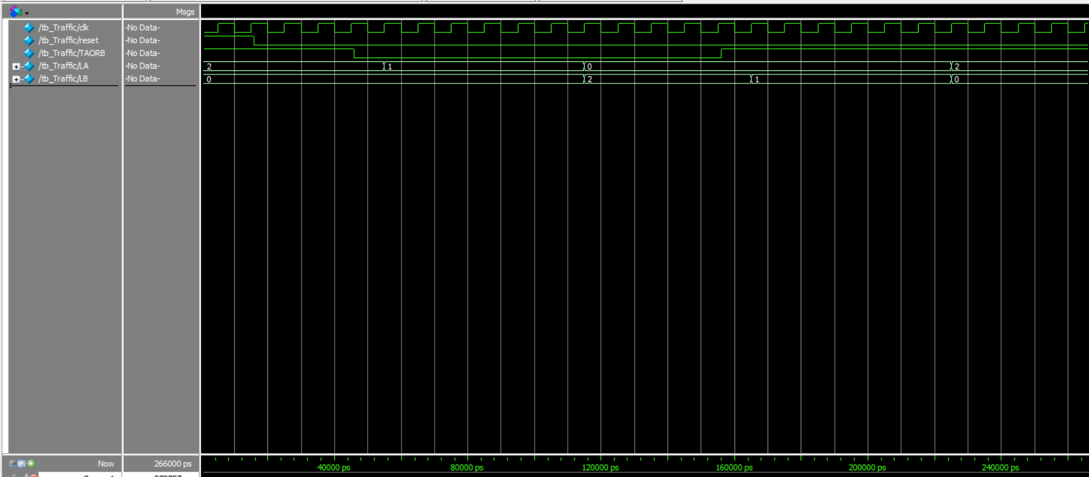
The waveform below shows all signals over the full simulation. LA and LB transition correctly through all 4 states with 5-cycle yellow hold confirmed.

6. Verification Summary
Compile result: Errors: 0, Warnings: 0
S0 (LA=GREEN, LB=RED) held correctly while TAORB=1: PASS
S1 yellow hold for exactly 5 cycles before S2: PASS
S2 (LA=RED, LB=GREEN) held correctly while TAORB=0: PASS
S3 yellow hold for exactly 5 cycles before S0: PASS
Full cycle S0-S1-S2-S3-S0 completed successfully: PASS

