E11 — ClickUp Board Baseline Screenshot Sprint 1
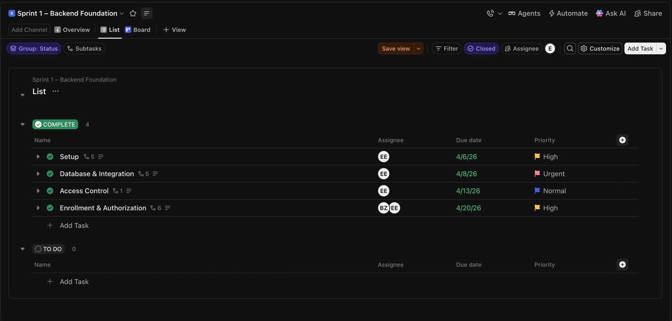
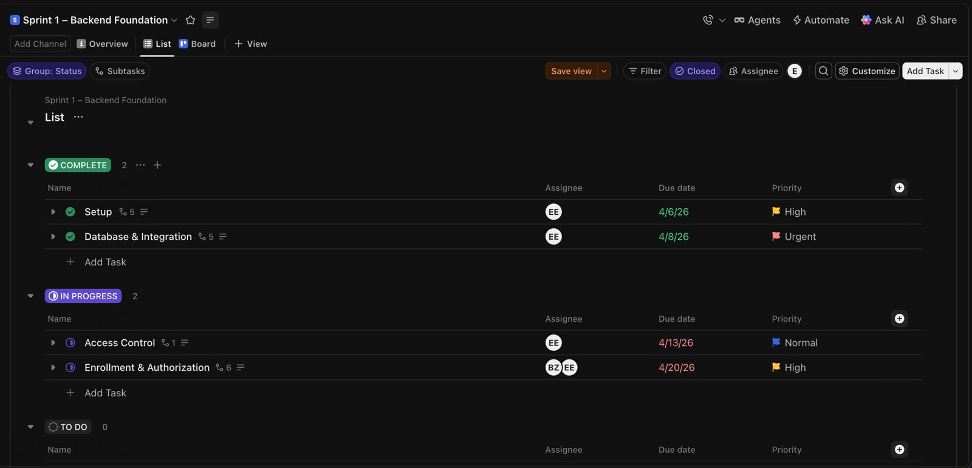
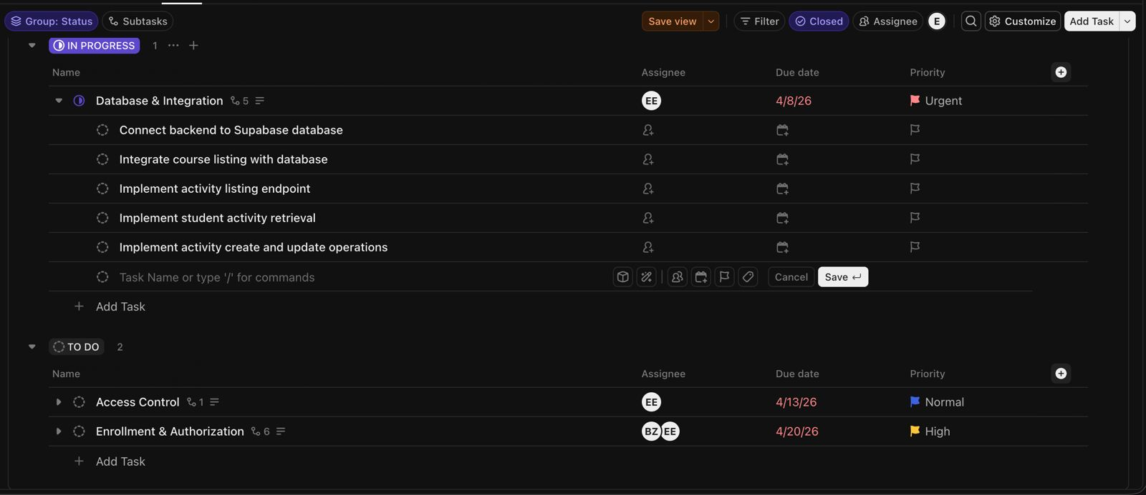
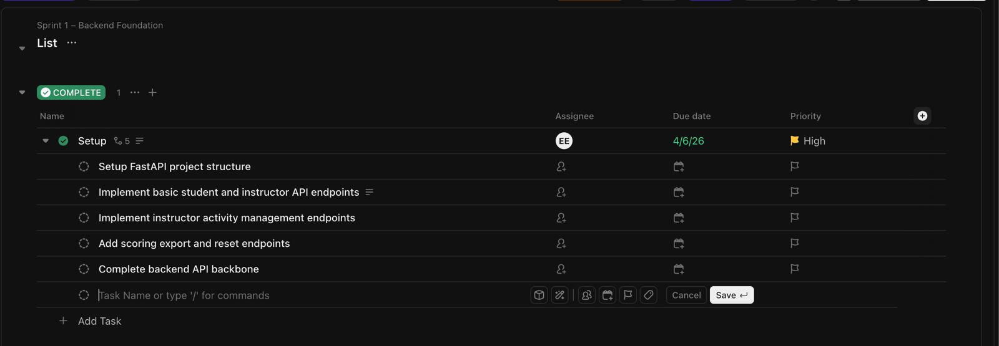
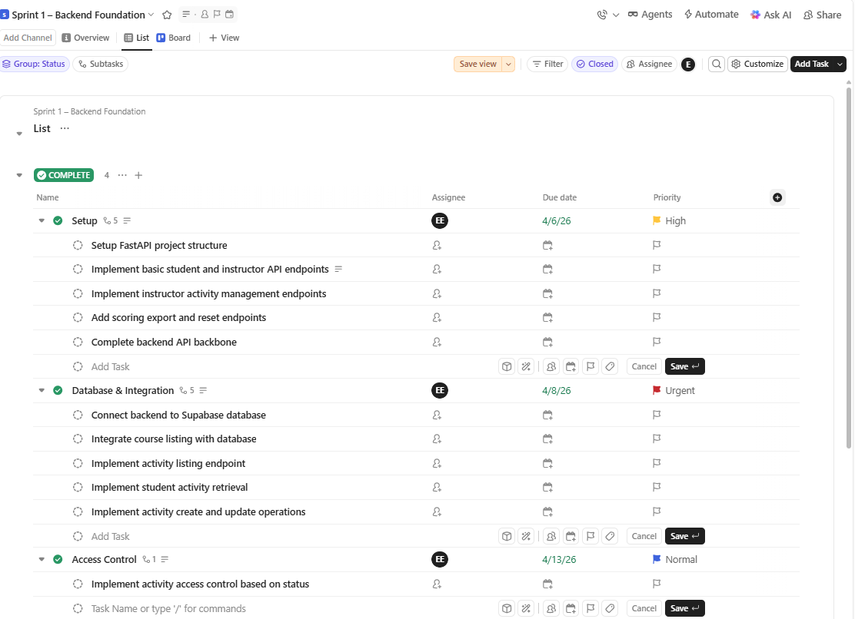
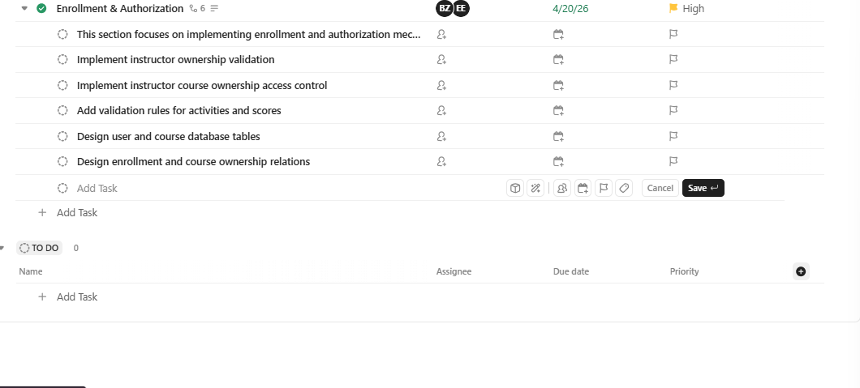
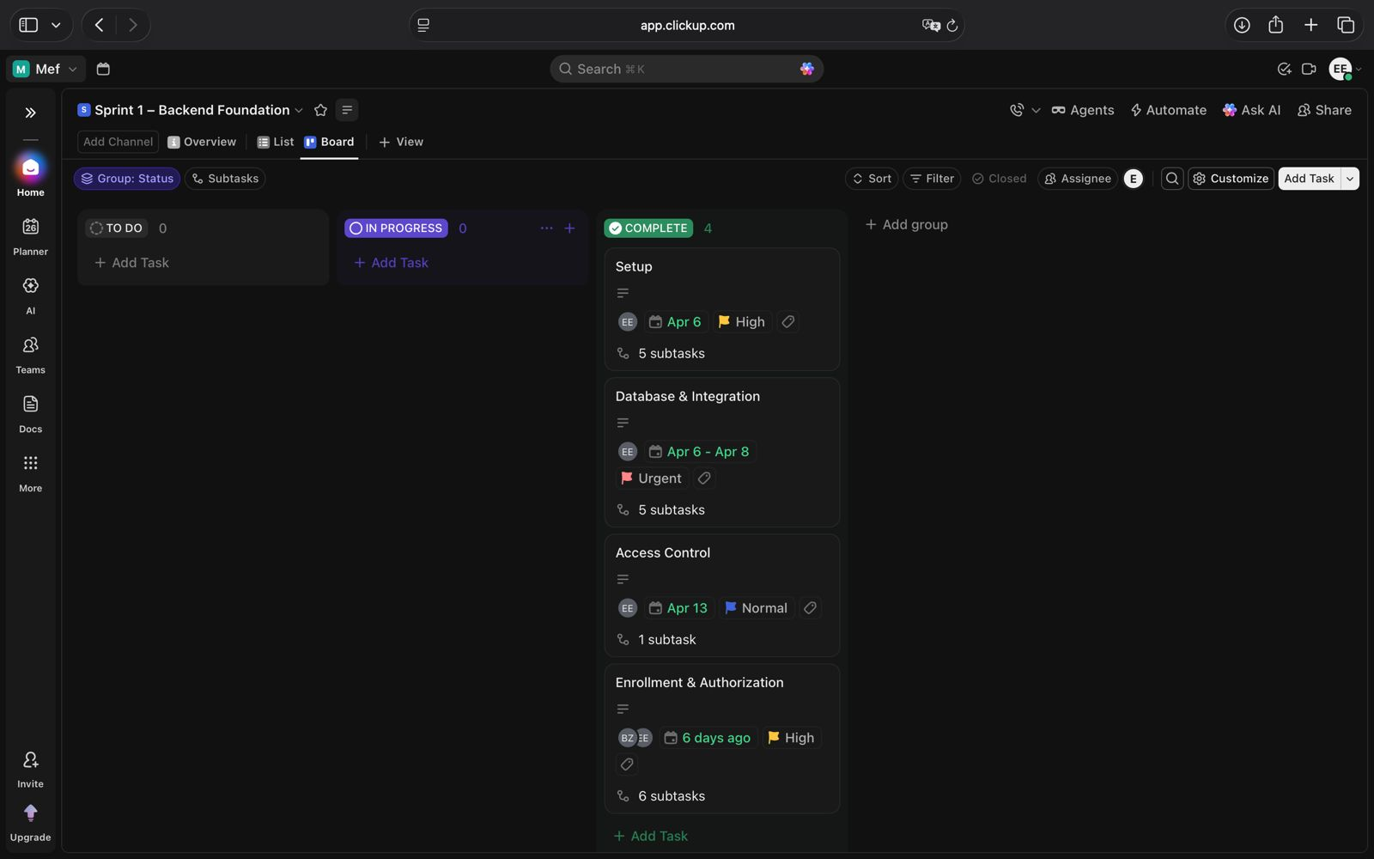

These screenshots present the Sprint 1 baseline ClickUp board configuration prepared after Sprint Planning. The board includes backend implementation tasks, database integration workflows, authorization systems, activity management tasks, assignees, due dates, and workflow status tracking used throughout Sprint 1.

