E12 — ClickUp Board Baseline Screenshot Sprint 2
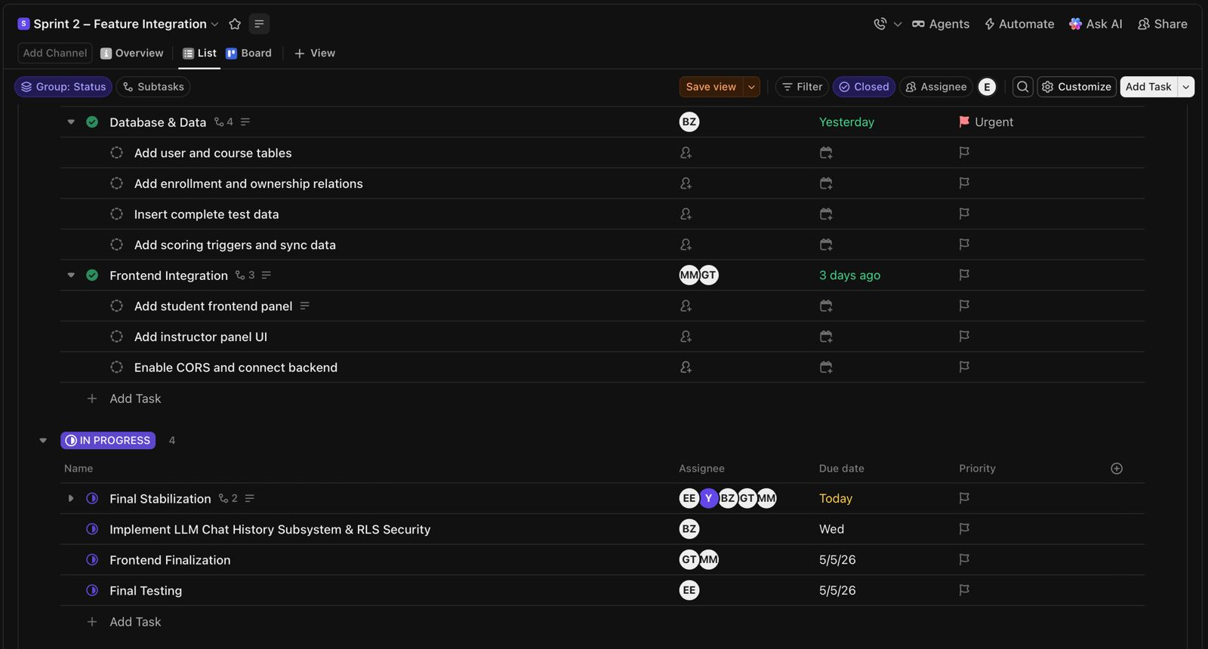
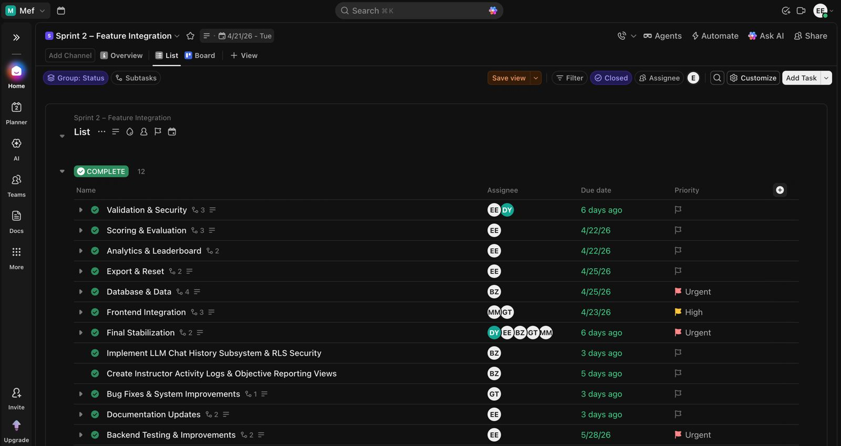
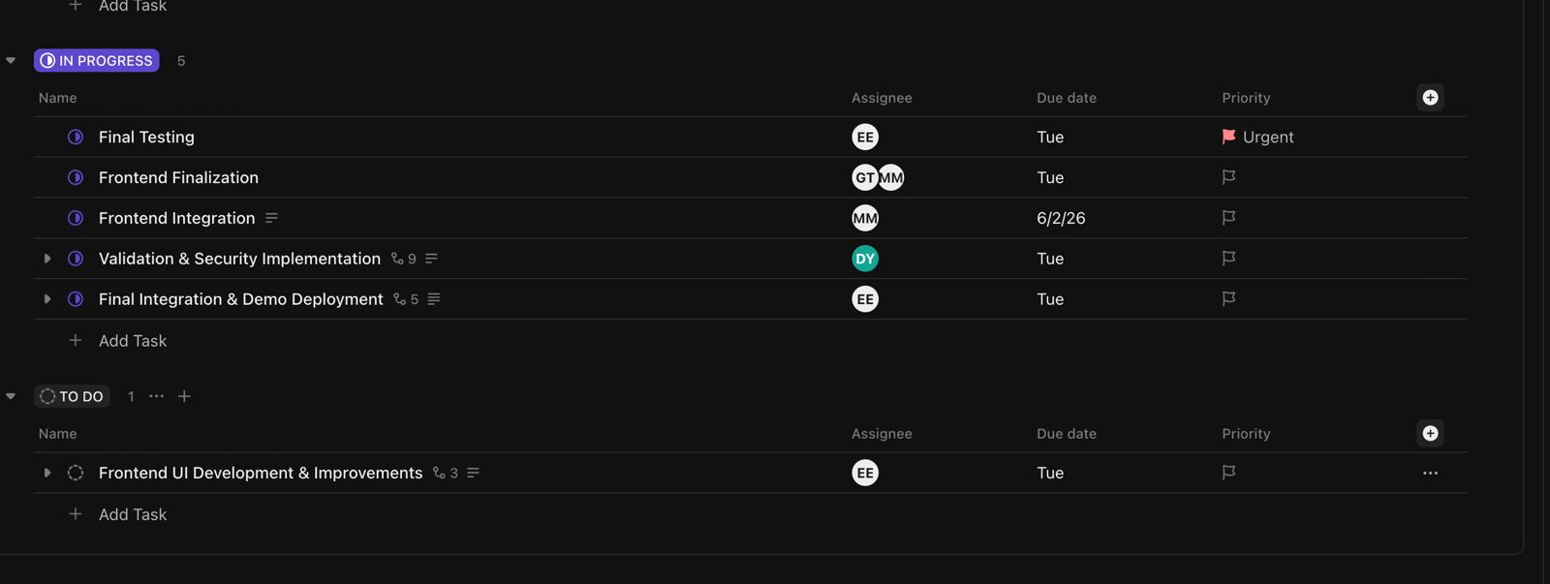
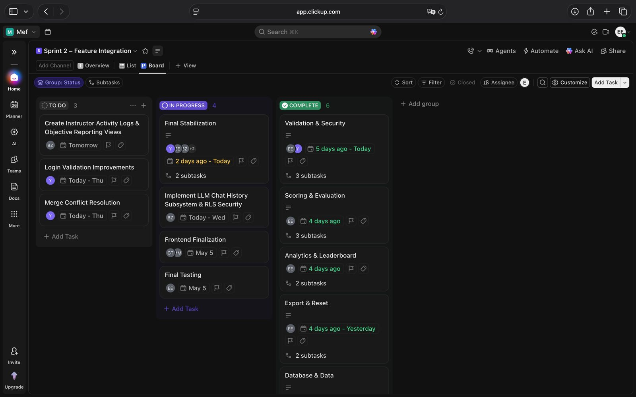
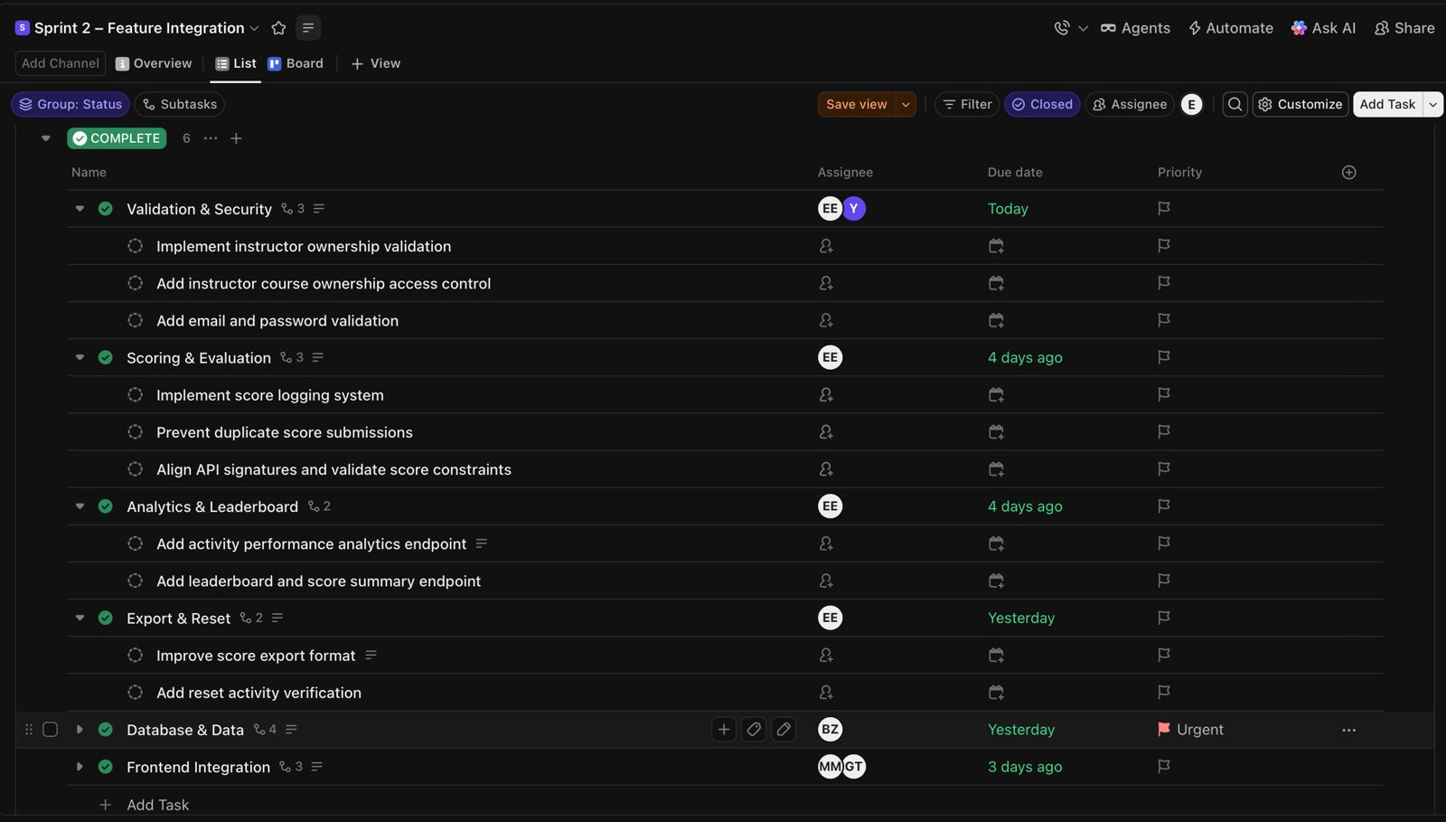
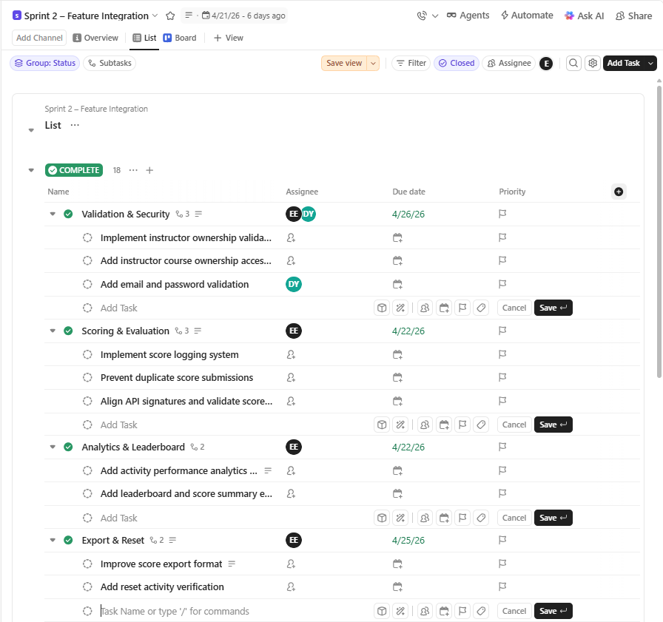
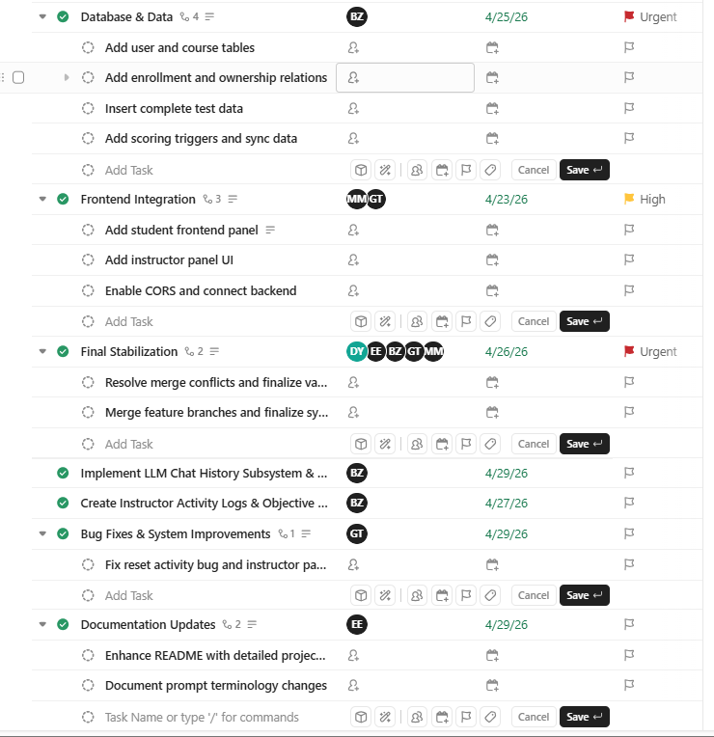
These screenshots present the Sprint 2 baseline ClickUp board configuration prepared after Sprint Planning. The board includes frontend integration workflows, validation and security tasks, analytics systems, reporting workflows, stabilization tasks, assignees, due dates, and workflow tracking used throughout Sprint 2.

