E13 - Daily Scrum Records for Sprint 1
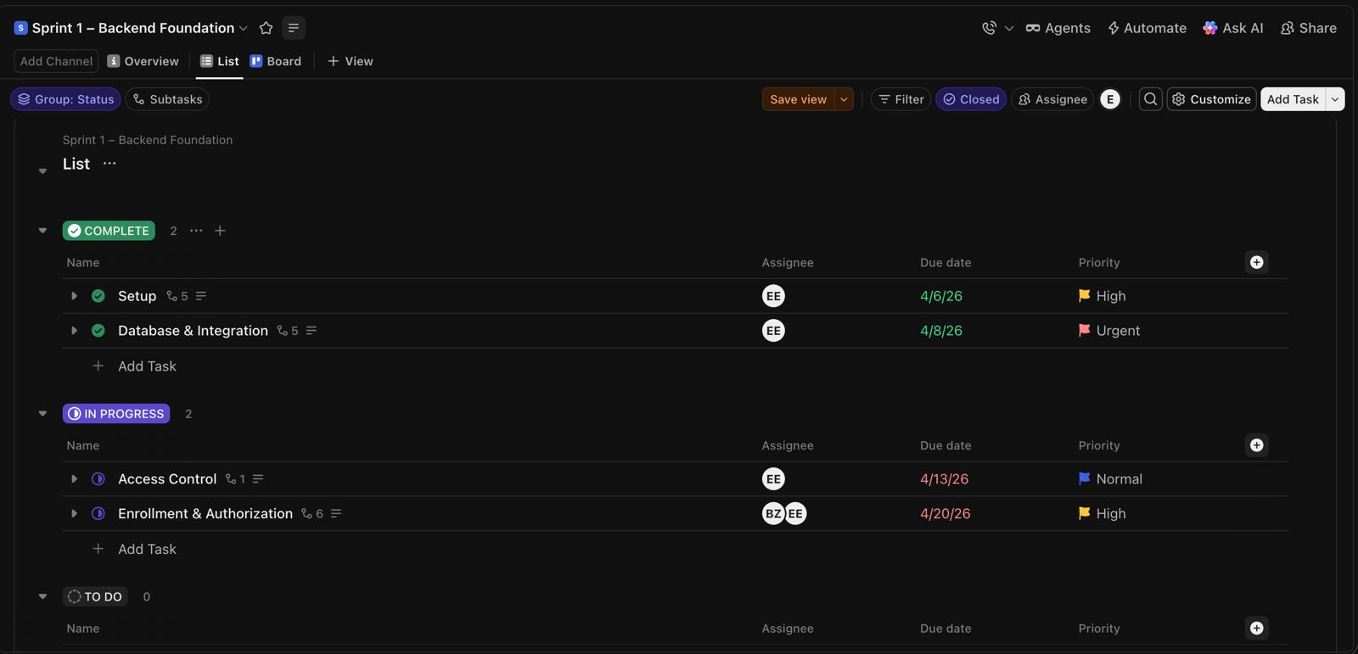
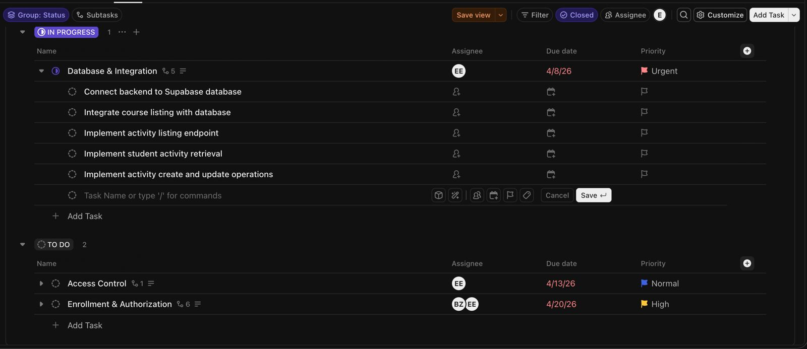

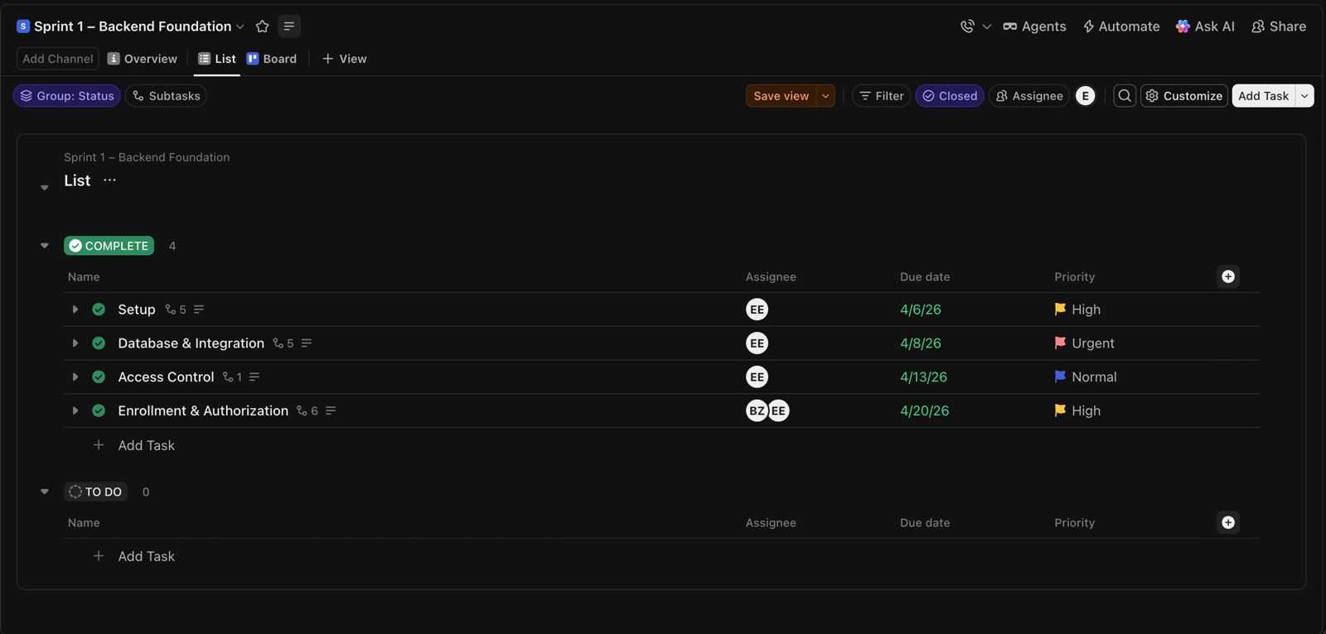
These records provide Daily Scrum evidence for Sprint 1 using ClickUp sprint board tracking. Task progress, backend implementation activities, authorization workflows, database integration tasks, and sprint status transitions were monitored and updated during Daily Scrum sessions throughout Sprint 1.

