E14 - Daily Scrum Records for Sprint 2
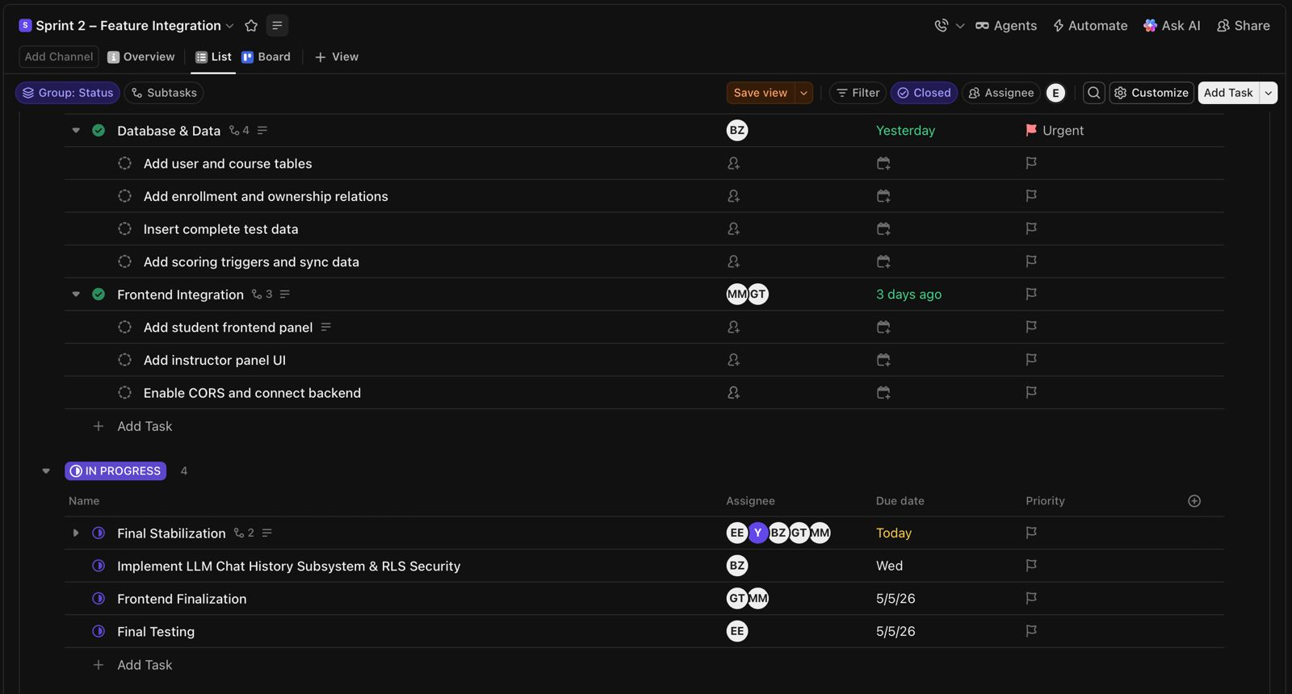
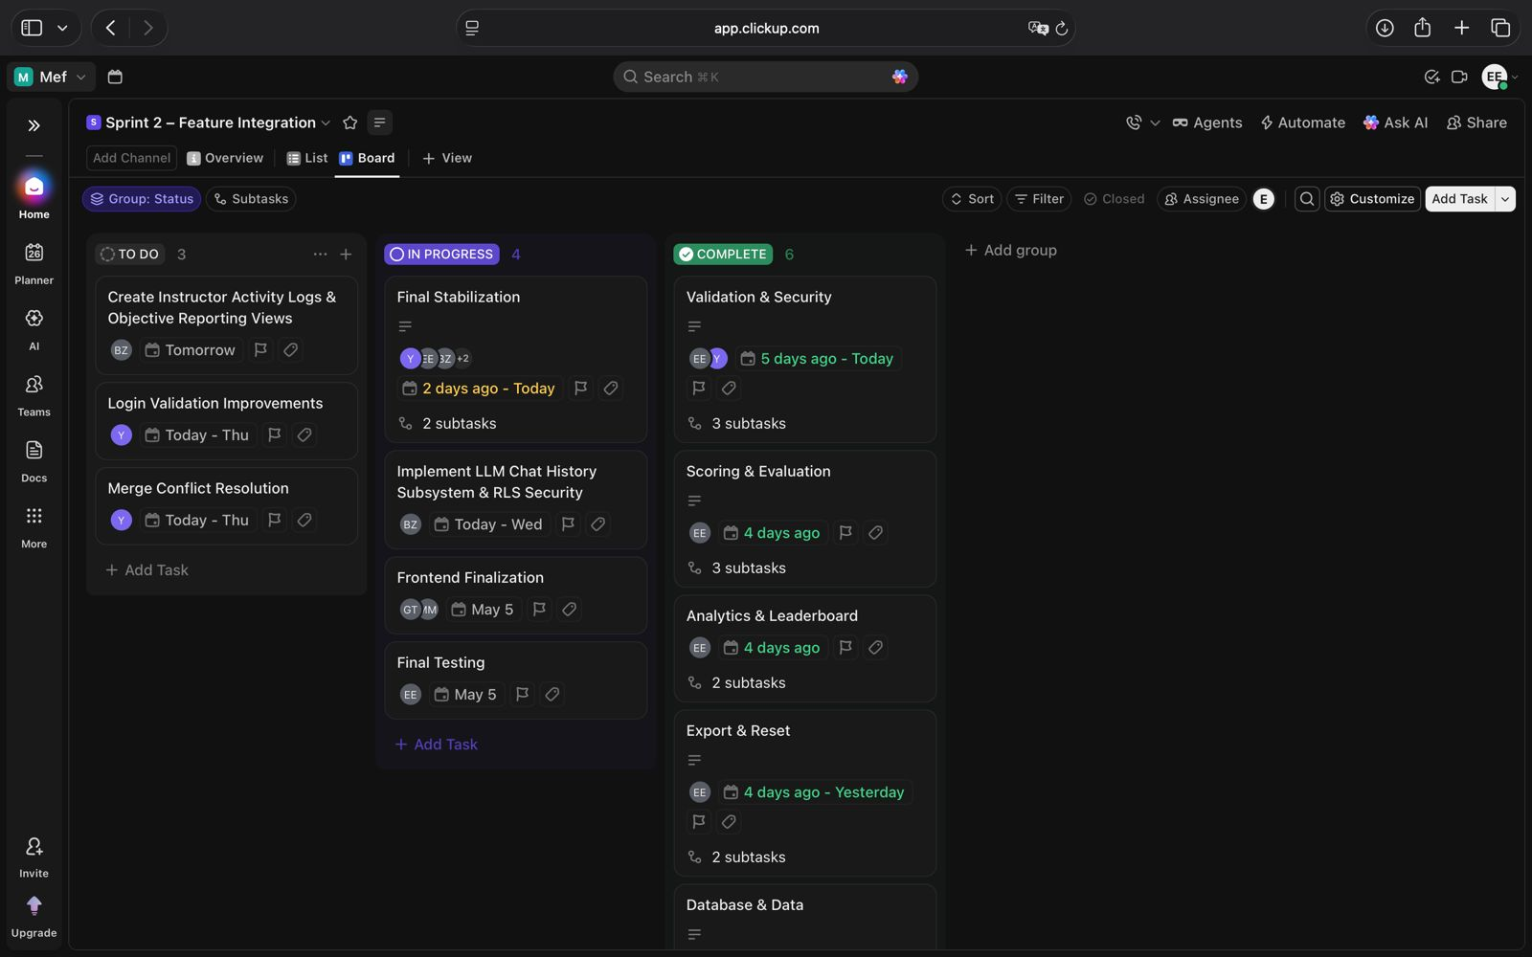
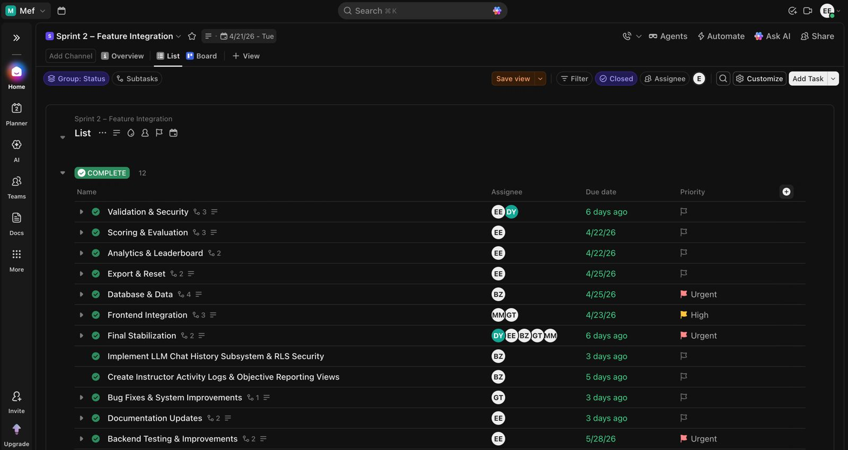
These records provide Daily Scrum evidence for Sprint 2 using ClickUp sprint board tracking. Frontend-backend integration progress, validation improvements, analytics development, reporting workflows, and sprint status transitions were monitored and updated during Daily Scrum sessions throughout Sprint 2.

