E15 - Post-Daily Board Screenshots for Sprint 1
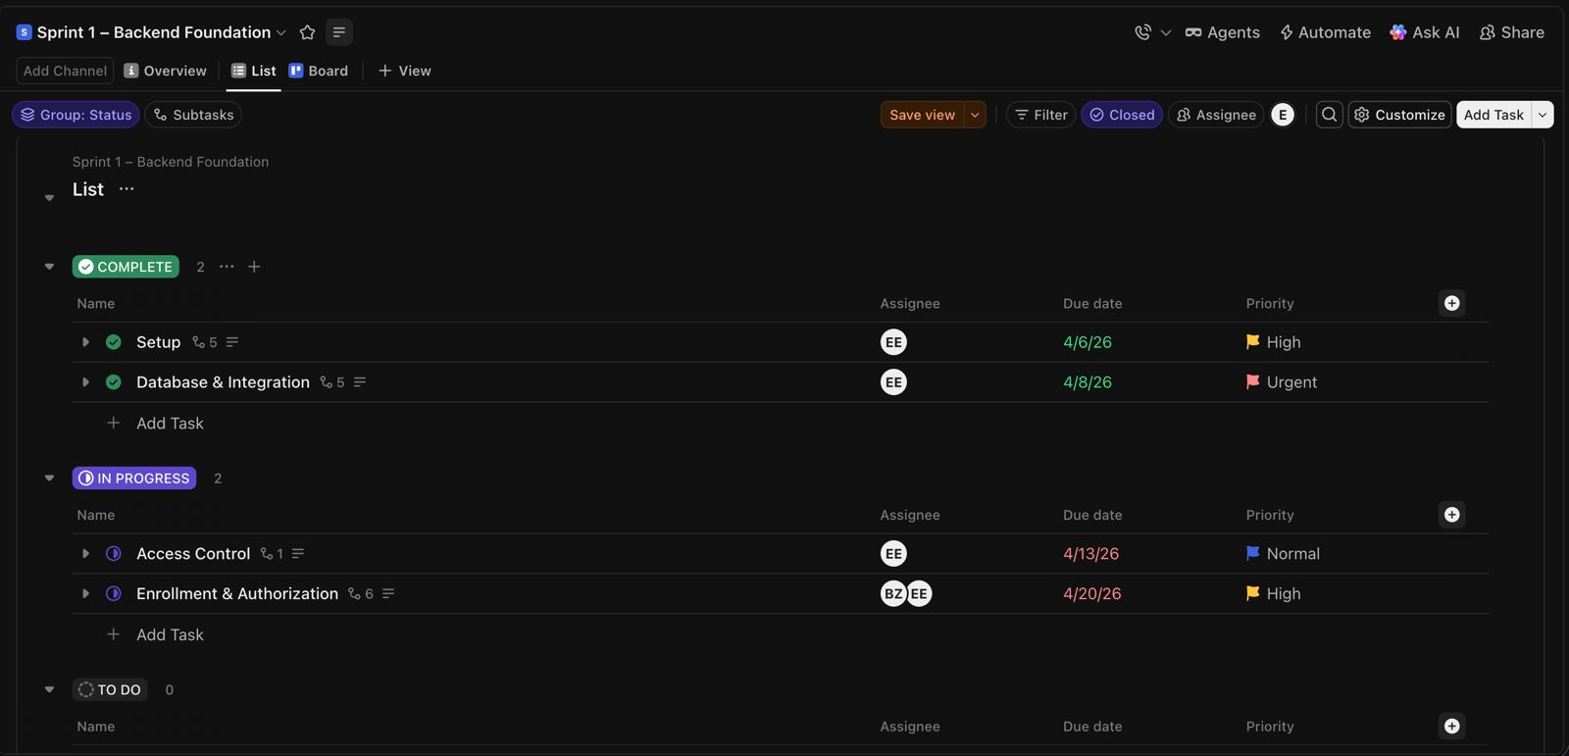
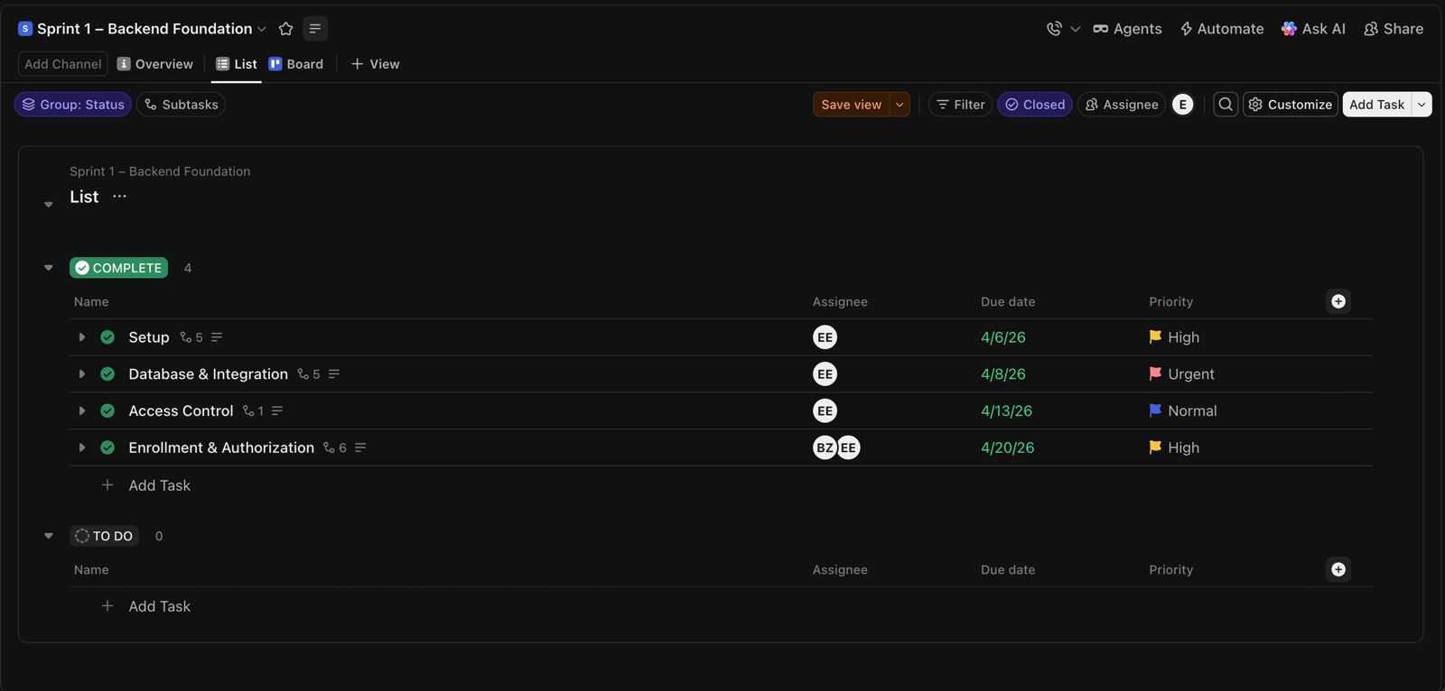

These screenshots show the updated ClickUp sprint board states after Daily Scrum meetings during Sprint 1. Task progress, backend implementation workflows, activity management development, authorization tasks, and sprint status transitions were tracked through the ClickUp board system during Sprint 1 development activities.

