E16 - Post-Daily Board Screenshots for Sprint 2
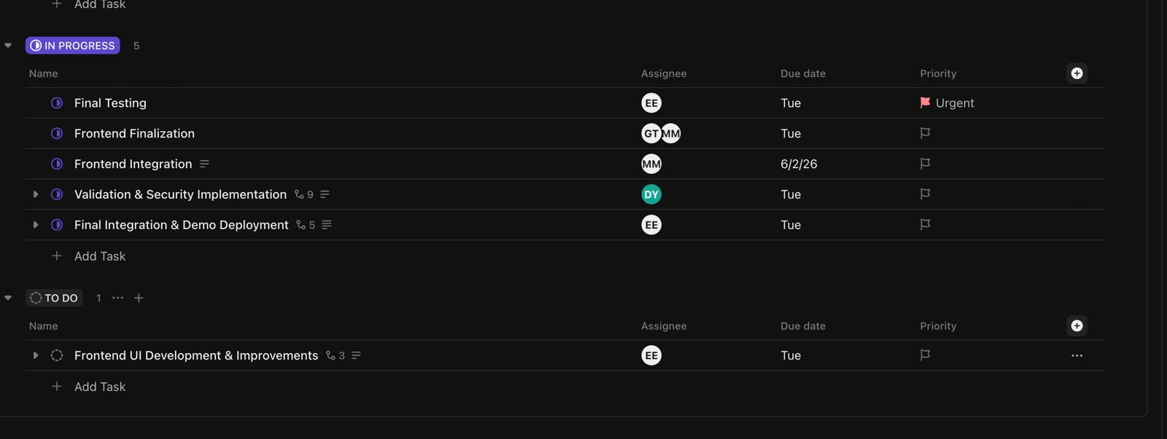
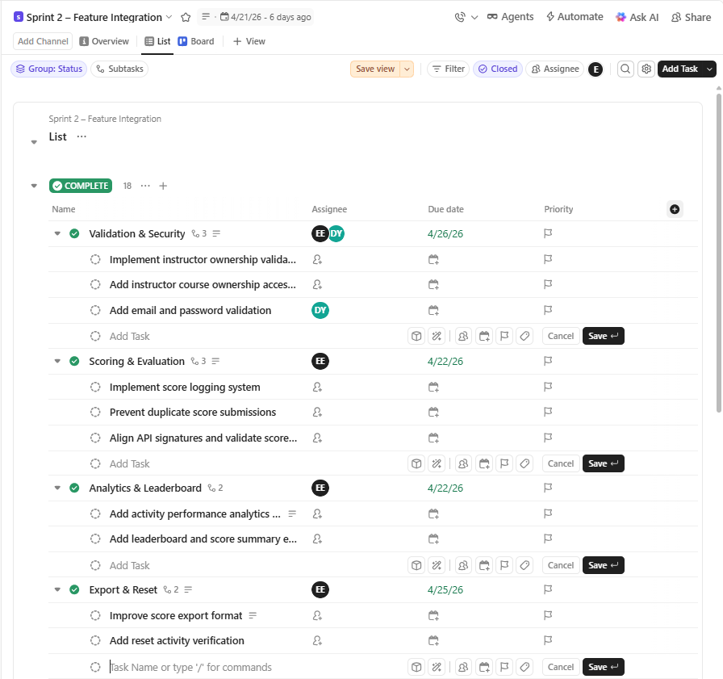
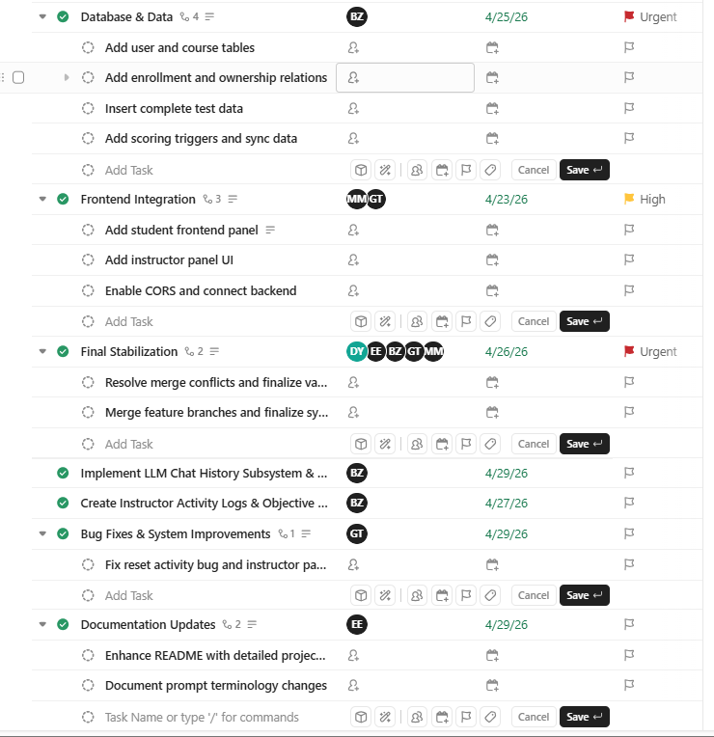

These screenshots show the updated ClickUp sprint board states after Daily Scrum meetings during Sprint 2. Task progress, frontend-backend integration workflows, validation improvements, and sprint tracking activities were monitored through ClickUp board updates.

