# Requirement

We want to collect data filed for cases in Gwinnett County Superior Court from 2011-2021. This data is displayed on their website at <https://odyssey.gwinnettcourts.com/Portal/>.

# Cases

Each case is assigned a unique identifier. Example is 16-A-00614-2.   
16 – the year 2016  
A – Letter based on the division (always be ‘A’)  
00614 – Unique number which is never repeated within the same year. Starts at ‘00001’. May go as high at ‘13000’ in a given year.  
2 – Number based on the district (May be 1-11)

*There will never be two cases in the same year with the same unique number (Ex. 16-A-00614-2 and 16-A-00614-3).

For each case, there are three distinct data sections: Case Information, Party, and Events and Hearings.

Case Information  
1. Six fields with labels that always display. 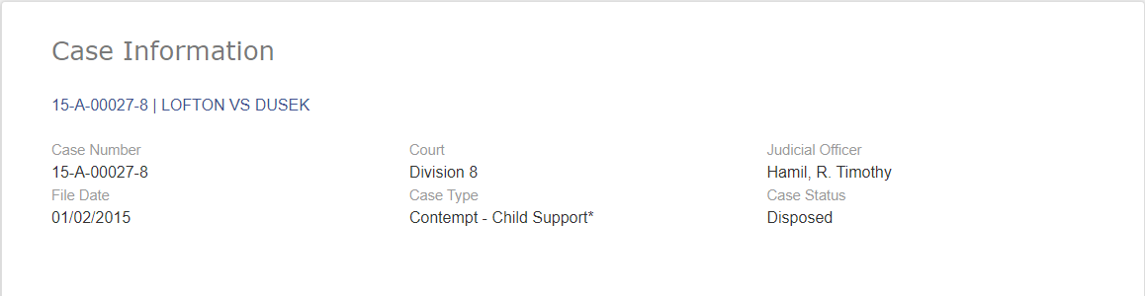  
2. There should only be one record per case.



Party  
1. Each case will always have at least two parties (Type: Plaintiff and Defendant) for each case. But there may be more than two.   
2. Each party will always have a name. A party may have an alias, address and attorney. But they may have more than one attorney

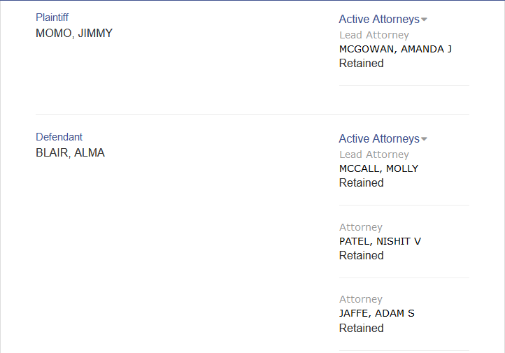

3. Each party/attorney combination will be a record. In my example, there are two parties. One party has 4 attorneys and another party has 1 attorney. There should be 5 records written for this case.



Events and Hearings  
1. Each case will have at least one event/hearing. However, most of them will have multiple events/hearings.

2. Events and hearings will always have a value in date and description with optional comment

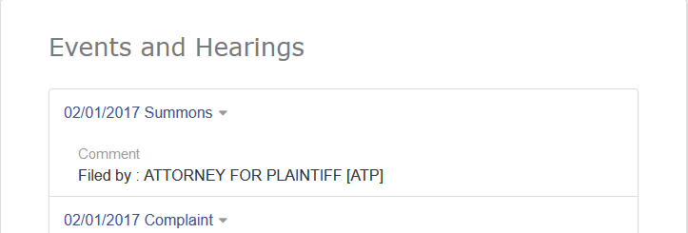

3. However, there are some events like Summons which may have different fields like:

-Served

-Anticipated Server

-Anticipated Method

-Serving Officer

-Serving Method

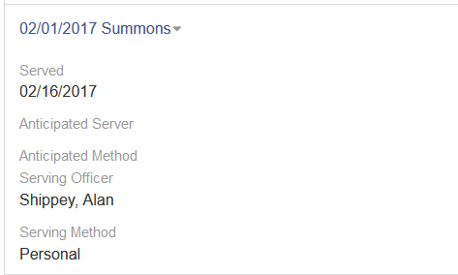

4. Hearings also have the following additional fields:

-Original Type

-Judicial Officer

-Hearing Time

-Result

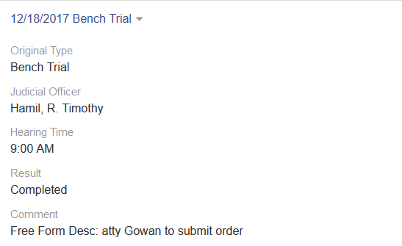

5. Each date and description displayed should be a record. Below is a sample:



# Instructions

1. The program should start at the first record for Year 2012: 12-A-00001-1

2. Once it completes it, it should go to 12-A-00001-2, then -3, through 12-A-00001-11. Remember there will only be one case for the 12-A-00001 series.

3. The program should not write records for a case number that does not exist.

4. Once it completes 12-A-00001-11, it should move to 12-A-00002-1

5. While we do not know the last case number for each year, the program should stop at the 12000 unique number for each year (Ex: 2012 - 12-A-12000-11).

6. It should continue through each year up to and including 2020 (20-A-12000-11).

7. I would expect that the data will be collected into three files (.csv or another type that can be uploaded to database): Case, Party, and Events/Hearings. Attached is a spreadsheet with a worksheet for each one.



8. All records should have the case number as the key.

9. I am thinking 2 weeks should be sufficient time to complete.

10. Unless noted otherwise, the cost for this work will not exceed $300. However, any block IPS might require additional expense which we can discuss if it occurs.