**Background:**

Your mission for level 1 is to kill 10 enemy spacecraft. Each enemy shot will remove 1 health. Each enemy destroyed will give you one health. Colliding with an enemy will destroy it, remove 1 health, and give you no points. There are bumpers on the edge of the screen, however if you try hard enough you will be allowed to fly through them. This will result in your death. This level you have 10 health.

The mission for level 2 is to kill 10 enemy spacecraft while avoiding the asteroids. The enemy will be much more varied in size and movement. The asteroids will damage your health proportional to their size. Each asteroid will have to be damaged to a minimum size to be destroyed. Destroying an asteroid will also give you 1 point. This level you have 50 health.

**Controls:**

Movement – WASD, Arrow Keys, or Mouse Movement

Space Bar/Left Mouse – Fire weapon

P – Pause

Q – Quit

Right Mouse – self-destruct

K/M – Volume up/down

R – reset

N – next level

**Game Features:**

Side-scrolling space shooter

Classic art-style

2 levels and 70 waves of challenge

Audio sounds from Mario 64

Gallery:

**Your Ship**

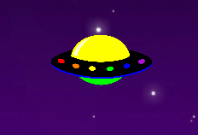

**Enemy Ship**

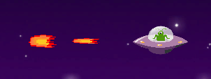

**Asteroids**

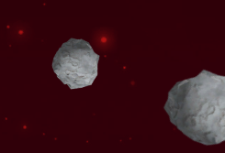

Sources for sound effects : http://themushroomkingdom.net/media/sm64/wav

Sources for music: https://downloads.khinsider.com/game-soundtracks/album/super-mario-64-soundtrack

Images from GIS