Texture 1 :

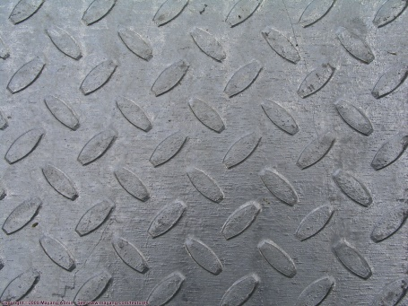

Texture 2 :

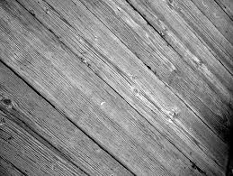

Texture 3 :

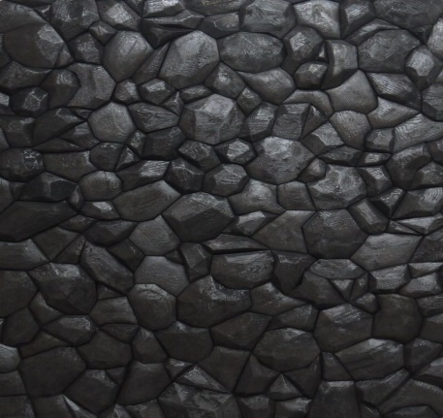

2a.

2b.

Texture 1 :

AA :

mean : 1191.82812500000

var : 8286.02898185484

AD :

mean : 0.343749999999997

var : 673.852822580646

AH :

mean : -1.31250000000002

var : 1423.50302419355

AV :

mean : -1.40625000000000

var : 3292.92540322581

Texture 2 :

AA

mean : 782.078125000000

var : 29139.4443044355

AD

mean : 3.23437500000000

var : 3390.05115927420

AH

mean : -2.76562500000001

var : 2183.06325604839

AV

mean : -6.73437500000001

var : 3606.36164314516

Texture 3 :

AA

mean :330.113281250000

var :5560.75439453126

AD

mean : -0.199218750000003

var :387.706511466734

AH

mean : -10.3320312500000

var :3088.01674332158

AV

mean : 3.55859375000000

var : 1667.22780682964

2c.

Jarak(1,2) : 1,1191828125

Jarak(1,3) : 1,190330078

Kesimpulan : texture 1 dengan 3 lebih mirip jarak nya dibandingkan texture 2