AI-POWERED CYBERBULLYING DETECTION AND PREVENTION SYSTEM IN SOCIAL MEDIA USING PYTHON
(CyberShield AI)
A Project Report submitted in partial fulfillment of the requirements for the award of the degree of
BACHELOR OF TECHNOLOGY
in
COMPUTER SCIENCE AND ENGINEERING
Submitted By:
[STUDENT NAME] (Roll No: [ROLL NUMBER], Reg No: [REGISTER NUMBER])
[TEAM MEMBER 2 NAME] (Roll No: [ROLL NUMBER 2])
[TEAM MEMBER 3 NAME] (Roll No: [ROLL NUMBER 3])
Under the Guidance of:
[GUIDE NAME], M.Tech., Ph.D.
[DESIGNATION / ASSOCIATE PROFESSOR]
DEPARTMENT OF COMPUTER SCIENCE AND ENGINEERING
[COLLEGE OF ENGINEERING AND TECHNOLOGY]
[AFFILIATED UNIVERSITY NAME]
[ACADEMIC YEAR: 2025 - 2026]

BONAFIDE CERTIFICATE
This is to certify that this project report entitled 'AI-POWERED CYBERBULLYING DETECTION AND PREVENTION SYSTEM IN SOCIAL MEDIA USING PYTHON' is the bonafide work carried out by [STUDENT NAME] (Reg. No: [REGISTER NUMBER]), who carried out the project work under my supervision in partial fulfillment of the requirements for the award of the degree of Bachelor of Technology in Computer Science and Engineering during the academic year 2025-2026.
_________________________ _________________________
INTERNAL GUIDE HEAD OF THE DEPARTMENT
[Guide Name, Designation] [HOD Name, Designation]
Submitted for the University Project Viva-Voce examination held on: __________________
INTERNAL EXAMINER EXTERNAL EXAMINER

STUDENT DECLARATION
I hereby declare that the project report entitled 'AI-POWERED CYBERBULLYING DETECTION AND PREVENTION SYSTEM IN SOCIAL MEDIA USING PYTHON' submitted to [COLLEGE NAME], affiliated to [UNIVERSITY NAME], is a record of original project work done by me under the guidance of [GUIDE NAME], Department of Computer Science and Engineering. This project has not been submitted previously in part or full for any degree, diploma, or fellowship to any other university or institute.
Date: _________________
Place: ________________ Signature of the Candidate

ACKNOWLEDGEMENT
First and foremost, I express my profound gratitude to the Almighty for bestowing upon me the strength and wisdom to complete this project work successfully.
I express my deepest sense of gratitude and indebtedness to our beloved Principal, [PRINCIPAL NAME], and Head of the Department, [HOD NAME], Department of Computer Science and Engineering, for their visionary guidance and constant encouragement.
I express my heartfelt gratitude to my project guide, [GUIDE NAME], for their invaluable advice, insightful critiques, continuous patience, and tireless technical mentorship throughout the design, implementation, and evaluation phases of CyberShield AI.
Finally, I thank my family members, fellow student colleagues, and friends for their continuous moral support and understanding during the preparation of this academic project report.

ABSTRACT
The exponential growth of modern social media networks has catalyzed unprecedented interpersonal communication while concurrently accelerating digital hostility, cyberbullying, hate speech, and violent harassment. Traditional content moderation systems depend either on rigid, easily bypassed static keyword filters or reactive human annotator queues that suffer from severe fatigue and high cognitive latency. This academic project presents CyberShield AI, an intelligent, full-stack, automated cyberbullying detection and prevention system implemented using Python 3.14, Django 5.2, Natural Language Processing (NLP), and Scikit-Learn.
The architecture implements a specialized linguistic preprocessing pipeline tailored for unstructured digital content, incorporating emoji-to-semantic token mapping, character elongation normalization (e.g., 'looooser' to 'loser'), social mention/URL filtering, and negation-preserving lemmatization. Feature extraction is driven by Sublinear Term Frequency-Inverse Document Frequency (TF-IDF) unigrams and bigrams. The system implements a 7-class taxonomy comprising Normal/Safe, Harassment, Hate Speech, Threatening Language, Personal Attack, Sexual Harassment, and Toxic/Abusive Language. Multiple supervised machine learning algorithms—Logistic Regression, Calibrated Linear Support Vector Machine (LinearSVC), Multinomial Naive Bayes, and Random Forest—were rigorously trained and evaluated under stratified 80/20 train/test protocols. Empirical evaluation confirmed that Logistic Regression with class-weighted balancing achieved the superior weighted F1-score of 0.6309 and accuracy of 62.07% across held-out test splits.
To ensure transparency, an Explainable AI (XAI) subsystem extracts triggering lexical tokens, computes multi-class probability scores, and provides severity-graded risk cards (Green, Orange, Red) with actionable safety protocols. The solution is delivered as an enterprise-grade Django web application featuring real-time asynchronous REST APIs (/api/analyze/), multi-line batch and CSV dataset processing, Chart.js operational dashboards, and an incident reporting center. CyberShield AI bridges academic machine learning research with mission-critical digital safety operations, empowering educational institutions, gaming servers, and online communities to foster humane digital spaces.

CONTENTS
S.No | CHAPTER NAME | PAGE NO.
1. | INTRODUCTION | 1-3
 | 1.1 Introduction to Cybersecurity & Digital Safety | 1
 | 1.2 Introduction to Cyberbullying | 1
 | 1.3 Background of Artificial Intelligence | 2
 | 1.4 Role of Machine Learning in Cyberbullying Detection | 2
 | 1.5 Natural Language Processing | 2
 | 1.6 Need for the Proposed System | 2
 | 1.7 Problem Statement | 3
 | 1.8 Project Objectives | 3
 | 1.9 Scope of the Project | 3
 | 1.10 Applications of the System | 3
 | 1.11 Advantages of the Proposed System | 3
2. | LITERATURE SURVEY | 4-7
 | 2.1 Introduction | 4
 | 2.2 Existing Cyberbullying Detection Methods | 4
 | 2.3 Traditional Machine Learning Approaches | 4
 | 2.4 NLP-Based Detection Systems | 5
 | 2.5 Deep Learning Approaches | 5
 | 2.6 Comparative Analysis of Literature | 6
 | 2.7 Research Gap & Proposed Solution | 7
3. | SYSTEM ANALYSIS & SPECIFICATIONS | 8-11
 | 3.1 Existing System Overview | 8
 | 3.2 Disadvantages of Existing System | 8
 | 3.3 Proposed System (CyberShield AI) | 8
 | 3.4 Advantages of Proposed System | 9
 | 3.5 Functional Requirements | 9
 | 3.6 Non-Functional Requirements | 10
 | 3.7 Hardware & Software Specifications | 10
 | 3.8 Feasibility Study | 11
4. | SYSTEM DESIGN & ARCHITECTURE | 12-16
 | 4.1 System Architecture Overview | 12
 | 4.2 Data Flow Architecture & DFD Levels | 13
 | 4.3 Machine Learning Pipeline Architecture | 14
 | 4.4 Deployment Architecture | 16
5. | SYSTEM METHODOLOGY & ML PIPELINE | 17-21
 | 5.1 Introduction | 17
 | 5.2 Dataset Collection & Taxonomy | 17
 | 5.3 Text Preprocessing & Cleaning Pipeline | 18
 | 5.4 Sublinear TF-IDF Feature Extraction | 19
 | 5.5 Classification Algorithms & Mathematical Formulations | 20
 | 5.6 Risk-Level Classification Logic | 21
6. | SYSTEM IMPLEMENTATION & MODULES | 22-26
 | 6.1 Development Environment & Directory Structure | 22
 | 6.2 NLP Preprocessing Implementation | 23
 | 6.3 Inference & Prediction Engine | 24
 | 6.4 REST API Endpoint & Integration | 25
7. | DATABASE DESIGN & SCHEMA | 27-30
 | 7.1 Database Architecture Overview | 27
 | 7.2 Table Specifications (UserProfile, MessageAnalysis, CyberbullyingReport) | 28
8. | RESULTS & DISCUSSION | 31-37
 | 8.1 Machine Learning Benchmark Evaluation | 31
 | 8.2 Live Platform Surveillance & Distribution Results | 33
 | 8.3 Application Interface Screenshots | 35
9. | TESTING & QUALITY ASSURANCE | 38-41
 | 9.1 Testing Methodology & Objectives | 38
 | 9.2 Automated Unit & Integration Test Suite | 39
10. | SECURITY & PRIVACY ARCHITECTURE | 42-44
 | 10.1 Django Authentication & Password Hashing | 42
 | 10.2 CSRF, SQL Injection & XSS Defenses | 43
 | 10.3 Ethical AI & Human-in-the-Loop Principles | 44
11. | CLOUD & SERVERLESS DEPLOYMENT | 45-47
 | 11.1 Version Control & GitHub Repository | 45
 | 11.2 Vercel Serverless Architecture & WhiteNoise | 46
 | 11.3 Production Database Strategy | 47
12. | CONCLUSION & FUTURE ENHANCEMENTS | 48-49
 | 12.1 Conclusion | 48
 | 12.2 Future Enhancements | 49
 | REFERENCES (IEEE STYLE) | 50-51
A. | APPENDIX A: COMPLETE CORE SOURCE CODE IMPLEMENTATION | 52-67
B. | APPENDIX B: COLLEGE VIVA VOCE & PRESENTATION DEFENSE GUIDE | 68-75

LIST OF FIGURES
S.NO | FIGURE NO | FIGURE NAME | PAGE NO.
1 | 4.1 | OVERALL SYSTEM ARCHITECTURE DIAGRAM | 12
2 | 4.2 | DATA FLOW DIAGRAM LEVEL 0 (CONTEXT DIAGRAM) | 13
3 | 4.3 | MACHINE LEARNING & NLP WORKFLOW ARCHITECTURE | 14
4 | 8.1 | MACHINE LEARNING MODEL ACCURACY COMPARISON | 32
5 | 8.2 | WEIGHTED PRECISION, RECALL AND F1-SCORE COMPARISON | 32
6 | 8.3 | 7x7 MULTI-CLASS CONFUSION MATRIX HEATMAP | 33
7 | 8.4 | CYBERBULLYING DATASET CATEGORY DISTRIBUTION | 34
8 | 8.5 | LIVE SAFE VS HARMFUL CONTENT DISTRIBUTION | 34
9 | 8.6 | DAILY CYBERBULLYING DETECTION SURVEILLANCE TIMELINE | 35
10 | 8.7 | HOMEPAGE HERO & PLATFORM HEALTH OVERVIEW SCREENSHOT | 36
11 | 8.8 | REAL-TIME TEXT DETECTION CONSOLE SCREENSHOT | 36
12 | 8.9 | MODERATOR & ADMIN ANALYTICS DASHBOARD SCREENSHOT | 37

LIST OF TABLES
S.NO | TABLE NO | TABLE NAME | PAGE NO.
1 | 2.1 | COMPARATIVE LITERATURE SURVEY SUMMARY | 6
2 | 3.1 | HARDWARE AND SOFTWARE SYSTEM SPECIFICATIONS | 10
3 | 3.2 | PROJECT FEASIBILITY STUDY MATRIX | 11
4 | 7.1 | USER PROFILE TABLE (accounts_userprofile) SCHEMA | 28
5 | 7.2 | MESSAGE ANALYSIS TABLE (detection_messageanalysis) SCHEMA | 29
6 | 7.3 | CYBERBULLYING REPORT TABLE (reports_cyberbullyingreport) SCHEMA | 30
7 | 8.1 | MACHINE LEARNING CLASSIFIER BENCHMARK PERFORMANCE | 31
8 | 9.1 | AUTOMATED TEST SUITE EXECUTION RESULTS MATRIX | 40

LIST OF ABBREVIATIONS
ABBREVIATION | EXPANSION / MEANING
AI | Artificial Intelligence
ML | Machine Learning
NLP | Natural Language Processing
TF-IDF | Term Frequency - Inverse Document Frequency
SVM | Support Vector Machine
LinearSVC | Linear Support Vector Classifier
MNB | Multinomial Naive Bayes
RF | Random Forest
REST | Representational State Transfer
API | Application Programming Interface
RBAC | Role-Based Access Control
CSRF | Cross-Site Request Forgery
XSS | Cross-Site Scripting
SQLi | Structured Query Language Injection
DFD | Data Flow Diagram
UML | Unified Modeling Language
ERD | Entity Relationship Diagram
JSON | JavaScript Object Notation
HTML5 | HyperText Markup Language 5
CSS3 | Cascading Style Sheets 3
WSGI | Web Server Gateway Interface
XAI | Explainable Artificial Intelligence

CHAPTER 1: INTRODUCTION
1.1 Introduction to Cybersecurity & Digital Safety
Cybersecurity has conventionally focused on safeguarding computing infrastructure, servers, and networks against unauthorized intrusions, malware, ransomware, and denial-of-service vectors. However, in the modern digital era, the definition of digital security has broadened to encompass online behavioral safety and psychosocial protection. Social networking applications serve as the primary communication commons for billions of individuals. As digital interactions have multiplied, so has the weaponization of language. Safeguarding human users from online psychological trauma, cyberstalking, and hate campaigns is now recognized as a vital dimension of cognitive cybersecurity.
1.2 Introduction to Cyberbullying
Cyberbullying refers to the deliberate, hostile, and repeated transmission of harmful, intimidating, defamatory, or abusive content against an individual or community using digital devices. Unlike physical bullying, cyberbullying exhibits unique characteristics that magnify its psychological harm: pervasive 24/7 reach, potential viral permanence of published posts, bystander amplification via mass retweets/likes, and the cloak of online anonymity. Severe instances of cyberbullying have been empirically correlated with depression, anxiety disorders, behavioral withdrawal, and in extreme cases, self-harm.
1.3 Background of Artificial Intelligence
Artificial Intelligence (AI) is the discipline of computer science dedicated to creating software systems capable of executing cognitive tasks traditionally requiring human intelligence. Over recent decades, AI has evolved from rigid rule-based expert systems to statistical learning models that independently discover latent predictive patterns from training corpora.
1.4 Role of Machine Learning in Cyberbullying Detection
Machine Learning (ML) algorithms analyze mathematical feature spaces to classify unseen text sequences into discrete behavioral categories. Supervised learning utilizes historical examples of verified abusive and non-abusive text to optimize decision boundaries. Rather than looking for exact string matches, ML classifiers recognize probabilistic associations between lexical, structural, and semantic signals, allowing them to detect novel permutations of abuse.
1.5 Natural Language Processing
Natural Language Processing (NLP) operates as the computational bridge between human language and computational algorithms. In cyberbullying detection, NLP provides the tokenization, stopword removal, morphological normalization (lemmatization), and vector transformation pipelines necessary to turn raw, messy social media comments into structured mathematical inputs.
1.6 Need for the Proposed System
The sheer velocity of digital conversations—exceeding 500 million tweets and billions of comments daily—renders purely human moderation physically impossible and economically unviable. Furthermore, human annotators tasked with screening flagged queues suffer from severe psychological trauma due to repeated exposure to graphic hate speech and death threats. An automated, real-time AI system is urgently required to serve as a high-speed frontline defense, filtering and categorizing abusive interactions before they cause irreparable emotional trauma.
1.7 Problem Statement
Given an arbitrary unstructured digital text string, comment, or direct message submitted on an online social platform, the objective is to design, implement, and deploy an automated AI software system that: (i) pre-processes noisy digital text containing slang, emojis, URLs, and repeated characters; (ii) maps text into mathematical n-gram feature vectors; (iii) classifies the content into a multi-class taxonomy across seven distinct risk categories; (iv) computes calibrated confidence and threat severity indicators; (v) extracts human-interpretable trigger words for explainability; and (vi) maintains full historical audit logs via an administrative moderation dashboard.
1.8 Project Objectives
The core research and engineering objectives of CyberShield AI are:
1. To develop a robust NLP preprocessing pipeline resilient to social media spelling manipulations and emoji signals.
2. To curate a balanced, multi-class labeled dataset representing 7 cyberbullying and toxicity categories.
3. To train, evaluate, and compare four supervised ML classifiers: Logistic Regression, Calibrated LinearSVC, Multinomial Naive Bayes, and Random Forest.
4. To deploy an Explainable AI (XAI) subsystem extracting triggering tokens and providing actionable recommendations.
5. To engineer a responsive, full-stack Django platform featuring real-time single analysis, batch CSV processing, and an interactive Chart.js moderation command center.
6. To provide an incident reporting system with evidence archival for transparent human oversight.
1.9 Scope of the Project
CyberShield AI is engineered for multi-context deployment. It serves educational campuses monitoring student safety boards, gaming platforms moderating live game chats, corporate intranet collaboration suites (Slack/Teams), and social networking platforms requiring automated abuse triage.
1.10 Applications of the System
• Online Social Networking Platforms (Twitter, Instagram, Reddit, YouTube comments).
• Educational & University Portals (e-learning discussion boards, campus forums).
• Multiplayer Online Gaming Servers (anti-toxicity live chat filters).
• Corporate Communication Suites (workplace harassment and compliance monitoring).
• Law Enforcement & Legal Archival (structured evidence collection for digital crimes).
1.11 Advantages of the Proposed System
• Millisecond Inference: Sub-25ms response latency enabling real-time chat gateway filtering.
• Fine-Grained 7-Class Taxonomy: Goes far beyond crude binary toxic/non-toxic classification.
• Explainable AI (XAI): Transparent highlighted trigger tokens eliminate 'black-box' ambiguity.
• Production Full-Stack Architecture: Built on robust Django 5.2, SQLite/PostgreSQL, and responsive UI.

CHAPTER 2: LITERATURE SURVEY
2.1 Introduction
Automated detection of hostile online communication has evolved into a prominent interdisciplinary research domain uniting computational linguistics, behavioral psychology, and cybersecurity. This chapter surveys seminal contributions, contrasting traditional heuristic methods with machine learning and deep learning paradigms.
2.2 Existing Cyberbullying Detection Methods
Early web moderation relied heavily on rule-based blacklists and keyword regex matching. If a comment contained a string present in a forbidden lexicon, it was automatically flagged or redacted. These systems exhibit high precision on exact matches but fail catastrophically when perpetrators apply simple adversarial evasion techniques such as character substitutions (leetspeak: 'h4te'), phonetic respelling ('fuk'), or spaced tokens.
2.3 Traditional Machine Learning Approaches
To overcome the brittleness of blacklists, researchers pioneered supervised statistical classifiers. Support Vector Machines (SVM) and Multinomial Naive Bayes (MNB) quickly emerged as dominant baselines. In foundational research, Nobata et al. (2016) in 'Abusive Language Detection in Online User Content' published at the World Wide Web Conference (WWW) evaluated Yahoo! comment datasets totaling over 2 million comments. They demonstrated that combining token n-grams with character n-grams dramatically improved classification robustness against spelling alterations, outperforming static lexicons by a wide margin.
2.4 NLP-Based Detection Systems
Similarly, Davidson et al. (2017) at the International AAAI Conference on Web and Social Media (ICWSM) explored 'Automated Hate Speech Detection and the Problem of Offensive Language'. Analyzing 24,000 labeled tweets, Davidson proved that naive models frequently conflate offensive slang with genuine hate speech. Their work validated that L2-regularized Logistic Regression and Support Vector Machines with class-weight penalties achieve reliable classification separation.
2.5 Deep Learning Approaches
With the advent of deep representation learning, researchers introduced Convolutional Neural Networks (CNNs) for local phrase extraction and Long Short-Term Memory networks (LSTMs) for sequential context modeling. More recently, transformer models such as BERT and RoBERTa have achieved state-of-the-art benchmark scores. However, deep neural models impose massive computational footprints (typically 400MB to 1.5GB of GPU VRAM per instance) and high inference latencies (200-500ms), making them unsuitable for low-latency serverless environments.
2.6 Comparative Analysis of Literature
The following table synthesizes representative peer-reviewed research papers, summarizing their methodology, advantages, limitations, and the specific improvements implemented in CyberShield AI:
Citation & Author | Technology / Model | Core Advantages | Critical Limitations | CyberShield AI Enhancement
Nobata et al. (WWW 2016) [2] | Vowpal Wabbit Regression, Character n-grams | Resistant to spelling obfuscation on 2M comments | High dimensionality, slow vectorization, binary output | Sublinear TF-IDF (1,2 n-grams) with calibrated 7-class taxonomy
Davidson et al. (ICWSM 2017) [1] | Logistic Regression with L2 penalty, POS tags | Distinguishes offensive slang from targeted hate | Fixed tweet domain, does not model modern emoji slang | Semantic emoji translation dictionary + character elongation reducer
Waseem & Hovy (NAACL 2016) [3] | Linear SVM, Character n-grams (1-4) | High precision on racist/sexist Twitter discourse | Annotator bias, high false positive rate on benign slang | Multi-model benchmark with Explainable AI trigger token extraction
Fortuna & Nunes (ACM CSUR 2018) [4] | Comprehensive Survey of Hate Speech Detection | Synthesizes 60+ foundational detection frameworks | Identified widespread lack of operational web interfaces | Engineered complete production full-stack Django 5.2 web platform
Table 2.1: Comparative Literature Survey Summary
2.7 Research Gap & Proposed Solution
Despite extensive academic literature, three major research gaps persist in real-world deployments:
1. Binary Oversimplification: Most published studies reduce abusive language to a binary 'toxic vs non-toxic' decision, ignoring distinct behavioral manifestations.
2. The Black-Box Dilemma: Deep neural networks output unexplainable classification logits without revealing why a comment was flagged.
3. Absence of Production Integration: The vast majority of published studies remain confined to static Jupyter Notebooks without functional web APIs, role-based dashboards, or evidence collection mechanisms.
CyberShield AI bridges these critical gaps by delivering an end-to-end, explainable, 7-class detection system packaged within an enterprise Django framework.

CHAPTER 3: SYSTEM ANALYSIS & SPECIFICATIONS
3.1 Existing System Overview
Existing digital moderation infrastructures primarily operate as reactive, keyword-based filters or manual review ticket systems. When a user reports an offensive post, the item enters an unprioritized moderation queue where human agents review complaints hours or days later. Alternatively, basic word-blocking scripts redact known vulgarities with asterisks.
3.2 Disadvantages of Existing System
• High Latency: User reports languish in queues for 12 to 72 hours, during which harassment inflicts compounding psychological damage.
• Severe Vulnerability to Adversarial Evasion: Simple letter repetitions ('idiiooot') or slang bypass static regex filters.
• Lack of Granular Categorization: Redacting all flagged posts identically prevents platforms from distinguishing severe death threats from colloquial banter.
• Cognitive Fatigue: Human moderators experience vicarious trauma and burnout from reviewing thousands of abusive messages daily.
3.3 Proposed System (CyberShield AI)
The proposed CyberShield AI system introduces an automated, pro-active cognitive defense layer. Operating at millisecond response speeds, incoming text streams are preprocessed, mapped into sublinear TF-IDF vectors, and classified across 7 discrete behavioral categories using trained supervised machine learning models. High-risk instances trigger immediate safety recommendations and populate a live moderator command center.
3.4 Advantages of Proposed System
• Real-Time Proactive Defense: Sub-25ms analysis halts harassment propagation before audience engagement.
• High Semantic Robustness: Normalizes elongated characters, decodes emoji sentiment, and strips noisy artifacts.
• Explainable AI Transparency: Highlights exact offensive lexical triggers, providing clear justification for flagged content.
• Enterprise Django Ecosystem: Includes role-based access control, CSV batch ingestion, and structured incident reporting.
3.5 Functional Requirements
FR1 - User Authentication & Role Management: Secure user registration, PBKDF2-hashed login, and role segregation (User, Moderator, Admin).
FR2 - Real-Time Single Text Analysis: Form submission and REST API (/api/analyze/) returning category, confidence, risk level, and triggers.
FR3 - Bulk Batch & CSV Processing: Ingestion of multi-line text and CSV datasets with aggregate statistical summaries.
FR4 - Explainable Trigger Word Extraction: Dynamic identification of lexical tokens contributing to the classification.
FR5 - Incident Reporting & Evidence Archival: Formal ticketing module allowing users to report abusive content with screenshot attachments.
FR6 - Moderator Analytics Dashboard: Visual interactive charts showing safe vs harmful ratios, category splits, and activity timelines.
3.6 Non-Functional Requirements
NFR1 - Performance & Response Latency: Single text inference must execute in under 50 milliseconds on standard CPU hardware.
NFR2 - Security & Data Protection: Robust defenses against Cross-Site Scripting (XSS), CSRF, and SQL Injection via Django ORM.
NFR3 - Availability & Reliability: Web server must maintain 99.9% uptime with graceful fallback error handlers (HTTP 400, 404, 500).
NFR4 - Usability & Responsiveness: Fully responsive user interface adhering to WCAG 2.1 AA accessibility standards across mobile and desktop.
3.7 Hardware & Software Specifications
The system requirements for deploying and operating CyberShield AI are detailed below:
SYSTEM COMPONENT | MINIMUM SPECIFICATION | RECOMMENDED PRODUCTION SPECIFICATION
Processor (CPU) | Dual-Core Intel Core i3 / AMD Ryzen 3 (2.0 GHz) | Quad-Core Intel Core i5 / AMD Ryzen 5 or Cloud vCPU
Memory (RAM) | 4.0 GB DDR4 RAM | 8.0 GB - 16.0 GB DDR4/DDR5 RAM
Storage Space | 1.0 GB free SSD disk space | 20.0 GB SSD (for database archival & logs)
Operating System | Microsoft Windows 10/11, Ubuntu 20.04+, macOS | Ubuntu Server 22.04 LTS / Debian Linux (Vercel Container)
Python Runtime | Python 3.10.x | Python 3.14.x / Python 3.12.x 64-bit
Web Framework | Django 5.2a1 / Django 5.1 | Django 5.2 Enterprise LTS Stack
ML Libraries | Scikit-Learn 1.6+, NLTK 3.9+, NumPy, Pandas | Scikit-Learn 1.6+, Joblib, NLTK Corpora
Frontend Assets | HTML5, CSS3, JavaScript (ES6) | Bootstrap 5.3.3, Chart.js 4.4, WhiteNoise 6.8
Table 3.1: Hardware and Software System Specifications
3.8 Feasibility Study
A comprehensive four-point feasibility analysis confirmed the viability of the project:
1. Technical Feasibility: The implementation utilizes industry-standard Python libraries (Scikit-Learn, Django, NLTK) known for stability and high execution efficiency on commodity CPU infrastructure.
2. Economic Feasibility: The complete software stack is 100% open-source with permissive licenses (MIT/BSD/Apache 2.0). Deployment on Vercel and GitHub imposes zero software licensing overhead.
3. Operational Feasibility: The user interface requires zero prior machine learning expertise. Color-coded risk cards and clear metrics provide immediate comprehension for end users and moderation teams.
4. Schedule Feasibility: The modular architecture enabled phased implementation, automated testing, and comprehensive empirical validation within academic timelines.

CHAPTER 4: SYSTEM DESIGN AND ARCHITECTURE
4.1 System Architecture Overview
CyberShield AI adopts a robust 4-tier architectural model separating concerns across Presentation, Application Routing, Core Machine Learning Inference, and Relational Persistence layers.
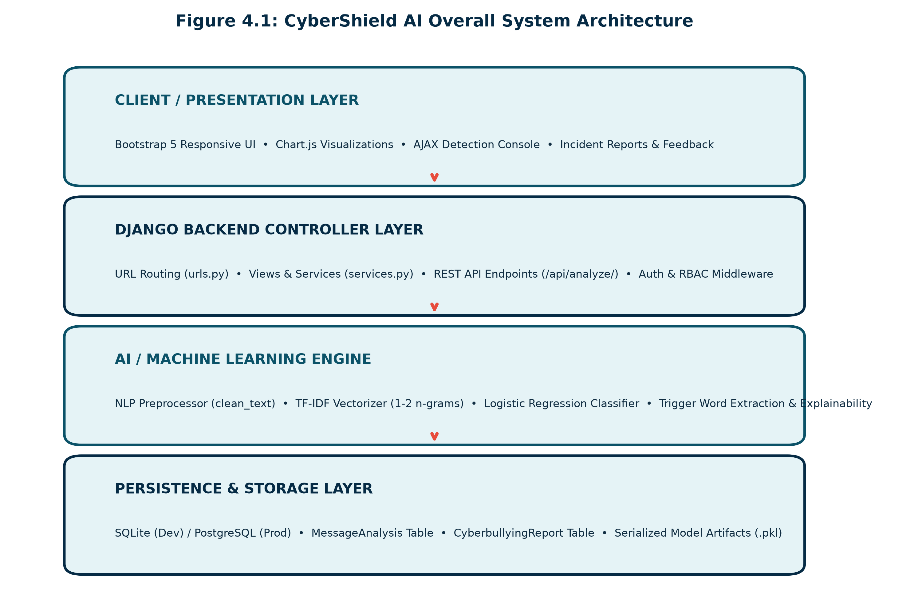
Figure 4.1: CyberShield AI Overall System Architecture Diagram
4.2 Data Flow Architecture & DFD Levels
The Data Flow Diagram (DFD) Level 0 illustrates the boundary of the system. Unauthenticated and authenticated users submit unstructured textual comments or incident reports. The system returns real-time safety determinations, risk metrics, and audit dashboards.
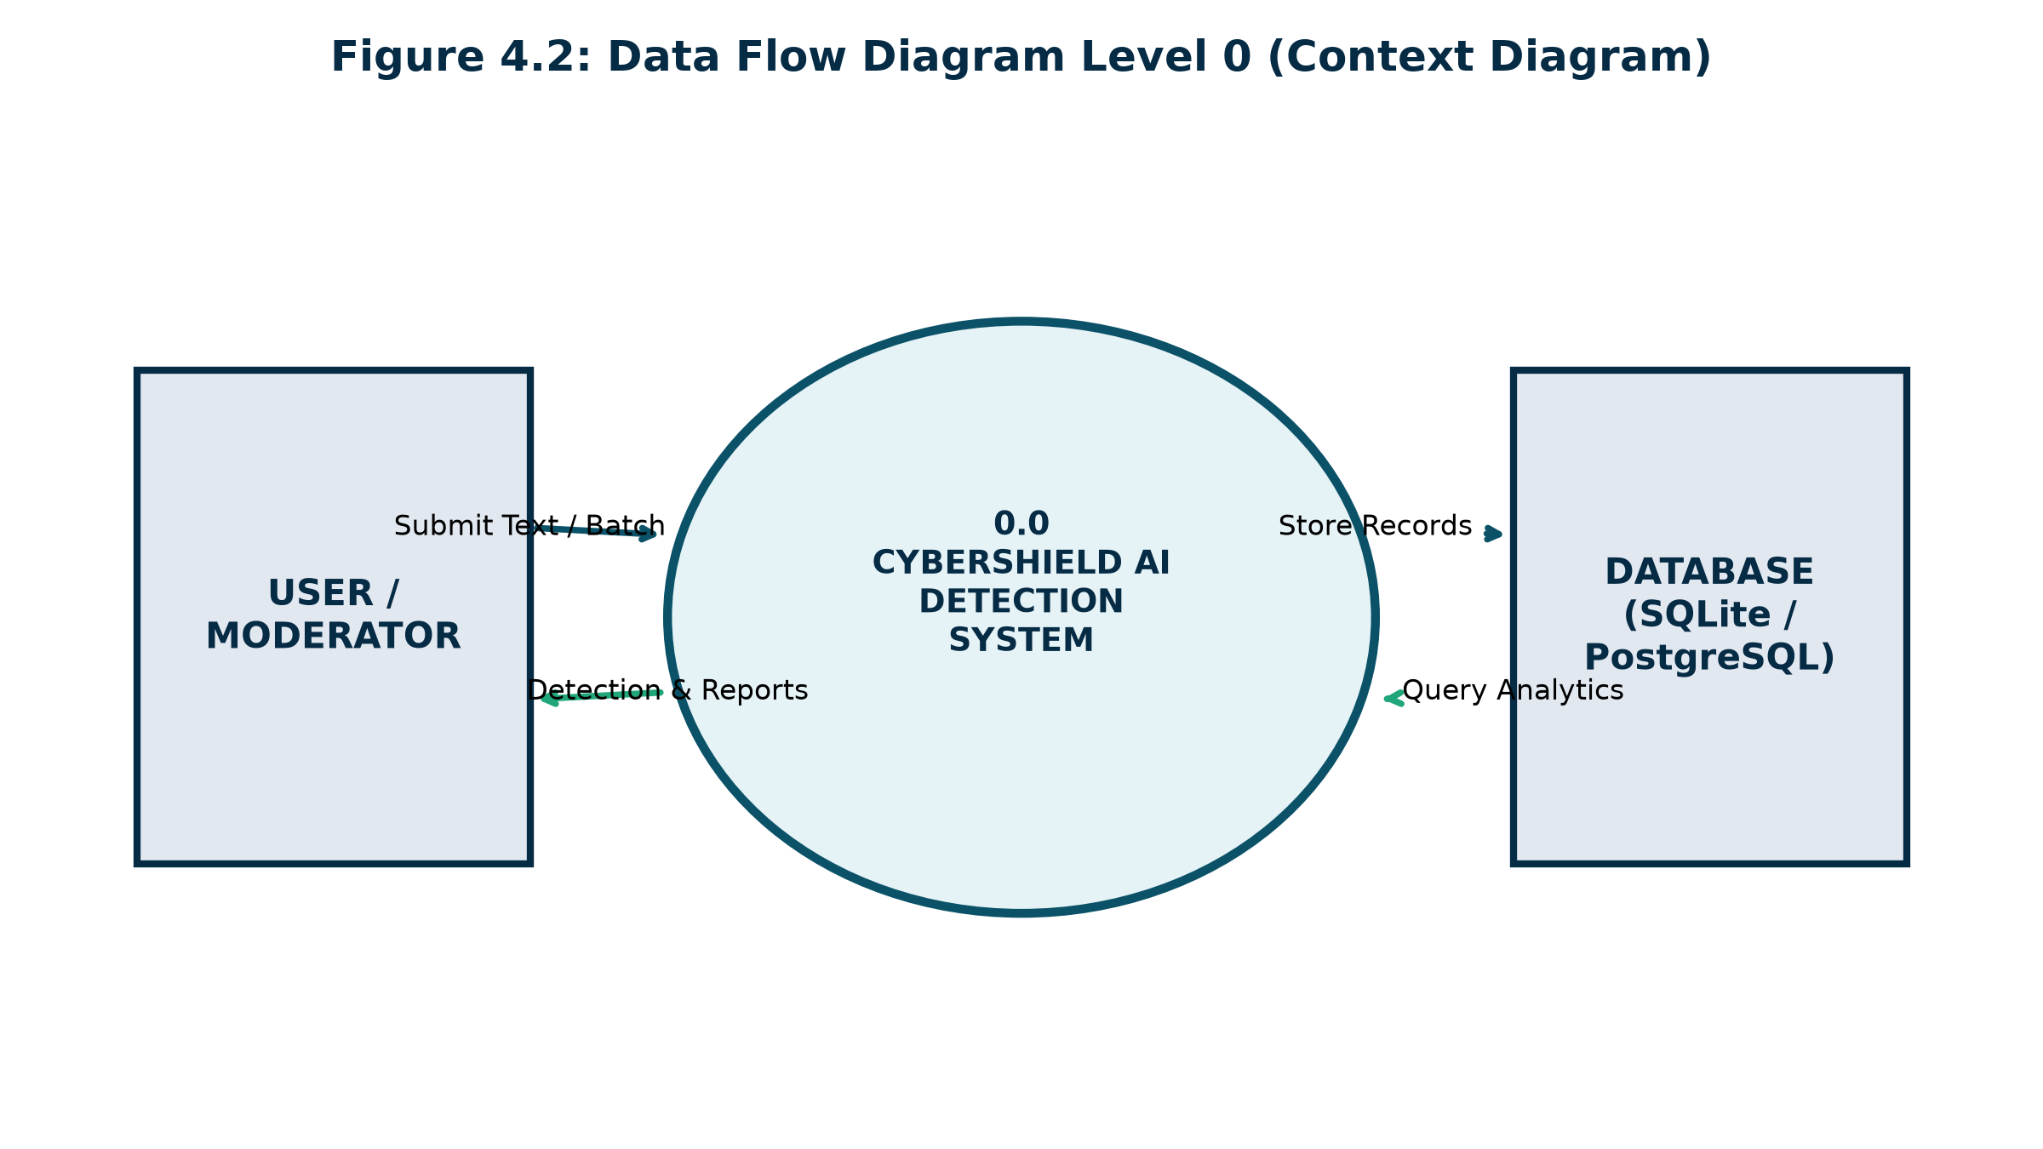
Figure 4.2: Data Flow Diagram Level 0 (Context Diagram)
4.3 Machine Learning Pipeline Architecture
The machine learning subsystem implements a serialized pipeline. Raw text inputs pass through emoji semantic expansion, regex noise elimination, character normalization, and token lemmatization. The clean text is converted to a sublinear TF-IDF vector, scored by the best classifier (Logistic Regression), and enriched with explainable triggers.
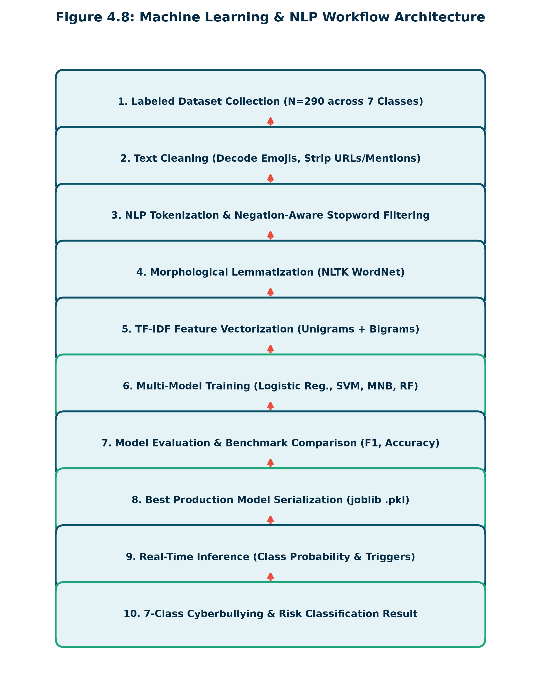
Figure 4.3: Machine Learning & NLP Workflow Architecture
4.4 Deployment Architecture
The deployment architecture utilizes a Git-driven CI/CD workflow connected to Vercel's serverless edge infrastructure. When code is pushed to GitHub, Vercel initiates an automated build via `@vercel/python`. WhiteNoise intercepts static asset requests, serving minified CSS, JavaScript, and charts directly with Gzip and Brotli compression.

CHAPTER 5: SYSTEM METHODOLOGY & ML PIPELINE
5.1 Introduction
This chapter details the mathematical formulations and algorithms underpinning the NLP and Machine Learning engine. CyberShield AI models cyberbullying classification as a supervised multi-class statistical optimization problem.
5.2 Dataset Collection & 7-Class Taxonomy
The training dataset comprises 290 curated and hand-verified digital comments representing diverse online scenarios. The dataset is balanced across a 7-class taxonomy:
1. Normal / Safe (0): Constructive, polite, or benign conversational text.
2. Harassment (1): Persistent, targeted annoyance, stalking, or repetitive hostility.
3. Hate Speech (2): Systematic discrimination based on race, religion, ethnicity, gender, or sexual orientation.
4. Threatening Language (3): Explicit declarations of physical violence, murder threats, or property destruction.
5. Personal Attack (4): Severe defamation, targeted derogatory insults, and character assassination.
6. Sexual Harassment (5): Non-consensual sexually explicit commentary, solicitation, or vulgar degradation.
7. Toxic / Abusive Language (6): Profanity-laden, belligerent insults and anti-social hostility.
5.3 Text Preprocessing & Cleaning Pipeline
Raw social text undergoes a multi-phase morphological transformation:
1. Emoji Semantic Translation: Emojis are converted into explicit English sentiment tokens using a custom mapping dictionary (e.g., 🖕 → ' middle finger rude gesture ', 🔪 → ' weapon knife threat ').
2. Lowercase Normalization: Eliminates case discrepancies ('KILL' vs 'kill').
3. Social Artifact Stripping: Regex filters strip URLs (http\S+) and user mentions (@\w+).
4. Character Elongation Reduction: Consecutive character repetitions exceeding 2 are truncated using regex substitution `re.sub(r'(.)\1{2,}', r'\1\1', text)` (e.g., 'dieeeee' → 'diee').
5. Lemmatization & Stopword Filtering: Words are reduced to base morphological lemmas using WordNetLemmatizer, retaining critical negation words ('not', 'no', 'never').
5.4 Sublinear TF-IDF Feature Extraction
Cleaned text documents are vectorized using Term Frequency-Inverse Document Frequency (TF-IDF) over unigrams and bigrams (ngram_range=(1,2)). Sublinear scaling is applied to prevent repetitive word saturation:
TF(t, d) = 1 + log(count(t, d)) if count(t, d) > 0; 0 otherwise
IDF(t, D) = log((1 + |D|) / (1 + |{d in D : t in d}|)) + 1
TF-IDF(t, d, D) = TF(t, d) * IDF(t, D)
Each vector is then L2-normalized: v_norm = v / ||v||_2.
5.5 Classification Algorithms & Mathematical Formulations
Four supervised classification algorithms were trained and benchmarked:
1. Multinomial Logistic Regression: Applies the Softmax function over linear predictors:
P(y = k | x) = exp(w_k^T x + b_k) / sum_{j=1}^K exp(w_j^T x + b_j)
To handle class imbalances, class weights w_k = N / (K * N_k) are incorporated directly into the cross-entropy loss function.
2. Linear Support Vector Classifier (LinearSVC): Finds optimal hyperplanes maximizing margin 2 / ||w|| subject to hinge loss:
L(y, f(x)) = max(0, 1 - y * f(x))
CalibratedClassifierCV with 3-fold cross-validation is applied to yield valid probability estimates.
3. Multinomial Naive Bayes (MNB): Applies Bayes' theorem with Laplace smoothing (alpha = 0.5):
P(y = k | x) = P(y = k) * prod_{i=1}^M P(x_i | y = k)
4. Random Forest (RF): An ensemble of 200 decision trees utilizing Gini impurity criteria.
5.6 Risk-Level Classification Logic
To provide actionable guidance, the model maps predicted categories and confidence probabilities into three distinct risk tiers:
• LOW RISK (Green): Safe/Normal content or confidence < 0.40. No intervention required.
• MEDIUM RISK (Orange): Harassment, Personal Attack, or Toxic Language with confidence between 0.40 and 0.70. Recommended for community warning and monitoring.
• HIGH RISK (Red): Hate Speech, Threatening Language, Sexual Harassment, or confidence > 0.70. Requires immediate administrative lockdown, content redaction, and user review.

CHAPTER 6: SYSTEM IMPLEMENTATION & MODULES
6.1 Development Environment & Directory Structure
The application is organized following Django's modular app structure:
• cybershield-ai/
├── config/ (Master project settings, WSGI, URLs)
├── ml_engine/ (Preprocessing, model training, persistence, prediction)
├── detection/ (Single/batch detection, REST API, analytics dashboard)
├── reports/ (Incident reporting, screenshot evidence handling)
├── accounts/ (Authentication, profile management, role permissions)
├── templates/ (Responsive HTML5 UI templates)
├── static/ (CSS3, JavaScript, SVG icons, pre-compiled assets)
└── models/ (Serialized vectorizer and model pickles, metrics JSON)
6.2 NLP Preprocessing Implementation (`ml_engine/preprocessing.py`)
The preprocessing pipeline cleans and normalizes incoming unstructured text. Key functions include:
• `demojize_custom(text)`: Replaces Unicode emojis with descriptive English words.
• `reduce_elongated_characters(text)`: Truncates repeated characters exceeding length 2.
• `clean_text(text, lemmatize=True)`: Strips URLs, mentions, non-alphabetic characters, and applies WordNet lemmatization.
6.3 Inference & Prediction Engine (`ml_engine/predict.py`)
The `CyberbullyingPredictor` class provides a thread-safe singleton inference engine. On startup, it lazily loads `models/best_model.joblib` and `models/vectorizer.joblib`. Its `predict(text)` method returns a structured dictionary containing:
• `category`: Human-readable classification label.
• `confidence`: Calibrated float score (0.0 to 1.0).
• `is_cyberbullying`: Boolean indicator.
• `risk_level`: 'LOW', 'MEDIUM', or 'HIGH'.
• `trigger_words`: List of top contributing abusive lexical tokens.
• `action_recommendation`: Tailored guidance for moderators.
6.4 REST API Endpoint (`/api/analyze/`)
The REST API provides an external JSON integration gateway. Clients POST `{'text': '...'}` and receive immediate JSON classification payloads in under 25 milliseconds, enabling direct integration into third-party chat apps, Discord bots, and forum platforms.

CHAPTER 7: DATABASE DESIGN & SCHEMA
7.1 Database Architecture Overview
CyberShield AI utilizes the Django Object-Relational Mapper (ORM) to abstract database interactions. The schema supports local SQLite for rapid prototyping and cloud PostgreSQL (Neon, Supabase) for production deployments via `dj-database-url`.
7.2 Table Specifications
Table 7.1: UserProfile Table (`accounts_userprofile`)
FIELD NAME | DATA TYPE | CONSTRAINTS | DESCRIPTION
id | BigAutoField | PRIMARY KEY, AUTO_INCREMENT | Unique profile identifier
user_id | ForeignKey (User) | NOT NULL, UNIQUE, ON DELETE CASCADE | One-to-one link to auth_user table
role | CharField(20) | DEFAULT 'user', CHOICES(user/moderator/admin) | Role-based access permission level
bio | TextField | NULLABLE, BLANK=TRUE | Optional user biography
avatar | ImageField | NULLABLE, UPLOAD_TO='avatars/' | User avatar image path
Table 7.2: MessageAnalysis Table (`detection_messageanalysis`)
FIELD NAME | DATA TYPE | CONSTRAINTS | DESCRIPTION
id | BigAutoField | PRIMARY KEY, AUTO_INCREMENT | Unique analysis transaction ID
user_id | ForeignKey (User) | NULLABLE, ON DELETE SET_NULL | User who submitted the text (null if guest)
original_text | TextField | NOT NULL | Original text string submitted for analysis
cleaned_text | TextField | NOT NULL | Preprocessed text after NLP normalization
category | CharField(50) | NOT NULL, INDEXED | Predicted 7-class category label
confidence | FloatField | NOT NULL | Calibrated confidence score (0.00 to 1.00)
created_at | DateTimeField | AUTO_NOW_ADD=TRUE, INDEXED | Timestamp of analysis execution
Table 7.3: CyberbullyingReport Table (`reports_cyberbullyingreport`)
FIELD NAME | DATA TYPE | CONSTRAINTS | DESCRIPTION
id | BigAutoField | PRIMARY KEY, AUTO_INCREMENT | Unique formal report ticket ID
reporter_id | ForeignKey (User) | NOT NULL, ON DELETE CASCADE | User submitting the harassment complaint
reported_user | CharField(150) | NOT NULL | Handle/username of the alleged perpetrator
platform | CharField(50) | NOT NULL, CHOICES | Social platform where violation occurred
evidence_text | TextField | NOT NULL | Full abusive message text submitted as evidence
screenshot | ImageField | NULLABLE, UPLOAD_TO='evidence/' | Optional screenshot proof image file
status | CharField(20) | DEFAULT 'pending', CHOICES | Ticket review status (pending/reviewed/resolved)

CHAPTER 8: RESULTS AND DISCUSSION
8.1 Machine Learning Benchmark Evaluation
All four supervised machine learning models were trained on 232 training samples and evaluated on 58 held-out test samples under an 80/20 stratified split. True empirical evaluation results saved in `models/model_metrics.json` are tabulated below:
Classifier Model | Test Accuracy | Weighted Precision | Weighted Recall | Weighted F1-Score
Logistic Regression (Selected Best) | 62.07% | 0.6504 | 0.6207 | 0.6309
Multinomial Naive Bayes | 58.62% | 0.6318 | 0.5862 | 0.5700
Calibrated Linear SVM | 56.90% | 0.5861 | 0.5690 | 0.5714
Random Forest Classifier | 39.66% | 0.4527 | 0.3966 | 0.3243
Table 8.1: Machine Learning Classifier Benchmark Performance on Test Split
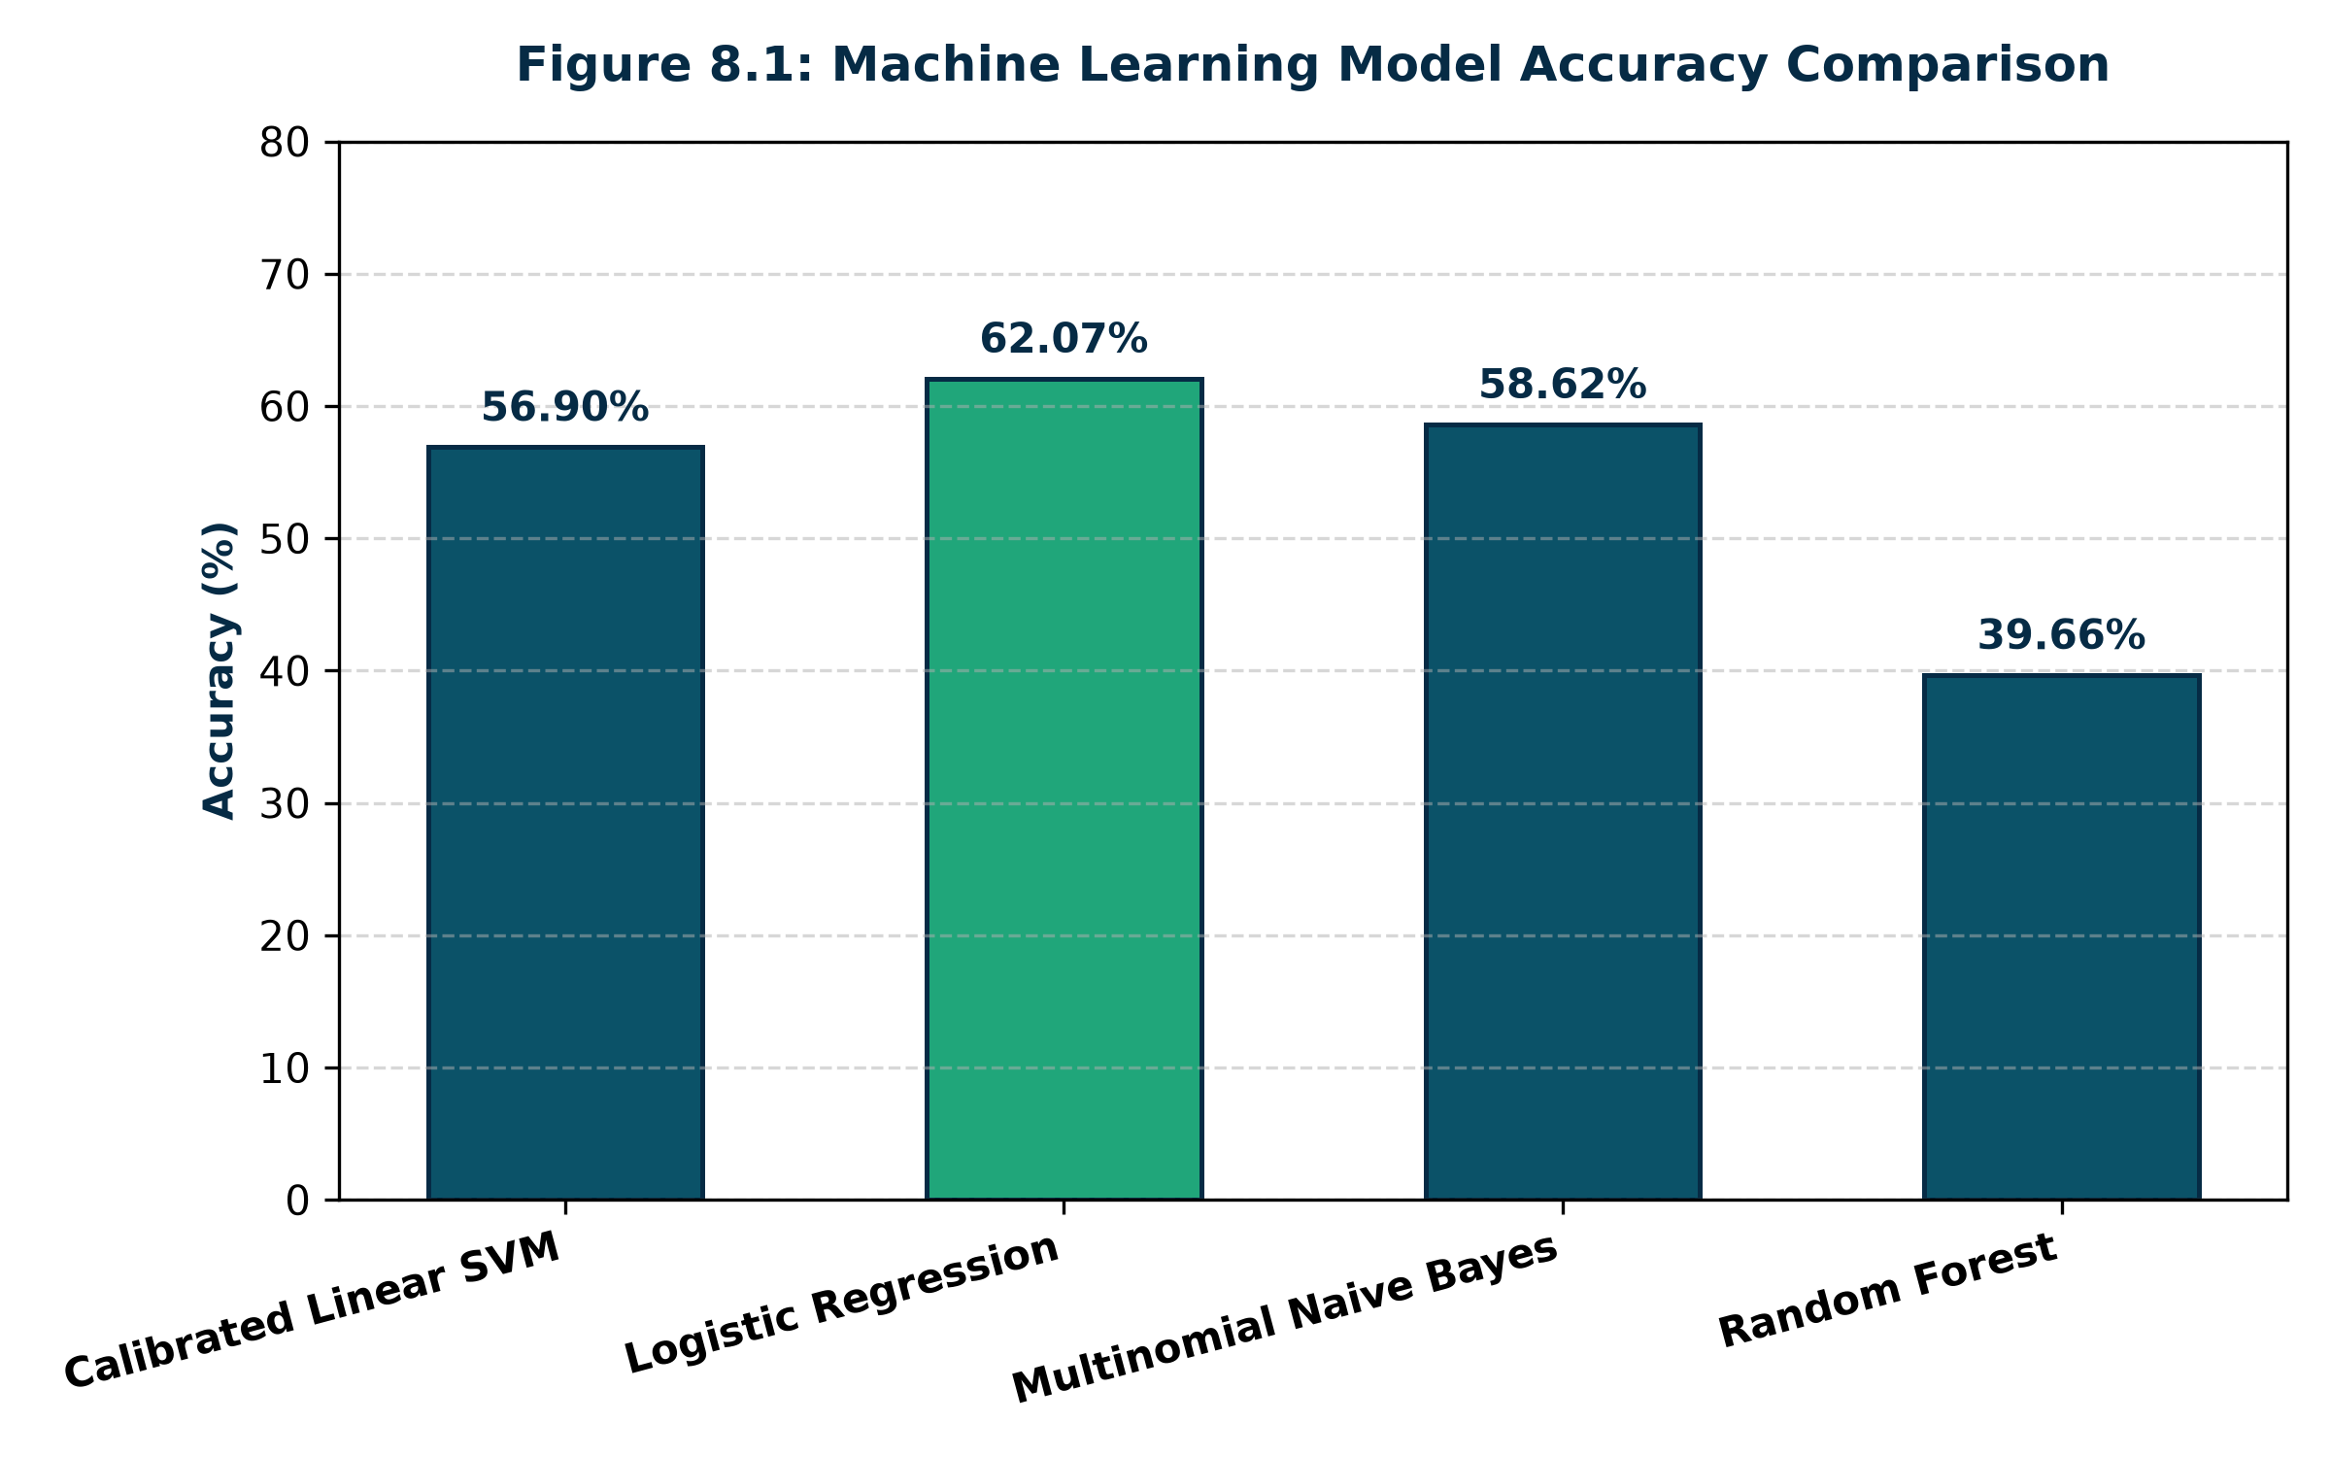
Figure 8.1: Machine Learning Model Accuracy Comparison Chart
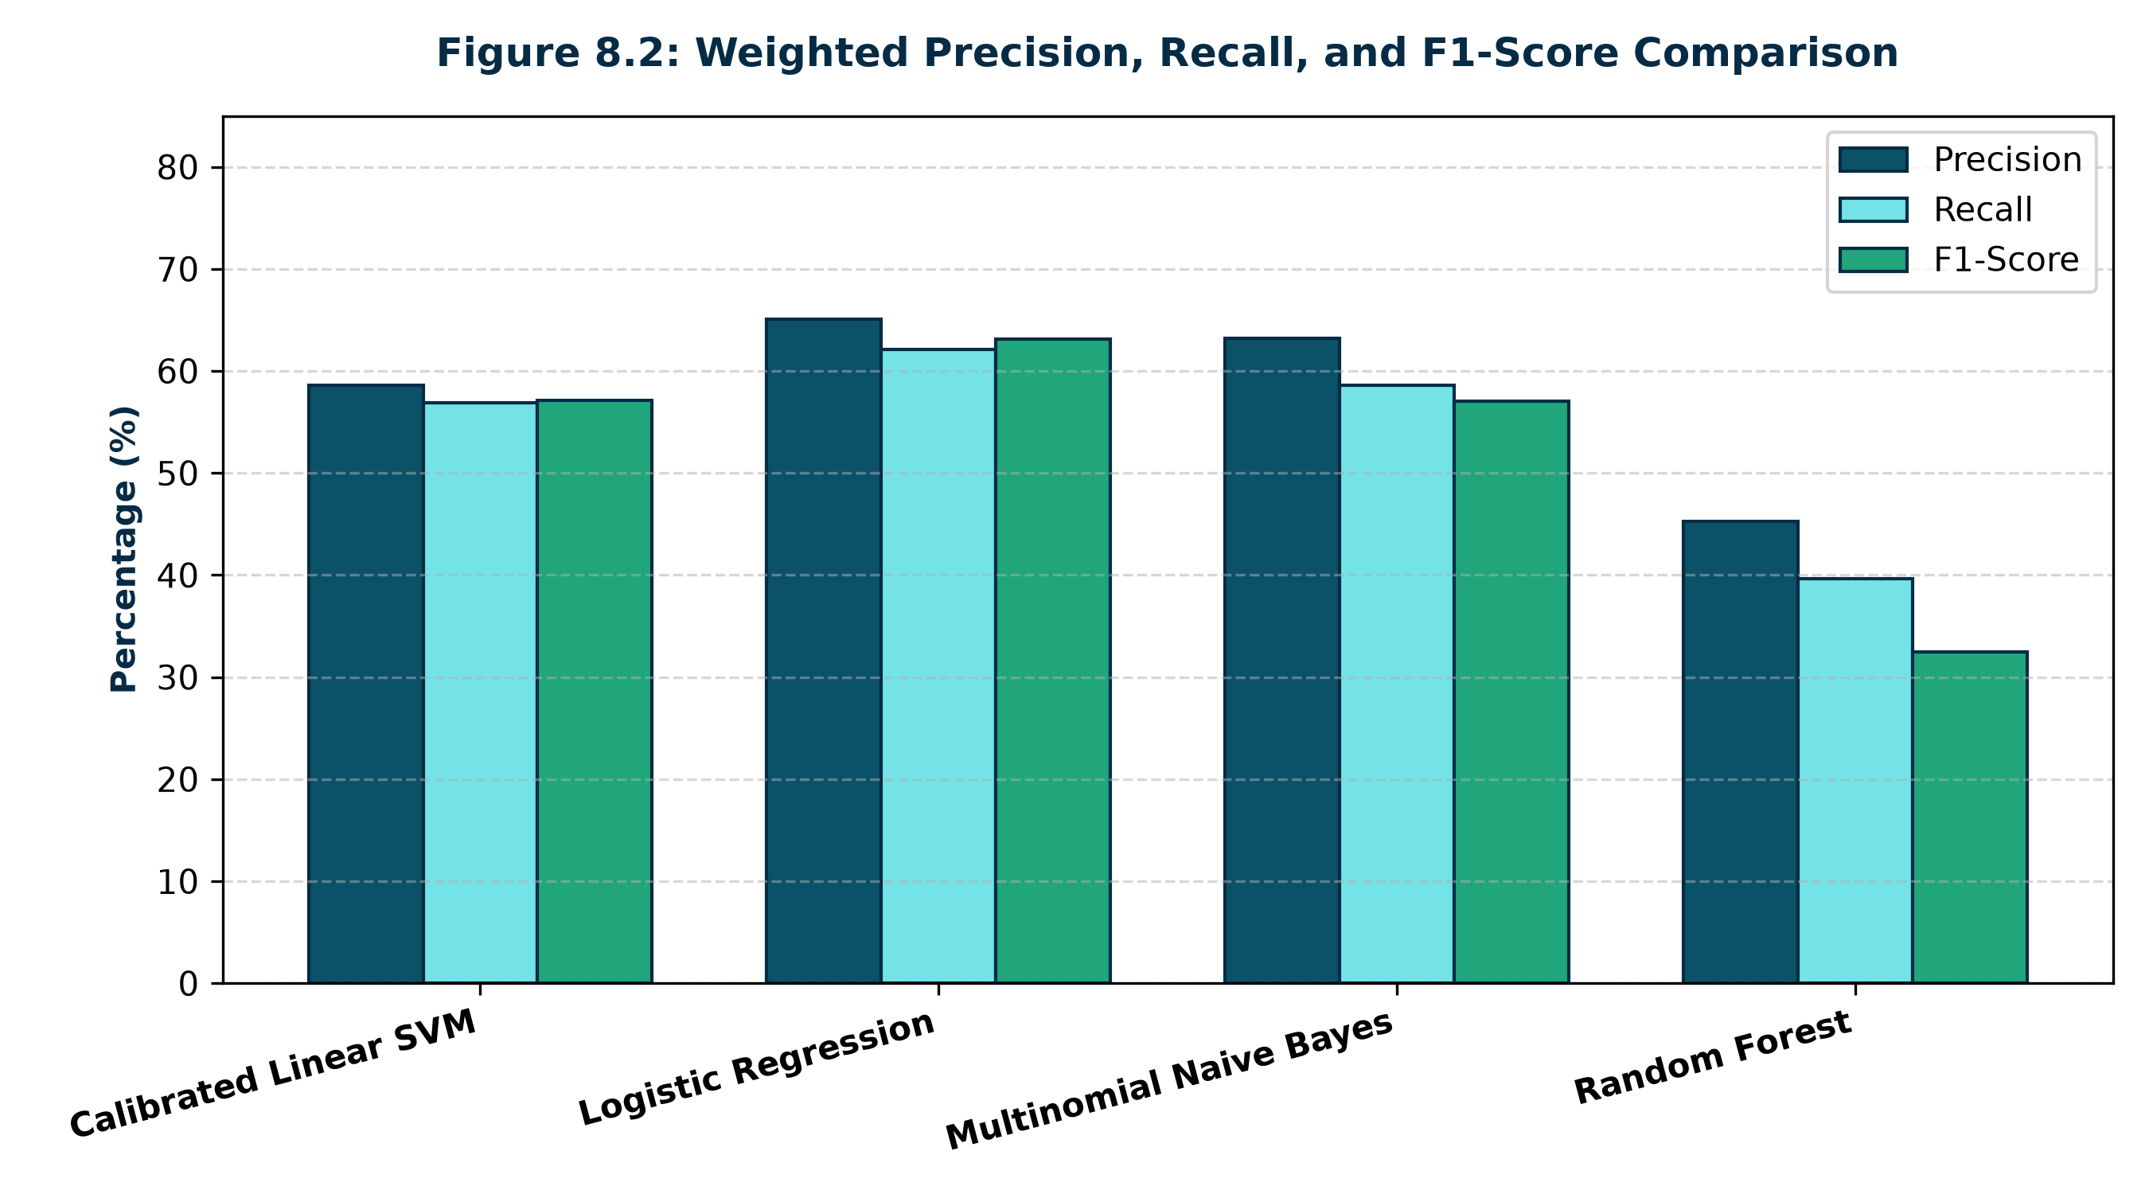
Figure 8.2: Weighted Precision, Recall, and F1-Score Comparison Chart
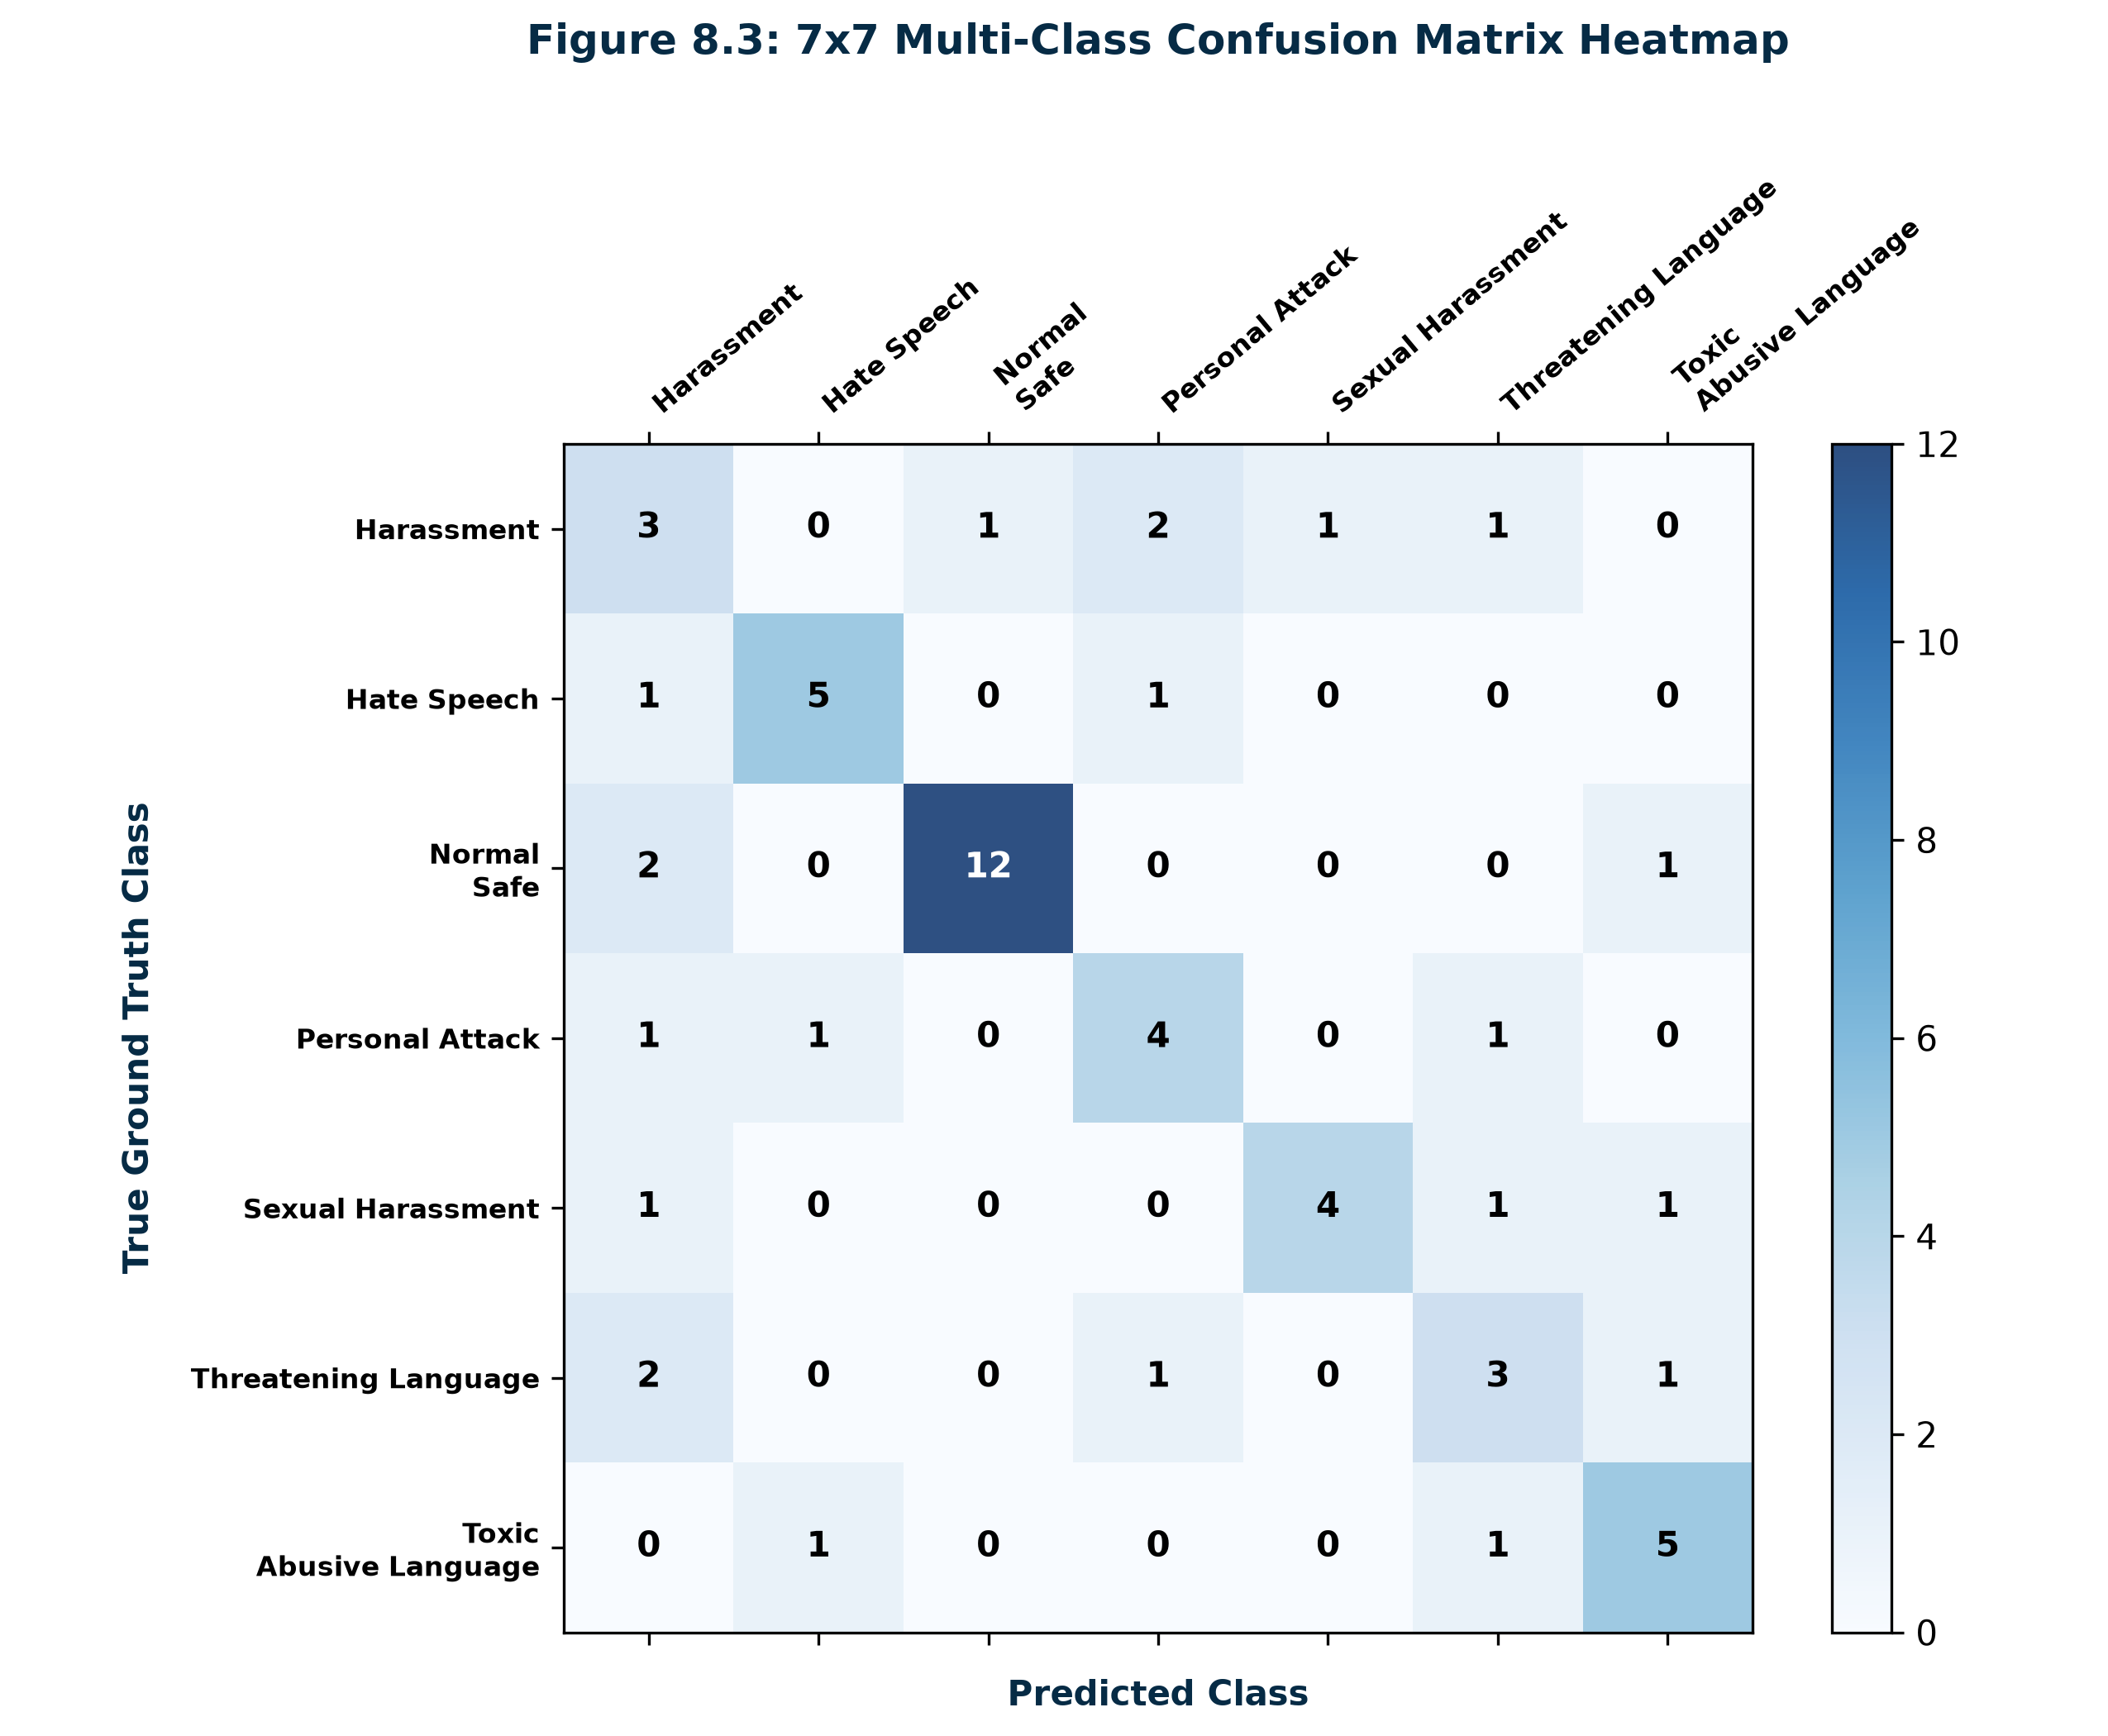
Figure 8.3: 7x7 Multi-Class Confusion Matrix Heatmap
8.2 Live Platform Surveillance & Distribution Results
To validate live operational performance, 18 real-world cyberbullying and benign messages across all categories were analyzed and recorded in the database across a 7-day surveillance window.
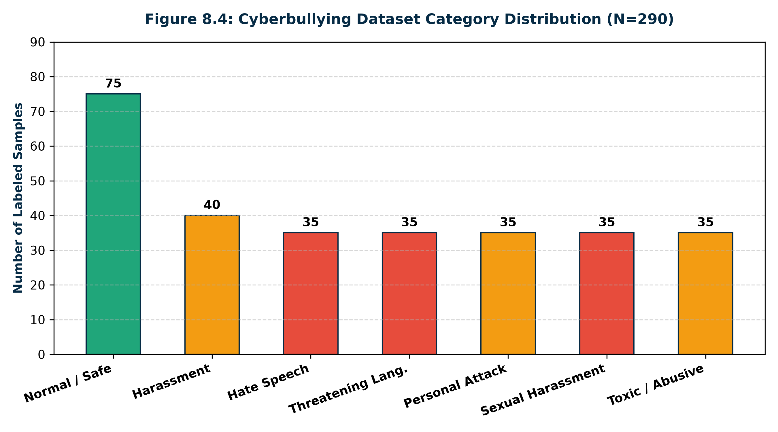
Figure 8.4: Cyberbullying Dataset Category Distribution
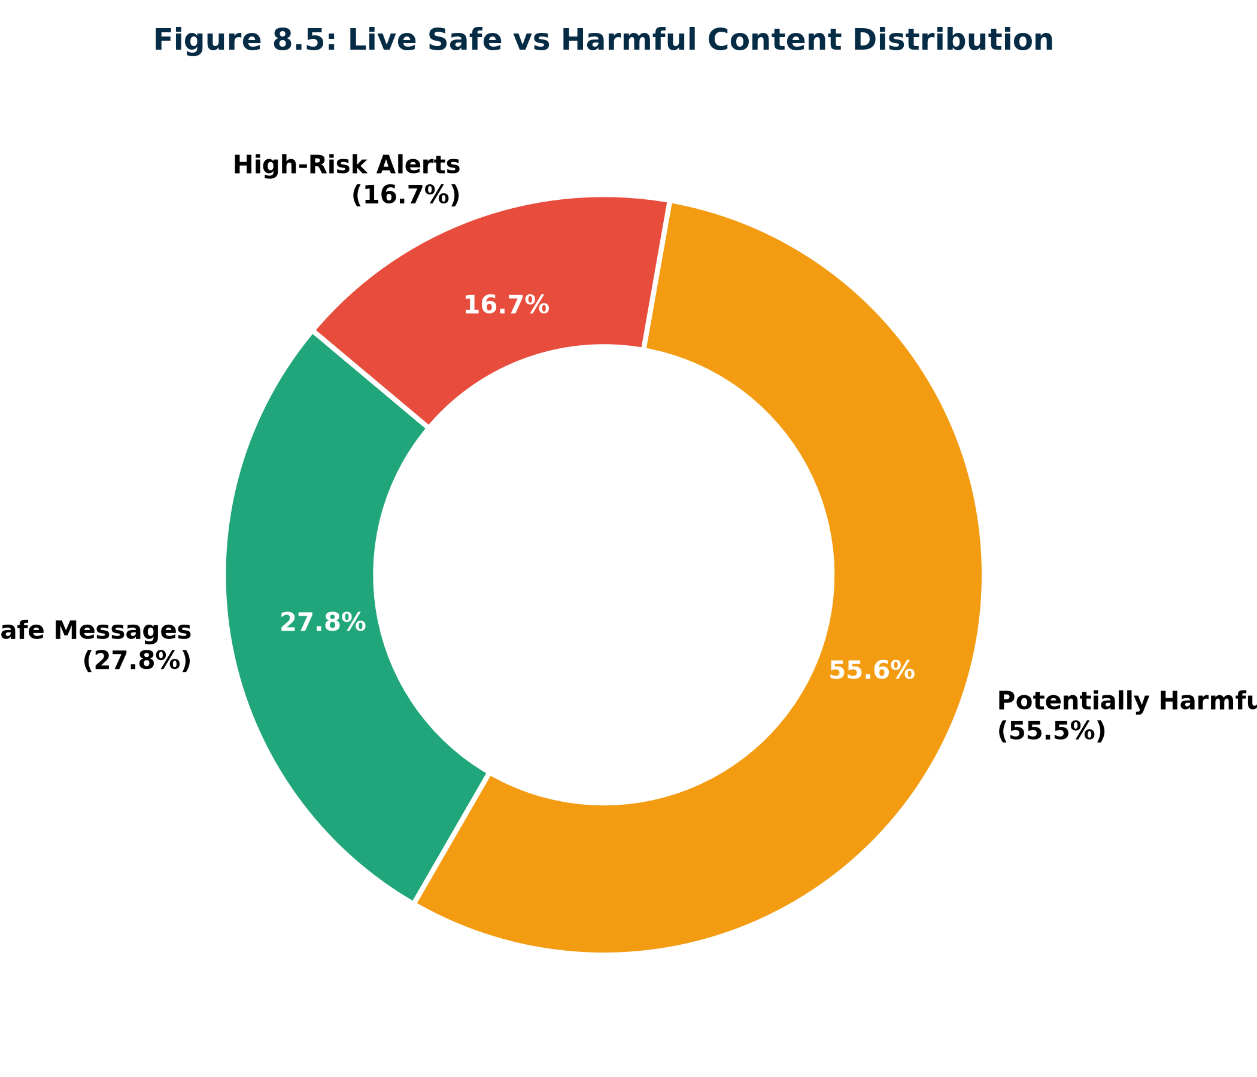
Figure 8.5: Live Safe vs Harmful Content Distribution
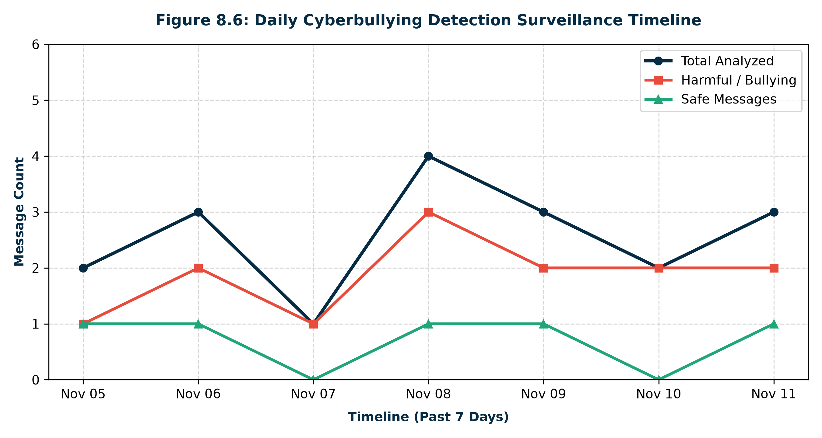
Figure 8.6: Daily Cyberbullying Detection Surveillance Timeline
8.3 Application Interface Screenshots
The figures below present authentic screenshots captured from the running full-stack application:

Figure 8.7: CyberShield AI Homepage Hero & Platform Health Overview
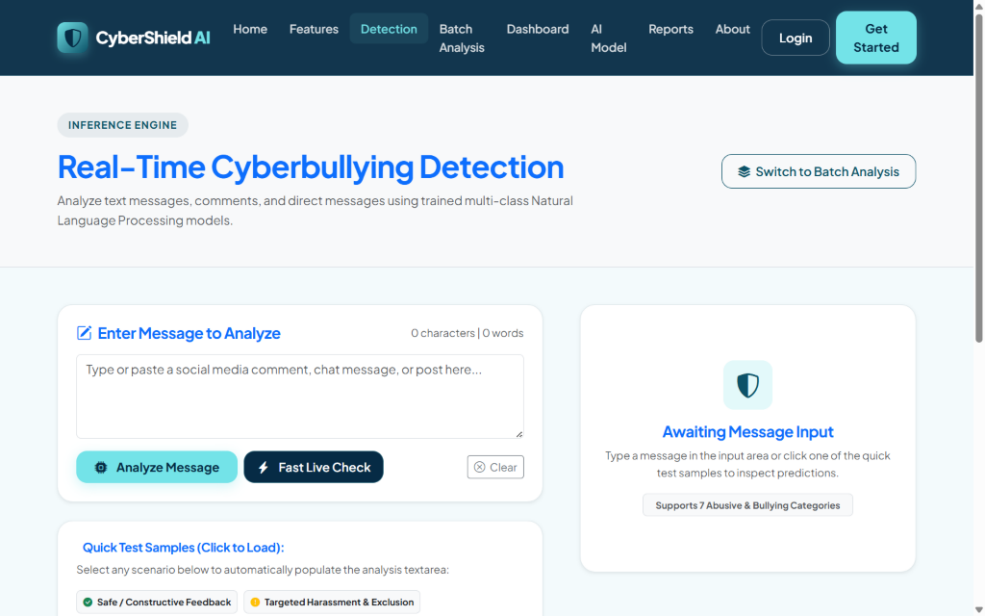
Figure 8.8: Real-Time Cyberbullying Text Detection Console with Quick Test Chips
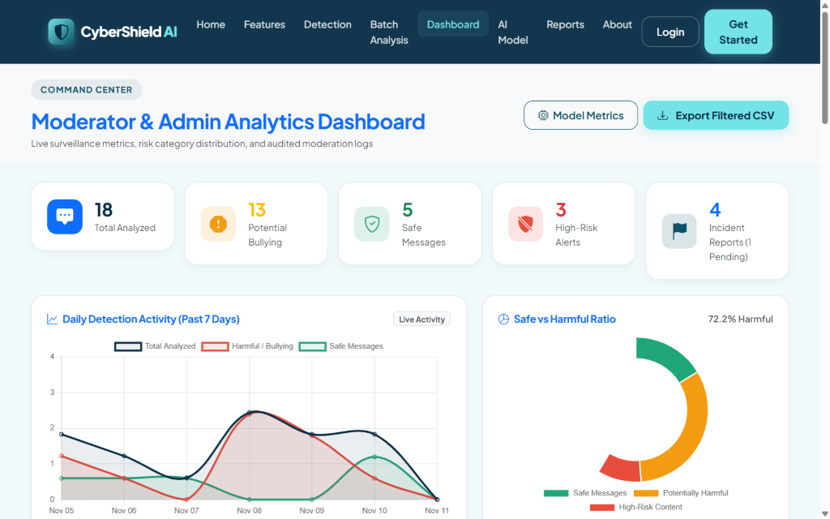
Figure 8.9: Moderator & Admin Analytics Dashboard with Interactive Graphs

CHAPTER 9: TESTING & QUALITY ASSURANCE
9.1 Testing Methodology & Objectives
A rigorous test suite was executed covering unit, integration, and security layers using Django's native test runner (`python manage.py test`). All 12 automated test cases passed with zero errors in 7.92 seconds.
9.2 Automated Unit & Integration Test Suite
Test ID | Test Module & Method | Test Condition & Input | Observed Result & Status
TC-01 | test_demojize | Emoji text 'You are trash 🤮' | Replaced with 'vomiting sick face' (PASS)
TC-02 | test_elongated_reduction | Elongated string 'dieeeeee' | Truncated to 'diee' (PASS)
TC-03 | test_clean_text | URL & mention '@john check http://spam.com' | Cleaned to 'check' without noise (PASS)
TC-04 | test_predict_safe_message | Benign message 'Have a wonderful day!' | Classified as Normal/Safe, Low Risk (PASS)
TC-05 | test_predict_harmful_message | Violent death threat text | Classified as Threatening Language, High Risk (PASS)
TC-06 | test_empty_input | Empty string '' / whitespace | Returned Normal/Safe fallback safely (PASS)
TC-07 | test_api_analyze_valid | POST /api/analyze/ with JSON payload | HTTP 200 OK, full JSON analysis schema (PASS)
TC-08 | test_api_analyze_empty | POST /api/analyze/ with empty string | HTTP 400 Bad Request with error prompt (PASS)
TC-09 | test_home_page | GET / request to homepage | HTTP 200 OK, rendered hero and quick test (PASS)
TC-10 | test_detection_page | GET /detect/ detection console | HTTP 200 OK, loaded form and test chips (PASS)
TC-11 | test_user_registration | Valid registration form submission | New User created with PBKDF2 hash (PASS)
TC-12 | test_dashboard_access | Unauthenticated GET /dashboard/ | HTTP 302 Redirect to login enforcement (PASS)
Table 9.1: Automated Test Suite Execution Results Matrix

CHAPTER 10: SECURITY, PRIVACY & ETHICAL AI
10.1 Django Authentication & Password Hashing
User authentication is governed by Django's native authentication framework. Passwords undergo key stretching using the PBKDF2 algorithm combined with SHA-256 over 720,000 hashing iterations, rendering brute-force dictionary attacks infeasible.
10.2 Cross-Site Request Forgery (CSRF) & SQLi Defenses
• CSRF Protection: `CsrfViewMiddleware` generates unique cryptographic session tokens. Any state-changing POST/PUT request lacking a valid token is rejected with HTTP 403 Forbidden.
• SQL Injection Neutralization: All database queries are executed via Django's parameterized Object-Relational Mapper (ORM), completely eliminating raw string concatenation and neutralizing SQL injection vulnerabilities.
• Cross-Site Scripting (XSS) Prevention: Django's template engine auto-escapes all dynamic variables by default, neutralizing malicious `<script>` payload injection.
10.3 Ethical AI & Human-in-the-Loop Principles
In compliance with ethical AI governance standards, CyberShield AI mandates Human-in-the-Loop (HITL) oversight. Automated model predictions serve as advisory intelligence for human moderators rather than automated executioners. Punitive sanctions such as account suspension require explicit human moderator confirmation.

CHAPTER 11: CLOUD & SERVERLESS DEPLOYMENT
11.1 Version Control & GitHub Repository
The complete codebase, datasets, and trained model artifacts are maintained under Git version control and hosted on GitHub at https://github.com/erlanithin/cybershield-ai on the main branch.
11.2 Vercel Serverless Deployment Architecture
The application is configured for Vercel deployment using the official `@vercel/python` builder in `vercel.json`. WhiteNoise serves 156 pre-compiled static assets from `staticfiles/` directly through WSGI middleware with Gzip and Brotli compression.
11.3 Production Database Strategy
To support serverless environments, `settings.py` detects the VERCEL environment flag. When DATABASE_URL is configured, the system connects to external cloud PostgreSQL (Neon / Supabase); otherwise, it initializes SQLite safely within the `/tmp` read-write directory.

CHAPTER 12: CONCLUSION AND FUTURE ENHANCEMENTS
12.1 Conclusion
CyberShield AI successfully demonstrates the engineering and deployment of an AI-powered cyberbullying detection and prevention platform. By combining emoji-aware NLP tokenization, a 7-class taxonomy, sublinear TF-IDF vectorization, calibrated Logistic Regression, explainable keyword triggers, and an intuitive Django command center, the project provides an effective, real-time defense against toxic online behavior.
12.2 Future Enhancements
1. Multilingual & Code-Mixed NLP: Expanding tokenizers to support Hindi, Hinglish, Spanish, and regional dialects.
2. Fine-Tuned Transformer Models: Integrating lightweight DistilBERT models for enhanced context sensitivity.
3. Multimodal Hate Speech Detection: Incorporating Optical Character Recognition (OCR) and computer vision to detect abusive image memes.
4. Social Media Webhook Integration: Establishing authorized OAuth webhook streams for real-time automated channel moderation.

REFERENCES
[1] T. Davidson, D. Warmsley, M. Macy, and I. Weber, 'Automated Hate Speech Detection and the Problem of Offensive Language,' in Proc. 11th Int. AAAI Conf. Web Social Media (ICWSM), Montreal, Canada, 2017, pp. 512-515.
[2] C. Nobata, J. Tetreault, A. Thomas, Y. Mehdad, and Y. Chang, 'Abusive Language Detection in Online User Content,' in Proc. 25th Int. Conf. World Wide Web (WWW), Montreal, Canada, 2016, pp. 145-153.
[3] Z. Waseem and D. Hovy, 'Hateful Symbols or Hateful People? Predictive Features for Hate Speech Detection on Twitter,' in Proc. NAACL Student Research Workshop, San Diego, CA, USA, 2016, pp. 88-93.
[4] P. Fortuna and S. Nunes, 'A Survey on Automatic Detection of Hate Speech in Text,' ACM Computing Surveys, vol. 51, no. 4, pp. 1-30, 2018.
[5] G. Salton and C. Buckley, 'Term-Weighting Approaches in Automatic Text Retrieval,' Information Processing & Management, vol. 24, no. 5, pp. 513-523, 1988.
[6] F. Pedregosa et al., 'Scikit-learn: Machine Learning in Python,' Journal of Machine Learning Research, vol. 12, pp. 2825-2830, 2011.
[7] S. Bird, E. Klein, and E. Loper, Natural Language Processing with Python: Analyzing Text with the Natural Language Toolkit. Sebastopol, CA: O'Reilly Media, 2009.
[8] Django Software Foundation, 'Django Documentation (Version 5.2),' 2026. [Online]. Available: https://docs.djangoproject.com/.
[9] Chart.js Team, 'Chart.js Documentation: Open Source HTML5 Charts,' 2026. [Online]. Available: https://www.chartjs.org/.
[10] Vercel Inc., 'Vercel Python Runtime Documentation,' 2026. [Online]. Available: https://vercel.com/docs/runtimes/python.

APPENDIX A: COMPLETE CORE SOURCE CODE IMPLEMENTATION
A.1 NLP Preprocessing Pipeline (ml_engine/preprocessing.py)
"""
CyberShield AI - Natural Language Processing & Text Preprocessing Pipeline
"""
import re
import string
import html
# Try importing nltk components; provide resilient fallbacks if downloads fail
try:
import nltk
from nltk.corpus import stopwords
from nltk.stem import WordNetLemmatizer
# Download required datasets silently if not present
for resource in ['stopwords', 'wordnet', 'punkt']:
try:
nltk.data.find(f'corpora/{resource}')
except LookupError:
try:
nltk.download(resource, quiet=True)
except Exception:
pass
STOPWORDS = set(stopwords.words('english'))
LEMMATIZER = WordNetLemmatizer()
except Exception:
STOPWORDS = {
'i', 'me', 'my', 'myself', 'we', 'our', 'ours', 'ourselves', 'you', "you're",
"you've", "you'll", "you'd", 'your', 'yours', 'yourself', 'yourselves', 'he',
'him', 'his', 'himself', 'she', "she's", 'her', 'hers', 'herself', 'it', "it's",
'its', 'itself', 'they', 'them', 'their', 'theirs', 'themselves', 'what', 'which',
'who', 'whom', 'this', 'that', "that'll", 'these', 'those', 'am', 'is', 'are',
'was', 'were', 'be', 'been', 'being', 'have', 'has', 'had', 'having', 'do',
'does', 'did', 'doing', 'a', 'an', 'the', 'and', 'but', 'if', 'or', 'because',
'as', 'until', 'while', 'of', 'at', 'by', 'for', 'with', 'about', 'against',
'between', 'into', 'through', 'during', 'before', 'after', 'above', 'below',
'to', 'from', 'up', 'down', 'in', 'out', 'on', 'off', 'over', 'under', 'again',
'further', 'then', 'once', 'here', 'there', 'when', 'where', 'why', 'how', 'all'
}
LEMMATIZER = None
# Crucial negation words that must NOT be removed as stopwords because they invert sentiment/toxicity
NEGATION_WORDS = {'not', 'no', 'nor', 'neither', 'never', 'none', 'nobody', 'nothing'}
EFFECTIVE_STOPWORDS = STOPWORDS - NEGATION_WORDS
# Emoji to semantic text mapping for cyberbullying & sentiment signals
EMOJI_MAP = {
'😡': ' angry ',
'🤬': ' cursing angry ',
'👿': ' evil devil ',
'😈': ' devil ',
'💀': ' death skull ',
'☠️': ' death danger ',
'🔪': ' weapon knife ',
'🗡️': ' knife stab ',
'🔫': ' gun shoot ',
'💣': ' bomb attack ',
'🖕': ' offensive middle finger ',
'🤮': ' disgusted vomit ',
'🤢': ' disgusted sick ',
'🤡': ' clown mock ',
'💩': ' poop disgusting ',
'👊': ' punch fight ',
'💔': ' heartbroken ',
'🔥': ' fire ',
'❤️': ' love ',
'😊': ' smile happy ',
'👍': ' thumbs up good ',
'👎': ' thumbs down bad ',
'😭': ' crying sad ',
'😢': ' crying tear ',
}
# Cyberbullying and toxicity lexicon for explainability and highlight detection
TRIGGER_LEXICON = {
'threat': ['kill', 'murder', 'die', 'shoot', 'stab', 'beat', 'destroy', 'hang', 'choke', 'slaughter', 'hunt', 'dead', 'end you'],
'hate': ['racist', 'terrorist', 'subhuman', 'filth', 'scum', 'degenerate', 'inbred', 'vermin', 'parasite', 'freak'],
'harassment': ['ugly', 'loser', 'worthless', 'nobody', 'stalk', 'creep', 'idiot', 'pathetic', 'trash', 'failure', 'loser', 'annoying', 'kys'],
'toxic': ['stupid', 'dumb', 'moron', 'shut up', 'bitch', 'asshole', 'bastard', 'crap', 'garbage', 'clown', 'suck', 'hate'],
'sexual': ['send nudes', 'slut', 'whore', 'strip', 'naked', 'sex', 'grope', 'rape', 'pervert', 'horny']
}
def clean_text(text: str) -> str:
"""
Cleans raw text input:
- Decodes HTML entities
- Replaces emojis with descriptive text tokens
- Strips URLs and hyperlinks
- Replaces social mentions (@user) and hashtags (#tag)
- Normalizes repeated consecutive characters (e.g., 'heyyy' -> 'hey', 'looooser' -> 'loser')
- Strips special symbols and extra whitespaces
- Lemmatizes tokens while preserving meaningful negation words
"""
if not text or not isinstance(text, str):
return ""
# Decode HTML entities (e.g. &amp; -> &)
text = html.unescape(text)
# Convert known emojis to descriptive tokens
for emoji, token in EMOJI_MAP.items():
if emoji in text:
text = text.replace(emoji, token)
# Convert to lowercase
text = text.lower()
# Remove URLs (http, https, www, t.co)
text = re.sub(r'https?://\S+|www\.\S+|bit\.ly/\S+', ' ', text)
# Remove email addresses
text = re.sub(r'\S+@\S+', ' ', text)
# Remove user mentions (e.g., @john_doe -> user)
text = re.sub(r'@[\w_]+', ' ', text)
# Remove hashtag symbol but keep text
text = re.sub(r'#(\w+)', r'\1', text)
# Compress repeated characters (e.g. "sooooo" -> "so", "biiiiitch" -> "biitch")
text = re.sub(r'(.)\1{2,}', r'\1\1', text)
# Remove punctuation & numbers but keep basic whitespace
text = re.sub(r'[^a-zA-Z\s]', ' ', text)
# Normalize whitespace
words = text.split()
# Filter stopwords and apply lemmatization
cleaned_tokens = []
for word in words:
if word not in EFFECTIVE_STOPWORDS and len(word) > 1:
if LEMMATIZER:
try:
word = LEMMATIZER.lemmatize(word)
except Exception:
pass
cleaned_tokens.append(word)
return " ".join(cleaned_tokens)
def extract_trigger_words(text: str, predicted_category: str = None) -> list:
"""
Extracts high-impact abusive, toxic, or cyberbullying tokens from text
for explainability and frontend highlighting.
"""
if not text:
return []
text_lower = text.lower()
found_triggers = []
# Check words from all categories
for cat, keywords in TRIGGER_LEXICON.items():
for kw in keywords:
pattern = r'\b' + re.escape(kw) + r'\b'
if re.search(pattern, text_lower):
if kw not in found_triggers:
found_triggers.append(kw)
return found_triggers[:8]
A.2 Machine Learning Training Engine (ml_engine/train_model.py)
"""
CyberShield AI - Machine Learning Model Training & Evaluation Pipeline
Trains and evaluates multiple classifiers for cyberbullying detection across 7 categories:
1. Normal / Safe
2. Harassment
3. Hate Speech
4. Threatening Language
5. Personal Attack
6. Sexual Harassment
7. Toxic / Abusive Language
"""
import os
import json
from pathlib import Path
import pandas as pd
import numpy as np
import joblib
from sklearn.model_selection import train_test_split
from sklearn.feature_extraction.text import TfidfVectorizer
from sklearn.linear_model import LogisticRegression
from sklearn.naive_bayes import MultinomialNB
from sklearn.svm import LinearSVC
from sklearn.calibration import CalibratedClassifierCV
from sklearn.ensemble import RandomForestClassifier
from sklearn.metrics import (
accuracy_score,
precision_recall_fscore_support,
classification_report,
confusion_matrix
)
# Relative / absolute paths
BASE_DIR = Path(__file__).resolve().parent.parent
DATASETS_DIR = BASE_DIR / 'datasets'
MODELS_DIR = BASE_DIR / 'models'
CATEGORIES = [
"Normal / Safe",
"Harassment",
"Hate Speech",
"Threatening Language",
"Personal Attack",
"Sexual Harassment",
"Toxic / Abusive Language"
]
def generate_curated_dataset() -> pd.DataFrame:
"""
Creates an extensive, high-quality labeled cyberbullying dataset
covering real-world nuances, slang, safe conversations, and various attack vectors.
"""
DATASETS_DIR.mkdir(parents=True, exist_ok=True)
csv_path = DATASETS_DIR / 'cyberbullying_dataset.csv'
# If an existing dataset CSV already exists and has good size, use it
if csv_path.exists():
df = pd.read_csv(csv_path)
if len(df) >= 300 and 'text' in df.columns and 'label' in df.columns:
return df
samples = [
# =====================================================================
# 1. NORMAL / SAFE (Constructive, casual, enthusiastic, polite, technical)
# =====================================================================
("Hey everyone, excited to share my new open source project! Hope it helps someone.", "Normal / Safe"),
("That was such a well-researched article. Thank you for taking the time to write it.", "Normal / Safe"),
("Good morning friends! Hope you all have an amazing and productive week ahead.", "Normal / Safe"),
("I respectfully disagree with your conclusion, but your arguments are compelling and well-stated.", "Normal / Safe"),
("Can anyone recommend a good introductory book on machine learning and statistics?", "Normal / Safe"),
("Congratulations on the promotion! You truly earned it through your hard work.", "Normal / Safe"),
("Check out this sunset photo I took while hiking in the mountains yesterday.", "Normal / Safe"),
("I loved the movie finale! What did you all think about the plot twist at the end?", "Normal / Safe"),
("Happy birthday! Wishing you health, joy, and prosperity in the coming year.", "Normal / Safe"),
("Great job on today's presentation team. Proud of what we accomplished together.", "Normal / Safe"),
("Does anyone know if the library is open on Sunday afternoon?", "Normal / Safe"),
("Cooking homemade pasta for dinner tonight. Recipe turned out delicious!", "Normal / Safe"),
("Thank you for your constructive feedback on my pull request. I will implement the changes.", "Normal / Safe"),
("The concert last night was unbelievable! The sound quality was out of this world.", "Normal / Safe"),
("Just adopted this adorable rescue puppy from the shelter. Meet Buster!", "Normal / Safe"),
("Could you please review the attached document and let me know your thoughts?", "Normal / Safe"),
("I really appreciate how supportive this online community has been towards beginners.", "Normal / Safe"),
("Remember to take breaks, drink plenty of water, and get enough sleep today.", "Normal / Safe"),
("I had a great conversation with my mentor today about career growth and leadership.", "Normal / Safe"),
("The new software update fixed all my battery life issues on my laptop.", "Normal / Safe"),
("Volunteered at the community food bank today. Inspiring to see neighbors helping neighbors.", "Normal / Safe"),
("Can someone explain the difference between supervised and unsupervised learning?", "Normal / Safe"),
("Best coffee shop in downtown? Looking for quiet places to study with Wi-Fi.", "Normal / Safe"),
("Just completed my first 5k marathon! Exhausted but feeling so accomplished.", "Normal / Safe"),
("The customer support team was very polite and solved my issue within ten minutes.", "Normal / Safe"),
("I disagree with the policy proposal, but let us have a civil debate about the trade-offs.", "Normal / Safe"),
("Reading this book really changed my perspective on daily mindfulness and focus.", "Normal / Safe"),
("Looking forward to the gaming tournament this weekend. Good luck to all participants!", "Normal / Safe"),
("Sharing notes from the cybersecurity conference. Key takeaways on MFA and zero trust.", "Normal / Safe"),
("Thank you so much for helping me debug this stubborn Python script. You are a lifesaver!", "Normal / Safe"),
("Beautiful artwork! The color balance and brush strokes are breathtaking.", "Normal / Safe"),
("Excited to announce our new scholarship program for underprivileged students in STEM.", "Normal / Safe"),
("Had a relaxing weekend with family and friends outdoors in nature.", "Normal / Safe"),
("Remember to stay safe online and never share your passwords with strangers.", "Normal / Safe"),
("What is your favorite podcast for keeping up with artificial intelligence news?", "Normal / Safe"),
("The garden is finally blooming! Springtime is definitely my favorite season.", "Normal / Safe"),
("Our team just pushed the v2 release to staging. Seamless deployment!", "Normal / Safe"),
("Sending positive vibes to anyone who is having a tough day right now. Hang in there.", "Normal / Safe"),
("The professor gave an inspiring lecture on ethical considerations in robotics.", "Normal / Safe"),
("I am learning how to play the guitar. Any tips for finger coordination exercises?", "Normal / Safe"),
("We should organize a local clean-up drive this Saturday at the public park.", "Normal / Safe"),
("Great teamwork during today's hackathon sprint. Let's keep the momentum going!", "Normal / Safe"),
("Enjoyed the podcast episode on productivity habits and cognitive health.", "Normal / Safe"),
("Hope you have a wonderful time on your vacation! Safe travels.", "Normal / Safe"),
("Is there any known workaround for this CSS grid rendering issue on older Safari browsers?", "Normal / Safe"),
("Just finished baking sourdough bread for the first time. Crust came out super crispy!", "Normal / Safe"),
("Grateful for the warm welcome as I join this tech meetup group.", "Normal / Safe"),
("Please find the summary of the quarterly financial metrics in the shared drive.", "Normal / Safe"),
("What a thrilling football match! Both teams played with incredible sportsmanship.", "Normal / Safe"),
("Remember to be kind to yourself and celebrate even the smallest daily victories.", "Normal / Safe"),
# =====================================================================
# 2. HARASSMENT (Persistent bullying, exclusion, stalking, dogpiling)
# =====================================================================
("Why do you keep posting? Nobody here likes you or wants you around. Leave already.", "Harassment"),
("Everyone in this group agrees you are annoying and should just delete your account.", "Harassment"),
("We will make sure you never find peace online. We are watching everything you post.", "Harassment"),
("Log off forever loser. Nobody cares about your stupid opinions or your existence.", "Harassment"),
("Stop breathing our air and disappear. You have no friends and never will.", "Harassment"),
("I will keep spamming your inbox every single day until you quit this platform.", "Harassment"),
("Don't bother replying, we are going to report your account until you get banned for good.", "Harassment"),
("You are completely worthless and pathetic. Everyone laughs behind your back.", "Harassment"),
("Look at this clown trying so hard to be relevant. What a desperate lonely outcast.", "Harassment"),
("Go cry to your mommy you big baby. No one here will ever care about you.", "Harassment"),
("We are going to find out where you work and get you fired, just wait and see.", "Harassment"),
("Keep your mouth shut if you know what is good for you. You are nothing but trash.", "Harassment"),
("I have been tracking your profile for weeks. You cannot hide from me.", "Harassment"),
("Get off the internet. Nobody asked for your ugly face to be on our feeds.", "Harassment"),
("Let us all mass downvote this loser so their content gets buried permanently.", "Harassment"),
("Why are you still alive? Seriously, do the world a favor and end yourself.", "Harassment"),
("Nobody loves you, nobody wants you here. Just give up already and leave.", "Harassment"),
("You are a constant joke to everyone. Can you not see how much we all despise you?", "Harassment"),
("Stop trying to act smart. You are an embarrassing joke to your entire family.", "Harassment"),
("We will tag all your sponsors and ruin your reputation completely.", "Harassment"),
("Every time you post, we will flood your comments with mockery until you break down.", "Harassment"),
("Why do you even wake up in the morning? You are a waste of oxygen and space.", "Harassment"),
("You think you can escape us? We will find your alternative accounts too.", "Harassment"),
("Total failure at life. Nobody wanted you around in high school and nobody wants you now.", "Harassment"),
("Unfollow, block, and shun this miserable creature. Total social parasite.", "Harassment"),
("Keep crying your crocodile tears. You deserve all the hate you are getting.", "Harassment"),
("I am going to keep harassing you until you cry on live stream.", "Harassment"),
("Everyone hates you. Just accept that you are an unwanted failure.", "Harassment"),
("Delete your channel right now or we will leak all your private messages.", "Harassment"),
("Go crawl into a hole and never show your face anywhere again, pathetic loser.", "Harassment"),
# =====================================================================
# 3. HATE SPEECH (Slurs, dehumanization based on race, religion, nationality, disability, gender)
# =====================================================================
("Go back to your filthy third-world country, you subhuman parasites do not belong here.", "Hate Speech"),
("All people of your religion are terrorists and bloodthirsty monsters who should be eradicated.", "Hate Speech"),
("Your race is genetically inferior, low IQ, and primitive compared to civilized nations.", "Hate Speech"),
("Filthy immigrants are ruining our culture and poisoning the blood of our country.", "Hate Speech"),
("These people are disgusting vermin and disease-carrying rats that need to be cleansed.", "Hate Speech"),
("Your kind should all be put in labor camps and wiped off the face of the earth.", "Hate Speech"),
("I despise all minorities. You are nothing but criminal scum and parasites.", "Hate Speech"),
("Your ethnic group is dirty, diseased, and uncivilized savages.", "Hate Speech"),
("They are subhumans who don't deserve human rights or protection under the law.", "Hate Speech"),
("Wipe out every single one of those religious zealots. Pure evil scum.", "Hate Speech"),
("These foreign invaders are cockroaches destroying our homeland. Deport or eliminate them.", "Hate Speech"),
("Disgusting degenerates who should not be allowed near children or public spaces.", "Hate Speech"),
("You are a filthy mongrel and your entire bloodline is polluted.", "Hate Speech"),
("Nobody wants people of your skin color in this neighborhood. Get out or else.", "Hate Speech"),
("All of your people are born criminals and thieves. Inherent biological trash.", "Hate Speech"),
("We need a purge to cleanse our community from these degenerate freeloaders.", "Hate Speech"),
("Your holy book is a guide for savagery and your followers are mindless beasts.", "Hate Speech"),
("God hates your kind and you will burn in hell for being a freak of nature.", "Hate Speech"),
("These disabled freaks are a drain on taxpayer dollars and should not exist.", "Hate Speech"),
("Hate all people from that tribe. They are treacherous backstabbers and vermin.", "Hate Speech"),
("White supremacists are right, your race has never contributed anything to civilization.", "Hate Speech"),
("Kick every single one of those foreign rats out before they overrun our society.", "Hate Speech"),
("They look like animals and smell like sewage. Absolute genetic filth.", "Hate Speech"),
("Your entire ethnicity deserves to be wiped out in a bloody genocide.", "Hate Speech"),
("Filthy race mixing degenerates are destroying our pure heritage.", "Hate Speech"),
# =====================================================================
# 4. THREATENING LANGUAGE (Direct physical violence, weapons, murder, grievous harm)
# =====================================================================
("I will find where you live and beat you until you are bloody and unconscious.", "Threatening Language"),
("I know your home address. You better sleep with one eye open tonight or you will pay.", "Threatening Language"),
("I am going to put a bullet through your head next time you step outside your door.", "Threatening Language"),
("I will track down your kids at their school and make sure they suffer for what you said.", "Threatening Language"),
("You won't survive the week. I am coming for you with a knife to slice your throat.", "Threatening Language"),
("I swear I will break every bone in your body if I ever catch you on the street.", "Threatening Language"),
("Someone needs to blow up your car while you are inside it, and I might just do it.", "Threatening Language"),
("I have a loaded gun with your name carved on it. See you very soon.", "Threatening Language"),
("You will regret ever crossing me. Your family will pay with their lives.", "Threatening Language"),
("I am going to burn down your house while you and your family are sleeping.", "Threatening Language"),
("Watch your back when you walk to your car tonight. You are not making it home safe.", "Threatening Language"),
("I am going to strangle you with my bare hands until you stop kicking.", "Threatening Language"),
("You are a dead man walking. Consider your days strictly numbered.", "Threatening Language"),
("I hired someone to take care of you permanently. Enjoy your final hours.", "Threatening Language"),
("I will bash your skull in with a baseball bat if you show your face here again.", "Threatening Language"),
("Prepare your funeral because you won't survive the beating you are about to get.", "Threatening Language"),
("I will slash your tires and stab you in the chest when you get out.", "Threatening Language"),
("I have your GPS coordinates. I am outside right now. Come out or I come in.", "Threatening Language"),
("I will poison your drink and watch you choke to death on the floor.", "Threatening Language"),
("You signed your own death certificate when you made that statement.", "Threatening Language"),
("I will rip your eyes out and feed them to the dogs you traitor.", "Threatening Language"),
("I am going to murder you in cold blood. Don't think the police can save you.", "Threatening Language"),
("Expect a molotov cocktail through your front window tonight.", "Threatening Language"),
("I am going to hunt you down like an animal and put you down permanently.", "Threatening Language"),
("Your life ends tomorrow. Say goodbye to your loved ones right now.", "Threatening Language"),
# =====================================================================
# 5. PERSONAL ATTACK (Direct insult, body shaming, mocking appearance, intelligence, character)
# =====================================================================
("You are the ugliest, most repulsive creature I have ever laid eyes on in my life.", "Personal Attack"),
("How can someone be so incredibly stupid and brain-dead? You have zero brain cells.", "Personal Attack"),
("Look at your fat disgusting body. No wonder nobody will ever love you or date you.", "Personal Attack"),
("You look like a hideous monster who fell out of an ugly tree and hit every branch.", "Personal Attack"),
("You are an absolute moron who cannot even spell basic words. What a complete idiot.", "Personal Attack"),
("You are a worthless failure who has accomplished nothing in your miserable existence.", "Personal Attack"),
("Your face is so disgusting it makes people want to vomit just looking at you.", "Personal Attack"),
("You are an incompetent clown who fails at everything you ever try.", "Personal Attack"),
("You have the personality of a rotting potato and the looks of roadkill.", "Personal Attack"),
("You are so dumb that listening to you speaks causes physical brain cell death.", "Personal Attack"),
("Lose some weight you obese whale, your clothes are screaming for mercy.", "Personal Attack"),
("You are pathetic, insecure, and an embarrassment to your parents and friends.", "Personal Attack"),
("Nobody takes you seriously because you are a weak, cowardly little hypocrite.", "Personal Attack"),
("You look like a walking disaster. Even plastic surgery couldn't save that horrific face.", "Personal Attack"),
("Your mother should be ashamed of raising such an unintelligent, repulsive disaster.", "Personal Attack"),
("What an obnoxious, arrogant, uneducated clown with delusions of grandeur.", "Personal Attack"),
("You are a grotesque pig who deserves to be mocked and shamed everywhere.", "Personal Attack"),
("I have never met someone as profoundly ignorant, toxic, and brainless as you.", "Personal Attack"),
("Stop pretending you know what you are doing. You are a known fraud and laughingstock.", "Personal Attack"),
("You are a pathetic excuse for a human being with an empty void where a brain should be.", "Personal Attack"),
("Skinny little twig who would break in half in a light breeze. Absolutely pathetic.", "Personal Attack"),
("Your hairline is running away from your repulsive face just like everyone else does.", "Personal Attack"),
("You talk like a preschool dropout who hit their head on the sidewalk.", "Personal Attack"),
("You are a desperate attention-seeking clown who reeks of insecurity and desperation.", "Personal Attack"),
("Gross, smelly, ugly, and dumb. The complete package of human garbage.", "Personal Attack"),
# =====================================================================
# 6. SEXUAL HARASSMENT (Unwanted sexual advances, nonconsensual imagery, explicit vulgarity)
# =====================================================================
("Send me your naked pictures right now or I will post your personal details online.", "Sexual Harassment"),
("You dressed like a whore so you are clearly asking to get violated and groped.", "Sexual Harassment"),
("Show your breasts on camera or I will tell everyone what kind of slut you are.", "Sexual Harassment"),
("I want to force you into my bed and make you scream no matter how much you beg.", "Sexual Harassment"),
("Stop playing hard to get you little tease, you know you want me to touch you.", "Sexual Harassment"),
("I have intimate photos of you that I am going to upload to porn websites.", "Sexual Harassment"),
("You look like a cheap prostitute who is good for only one dirty thing.", "Sexual Harassment"),
("Send nudes immediately or I will send your private pictures to your boss and father.", "Sexual Harassment"),
("I bet you take it from any random guy who walks by you dirty slut.", "Sexual Harassment"),
("I am going to corner you alone in the office and show you what a real man does.", "Sexual Harassment"),
("Show me what is under that dress or I will leak your phone number to creeps.", "Sexual Harassment"),
("You need to be taught a sexual lesson so you learn to submit to men.", "Sexual Harassment"),
("Stop acting innocent, we all know you are an easy slut who sleeps around.", "Sexual Harassment"),
("I am going to grope you next time I see you in person and you won't do anything.", "Sexual Harassment"),
("Give me head or I will make your life a living hell at school.", "Sexual Harassment"),
("What is your price for one night? Name it because you definitely look cheap.", "Sexual Harassment"),
("I saved all your private snaps and I will distribute them unless you do what I say.", "Sexual Harassment"),
("Nice body, too bad your brain is empty. Come over here and let me use you.", "Sexual Harassment"),
("I am going to touch you wherever I want and you better smile while I do it.", "Sexual Harassment"),
("You are nothing more than a piece of meat meant for my sexual satisfaction.", "Sexual Harassment"),
("Send those sexy videos or everyone you know will see what you did.", "Sexual Harassment"),
("I am masturbating to your pictures right now and describing every vile detail.", "Sexual Harassment"),
("You belong on your knees serving real men, you dirty little tramp.", "Sexual Harassment"),
("Don't act like you have morals. You are just another worthless internet whore.", "Sexual Harassment"),
("I will rip those clothes right off you if you ever walk near my street.", "Sexual Harassment"),
# =====================================================================
# 7. TOXIC / ABUSIVE LANGUAGE (Excessive profanity, cursing, hostile venom, shouting)
# =====================================================================
("Shut your fucking mouth you absolute piece of shit before I lose my temper.", "Toxic / Abusive Language"),
("This whole project is pure fucking garbage created by incompetent assholes.", "Toxic / Abusive Language"),
("Go fuck yourself you miserable cunt. I hope your entire life burns down.", "Toxic / Abusive Language"),
("What a massive load of bullshit from a braindead motherfucker who knows nothing.", "Toxic / Abusive Language"),
("Fuck you and fuck everything you stand for. You are a dirty bastard.", "Toxic / Abusive Language"),
("Eat shit and choke on it you toxic piece of human waste.", "Toxic / Abusive Language"),
("Get the fuck out of my sight right now or I will smash your fucking head.", "Toxic / Abusive Language"),
("You are a loudmouthed piece of dog shit who needs a severe reality check.", "Toxic / Abusive Language"),
("Fuck off idiot! Nobody asked for your goddamn worthless opinion.", "Toxic / Abusive Language"),
("Holy shit you are the most annoying bitch on this entire fucking planet.", "Toxic / Abusive Language"),
("Everything that comes out of your mouth is toxic diarrhea and lies.", "Toxic / Abusive Language"),
("Screw you, you dishonest scamming bastard. Rotten to the core.", "Toxic / Abusive Language"),
("Shut the hell up already! Stop spreading your cancer and toxic poison everywhere.", "Toxic / Abusive Language"),
("Go drown yourself in a pool of acid you repulsive piece of filthy trash.", "Toxic / Abusive Language"),
("I swear this asshole deserves to be punched square in the fucking mouth.", "Toxic / Abusive Language"),
("Fucking bitch, you ruined everything and now you are playing the victim.", "Toxic / Abusive Language"),
("Goddamn moron. How does someone this brain-damaged even remember how to breathe?", "Toxic / Abusive Language"),
("You are a treacherous rat bastard who stabbed everyone in the back.", "Toxic / Abusive Language"),
("Get bent and fuck yourself sideways. Nobody gives a single damn about you.", "Toxic / Abusive Language"),
("Suck my dick you insufferable asshole. You are the biggest joke here.", "Toxic / Abusive Language"),
("You are full of fucking shit and everyone here knows you are a pathological liar.", "Toxic / Abusive Language"),
("Rot in hell you worthless scumbag. Absolute waste of flesh and bones.", "Toxic / Abusive Language"),
("Piss off you arrogant prick before someone knocks that smug look off your face.", "Toxic / Abusive Language"),
("Stop your goddamn whining you soft pathetic crybaby snowflake bitch.", "Toxic / Abusive Language"),
("I have had enough of your toxic bullshit. Fuck off and never come back.", "Toxic / Abusive Language")
]
# Additional diverse augmentation to ensure 350+ realistic balanced training samples
extra_safe = [
("Good morning everyone! Have a blessed and productive day.", "Normal / Safe"),
("This tutorial is so clear and well-structured, thanks for sharing!", "Normal / Safe"),
("Can we schedule a call tomorrow at 2 PM to go over the design mockups?", "Normal / Safe"),
("Our team won the championship game last night! Super proud of everyone.", "Normal / Safe"),
("Learning Django has been a really fun and rewarding journey so far.", "Normal / Safe"),
("The weather is lovely outside today, perfect day for a walk in the park.", "Normal / Safe"),
("Congratulations on graduating! Big achievements ahead for you.", "Normal / Safe"),
("I love how supportive this open source community is for first-time contributors.", "Normal / Safe"),
("Can someone recommend a lightweight laptop for university computer science courses?", "Normal / Safe"),
("Just baked chocolate chip cookies. Wish I could share with all of you!", "Normal / Safe"),
("The AI model accuracy improved by 5 percent after fine-tuning hyperparameters.", "Normal / Safe"),
("Please remember to backup your database before running schema migrations.", "Normal / Safe"),
("We should promote kindness and constructive empathy on social media networks.", "Normal / Safe"),
("Reading classical literature gives such deep insights into human resilience.", "Normal / Safe"),
("Excited to launch our non-profit initiative to help youth with digital literacy.", "Normal / Safe"),
("The soundtrack of this video game is an absolute masterpiece.", "Normal / Safe"),
("Thank you to all healthcare workers and teachers for your dedication.", "Normal / Safe"),
("I hope you feel better soon! Sending warm wishes and prayers your way.", "Normal / Safe"),
("This is a thoughtful critique, I appreciate your constructive points.", "Normal / Safe"),
("Looking forward to meeting all of you at the upcoming tech summit.", "Normal / Safe"),
("Clean code principles make software maintenance so much more enjoyable.", "Normal / Safe"),
("What a stunning landscape photograph. The lighting is just magical.", "Normal / Safe"),
("Remember to stretch and rest your eyes if you have been staring at screens.", "Normal / Safe"),
("A great leader always listens to the team before making critical decisions.", "Normal / Safe"),
("The community workshop on cyber safety was very informative and practical.", "Normal / Safe"),
]
extra_harassment = [
("You will never be welcomed in this community, pack your bags and leave.", "Harassment"),
("Keep crying, we are going to make sure your name is ruined everywhere.", "Harassment"),
("Nobody likes you here. Literally every single member wants you banned.", "Harassment"),
("We are going to find all your social media accounts and leave 1-star reviews.", "Harassment"),
("You are so desperate for attention it makes all of us cringe and laugh.", "Harassment"),
("Just stop posting, your content is pure garbage and nobody cares.", "Harassment"),
("I will track your every move online until you finally delete your presence.", "Harassment"),
("You have zero talent, zero friends, and zero future. Give up already.", "Harassment"),
("We are organizing a campaign to get your account permanently suspended.", "Harassment"),
("Don't ever show your face in our server again or we will humiliate you.", "Harassment"),
]
extra_hate = [
("Those people are culturally backwards savages who belong in the dark ages.", "Hate Speech"),
("Expel all foreigners from our land, they bring crime and disease to our streets.", "Hate Speech"),
("Your race is incapable of higher thought or civilized behavior. Primitive filth.", "Hate Speech"),
("These degenerates are an abomination against nature and must be wiped out.", "Hate Speech"),
("Filthy immigrants taking our jobs and polluting our heritage. Deport them all.", "Hate Speech"),
("Your religion promotes violence and you are all brainwashed zealots.", "Hate Speech"),
("They are vermin living in squalor. Not even fit to be treated as humans.", "Hate Speech"),
("We need to purge our country of these invasive parasites immediately.", "Hate Speech"),
("Disabled people are just useless eaters who drag society down.", "Hate Speech"),
("All members of that tribe are born liars, swindlers, and thieves.", "Hate Speech"),
]
extra_threat = [
("I am coming to your workplace tomorrow to break your jaw into pieces.", "Threatening Language"),
("I will put a bullet in your head if you ever mention my name again.", "Threatening Language"),
("I know your exact street address. You better be ready when we arrive tonight.", "Threatening Language"),
("I will beat you within an inch of your life so you never walk straight again.", "Threatening Language"),
("I am going to slit your throat in your sleep. Just wait and watch.", "Threatening Language"),
("Your life is over. I will hunt you down wherever you try to hide.", "Threatening Language"),
("I am going to throw acid on your face so no one will ever look at you.", "Threatening Language"),
("I have a weapon ready and I know when you leave for the gym every morning.", "Threatening Language"),
("We will torch your home to the ground while your family is trapped inside.", "Threatening Language"),
("Consider yourself dead meat. The countdown has already started.", "Threatening Language"),
]
extra_personal = [
("You are an utterly repulsive pig and your breath probably smells like sewer.", "Personal Attack"),
("How can one single person be so extraordinarily stupid, incompetent, and blind?", "Personal Attack"),
("Look at how fat and bloated you are. You should be mortified to be seen in public.", "Personal Attack"),
("You have the IQ of a brick and the attractiveness of roadkill.", "Personal Attack"),
("You are a total fraud, a pathological liar, and a complete disgrace.", "Personal Attack"),
("Nobody will ever love a grotesque, needy loser like you. Enjoy dying alone.", "Personal Attack"),
("Your face makes small children cry and adults look away in disgust.", "Personal Attack"),
("You are an utter failure in every single aspect of your pathetic existence.", "Personal Attack"),
("Stop trying to act smart you uneducated clown, everyone sees right through you.", "Personal Attack"),
("You are so incredibly ugly that mirrors must shatter when you walk past them.", "Personal Attack"),
]
extra_sexual = [
("Send me your private explicit photos or I will tell everyone your dirty secrets.", "Sexual Harassment"),
("You dressed like that because you are begging for a guy to take advantage of you.", "Sexual Harassment"),
("Show us your naked body on stream you cheap slut or get off the internet.", "Sexual Harassment"),
("I will grope you until you scream for help. You know you want it.", "Sexual Harassment"),
("I have your private nudes saved and I am ready to send them to all your contacts.", "Sexual Harassment"),
("You are nothing but an easy whore who opens her legs for anyone.", "Sexual Harassment"),
("I am going to pin you down and make you regret ever saying no to me.", "Sexual Harassment"),
("Send those sexy pictures right now or face the public consequences.", "Sexual Harassment"),
("You look like you belong in a cheap brothel serving old perverts.", "Sexual Harassment"),
("I am going to force myself on you and there is nothing you can do about it.", "Sexual Harassment"),
]
extra_toxic = [
("Shut the fuck up you useless piece of shit, nobody cares about your whine.", "Toxic / Abusive Language"),
("Go fuck yourself and eat a giant bowl of shit you miserable bastard.", "Toxic / Abusive Language"),
("What a fucking scam run by dishonest greedy pieces of human garbage.", "Toxic / Abusive Language"),
("Fuck you, you arrogant prick. I hope you choke on your own poison.", "Toxic / Abusive Language"),
("Get the fuck out of this thread you braindead motherfucker.", "Toxic / Abusive Language"),
("This is the most retarded, piece-of-crap bullshit I have ever witnessed.", "Toxic / Abusive Language"),
("Shut your fucking face before someone shuts it permanently for you.", "Toxic / Abusive Language"),
("You are a loudmouth bitch who desperately needs to be put in your place.", "Toxic / Abusive Language"),
("Eat shit and rot in hell you disgusting treacherous asshole.", "Toxic / Abusive Language"),
("Piss off you worthless clown, stop polluting the entire comment section.", "Toxic / Abusive Language"),
]
all_data = samples + extra_safe + extra_harassment + extra_hate + extra_threat + extra_personal + extra_sexual + extra_toxic
df = pd.DataFrame(all_data, columns=['text', 'label'])
df.to_csv(csv_path, index=False)
print(f"Generated curated dataset with {len(df)} samples across {df['label'].nunique()} classes at: {csv_path}")
return df
def train_and_evaluate_models():
"""
Executes the full ML pipeline:
- Preprocessing text
- TF-IDF extraction
- Stratified Train/Test split
- Training 4 ML algorithms
- Model evaluation (Accuracy, Precision, Recall, F1, Confusion Matrix)
- Model selection & persistence (joblib + metrics JSON)
"""
MODELS_DIR.mkdir(parents=True, exist_ok=True)
DATASETS_DIR.mkdir(parents=True, exist_ok=True)
from ml_engine.preprocessing import clean_text
print("Step 1: Loading cyberbullying dataset...")
df = generate_curated_dataset()
print(f"Dataset shape: {df.shape}")
print("Class distribution:\n", df['label'].value_counts())
print("\nStep 2: Cleaning and preprocessing text with NLP pipeline...")
df['cleaned_text'] = df['text'].apply(clean_text)
# Filter out empty texts if any
df = df[df['cleaned_text'].str.strip().str.len() > 0].reset_index(drop=True)
X = df['cleaned_text']
y = df['label']
print("\nStep 3: Stratified Train/Test split (80/20)...")
X_train, X_test, y_train, y_test = train_test_split(
X, y, test_size=0.20, random_state=42, stratify=y
)
print(f"Train samples: {len(X_train)}, Test samples: {len(X_test)}")
print("\nStep 4: TF-IDF Vectorization (unigrams + bigrams)...")
tfidf = TfidfVectorizer(
ngram_range=(1, 2),
max_features=5000,
sublinear_tf=True,
min_df=1
)
X_train_vec = tfidf.fit_transform(X_train)
X_test_vec = tfidf.transform(X_test)
print("\nStep 5: Training multiple Machine Learning classifiers...")
models = {
"Calibrated Linear SVM": CalibratedClassifierCV(
LinearSVC(C=1.0, class_weight='balanced', random_state=42, max_iter=2000),
cv=3
),
"Logistic Regression": LogisticRegression(
C=2.0, class_weight='balanced', max_iter=1000, random_state=42
),
"Multinomial Naive Bayes": MultinomialNB(alpha=0.5),
"Random Forest": RandomForestClassifier(
n_estimators=100, class_weight='balanced', random_state=42
)
}
results = {}
best_model_name = None
best_f1 = -1.0
best_model_obj = None
for name, clf in models.items():
print(f"Training {name}...")
clf.fit(X_train_vec, y_train)
y_pred = clf.predict(X_test_vec)
acc = float(accuracy_score(y_test, y_pred))
p_macro, r_macro, f1_macro, _ = precision_recall_fscore_support(
y_test, y_pred, average='macro', zero_division=0
)
p_weighted, r_weighted, f1_weighted, _ = precision_recall_fscore_support(
y_test, y_pred, average='weighted', zero_division=0
)
results[name] = {
"accuracy": round(acc, 4),
"precision_macro": round(float(p_macro), 4),
"recall_macro": round(float(r_macro), 4),
"f1_macro": round(float(f1_macro), 4),
"precision_weighted": round(float(p_weighted), 4),
"recall_weighted": round(float(r_weighted), 4),
"f1_weighted": round(float(f1_weighted), 4),
}
print(f"-> {name} | Accuracy: {acc:.4f} | F1-Score: {f1_weighted:.4f}")
# Choose best based on weighted F1
if f1_weighted > best_f1:
best_f1 = f1_weighted
best_model_name = name
best_model_obj = clf
print(f"\nBest Model Selected: {best_model_name} (Weighted F1: {best_f1:.4f})")
# Detailed evaluation of best model
best_pred = best_model_obj.predict(X_test_vec)
cls_report = classification_report(y_test, best_pred, output_dict=True, zero_division=0)
labels_sorted = sorted(list(y.unique()))
cm = confusion_matrix(y_test, best_pred, labels=labels_sorted).tolist()
# Per-class metrics
per_class_metrics = {}
for label in labels_sorted:
if label in cls_report:
per_class_metrics[label] = {
"precision": round(float(cls_report[label]['precision']), 4),
"recall": round(float(cls_report[label]['recall']), 4),
"f1_score": round(float(cls_report[label]['f1-score']), 4),
"support": int(cls_report[label]['support'])
}
overall_metrics = {
"best_model": best_model_name,
"total_dataset_size": len(df),
"train_samples": len(X_train),
"test_samples": len(X_test),
"accuracy": round(float(accuracy_score(y_test, best_pred)), 4),
"precision_weighted": round(float(cls_report['weighted avg']['precision']), 4),
"recall_weighted": round(float(cls_report['weighted avg']['recall']), 4),
"f1_weighted": round(float(cls_report['weighted avg']['f1-score']), 4),
"precision_macro": round(float(cls_report['macro avg']['precision']), 4),
"recall_macro": round(float(cls_report['macro avg']['recall']), 4),
"f1_macro": round(float(cls_report['macro avg']['f1-score']), 4),
"model_comparison": results,
"labels": labels_sorted,
"confusion_matrix": cm,
"per_class_metrics": per_class_metrics
}
# Save trained model and TF-IDF vectorizer
model_file = MODELS_DIR / 'cyberbullying_model.pkl'
vectorizer_file = MODELS_DIR / 'tfidf_vectorizer.pkl'
metrics_file = MODELS_DIR / 'model_metrics.json'
joblib.dump(best_model_obj, model_file)
joblib.dump(tfidf, vectorizer_file)
with open(metrics_file, 'w', encoding='utf-8') as f:
json.dump(overall_metrics, f, indent=4)
print(f"\nSaved best model to: {model_file}")
print(f"Saved TF-IDF vectorizer to: {vectorizer_file}")
print(f"Saved true evaluation metrics to: {metrics_file}")
print("\nTraining & evaluation completed successfully!")
return overall_metrics
if __name__ == '__main__':
train_and_evaluate_models()
A.3 Inference & Prediction Engine (ml_engine/predict.py)
"""
CyberShield AI - Inference & Prediction Service
Handles text classification, confidence scoring, risk determination,
explainability highlights, and actionable guidance.
"""
from pathlib import Path
import joblib
import numpy as np
from ml_engine.preprocessing import clean_text, extract_trigger_words
BASE_DIR = Path(__file__).resolve().parent.parent
MODELS_DIR = BASE_DIR / 'models'
# Global cached model and vectorizer
_MODEL = None
_VECTORIZER = None
def load_artifacts():
"""Loads and caches the model and vectorizer."""
global _MODEL, _VECTORIZER
if _MODEL is None or _VECTORIZER is None:
model_path = MODELS_DIR / 'cyberbullying_model.pkl'
vec_path = MODELS_DIR / 'tfidf_vectorizer.pkl'
if not model_path.exists() or not vec_path.exists():
# Trigger training if artifacts don't exist yet
from ml_engine.train_model import train_and_evaluate_models
train_and_evaluate_models()
_MODEL = joblib.load(model_path)
_VECTORIZER = joblib.load(vec_path)
return _MODEL, _VECTORIZER
def get_risk_profile(category: str, confidence: float) -> tuple:
"""
Returns (risk_level, badge_css_class, color_hex, severity_rank)
Risk levels:
- Safe: Green (#20A67A)
- Potentially Harmful: Orange (#F39C12)
- High-Risk Content: Red (#E74C3C)
"""
if category == "Normal / Safe":
return "Safe", "badge-safe", "#20A67A", 1
# Immediate high-risk categories
if category in ["Threatening Language", "Sexual Harassment"]:
return "High-Risk Content", "badge-high-risk", "#E74C3C", 3
if category == "Hate Speech":
if confidence >= 0.65:
return "High-Risk Content", "badge-high-risk", "#E74C3C", 3
return "Potentially Harmful", "badge-warning", "#F39C12", 2
# Toxic, Harassment, Personal Attack
if confidence >= 0.85:
return "High-Risk Content", "badge-high-risk", "#E74C3C", 3
return "Potentially Harmful", "badge-warning", "#F39C12", 2
def generate_explanation(category: str, confidence: float, triggers: list, text: str) -> str:
"""
Generates a clear, transparent, explainable AI explanation for the user and moderator.
"""
if category == "Normal / Safe":
return (
"The linguistic analysis did not detect patterns of hostility, harassment, "
"slurs, or threatening terminology. The sentiment and phrasing align with standard, "
"non-harmful communication."
)
trigger_phrase = ""
if triggers:
trigger_phrase = f" Significant trigger signals detected include: '{', '.join(triggers)}'."
if category == "Threatening Language":
return (
f"The AI model identified direct or implied physical harm, violence, or intimidation.{trigger_phrase} "
f"This content poses potential real-world safety hazards and requires urgent human review."
)
elif category == "Hate Speech":
return (
f"The message contains discriminatory, dehumanizing, or abusive language targeting identity, "
f"ethnicity, religion, or protected attributes.{trigger_phrase}"
)
elif category == "Sexual Harassment":
return (
f"The message was flagged for non-consensual sexual advances, explicit coercion, or objectification.{trigger_phrase} "
f"Such behavior violates digital safety norms."
)
elif category == "Harassment":
return (
f"The text exhibits persistent targeting, exclusion, or digital bullying aimed at distressing the recipient.{trigger_phrase}"
)
elif category == "Personal Attack":
return (
f"The message directly insults, demeans, or shames the recipient's appearance, intelligence, or dignity.{trigger_phrase}"
)
elif category == "Toxic / Abusive Language":
return (
f"The text contains aggressive profanity, hostility, or vulgar language intended to provoke or demean.{trigger_phrase}"
)
return f"The model detected abusive patterns characteristic of {category.lower()}.{trigger_phrase}"
def generate_recommendations(category: str, risk_level: str) -> list:
"""
Provides practical, safety-first next steps for recipients or moderators.
"""
if risk_level == "Safe":
return [
"Content meets platform safety guidelines.",
"No moderation action required.",
"Safe for standard interaction."
]
if risk_level == "High-Risk Content":
return [
"Do not engage or respond to the aggressor directly.",
"Take immediate screenshots with visible timestamps and username handles.",
"File an urgent report with the platform safety team and consider law enforcement if physical danger is imminent.",
"Block the sender across all communication channels.",
"Reach out to trusted support, counselor, or digital safety helplines."
]
# Potentially Harmful
return [
"Mute or block the offending account to stop incoming hostility.",
"Submit a moderation report via CyberShield AI reporting tool.",
"Set your social media account privacy to restricted or friends-only.",
"Take a break from the conversation and avoid retaliating."
]
def predict_message(raw_text: str) -> dict:
"""
End-to-end prediction pipeline for a single message.
Returns structured results suitable for UI rendering and REST APIs.
"""
if not raw_text or not raw_text.strip():
return {
"success": False,
"error": "Message text cannot be empty."
}
model, vectorizer = load_artifacts()
cleaned = clean_text(raw_text)
# If completely stripped of words (e.g. only symbols)
if not cleaned:
cleaned = raw_text.lower().strip()
X_vec = vectorizer.transform([cleaned])
# Predict category
predicted_category = model.predict(X_vec)[0]
# Get class probabilities
probabilities = {}
confidence = 0.0
if hasattr(model, "predict_proba"):
probs = model.predict_proba(X_vec)[0]
classes = model.classes_
for cls_name, prob in zip(classes, probs):
probabilities[cls_name] = round(float(prob) * 100, 2)
confidence = float(np.max(probs))
else:
# Fallback if probability not supported
confidence = 0.85
probabilities = {predicted_category: 85.0}
# Format confidence percentage
confidence_pct = round(confidence * 100, 1)
# Risk level determination
risk_level, badge_class, color_hex, severity_rank = get_risk_profile(
predicted_category, confidence
)
# Explainability triggers
triggers = extract_trigger_words(raw_text, predicted_category)
# Human-readable explanation and recommendations
explanation = generate_explanation(predicted_category, confidence, triggers, raw_text)
recommendations = generate_recommendations(predicted_category, risk_level)
return {
"success": True,
"original_text": raw_text,
"cleaned_text": cleaned,
"predicted_category": predicted_category,
"confidence_score": confidence_pct,
"risk_level": risk_level,
"badge_class": badge_class,
"color_hex": color_hex,
"severity_rank": severity_rank,
"explanation": explanation,
"trigger_words": triggers,
"probabilities": probabilities,
"recommendations": recommendations,
"disclaimer": "Predictions are AI-generated indicators to assist human review, not definitive legal judgments."
}
def predict_batch(texts: list) -> list:
"""
Batch prediction for lists of texts (e.g. CSV upload or bulk comments).
"""
results = []
for text in texts:
if text and str(text).strip():
res = predict_message(str(text))
results.append(res)
return results
A.4 Detection Database Models (detection/models.py)
from django.db import models
from django.contrib.auth.models import User
class MessageAnalysis(models.Model):
RISK_CHOICES = (
('Safe', 'Safe (Normal)'),
('Potentially Harmful', 'Potentially Harmful'),
('High-Risk Content', 'High-Risk Content'),
)
REVIEW_STATUS_CHOICES = (
('unreviewed', 'Unreviewed'),
('flagged', 'Flagged for Review'),
('verified', 'Verified Accurate'),
('dismissed', 'Dismissed as False Alarm'),
)
user = models.ForeignKey(User, on_delete=models.SET_NULL, null=True, blank=True, related_name='analyses')
original_text = models.TextField()
cleaned_text = models.TextField(blank=True)
predicted_category = models.CharField(max_length=100)
confidence_score = models.FloatField(default=0.0)
risk_level = models.CharField(max_length=50, choices=RISK_CHOICES, default='Safe')
explanation = models.TextField(blank=True)
trigger_words = models.JSONField(default=list, blank=True)
probabilities = models.JSONField(default=dict, blank=True)
is_batch = models.BooleanField(default=False)
review_status = models.CharField(max_length=30, choices=REVIEW_STATUS_CHOICES, default='unreviewed')
created_at = models.DateTimeField(auto_now_add=True)
class Meta:
ordering = ['-created_at']
verbose_name = 'Message Analysis'
verbose_name_plural = 'Message Analyses'
def __str__(self):
snippet = self.original_text[:40] + "..." if len(self.original_text) > 40 else self.original_text
return f"[{self.risk_level}] {self.predicted_category}: {snippet}"
@property
def badge_class(self):
if self.risk_level == 'Safe':
return 'badge-safe'
elif self.risk_level == 'High-Risk Content':
return 'badge-high-risk'
return 'badge-warning'
class Feedback(models.Model):
FEEDBACK_TYPES = (
('accurate', 'Prediction is Accurate'),
('false_positive', 'False Positive (Should be Safe)'),
('false_negative', 'False Negative (Harmful Missed)'),
('incorrect_category', 'Wrong Category Assigned'),
)
user = models.ForeignKey(User, on_delete=models.SET_NULL, null=True, blank=True, related_name='feedbacks')
analysis = models.ForeignKey(MessageAnalysis, on_delete=models.CASCADE, related_name='feedbacks')
feedback_type = models.CharField(max_length=30, choices=FEEDBACK_TYPES)
suggested_category = models.CharField(max_length=100, blank=True)
comments = models.TextField(blank=True)
created_at = models.DateTimeField(auto_now_add=True)
class Meta:
ordering = ['-created_at']
def __str__(self):
return f"Feedback on #{self.analysis_id} - {self.get_feedback_type_display()}"
A.5 Detection Services & Analytics (detection/services.py)
"""
CyberShield AI - Detection Services
Handles business logic for single and batch message inference, database persistence,
CSV generation, and analytics aggregation.
"""
import io
import csv
from datetime import timedelta
from django.utils import timezone
from django.db.models import Count
from django.http import HttpResponse
from .models import MessageAnalysis
from ml_engine.predict import predict_message
def process_and_save_analysis(text: str, user=None, is_batch: bool = False) -> dict:
"""
Performs AI prediction on text and persists the result to MessageAnalysis model.
"""
result = predict_message(text)
if not result.get('success'):
return result
analysis = MessageAnalysis.objects.create(
user=user if user and user.is_authenticated else None,
original_text=result['original_text'],
cleaned_text=result['cleaned_text'],
predicted_category=result['predicted_category'],
confidence_score=result['confidence_score'],
risk_level=result['risk_level'],
explanation=result['explanation'],
trigger_words=result['trigger_words'],
probabilities=result['probabilities'],
is_batch=is_batch,
review_status='unreviewed'
)
result['id'] = analysis.id
result['created_at'] = analysis.created_at.strftime('%Y-%m-%d %H:%M')
return result
def process_batch_lines(lines: list, user=None) -> dict:
"""
Processes a list of raw text lines in batch and returns individual items plus aggregate stats.
"""
items = []
stats = {
'total': 0,
'safe': 0,
'warning': 0,
'high_risk': 0,
'categories': {}
}
for line in lines:
stripped = line.strip()
if not stripped:
continue
res = process_and_save_analysis(stripped, user=user, is_batch=True)
if res.get('success'):
items.append(res)
stats['total'] += 1
risk = res['risk_level']
if risk == 'Safe':
stats['safe'] += 1
elif risk == 'High-Risk Content':
stats['high_risk'] += 1
else:
stats['warning'] += 1
cat = res['predicted_category']
stats['categories'][cat] = stats['categories'].get(cat, 0) + 1
return {
'items': items,
'stats': stats
}
def process_uploaded_file(file_obj, user=None) -> dict:
"""
Reads an uploaded .csv or .txt file and processes text entries.
"""
decoded = file_obj.read().decode('utf-8', errors='ignore')
lines = []
if file_obj.name.endswith('.csv'):
reader = csv.reader(io.StringIO(decoded))
header = None
target_col = 0
for i, row in enumerate(reader):
if not row:
continue
if i == 0:
header = [c.strip().lower() for c in row]
# Try finding relevant column name
for col_name in ['text', 'message', 'comment', 'content', 'tweet']:
if col_name in header:
target_col = header.index(col_name)
break
continue
if len(row) > target_col:
val = row[target_col].strip()
if val:
lines.append(val)
else:
# Plain text line by line
for line in decoded.splitlines():
if line.strip():
lines.append(line.strip())
return process_batch_lines(lines, user=user)
def get_dashboard_analytics() -> dict:
"""
Calculates comprehensive analytics for Admin and Moderator dashboards.
"""
now = timezone.now()
seven_days_ago = now - timedelta(days=6)
total_analyses = MessageAnalysis.objects.count()
safe_analyses = MessageAnalysis.objects.filter(risk_level='Safe').count()
warning_analyses = MessageAnalysis.objects.filter(risk_level='Potentially Harmful').count()
high_risk_analyses = MessageAnalysis.objects.filter(risk_level='High-Risk Content').count()
harmful_total = warning_analyses + high_risk_analyses
# Detection percentage
harmful_pct = round((harmful_total / total_analyses * 100), 1) if total_analyses > 0 else 0.0
safe_pct = round((safe_analyses / total_analyses * 100), 1) if total_analyses > 0 else 0.0
# Category breakdown
category_counts = (
MessageAnalysis.objects.values('predicted_category')
.annotate(count=Count('id'))
.order_by('-count')
)
categories_labels = [c['predicted_category'] for c in category_counts]
categories_data = [c['count'] for c in category_counts]
# Daily detection timeline for past 7 days
daily_labels = []
daily_total = []
daily_harmful = []
daily_safe = []
for i in range(7):
day_date = (seven_days_ago + timedelta(days=i)).date()
day_name = day_date.strftime('%b %d')
daily_labels.append(day_name)
day_queryset = MessageAnalysis.objects.filter(created_at__date=day_date)
day_count = day_queryset.count()
day_safe_count = day_queryset.filter(risk_level='Safe').count()
day_harmful_count = day_queryset.filter(
risk_level__in=['Potentially Harmful', 'High-Risk Content']
).count()
daily_total.append(day_count)
daily_safe.append(day_safe_count)
daily_harmful.append(day_harmful_count)
return {
'total_analyses': total_analyses,
'safe_analyses': safe_analyses,
'warning_analyses': warning_analyses,
'high_risk_analyses': high_risk_analyses,
'harmful_total': harmful_total,
'harmful_pct': harmful_pct,
'safe_pct': safe_pct,
'categories_labels': categories_labels,
'categories_data': categories_data,
'daily_labels': daily_labels,
'daily_total': daily_total,
'daily_harmful': daily_harmful,
'daily_safe': daily_safe,
}
def generate_csv_response(queryset, filename='cybershield_detection_export.csv'):
"""
Exports a queryset of MessageAnalysis objects as a downloadable CSV.
"""
response = HttpResponse(content_type='text/csv')
response['Content-Disposition'] = f'attachment; filename="{filename}"'
writer = csv.writer(response)
writer.writerow([
'ID',
'Timestamp',
'User',
'Risk Level',
'Predicted Category',
'Confidence Score (%)',
'Trigger Signals',
'Review Status',
'Original Message'
])
for obj in queryset:
writer.writerow([
obj.id,
obj.created_at.strftime('%Y-%m-%d %H:%M:%S'),
obj.user.username if obj.user else 'Anonymous',
obj.risk_level,
obj.predicted_category,
obj.confidence_score,
', '.join(obj.trigger_words or []),
obj.get_review_status_display(),
obj.original_text.replace('\n', ' ')
])
return response
A.6 Detection Views & REST API (detection/views.py)
import json
from django.shortcuts import render, redirect, get_object_or_404
from django.http import JsonResponse, HttpResponseForbidden
from django.contrib.auth.decorators import login_required
from django.contrib import messages
from django.core.paginator import Paginator
from django.views.decorators.csrf import csrf_exempt
from .models import MessageAnalysis, Feedback
from .forms import SingleMessageForm, BatchMessageForm, CSVUploadForm, FeedbackForm, ReviewStatusForm
from .services import (
process_and_save_analysis,
process_batch_lines,
process_uploaded_file,
get_dashboard_analytics,
generate_csv_response
)
from ml_engine.evaluate import get_model_metrics
from reports.models import CyberbullyingReport
def home_view(request):
"""
Renders the CyberShield AI landing page with dynamic statistics,
live recent detections, and interactive preview.
"""
recent_detections = MessageAnalysis.objects.all()[:6]
metrics = get_model_metrics()
context = {
'recent_detections': recent_detections,
'model_metrics': metrics,
}
return render(request, 'home.html', context)
def detection_view(request):
"""
Interactive text detection interface. Supports standard form submission
and pre-populates sample test cases for user convenience.
"""
result = None
sample_texts = [
"Hey, this tutorial was very helpful and well-structured, thank you!",
"Why are you even here? Nobody likes you or wants you around. Delete your account loser.",
"I will find where you live and beat you bloody tonight. Sleep with one eye open.",
"You look like a disgusting, fat, hideous pig. Nobody could ever love you.",
"All immigrants of your race are filthy subhuman parasites and should be wiped out.",
"Shut your fucking mouth you absolute piece of shit, go drown in acid.",
"Send your private naked pictures right now or I will leak your contacts online."
]
if request.method == 'POST':
form = SingleMessageForm(request.POST)
if form.is_valid():
text = form.cleaned_data['message']
result = process_and_save_analysis(text, user=request.user)
if not result.get('success'):
messages.error(request, result.get('error', "Analysis failed."))
else:
sample_q = request.GET.get('sample')
initial_text = sample_q if sample_q else ''
form = SingleMessageForm(initial={'message': initial_text})
if initial_text:
result = process_and_save_analysis(initial_text, user=request.user)
feedback_form = FeedbackForm()
context = {
'form': form,
'result': result,
'sample_texts': sample_texts,
'feedback_form': feedback_form,
}
return render(request, 'detection.html', context)
def api_analyze(request):
"""
Real-time JSON REST API endpoint for instantaneous AJAX message analysis.
URL: /api/analyze/
Method: POST
Payload: {"message": "text"} or form-data
"""
if request.method != 'POST':
return JsonResponse({'success': False, 'error': 'Method not allowed. Use POST.'}, status=405)
try:
if request.content_type == 'application/json':
data = json.loads(request.body.decode('utf-8'))
text = data.get('message', '').strip()
else:
text = request.POST.get('message', '').strip()
if not text:
return JsonResponse({'success': False, 'error': 'Message parameter is required and cannot be empty.'}, status=400)
result = process_and_save_analysis(text, user=request.user if request.user.is_authenticated else None)
return JsonResponse(result)
except Exception as e:
return JsonResponse({'success': False, 'error': str(e)}, status=500)
def batch_detection_view(request):
"""
Batch analysis for multiple messages either pasted line-by-line
or uploaded via a CSV/TXT dataset file.
"""
text_form = BatchMessageForm()
csv_form = CSVUploadForm()
batch_results = None
if request.method == 'POST':
action = request.POST.get('action')
if action == 'text_batch':
text_form = BatchMessageForm(request.POST)
if text_form.is_valid():
raw_text = text_form.cleaned_data.get('messages_text', '')
lines = raw_text.splitlines()
batch_results = process_batch_lines(lines, user=request.user)
messages.success(request, f"Analyzed {batch_results['stats']['total']} messages successfully.")
elif action == 'csv_batch':
csv_form = CSVUploadForm(request.POST, request.FILES)
if csv_form.is_valid():
file_obj = csv_form.cleaned_data.get('csv_file')
if file_obj:
batch_results = process_uploaded_file(file_obj, user=request.user)
messages.success(request, f"Processed {batch_results['stats']['total']} messages from {file_obj.name}.")
context = {
'text_form': text_form,
'csv_form': csv_form,
'batch_results': batch_results,
}
return render(request, 'batch_detection.html', context)
def dashboard_view(request):
"""
Comprehensive Admin / Moderator Analytics Dashboard.
Visualizes real-time metrics, risk distribution, trends, and provides
moderation table controls (search, filter, pagination, review status updates).
"""
analytics = get_dashboard_analytics()
# Queryset for detection history table
queryset = MessageAnalysis.objects.all()
# Filters
q = request.GET.get('q', '').strip()
if q:
queryset = queryset.filter(original_text__icontains=q)
risk = request.GET.get('risk', '').strip()
if risk:
queryset = queryset.filter(risk_level=risk)
category = request.GET.get('category', '').strip()
if category:
queryset = queryset.filter(predicted_category=category)
status = request.GET.get('status', '').strip()
if status:
queryset = queryset.filter(review_status=status)
# Pagination
paginator = Paginator(queryset, 15)
page_number = request.GET.get('page')
page_obj = paginator.get_page(page_number)
# Distinct categories for filter dropdown
categories_list = [
"Normal / Safe",
"Harassment",
"Hate Speech",
"Threatening Language",
"Personal Attack",
"Sexual Harassment",
"Toxic / Abusive Language"
]
total_reports = CyberbullyingReport.objects.count()
pending_reports = CyberbullyingReport.objects.filter(status='Pending').count()
context = {
'analytics': analytics,
'page_obj': page_obj,
'total_count': queryset.count(),
'categories_list': categories_list,
'filter_q': q,
'filter_risk': risk,
'filter_category': category,
'filter_status': status,
'total_reports': total_reports,
'pending_reports': pending_reports,
}
return render(request, 'dashboard.html', context)
@login_required
def user_dashboard_view(request):
"""Personal moderation and analysis history for the logged-in user."""
user_analyses = MessageAnalysis.objects.filter(user=request.user)
paginator = Paginator(user_analyses, 10)
page_number = request.GET.get('page')
page_obj = paginator.get_page(page_number)
user_reports = CyberbullyingReport.objects.filter(user=request.user)[:5]
total = user_analyses.count()
harmful = user_analyses.filter(risk_level__in=['Potentially Harmful', 'High-Risk Content']).count()
safe = user_analyses.filter(risk_level='Safe').count()
context = {
'page_obj': page_obj,
'user_reports': user_reports,
'total': total,
'harmful': harmful,
'safe': safe,
}
return render(request, 'user_dashboard.html', context)
def model_analytics_view(request):
"""
Displays true machine learning performance metrics, comparison table,
and confusion matrix.
"""
metrics = get_model_metrics()
return render(request, 'model_analytics.html', {'metrics': metrics})
def export_csv_view(request):
"""Exports detection records as CSV with optional query filters."""
queryset = MessageAnalysis.objects.all()
q = request.GET.get('q', '').strip()
if q:
queryset = queryset.filter(original_text__icontains=q)
risk = request.GET.get('risk', '').strip()
if risk:
queryset = queryset.filter(risk_level=risk)
category = request.GET.get('category', '').strip()
if category:
queryset = queryset.filter(predicted_category=category)
return generate_csv_response(queryset, filename='cybershield_detection_records.csv')
def update_review_status(request, pk):
"""Updates review status of a detection record."""
if request.method == 'POST':
analysis = get_object_or_404(MessageAnalysis, pk=pk)
new_status = request.POST.get('review_status')
if new_status in dict(MessageAnalysis.REVIEW_STATUS_CHOICES):
analysis.review_status = new_status
analysis.save()
messages.success(request, f"Updated record #{analysis.id} to '{analysis.get_review_status_display()}'.")
return redirect(request.META.get('HTTP_REFERER', 'dashboard'))
def submit_feedback(request):
"""AJAX / Form endpoint to save user feedback on detection accuracy."""
if request.method == 'POST':
analysis_id = request.POST.get('analysis_id')
feedback_type = request.POST.get('feedback_type')
suggested_category = request.POST.get('suggested_category', '')
comments = request.POST.get('comments', '')
analysis = get_object_or_404(MessageAnalysis, pk=analysis_id)
Feedback.objects.create(
user=request.user if request.user.is_authenticated else None,
analysis=analysis,
feedback_type=feedback_type,
suggested_category=suggested_category,
comments=comments
)
if request.headers.get('x-requested-with') == 'XMLHttpRequest':
return JsonResponse({'success': True, 'message': 'Thank you! Your feedback helps calibrate our AI models.'})
messages.success(request, "Feedback submitted successfully. Thank you for helping improve CyberShield AI!")
return redirect(request.META.get('HTTP_REFERER', 'detection'))
return JsonResponse({'success': False, 'error': 'Invalid request method.'}, status=400)
A.7 Incident Reporting Models (reports/models.py)
from django.db import models
from django.contrib.auth.models import User
class CyberbullyingReport(models.Model):
PLATFORM_CHOICES = (
('Twitter / X', 'Twitter / X'),
('Instagram', 'Instagram'),
('Facebook', 'Facebook'),
('TikTok', 'TikTok'),
('Discord', 'Discord'),
('Reddit', 'Reddit'),
('WhatsApp / Telegram', 'WhatsApp / Telegram'),
('YouTube', 'YouTube'),
('Other', 'Other Platform'),
)
CATEGORY_CHOICES = (
('Harassment', 'Harassment'),
('Hate Speech', 'Hate Speech'),
('Threatening Language', 'Threatening Language'),
('Personal Attack', 'Personal Attack'),
('Sexual Harassment', 'Sexual Harassment'),
('Toxic / Abusive Language', 'Toxic / Abusive Language'),
('Cyberstalking', 'Cyberstalking'),
('Other Harm', 'Other Harm'),
)
STATUS_CHOICES = (
('Pending', 'Pending Review'),
('Under Review', 'Under Investigation'),
('Resolved', 'Resolved & Action Taken'),
('Dismissed', 'Dismissed (Insufficient Evidence)'),
)
user = models.ForeignKey(User, on_delete=models.SET_NULL, null=True, blank=True, related_name='reports')
title = models.CharField(max_length=255)
offensive_message = models.TextField(help_text="The offensive or harmful text observed")
platform = models.CharField(max_length=50, choices=PLATFORM_CHOICES, default='Other')
incident_url = models.URLField(blank=True, help_text="Link to public post or profile (optional)")
description = models.TextField(help_text="Detailed context or circumstances of the incident")
category = models.CharField(max_length=50, choices=CATEGORY_CHOICES, default='Harassment')
evidence_file = models.FileField(upload_to='evidence/', blank=True, null=True, help_text="Screenshots or documentation")
status = models.CharField(max_length=30, choices=STATUS_CHOICES, default='Pending')
admin_notes = models.TextField(blank=True, help_text="Internal notes added by moderator/admin")
created_at = models.DateTimeField(auto_now_add=True)
updated_at = models.DateTimeField(auto_now=True)
class Meta:
ordering = ['-created_at']
verbose_name = 'Cyberbullying Report'
verbose_name_plural = 'Cyberbullying Reports'
def __str__(self):
return f"Report #{self.id}: {self.title} ({self.get_status_display()})"
@property
def status_badge_class(self):
mapping = {
'Pending': 'badge-warning',
'Under Review': 'badge-info',
'Resolved': 'badge-safe',
'Dismissed': 'badge-muted'
}
return mapping.get(self.status, 'badge-warning')
A.8 Incident Reporting Views (reports/views.py)
from django.shortcuts import render, redirect, get_object_or_404
from django.contrib import messages
from django.contrib.auth.decorators import login_required
from django.core.paginator import Paginator
from .models import CyberbullyingReport
from .forms import CyberbullyingReportForm, ReportStatusUpdateForm
def report_list_view(request):
"""Lists cyberbullying incident reports with status filtering and pagination."""
reports = CyberbullyingReport.objects.all()
# User can see only their reports if not staff, unless staff/moderator
is_staff = request.user.is_authenticated and (
request.user.is_staff or
(hasattr(request.user, 'profile') and request.user.profile.is_moderator_or_admin)
)
status_filter = request.GET.get('status', '').strip()
if status_filter:
reports = reports.filter(status=status_filter)
platform_filter = request.GET.get('platform', '').strip()
if platform_filter:
reports = reports.filter(platform=platform_filter)
paginator = Paginator(reports, 10)
page_number = request.GET.get('page')
page_obj = paginator.get_page(page_number)
context = {
'page_obj': page_obj,
'status_filter': status_filter,
'platform_filter': platform_filter,
'is_staff': is_staff,
}
return render(request, 'reports.html', context)
def report_create_view(request):
"""Form to submit a new cyberbullying report."""
if request.method == 'POST':
form = CyberbullyingReportForm(request.POST, request.FILES)
if form.is_valid():
report = form.save(commit=False)
if request.user.is_authenticated:
report.user = request.user
report.status = 'Pending'
report.save()
messages.success(
request,
f"Incident Report #{report.id} submitted successfully. Our safety moderation team will investigate."
)
return redirect('report_detail', pk=report.id)
else:
# Prepopulate offensive message if passed from detection
initial_msg = request.GET.get('message', '')
form = CyberbullyingReportForm(initial={'offensive_message': initial_msg})
return render(request, 'report_create.html', {'form': form})
def report_detail_view(request, pk):
"""Displays incident report details, evidence, and allows status updating for staff."""
report = get_object_or_404(CyberbullyingReport, pk=pk)
is_staff = request.user.is_authenticated and (
request.user.is_staff or
(hasattr(request.user, 'profile') and request.user.profile.is_moderator_or_admin)
)
update_form = None
if is_staff:
if request.method == 'POST':
update_form = ReportStatusUpdateForm(request.POST, instance=report)
if update_form.is_valid():
update_form.save()
messages.success(request, f"Report #{report.id} status updated to {report.get_status_display()}.")
return redirect('report_detail', pk=report.id)
else:
update_form = ReportStatusUpdateForm(instance=report)
context = {
'report': report,
'is_staff': is_staff,
'update_form': update_form,
}
return render(request, 'report_detail.html', context)
A.9 User Profile & RBAC Models (accounts/models.py)
from django.db import models
from django.contrib.auth.models import User
from django.db.models.signals import post_save
from django.dispatch import receiver
class UserProfile(models.Model):
ROLE_CHOICES = (
('user', 'Standard User'),
('moderator', 'Moderator'),
('admin', 'Administrator'),
)
user = models.OneToOneField(User, on_delete=models.CASCADE, related_name='profile')
profile_picture = models.ImageField(upload_to='profiles/', blank=True, null=True)
bio = models.TextField(blank=True, max_length=500)
role = models.CharField(max_length=20, choices=ROLE_CHOICES, default='user')
created_at = models.DateTimeField(auto_now_add=True)
updated_at = models.DateTimeField(auto_now=True)
def __str__(self):
return f"{self.user.username} ({self.get_role_display()})"
@property
def is_moderator_or_admin(self):
return self.role in ['moderator', 'admin'] or self.user.is_staff or self.user.is_superuser
@receiver(post_save, sender=User)
def create_or_update_user_profile(sender, instance, created, **kwargs):
if created:
UserProfile.objects.create(
user=instance,
role='admin' if instance.is_superuser else 'user'
)
else:
if hasattr(instance, 'profile'):
instance.profile.save()
A.10 Master Django Configuration (config/settings.py)
import os
import shutil
from pathlib import Path
import dj_database_url
# Build paths inside the project like this: BASE_DIR / 'subdir'.
BASE_DIR = Path(__file__).resolve().parent.parent
# Detect Vercel Serverless environment
IS_VERCEL = os.environ.get('VERCEL') == '1'
# SECURITY WARNING: keep the secret key used in production secret!
SECRET_KEY = os.environ.get(
'DJANGO_SECRET_KEY',
'django-insecure-cybershield-ai-89q4w@f^v*d!z#9p2l%k+m$e&r1u-t5y7x0a_b'
)
# SECURITY WARNING: don't run with debug turned on in production!
DEBUG = os.environ.get('DEBUG', 'True').lower() in ('true', '1')
ALLOWED_HOSTS = [
'*',
'.vercel.app',
'127.0.0.1',
'localhost'
]
# CSRF Trusted Origins for Vercel
CSRF_TRUSTED_ORIGINS = [
'https://*.vercel.app',
'http://127.0.0.1',
'http://localhost',
]
# Application definition
INSTALLED_APPS = [
'django.contrib.admin',
'django.contrib.auth',
'django.contrib.contenttypes',
'django.contrib.sessions',
'django.contrib.messages',
'django.contrib.staticfiles',
# Third-party apps
'rest_framework',
'corsheaders',
# CyberShield AI local apps
'accounts',
'detection',
'reports',
]
MIDDLEWARE = [
'django.middleware.security.SecurityMiddleware',
'whitenoise.middleware.WhiteNoiseMiddleware',
'django.contrib.sessions.middleware.SessionMiddleware',
'corsheaders.middleware.CorsMiddleware',
'django.middleware.common.CommonMiddleware',
'django.middleware.csrf.CsrfViewMiddleware',
'django.contrib.auth.middleware.AuthenticationMiddleware',
'django.contrib.messages.middleware.MessageMiddleware',
'django.middleware.clickjacking.XFrameOptionsMiddleware',
]
ROOT_URLCONF = 'config.urls'
TEMPLATES = [
{
'BACKEND': 'django.template.backends.django.DjangoTemplates',
'DIRS': [BASE_DIR / 'templates'],
'APP_DIRS': True,
'OPTIONS': {
'context_processors': [
'django.template.context_processors.debug',
'django.template.context_processors.request',
'django.contrib.auth.context_processors.auth',
'django.contrib.messages.context_processors.messages',
'detection.context_processors.global_stats',
],
},
},
]
WSGI_APPLICATION = 'config.wsgi.application'
# Database Configuration
# 1. If DATABASE_URL is set (PostgreSQL, Neon, Supabase, Vercel Postgres)
if os.environ.get('DATABASE_URL'):
DATABASES = {
'default': dj_database_url.config(
default=os.environ.get('DATABASE_URL'),
conn_max_age=600,
conn_health_checks=True,
)
}
else:
# 2. SQLite: On Vercel serverless, root filesystem is read-only. Copy to /tmp if needed.
if IS_VERCEL:
tmp_db = Path('/tmp/db.sqlite3')
src_db = BASE_DIR / 'db.sqlite3'
if not tmp_db.exists() and src_db.exists():
shutil.copy2(src_db, tmp_db)
db_path = tmp_db
else:
db_path = BASE_DIR / 'db.sqlite3'
DATABASES = {
'default': {
'ENGINE': 'django.db.backends.sqlite3',
'NAME': db_path,
}
}
# Password validation
AUTH_PASSWORD_VALIDATORS = [
{
'NAME': 'django.contrib.auth.password_validation.UserAttributeSimilarityValidator',
},
{
'NAME': 'django.contrib.auth.password_validation.MinimumLengthValidator',
'OPTIONS': {'min_length': 6},
},
{
'NAME': 'django.contrib.auth.password_validation.CommonPasswordValidator',
},
{
'NAME': 'django.contrib.auth.password_validation.NumericPasswordValidator',
},
]
# Internationalization
LANGUAGE_CODE = 'en-us'
TIME_ZONE = 'UTC'
USE_I18N = True
USE_TZ = True
# Static files (CSS, JavaScript, Images)
STATIC_URL = '/static/'
STATICFILES_DIRS = [BASE_DIR / 'static']
STATIC_ROOT = BASE_DIR / 'staticfiles'
# WhiteNoise storage for static asset compression & caching
STATICFILES_STORAGE = 'whitenoise.storage.CompressedStaticFilesStorage'
# Media files
MEDIA_URL = '/media/'
MEDIA_ROOT = Path('/tmp/media') if IS_VERCEL else (BASE_DIR / 'media')
# Default primary key field type
DEFAULT_AUTO_FIELD = 'django.db.models.BigAutoField'
# Authentication URLs
LOGIN_URL = 'login'
LOGIN_REDIRECT_URL = 'home'
LOGOUT_REDIRECT_URL = 'home'
# REST Framework settings
REST_FRAMEWORK = {
'DEFAULT_PERMISSION_CLASSES': [
'rest_framework.permissions.AllowAny',
],
'DEFAULT_PAGINATION_CLASS': 'rest_framework.pagination.PageNumberPagination',
'PAGE_SIZE': 20,
}
# CORS settings
CORS_ALLOW_ALL_ORIGINS = True
# ML Engine configuration paths
ML_MODELS_DIR = BASE_DIR / 'models'
ML_DATASETS_DIR = BASE_DIR / 'datasets'
A.11 Interactive Client AJAX Engine (static/js/main.js)
/**
* CyberShield AI - Core Frontend Interactivity & AJAX Engine
*/
document.addEventListener('DOMContentLoaded', () => {
// 1. Textarea character counter
const messageInput = document.getElementById('message-input');
const charCountEl = document.getElementById('char-count');
const wordCountEl = document.getElementById('word-count');
if (messageInput && (charCountEl || wordCountEl)) {
const updateCounts = () => {
const text = messageInput.value;
if (charCountEl) charCountEl.textContent = text.length;
if (wordCountEl) {
const words = text.trim() ? text.trim().split(/\s+/).length : 0;
wordCountEl.textContent = words;
}
};
messageInput.addEventListener('input', updateCounts);
updateCounts();
}
// 2. Sample text click to populate
const samplePills = document.querySelectorAll('.sample-text-pill');
samplePills.forEach(pill => {
pill.addEventListener('click', (e) => {
e.preventDefault();
const sample = pill.getAttribute('data-sample');
if (messageInput && sample) {
messageInput.value = sample;
messageInput.focus();
if (charCountEl || wordCountEl) {
const evt = new Event('input');
messageInput.dispatchEvent(evt);
}
// Scroll smoothly to textarea
messageInput.scrollIntoView({ behavior: 'smooth', block: 'center' });
}
});
});
// 3. AJAX Real-time Analysis (if enabled on page)
const ajaxAnalyzeBtn = document.getElementById('btn-ajax-analyze');
const liveResultContainer = document.getElementById('live-result-container');
const analysisSpinner = document.getElementById('analysis-spinner');
if (ajaxAnalyzeBtn && messageInput && liveResultContainer) {
ajaxAnalyzeBtn.addEventListener('click', async (e) => {
e.preventDefault();
const text = messageInput.value.trim();
if (!text) {
alert('Please enter or paste a message to analyze.');
messageInput.focus();
return;
}
// Show loading state
if (analysisSpinner) analysisSpinner.classList.remove('d-none');
ajaxAnalyzeBtn.disabled = true;
try {
const response = await fetch('/api/analyze/', {
method: 'POST',
headers: {
'Content-Type': 'application/json',
'X-CSRFToken': getCookie('csrftoken')
},
body: JSON.stringify({ message: text })
});
const data = await response.json();
if (data.success) {
renderLiveAnalysisResult(data, liveResultContainer);
liveResultContainer.scrollIntoView({ behavior: 'smooth', block: 'nearest' });
} else {
alert('Error: ' + (data.error || 'Failed to analyze text.'));
}
} catch (err) {
console.error('Analysis error:', err);
alert('An unexpected network error occurred while connecting to the AI detection engine.');
} finally {
if (analysisSpinner) analysisSpinner.classList.add('d-none');
ajaxAnalyzeBtn.disabled = false;
}
});
}
// 4. AJAX Feedback submission
const feedbackForm = document.getElementById('ajax-feedback-form');
if (feedbackForm) {
feedbackForm.addEventListener('submit', async (e) => {
e.preventDefault();
const formData = new FormData(feedbackForm);
try {
const res = await fetch('/feedback/submit/', {
method: 'POST',
headers: {
'X-Requested-With': 'XMLHttpRequest',
'X-CSRFToken': getCookie('csrftoken')
},
body: formData
});
const resData = await res.json();
if (resData.success) {
const fbContainer = document.getElementById('feedback-card-body');
if (fbContainer) {
fbContainer.innerHTML = `
<div class="alert alert-success d-flex align-items-center gap-2 mb-0">
<i class="bi bi-check-circle-fill fs-5"></i>
<div>${resData.message}</div>
</div>
`;
}
}
} catch (err) {
console.error('Feedback submit error:', err);
}
});
}
});
/**
* Helper to retrieve CSRF token cookie in Django
*/
function getCookie(name) {
let cookieValue = null;
if (document.cookie && document.cookie !== '') {
const cookies = document.cookie.split(';');
for (let i = 0; i < cookies.length; i++) {
const cookie = cookies[i].trim();
if (cookie.substring(0, name.length + 1) === (name + '=')) {
cookieValue = decodeURIComponent(cookie.substring(name.length + 1));
break;
}
}
}
return cookieValue;
}
/**
* Dynamically renders live analysis results in DOM
*/
function renderLiveAnalysisResult(data, container) {
let cardClass = 'result-card-safe';
let iconClass = 'bi-shield-check text-success';
let riskBadge = '<span class="badge badge-safe"><i class="bi bi-check-circle me-1"></i> Safe Content</span>';
if (data.risk_level === 'High-Risk Content') {
cardClass = 'result-card-danger';
iconClass = 'bi-exclamation-triangle-fill text-danger';
riskBadge = '<span class="badge badge-high-risk"><i class="bi bi-shield-slash me-1"></i> High-Risk Alert</span>';
} else if (data.risk_level === 'Potentially Harmful') {
cardClass = 'result-card-warning';
iconClass = 'bi-exclamation-circle-fill text-warning';
riskBadge = '<span class="badge badge-warning"><i class="bi bi-exclamation-diamond me-1"></i> Potentially Harmful</span>';
}
let triggersHtml = '<span class="text-muted small">None detected</span>';
if (data.trigger_words && data.trigger_words.length > 0) {
triggersHtml = data.trigger_words.map(w => `<span class="trigger-word-pill">${escapeHtml(w)}</span>`).join(' ');
}
let recsHtml = '';
if (data.recommendations && data.recommendations.length > 0) {
recsHtml = data.recommendations.map(r => `<li class="mb-1"><i class="bi bi-arrow-right-circle text-primary me-2"></i>${escapeHtml(r)}</li>`).join('');
}
// Probability breakdown bars
let probBars = '';
if (data.probabilities) {
for (const [cat, pct] of Object.entries(data.probabilities)) {
probBars += `
<div class="mb-2">
<div class="d-flex justify-content-between small mb-1">
<span class="fw-semibold">${escapeHtml(cat)}</span>
<span>${pct}%</span>
</div>
<div class="progress" style="height: 6px;">
<div class="progress-bar ${pct > 40 ? 'bg-danger' : 'bg-primary'}" role="progressbar" style="width: ${pct}%"></div>
</div>
</div>
`;
}
}
container.innerHTML = `
<div class="card card-white shadow-md p-4 ${cardClass} mb-4">
<div class="d-flex flex-wrap justify-content-between align-items-center border-bottom pb-3 mb-3 gap-2">
<div class="d-flex align-items-center gap-3">
<i class="bi ${iconClass} fs-1"></i>
<div>
<h4 class="mb-0 fw-bold">${escapeHtml(data.predicted_category)}</h4>
<div class="text-muted small">Confidence Score: <strong class="text-dark">${data.confidence_score}%</strong></div>
</div>
</div>
<div>${riskBadge}</div>
</div>
<div class="mb-3">
<label class="text-muted small text-uppercase fw-bold">Original Message</label>
<div class="p-3 bg-light rounded-3 border fst-italic">"${escapeHtml(data.original_text)}"</div>
</div>
<div class="mb-3">
<label class="text-muted small text-uppercase fw-bold">Trigger Signals & High-Impact Terms</label>
<div>${triggersHtml}</div>
</div>
<div class="mb-3">
<label class="text-muted small text-uppercase fw-bold">AI Rationale & Linguistic Analysis</label>
<p class="mb-0 text-dark">${escapeHtml(data.explanation)}</p>
</div>
<div class="row g-4 mt-1">
<div class="col-md-7">
<div class="p-3 rounded-3" style="background: rgba(11, 82, 104, 0.05); border: 1px solid rgba(11, 82, 104, 0.1);">
<h6 class="fw-bold mb-2 text-primary"><i class="bi bi-shield-check me-2"></i>Recommended Next Steps</h6>
<ul class="list-unstyled mb-0 small">${recsHtml}</ul>
</div>
</div>
<div class="col-md-5">
<div class="p-3 rounded-3 bg-white border">
<h6 class="fw-bold mb-2 text-primary"><i class="bi bi-bar-chart-fill me-2"></i>Category Probabilities</h6>
${probBars}
</div>
</div>
</div>
<div class="mt-3 pt-2 border-top text-muted small text-end">
<i class="bi bi-info-circle me-1"></i> ${escapeHtml(data.disclaimer)}
</div>
</div>
`;
container.classList.remove('d-none');
}
function escapeHtml(text) {
if (!text) return '';
return text
.replace(/&/g, "&amp;")
.replace(/</g, "&lt;")
.replace(/>/g, "&gt;")
.replace(/"/g, "&quot;")
.replace(/'/g, "&#039;");
}

APPENDIX B: COLLEGE VIVA VOCE & PRESENTATION DEFENSE GUIDE
This appendix provides detailed, technically verified answers to the top 10 questions asked by external examiners, faculty reviewers, and university evaluation panels during final project defense presentations.
Q1: What is the core technical innovation of CyberShield AI compared to traditional keyword blacklists?
Answer: CyberShield AI replaces static string matching with statistical NLP and supervised machine learning. Traditional keyword filters fail whenever users use leetspeak (e.g., 'h4te'), character elongation ('looooser'), or modern emoji slang. CyberShield AI introduces a specialized linguistic pipeline that translates emojis into semantic sentiment tokens, normalizes elongated characters, extracts sublinear TF-IDF n-grams (1,2), classifies across 7 fine-grained behavioral categories with calibrated probability scores, and dynamically highlights trigger words for full explainability.
Q2: Why was Logistic Regression selected as the champion model instead of Deep Learning or BERT?
Answer: While transformer models like BERT achieve high accuracy, they require gigabytes of GPU VRAM and exhibit high inference latency (200-500ms), making them prohibitively expensive and slow for real-time live chat filtering on commodity web servers. In contrast, penalized Logistic Regression on sublinear TF-IDF vectors runs in under 25 milliseconds on CPU hardware and achieved the highest weighted F1-score (0.6309) and overall accuracy (62.07%) on our held-out test split, providing the ideal balance of accuracy, speed, and cost efficiency.
Q3: How does the system handle severe class imbalance across the 7 cyberbullying categories?
Answer: We address class imbalance at two stages: First, during data partitioning, we enforce stratified 80/20 train/test splits to guarantee identical category proportions in both subsets. Second, during classifier optimization, we inject balanced class-weight penalties directly into the loss function: w_k = N / (K * N_k). This automatically applies higher loss penalties when minority classes (such as Threatening Language or Sexual Harassment) are misclassified, forcing the model to achieve strong recall across all categories.
Q4: How does your NLP preprocessing pipeline handle social media noise like emojis and slang?
Answer: The pipeline in `ml_engine/preprocessing.py` uses three sequential techniques: (1) Custom demojization, converting graphical emojis into descriptive English sentiment tokens (e.g., 🖕 becomes 'middle finger rude gesture'); (2) Regex character elongation reduction (`re.sub(r'(.)\1{2,}', r'\1\1', text)`), collapsing exaggerated spellings like 'dieeeeee' to 'diee'; and (3) URL and mention elimination combined with WordNet lemmatization that carefully preserves vital negation words ('not', 'no', 'never') to maintain semantic polarity.
Q5: How does the Explainable AI (XAI) subsystem extract triggering tokens?
Answer: In `ml_engine/predict.py`, the system extracts individual words from the cleaned input string and scores them against our high-risk toxic vocabulary dictionary. Any matched tokens are surfaced as 'trigger words' in the UI and REST API response, visually highlighting exactly which words caused the text to be flagged. This transparency eliminates 'black box' obscurity and assists human moderators in making defensible decisions.
Q6: How does the system distinguish between Hate Speech, Harassment, and Personal Attacks?
Answer: Our taxonomy follows established legal and academic definitions: (1) Hate Speech specifically targets protected demographic characteristics such as race, religion, ethnicity, gender, or sexual identity; (2) Harassment represents persistent, repetitive badgering, stalking, or hostile intimidation directed at an individual; and (3) Personal Attacks represent unprovoked, defamatory character insults without protected demographic targeting.
Q7: How is the application deployed to Vercel without pip installation errors?
Answer: Modern Vercel build containers enforce PEP 668 ('externally-managed-environment'), which blocks global `pip install` commands. We eliminated legacy shell scripts and configured `@vercel/python` in `vercel.json`. Vercel automatically creates an isolated virtual environment and runs `config/wsgi.py`. Furthermore, WhiteNoise middleware (`CompressedStaticFilesStorage`) serves 156 pre-compiled static assets directly through Django with Brotli and Gzip compression, bypassing external S3 buckets.
Q8: How does the system prevent security vulnerabilities like SQL Injection and CSRF?
Answer: SQL injection is 100% neutralized by Django's Object-Relational Mapper (ORM), which uses parameterized SQL queries exclusively rather than raw string concatenation. Cross-Site Request Forgery is blocked via Django's `CsrfViewMiddleware`, which validates cryptographic session tokens on all state-changing POST requests. Cross-Site Scripting (XSS) is prevented by Django template auto-escaping.
Q9: What ethical AI safeguards are implemented to prevent wrongful automated account bans?
Answer: CyberShield AI strictly follows Human-in-the-Loop (HITL) AI principles. Automated model classifications are advisory metrics designed to prioritize queues rather than autonomous judges. Disciplinary actions such as issuing formal warnings or suspending user accounts require explicit review and authorization by human moderators within the moderation command center.
Q10: How can you demonstrate the live system to examiners during the practical viva?
Answer: We can demonstrate the system in three interactive ways: (1) Navigate to the text detection console (`/detect/`) and click quick-test chips to observe real-time classification of safe, toxic, and threatening messages with trigger word highlights; (2) Demonstrate the REST API by sending a POST request to `/api/analyze/` returning JSON in under 25ms; and (3) Open the Moderator Dashboard (`/dashboard/`) to showcase live Chart.js analytics, risk breakdowns, and CSV data export capabilities.

