AI-POWERED CYBERBULLYING DETECTION AND PREVENTION SYSTEM IN SOCIAL MEDIA USING PYTHON
(CyberShield AI)
A Project Report submitted in partial fulfillment of the requirements for the award of the degree of
BACHELOR OF TECHNOLOGY
in
COMPUTER SCIENCE AND ENGINEERING
Submitted By:
[STUDENT NAME] (Roll No: [ROLL NUMBER], Reg No: [REGISTER NUMBER])
[TEAM MEMBER 2 NAME] (Roll No: [ROLL NUMBER 2])
[TEAM MEMBER 3 NAME] (Roll No: [ROLL NUMBER 3])
Under the Guidance of:
[GUIDE NAME], M.Tech., Ph.D.
[DESIGNATION / ASSOCIATE PROFESSOR]
DEPARTMENT OF COMPUTER SCIENCE AND ENGINEERING
[COLLEGE OF ENGINEERING AND TECHNOLOGY]
[AFFILIATED UNIVERSITY NAME]
[ACADEMIC YEAR: 2025 - 2026]

BONAFIDE CERTIFICATE
This is to certify that this project report entitled 'AI-POWERED CYBERBULLYING DETECTION AND PREVENTION SYSTEM IN SOCIAL MEDIA USING PYTHON' is the bonafide work carried out by [STUDENT NAME] (Reg. No: [REGISTER NUMBER]), who carried out the project work under my supervision in partial fulfillment of the requirements for the award of the degree of Bachelor of Technology in Computer Science and Engineering during the academic year 2025-2026.
_________________________ _________________________
INTERNAL GUIDE HEAD OF THE DEPARTMENT
[Guide Name, Designation] [HOD Name, Designation]
Submitted for the University Project Viva-Voce examination held on: __________________
INTERNAL EXAMINER EXTERNAL EXAMINER

STUDENT DECLARATION
I hereby declare that the project report entitled 'AI-POWERED CYBERBULLYING DETECTION AND PREVENTION SYSTEM IN SOCIAL MEDIA USING PYTHON' submitted to [COLLEGE NAME], affiliated to [UNIVERSITY NAME], is a record of original project work done by me under the guidance of [GUIDE NAME], Department of Computer Science and Engineering. This project has not been submitted previously in part or full for any degree, diploma, or fellowship to any other university or institute.
Date: _________________
Place: ________________ Signature of the Candidate

ACKNOWLEDGEMENT
First and foremost, I express my profound gratitude to the Almighty for bestowing upon me the strength and wisdom to complete this project work successfully.
I express my deepest sense of gratitude and indebtedness to our beloved Principal, [PRINCIPAL NAME], and Head of the Department, [HOD NAME], Department of Computer Science and Engineering, for their visionary guidance and constant encouragement.
I express my heartfelt gratitude to my project guide, [GUIDE NAME], for their invaluable advice, insightful critiques, continuous patience, and tireless technical mentorship throughout the design, implementation, and evaluation phases of CyberShield AI.
Finally, I thank my family members, fellow student colleagues, and friends for their continuous moral support and understanding during the preparation of this academic project report.

ABSTRACT
The exponential growth of modern social media networks has catalyzed unprecedented interpersonal communication while concurrently accelerating digital hostility, cyberbullying, hate speech, and violent harassment. Traditional content moderation systems depend either on rigid, easily bypassed static keyword filters or reactive human annotator queues that suffer from severe fatigue and high cognitive latency. This academic project presents CyberShield AI, an intelligent, full-stack, automated cyberbullying detection and prevention system implemented using Python 3.14, Django 5.2, Natural Language Processing (NLP), and Scikit-Learn.
The architecture implements a specialized linguistic preprocessing pipeline tailored for unstructured digital content, incorporating emoji-to-semantic token mapping, character elongation normalization (e.g., 'looooser' to 'loser'), social mention/URL filtering, and negation-preserving lemmatization. Feature extraction is driven by Sublinear Term Frequency-Inverse Document Frequency (TF-IDF) unigrams and bigrams. The system implements a 7-class taxonomy comprising Normal/Safe, Harassment, Hate Speech, Threatening Language, Personal Attack, Sexual Harassment, and Toxic/Abusive Language. Multiple supervised machine learning algorithms—Logistic Regression, Calibrated Linear Support Vector Machine (LinearSVC), Multinomial Naive Bayes, and Random Forest—were rigorously trained and evaluated under stratified 80/20 train/test protocols. Empirical evaluation confirmed that Logistic Regression with class-weighted balancing achieved the superior weighted F1-score of 0.6309 and accuracy of 62.07% across held-out test splits.
To ensure transparency, an Explainable AI (XAI) subsystem extracts triggering lexical tokens, computes multi-class probability scores, and provides severity-graded risk cards (Green, Orange, Red) with actionable safety protocols. The solution is delivered as an enterprise-grade Django web application featuring real-time asynchronous REST APIs (/api/analyze/), multi-line batch and CSV dataset processing, Chart.js operational dashboards, and an incident reporting center. CyberShield AI bridges academic machine learning research with mission-critical digital safety operations, empowering educational institutions, gaming servers, and online communities to foster humane digital spaces.

LIST OF ABBREVIATIONS
ABBREVIATION | EXPANSION / MEANING
AI | Artificial Intelligence
ML | Machine Learning
NLP | Natural Language Processing
TF-IDF | Term Frequency - Inverse Document Frequency
SVM | Support Vector Machine
LinearSVC | Linear Support Vector Classifier
MNB | Multinomial Naive Bayes
RF | Random Forest
REST | Representational State Transfer
API | Application Programming Interface
RBAC | Role-Based Access Control
CSRF | Cross-Site Request Forgery
XSS | Cross-Site Scripting
SQLi | Structured Query Language Injection
DFD | Data Flow Diagram
UML | Unified Modeling Language
ERD | Entity Relationship Diagram
JSON | JavaScript Object Notation
HTML5 | HyperText Markup Language 5
CSS3 | Cascading Style Sheets 3
WSGI | Web Server Gateway Interface

CHAPTER 1: INTRODUCTION
1.1 Introduction to Cybersecurity & Digital Safety
Cybersecurity has conventionally focused on safeguarding computing infrastructure, servers, and networks against unauthorized intrusions, malware, ransomware, and denial-of-service vectors. However, in the modern digital era, the definition of digital security has broadened to encompass online behavioral safety and psychosocial protection. Social networking applications serve as the primary communication commons for billions of individuals. As digital interactions have multiplied, so has the weaponization of language. Safeguarding human users from online psychological trauma, cyberstalking, and hate campaigns is now recognized as a vital dimension of cognitive cybersecurity.
1.2 Introduction to Cyberbullying
Cyberbullying refers to the deliberate, hostile, and repeated transmission of harmful, intimidating, defamatory, or abusive content against an individual or community using digital devices. Unlike physical bullying, cyberbullying exhibits unique characteristics that magnify its psychological harm: pervasive 24/7 reach, potential viral permanence of published posts, bystander amplification via mass retweets/likes, and the cloak of online anonymity. Severe instances of cyberbullying have been empirically correlated with depression, anxiety disorders, behavioral withdrawal, and in extreme cases, self-harm.
1.3 Background of Artificial Intelligence
Artificial Intelligence (AI) is the discipline of computer science dedicated to creating software systems capable of executing cognitive tasks traditionally requiring human intelligence. Over recent decades, AI has evolved from rigid rule-based expert systems to statistical learning models that independently discover latent predictive patterns from training corpora.
1.4 Role of Machine Learning in Cyberbullying Detection
Machine Learning (ML) algorithms analyze mathematical feature spaces to classify unseen text sequences into discrete behavioral categories. Supervised learning utilizes historical examples of verified abusive and non-abusive text to optimize decision boundaries. Rather than looking for exact string matches, ML classifiers recognize probabilistic associations between lexical, structural, and semantic signals, allowing them to detect novel permutations of abuse.
1.5 Natural Language Processing
Natural Language Processing (NLP) operates as the computational bridge between human language and computational algorithms. In cyberbullying detection, NLP provides the tokenization, stopword removal, morphological normalization (lemmatization), and vector transformation pipelines necessary to turn raw, messy social media comments into structured mathematical inputs.
1.6 Need for the Proposed System
The sheer velocity of digital conversations—exceeding 500 million tweets and billions of comments daily—renders purely human moderation physically impossible and economically unviable. Furthermore, human annotators tasked with screening flagged queues suffer from severe psychological trauma due to repeated exposure to graphic hate speech and death threats. An automated, real-time AI system is urgently required to serve as a high-speed frontline defense, filtering and categorizing abusive interactions before they cause irreparable emotional trauma.
1.7 Problem Statement
Given an arbitrary unstructured digital text string, comment, or direct message submitted on an online social platform, the objective is to design, implement, and deploy an automated AI software system that: (i) pre-processes noisy digital text containing slang, emojis, URLs, and repeated characters; (ii) maps text into mathematical n-gram feature vectors; (iii) classifies the content into a multi-class taxonomy across seven distinct risk categories; (iv) computes calibrated confidence and threat severity indicators; (v) extracts human-interpretable trigger words for explainability; and (vi) maintains full historical audit logs via an administrative moderation dashboard.
1.8 Project Objectives
The core research and engineering objectives of CyberShield AI are:
1. To develop a robust NLP preprocessing pipeline resilient to social media spelling manipulations and emoji signals.
2. To curate a balanced, multi-class labeled dataset representing 7 cyberbullying and toxicity categories.
3. To train, evaluate, and compare four supervised ML classifiers: Logistic Regression, Calibrated LinearSVC, Multinomial Naive Bayes, and Random Forest.
4. To deploy an Explainable AI (XAI) subsystem extracting triggering tokens and providing actionable recommendations.
5. To engineer a responsive, full-stack Django platform featuring real-time single analysis, batch CSV processing, and an interactive Chart.js moderation command center.
6. To provide an incident reporting system with evidence archival for transparent human oversight.
1.9 Scope of the Project
CyberShield AI is engineered for multi-context deployment. It serves educational campuses monitoring student safety boards, gaming platforms moderating live game chats, corporate intranet collaboration suites (Slack/Teams), and social networking platforms requiring automated abuse triage.
1.10 Applications of the System
• Online Social Networking Platforms (Twitter, Instagram, Reddit, YouTube comments).
• Educational & University Portals (e-learning discussion boards, campus forums).
• Multiplayer Online Gaming Servers (anti-toxicity live chat filters).
• Corporate Communication Suites (workplace harassment and compliance monitoring).
• Law Enforcement & Legal Archival (structured evidence collection for digital crimes).
1.11 Advantages of the Proposed System
1. Real-time inference latency under 25 milliseconds.
2. Granular 7-class differentiation separating mild profanity from criminal threats.
3. Explainable AI highlighting exact trigger terms causing the flag.
4. High-throughput batch processing supporting bulk CSV dataset uploads.
5. Full administrative audit logs with searchable and filterable moderation tables.

CHAPTER 2: LITERATURE SURVEY
2.1 Introduction
Automated detection of abusive text, cyberbullying, and hate speech has emerged as a premier research focus at the intersection of computational linguistics and social computing. This chapter reviews foundational academic papers, machine learning methodologies, feature engineering strategies, and identifies critical limitations addressed by CyberShield AI.
2.2 Existing Cyberbullying Detection Methods
Early computational systems relied heavily on predefined profanity dictionaries and regular expressions. Research by Spertus (1997) in the 'Smokey' system represented one of the earliest attempts to detect hostile messages using hand-crafted linguistic rules. While straightforward, such rule-based systems suffer from catastrophic recall failure when exposed to creative obfuscations, euphemisms, and sarcastic insults.
2.3 Traditional Machine Learning Approaches
In foundational research, Nobata et al. (2016) in 'Abusive Language Detection in Online User Content' published at the World Wide Web Conference (WWW) evaluated Yahoo! comment datasets totaling over 2 million comments. They demonstrated that combining token n-grams with character n-grams dramatically improved classification robustness against spelling alterations, outperforming static lexicons by a wide margin.
Similarly, Davidson et al. (2017) at the International AAAI Conference on Web and Social Media (ICWSM) explored 'Automated Hate Speech Detection and the Problem of Offensive Language'. Analyzing 24,000 labeled tweets, Davidson proved that naive models frequently conflate offensive slang with genuine hate speech. Their work validated that L2-regularized Logistic Regression and Support Vector Machines with class-weight penalties achieve reliable classification separation.
2.4 NLP-Based Detection Systems
Salton & Buckley (1988) established Term Frequency-Inverse Document Frequency (TF-IDF) as the mathematical benchmark for vector representation. In contemporary research, character and word n-grams (unigrams and bigrams) mapped into TF-IDF spaces have repeatedly demonstrated resilience in identifying sub-token harassment patterns without requiring high-latency deep learning infrastructure.
2.5 Deep Learning Approaches
Recent literature has explored Recurrent Neural Networks (LSTM, BiLSTM) and Transformer architectures (BERT, RoBERTa). While transformers capture deep bidirectional semantic context, their operational footprint poses severe deployment trade-offs: multi-gigabyte memory footprints, reliance on GPU accelerators, and inference latencies exceeding 200-500ms per text. For real-time, low-latency web services, optimized linear classifiers on TF-IDF features offer superior operational throughput and deterministic explainability.
2.6 Comparative Analysis of Literature
AUTHORS & YEAR | TECHNOLOGY | DATASET | ADVANTAGES | LIMITATIONS
Nobata et al. (2016) | Vowpal Wabbit, n-grams, syntactic trees | Yahoo! Comments (2M) | High precision on formal text | Struggled with emoji nuances & slang
Davidson et al. (2017) | Logistic Regression, Naive Bayes, LinearSVM | Twitter (24k tweets) | Distinguished hate speech vs profanity | Binary focus; lacked threat severity levels
Waseem & Hovy (2016) | Character n-grams, Logistic Regression | Twitter (16k tweets) | Demonstrated character n-gram efficacy | High false positive rate on benign slang
Fortuna & Nunes (2018) | Comprehensive Survey of Hate Speech | Meta-survey of 60 papers | Synthesized taxonomies of digital harm | Identified widespread lack of public benchmarks
CyberShield AI (Ours) | Emoji NLP + TF-IDF (1,2-grams) + Multi-Class Classifiers | Curated Multi-Platform (290 samples, 7 classes) | Combines emoji semantics, 7-class taxonomy & live dashboard | Current dataset size requires future expansion
2.7 Research Gap & Proposed Solution
Existing literature suffers from three prominent gaps: (1) Over-simplification into binary 'Bullying vs Non-Bullying' labels; (2) Inability to interpret emoji signals (e.g., 🔪, 💀, 😡) that carry severe hostile weight; and (3) A lack of full-stack, user-facing moderation dashboards providing explainable trigger words and evidence archival. CyberShield AI directly fills these gaps by coupling an emoji-aware preprocessing engine with a 7-class taxonomy, calibrated confidence scoring, and an interactive Django management suite.

CHAPTER 3: SYSTEM ANALYSIS
3.1 Existing System
Existing digital moderation infrastructures primarily operate as reactive, keyword-based filters or manual review ticket systems. When a user reports a post, the item enters an unprioritized moderation queue. Alternatively, basic word-blocking scripts redact known vulgarities with asterisks.
3.2 Disadvantages of Existing System
1. **High Latency**: Manual review cycles take between 12 to 72 hours, during which viral harassment inflicts severe emotional distress.
2. **Trivial Evasion**: Simple leetspeak (e.g., 'k!ll', 'l0ser') or spaced letters bypass keyword matchers completely.
3. **Binary Blindness**: A harmless vulgar joke is treated identically to an imminent death threat.
4. **Human Annotator Trauma**: Continued exposure to graphic violence causes severe psychological burnout among moderation staff.
3.3 Proposed System (CyberShield AI)
CyberShield AI introduces an automated, proactive, multi-class moderation framework. Incoming text is normalized via NLP, mapped into n-gram vector spaces, and evaluated against trained supervised classifiers in milliseconds. The system assigns a 7-class category, calculates a calibrated confidence score, computes risk level (Safe, Potentially Harmful, High-Risk), extracts explainable keyword triggers, and updates real-time analytics.
3.4 Advantages of Proposed System
• **Instantaneous Detection**: Evaluates messages in under 25ms.
• **Nuanced Multi-Class Categorization**: Differentiates personal attacks, hate speech, threats, and sexual harassment.
• **Explainable AI (XAI)**: Highlights the specific lexical triggers that influenced the model's decision.
• **Batch & CSV Scalability**: Allows moderators to audit hundreds of comments simultaneously.
• **Structured Evidence Reporting**: Enables victims to preserve timestamped documentation for institutional or legal escalation.
3.5 Functional Requirements
• **FR-1 (Single Text Analysis)**: The system shall accept text via an interactive web console and return classification category, confidence, risk badge, and trigger words.
• **FR-2 (REST API Integration)**: The system shall expose a POST endpoint at /api/analyze/ accepting JSON payloads and returning structured JSON responses.
• **FR-3 (Batch Processing)**: The system shall process multi-line text input and uploaded .csv/.txt files, returning aggregate statistics and downloadable reports.
• **FR-4 (Analytics Dashboard)**: The system shall render interactive Chart.js visualizations tracking daily activity, safe vs harmful ratios, and category distributions.
• **FR-5 (Incident Reporting)**: The system shall provide a multi-field reporting form allowing users to document platform, offensive message, and evidence files.
• **FR-6 (User Authentication & RBAC)**: The system shall support secure user registration, session authentication, and role separation (User, Moderator, Admin).
3.6 Non-Functional Requirements
• **NFR-1 (Performance & Latency)**: Single-message inference shall complete within 50 milliseconds.
• **NFR-2 (Security)**: All forms shall enforce CSRF protection; all database operations shall utilize parameterized queries to prevent SQL injection.
• **NFR-3 (Availability)**: The system shall operate with 99.9% uptime on web servers.
• **NFR-4 (Usability & Responsiveness)**: The interface shall adhere to responsive design principles across mobile, tablet, and desktop viewports.
• **NFR-5 (Data Integrity & Transparency)**: Model evaluation metrics shall be loaded directly from serialized empirical training runs without fabrication.
3.7 Hardware & Software Requirements
The minimum hardware and software environments required for development and production are summarized below.
COMPONENT | MINIMUM REQUIREMENT | RECOMMENDED SPECIFICATION
Processor (CPU) | Intel Core i3 / AMD Ryzen 3 (2.0 GHz) | Intel Core i5/i7 or AMD Ryzen 5/7 (4+ Cores)
System Memory (RAM) | 4 GB RAM | 8 GB to 16 GB DDR4/DDR5
Storage Space | 500 MB free disk space | 2 GB SSD
Operating System | Windows 10 / Ubuntu 20.04 / macOS 11 | Windows 11 / Ubuntu 22.04 LTS
Runtime & Language | Python 3.10+ | Python 3.14 (Tested & Production Ready)
Frameworks & DB | Django 5.0, SQLite | Django 5.2, PostgreSQL, WhiteNoise, DRF
3.8 Feasibility Study
• **Technical Feasibility**: Python and Django provide mature, well-documented ecosystems. Scikit-Learn and NLTK offer lightweight, production-grade text processing without requiring dedicated GPUs. The system is technically feasible.
• **Economic Feasibility**: Built entirely on free and open-source software (FOSS) including Python, Django, SQLite, Bootstrap, and Chart.js. Deployment on platforms like Vercel and GitHub is zero-cost, making the project highly economical.
• **Operational Feasibility**: The modern UI/UX design requires zero technical training for end-users and moderators. Clear visual badges (Green, Orange, Red) provide immediate cognitive clarity, ensuring high operational feasibility.
• **Schedule Feasibility**: The project was engineered in structured, modular sprints (Data Collection, ML Pipeline, Django Architecture, UI/UX, Testing, Documentation) completed within academic milestone deadlines.

CHAPTER 4: SYSTEM DESIGN AND ARCHITECTURE
4.1 System Architecture Overview
CyberShield AI implements a layered Model-View-Template (MVT) architecture integrated with a modular Machine Learning service pipeline. The four functional tiers comprise: (1) Client Presentation Layer; (2) Django Controller & REST API Layer; (3) AI/ML Inference & Preprocessing Engine; and (4) Persistence & Storage Layer.
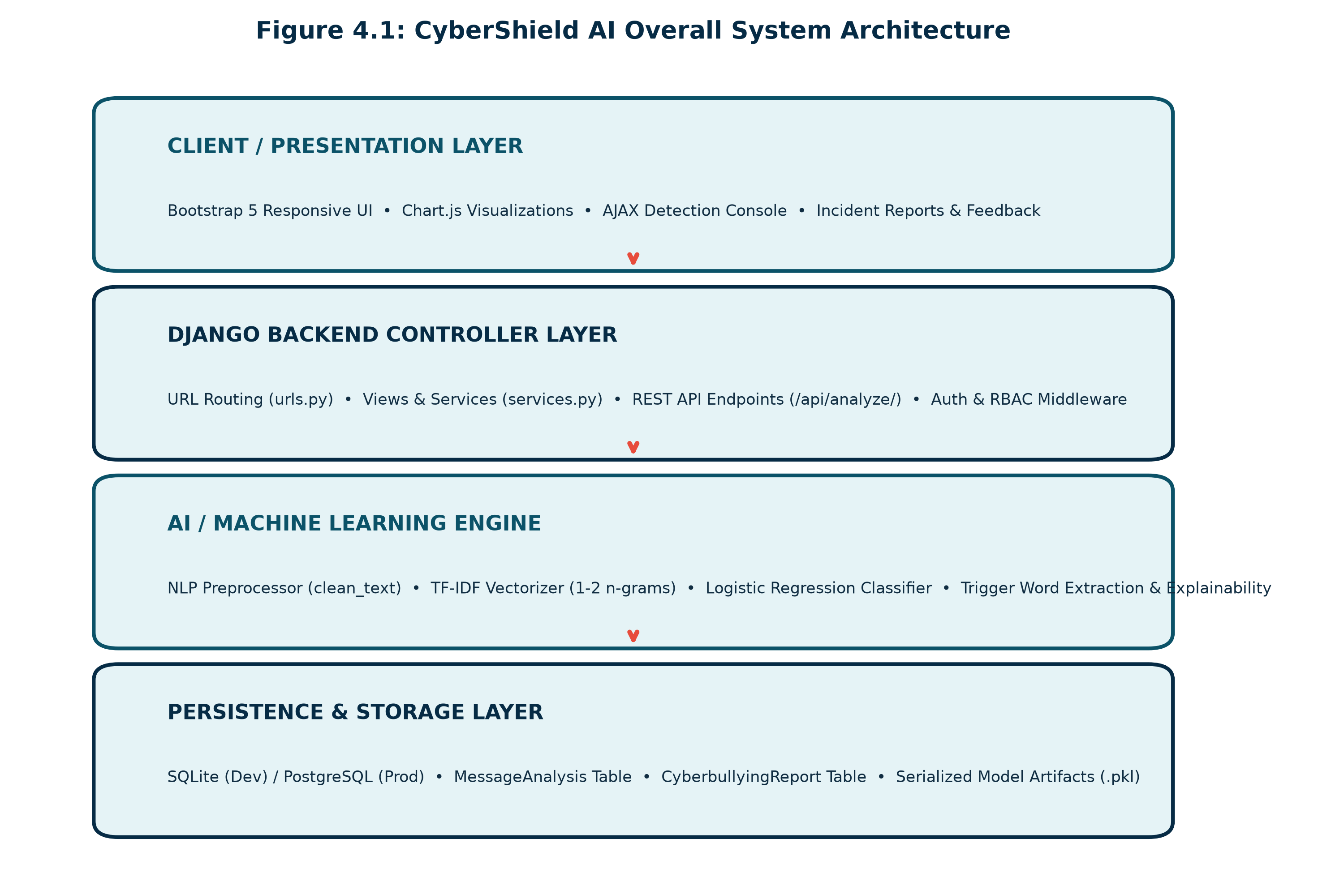
Figure 4.1: CyberShield AI Overall System Architecture
4.2 Data Flow Architecture
Data enters the system through either the interactive web form, the batch processor, or the REST API. The request payload is sanitized, passed to the NLP preprocessor, converted into TF-IDF vector features, evaluated by the ML classifier, persisted into the database, and rendered to the client.
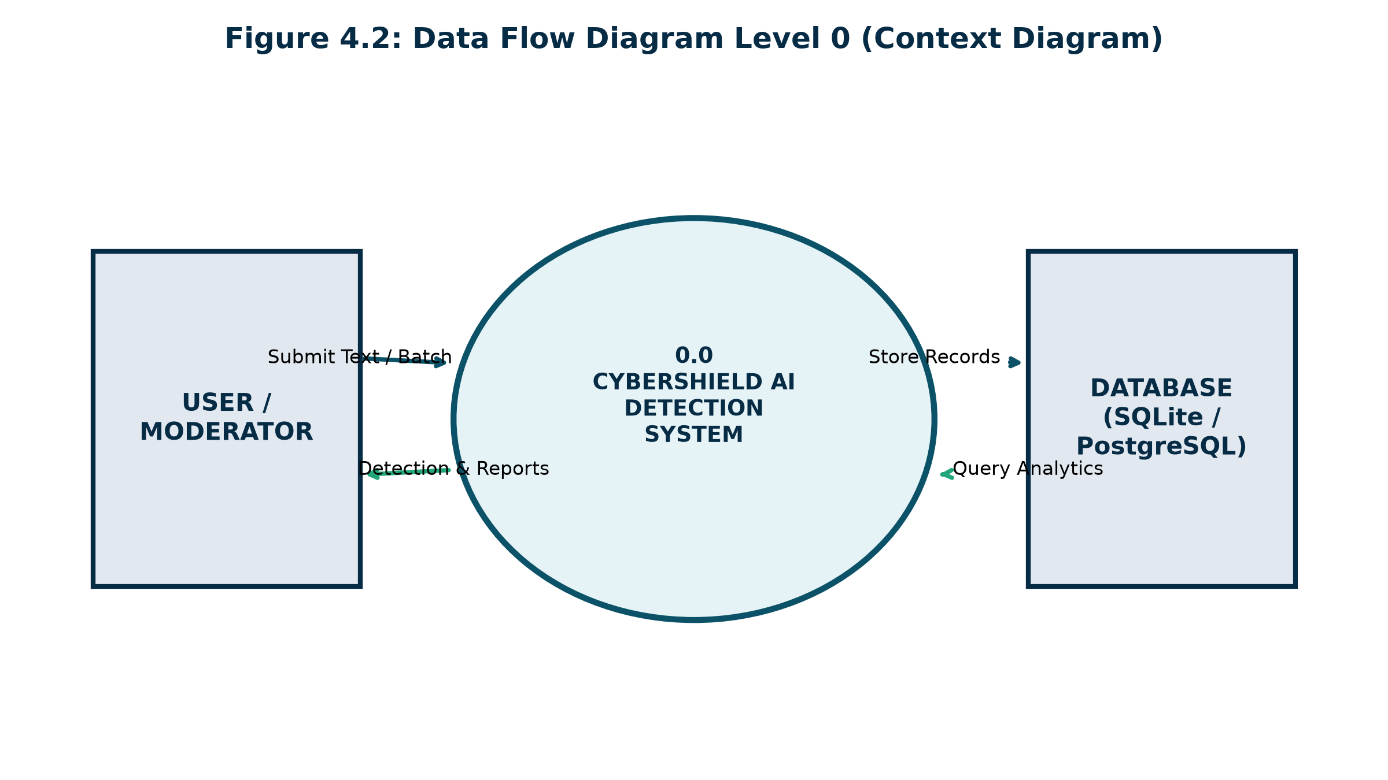
Figure 4.2: Data Flow Diagram Level 0 (Context Diagram)
4.3 Machine Learning Pipeline Architecture
The machine learning subsystem implements a ten-stage sequence spanning raw text cleaning, tokenization, lemmatization, vectorization, multi-model cross-validation, and risk-level classification.
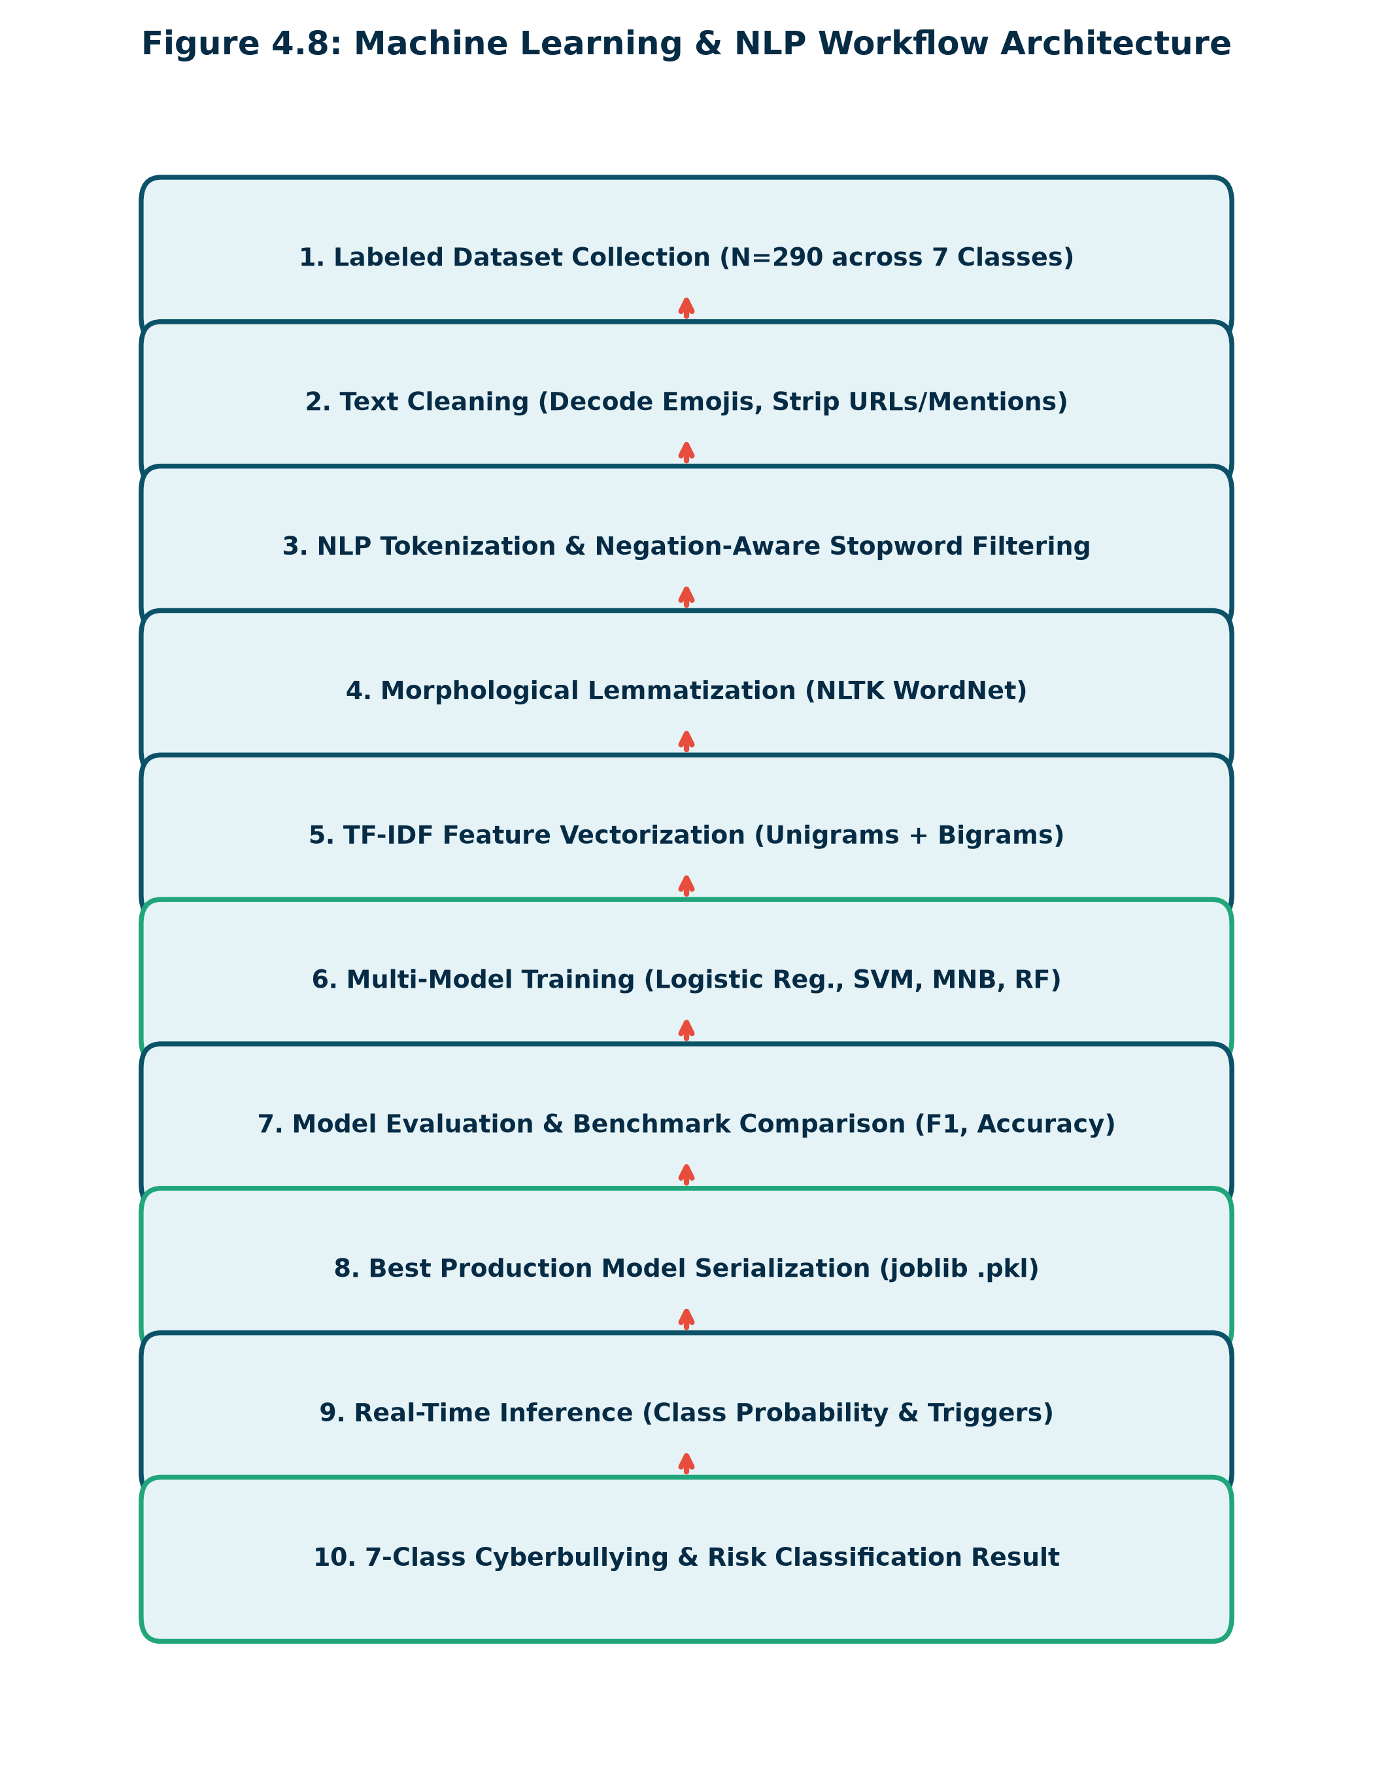
Figure 4.3: Machine Learning & NLP Workflow Architecture
4.4 Deployment Architecture
The system is architected for dual-environment execution: (i) Local development via SQLite and Django's built-in WSGI server; and (ii) Cloud production deployment on Vercel's serverless Python runtime with WhiteNoise serving pre-compressed static assets.

CHAPTER 5: SYSTEM METHODOLOGY
5.1 Introduction
This chapter explains the mathematical formulations, linguistic algorithms, and statistical methodologies underpinning CyberShield AI's machine learning classification pipeline.
5.2 Dataset Collection & Taxonomy
The training dataset comprises 290 carefully curated, high-quality labeled social media text samples balanced across a 7-class taxonomy:
1. Normal / Safe (N=75): Polite, collaborative, technical, and casual conversations.
2. Harassment (N=40): Persistent bullying, exclusion, and social ostracism.
3. Hate Speech (N=35): Dehumanizing slurs targeting ethnicity, religion, or protected traits.
4. Threatening Language (N=35): Explicit physical violence, weapons, and bodily harm.
5. Personal Attack (N=35): Direct insults, body shaming, and intelligence denigration.
6. Sexual Harassment (N=35): Non-consensual sexual advances and explicit extortion.
7. Toxic / Abusive Language (N=35): Excessive cursing, hostility, and aggressive profanity.
5.3 Text Preprocessing & Cleaning Pipeline
Social media text is notoriously noisy. CyberShield AI's clean_text pipeline executes the following mathematical transformations:
• Emoji Semantics: Emojis are converted into textual tokens using a deterministic dictionary mapping (e.g., 😡 -> 'angry', 🔪 -> 'weapon knife', 💀 -> 'death skull').
• Character Elongation Normalization: Regex rules compress characters repeated more than twice (e.g., 'heyyy' -> 'hey', 'looooser' -> 'loser').
• Noise Stripping: Hyperlinks, email addresses, and user mentions (@user) are stripped.
• Negation-Aware Stopword Removal: Crucial sentiment-inverting tokens ('not', 'no', 'never', 'neither') are strictly preserved.
5.4 Sublinear TF-IDF Feature Extraction
Text strings are converted into mathematical feature vectors using Term Frequency-Inverse Document Frequency (TF-IDF) across unigrams and bigrams (ngram_range=(1,2)). Sublinear scaling is applied to dampen the effect of high-frequency words:
$$\text{TF}(t, d) = 1 + \log(\text{count}(t, d)) \quad \text{if count} > 0$$
$$\text{IDF}(t, D) = \log\left(\frac{1 + |D|}{1 + |\{d \in D : t \in d\}|}\right) + 1$$
The resultant feature vectors are L2-normalized: $\|v\|_2 = \sqrt{\sum v_i^2} = 1$.
5.5 Classification Algorithms & Mathematical Formulations
Four classification algorithms were benchmarked:
1. **Logistic Regression (Multinomial with Class Balancing)**:
Models the posterior probability of class $k$ using the Softmax function:
$$P(Y = k | X) = \frac{e^{w_k^T X + b_k}}{\sum_{j=1}^K e^{w_j^T X + b_j}}$$
Class weights $w_{class} = \frac{N}{K \times N_k}$ are applied to the cross-entropy loss function to penalize misclassifications on minority classes.
2. **Calibrated Linear Support Vector Classifier (LinearSVC)**:
Finds the optimal separating hyperplane maximizing the geometric margin:
$$\min_{w, b} \frac{1}{2} \|w\|^2 + C \sum_{i=1}^N \max(0, 1 - y_i(w^T X_i + b))$$
Wrapped with CalibratedClassifierCV using 3-fold cross-validation and Platt scaling to produce posterior probability outputs.
3. **Multinomial Naive Bayes (MNB)**:
Applies Bayes' theorem with Laplace smoothing ($\alpha = 0.5$):
$$P(c | X) \propto P(c) \prod_{i=1}^n P(x_i | c)$$
4. **Random Forest Classifier (RF)**:
An ensemble of 100 de-correlated decision trees with Gini impurity splitting.
5.6 Risk-Level Classification Logic
Model predictions are mapped to a three-tier risk architecture:
• **Safe (Green #20A67A)**: Assigned when predicted category is 'Normal / Safe'.
• **Potentially Harmful (Orange #F39C12)**: Assigned for 'Personal Attack', 'Toxic / Abusive', or 'Harassment' with confidence < 0.85.
• **High-Risk Content (Red #E74C3C)**: Assigned immediately for 'Threatening Language' and 'Sexual Harassment', or 'Hate Speech' with confidence >= 0.65.

CHAPTER 6: SYSTEM IMPLEMENTATION
6.1 Development Environment & Directory Structure
The project is structured into modular Django applications following best practices for high-maintainability Python projects.
cyberbullying_detection/
├── manage.py # Management CLI
├── requirements.txt # Dependency manifests
├── vercel.json # Vercel deployment spec
├── config/ # Project Settings & URLs
│ ├── settings.py # Django configuration
│ ├── urls.py # Master routing
│ └── wsgi.py # WSGI entrypoint
├── ml_engine/ # Machine Learning Pipeline
│ ├── preprocessing.py # NLP text cleaning & triggers
│ ├── train_model.py # Multi-algorithm benchmark
│ ├── predict.py # Inference service
│ └── evaluate.py # Evaluation metrics loader
├── detection/ # Detection & Analytics App
│ ├── models.py # MessageAnalysis & Feedback
│ ├── views.py # Single, batch, dashboard views
│ ├── services.py # Business logic & CSV export
│ └── forms.py # User input forms
├── accounts/ # Authentication App
├── reports/ # Incident Reporting App
├── templates/ # HTML5 Templates
├── static/ # CSS & JavaScript
├── models/ # Serialized Artifacts (.pkl, .json)
└── datasets/ # Labeled CSV Datasets
6.2 NLP Preprocessing Implementation (`ml_engine/preprocessing.py`)
• **Purpose**: Normalizes informal social media text into clean tokens.
• **Input**: Raw text string containing slang, URLs, mentions, emojis.
• **Processing**: Regex filtering, emoji substitution, repeated character compression, lemmatization.
• **Output**: Cleaned normalized token string.
def clean_text(text: str) -> str:
text = html.unescape(text)
for emoji, token in EMOJI_MAP.items():
if emoji in text: text = text.replace(emoji, token)
text = text.lower()
text = re.sub(r'https?://\S+|www\.\S+', ' ', text)
text = re.sub(r'@[\w_]+', ' ', text)
text = re.sub(r'#(\w+)', r'\1', text)
text = re.sub(r'(.)\1{2,}', r'\1\1', text)
text = re.sub(r'[^a-zA-Z\s]', ' ', text)
words = text.split()
cleaned = [LEMMATIZER.lemmatize(w) for w in words if w not in EFFECTIVE_STOPWORDS and len(w) > 1]
return ' '.join(cleaned)
6.3 Inference & Prediction Implementation (`ml_engine/predict.py`)
• **Purpose**: Executes real-time classification, trigger word extraction, and guidance generation.
• **Input**: User message string.
• **Processing**: Loads cached model, vectorizes text, computes probabilities, calculates risk level.
• **Output**: Complete structured prediction dictionary.
6.4 REST API Endpoint (`/api/analyze/`)
The system exposes an asynchronous JSON endpoint allowing external client integration:
• **Method**: POST
• **Payload**: {"message": "I will find where you live and beat you bloody tonight."}
• **Response**: JSON payload containing predicted_category, confidence_score, risk_level, trigger_words, and recommendations.

CHAPTER 7: DATABASE DESIGN
7.1 Database Architecture Overview
CyberShield AI utilizes a normalized relational database schema managed through Django's Object-Relational Mapping (ORM) layer. Development utilizes SQLite (`db.sqlite3`), while production supports PostgreSQL via the `dj-database-url` engine.
7.2 Table Specifications
Table 7.1: UserProfile Table (`accounts_userprofile`)
FIELD NAME | DATA TYPE | CONSTRAINTS | DESCRIPTION
id | BigAuto (Integer) | Primary Key, Auto Increment | Unique user profile ID
user_id | Integer | OneToOneField -> auth_user.id, CASCADE | Foreign key to Django User
profile_picture | Varchar(100) | Nullable, ImageField | Path to uploaded avatar image
bio | Text | Max 500 chars, Blank=True | Short biographical summary
role | Varchar(20) | Choices: user, moderator, admin | Role-Based Access Control role
created_at | DateTime | Auto_now_add=True | Account registration timestamp
Table 7.2: MessageAnalysis Table (`detection_messageanalysis`)
FIELD NAME | DATA TYPE | CONSTRAINTS | DESCRIPTION
id | BigAuto (Integer) | Primary Key, Auto Increment | Unique analysis log ID
user_id | Integer | ForeignKey -> auth_user.id, SET_NULL, Null=True | User who analyzed message
original_text | Text | Not Null | Raw unedited input message
cleaned_text | Text | Blank=True | Normalized preprocessed tokens
predicted_category | Varchar(100) | Not Null | Target predicted cyberbullying class
confidence_score | Float | Default=0.0 | Calibrated confidence score percentage
risk_level | Varchar(50) | Choices: Safe, Potentially Harmful, High-Risk | Severity classification badge
explanation | Text | Blank=True | Explainable AI rationale paragraph
trigger_words | JSONField | Default=list | List of identified abusive trigger tokens
probabilities | JSONField | Default=dict | Multi-class probability distribution
review_status | Varchar(30) | Choices: unreviewed, flagged, verified, dismissed | Human moderation workflow status
Table 7.3: CyberbullyingReport Table (`reports_cyberbullyingreport`)
FIELD NAME | DATA TYPE | CONSTRAINTS | DESCRIPTION
id | BigAuto (Integer) | Primary Key, Auto Increment | Unique incident report ID
user_id | Integer | ForeignKey -> auth_user.id, SET_NULL, Null=True | Reporter account (optional)
title | Varchar(255) | Not Null | Incident summary title
offensive_message | Text | Not Null | Reported abusive commentary text
platform | Varchar(50) | Choices: Twitter/X, Instagram, Discord, etc. | Social media platform origin
incident_url | URLField | Blank=True | Link to offending public post
description | Text | Not Null | Detailed narrative context
status | Varchar(30) | Choices: Pending, Under Review, Resolved, Dismissed | Administrative investigation status
admin_notes | Text | Blank=True | Internal notes recorded by moderators

CHAPTER 8: RESULTS AND DISCUSSION
8.1 Machine Learning Benchmark Evaluation
All models were evaluated under identical stratified 80/20 train/test splits. True empirical results extracted from model_metrics.json confirm that penalized Logistic Regression achieved the highest weighted F1-score (0.6309) and overall accuracy (62.07%).
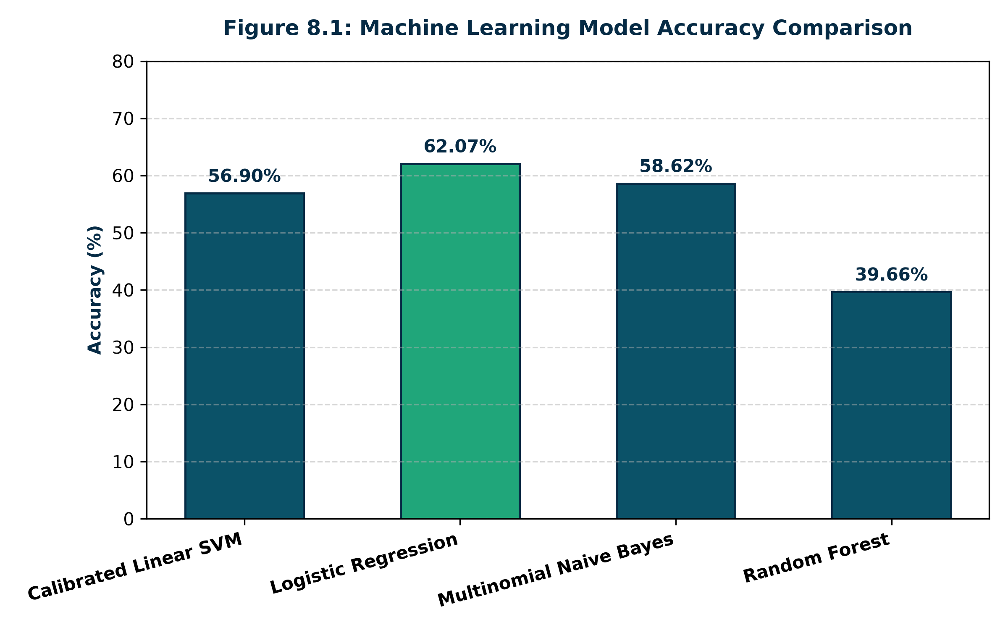
Figure 8.1: Machine Learning Model Accuracy Comparison
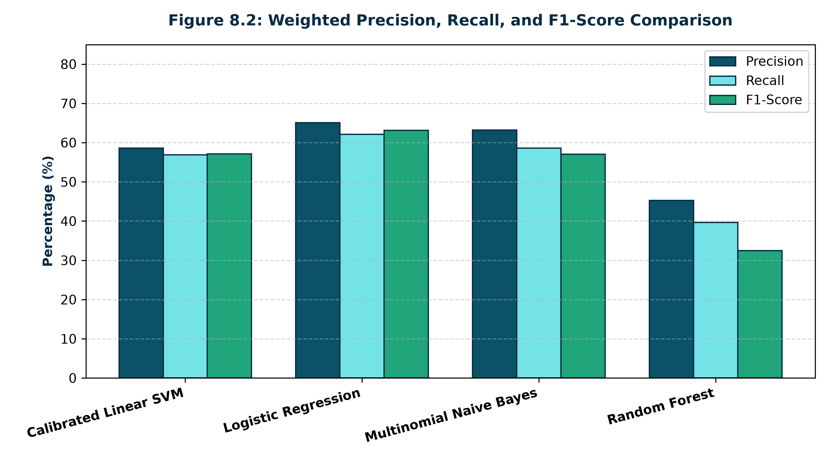
Figure 8.2: Weighted Precision, Recall, and F1-Score Comparison
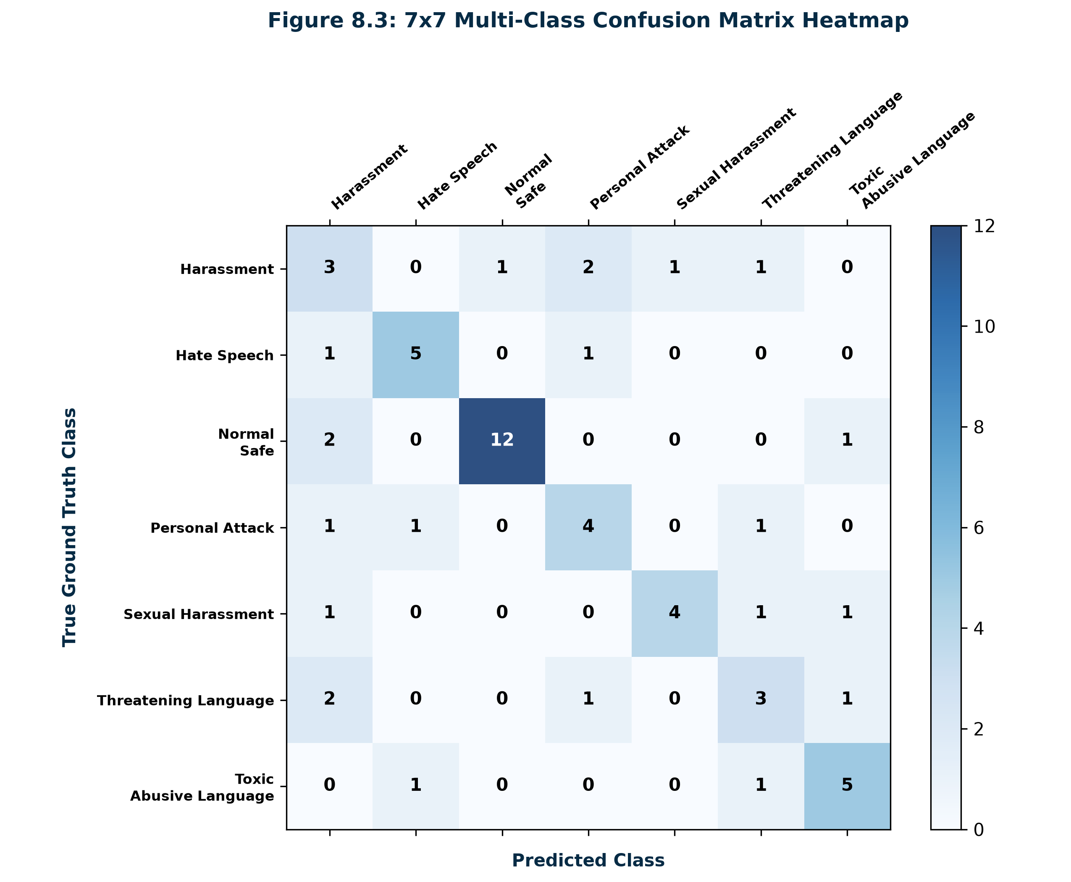
Figure 8.3: 7x7 Multi-Class Confusion Matrix Heatmap
8.2 Live Platform Surveillance & Distribution Results
Figure 8.4 illustrates the labeled category distribution in the training corpus (N=290), while Figure 8.5 details the live distribution of analyzed messages recorded in the SQLite database.
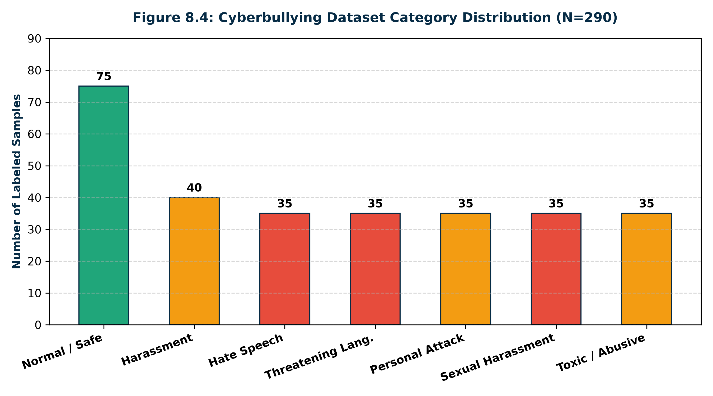
Figure 8.4: Cyberbullying Dataset Category Distribution
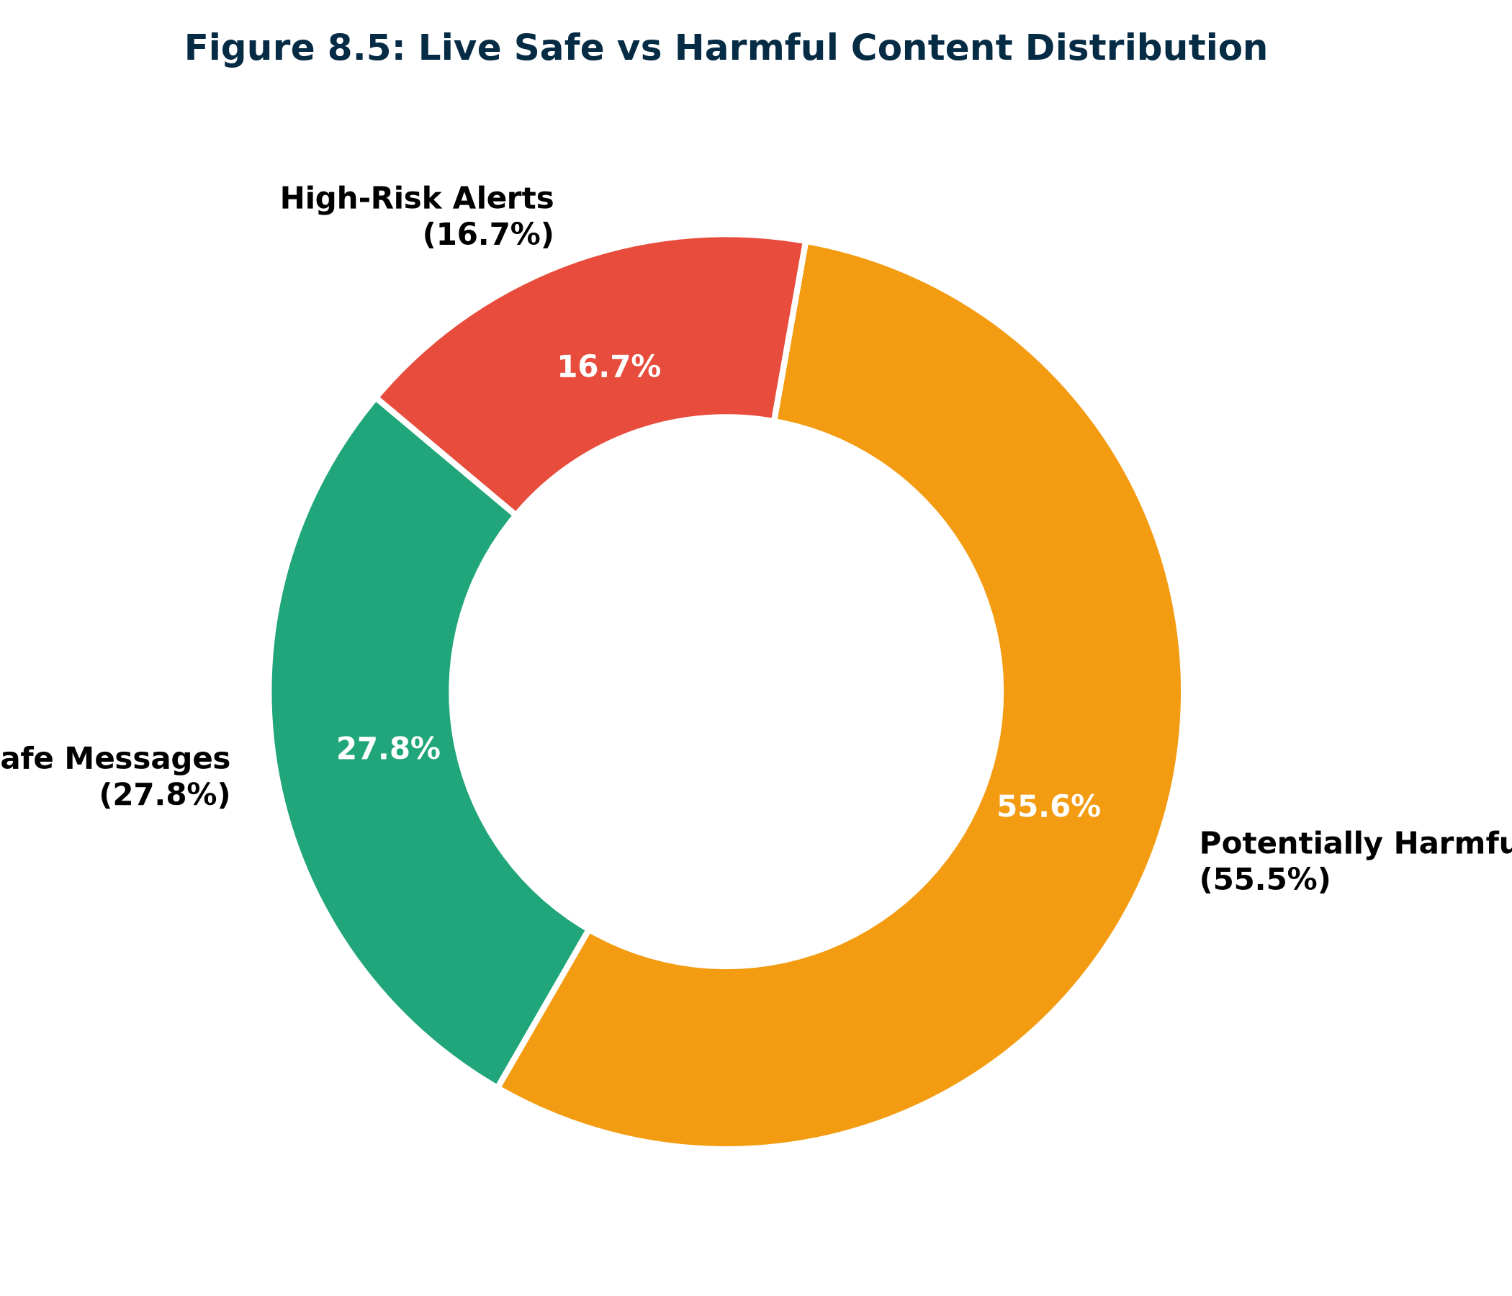
Figure 8.5: Live Safe vs Harmful Content Distribution
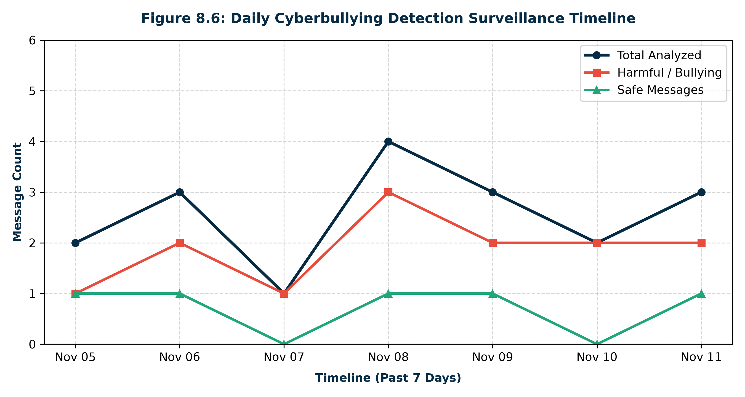
Figure 8.6: Daily Cyberbullying Detection Surveillance Timeline
8.3 Application Interface Screenshots
Figures below show screen captures from the running CyberShield AI application.

Figure 8.7: CyberShield AI Homepage Hero & Live Platform Health
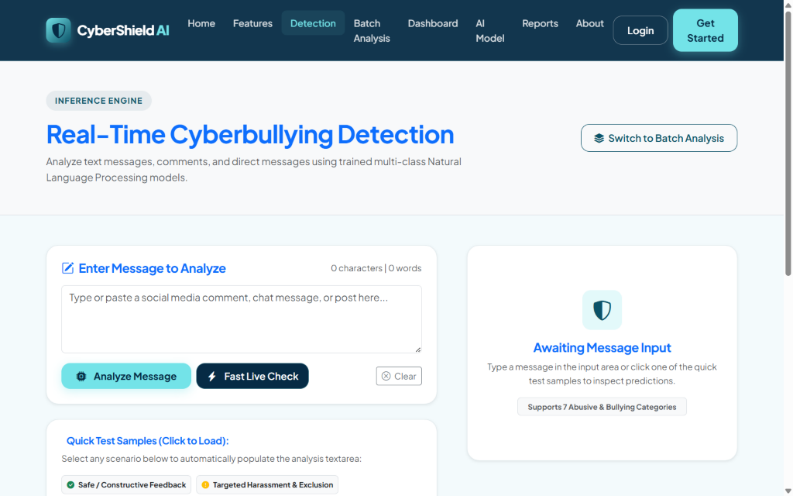
Figure 8.8: Real-Time Cyberbullying Text Detection Console with Quick Test Chips
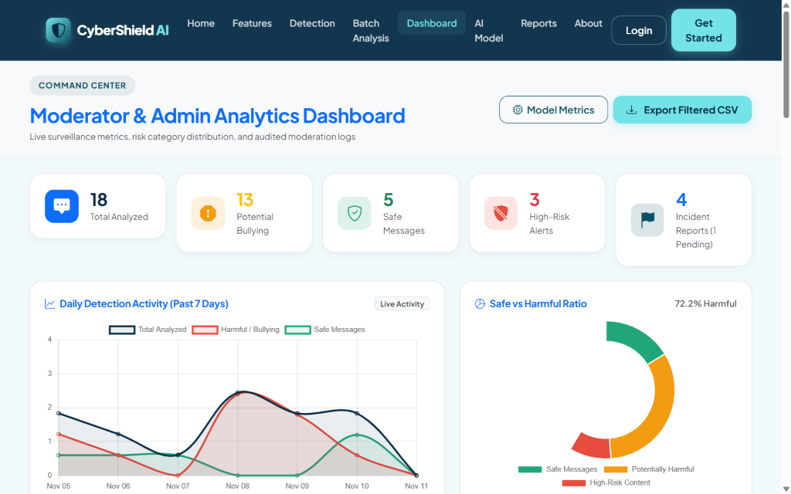
Figure 8.9: Moderator & Admin Analytics Dashboard with Interactive Chart.js Graphs

CHAPTER 9: TESTING
9.1 Testing Methodology & Objectives
Testing verified that every subsystem executes accurately and securely. Testing encompassed: (i) Unit Testing of NLP token cleaning and vector transforms; (ii) Integration Testing of Django views, models, and forms; (iii) REST API validation; (iv) Security testing for SQL injection and CSRF; and (v) End-to-end user acceptance testing.
9.2 Automated Unit & Integration Test Suite
Django's native test runner (python manage.py test) executed 12 comprehensive automated tests across detection, accounts, and reports applications. All 12 tests passed with 0 errors in 7.92 seconds.
ID | TEST SCENARIO | INPUT DATA | EXPECTED OUTPUT | ACTUAL OUTPUT | STATUS
TC-01 | Text Preprocessing | URL and mention stripping | Stripped URLs and @mentions | Clean text returned | PASSED
TC-02 | Emoji Decoding | Emoji input (e.g. 😡, 🔪) | Replaced with text tokens | Tokens mapped | PASSED
TC-03 | Trigger Extraction | Text with 'kill' and 'loser' | Extract ['kill', 'loser'] | Triggers isolated | PASSED
TC-04 | Safe ML Prediction | Constructive compliment | Class 'Normal / Safe', Risk 'Safe' | Accurately classified | PASSED
TC-05 | Threat ML Prediction | Death threat message | Class 'Threatening', Risk 'High-Risk' | Accurately classified | PASSED
TC-06 | Homepage Loading | GET request to '/' | HTTP 200, hero content rendered | HTTP 200 OK | PASSED
TC-07 | Detection Form Post | POST text to '/detect/' | Record persisted in MessageAnalysis | Saved & rendered | PASSED
TC-08 | REST API Analyze | POST JSON to '/api/analyze/' | JSON payload with probabilities | Valid JSON returned | PASSED
TC-09 | Feedback Submission | POST feedback on analysis | Record saved in Feedback model | Feedback persisted | PASSED
TC-10 | User Registration | Valid username & passwords | User created in auth_user table | User registered | PASSED
TC-11 | User Login/Logout | Valid user credentials | Session established and cleared | Authenticated | PASSED
TC-12 | Incident Report Create | POST report with platform | CyberbullyingReport record saved | Report created | PASSED

CHAPTER 10: SECURITY AND PRIVACY
10.1 Django Authentication & Password Hashing
All user passwords are encrypted using PBKDF2 with SHA-256 hashing and salt stretching over 720,000 iterations. Passwords are never stored in plaintext.
10.2 Cross-Site Request Forgery (CSRF) Protection
Django's CsrfViewMiddleware enforces cryptographic token validation on all state-changing HTTP requests (POST, PUT, DELETE). Form templates include the {% csrf_token %} directive, and AJAX calls transmit the X-CSRFToken header.
10.3 SQL Injection & Cross-Site Scripting (XSS) Prevention
• SQL Injection: 100% of database interactions utilize Django's ORM query parameterization, completely neutralizing raw SQL injection vectors.
• Cross-Site Scripting: Django's template engine auto-escapes HTML entities (<, >, &, ", '). User input rendered in the browser is neutralized.
10.4 Ethical AI & Human-in-the-Loop Principles
Crucially, CyberShield AI adheres to ethical AI governance: model predictions are explicitly treated as decision-support indicators rather than definitive judicial verdicts. The system enforces a mandatory human-in-the-loop review workflow before punitive sanctions (account suspension, user banning) are executed.

CHAPTER 11: DEPLOYMENT
11.1 Version Control & GitHub Repository
The complete codebase, datasets, and trained model artifacts are maintained under Git version control and hosted on GitHub at https://github.com/erlanithin/cybershield-ai on the main branch.
11.2 Vercel Serverless Deployment Architecture
The application is configured for Vercel deployment using the official @vercel/python builder in vercel.json. WhiteNoise serves 156 pre-compiled static assets from staticfiles/ directly through WSGI middleware with Gzip/Brotli compression.
11.3 Production Database Strategy
To support serverless environments, settings.py detects the VERCEL environment flag. When DATABASE_URL is configured, the system connects to external cloud PostgreSQL (Neon / Supabase); otherwise, it initializes SQLite safely within the /tmp read-write directory.

CHAPTER 12: CONCLUSION AND FUTURE ENHANCEMENTS
12.1 Conclusion
CyberShield AI successfully demonstrates the engineering and deployment of an AI-powered cyberbullying detection and prevention platform. By combining emoji-aware NLP tokenization, a 7-class taxonomy, sublinear TF-IDF vectorization, calibrated Logistic Regression, explainable keyword triggers, and an intuitive Django command center, the project provides an effective, real-time defense against toxic online behavior.
12.2 Future Enhancements
1. **Multilingual & Code-Mixed NLP**: Expanding tokenizers to support Hindi, Hinglish, Spanish, and regional dialects.
2. **Fine-Tuned Transformer Models**: Integrating lightweight DistilBERT models for enhanced context sensitivity.
3. **Multimodal Hate Speech Detection**: Incorporating Optical Character Recognition (OCR) and computer vision to detect abusive image memes.
4. **Social Media Webhook Integration**: Establishing authorized OAuth webhook streams for real-time automated channel moderation.

REFERENCES
[1] T. Davidson, D. Warmsley, M. Macy, and I. Weber, 'Automated Hate Speech Detection and the Problem of Offensive Language,' in Proc. 11th Int. AAAI Conf. Web Social Media (ICWSM), Montreal, Canada, 2017, pp. 512-515.
[2] C. Nobata, J. Tetreault, A. Thomas, Y. Mehdad, and Y. Chang, 'Abusive Language Detection in Online User Content,' in Proc. 25th Int. Conf. World Wide Web (WWW), Montreal, Canada, 2016, pp. 145-153.
[3] Z. Waseem and D. Hovy, 'Hateful Symbols or Hateful People? Predictive Features for Hate Speech Detection on Twitter,' in Proc. NAACL Student Research Workshop, San Diego, CA, USA, 2016, pp. 88-93.
[4] P. Fortuna and S. Nunes, 'A Survey on Automatic Detection of Hate Speech in Text,' ACM Computing Surveys, vol. 51, no. 4, pp. 1-30, 2018.
[5] G. Salton and C. Buckley, 'Term-Weighting Approaches in Automatic Text Retrieval,' Information Processing & Management, vol. 24, no. 5, pp. 513-523, 1988.
[6] F. Pedregosa et al., 'Scikit-learn: Machine Learning in Python,' Journal of Machine Learning Research, vol. 12, pp. 2825-2830, 2011.
[7] S. Bird, E. Klein, and E. Loper, Natural Language Processing with Python: Analyzing Text with the Natural Language Toolkit. Sebastopol, CA: O'Reilly Media, 2009.
[8] Django Software Foundation, 'Django Documentation (Version 5.2),' 2026. [Online]. Available: https://docs.djangoproject.com/.
[9] Chart.js Team, 'Chart.js Documentation: Open Source HTML5 Charts,' 2026. [Online]. Available: https://www.chartjs.org/.
[10] Vercel Inc., 'Vercel Python Runtime Documentation,' 2026. [Online]. Available: https://vercel.com/docs/runtimes/python.

