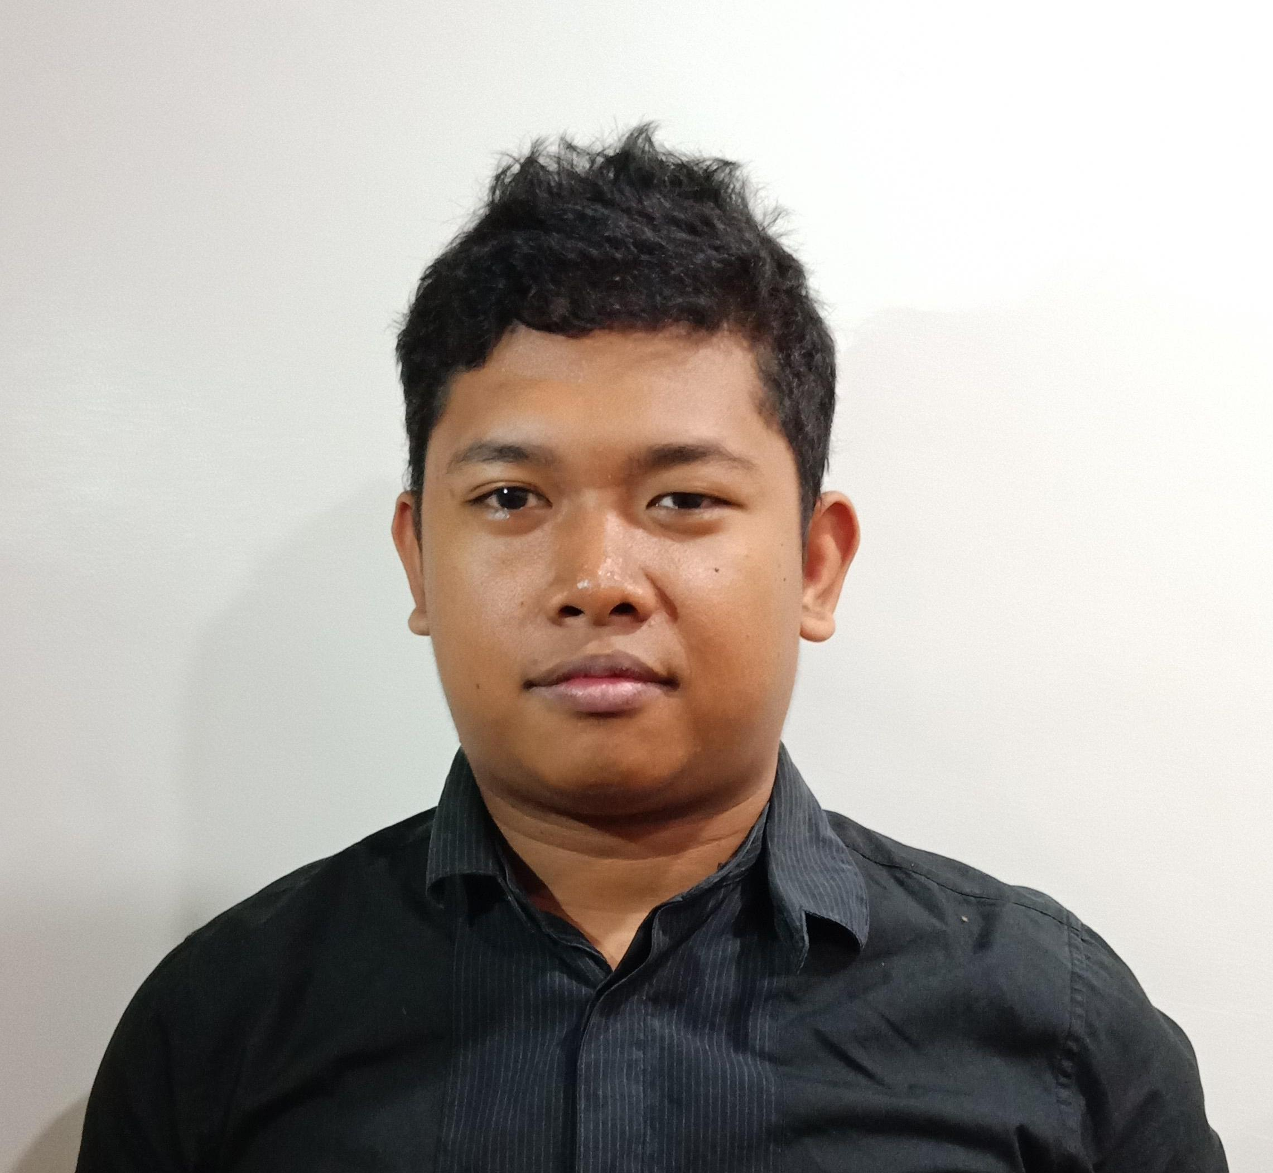

|  |
| --- |
|  |

|  |  |
| --- | --- |
|  | ▶Erlou T. Cabilan  09685600952  [erloucabilan94@gmail.com](mailto:erloucabilan94@gmail.com)  <https://erloucabilan.github.io/hello/> |

|  |  |
| --- | --- |
| ) | **Career Overview**  Been in several years working in web development as a Web Developer. Helping companies to achieve their goals. Build stuff that requires skill and precision for the client's satisfaction. Finding solutions whenever a new problem occurs. Understanding what the client wants and needs.  **Experience**  Company: **MOPRO**  Date : 2017-2018 Position : Web Designer  Role : Plan, create and design a website that fits on the client’s business, embeds code whenever features that are suggested by the client is out of scope in the platform. Checking the mobile friendliness of the site and fixing bugs in existing sites from the clients.  Company: **TRMMC**  Date **:** 2018-current  Position : Front-end Developer  Role : Maintains the website from one of the school in HK. Planning the front-end especially on mobile. Checking the Google Analytics for the mobile view. Made an internal web-app from the client.  **Personal Data:**  Date of Birth: October 3, 1994  Birth of Place: Cebu City  Age: 27  Gender: Male  Status: Single  Nationality: Filipino  Height: 5’6 ft  **Education**  SY 2010-2011  High School  Consolacion National High School  Consolacion, Cebu  2009-2010  SY 2011-2017  College  University of Cebu (Lapu-Lapu Mandaue Campus)  Bachelor of Science on Computer Science  **Competences**   * **Writes clean and readable codes.** * **Willing to learn something new for the company** * **A self-learner and enthusiastic coder** * **Loves web designing** |
|  | **Character References**  Jan Croonen 09273739747 Team Leader  Mandy Law 85298716777  Admin Staff mandygreat@gmail.com |
|  |  |