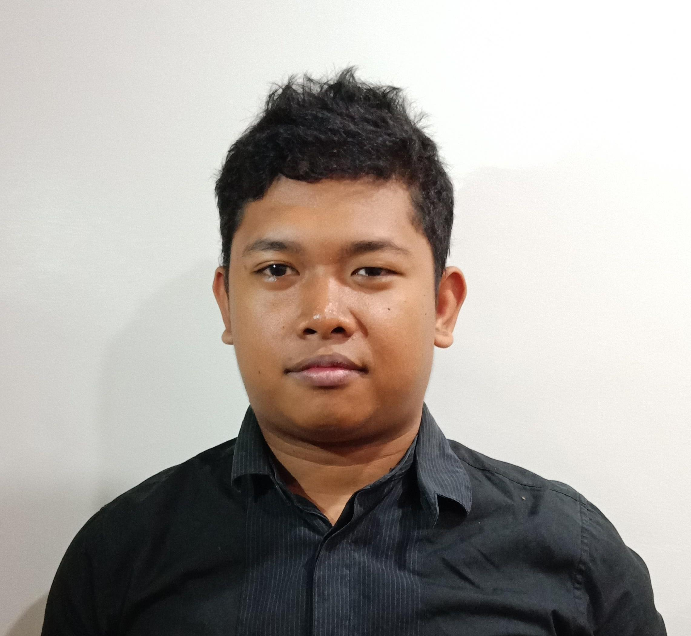

|  |
| --- |
|  |

|  |  |
| --- | --- |
|  | ▶Erlou T. Cabilan  09685600952  [erloucabilan94@gmail.com](mailto:erloucabilan94@gmail.com)  [https://erloucabilan.github.io/dev-site/](https://erloucabilan.github.io/dev-site/#about) |

|  |  |
| --- | --- |
| ) | **Career Overview**  Been in several years working in web development as a Web Developer. Helping companies to achieve their goals. Build stuff that requires skill and precision for the client's satisfaction. Finding solutions whenever a new problem occurs. Understanding what the client wants and needs.  **Experience**  Company: **MOPRO**  Date : 2017-2018 Position : Web Designer  Company: **TRMMC**  Date **:** 2018-current  Position : Front-end Developer  **Personal Data:**  Date of Birth: October 3, 1994  Birth of Place: Cebu City  Age: 26  Gender: Male  Status: Single  Nationality: Filipino  Height: 5’6 ft  **Education**  SY 2010-2011  High School  Consolacion National High School  Consolacion, Cebu  2009-2010  SY 2011-2017  College  University of Cebu (Lapu-Lapu Mandaue Campus)  Bachelor of Science on Computer Science  **Competences**   * **Creates clean and readable codes.** * **Willing to learn something new for the company** * **A self-learner and enthusiastic coder** * **Can work under pressure** * **Willing to adapt new environment** |
|  | **Character References**  Jan Croonen 09273739747 Team Leader |
|  |  |