CS 50 AI Week 1

Search Terminology & Concepts

Agent

Definition: An entity that perceives its environment and acts upon it.
Example: In Google Maps, the agent could be the car navigating based on directions.

State
Definition: A representation of a specific configuration of data or the environment.

Actions

Definition: Choices available in a given state.
Example: In a sliding puzzle, an action is sliding a tile in a direction.
Notation: Actions(s) = all possible actions in state s.

Transision model
How state and actions are related to each other.

Decription of what state we get after performing some kind of available action
Result(s, a) returns the state resulting from performation action a in state s

The "model" refers to the internal logic or rules that define how actions affect states. It's not just the function call Result(s, a) — it's the underlying mechanism that determines what the result should be.

State space: The overall structure
A collection/set of all states reacable from the initial state by any action sequance.
Usually presented as a tree/ graph
Nodes are the vertices, and actions are the edges/arrows.

In the graph the nodes are states, and arrows are actions.

Abstracting problems
State and actions are usually just encoded as a number in real world use.

How do we know when the AI reached the goal?

Goal test

way to determine if a given state is the goal
ex. in maze puzzle the end of the maze is the goal

Path cost
numerical cost associated with a given path
we give actions a number represention its cost. important for AI to find optimal soulutions,

In the example state space graph we here see the numerical cost associated with each action

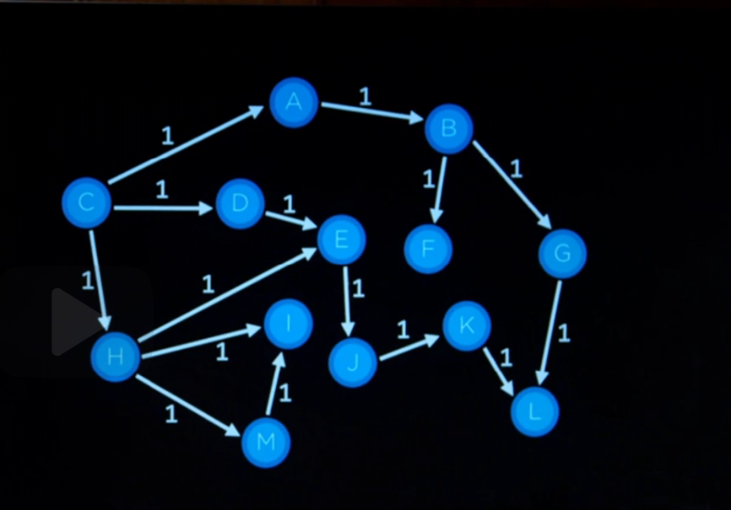

Soulution:
action squence that takes us from initial to goal state.
Example: we can backtrack parent nodes to find how we arrived at goal , returning the soulution as something like steps and total cost

Optimal souluton:
Lowest path cost possible

Key components in solving a search problem
- Inital state
- Actions
- Transition model
- Goal test
- Path cost function

Useful Data Structure: Node
- State
- Parent ( node that generated this node)
- Action ( action applied to parent to get node)
- Path cost

General Search Strategy

- Start from a state and explore available options
- The frontier – a single datastructure holding nodes to explore
- another datastructure containeing explored nodes
- remove and explore a node in the frontier
- add resulting new nodes to frontier

Depth first search (dfs)
serch algorithm that always expands node ( stack frontier )
might not find the best soulution, but will find one given its a finite problem

Breath-first search (bfs )
explores the shallowest ( que frontier )

Uninformed search
dumb search stragety that uses no problem specific knowledge. Dfs and bfs is subtypes of this.

Greedy best-first search
expand the node that I think is closes to the goal ( f.ex coordinates )
node expansion is picked by a heuristic function (notation: h(n) )instead of stack or que for picking the next node.

A* search

search algorithm that expands node with lowest value of g(n) + h(n)
g(n) = cost to reach node
h(n) = estimated cost to goal

Takes into account the how far you travelled.

Optimal if:

- h(n) never overestimates the true cost. In the maze example if it thinks you are further away than you actually are.

- h(n) is consisnt for every node n and successor n’ with step cost c between the nodes, h(n) ≤ h(n′) + c
I.e If you move one step closer to the goal, your estimated cost to goal should decrease by no more than that step cost

Downsides: Can be a bit memeory heavy

Adversarial search - search functions with multiple agents competing 13

ex. a game. Tic-tac-toe, chess

Minimax algorithm
- The MAX agent or player ) aims to maximize the score
- The MIN agent (or player ) aims to minimize the score.

Game
- s0 Initial state
- Player(s): return which player to move in state s
- actions (s) returns legal moves in state s
- result : return state after action a is taken in state s. Transision model.
- terminal (s) : check end game , ie. checkmate in chess
- utility (s): final numerical value for terminal state s. I.e white winning 1 , black -1 draw 0

Alpha-beta pruning

reduces the number of nodes evaluated in the game tree by eliminating branches that cannot influence the final decision
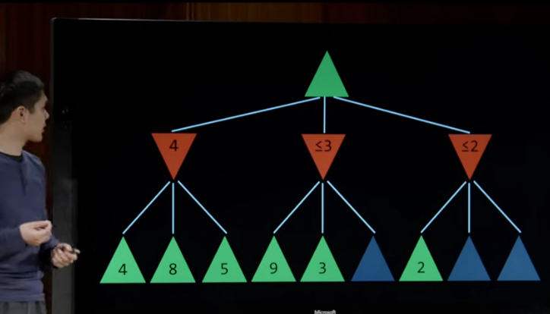

depth limited minimax

elvuation function
estimate how good the game state is
the better the evalutation function the better the ai

Quiz 0

Q1
Between depth first search (DFS) and breadth first search (BFS), which will find a shorter path through a maze?

My answers
- DFS will always find a shorter path than BFS False
- BFS will always find a shorter path than DFS False
- DFS will sometimes, but not always, find a shorter path than BFS True
- BFS will sometimes, but not always, find a shorter path than DFS True
- Both algorithms will always find paths of the same length False

Correct answer : BFS will sometimes, but not always, find a shorter path than DFS. My wrong answers are highlighted in red.
Comment: sometimes they will find the same length path that is

Q2

Of the four search algorithms discussed in lecture — depth-first search, breadth-first search, greedy best-first search with Manhattan distance heuristic, and A* search with Manhattan distance heuristic — which one (or multiple, if multiple are possible) could be the algorithm used?
- Could only be A*
- Could only be greedy best-first search
- Could only be DFS
- Could only be BFS
- Could be either A* or greedy best-first search
- Could be either DFS or BFS
- Could be any of the four algorithms
- Could not be any of the four algorithms
Correct answer: Could only be DFS

Q3

Consider the Minimax tree below, where the green up arrows indicate the MAX player and red down arrows indicate the MIN player. The leaf nodes are each labelled with their value.

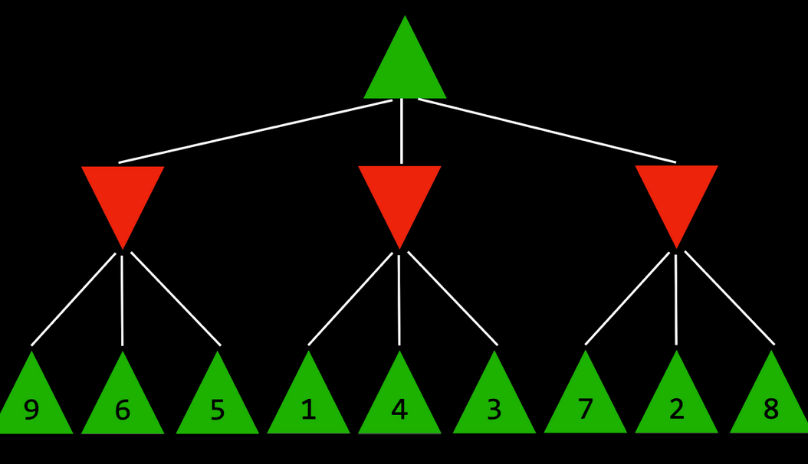
My answer: 5

Correct answer : 5

