Baseline RMSE: 0.1332553185220267
Best RMSE: 0.11132883564301511
Selected features: 53 / 101
Popsize 60, gen 200, pc 0.02, pm 0.9, elitist 2
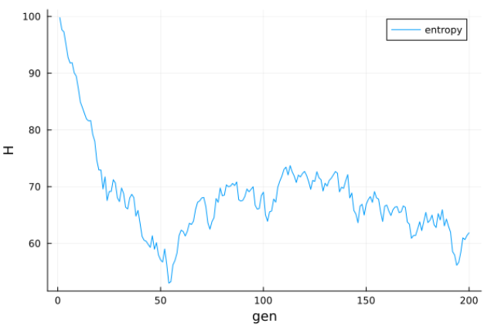
Baseline RMSE: 0.1332553185220267
gen=1 best=0.12278 mean=0.14011 entropy=99.789
gen=25 best=0.12665 mean=0.13831 entropy=83.387
gen=50 best=0.12042 mean=0.13668 entropy=74.788
gen=75 best=0.12663 mean=0.13648 entropy=71.938
gen=100 best=0.12021 mean=0.13594 entropy=72.617
gen=125 best=0.12224 mean=0.13765 entropy=74.34
gen=150 best=0.12308 mean=0.13643 entropy=69.23
gen=175 best=0.11962 mean=0.13802 entropy=76.452
gen=200 best=0.12644 mean=0.13718 entropy=79.999
Best RMSE: 0.11019757852360094
Selected features: 43 / 101
Popsize 60, generations 200, pm 0.03, pc 0.9, elitist 2
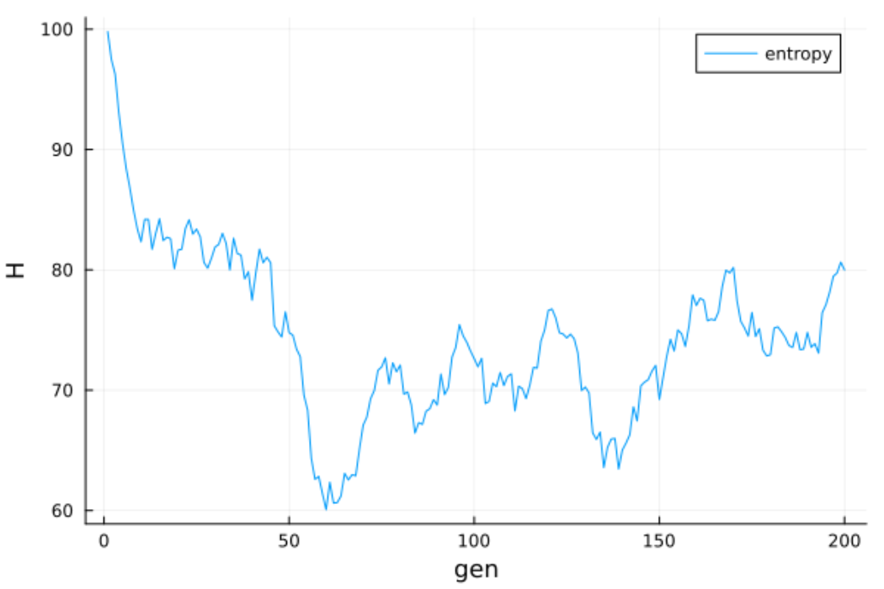
Baseline RMSE: 0.1332553185220267
gen=1 best=0.12278 mean=0.14011 entropy=99.789
gen=25 best=0.12665 mean=0.13831 entropy=83.387
gen=50 best=0.12042 mean=0.13668 entropy=74.788
gen=75 best=0.12663 mean=0.13648 entropy=71.938
gen=100 best=0.12021 mean=0.13594 entropy=72.617
gen=125 best=0.12224 mean=0.13765 entropy=74.34
gen=150 best=0.12308 mean=0.13643 entropy=69.23
gen=175 best=0.11962 mean=0.13802 entropy=76.452
gen=200 best=0.12644 mean=0.13718 entropy=79.999
gen=225 best=0.12223 mean=0.13753 entropy=61.586
gen=250 best=0.1205 mean=0.13643 entropy=70.484
gen=275 best=0.12337 mean=0.1377 entropy=78.831
gen=300 best=0.12445 mean=0.13744 entropy=70.715
gen=325 best=0.1144 mean=0.13565 entropy=79.518
gen=350 best=0.1223 mean=0.13626 entropy=72.727
gen=375 best=0.11945 mean=0.13604 entropy=71.953
gen=400 best=0.1219 mean=0.13824 entropy=73.56
Best RMSE: 0.11019757852360094
Selected features: 43 / 101
Not sure what I did here

Best RMSE: 0.11402167251858901
Selected features: 56 / 101
Pm:0.03, PC:0.9, popsize:60, generations 400, elitist 2
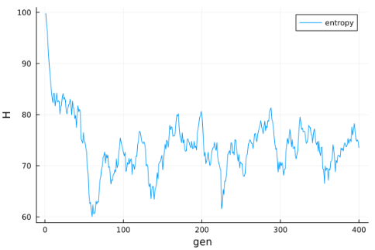
Baseline RMSE: 0.1332553185220267
gen=1 best=0.11784 mean=0.13971 entropy=100.067
gen=25 best=0.1234 mean=0.13716 entropy=85.705
gen=50 best=0.11913 mean=0.13772 entropy=77.695
gen=75 best=0.11851 mean=0.13666 entropy=80.444
gen=100 best=0.12148 mean=0.13584 entropy=78.526
gen=125 best=0.11932 mean=0.13647 entropy=81.582
gen=150 best=0.11925 mean=0.13637 entropy=84.723
gen=175 best=0.11785 mean=0.13725 entropy=82.309
gen=200 best=0.11768 mean=0.13734 entropy=80.612
Best RMSE: 0.10827473071609865
Selected features: 51 / 101
Pm:0.03, PC:0.9, popsize:100, generations 200
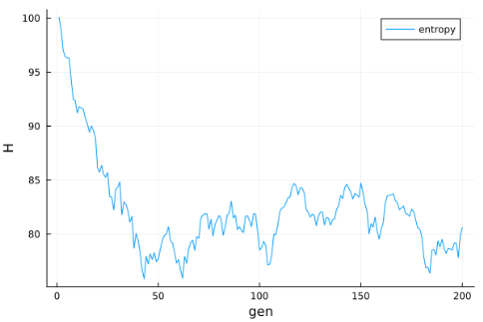
Best RMSE: 0.10827473071609865
Selected features: 51 / 101
Pm:0.03, PC:0.9, popsize:100, generations 1000, elite=2
So, increasing the generations did nothing, but popsize did well

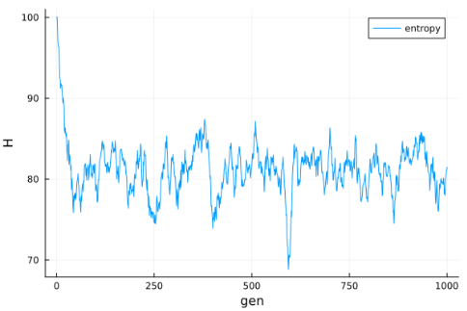
ALL ELITIST SO FAR HAVE ELITE = 2
Best RMSE: 0.11131774691240974
Selected features: 57 / 101
Pm:0.03, PC:0.9, popsize:150, generations 200, elite=2

Generational
Best RMSE: 0.11402167251858901
Selected features: 56 / 101
Pm:0.03, PC:0.9, popsize:60, generations 200

