How and why did I implement PHP in my last project?

In my last project I had to design and develop a shop online. The topic I chose was watch sales and I had to use some programming languages like PHP, MySQL and Twig, I also used HTML, CSS (Bootstrap).
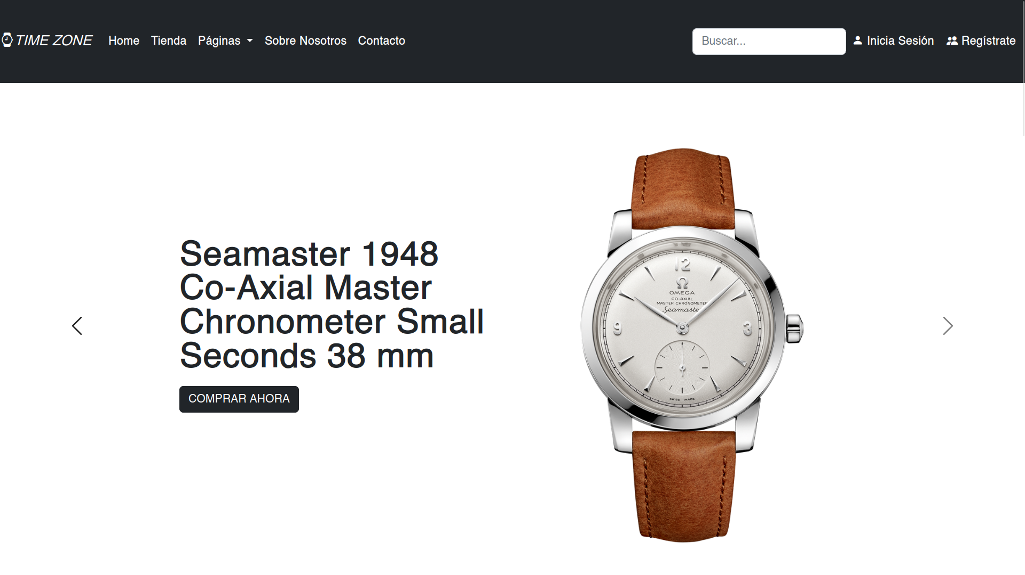

The design and making of the database
We design the database to store information in the data base like products, customers, orders, etc. Then we need to design and create the web pages for the shop online, using HTML, CSS and JavaScript.

We need to write the necessary PHP code to connect to the database and perform operations such as adding products, processing payments, store information on customers who have registered.

When using PHP we comunicate with the database trough MySQL commands, we can create a customer, add a product, check if there are stock of the products, verify if the customers are registered so they can log in in the shop to buy the products.

We have two areas, the customer area and the administrator area. The customer area is where everyone can enter and watch our website, check the products, add to a shopping cart some products and buy them. Then we have the administrator area, where only the administrator of the website can log in to verify or add the products, the customers profiles, he can create, read, update and delete information or data in our website.

In conclusion, PHP is so important to use in a project like this because we need to comunicate always to the database, because everything is store in the database.

