Comprehensive JEE Advanced Analysis from 2011-25

Submitted by
Madan Vishwakarma
ID: B24DS504

Major Project: Data Analytics and Visualization

Course Instructor: Gagan Raj Gupta

1. Project Overview & Objectives
This project presents a comprehensive analysis of the JEE Advanced examination, covering various trends, patterns, and insights from 2011 to 2025. The analysis highlights the variations, complexity, and student participation rates over this period, providing a clear understanding of how the examination has evolved. To ensure an engaging user experience, the project features an interactive dashboard equipped with dynamic plots and visualizations.
The primary aim of this analysis is to provide a holistic perspective on the exam. It is designed to serve a diverse audience—including students, researchers, and individuals unfamiliar with the examination—offering them a clear and detailed understanding of the JEE Advanced landscape.

2. Data Acquisition
Data is the cornerstone of this analysis. While the JEE Advanced organizing bodies publish official annual reports, the time and effort required to interpret them is substantial. With each report averaging approximately 500 pages, gaining a comprehensive understanding of the examination's history is a daunting task for the average viewer.
This project alleviates that burden by consolidating and structuring this information. The data was meticulously gathered from official JEE Advanced annual reports, the JoSAA portal, and supplemental research from reliable platforms that track examination metrics. By synthesizing these fragmented sources, the project provides a streamlined and accessible dataset for analysis.

3. Data Preprocessing
Beyond the initial challenges of extracting relevant information from voluminous annual reports, the data required significant structuring to be viable for analysis and model training. This stage involved overcoming several technical and manual hurdles:
- Handling Missing Values: A primary challenge was addressing data gaps within official documentation. For example, in years where reports did not explicitly state average marks, the information was sourced and verified through external web research and reliable educational archives.
- Data Organization & Formatting: Although the raw data was available, converting it into a structured format suitable for the intended analysis required extensive manual intervention. Tools such as Microsoft Excel and Google Sheets were utilized to standardize variables and ensure consistency across the 14-year dataset.

4. Exploratory Data Analysis (EDA)
Since the data was collected under distinct cohorts of analysis, the EDA phase was structured around individual datasets to uncover specific trends. Each CSV was treated as a unique analytical pillar:
- Examination Metrics: Analysis of the overall exam level and year-on-year difficulty shifts.
- Demographic Distribution: Tracking candidate participation and performance across different categories over the years.
- Gender Dynamics: A longitudinal study of female vs. male participation rates.
- Socio-Economic Factors: Analyzing the correlation between parental occupation and the success rates of qualifying students.
While the rank_predictor.csv was reserved strictly for model training, the remaining datasets were subjected to rigorous visualization. This involved generating various plots to identify hidden patterns and outliers before moving toward final dashboard integration.

- Analysis related to Difficulty

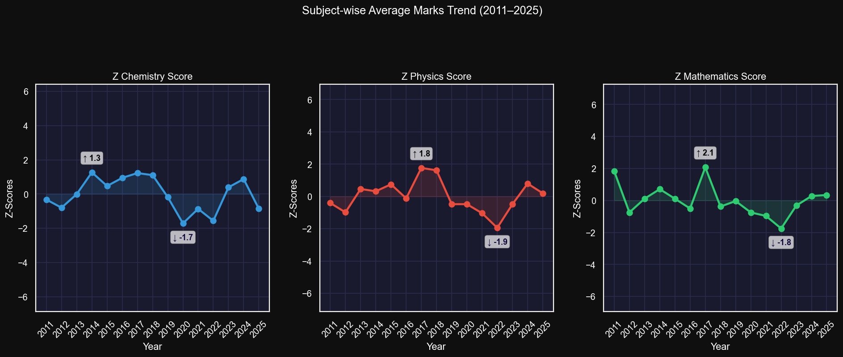

Interpretation:
Chemistry:
Peak (~ +1.3 in 2014) → Chemistry was relatively easier that year
Consistent positive (2015–2018) → Stable, scoring-friendly phase
Sharp dip (~ -1.7 in 2020) → clearly tougher paper
Recovery (2023–2024) → back to above-average scoring
2025 drop again → slight increase in difficulty
Physics:
Peak (~ +1.8 in 2017–18) → easiest phase for Physics
Major drop (~ -1.9 in 2022) → toughest year in entire dataset
Frequent swings → up-down pattern more than Chemistry
Maths:
Highest peak (~ +2.1 in 2017) → extremely scoring year
Deep dip (~ -1.8 in 2022) → very tough year
Post-2022 recovery → gradually improving

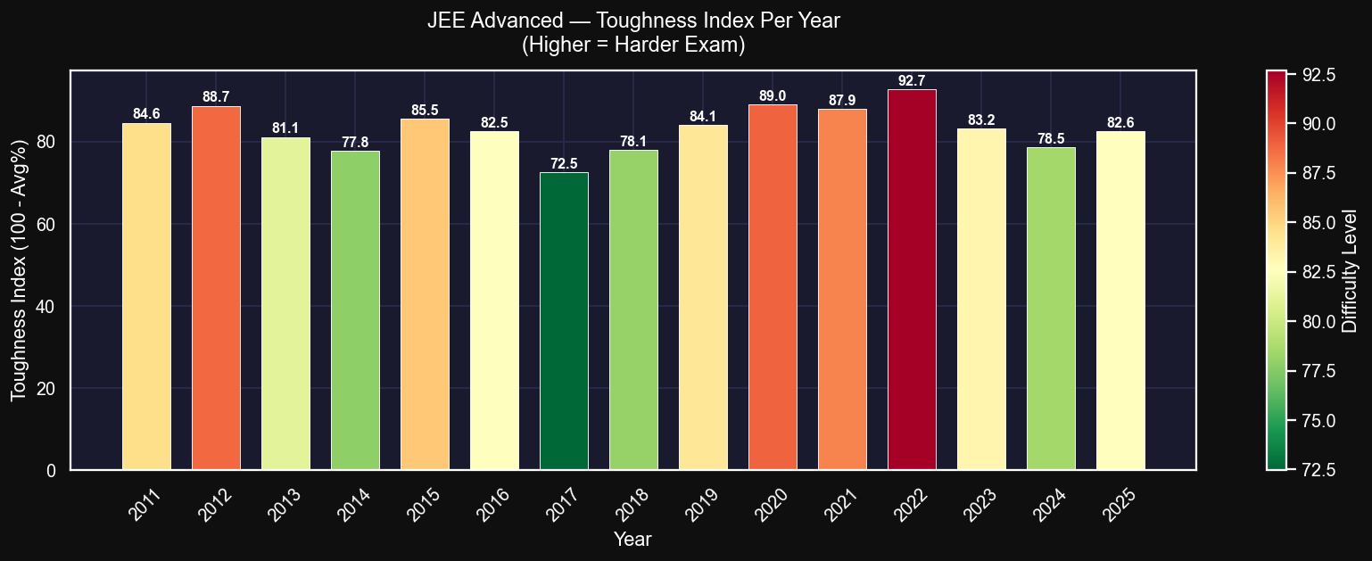

Interpretation: 2022 Set By IIT Bombay Tested the student's mind on complex math and physics concepts. While in 2017, IIT Madras Served as the Easier Year in JEE Advanced History

- Analysis related to Gender-wise Participation
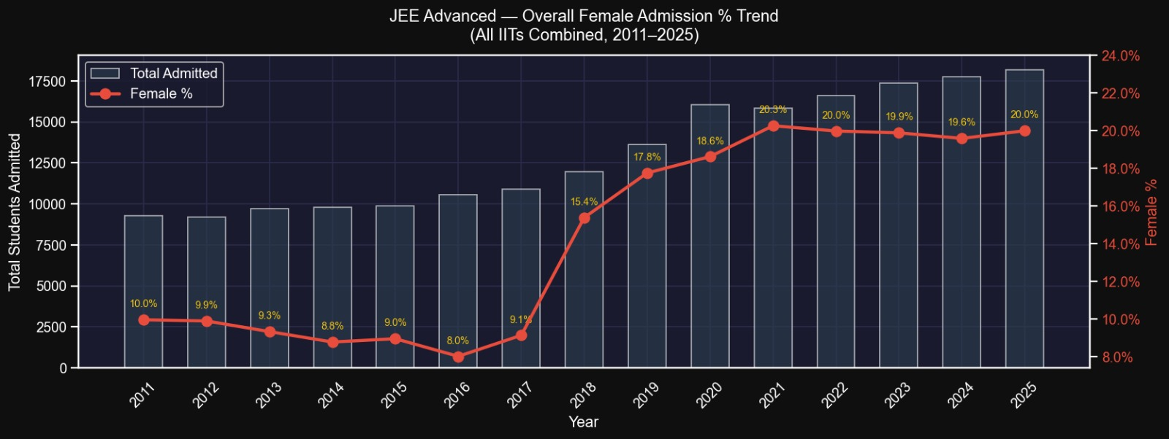

Insight: The plot speaks that Participation of Female in India Most Premier Institutions has been considerably low since inception of the exam. Mainly the things that could be held accountable is the thinking that girls should not get involved in the Engineering fields. One should definitely not doubt on the brains of female, Because the same girl performs extremely Outstanding in NEET Examination.

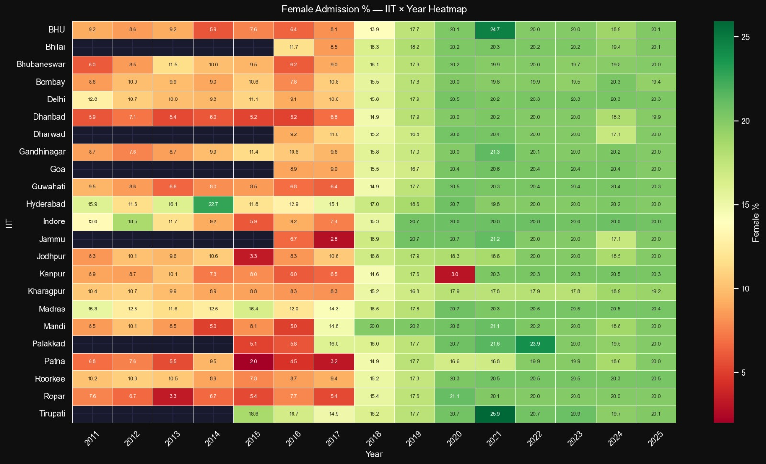

Insight: Till 2018 all IIT's had extremely low participation, But, one would be feel strange to know that Most female preferred the IIT's in southern part of country. It could have possible reason, they belong to southern part i.e. literacy rates have been significantly higher in southern states of the country. In 2018, Government Decided to give 20% reservation to the female (supernumerary seats) to promote inclusion in engineering-Technology. It indeed increased participation, can be admired as the good.

- Analysis based on Parent Occupation of Qualified Students

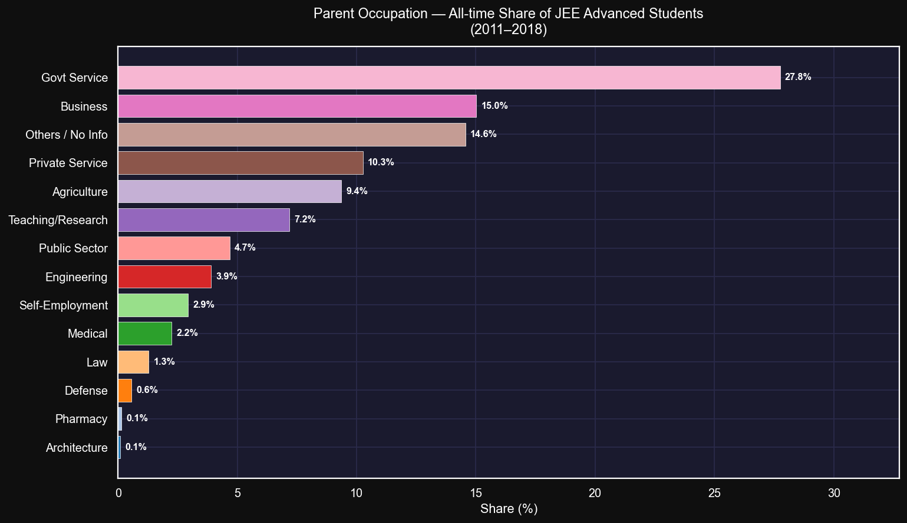

Interpretation: Analysis tells us that Government Service and Business background students are more in number, but Agriculture background is also showing steady growth.

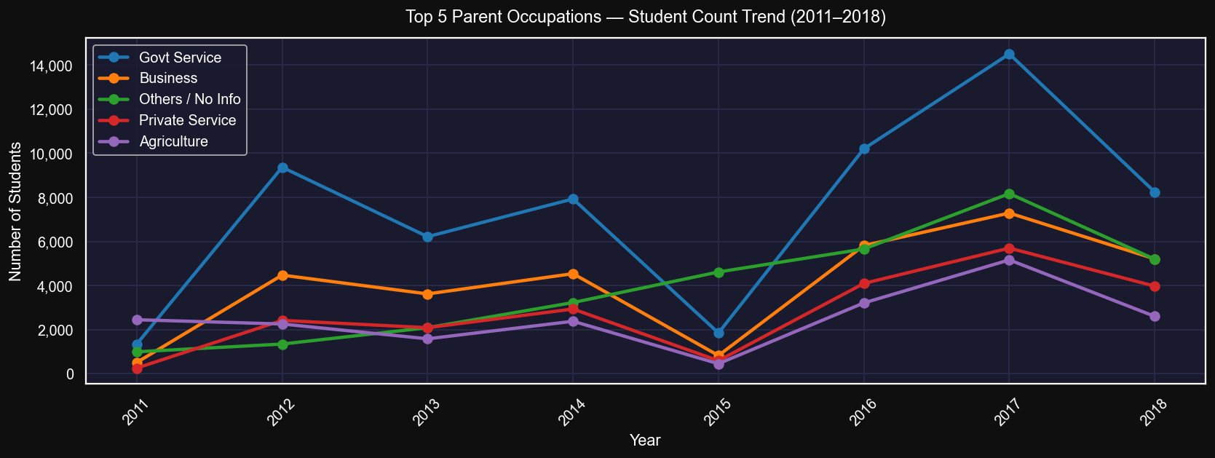

Interpretation: It Probably means that Students with parents working in Agriculture or small private sectors are try hard to improve their livelihood, such students have been increasing since 2015. One of the reasons could be in 2015 the digitalization in India started flourishing which connected people with various information that wasn't available earlier. Hence, students from agricultural families showed significant selection

- Category-based Analysis

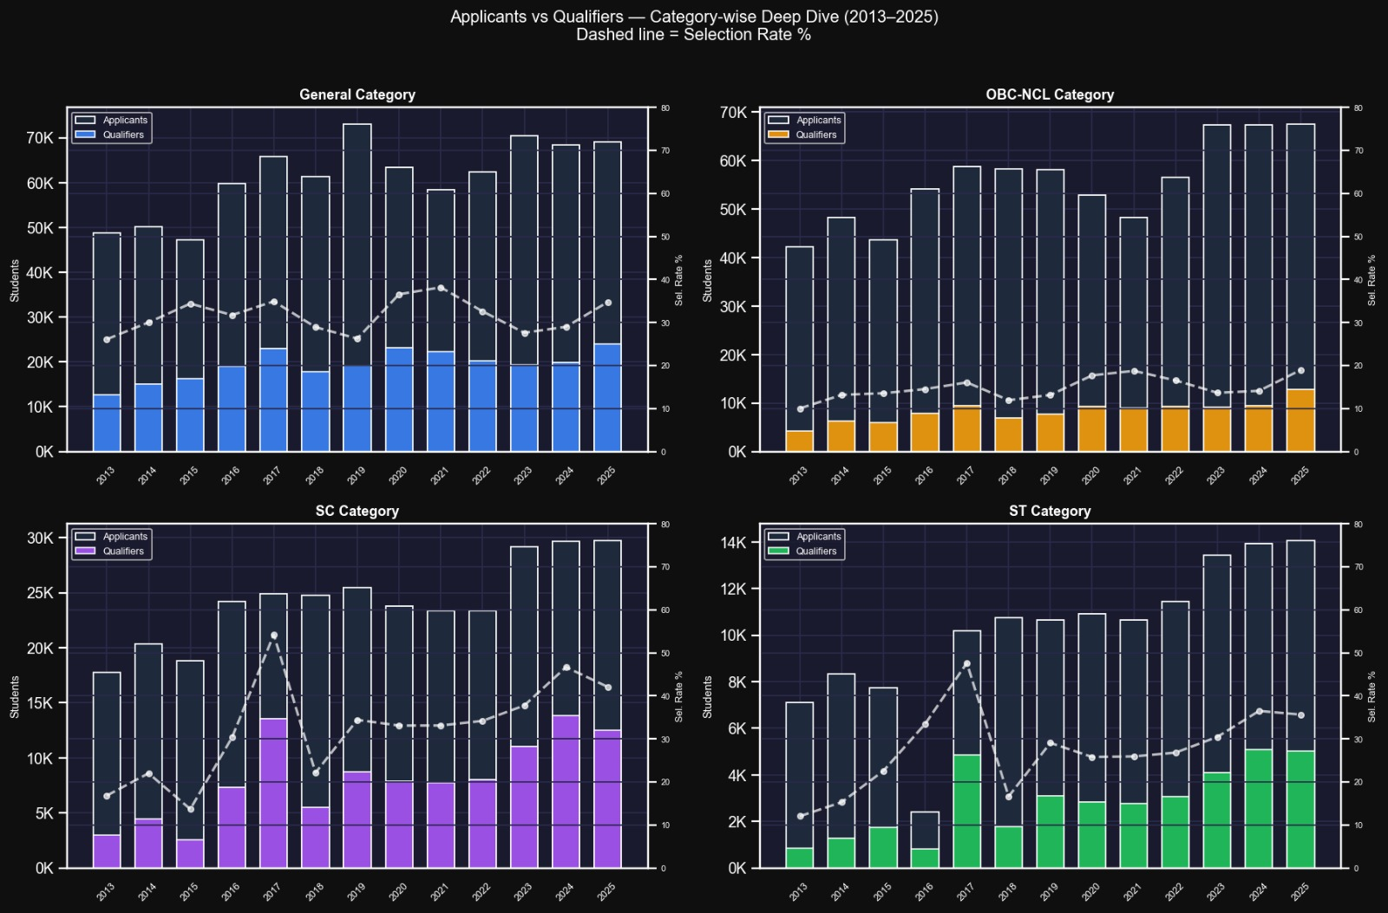
Insight: General Category : The No. of students appearing in examination have always been higher in numbers, that is held accountable by the fact that most of general candidates are well aware of the examination. Since, good chunk of general population have at least one parent educated in the family, exceptions are excused. The advantage is clearly visible through the selection rate in various years.

OBC Category : The number of students taking the examination though comparable enough with general students. But, the selection rate is relative lower than as compared to general students. The difference is probably due to the unavailability of mentorship and guidance. Since, a good chunk of OBC student have both parents not even completed high school education.

SC Category : The participation from these students have been comparatively on lower side. But, the selection ratio has changed abruptly showing increasing selection rates.

ST Category : The most vulnerable students in the examination. Though government gave reservation to the ST students but the participation from them stood on extreme lower side. The possible reason could be their social and economical condition are highly unstable, which creates the difficulty for student to even pursue studying.

- Fee Trend Analysis

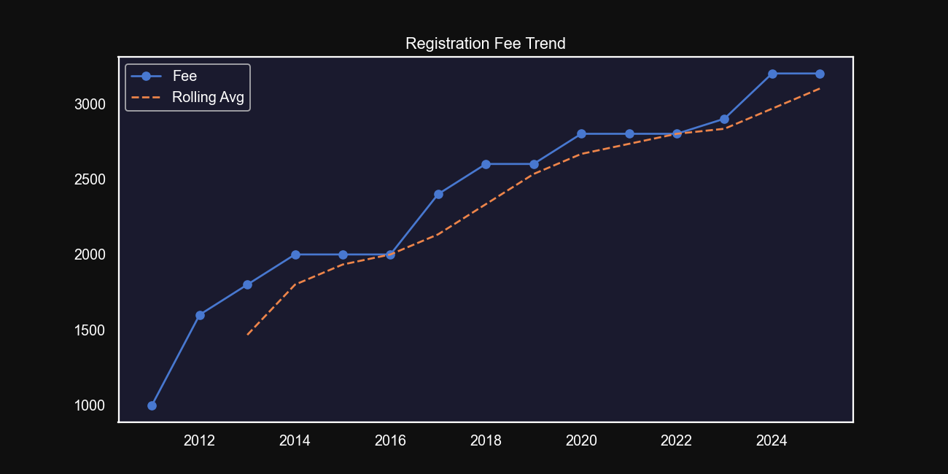

Insight: If it continues to grow at the current rate then Future Predictions: 2026 -> ₹ 3462.85, 2027 -> ₹ 3598.21, 2028 -> ₹ 3733.57
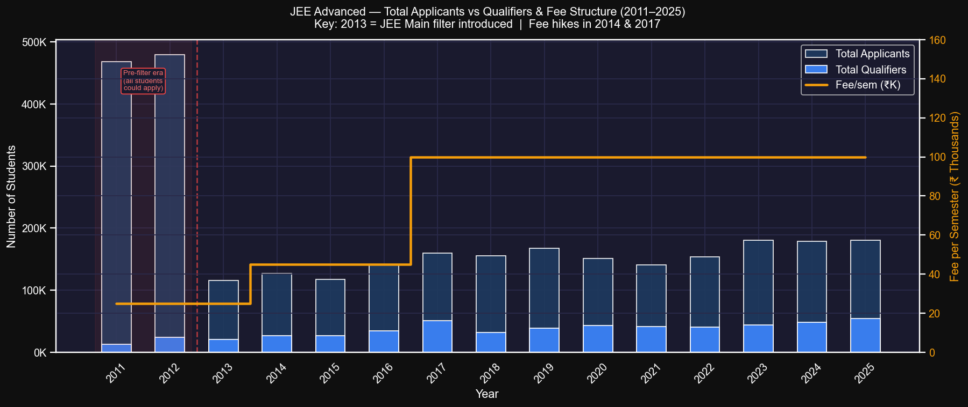

Insight: The most of all fee hikes was the hike in 2017 of 122 % till date

5. Model Building
The predictive core of this project utilizes the rank_predictor.csv dataset, which contains over 3,000 data points. A regression model was developed to forecast a candidate's rank based on three key parameters: marks obtained, maximum marks, and the estimated number of candidates appearing in the exam.
- Feature Engineering: To capture the true difficulty and scaling of the exam across different years, marks were converted into percentages. This normalization was critical in ensuring the model captured the underlying patterns of rank distribution rather than being biased by varying total marks.
- Algorithm & Performance: The model utilizes a Gradient Boosting Regressor, which achieved an R² score of 0.70+. This level of accuracy makes it a valuable tool for anyone seeking to estimate potential ranks based on historical examination trends.
- Deployment: Once training was complete, the model was serialized as a .pkl file. This file is loaded into the primary Dashboard.py file using the joblib package, enabling real-time rank predictions within the live web application.

6. System Architecture
To ensure a seamless and lag-free user experience, the web application was developed using Streamlit, a lightweight framework designed for high-performance data applications. The architecture focuses on optimization and efficiency through the following implementations:
- Optimized Resource Loading: To achieve near-instant loading times, static visualizations are not rendered in real-time. Instead, plots generated in dedicated Jupyter Notebooks were saved as high-quality images and are directly fetched from a local directory.
- Interactive Visualization Integration: For dynamic exploration, interactive Plotly charts were exported as HTML files during the analysis phase. These pre-rendered files are embedded within the Streamlit interface, providing full interactivity without the computational overhead of generating plots upon each page load.
- Model Integration: The predictive model was serialized as a .pkl file. By loading the pre-trained model via joblib, the application avoids the redundant effort of retraining the model during each user session, significantly reducing latency.
- Interface Design: The UI is designed with simplicity and accessibility in mind. A streamlined menu ribbon is utilized to facilitate easy navigation between different analytical cohorts and the rank predictor tool.
- Deployment: The project is hosted on Streamlit Cloud. The deployment pipeline involved migrating the codebase to a dedicated GitHub repository and linking it to the cloud platform for continuous delivery and public accessibility.

7. Conclusion
This concludes a multifaceted analysis of India's most prestigious engineering entrance examination. Each year, thousands of aspirants attempt the JEE Advanced—some driven by passion, others by the dream of academic excellence, and many by the hope of elevating their family's socio-economic standing. This analysis serves as a testament to the vividness and enduring significance of the exam within Indian society.
The data reveals a complex narrative: from the commendable impact of government initiatives designed to boost female participation and the representation of underprivileged backgrounds, to the rising concerns regarding IIT fee structures. Ultimately, this study encourages viewers to appreciate the sheer scale and demand of the examination while acknowledging the systemic shifts occurring over the last 14 years.

8. Future Scope
To further enhance the utility of this project, future iterations will focus on:
- Advanced College Prediction: Implementing a statistical recommendation engine that suggests the most probable IIT and branch options based on a candidate's rank, category, and gender.
- Optimized Choice Filling: Integrating JoSAA opening and closing rank data to help students organize their preference lists more effectively during the counseling process.

9. Project Access
Interactive dashboard link:
https://course-project---comprehensive-jee-advanced-analysis-bxfpjkhyy.streamlit.app/
Resources and source code (GitHub Repository Link):
https://github.com/ermadanvk-afk/Course-Project---Comprehensive-Jee-Advanced-Analysis

10. Bibliography
For data set collections, official reports published by JEE Advanced Organising Committee every year. Below are the links:
- https://jeeadv.ac.in/reports.html
- https://josaa.nic.in/
- In case of missing data, some coaching sites who track JEE Advanced pattern every year were used.
For purpose of ideation only about what type of plots suits the best for the particular dataset, tools like ChatGPT and Gemini were used.

