

|  |
| --- |
| React boot camp  Tasks |
|  |

Contents

1 Task 1 - (Core concepts pt.1, pt.2) 3

2 Task 2 - Components, Routing 5

3 Task 3 – Redux 11

4 Task 4 – Testing, Project structure 11

# Task 1 - (Core concepts pt.1, pt.2)

You should only layout these pages using JSX. They will be used in future tasks.

Each category has its own list of tasks and shows only them, even if the category has nested categories.

Selected category should be highlighted. If no category is selected hide right section with tasks input.

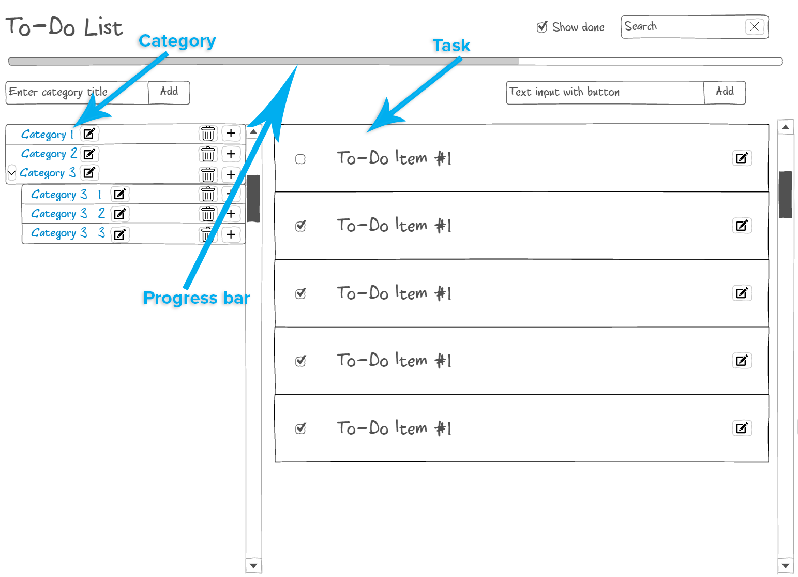

Figure 1 Main page

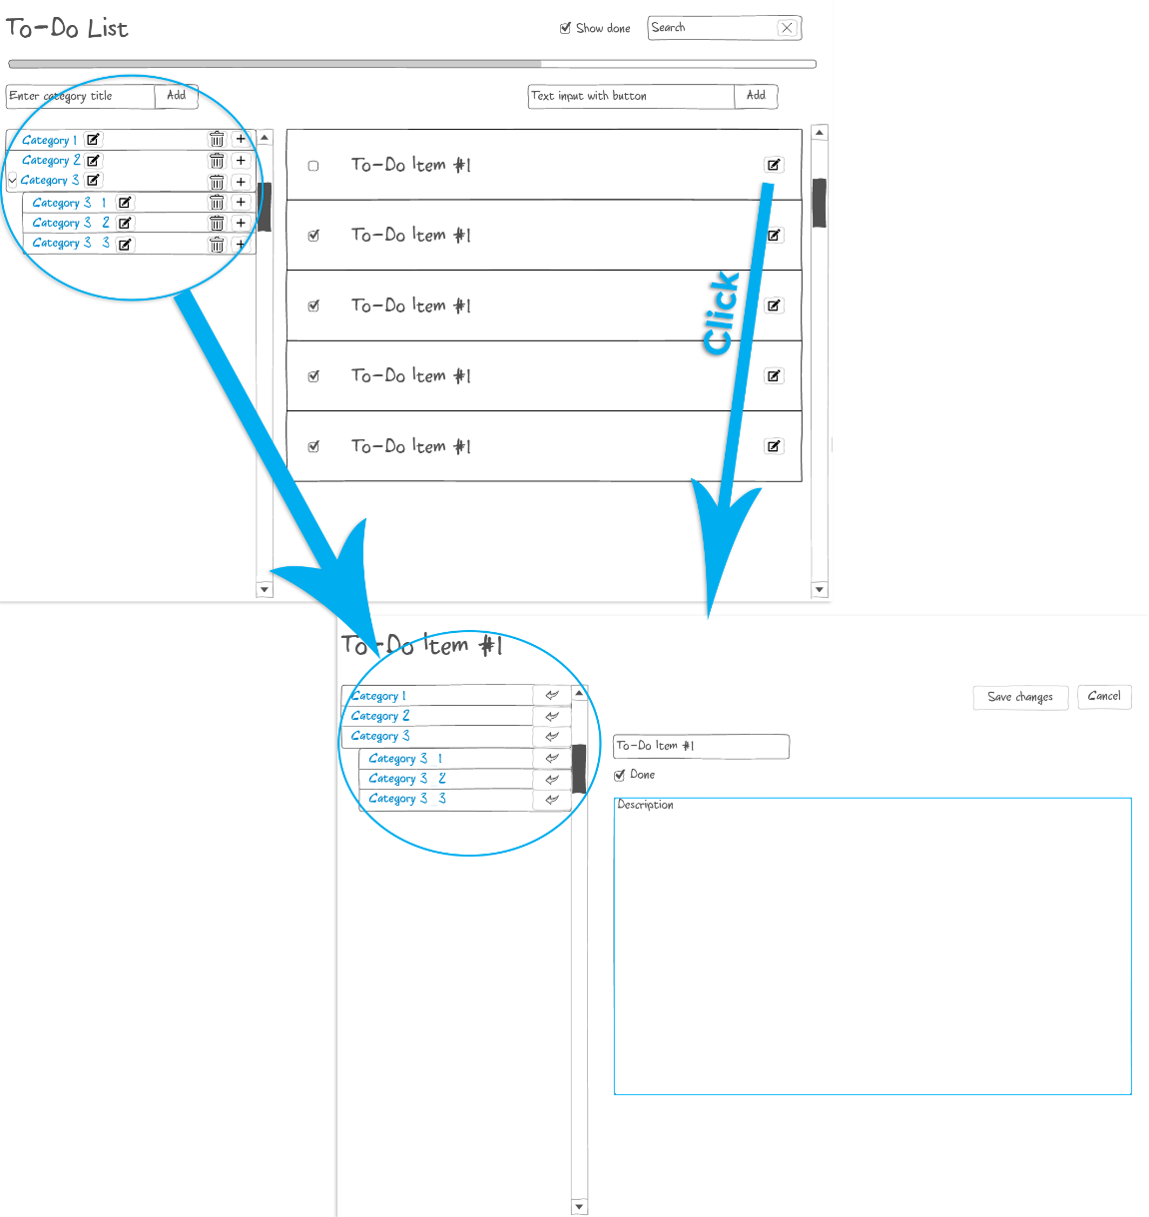

Figure 2 Task edit page

# Task 2 - Components, Routing

Create such TODO application

Filter and selected category and task must be in URL. The search filter applies to tasks.

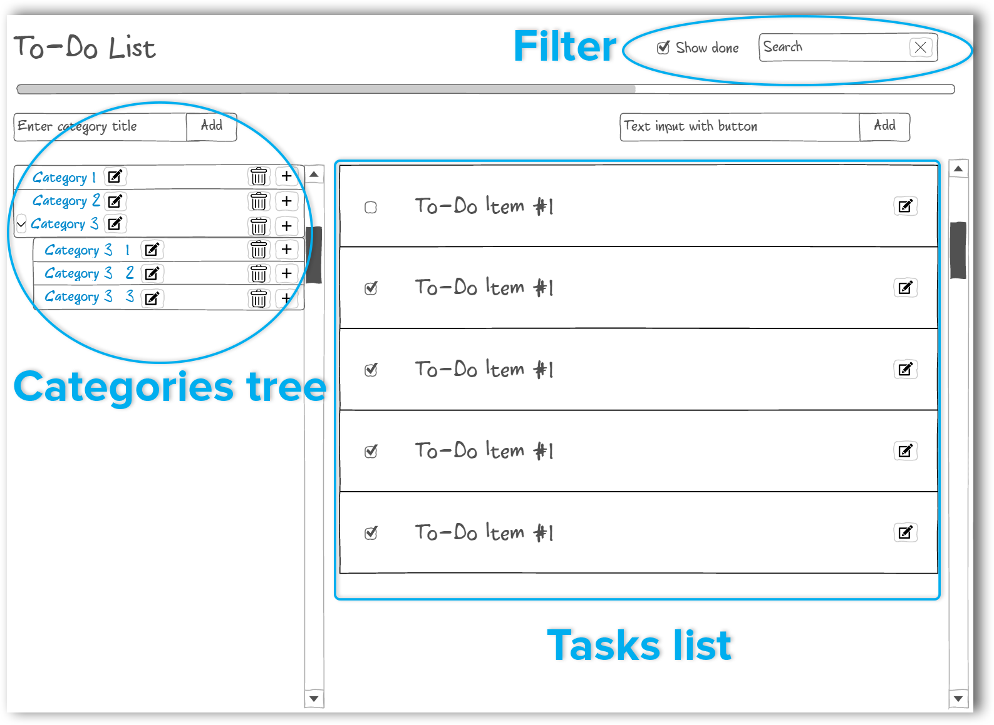

When you click on category you will see its tasks

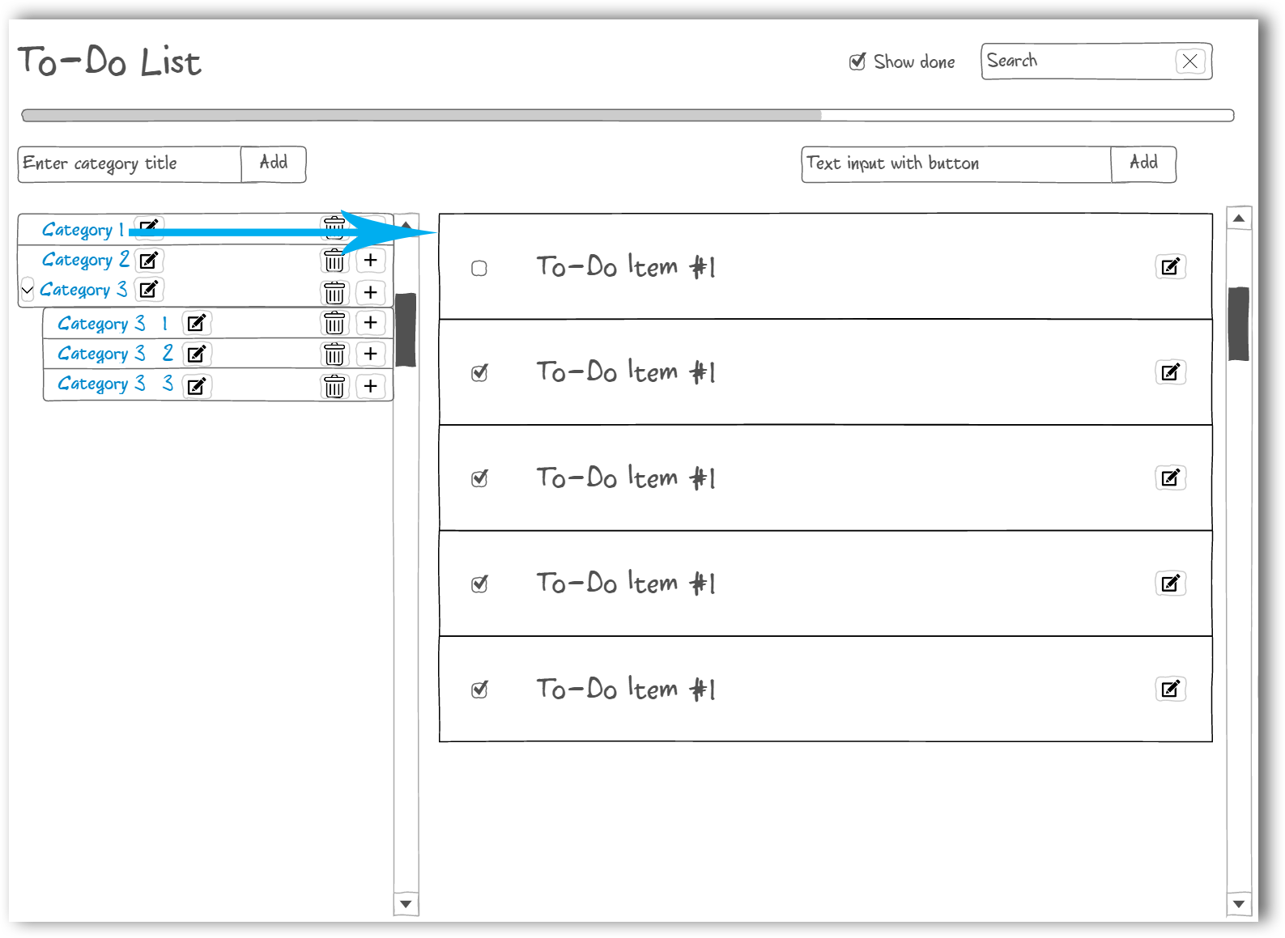

The categories tree may have infinite hierarchy

When user adds new category it goes to top of the tree. The UI of how to get the name is up to you (i.e. modal window or inline input)

When user deletes category all the nested categories are also become deleted. Confirmation should be shown.

New task goes to top of the list

By clicking “Edit category” user can rename the category. The UI should be the same as in adding new category.

* User can’t move categories, only delete or create new category. Also user can’t delete tasks.

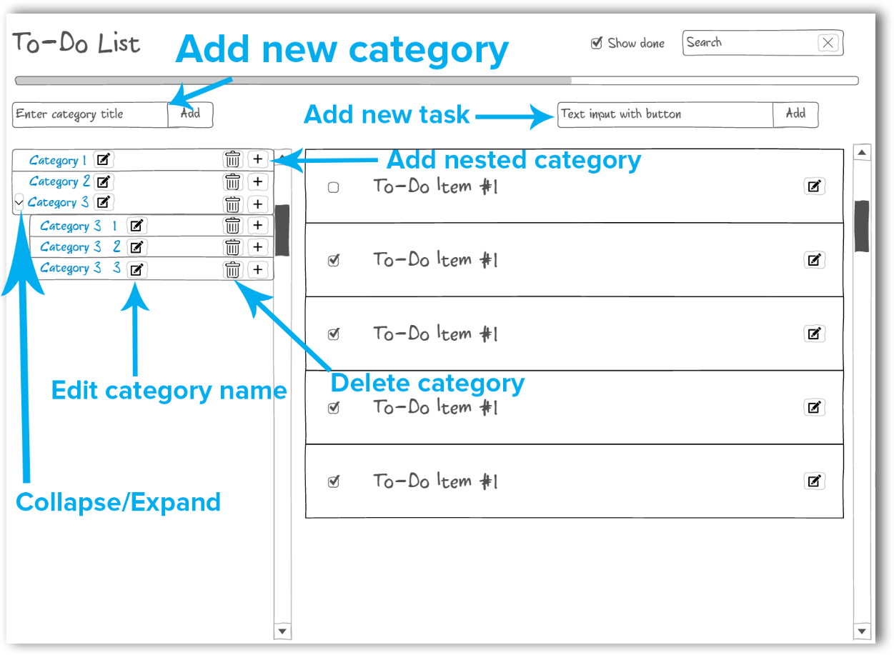

Category flow:

1. Case – you type category title in the input and click ‘Add’
2. Case – you click on ‘Add nested category’ and then i.e. modal window is appeared in which you can type name for nested category
3. Case – you click on ‘Edit category name’ and then the component of the second case is appeared with filled value. The purpose of it is to show reusable components approach.

Progress of all completed categories. Completed category is a category in which all tasks are done or if it’s empty (empty categories are always visible). If parent category is completed but child is not, the parent category stays in the tree but the progress bar counts it as completed.

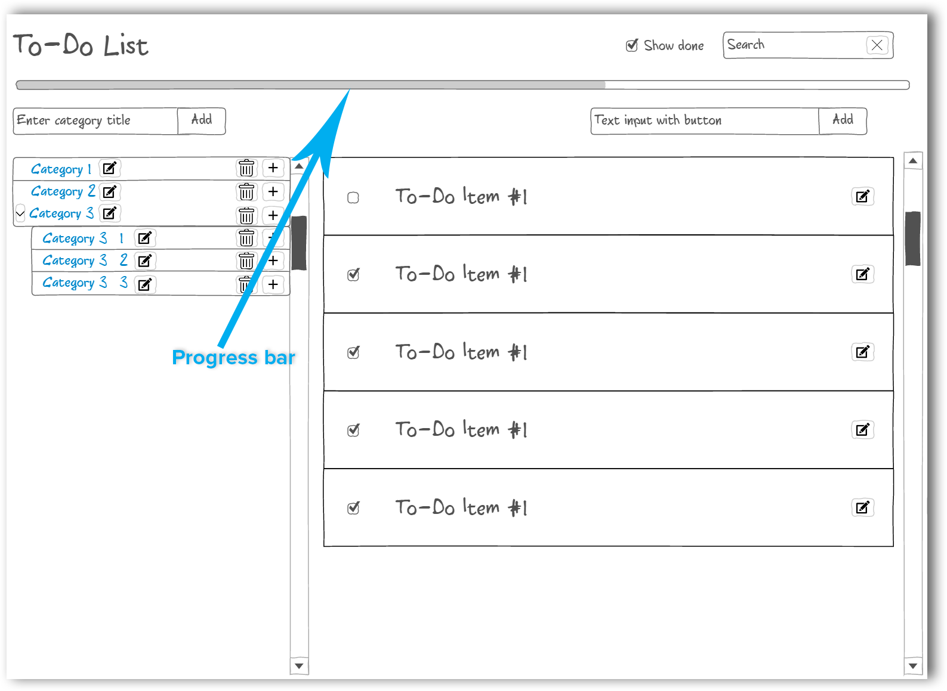

It is possible to edit particular task. It should be added to URL.

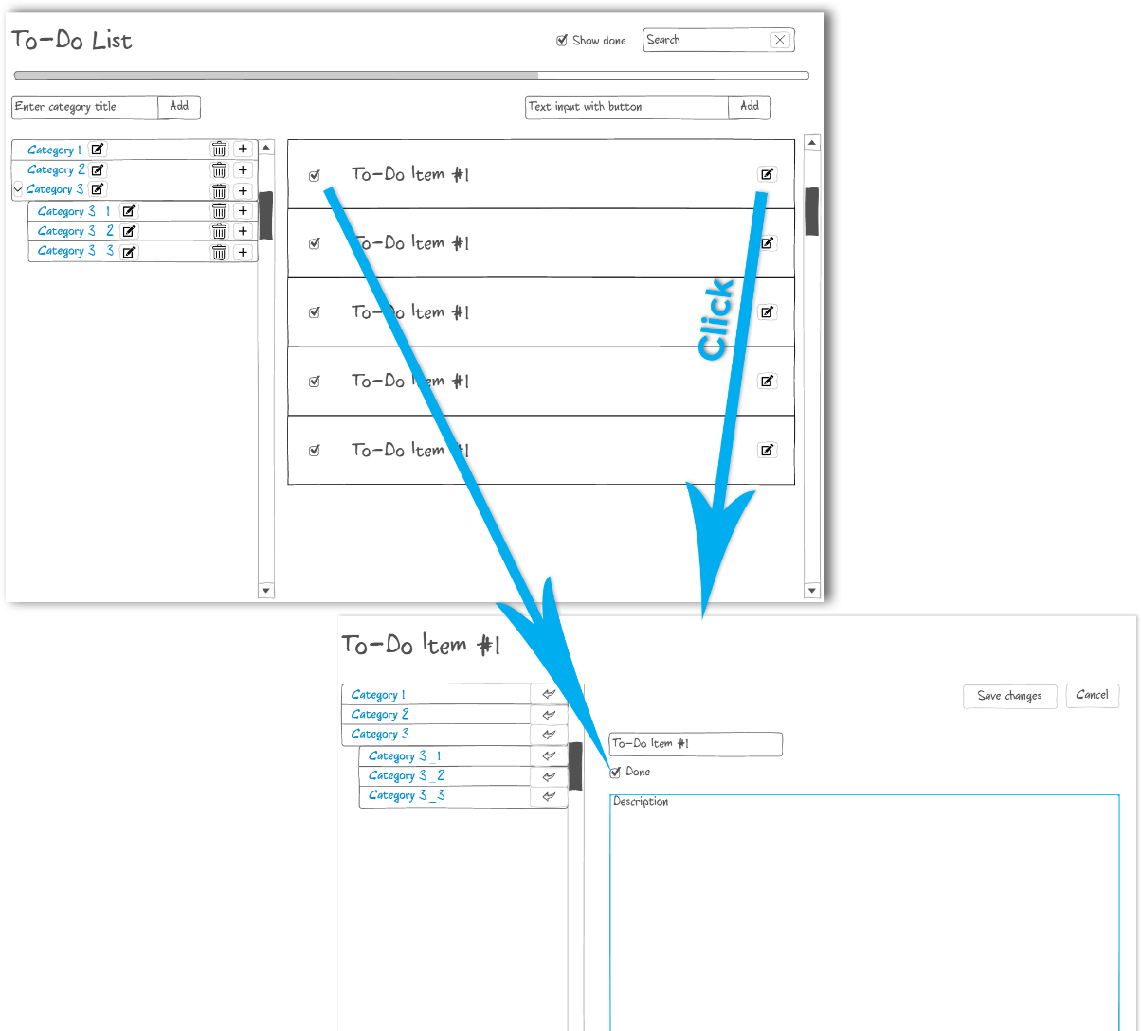

Also, you can move task into another category by clicking move icon. The move icon is hidden in the current task is presented in the category.

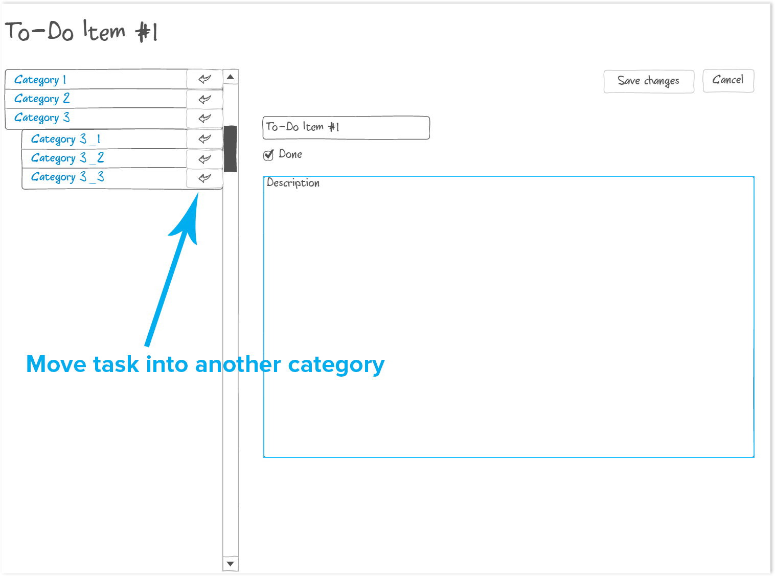

# Task 3 – Redux

* Add Undo/Redo (You can add these buttons to any place you want in the application)
* Use Redux as your data flow container

# Task 4 – Testing, Project structure

* Create tests special for Redux
* Reorganize and refactor your project