Erman Gurses

Dr. Ajay K. Katangur

COSC 5352, Advanced Operating Systems

March 7, 2013

Jump-Shot

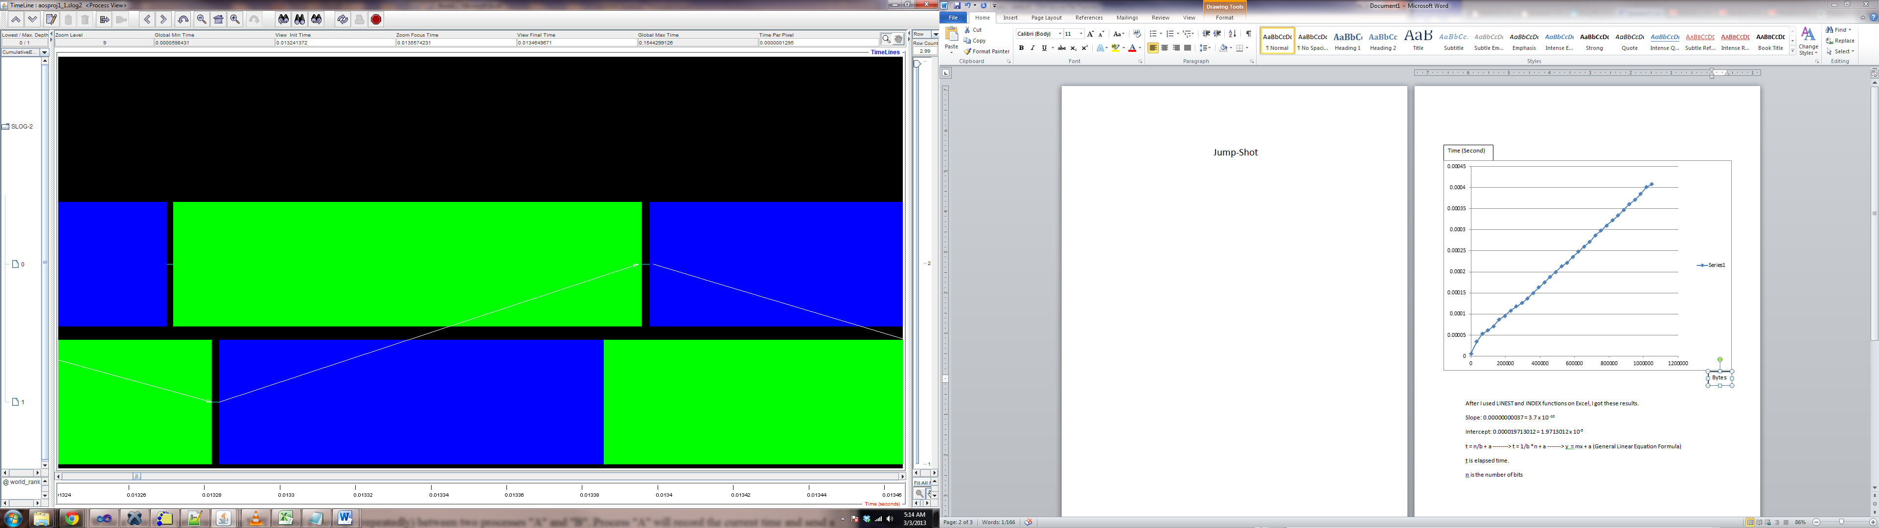

Time (Second)

Bytes

After I used LINEST and INDEX functions on Excel, I got these results.

Slope: 0.00000000037 = 3.7 x 10 -10

Intercept: 0.000019713012 = 1.9713012 x 10-5

t = n/b + a --------> t = 1/b \*n + a -------> y = mx + a (General Linear Equation Formula)

t is elapsed time.

n is the number of bits

m = 1/b which is Slope.

a is the intercept which is latency.

b is the bandwidth.

To find bandwidth the formula can be interpreted as b = n / (t-a)

The sample which is from the ping pong program is used to calculate the result of this formula.

n = 917504\* 8 = 262144 bits

t = 0.000034 = 3.4 x 10-5 seconds

a (intercept) = 1.9713012 x 10-5 seconds

So bandwidth is;

b = 21506920152 bits/second ----------> 20.02988025 Gbits/second

or we already know what slope is so;

m = 1/b = 3.7 x 10 -10

b = 20.13670432 Gbit/second