CHAUDHARY RANBIR SINGH
UNIVERSITY, JIND

INTERENSHIP REPORT ON
PYTHON PROGRAMMING (AI & ML)
BY
NEHA
Roll no. 245115
DEPARTMENT OF
COMPUTER SCIENCE & APPLICATIONS
SESSION :- 2024-2026

Acknowledgments
I am profoundly honored to extend my sincere gratitude to Code Scaler, Jind for granting me the invaluable opportunity to pursue my internship in the domain of Python Programming and Machine Learning. This transformative experience has served as a pivotal milestone in both my academic journey and professional growth, equipping me not only with robust technical skills but also instilling in me a deep sense of professional discipline, curiosity, and confidence.
My heartfelt appreciation goes out to the entire Code Scaler team, whose unwavering commitment to nurturing learners was evident in every interaction. The trainers and mentors demonstrated exceptional dedication, going above and beyond to ensure that each concept was thoroughly understood. Their patience, clarity in explanation, and openness to addressing even the most fundamental questions created a learning environment that was welcoming, engaging, and empowering.
I am especially grateful to my mentor, Mr. Deepak Jangra, for his insightful guidance, technical expertise, and constant encouragement throughout the internship. His mentorship played a crucial role in helping me navigate challenges, deepen my understanding of machine learning concepts, and apply them effectively in real-world scenarios.
I also extend my sincere thanks to Mr. Ajay Kumar, for his leadership and support, which helped shape the overall direction of my project and learning experience.
Additionally, I am thankful to my faculty members at university, whose constant encouragement and belief in my potential motivated me to embrace this opportunity wholeheartedly. Their guidance and moral support reinforced the importance of internships as a bridge between academic learning and industry readiness. Their emphasis on continuous self-improvement and pushing boundaries inspired me to step out of my comfort zone and make the most of this enriching experience.
This internship at Code Scaler, Jind has not only enhanced my technical proficiency but also shaped my mindset as a lifelong learner and aspiring professional. I carry forward the lessons, values, and skills imparted during this journey with immense pride and gratitude.

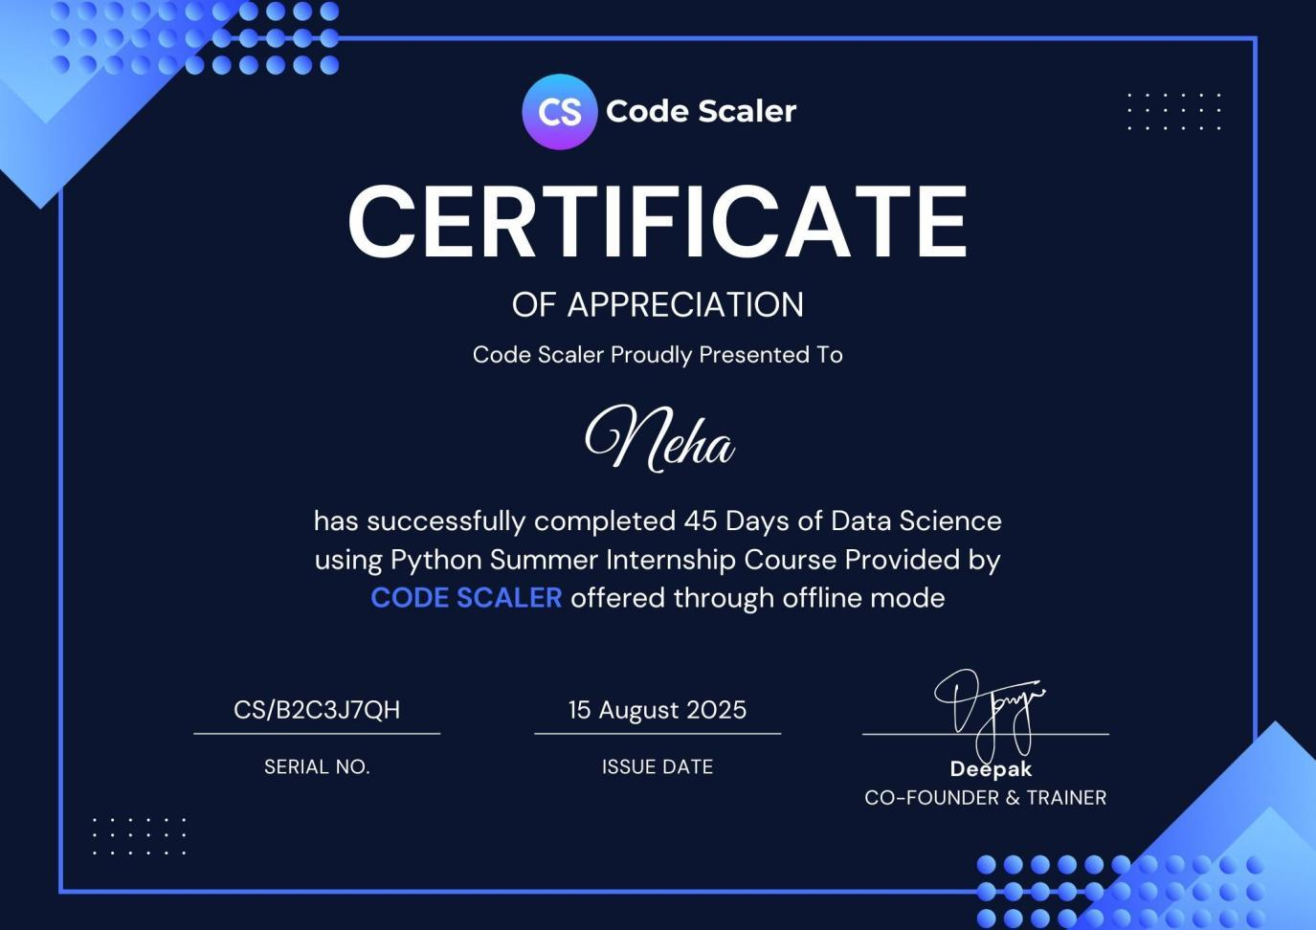

Index of Contents
Chapter Name
1. Introduction
2. Objectives of internship
3. Learning Experience
4. Learning Outcomes
5. Conclusion/Summary
6. Attachments of result
7. References

1. Objectives of Internship:
The internship at Code Scaler, Jind in the domain of Python Programming and Machine Learning was thoughtfully designed to foster both technical mastery and professional growth. With a curriculum rooted in real-world application and guided mentorship, the program aimed to bridge the gap between academic theory and industry practice. The experience provided a robust foundation in programming, data analysis, and machine learning, while also cultivating essential workplace competencies.
1. Strengthen Fundamentals of Python Programming
- Develop a solid grasp of Python syntax, operators, and control structures.
- Write modular, reusable, and clean code that adheres to best practices.
- Apply functions, recursion, and object-oriented programming in practical scenarios.
2. Gain Proficiency in Data Handling and Analysis
- Work with essential Python libraries such as NumPy and Pandas.
- Efficiently store, manipulate, and filter large datasets.
- Implement data cleaning techniques to manage missing values, duplicates, and formatting issues.
3. Develop Data Visualization Skills
- Create compelling visualizations using Matplotlib and Seaborn.
- Customize plots for clarity, professionalism, and visual impact.
- Understand the role of visual storytelling in data interpretation and communication.
4. Understand the Basics of Machine Learning
- Explore foundational ML concepts including supervised and unsupervised learning.
- Implement algorithms for regression, classification, and clustering.
- Use Scikit-learn to build and evaluate basic machine learning models.
- Analyze model performance using metrics like accuracy, precision, recall, and confusion matrices.
5. Learn Data Preprocessing for ML Pipelines
- Apply imputation techniques to handle missing and inconsistent data.
- Perform feature scaling and encoding for optimized model performance.
- Split datasets into training and testing sets for effective evaluation.
- Understand how preprocessing impacts model accuracy and reliability.
6. Build Logical Thinking and Problem-Solving Abilities
- Strengthen algorithmic thinking through structured coding challenges.
- Deconstruct complex problems into manageable components.
- Explore multiple solution strategies to enhance adaptability and creativity.
7. Develop Self-Learning and Research Skills
- Cultivate the habit of reading technical documentation to learn new tools and libraries.
- Enhance the ability to search, evaluate, and apply online resources effectively.
- Embrace continuous learning to stay updated with evolving technologies.
8. Enhance Professional Skills
- Improve time management by adhering to daily and weekly learning goals.
- Foster teamwork and communication through collaborative coding exercises.
- Gain exposure to workplace-like environments that emphasize accountability, discipline, and ownership.

2. Learning Experiences
The internship at Code Scaler, Jind followed a thoughtfully structured yet flexible learning path, enabling me to progress steadily while gaining hands-on experience with industry-relevant tools and techniques. The program was divided into progressive modules, each focusing on a core area of Python programming, data handling, visualization, and introductory machine learning.
Below is a detailed breakdown of the work completed during the internship:
1. Introduction to Python Programming
- Learned Python syntax, indentation rules, and the importance of writing clean, well-commented code.
- Worked with core data types: integers, floats, strings, booleans, lists, tuples, sets, and dictionaries.
- Practiced using arithmetic, comparison, logical, and assignment operators in coding exercises.
- Applied conditional statements (if, elif, else) to control program logic.
- Used loops (for, while) and loop control statements (break, continue, pass) for iterative tasks.
- Created and invoked functions to build modular and reusable code blocks.
2. Python Data Structures
- Explored built-in data structures: lists, tuples, dictionaries, and sets.
- Performed operations like adding, removing, slicing, and iterating over elements.
- Implemented list comprehensions for efficient data transformation.
- Used dictionaries for key-value mapping and sets for handling unique data.
3. Data integration
Key topics:
- Use GROQ LLM via HUGGINGFACE
- Use versatile LLM to give versatile info(almost about everthing)
4. User interface with streamlit
Key topics:
- Create the title using title method and explore header and other sections
- Apply in built methods to create sidebar.
5. Authetication
Learn to store data at backend for user authentication
Key topics:
- Use json file to store user data like name and password

Learning Outcomes
The internship at Code Scaler, Jind was a transformative experience that offered structured learning, hands-on exposure, and real-world skill development. By the end of the program, I had built a strong foundation in Python and machine learning, while also growing in confidence, adaptability, and professional readiness.
Programming & Technical Skills
- Proficient in Python: Gained strong command over Python syntax, data structures, and control flow, forming the backbone for all further learning.
- Data Manipulation: Learned to clean, transform, and analyze datasets using NumPy and Pandas, including handling missing values, filtering, grouping, and aggregating data.
- User interface: Learned to use the inbuilt methods and technology of streamlit using title,sidebar,session,images and tokens.
- Data Visualization: Developed the ability to create meaningful visualizations using Matplotlib and Seaborn, aiding in data storytelling and insight generation.
- Machine Learning Fundamentals: Built and trained models using Scikit-learn, including logistic regression, decision trees, and ensemble methods.
- Model Evaluation: Understood and applied key performance metrics such as accuracy, precision, recall, F1-score, and confusion matrix to assess model effectiveness.
Data Analysis & Problem Solving
- Data Preprocessing: Learned techniques for handling noisy and incomplete data, including encoding categorical variables and scaling features.
- Exploratory Data Analysis (EDA): Identified patterns, trends, and outliers through visual and statistical methods.
- Logical Thinking: Strengthened algorithmic thinking through regular coding challenges and real-world problem-solving exercises.
Understanding Machine Learning Workflows
Though introductory, the machine learning segment gave me a solid grasp of:
- Supervised vs. unsupervised learning.
- Algorithms like linear regression and decision trees.
- Using Scikit-learn to train and evaluate models.
With the Iris dataset, I trained a decision tree classifier and assessed its accuracy—gaining insight into model performance and evaluation metrics.
Web App Development with Streamlit
- Interactive UI Design: Created a multi-tab interface using Streamlit, enabling users to interact with the ML model through forms, sidebars, and input widgets.
- Model Insights Visualization: Displayed feature importance and evaluation metrics directly in the app, improving transparency and interpretability.
- Session State Management: Used st.session_state to maintain recent predictions and user interactions across sessions.
- Deployment Readiness: Prepared the app for hosting on platforms like Streamlit Cloud, making it accessible to non-technical users.
Personal & Professional Development
- Discipline & Time Management: Managed deadlines and balanced multiple learning modules effectively.
- Adaptability: Quickly learned new tools and concepts, adjusting to evolving project requirements.
- Communication Skills: Improved ability to explain technical concepts clearly, both in writing and during presentations.
- Growth Mindset: Embraced feedback and challenges as opportunities for learning and improvement.
- Industry Awareness: Gained exposure to professional workflows, bridging the gap between academic learning and real-world applications.

Summary
The internship I completed at Code Scaler, Jind has been one of the most enriching and transformative experiences of my academic journey. What began as a structured technical training program gradually evolved into a comprehensive learning pathway that not only strengthened my programming skills but also expanded my understanding of real-world software development practices. This internship provided me with exposure to the complete cycle of developing an AI-based project—from basic coding to deployment—something that traditional classroom learning seldom offers.
The journey started with the fundamentals of Python programming. By revisiting and mastering core concepts such as variables, data types, operators, functions, loops, conditional statements, and file handling, I developed a strong foundation that supported everything I built later. Through hands-on exercises and coding challenges, I learned to write clean, logical, and efficient code. As the difficulty level gradually increased, I gained confidence in solving problems independently and approaching tasks with a structured mindset.
Moving forward, I shifted into working with data—learning how to manipulate, clean, and analyze datasets using essential Python libraries like NumPy and Pandas. This phase helped me understand how real-world data is often messy and requires careful preprocessing before being used for any meaningful purpose. The experience of handling missing values, duplicates, and formatting inconsistencies taught me the importance of data quality in analytical and AI-driven applications.
Another significant highlight of the internship was learning data visualization using Matplotlib and Seaborn. By creating bar charts, scatter plots, heatmaps, and line graphs, I learned how to convert raw data into meaningful visual insights. This helped me understand the role of visual storytelling in making data understandable and actionable, especially when presenting results to nontechnical audiences.
As I advanced further, I explored how to build user interfaces using Streamlit. This was one of the most exciting parts of the internship because it enabled me to bring my code to life in the form of a functional web application. Learning how to create interactive elements—such as input fields, buttons, and sidebar menus—enhanced my understanding of how users interact with applications. I also learned about session management, responsive layouts, and how to make UI intuitive and user-friendly.
The most crucial and rewarding component of my internship was the AI Chatbot Project, which integrated everything I learned during the internship. I built a complete chatbot using Python, Streamlit, and advanced LLMs such as Groq (via Hugging Face). This required understanding how APIs work, how to send requests and handle responses, and how to integrate large language models for generating intelligent answers. I also implemented user authentication using a JSON file-based backend, ensuring that each user has a secure login and personalized experience.
Deploying the chatbot on Streamlit Cloud added another dimension to my learning. I gained hands-on experience in working with environment variables, managing secret API keys, using a .gitignore file to secure sensitive data, and publishing a fully functional application on the internet. This step reinforced the importance of security, version control, and cloud deployment in modern software development.
Beyond the technical skills, the internship helped me grow personally and professionally. I learned to manage my time effectively, work consistently, and remain disciplined throughout the learning process. The guidance from mentors helped me build confidence, ask questions without hesitation, and approach challenges with a problem-solving mindset. Working on a real project taught me how to test code, debug issues, refactor logic, and document my work clearly.
Overall, this internship served as a bridge between theoretical knowledge and industry practices. It gave me a clear picture of how software applications are developed, structured, deployed, and maintained. It strengthened my passion for technology and motivated me to continue exploring Python, AI, and machine learning in depth. The experience has prepared me for future roles in the tech industry and has given me a strong foundation to pursue advanced learning and projects.

Attachments :
Chatbot
https://chatbot1-jaq4u83mnfsqyu6k2afnrx.streamlit.app/
Project Overview
The project focuses on building and deploying an AI-powered chatbot capable of handling multiple queries. The chatbot integrates with Groq LLM models (via Hugging Face) for natural language understanding and response generation. To provide a user-friendly web interface, the project is built using Streamlit and deployed on Streamlit Cloud, making it accessible to anyone with the app’s link.
The system includes user authentication, where credentials are stored securely in a users.json file. Sensitive API keys are managed using an .env file, with .gitignore ensuring they are not exposed in version control.
Objectives
- Build and deploy an AI chatbot with multi-query handling.
- Provide secure user authentication using JSON-based storage.
- Protect API keys via environment variables.
- Ensure the application is accessible online via Streamlit Cloud.
- Maintain best practices for security and deployment.
2. Tools and Technologies Used
The development of the AI-powered chatbot system involved a combination of programming languages, frameworks, deployment tools, and version control systems. Each technology contributed to the project’s functionality, security, and maintainability. Below is a detailed explanation of all tools and technologies categorized according to their purpose.
- Programming Language
Python was the primary programming language used throughout the project. Its simplicity, extensive libraries, and strong support for AI, data processing, and web-based tools made it ideal for developing the chatbot system. Python enabled the implementation of backend logic, API integration, user authentication, and overall system functionality.
- Web Framework
Streamlit was used to build the interactive web interface for the chatbot. It allowed rapid creation of UI components such as text inputs, buttons, sidebars, and containers without requiring HTML, CSS, or JavaScript. Streamlit also supports real-time updates and seamless deployment, making it an excellent choice for building lightweight, data-driven applications.
- AI Model Integration
Groq LLM served as the core AI engine of the chatbot. Using the Hugging Face API, the chatbot was able to generate intelligent, human-like responses based on user prompts. This integration provided high-speed inference, reliable performance, and access to a wide range of natural language processing capabilities.
- Authentication System
Instead of using a full database, the project implemented a simple authentication system using a users.json file. It stored user credentials and login details in a structured format, enabling quick verification during the login process. JSON-based authentication is lightweight and efficient for small-scale applications like this chatbot.
- Security
To ensure secure handling of sensitive information, environment variables were stored in a .env file using the python-dotenv library. This allowed secure management of API keys and confidential credentials.
The .gitignore file prevented sensitive files—such as .env and users.json—from being uploaded to GitHub, ensuring safe version control practices and preventing accidental exposure of secrets.
- Deployment Platform
The complete chatbot application was deployed using Streamlit Cloud, enabling global access through a sharable URL. Streamlit Cloud simplifies deployment by automatically detecting dependencies, managing server resources, and providing continuous updates whenever the GitHub repository is updated.
- File Management
  - JSON was used for storing user data and managing structured information such as login details.
  - The OS module helped in handling file paths, directory checks, environment variable access, and system-level interactions required during project execution.
  - These tools contributed to efficient data handling and secure file operations within the project.
- Version Control
GitHub was used for managing the project code, uploading updates, and storing version histories. It allowed smooth integration with Streamlit Cloud during deployment and ensured the project remained organized, trackable, and easily maintainable.
3. System Architecture
Workflow:
1. Authentication: User logs in/signs up → credentials verified from users.json.
2. Query Handling: User enters a question → sent to Groq LLM.
3. Response: Hugging Face model generates the reply → displayed in Streamlit UI.
4. Deployment: App hosted on Streamlit Cloud → accessible globally.
5. Security: API keys in .env, excluded from GitHub using .gitignore.
4.Implement
Key Files
- app1.py → Main chatbot application (UI + query handling).
- users.json → Stores user credentials.
- .env → Contains API keys (e.g., Hugging Face, Groq).
- .gitignore → Prevents sensitive files from being committed.
5.Deployment Process
1. Push project to GitHub repository.
2. Connect GitHub repo with Streamlit Cloud.
3. Add environment variables (API keys) in Streamlit Cloud settings (not from .env).
4. Deploy and share the Streamlit Cloud link.
6.Security Features
- API keys hidden using .env and Streamlit Cloud secrets manager.
- Sensitive files (.env, users.json) excluded from GitHub using .gitignore.
- Users must log in before accessing chatbot features.
7.Deployment Details
- Hosting Platform: Streamlit Cloud
- Access: Web app accessible via a unique Streamlit Cloud link.
- Scalability: Automatic scaling with Streamlit Cloud.
- Secrets Management: API keys added securely in the cloud environment.

Results
- Interactive Login Page for authentication.
- Deployed Chatbot Interface accessible online.
- Handles multiple queries with real-time responses.
- Demonstrates secure deployment best practices.
LOGIN PAGE
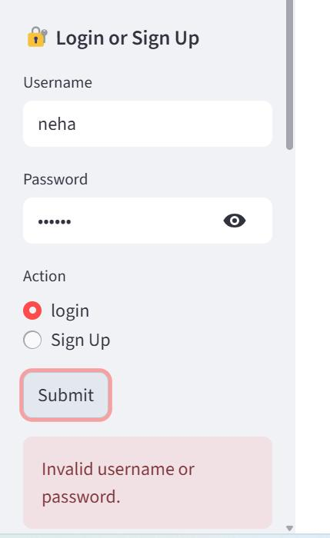
SIGN UP
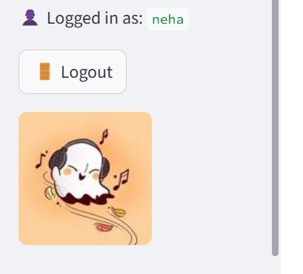

CHATBOT INTERFACE
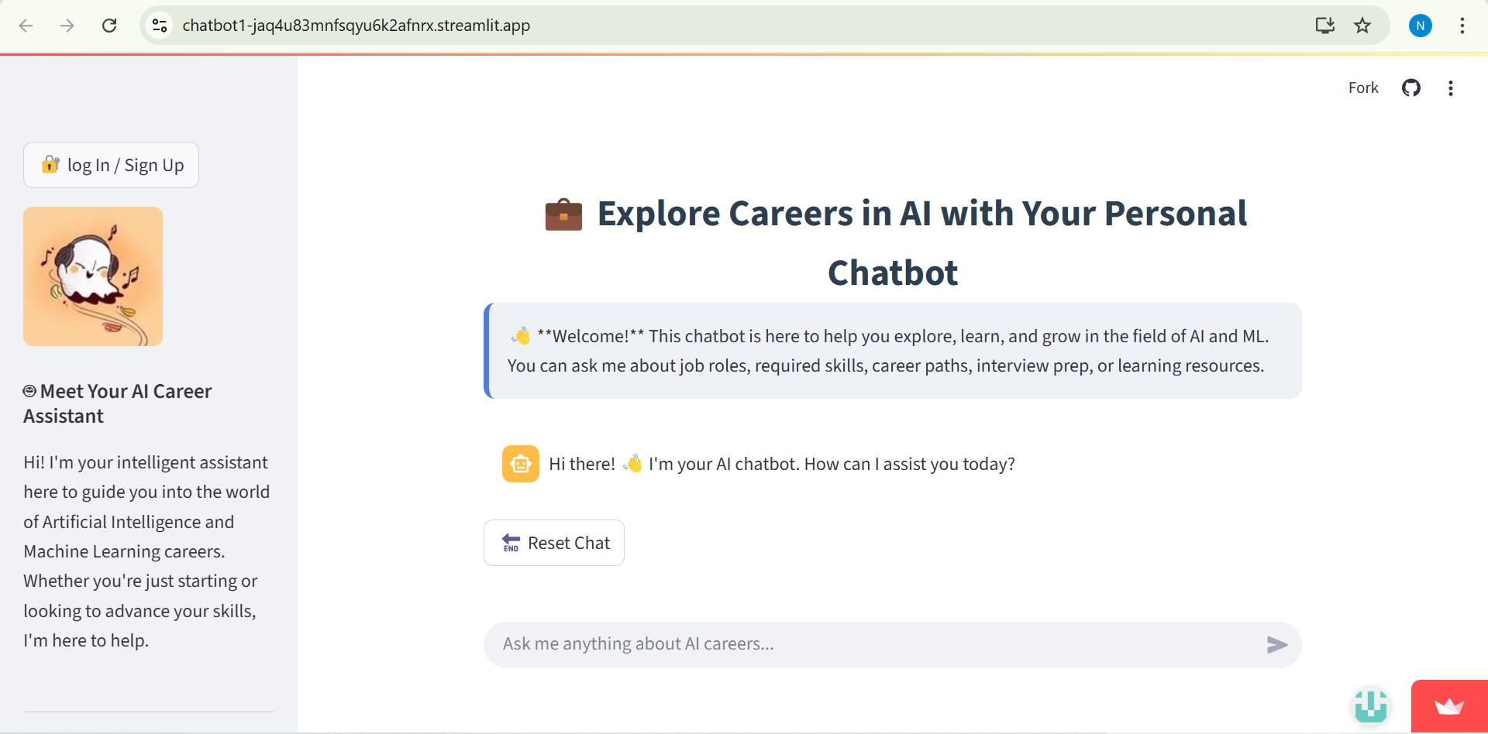
DEPLOYMENT DASHBOARD
GITHUB
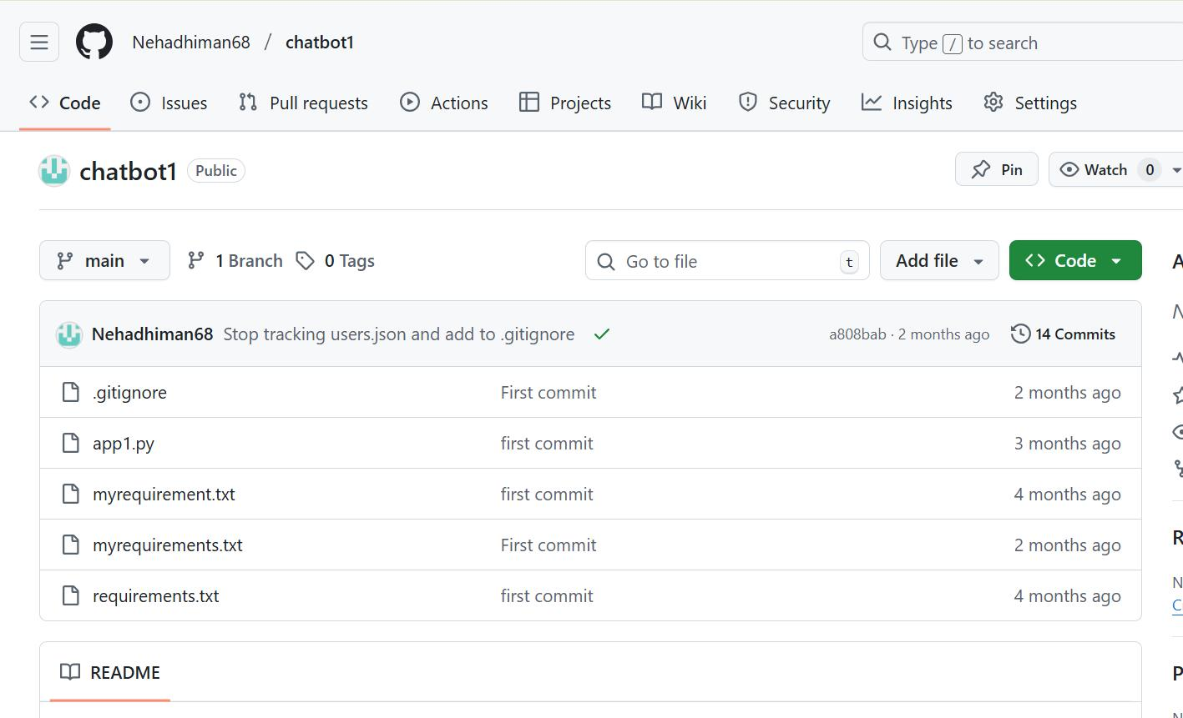
STREAMLIT CLOUD
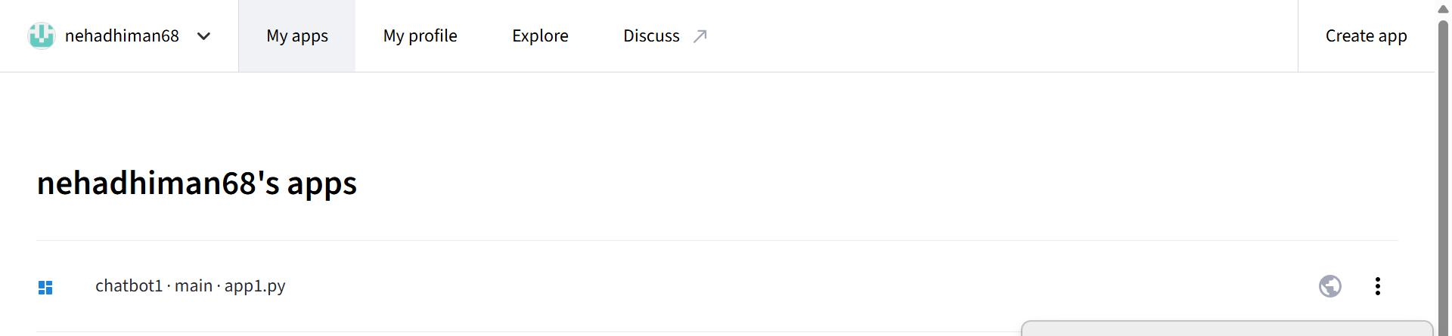

Conclusion
The internship at Code Scaler, Jind, has been a transformative learning experience that significantly contributed to my academic, technical, and professional development. Over the course of this internship, I gained practical exposure to real-world technologies, hands-on development practices, and industry-oriented problem-solving techniques. The key outcome of this internship was the successful development of an AI-powered chatbot application using Python, Streamlit, Groq LLM, and secure deployment practices. This project not only strengthened my technical foundation but also helped me understand how modern AI applications are designed, implemented, tested, and deployed.
One of the most valuable aspects of this internship was the opportunity to apply classroom concepts in a practical environment. Throughout the development of the chatbot project, I worked with essential technologies such as Python programming, JSON-based authentication, API integration, and environment variable management. These experiences deepened my understanding of backend development workflows and the importance of writing secure, maintainable, and scalable code. The integration of Groq LLM via Hugging Face further exposed me to the rapidly growing field of generative AI and large language models—skills that are increasingly relevant in today’s industry.
Beyond technical learning, the internship also strengthened my problem-solving abilities, analytical thinking, and self-learning capabilities. Facing challenges such as API errors, authentication issues, and interface refinement encouraged me to explore documentation, debug effectively, and think creatively to find solutions. These experiences played a crucial role in helping me grow as an independent developer who can handle real-world project complexities.
In conclusion, the internship provided me with a holistic blend of theoretical understanding and practical application. The skills I gained—ranging from Python development and AI model integration to deployment and version control—will continue to benefit me in future academic projects and professional endeavors. This experience has strengthened my confidence and motivated me to pursue more advanced projects in artificial intelligence, software development, and cloud technologies. I am truly grateful for the guidance, opportunities, and learning environment provided by Code Scaler, and I believe this internship marks an important stepping stone in my career growth and technical journey.

REFERENCES
Streamlit Cloud:
https://streamlit.io/cloud
Hugging face:
https://huggingface.co/
Groq:
https://groq.com/
Github:
https://github.com/
Repository:
https://github.com/Nehadhiman68/chatbot1

