Docker learning whole details on w520

first install docker, ubuntu, Hello World

./How To Install and Use Docker Compose on Ubuntu 18.04.odt

second install compose

./How To Install and Use Docker Compose on Ubuntu 18.04.odt

third docker basic commands
Basic  : docker version  : docker -v  : docker infod  : docker --help  : docker login  ————————————  Images  : docker images  : docker pull  : docker rmi  ————————————  Containers  : docker ps  : docker run  : docker start  : docker stop  ————————————  System  : docker stats  : docker system df  : docker system prune References  -  https://hub.docker.com/  https://docs.docker.com/engine/refere... | Today we will learn  : 1. What are images  2. How to pull image  3. How to run a container using an image  4. Basic Commands  TIPS & TRICKS  What are Images  Docker Images are templates used to create Docker containers  Container is a running instance of image  Where are Images Stored Registries (e.g. docker hub)  Can be stored locally or remote  : docker images --help : docker pull image  : docker images : docker images -q  : docker images -f “dangling=false”  : docker images -f “dangling=false” -q  : docker run image  : docker rmi image  : docker rmi -f image  : docker inspect  : docker history imageName  References:  https://hub.docker.com/_/ubuntu/ https://docs.docker.com/engine/refere... | COMMANDS  : docker ps  : docker run ImageName  : docker start ContainerName/ID  : docker stop ContainerName/ID  : docker pause ContainerName/ID  : docker unpause ContainerName/ID  : docker top ContainerName/ID  : docker stats ContainerName/ID  : docker attach ContainerName/ID  : docker kill ContainerName/ID  : docker rm ContainerName/ID  : docker history ImageName/ID References: https://www.google.co.in/search?rlz=1... https://docs.docker.com/engine/refere...

Password for w520 unbuntu

Name: ermao750125

username: ermaow520
password: ermaow520

Docker Selenium Grid setup

Setup Hub
sudo docker run -d -p 4444:4444 --name selenium-hub selenium/hub
Copy
Setup nodes with Chrome & Firefox and register to the hub
sudo docker run -d --link selenium-hub:hub selenium/node-chrome
sudo docker run -d --link selenium-hub:hub selenium/node-firefox
Copy
The above commands takes care of downloading already built image (with all the dependencies like java, chrome, firefox, selenium-server-standalone jar etc… required to run your selenium tests).
You can access the selenium-grid console using http://localhost:4444/grid/console

If you need one more chrome node instance, run this command.
sudo docker run -d --link selenium-hub:hub selenium/node-chrome
ermao750125@ermao750125-ThinkPad-W520:~$ sudo docker ps
CONTAINER ID IMAGE COMMAND CREATED STATUS PORTS NAMES
b22f89c4fd6f selenium/node-chrome "/opt/bin/entry_poin…" 51 seconds ago Up 49 seconds naughty_archimedes
1bb1ac3bd666 selenium/node-firefox "/opt/bin/entry_poin…" 2 minutes ago Up 2 minutes ecstatic_heisenberg
5ce06ddb654e selenium/node-chrome "/opt/bin/entry_poin…" 21 minutes ago Up 21 minutes agitated_goldstine
5d8dfd1999cf selenium/hub "/opt/bin/entry_poin…" 23 minutes ago Up 23 minutes 0.0.0.0:4444->4444/tcp selenium-hub
6dbbafffc9b4 jenkins "/bin/tini -- /usr/l…" 2 hours ago Up 2 hours 0.0.0.0:8080->8080/tcp, 0.0.0.0:50000->50000/tcp jovial_hopper

To shutdown the docker-grid infrastructure, run the below commands.
sudo docker stop $(sudo docker ps -a -q)
sudo docker rm $(sudo docker ps -a -q)
Copy
Docker has greatly simplified the selenium-grid setup process. However there is still some manual work.
It looks it stop all and rm all of what can be showed by docker ps -a

Issue below command
sudo docker-compose up -d
ermao750125@ermao750125-ThinkPad-W520:~/autoguru_app$ sudo docker-compose up -d
[sudo] password for ermao750125:
Creating network "autoguru_app_default" with the default driver
Creating selenium-hub ... done
Creating autoguru_app_chrome_1 ... done
Creating autoguru_app_firefox_1 ... done
sudo docker-compose ps
ermao750125@ermao750125-ThinkPad-W520:~/autoguru_app$ sudo docker-compose ps
Name Command State Ports
--------------------------------------------------------------------------------
autoguru_app_chrome_1 /opt/bin/entry_point.sh Up
autoguru_app_firefox_1 /opt/bin/entry_point.sh Up
selenium-hub /opt/bin/entry_point.sh Up 0.0.0.0:4444->4444/tcp
ermao750125@ermao750125-ThinkPad-W520:~/autoguru_app$

Now, do you need 5 instance of chrome? Not a big deal!! docker will take care of creating 4 more instances of chrome within few seconds. Just issue below command.
sudo docker-compose scale chrome=5
ermao750125@ermao750125-ThinkPad-W520:~/autoguru_app$ sudo docker-compose scale chrome=5
WARNING: The scale command is deprecated. Use the up command with the --scale flag instead.
Starting autoguru_app_chrome_1 ... done
Creating autoguru_app_chrome_2 ... done
Creating autoguru_app_chrome_3 ... done
Creating autoguru_app_chrome_4 ... done
Creating autoguru_app_chrome_5 ... done
ermao750125@ermao750125-ThinkPad-W520:~/autoguru_app$

sudo docker-compose ps

ermao750125@ermao750125-ThinkPad-W520:~/autoguru_app$ sudo docker-compose ps
Name Command State Ports
---------------------------------------------------------------------------------
autoguru_app_chrome_1 /opt/bin/entry_point.sh Up
autoguru_app_chrome_2 /opt/bin/entry_point.sh Up
autoguru_app_chrome_3 /opt/bin/entry_point.sh Up
autoguru_app_chrome_4 /opt/bin/entry_point.sh Up
autoguru_app_chrome_5 /opt/bin/entry_point.sh Up
autoguru_app_firefox_1 /opt/bin/entry_point.sh Up
selenium-hub /opt/bin/entry_point.sh Up 0.0.0.0:4444->4444/tcp
ermao750125@ermao750125-ThinkPad-W520:~/autoguru_app$

The selenium grid console at http://localhost:4444/grid/console will look like this
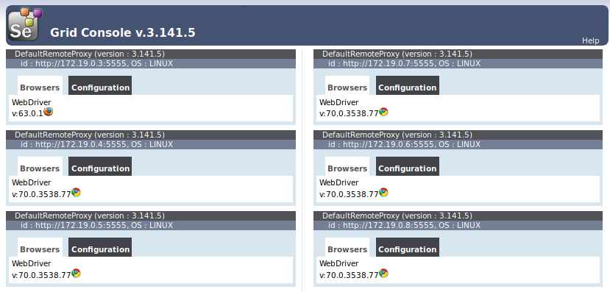
Now the entire grid can be brought down by issuing a single command.
sudo docker-compose down
ermao750125@ermao750125-ThinkPad-W520:~/autoguru_app$ sudo docker-compose down
[sudo] password for ermao750125:
Stopping autoguru_app_chrome_2 ... done
Stopping autoguru_app_chrome_5 ... done
Stopping autoguru_app_chrome_3 ... done
Stopping autoguru_app_chrome_4 ... done
Stopping autoguru_app_chrome_1 ... done
Stopping autoguru_app_firefox_1 ... done
Stopping selenium-hub ... done
Removing autoguru_app_chrome_2 ... done
Removing autoguru_app_chrome_5 ... done
Removing autoguru_app_chrome_3 ... done
Removing autoguru_app_chrome_4 ... done
Removing autoguru_app_chrome_1 ... done
Removing autoguru_app_firefox_1 ... done
Removing selenium-hub ... done
Removing network autoguru_app_default
ermao750125@ermao750125-ThinkPad-W520:~/autoguru_app$

Summary:
Managing selenium grid infrastructure was a pain. By using docker, we could reduce the significant amount of effort in setting the up the selenium grid. We can bring this infrastructure up and down anytime by issuing a single command and It is highly scalable as well.
However there is a dependency that this dockerized selenium grid should be up and running before you start tests. Once we are done with our tests, we do not have to keep the grid up and running. Currently as per this approach – this is managed outside the framework – either manually or some automated script.

Is there any way for us to manage this selenium-grid as part of our framework itself? Yes, Easily!! Check below article for more information.

Managing Selenium Grid Infrastructure using Arquillian Cube

./Selenium WebDriver – Managing Selenium Grid Infrastructure using Arquillian Cube.odt
Ok, so we have simplified selenium grid setup using Docker. But what about the automated selenium tests? Can we dockerize that too?
Sure, why not? Check below article.
Running automated tests inside docker container
./Selenium WebDriver – How To Run Automated Tests Inside A Docker Container – Part 1.odt
Happy Testing & Subscribe ??

./Selenium Docker Integration Through Jenkinsfile – Part 1 – Setting Up Tests & Dependencies.odt

