EDA Microservice Discovery System
Final Report
May 2026
Table of Contents
1. Project Overview
1.1 What the system does
1.2 The problem it solves
1.3 Design goals
1.4 What was built
2. System Architecture
2.1 Component diagram
2.2 What each component does
3. Component Design
3.1 discovery-service
3.2 api-gateway
3.3 service-a — Order service
3.4 service-b — Inventory service
3.5 Redis topology
3.6 Kafka
4. Data Flow
4.1 Service registration
4.2 Pod state change (via Kubernetes Watch)
4.3 Request flow (order placement)
4.4 Leader handoff after a crash
5. Scalability and Leader Election
5.1 The scaling problem
5.2 Partition-based leadership
5.3 The leader-election algorithm
5.4 Why a Lua script for renewal
5.5 Failover characteristics
5.6 Generation numbers and split-brain protection
5.7 Follower relay
6. Data Consistency
7. Deployment
7.1 Kubernetes manifests
7.2 StatefulSet rationale
7.3 preStop deregistration
7.4 Configuration
7.5 configure-cluster.sh
7.6 Local development (Docker Compose)
8. Testing
8.1 Unit tests
8.2 Integration testing
8.3 What is not tested automatically
9. Conclusion

EDA Microservice Discovery System — Final Report

1. Project Overview

1.1 What the system does
The EDA Microservice Discovery System is a Kubernetes-native service registry and routing layer. It tracks which microservices are alive, what their HTTP and OpenAPI endpoints are, and forwards traffic to them through a dynamic API gateway. No service URL is hardcoded anywhere in the caller code; instead, every service discovers its peers through the gateway, which learns the topology from an event stream.

1.2 The problem it solves
When a microservices system has more than a handful of services, three problems become difficult to manage:
- Who is running and where? Pod IPs change on every restart, services scale up and down, and a service that responded a moment ago might not respond now.
- How do callers find their peers? Hardcoding URLs couples every caller to every callee. Reconfiguring on each change is fragile.
- How does routing react to health changes? A traditional gateway has to be told what to route to. If a service goes down and the gateway does not notice, callers see errors that could have been avoided.
The system addresses these problems by combining a central registry, an event-driven gateway, and Kubernetes-native pod monitoring into one coherent pipeline.

1.3 Design goals
- Sub-second reaction time to pod state changes (no polling).
- No hardcoded service URLs in any caller.
- Horizontal scalability for the discovery service itself, with no duplicate work across replicas.
- Schema awareness at the gateway — callers can fetch any service’s live OpenAPI spec through a single endpoint.
- Cleanly defined consistency model so failure behaviour is predictable.

1.4 What was built
Four distinct workstreams produced the current system:
Task | Outcome
Leader election | Stopped three discovery replicas from doing the same Kubernetes polling three times.
Kubernetes Watch | Replaced the polling loop with a persistent Watch stream. Reaction time dropped from up to 15 seconds to well under a second.
API Gateway with Kafka | Removed hardcoded service URLs. The gateway updates its routing table from Kafka events published by the discovery service.
Partition-replicated discovery | Sharded the watch load across replicas. Per-partition leaders watch only their assigned services; followers stay warm through a Redis pub/sub relay.

2. System Architecture

2.1 Component diagram
The diagram below shows the components and their dependencies. Each box is a deployable unit; each arrow is a real network call or stream.
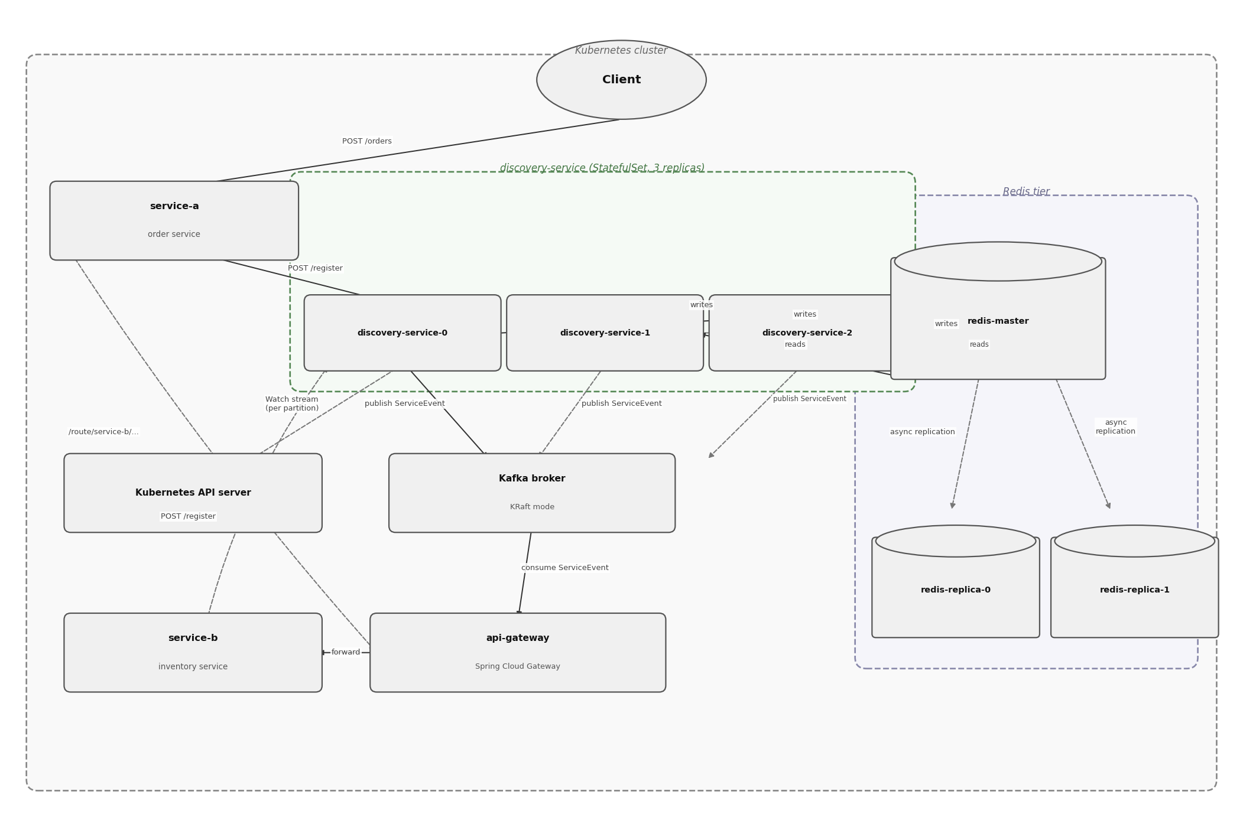
Figure 1: System Architecture

2.2 What each component does
Component | Role
discovery-service (3 replicas) | Owns the service registry. Per-partition leaders watch Kubernetes and publish events. All replicas serve reads.
Redis tier | Shared state — registry contents, leader-election locks, last-seen Kubernetes resource versions, pub/sub channel for follower relay.
Kubernetes API server | Source of truth for pod state. Per-partition leaders hold open Watch streams against it.
Kafka (single broker, KRaft mode) | Event bus between discovery and the gateway. Carries SERVICE_REGISTERED, SERVICE_DEREGISTERED, and STATUS_CHANGED events.
api-gateway (Spring Cloud Gateway) | Subscribes to Kafka events and maintains a live routing table. Exposes a /services catalog and an /openapi/{name} spec proxy.
service-a | Order service. Accepts POST /orders, calls the inventory service through the gateway to reserve stock.
service-b | Inventory service. Holds a static product catalogue and supports atomic stock reservation.

3. Component Design

3.1 discovery-service
Spring Boot application with the following responsibilities, each implemented by a single class:
Class | Responsibility
DiscoveryController | REST API — POST /register, GET /services, GET /services/{name}, DELETE /services/{name}, GET /health
ServiceRegistry | Maintains the in-memory registry, persists to a local JSON file, publishes ServiceEvent on every change, runs the health-check loop (leader-only)
LeaderElectionService | Owns the global discovery:leader key — Redis SET NX with 10 s TTL, renewed every 3 s, atomic Lua release on shutdown
PartitionLeaderElectionService | Per-partition election. Same primitive as LeaderElectionService, applied to N partition keys. Increments a monotonic generation counter each time a partition is won.
PartitionManager | Maps each service name to a partition via abs(hash(name)) % partitionCount
KubernetesWatchService | Holds one long-lived OkHttp Watch stream per service in each partition this replica leads. Resumes from the last resourceVersion stored in Redis. Publishes RelayEvent after each change.
KubernetesPollingService | Manual fallback for one-shot resync. Not on a scheduler since the Watch took over.
KubernetesDiscoveryService | One-shot Kubernetes API query used by the controller for live pod lookup and by the follower relay for resync
FollowerRelayService | Subscribes to Redis pub/sub channels for partitions where this replica is a follower; maintains warm state without hitting Kubernetes
ServiceEventPublisher | Thin wrapper over KafkaTemplate, publishes to the service-events topic keyed by service name
CacheService | Generic read-through cache around Redis
RedisConfig | Configures a master/replica Lettuce factory with ReadFrom.REPLICA_PREFERRED, plus a separate direct-master factory for pub/sub and leader keys

3.2 api-gateway
Spring Cloud Gateway built on WebFlux:
Class | Responsibility
GatewayController | GET /services — route catalog. GET /openapi/{name} — proxies the live OpenAPI spec from the upstream service.
ServiceEventConsumer | @KafkaListener on the service-events topic; adds, removes, or replaces routes via RouteDefinitionWriter
RouteRegistry | Thread-safe ConcurrentHashMap<String, RouteInfo> of currently-routed services
RouteInfo | Per-service record: name, URL, OpenAPI URL, status
ServiceEvent | Kafka DTO matching the discovery-service model

3.3 service-a — Order service
Class | Responsibility
OrderController | POST /orders, GET /orders, GET /orders/{id}, GET /health
DiscoveryRegistration | Registers with the discovery service on startup
OrderController calls the gateway, not the inventory service directly:
String reserveUrl = gatewayUrl + "/route/service-b/products/" + productId
+ "/reserve?quantity=" + quantity;
restTemplate.postForEntity(reserveUrl, null, Map.class);

3.4 service-b — Inventory service
Class | Responsibility
InventoryController | GET /products, GET /products/{id}, POST /products/{id}/reserve?quantity=N, GET /health
DiscoveryRegistration | Registers with the discovery service on startup
The reserve endpoint does both the stock check and the deduction inside a synchronized block so that two concurrent reservers cannot oversell stock.

3.5 Redis topology
One master, two replicas. Asynchronous replication. AOF persistence on a PersistentVolumeClaim. The Lettuce client uses ReadFrom.REPLICA_PREFERRED for registry reads and a separate direct-master connection for leader-election writes and pub/sub.

3.6 Kafka
Single broker in KRaft mode (no ZooKeeper). Topic service-events with service name as the message key, which guarantees per-service ordering across all events.

4. Data Flow

4.1 Service registration
When a new service starts, it registers with the discovery service. The discovery service stores the entry, publishes a Kafka event, and the gateway picks up the event and adds a route.
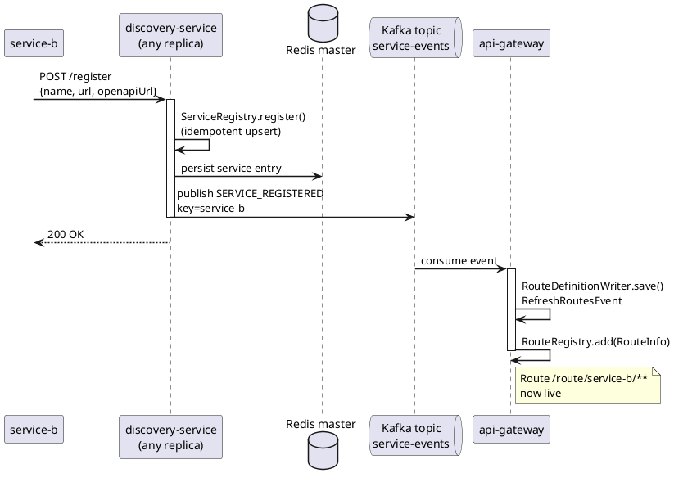
Figure 2: Service Registration

4.2 Pod state change (via Kubernetes Watch)
The leader of the partition that owns service-b has an open Watch stream against the Kubernetes API. When Kubernetes reports a pod-state change, the leader updates the registry, publishes a Kafka event, and broadcasts a relay event to followers in the same partition.
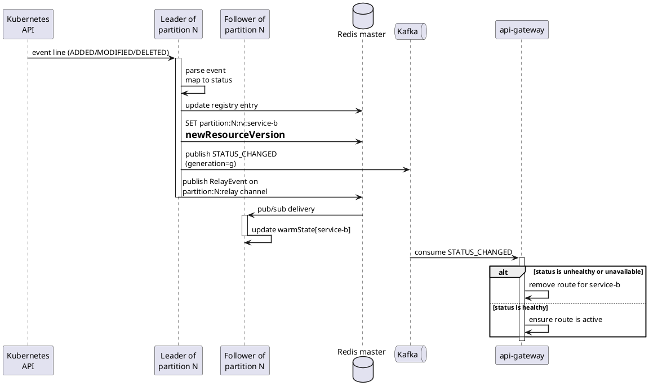
Figure 3: Pod State Change

4.3 Request flow (order placement)
The client calls service-a, which calls the gateway, which forwards to service-b. service-a never knows the address of service-b.
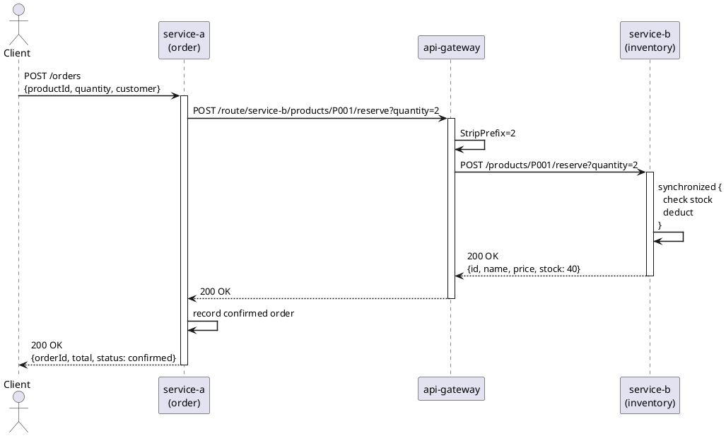
Figure 4: Request Flow

4.4 Leader handoff after a crash
If the leader of partition N crashes, the Redis lock for that partition expires within 10 seconds. The next replica to attempt acquisition wins the lock, increments the generation counter, and resumes the Watch stream from the last stored resourceVersion.

5. Scalability and Leader Election

5.1 The scaling problem
Three discovery replicas serve reads in parallel, but only one should mutate state for any given service. If all three watched the same pods, the system would do three times the Kubernetes API work for the same result, three times the Redis writes, and risk inconsistent ordering across replicas.

5.2 Partition-based leadership
Each service is mapped to a partition via consistent hashing on its name:
int partition = Math.abs(serviceName.hashCode() % partitionCount);
Each partition has its own leader-election key in Redis (discovery:partition:N:leader). A replica may be the leader of zero, one, several, or all partitions at any moment. This spreads the watch load across replicas — with three partitions and three replicas in a healthy cluster, each replica typically leads one partition.

5.3 The leader-election algorithm
Each replica runs the following loop every 3 seconds, for every partition:
if I am leader for partition N:
run Lua: if GET key == my pod name then EXPIRE key TTL
if renewed → still leader, continue
else → mark self as non-leader
if not leader:
attempt: SET NX discovery:partition:N:leader = POD_NAME EX 10
if SET NX succeeded:
INCR discovery:partition:N:generation
cache the new generation
mark self as leader
Setting | Value
TTL on the lock | 10 s
Renewal interval | 3 s
Identity | POD_NAME from the Kubernetes Downward API
Renewal atomicity | Lua script — GET + EXPIRE in one server-side step
Release on shutdown | @PreDestroy, Lua delete only if still owned

5.4 Why a Lua script for renewal
A naive GET key followed by EXPIRE key TTL from Java would have a race window between the two calls. Another replica could win the key between the check and the extend, and the original holder would then extend a key it no longer owns. The Lua script runs atomically on Redis — either the holder still owns the key and the TTL is extended, or it does not and the script returns 0.

5.5 Failover characteristics
Scenario | Recovery time
Graceful shutdown (rolling deploy, SIGTERM) | Sub-second — @PreDestroy releases the lock atomically; next renewal tick on another replica picks it up
Hard crash (kill -9, node failure) | Up to 10 s — the TTL has to expire before any replica can acquire
Network partition between leader and Redis | Up to 10 s — same as hard crash, from Redis’s perspective the leader has stopped renewing

5.6 Generation numbers and split-brain protection
Every event published by a leader carries the generation of the lock acquisition that produced it. If a deposed leader continues to publish events for a few seconds before noticing it lost the lock, those events carry a smaller generation than events from the new leader and can be discarded by consumers. This eliminates the classic split-brain hazard of distributed-lock-based leadership.

5.7 Follower relay
Followers stay warm without doing Kubernetes work:
- On becoming a follower for partition N, the replica performs a one-time List call against the Kubernetes API to rebuild its warm state.
- It subscribes to the Redis pub/sub channel partition:N:relay.
- Every event the leader processes is published to this channel; followers apply it to their local warmState map.
If a follower later becomes leader for that partition, it unsubscribes from the relay channel and starts its own Watch stream from the stored resourceVersion. State transitions are seamless.

6. Data Consistency
The full data consistency analysis lives in docs/CONSISTENCY_REPORT.md. The summary:
- Single writer per partition. Per-partition leader election ensures exactly one replica is responsible for mutations in any given partition at any time.
- Idempotent registration. Multiple registration attempts for the same service converge to the same end state.
- Read agreement. All replicas read through the same Redis tier (master + 2 replicas, asynchronous replication) and converge on the same in-memory state via the relay.
- Ordered per-service events. Kafka guarantees per-partition ordering; service-name keying guarantees all events for a service land on the same Kafka partition.
- Generation-stamped events. Every leader bumps a monotonic counter on acquisition; consumers can discard events from a deposed leader.
Failure scenarios — replica crash, Redis unavailable, Kafka unavailable, Kubernetes API unavailable, network partition — are analysed in detail in section 6 of the Consistency Report.

7. Deployment

7.1 Kubernetes manifests
All manifests live under k8s/.
File | Resources
discovery-service-deployment.yaml | StatefulSet/discovery-service (3 replicas), headless Service, ClusterIP Service, ServiceAccount, ClusterRole, ClusterRoleBinding
redis-deployment.yaml | Deployment/redis-master (1 replica, AOF on PVC), Deployment/redis-replica (2 replicas), two Service resources
kafka.yaml | Deployment/kafka (single broker, KRaft mode), Service/kafka
api-gateway-deployment.yaml | Deployment/api-gateway, Service/api-gateway
service-a-deployment.yaml | Deployment/service-a, Service/service-a (with preStop deregister hook)
service-b-deployment.yaml | Deployment/service-b, Service/service-b (with preStop deregister hook)

7.2 StatefulSet rationale
discovery-service is a StatefulSet, not a Deployment, so that each replica gets a stable pod name (discovery-service-0, -1, -2). The pod name is injected into the container via the Kubernetes Downward API and used as the replica identity in leader election. Stable names also make logs and metrics easier to follow across restarts.

7.3 preStop deregistration
service-a and service-b each have a preStop lifecycle hook:
lifecycle:
preStop:
exec:
command: ["/bin/sh", "-c", "curl -s -X DELETE http://discovery-service:8080/services/service-a || true"]
Kubernetes calls preStop before sending SIGTERM, so the pod is still healthy when the deregistration request is sent. The discovery service publishes a SERVICE_DEREGISTERED event immediately, and the gateway drops the route before the pod actually terminates. Callers never see a window of “service exists in routing but no longer responds.”

7.4 Configuration
Key configuration values in discovery-service/src/main/resources/application.properties:
spring.data.redis.host=redis-master
spring.data.redis.port=6379
spring.kafka.bootstrap-servers=kafka:9092
health-check.interval-ms=15000
health-check.max-retries=2
health-check.failure-threshold=3
health-check.timeout-ms=5000
leader-election.ttl-seconds=10
leader-election.renewal-interval-ms=3000
partition.count=3

7.5 configure-cluster.sh
The script configure-cluster.sh at the project root adjusts partition count and replica count without rebuilding any image:
./configure-cluster.sh 3 3 # 3 partitions, 3 replicas (default)
./configure-cluster.sh 5 5 # scale up to 5 partitions and 5 replicas
./configure-cluster.sh 3 1 # single replica for local testing
Internally it runs kubectl set env to set PARTITION_COUNT, kubectl scale to set the replica count, and kubectl rollout restart to apply the change.

7.6 Local development (Docker Compose)
The full stack — Redis, Kafka, all four services — runs locally via Docker Compose:
docker compose -f discovery-service/docker-compose.yml up
This is useful for development and integration testing without a Kubernetes cluster.

8. Testing

8.1 Unit tests
discovery-service/src/test/java/com/eda/discovery/ConsistencyTest.java contains five tests focused on consistency-critical paths. They use Mockito to simulate concurrent replicas competing for the Redis lock without requiring a live cluster.
Test | What it proves
only_one_replica_runs_health_checks_when_three_compete_for_lock | Distributed lock semantics — only one replica performs leader-gated work even when three call the method simultaneously
lock_holder_releases_lock_after_health_check_cycle | Clean handoff — the lock holder releases the lock when done
replica_skips_health_checks_when_lock_not_acquired | No work happens on replicas that did not win the lock
registration_is_idempotent_when_same_service_registered_from_three_replicas | Idempotent registration — three replicas registering the same service produce a single registry entry
getAllServices_filters_null_entries_from_orphaned_redis_indexes | Read correctness — orphaned secondary-index entries never reach callers

8.2 Integration testing
Manual integration tests against a running Minikube cluster confirmed:
- Three discovery-service replicas return identical /services payloads under steady-state load.
- Master writes are visible on both Redis replicas with effectively zero lag (per INFO replication).
- Three concurrent writes to the same Redis key converge to a single value on every replica.
- Leader failover after a kubectl delete pod on the current leader completes within the lock TTL.
- A preStop hook on service-a removes the gateway route before the pod is terminated, so concurrent traffic does not see a routing window onto a dead pod.

8.3 What is not tested automatically
The current test suite focuses on the consistency-critical paths. The following are exercised by manual or integration testing, not automated:
- End-to-end Kafka delivery from discovery to gateway.
- Watch stream reconnection after a Kubernetes API restart.
- Cross-partition behaviour under partial failures.
Adding integration tests for these paths is a natural next step.

9. Conclusion
The EDA Microservice Discovery System took an ordinary three-replica polling registry and turned it into an event-driven, partition-replicated, gateway-fronted system. The mechanics are well-understood pieces — Redis SET NX with TTL for leader election, Lua scripts for atomic renewal, Kubernetes Watch streams for push-based pod monitoring, Kafka for ordered event delivery, Spring Cloud Gateway for dynamic routing, Redis pub/sub for follower warm state. The contribution is in combining them into a coherent system with a clear consistency model and predictable failure behaviour.
Key properties of the result:
- Reaction time to pod state changes dropped from up to 15 seconds (polling) to well under a second (Watch).
- Kubernetes API load is one stream per service across the entire cluster, not one per service per replica.
- Service callers have no knowledge of where their peers live; the gateway is the only routing surface.
- Failure recovery is bounded: up to 10 seconds on hard crash, sub-second on graceful shutdown.
- Split-brain is structurally prevented by generation numbers stamped on every event.
Sensible next steps include Redis Sentinel or Redis Cluster for higher write availability, multi-broker Kafka with replication, mTLS between services, an Ingress controller in front of the gateway, a relational database for orders, and a proper observability stack. None of these would require structural change — the event-driven core accommodates all of them as additions.

