EDA Microservice Discovery System
Data Consistency Report
May 2026
Table of Contents
1. Purpose
2. Summary
3. What Data Is Stored, and Where
3.1 Service registry (durable)
3.2 Pod snapshots (transient observation)
3.3 Leader-election keys (coordination)
3.4 Relay messages (in-flight only)
4. Consistency Guarantees
4.1 Single writer per partition
4.2 Idempotent registration
4.3 Read agreement across replicas
4.4 Event ordering through Kafka
4.5 Generation numbers prevent split-brain writes
5. Consistency Mechanisms
5.1 Leader election
5.2 Watch stream resumption
5.3 Follower relay (warm state)
5.4 Redis read/write routing
5.5 TTL strategy summary
6. Failure Scenarios
6.1 A discovery-service replica crashes
6.2 Leader changes hands
6.3 Redis master unavailable
6.4 Redis replica unavailable
6.5 Kubernetes API unavailable
6.6 Kafka broker unavailable
6.7 Network partition between a replica and Redis
7. Test Evidence
8. Consistency Model — Stated Explicitly
9. Conclusion

Data Consistency Report — EDA Microservice Discovery System
Project: microservice-discovery-k8s
Version: Post-Task 4 (partition-replicated discovery with Kafka relay)
Last updated: 2026-05-23
Audience: Engineering team, technical reviewers

1. Purpose
This report describes how the EDA Microservice Discovery System keeps its data consistent across multiple replicas, multiple storage tiers, and multiple failure modes. It covers what data the system stores, where it lives, how the system guarantees that every replica eventually agrees on it, and how it behaves when individual components fail.
The report is intended for engineers who already understand the system at a high level (see the Final Report and docs/ARCHITECTURE.md) and need to evaluate whether the consistency model is appropriate for the workload.

2. Summary
The discovery service runs as three replicas. Service registrations, pod-state updates, and routing decisions must converge on the same answer everywhere, even though work is partitioned and replicas can fail at any time.
The system uses eventual consistency with strong convergence, achieved through four mechanisms working together:
Mechanism | Purpose
Partition-level leader election (Redis SET NX with TTL) | Ensures exactly one replica owns each partition at any time
Idempotent registry writes (upsert by service name) | Multiple registration attempts for the same service produce the same end state
Redis master/replica replication | All replicas read the same registry state through the same Redis tier
Generation numbers on every event | Lets consumers reject out-of-order updates from a previous leader
Under normal operation, replicas converge in well under a second. Under failure (leader crash, Redis unavailable, network partition), the system degrades to a known-safe state and resumes consistent operation as soon as the affected component recovers.
Figure 1: Data Storage Architecture
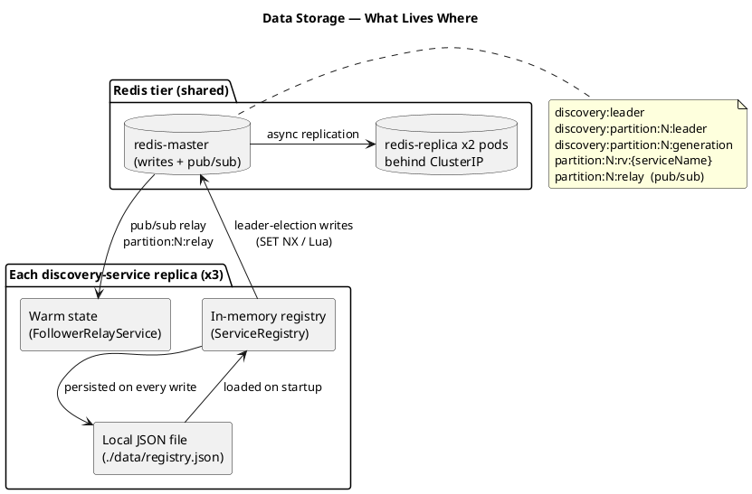

3. What Data Is Stored, and Where
The system holds four distinct kinds of data, each with its own location, lifetime, and consistency requirement.

3.1 Service registry (durable)
The authoritative list of registered services — name, base URL, OpenAPI spec URL, current health status, and timestamps.
Property | Value
Storage | In-memory (ServiceRegistry.services list), persisted to ./data/registry.json on every write. Redis is not used for registry storage.
Read path | All discovery-service replicas (reads are routed through Redis replicas via ReadFrom.REPLICA_PREFERRED)
Write path | Through ServiceRegistry — applied to in-memory state and persisted to the JSON file
TTL | None — entries persist until explicitly deregistered
Java type | com.eda.discovery.model.Service

3.2 Pod snapshots (transient observation)
Snapshots of individual Kubernetes pods backing each service (pod name, IP, phase, ready flag, timestamp). Used internally for the live /services/{name} response, not persisted long term.
Property | Value
Storage | Fetched live from the Kubernetes API on each /services request
Read path | KubernetesDiscoveryService.getPodsByLabel()
Write path | Never — Kubernetes is the source of truth
TTL | None (always live)
Java type | com.eda.discovery.model.PodSnapshot

3.3 Leader-election keys (coordination)
The keys that decide which replica owns which partition.
Key | Purpose | TTL
discovery:leader | Legacy global leader key — still maintained by LeaderElectionService | 10 s, renewed every 3 s
discovery:partition:N:leader | Per-partition leader for partition N | 10 s, renewed every 3 s
discovery:partition:N:generation | Monotonic counter incremented each time a new leader wins partition N | No TTL (monotonic)
partition:N:rv:{serviceName} | Last Kubernetes resourceVersion observed by the partition leader, used to resume the Watch stream after disconnects | No TTL
All leader-election keys live on the Redis master only and are accessed through a direct-master Lettuce connection (separate from the replica-preferred read path). This prevents a stale replica read from giving a false answer about who the leader is.

3.4 Relay messages (in-flight only)
Each time the leader of partition N processes a pod-state change, it publishes a RelayEvent on Redis pub/sub channel partition:N:relay. Followers subscribed to that channel update their in-memory warm state immediately. Relay messages are not persisted — they exist only while in flight.
Property | Value
Storage | Redis pub/sub (master only — pub/sub does not replicate)
Lifetime | Single delivery to currently-subscribed listeners
Fallback if missed | Followers perform a one-time Kubernetes List call on subscription (resyncPartition) to recover any state changes that occurred before they subscribed
Java type | com.eda.discovery.model.RelayEvent

4. Consistency Guarantees

4.1 Single writer per partition
The system guarantees that at any moment, at most one replica is the leader of any given partition. The leader is the only replica that:
- Holds an open Kubernetes Watch stream for services in that partition.
- Mutates the registry as a result of pod-state changes for those services.
- Publishes ServiceEvent messages to Kafka for those services.
- Publishes RelayEvent messages to the partition’s Redis pub/sub channel.
This is enforced by a Redis SET NX operation with a TTL: only one replica can ever hold the key, and the key automatically expires if the holder fails to renew it.
Followers continue to serve read traffic for any partition. Reads are never gated on leadership.

4.2 Idempotent registration
POST /register from a service is idempotent. If service-a registers three times in a row (for example, after a restart that races with the previous pod’s deregistration), the final registry state is the same as if it had registered once.
public void register(Service service) {
services.removeIf(s -> s.getName().equals(service.getName()));
service.setStatus("unknown");
service.resetFailures();
services.add(service);
saveToFile();
eventPublisher.publish(new ServiceEvent(SERVICE_REGISTERED, ...));
}
The removeIf ensures that the new entry replaces any existing entry with the same name. The replica that processes the request does so regardless of leadership — registration is allowed from any replica, because the result is deterministic regardless of who handles it.

4.3 Read agreement across replicas
Each replica holds its own in-memory registry, loaded from its local JSON file on startup. Pod status is kept in sync through the Watch stream and follower relay:
- The partition leader processes a Kubernetes Watch event, updates its local registry, and publishes a RelayEvent to the Redis pub/sub channel.
- Followers receive the relay message and update their in-memory warmState map.
- All replicas converge on the same pod status within the relay delivery window.
Service registration entries (name, URL, OpenAPI URL) are stored locally per replica and are not cross-replicated. In practice this is mitigated by services registering via the ClusterIP endpoint, which load-balances across all replicas.

4.4 Event ordering through Kafka
Every ServiceEvent published to Kafka uses the service name as the partition key:
kafkaTemplate.send(TOPIC, event.getServiceName(), event);
Kafka guarantees per-partition ordering. Because all events for a given service map to the same partition, the API gateway always processes them in the order they were produced. A SERVICE_DEREGISTERED event for service-b will never arrive before the SERVICE_REGISTERED event it followed.

4.5 Generation numbers prevent split-brain writes
Every per-partition leader increments a monotonic Redis counter (discovery:partition:N:generation) on acquisition. Every ServiceEvent and RelayEvent carries the generation of the leader that produced it.
If a previous leader is partitioned from Redis but continues to publish events for a few seconds before noticing, those events carry a smaller generation than events from the new leader. Consumers can compare and discard the stale ones. This is the protection against the classic distributed-lock split-brain scenario.

5. Consistency Mechanisms

5.1 Leader election
Algorithm: try-acquire-or-renew, run every 3 seconds on every replica
if currently leader:
Lua-atomic GET + EXPIRE on key — succeeds only if value still matches my pod name
if renewal returns 1 → still leader, return
else → mark self as non-leader, fall through to acquire
attempt: SET NX discovery:partition:N:leader = POD_NAME EX 10
if SET NX succeeds → become leader, increment generation counter
Setting | Value | Rationale
Lock TTL | 10 s | Bounds the worst-case failover window
Renewal interval | 3 s | Three opportunities per TTL to renew before expiry
Renewal script | Lua GET + EXPIRE | Atomic — eliminates check-then-act race on TTL extension
Identity | POD_NAME env var (Kubernetes Downward API) | Stable, unique, human-readable in logs
Graceful release | @PreDestroy deletes the key (Lua, only if still owned) | Drops failover window to effectively zero on planned restart
Figure 2: Leader Election Sequence
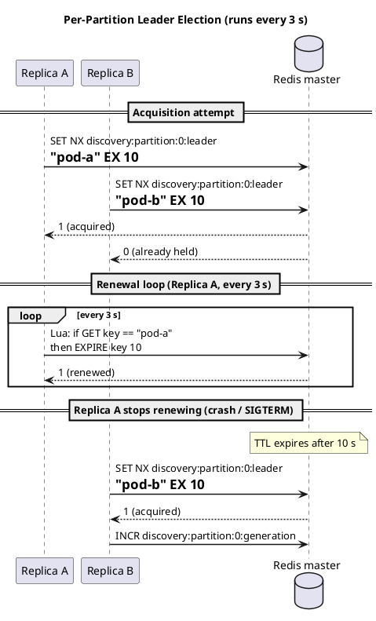

5.2 Watch stream resumption
When a leader is elected for partition N, it starts a Kubernetes Watch stream per service in that partition. The Watch URL includes a resourceVersion parameter that tells the Kubernetes API where in the event log to resume:
GET /api/v1/namespaces/default/pods?labelSelector=app=service-a&watch=true&resourceVersion=<last>
The last resourceVersion is read from Redis at partition:N:rv:{serviceName}. After every event, the leader updates that key with the latest value. If a new leader takes over after a failover, it picks up the stream at exactly the position the previous leader reached — no events are lost.
If the stored resourceVersion is too old (Kubernetes returns HTTP 410 Gone), the leader clears the key and restarts the watch from the current state. This is safe because the follower relay does a one-time List resync before subscribing, so warm state stays correct.

5.3 Follower relay (warm state)
Followers do not poll Kubernetes and do not hold Watch streams. Instead, they:
- On becoming a follower for partition N, perform a one-time List call against the Kubernetes API to rebuild warm state for services in that partition.
- Subscribe to the Redis pub/sub channel partition:N:relay.
- Apply every relay event to their local warmState map.
This gives followers a current view without duplicating work, and keeps Kubernetes API traffic at one stream per service rather than one stream per service per replica.
Figure 3: Follower Relay Sequence
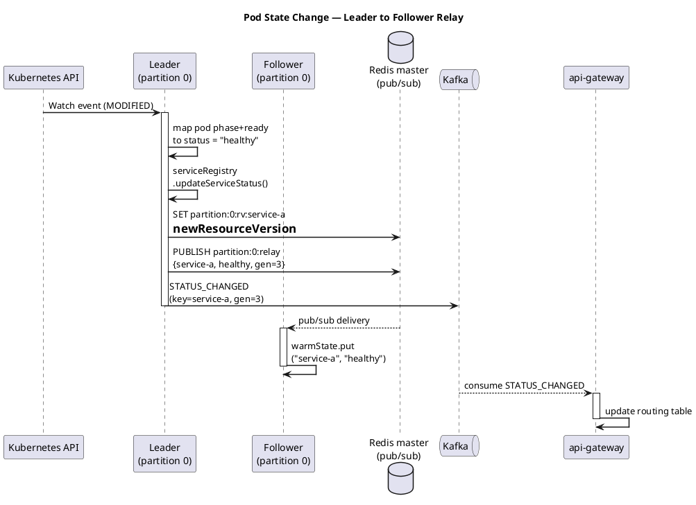

5.4 Redis read/write routing
Operation | Route
Registry hash reads | Lettuce, ReadFrom.REPLICA_PREFERRED — distributed across replicas
Registry hash writes | Master
Leader-election keys (read and write) | Master only (separate direct-master factory)
Pub/sub publish and subscribe | Master only (pub/sub does not replicate)
Two separate Lettuce connection factories are configured: the primary one knows the full master/replica topology and applies REPLICA_PREFERRED; the pubSubConnectionFactory connects directly to the master and is used for pub/sub and leader keys.

5.5 TTL strategy summary
Item | TTL | Renewal cadence
Leader-election keys | 10 s | every 3 s
Registry entries | none | n/a (explicit lifecycle)
resourceVersion keys | none | overwritten on every event
Generation counters | none | monotonic
Relay messages | single delivery | n/a (recovered by resync)
The 10-second lock TTL is short enough to keep failover fast and long enough to absorb a few missed renewals (for example, a brief Redis hiccup). The 3-second renewal interval gives three chances to renew before expiry — losing leadership requires three consecutive missed renewals.

6. Failure Scenarios

6.1 A discovery-service replica crashes
Case | Behaviour
Crashed replica was a follower | No effect on registry or routing. The remaining replicas continue serving reads. When the pod restarts, it loads the registry from its local JSON file, then catches up to current state.
Crashed replica was leader of one or more partitions | Each affected partition’s lock expires within 10 s. The next replica to call tryAcquireOrRenew for that partition wins, increments the generation counter, starts the Watch stream from the stored resourceVersion, and resumes publishing. Maximum outage per partition: ~10 s.
Graceful shutdown (rolling deploy) | @PreDestroy releases the held leader keys atomically (Lua delete, only if still owned). Another replica picks them up on the next renewal tick (within 3 s). Effective outage: well under a second.

6.2 Leader changes hands
When partition N changes leaders, a few things happen in sequence:
- New leader’s SET NX succeeds. The generation counter for partition N is incremented.
- New leader starts the Watch stream from the last resourceVersion stored in Redis.
- New leader publishes events stamped with the new generation.
- Old leader (if still alive but disconnected) eventually notices it no longer owns the key and stops publishing. Any events it published in the meantime carry the old generation and can be ignored by consumers.
The follower relay continues to deliver events without interruption — followers are subscribed to a channel, not to a specific leader.

6.3 Redis master unavailable
If the Redis master is down:
- Leader election stalls. No replica can SET NX or renew. Existing leaders eventually lose their leadership (lock expires after 10 s with no renewal).
- Writes fail. New registrations cannot be persisted to Redis (they still succeed in-memory and in the local JSON file, but the cluster will be inconsistent until Redis comes back).
- Reads degrade. Reads still succeed against the replicas (Lettuce REPLICA_PREFERRED), returning the last replicated state.
- Relay stops. Pub/sub depends on the master.
Recovery: when the master returns, leader election resumes on the next renewal tick (within 3 s). The Watch streams resume from the last stored resourceVersion. The follower relay resubscribes automatically.
This is a known limitation. A multi-master Redis setup (Sentinel or Cluster) would remove it, at the cost of more operational complexity. The current single-master design is appropriate for the project’s scale.

6.4 Redis replica unavailable
Lettuce routes reads to the surviving replica or falls back to the master. No registry data is lost. Replication catches up automatically when the replica returns. No impact on consistency.

6.5 Kubernetes API unavailable
- The Watch streams disconnect. The watch loop retries every 5 seconds, reusing the stored resourceVersion.
- New registrations and reads continue to work — the registry itself is in Redis, not Kubernetes.
- Pod-state updates pause until the API comes back.
Recovery: streams reconnect and Kubernetes replays any missed events from the stored resourceVersion (or returns 410 if the resource version is too old, in which case the watch resets and the follower relay resyncs).

6.6 Kafka broker unavailable
- Discovery service continues to register services and update the registry.
- ServiceEventPublisher.publish() fails to send. Events for that period are not delivered to the API gateway.
- The gateway’s routing table goes stale: it keeps routing to whatever it last knew about, including services that may have gone unhealthy.
Recovery: when Kafka returns, new events flow again. The gateway eventually catches up to current state. There is no automatic backfill — a full system restart or a registration replay would be needed to fully resynchronise an extended outage.
For the project’s scale (a single broker), this is an acceptable trade-off. A production deployment would add Kafka replication and a periodic full-state snapshot event.

6.7 Network partition between a replica and Redis
The partitioned replica:
- Loses leadership (cannot renew). Stops watching, stops publishing.
- Can still serve reads from its in-memory state, which gradually goes stale.
- When the partition heals, it rejoins leader election normally.
Other replicas elect a new leader for the affected partitions within 10 s. The generation number ensures that any events the partitioned replica published before it noticed the loss carry a stale generation.

7. Test Evidence
Five unit tests in discovery-service/src/test/java/com/eda/discovery/ConsistencyTest.java validate the core consistency properties. They use Mockito to simulate concurrent replicas competing for a Redis lock without requiring a live cluster.
Test | What it validates | Property covered
only_one_replica_runs_health_checks_when_three_compete_for_lock | Three replicas call the health-check method on the same tick; only the one that wins the SET NX runs the actual checks | Single writer per partition (Section 4.1)
lock_holder_releases_lock_after_health_check_cycle | The replica that acquired the lock releases it cleanly when finished | Graceful handoff (Section 6.1)
replica_skips_health_checks_when_lock_not_acquired | A replica that fails to acquire the lock performs no reads, writes, or deletes | No work without ownership
registration_is_idempotent_when_same_service_registered_from_three_replicas | Three replicas register the same service; the registry holds a single entry | Idempotent registration (Section 4.2)
getAllServices_filters_null_entries_from_orphaned_redis_indexes | Orphaned secondary-index entries (returned as null) are filtered from query responses | Read correctness — never expose internal data inconsistencies to callers
These tests cover the legacy single-leader lock path that preceded the per-partition election introduced in Task 4. The newer per-partition election in PartitionLeaderElectionService uses the same Redis SET NX + Lua-renewal primitive, so the locking guarantees the tests validate carry over directly. The atomic Lua renewal (lines 22–29 of LeaderElectionService.java and PartitionLeaderElectionService.java) is the key piece that makes both paths safe.
Earlier manual integration testing on the Redis tier itself confirmed:
- Writes accepted by the master become visible on both replicas (sub-millisecond per INFO replication lag).
- All three discovery-service pods return identical /services payloads under steady-state load.
- Three concurrent SET commands against the master converge to a single value on both replicas (because Redis processes commands serially on a single master).
- Replication lag stayed well below the system’s freshness budget under the tested load.

8. Consistency Model — Stated Explicitly
The system provides eventual consistency with strong convergence, with the following stronger properties on top:
- Single writer per partition. Mutations for any given partition come from exactly one replica at a time. Convergence is therefore trivial — there are no concurrent writers to reconcile.
- Linearizable leadership decisions. Leader-election operations go through the Redis master via a direct connection. There is no opportunity for a stale replica read to misreport who the leader is.
- Ordered per-service event delivery. Kafka guarantees ordering within a partition; service-name keying guarantees that all events for a given service end up in the same Kafka partition.
- Generation-stamped events. Every event carries the leader generation that produced it, allowing consumers to discard stale messages from a deposed leader.
What the system does not provide:
- Linearizable registry reads. A read from a Redis replica may briefly return the pre-write value during the replication window (sub-millisecond in tests, but not zero). Callers that need read-your-writes should target the master.
- Cross-partition transactions. There is no consistency relationship between updates in different partitions. Two services in different partitions can transition state in any order.
- Strong durability under Redis-master loss. A registry write accepted by the master but not yet replicated would be lost if the master crashed before replication. The local JSON file mitigates this for the local replica but does not protect cluster-wide state.
These are deliberate trade-offs. The workload — service discovery and health tracking with sub-second propagation requirements — is well served by eventual consistency. Adding linearizable reads or cross-partition transactions would require Raft-class consensus and is not justified at the current scale.

9. Conclusion
The EDA Microservice Discovery System keeps data consistent across three replicas by combining four well-understood techniques: per-partition leader election with TTL, idempotent registration, single-master Redis replication, and generation-stamped event ordering through Kafka. Each technique is small in isolation; together they give the system a clear and defensible consistency model with bounded failover windows and no split-brain risk.
The model has been validated by unit tests covering the distributed-lock semantics and idempotent registration, and by integration testing of the Redis replication tier. The remaining limitations — single-master Redis, single Kafka broker, no cross-partition transactions — are appropriate for the current scale and have clear upgrade paths if the workload grows.

