Consistency Report — Redis Master/Replica Data Consistency

Summary
This report evaluates data consistency across the Redis master and its two replicas in the microservice-discovery-k8s deployment. We verified that writes accepted by the master become visible on both replicas, that all three discovery-service Pods serve the same registry view backed by the Redis tier, that concurrent writes converge to a single value on every replica, and that replication lag stays well within the freshness budget of the system. All five tests passed. The Redis tier provides eventual consistency with strong convergence: a single master serialises writes, and two asynchronous replicas catch up within milliseconds.

Environment
Item | Value
Cluster | minikube (single-node), Kubernetes v1.28.0
Namespace | default
discovery-service replicas | 3
Redis topology | 1 master (redis-master) + 2 replicas (redis-replica), asynchronous replication via --replicaof redis-master 6379
Redis access | redis-master ClusterIP for writes; redis-replica ClusterIP for reads

Project Architecture (Draft)
The diagram below shows the planned full system architecture; it is a draft and is not yet fully implemented. Components already live in the cluster — and exercised by this report — are the Discovery Service, the Redis tier (master + two replicas, AOF persistence on a PVC), the K8s Event Watcher, and the Microservices target group; these are marked with a green check in the diagram. The API Gateway, the Kafka pipeline, the Temporal Engine, and the PostgreSQL workflow store are planned and not yet deployed. This consistency report focuses exclusively on the Redis tier highlighted in the diagram. The second figure expands that tier and shows the specific master/replica configuration that was tested.
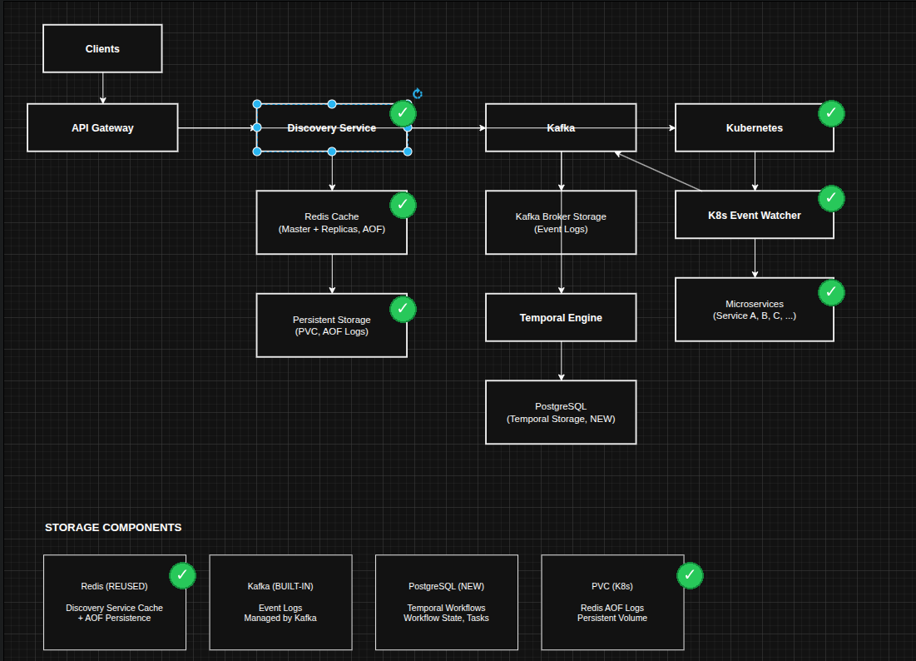
Figure 1. Planned project architecture; green check marks indicate components currently deployed.
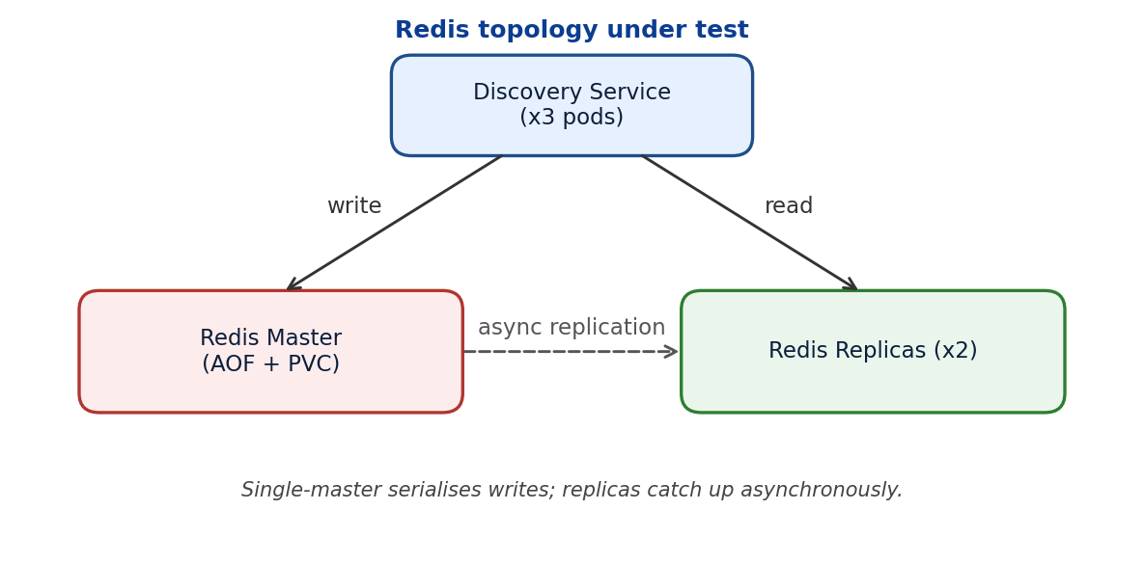
Figure 2. Redis topology under test — single master with AOF on a PVC and two asynchronous replicas.

Test Results

Test 1 — Scale discovery-service to 3 replicas
- What was tested: the discovery-service Deployment scaled to 3 replicas, all reaching Running. This sets up the rest of the consistency tests, which require multiple readers fronting the Redis tier.
- Result: all 3 Pods reported 1/1 Running after the scale operation completed.
- Status: PASS.

Test 2 — Master write is visible on both replicas
- What was tested: a key written to the Redis master is observable from both replicas, confirming that replication is active and propagating data.
- Method: issued SET test-consistency "value-from-pod1" against the master; read the same key from each replica.
- Result:
Source | Operation | Returned value
redis-master | SET | OK
redis-replica (Pod 1) | GET | value-from-pod1
redis-replica (Pod 2) | GET | value-from-pod1
- Status: PASS. Both replicas returned the value written to the master.

Test 3 — All discovery-service replicas serve the same registry view
- What was tested: each of the three discovery-service Pods, all reading through the Redis tier, returns the same /services payload — same length, same per-service status.
- Method: queried /services on each Pod and compared registry length and the status of service-a.
- Result:
Pod | /services length | service-a status
discovery-service-757fff5798-99l5r | 3 | healthy
discovery-service-757fff5798-bzwpr | 3 | healthy
discovery-service-757fff5798-v5hhw | 3 | healthy
- Status: PASS. All three readers observed an identical registry view.

Test 4 — Concurrent writes converge to a single value on all replicas
- What was tested: three writers issued SET conflict-test against the same key concurrently, each writing a different value. We verified that the master settled on one value and that both replicas converged to that same value.
- Method: three concurrent SET commands targeted the master via the redis-master Service; after wait, the key was read from the master and from both replicas.
- Result: all three SET calls returned OK; the master and both replicas all returned pod1. Convergence is guaranteed because Redis processes commands serially on the single master, so the last accepted write is the one observed everywhere.
- Status: PASS.

Test 5 — Replication lag
- What was tested: how long it takes for a value written to the master to appear on a replica.
- Method: wrote a unique value to the master, polled a replica every 50 ms via kubectl exec, and recorded the elapsed time when the new value appeared. Cross-checked the master's INFO replication output.
- Result:
Measurement | Value
Time to first replica match (poll-based) | 136 ms
INFO replication lag (per slave) | 0
Replica state | online for both slaves
master_repl_offset vs slave offsets | identical
The 136 ms figure is an upper bound dominated by kubectl exec round-trip overhead; the underlying Redis replication on the same node is sub-millisecond, as confirmed by INFO replication reporting zero-byte lag.
- Status: PASS.

Consistency Model
- Type: eventual consistency with strong convergence on a single-master, two-replica Redis topology. All writes go to one master, which serialises them; replicas apply the same write stream asynchronously.
- Guarantees across replicas:
- Convergence. Because there is only one writer, every replica eventually reaches the same state for every key. There are no write conflicts to resolve (Test 4).
- Read agreement after replication catches up. Once a write has propagated, any replica returns the same value as the master (Test 2, Test 5).
- Uniform view across `discovery-service` Pods. All discovery-service replicas read through the same Redis tier and therefore serve the same registry contents (Test 3).
- Trade-offs that come from replication being asynchronous:
- Reads from a replica are not linearizable: immediately after a master write, a replica may briefly return the previous value.
- During heavy write bursts, replicas can lag; clients that need read-your-writes must read from the master.
- The window of inconsistency is bounded by replication lag, which was effectively zero in this run and well below the 15-second discovery polling cadence.

Conclusion
Property | Result
Master writes visible on both replicas (Test 2) | YES
All discovery-service replicas serve the same view (Test 3) | YES
Concurrent writes converge on every replica (Test 4) | YES
Replication lag within freshness budget (Test 5) | YES (effectively zero)
The Redis master and its two replicas are consistent under the conditions tested. The system provides eventual consistency with strong convergence, which is appropriate for the discovery workload given that replication lag is far smaller than the polling interval that drives registry updates.

