P2P Betting Exchange
OOP Concepts Implementation Report

Introduction
This project utilizes Object-Oriented Programming to produce a clean, organized, and easily maintainable codebase for a betting exchange. By separating the application into distinct classes and modules, each component serves a specific business purpose. Core principles such as encapsulation, inheritance, and polymorphism are applied to model complex financial interactions like bet matching and settlement.

OOP CONCEPTS USED

DOMAIN MODEL & EXCHANGE MODULE

Introduction
The Domain Model is the core of the P2P Exchange, responsible for managing users, betting offers, and the settlement of matched bets. It uses OOP principles to ensure that financial transactions are atomic, valid, and secure.

Files involved:
User.java, StandardUser.java, AdminUser.java: Defines the core identity system and role-based permissions using a class hierarchy.
Wallet.java: Manages user financial state with careful balance tracking and operations (deposit, reserve, settle).
Money.java: A value object ensuring decimal precision and financial invariants for all currency operations.
Offer.java, Bet.java: Represents betting contracts and matched agreements.
Event.java: Represents sports events that bets are made on.

1. Information Hiding
Information hiding is the technical practice of protecting a class's internal state from unauthorized external access. It ensures that the internal representation of an object can only be accessed or modified through a well-defined, controlled interface. We follow a strict 3-step engineering process to enforce this consistently across the entire domain model:

Step 1 - PRIVACY: Mark attributes private
All instance variables must be declared as private to deny direct access from outside the class. This prevents external code from bypassing validation logic.

Step 2 - SCOPE: Determine scope (instance vs static)
Evaluate whether each field is instance-level (unique to each object) or class-level (shared across all instances). Most domain fields are instance-level, but constants are static.

Step 3 - CONSTANCY: Label as final or mutable
For each private field, determine whether it changes after object construction. If it does not change, mark it final (immutable). If it does change, leave it mutable. This distinction is critical:
final: Field value is set once during construction and never modified again.
mutable (not final): Field value changes throughout the object's lifecycle to reflect state transitions.

Applied Across All Domain Classes
Below are concrete examples showing how the 3-step information hiding principle is applied consistently across multiple critical classes in the exchange:

Example 1: User Class (Identity Fields)
public abstract class User implements UserInterface {
private final Long id;
private final String username;
private final String email;
private Password password;
protected User(Long id, String username,String email, Password password) { this.id = id;
this.username = username;
this.email = email;
this.password = password;
}
public boolean authenticate(String rawInput) {
return this.password != null && this.password.matches(rawInput);
}
public abstract String getRoleName();
public abstract Wallet getWallet() throws ExchangeException; }
Rationale: The id, username, and email are part of the user's identity and should never change after object creation. However, password can be changed via updatePassword(), so it is NOT marked final. This demonstrates selective application of the Constancy principle based on actual field behavior.

Example 2: Wallet Class
public class Wallet {
private final Long id;
private final User user;
private Money totalBalance;
private Money reservedBalance;
public Wallet(Long id, User user,Money totalBalance) {
this.id = id;
this.user = user;
this.totalBalance = totalBalance;
this.reservedBalance = Money.zero();
}

public void deposit(Money amount) throws ExchangeException {
this.totalBalance =this.totalBalance.plus(amount);
}

public void reserve(Money amount) throws InsufficientFundsException { if (!this.totalBalance.isGreaterThan(amount)) {
throw new InsufficientFundsException("Insufficient balance");
}
this.reservedBalance =this.reservedBalance.plus(amount); }

public Money getAvailableBalance() {
return this.totalBalance.minus(this.reservedBalance);
} }
Rationale: The wallet's owner (user) is fixed at creation and never changes. However, balances are fundamentally mutable because they change with every deposit, withdrawal, reservation, and settlement. The deposit(), reserve(), and settle methods all modify these balances, so they cannot be final.

Why This 3-Step Approach Matters
By enforcing privacy at all levels, we prevent accidental state corruption. The scope distinction ensures clarity about whether fields are shared or unique to instances. The constancy decision makes the programmer's intent explicit: immutable fields indicate stable identity, while mutable fields indicate state that changes over time. Together, these three steps create a predictable, secure, and maintainable domain model.

2. Encapsulation

How it works :
Encapsulation bundles data and methods that operate on that data within a single class, hiding the internal details and exposing only what is necessary through a controlled interface. In our Money class:
public final class Money implements Comparable<Money> {
private static final int SCALE = 2;
private final BigDecimal value;

public Money(BigDecimal value) {
this.value = normalize( Objects.requireNonNull(value));
}

public Money plus(Money other) {
return new Money(this.value.add(other.value));
}

public Money minus(Money other)throws IllegalBetException {

BigDecimal result =this.value.subtract(other.value);

if (result.compareTo(BigDecimal.ZERO) < 0) {

throw new IllegalBetException("Cannot have negative money");
} return new Money(result);
}

public static Money of(BigDecimal value) throws IllegalBetException {

if (value.compareTo(BigDecimal.ZERO) < 0) {
throw new IllegalBetException("Money cannot be negative");
}
return new Money(value);
}

private static BigDecimal normalize(BigDecimal value) {

return value.setScale(SCALE,RoundingMode.HALF_UP);
}
}

The internal BigDecimal value is private, so external code cannot directly access or modify it. All operations return new Money instances rather than modifying the original. This ensures immutability and prevents accidental state corruption.

The Client Perspective (User-Programmer):
From the service layer, you interact with Money through its public interface without needing to know about BigDecimal or rounding logic:
public void settleWin(Money winnings)throws ExchangeException {

this.totalBalance = this.totalBalance.plus(winnings);
this.reservedBalance = this.reservedBalance.minus(winnings);

}
You call settleWin() with a Money object, and the wallet handles all the internal balance adjustments. You don't need to understand how Money is represented internally or how rounding works.

Why we did this:
By hiding the implementation details, we can change how Money is represented internally without affecting code that uses it. If we later need to support multiple currencies or different rounding strategies, we can modify Money without breaking the rest of the application. Encapsulation reduces coupling and makes the system easier to maintain and extend.

3. Inheritance

How it works in our case:
Inheritance allows StandardUser and AdminUser to inherit common behavior from the abstract User base class, reducing code duplication and establishing a clear hierarchy of user types.
public abstract class User implements UserInterface {
private final Long id;
private final String username;
private final String email;
private Password password;
protected User(Long id, String username,String email, Password password) { this.id = id;
this.username = username;
this.email = email;
this.password = password;
}

public boolean authenticate(String rawInput) {
return this.password != null && this.password.matches(rawInput);

}

public abstract String getRoleName();

public abstract Wallet getWallet() throws ExchangeException;

}

public class StandardUser extends User {
private Wallet wallet;
public StandardUser(Long id, String username,String email, Password password) { super(id, username, email, password); }

@Override
public String getRoleName()
{ return "STANDARD"; }

@Override
public Wallet getWallet()throws ExchangeException
{
if (wallet == null)
{
throw new ExchangeException("Wallet not initialized");
} return wallet; }

public void setWallet(Wallet wallet) {this.wallet = wallet;}
}
public class AdminUser extends User {

private Wallet wallet;

public AdminUser(Long id, String username,String email, Password password)
{ super(id, username, email, password); }

@Override
public String getRoleName()
{ return "ADMIN"; }

@Override
public Wallet getWallet()throws ExchangeException
{
if (wallet == null)
{
throw new ExchangeException("Wallet not initialized");
}
return wallet;
}

public void setWallet(Wallet wallet) {
this.wallet = wallet;
}
}
Both StandardUser and AdminUser inherit authentication logic, identity fields, and the wallet reference from User. They each implement getRoleName() and getWallet() according to their specific role. This avoids duplicating the authenticate() method in both subclasses.

Why we did this:
Inheritance allows us to define common behavior once in the base class and share it across subclasses. If authentication logic needs to change in the future, we update it in one place. Inheritance also enforces consistency: both user types must implement the abstract methods, ensuring that all users have a way to identify their role and access their wallet.

4. Abstraction

How it works in our case:
Abstraction focuses on the essential qualities of an object rather than the specific details of its implementation. By defining high-level contracts for settling bets and accessing data, we allow the core exchange to function independently of specific sport rules or underlying database technologies.

public interface SettlementStrategy
{
Outcome determineWinner(int homeScore, int awayScore);

MarketType getMarketType();

}

Why we did this:
Using abstraction ensures the TradeService can resolve a bet by simply requesting a winner from a SettlementStrategy. It does not need to know the specific scoring rules for football versus other markets, making the exchange highly modular and easy to extend with new sports without modifying existing trade logic.

5. Composition

How it works in our case:
A User has-a Wallet. A Bet has-a Offer. An Offer has-a List<Bet>. Instead of inheriting wallet behavior, a User delegates to its Wallet instance. This is composition: classes work together by containing instances of other classes.
Example:
When a user needs to check available balance, the UserService does not directly access the wallet's fields. It delegates through the Wallet interface:
Money available = user.getWallet().getAvailableBalance();
The User does not copy wallet logic or inherit from Wallet. It uses composition to delegate balance checks to the Wallet class.

Why we did this:
Composition is more flexible than inheritance. A user can have exactly one wallet, but if we later need to support multiple wallets or a different storage mechanism, we can swap out the Wallet implementation without changing User. Composition also avoids the 'inheritance explosion' problem where deep hierarchies become hard to manage.

6. Polymorphism

6a) Ad-hoc Polymorphism (Method Overloading)
Multiple methods with the same name but different parameter types or counts.
Example in Money:
public Money plus(Money other) { ... } public Money multiply(BigDecimal factor) { ... }
Both methods perform 'operations' on Money but take different parameter types. The compiler chooses which method to call based on the argument types.

Why we made it work that way:
Overloading allows the same operation name to work with different types, making the API more intuitive. You can call plus() with another Money or multiply() with a BigDecimal, and the intent is clear from the method name.

6b) Inclusion Polymorphism (Subtype Polymorphism / Dynamic Binding)
A single object can be accessed through different type references. StandardUser and AdminUser are both Users, so they can be treated as User references. The actual method called is determined at runtime based on the object's true type.

How it works :
public final class UserFactory {
private UserFactory() { }

public static StandardUser createStandard
(
Long id,
String username,String email, String rawPassword) throws ExchangeException
{

return new StandardUser(id, username, email, Password.create(rawPassword));
}

public static AdminUser createAdmin(Long id,
String username,
String email,
String rawPassword) throws ExchangeException
{
return new AdminUser(id, username, email, Password.create(rawPassword));
}
}

UserFactory.createStandard() returns a StandardUser, but it is cast to a User reference. At runtime, when authenticate() is called on that reference, the JVM calls the inherited implementation from User, and any overridden methods call the StandardUser version.

The Client Perspective (Dynamic Binding in Action):
From the service layer, code works with User references without knowing the concrete type:
public void login(User user, String password)throws ExchangeException {

if (!user.authenticate(password)) {
throw new SecurityViolationException("Invalid credentials");
}
// Works for StandardUser or AdminUser

String role = user.getRoleName();
}
The login() method accepts any User. At runtime, the JVM calls the correct authenticate() method for StandardUser or AdminUser. The service layer does not need to know or care which subclass it is handling. This is inclusion polymorphism in action.

Why we did this:
Inclusion polymorphism allows code to work with abstractions rather than concrete types. The service layer remains independent of specific user types. If we add a new user type, existing code continues to work without modification.

6c) Coercion Polymorphism
Implicit type conversion. Example: Money.of() accepts both BigDecimal and String, automatically converting String to BigDecimal.

public static Money of(String value) throws IllegalBetException {
return of(new BigDecimal(value));
}

Why we made it work that way:
Coercion allows callers to pass values in convenient formats. They can pass a String like '25.50', and Money automatically converts it to BigDecimal. This reduces boilerplate in client code.

6d) Parametric Polymorphism (Generics)
Generic types like List<User> or Optional<Wallet> work with any type parameter. The same code handles User, Bet, Offer, etc.

public interface GenericRepository<T, ID> {
T save(T entity);

Optional<T> findById(ID id);

List<T> findAll();

void deleteById(ID id);

long count();
}

The GenericRepository interface works with any entity type T and any ID type ID. A single implementation can save, find, or delete any entity type.

Why we made it work that way:
Generics reduce code duplication. We write one GenericRepository implementation instead of separate UserRepository, BetRepository, and OfferRepository implementations. Generics also provide compile-time type safety: the compiler ensures you cannot accidentally store a User in a List<Bet>.

7. Subtyping

The Client Perspective (Accessing a Multitype Object):
A single StandardUser object can be accessed through different type references:

// Same object, different type views

StandardUser standardUser = new StandardUser(...);

User userView = standardUser;

UserInterface interfaceView = standardUser;

// Each view allows access to different operations

// userView can call inherited methods from User

// interfaceView can call methods defined in UserInterface

// standardUser can call StandardUser-specific methods

The StandardUser object is a subtype of both User (its superclass) and UserInterface (an interface it implements). Code can work with any of these types and still refer to the same object. The type determines which methods are accessible, but the underlying object is always StandardUser.

Why we did this:
Subtyping allows clients to depend on abstractions (User, UserInterface) rather than concrete implementations (StandardUser). If we replace StandardUser with PremiumUser, code that works with User or UserInterface references continues to work. This decoupling makes the system more flexible and easier to extend.

8. Exception Handling
Custom exceptions communicate specific error conditions to the caller. The system defines domain-specific exceptions for different failure modes:
ExchangeException: Base class for all domain errors
InsufficientFundsException: Wallet lacks funds for an operation
UserNotFoundException: User does not exist
IdentityConflictException: Username or email already registered
IllegalBetException: Invalid bet parameters

Why we did this:
Custom exceptions allow callers to handle specific error conditions differently. A client can catch InsufficientFundsException and offer to deposit funds, but catch UserNotFoundException and prompt for a new account. Without custom exceptions, all errors look the same, and recovery is harder.

INFRASTRUCTURE MODULE (SPORTS DATA & SETTLEMENT LOGIC)

Introduction
The Infrastructure Module handles external data sources (sports odds APIs), extensible settlement logic for different bet types, and the strategy pattern for pluggable market implementations.

Files involved:
MarketStrategy interface and H2HMarketStrategy implementation: Defines pluggable market pricing algorithms.
TheOddsApiClient: Integrates with external sports data provider.
SettlementStrategy interface and ThreeWaySettlementStrategy: Encapsulates settlement logic for different market types.

I. MODULARITY & THE OPEN-CLOSED PRINCIPLE (OCP)

a. Extending Betting Markets
New market types (Over/Under, Asian Handicap, Correct Score) can be added without modifying existing code. The MarketStrategy interface defines the contract:
public interface MarketStrategy {

boolean supports(MarketType type);

String getMarketKey();

BestOddsResult calculateBestOddsWithSources(TheOddsApiOddsDto dto);

List<Odds> calculateBestOdds(TheOddsApiOddsDto dto);

}

H2HMarketStrategy implements this interface for 3-way markets:
public class H2HMarketStrategy implements MarketStrategy {
private final FixtureNameMatcher nameMatcher;

public H2HMarketStrategy(FixtureNameMatcher nameMatcher)
{
this.nameMatcher = nameMatcher;
}

@Override
public boolean supports(MarketType type) {
return type == MarketType.THREE_WAY; }

@Override
public String getMarketKey()
{
return "h2h";
}

@Override
public BestOddsResult calculateBestOddsWithSources(TheOddsApiOddsDto dto) { // Implementation for 3-way odds
// calculation from multiple bookmakers
List<PricePoint> homePool = new ArrayList<>();
List<PricePoint> drawPool = new ArrayList<>();
List<PricePoint> awayPool = new ArrayList<>();

for (Bookmaker bm : dto.getBookmakers()) {

processBookmakerData(bm, homePool,drawPool, awayPool);

}
return aggregateResults(homePool,drawPool, awayPool);
}
}
To add a new market type, create a new class implementing MarketStrategy (e.g., OverUnderStrategy) and register it. Existing code that calls getMarketStrategy() automatically works with the new type.

Why we made it work that way:
The system is open for extension (add new strategies) but closed for modification (existing code does not change). This follows the Open-Closed Principle. Adding a new market type does not require editing TheOddsApiClient or any other existing class.

b. Extending Sports Data Sources
The SportsDataProvider interface allows different data sources (TheOddsAPI, Pinnacle, Betfair) to be swapped without changing the application logic.

Why we made it work that way:
If TheOddsAPI becomes unavailable or expensive, implement a new provider (e.g., PinnacleDataProvider) and swap it in. The betting logic remains unchanged because it depends on the SportsDataProvider interface, not a specific implementation.

c. Extending Settlement Logic
SettlementStrategy defines how different market types determine winners and payouts. 3-way markets, Asian Handicap, and other types can define settlement strategies without affecting the core settlement engine.

Why we made it work that way:
Settlement logic is complex and market-specific. By encapsulating it in pluggable strategies, we avoid large conditional statements like 'if market is 3-way, do this; if over-under, do that.' Each strategy is independent and testable.

II. FRAMEWORKS & TECHNOLOGIES

Introduction
This project uses Spring Boot, Spring Data JPA and Jackson. These frameworks rely on reflection and code generation to reduce boilerplate while maintaining clean, type-safe code.

UNDERSTANDING REFLECTION IN JAVA
Reflection is the ability for code to examine its own structure at runtime. Frameworks use reflection to inspect classes, instantiate objects, invoke methods, and access fields without hardcoding these details.

How it works:
At compile time, Java produces bytecode that describes the program structure. At runtime, the JVM can inspect this bytecode via the Class, Method, Field, and Constructor classes in java.lang.reflect. Frameworks use reflection to discover which classes are marked as entities, which fields need to be persisted, which setters exist, and how to construct objects dynamically.

Key Reflection Mechanisms used in this project:
1. Annotation Scanning: Spring detects classes marked with Repository, Service, Component, Entity, and creates instances automatically.
2. Constructor Inspection: Spring inspects constructor parameters to determine which beans to inject.
3. Method Introspection: Jackson uses reflection to find getter and setter methods and map them to JSON keys.
4. Field Inspection: Lombok uses reflection (at compile time via annotation processing) to generate getters, setters, and hashCode/equals methods.

Why we made it work that way:
Reflection-based frameworks reduce boilerplate. Without Spring, we would manually instantiate repositories, services, and inject dependencies. Without Jackson, we would manually map JSON to objects. Reflection allows frameworks to automate these tedious tasks.

a) SPRING BOOT & DEPENDENCY INJECTION (DI)

How it works in our case:
Spring scans for classes annotated with Component, Service, and Repository. It creates instances and manages their lifecycle. When a Service needs a Repository, Spring inspects the constructor, sees the Repository type, finds the matching bean, and injects it automatically.

@Service
public class UserService {
private final UserRepository userRepository;
private final WalletRepository walletRepository;
// Spring sees constructor parameters and injects
// matching beans automatically

public UserService(UserRepository userRepo, WalletRepository walletRepo)
{
this.userRepository = userRepo;

this.walletRepository = walletRepo;
}
}

Spring creates a UserService instance and injects the UserRepository and WalletRepository without explicit factory code.

Why we made it work that way:
Dependency Injection decouples classes. UserService depends on the UserRepository interface, not a concrete implementation. Spring swaps in the correct implementation at runtime. If we need to switch from in-memory repositories to database repositories, we change only the implementation, not UserService.

b) SPRING DATA JPA
Spring Data JPA provides GenericRepository implementations automatically via reflection. You declare a UserRepository interface extending JpaRepository, and Spring generates the implementation at runtime.

Entity Metadata Inspection:
JPA inspects Entity classes to discover fields, relationships, and primary keys. It uses this metadata to generate SQL queries and map results back to objects.

How it works in our case:

public interface UserRepository extends GenericRepository<User, Long> {
Optional<User> findByUsername(String username );
Optional<User> findByEmail(String email);
Long nextId();
}

You declare the interface. Spring Data JPA inspects User and generates SQL for findById(), save(), findAll(), findByUsername(), and other methods automatically. You never write SQL or boilerplate repository code.

Why we made it work that way:
Automatic repository implementation reduces code duplication. Every entity would need save(), findById(), findAll() methods. By using interfaces, Spring generates these methods once and reuses them across all repositories.

d) JACKSON & JSON SERIALIZATION
Serialization is the process of converting an object's state into a format that can be persisted or transmitted across a network. In its most basic form, Java provides a native mechanism to transform an object into a byte stream. In our P2P exchange, we evolved this concept into "JSON Serialization" using the Jackson framework, allowing our internal Java objects to communicate with external web services in a language-neutral format.

1. Native Java Serialization
Standard Java serialization relies on the java.io.Serializable marker interface. When a class implements this interface, it tells the Java Virtual Machine (JVM) that the object is safe to be converted into a sequence of bytes using an ObjectOutputStream. This is a low-level, binary approach that is primarily used for communication between two Java-based systems.

// Traditional Java Serialization
public class LegacyData implements java.io.Serializable {
private String data;
private long timestamp;
}

// How it is executed in code:

ObjectOutputStream out = new ObjectOutputStream
(new FileOutputStream("data.ser"));

out.writeObject(new LegacyData("Fixture Info", 123456789L));

2. Jackson: Building on the Serialization Concept
Jackson builds on the core idea of serialization but shifts the focus from binary streams to structured text (JSON). Instead of just being a "marker" like the Serializable interface, Jackson uses Reflection to "read" the object's structure at runtime. It inspects the class's fields and annotations to determine how to map Java data into JSON keys. This allows for much greater control, such as renaming fields or formatting dates, which is impossible with native Java serialization.

// Modern JSON Serialization with Jackson
@Data
public class TheOddsApiFixtureDto {
private String id;

@JsonProperty("home_team") // Reflection maps the JSON key to this field
private String homeTeam;

@JsonProperty("away_team")
private String awayTeam;

@JsonProperty("commence_time") // Converts JSON text to Java LocalDateTime
private LocalDateTime startTime;
}

Why we made it work that way:
We moved beyond native Java serialization to Jackson to achieve Domain Isolation. Native serialization is rigid and requires both the sender and receiver to use Java. By using Jackson's reflection-based JSON serialization, we decoupled our internal system from the specific data formats of third-party sports providers. This allows us to map any external API response regardless of its naming conventions into our clean, strongly-typed domain model, ensuring the core exchange remains stable even if external providers change their data structures.

Snippets from the frontend:


Figure 1: P2P Betting Exchange Landing Page
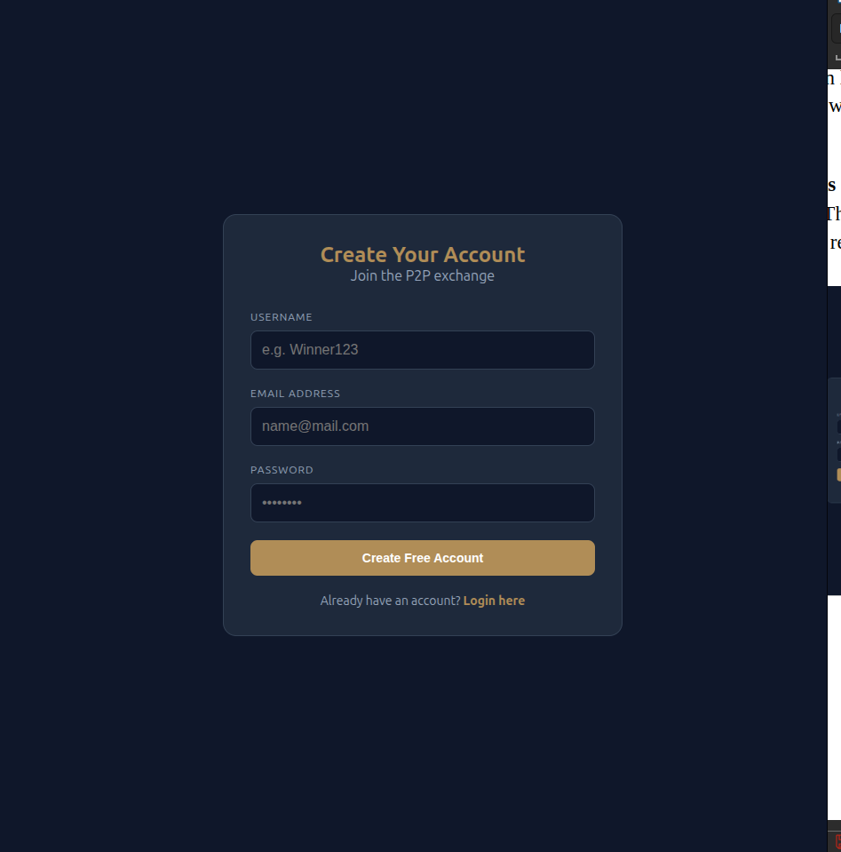


Figure 2-3: Role-Based Access Control Login Interface




Figure 4:User wallets Figure 5: "Post Your Offer" Form Entry Point
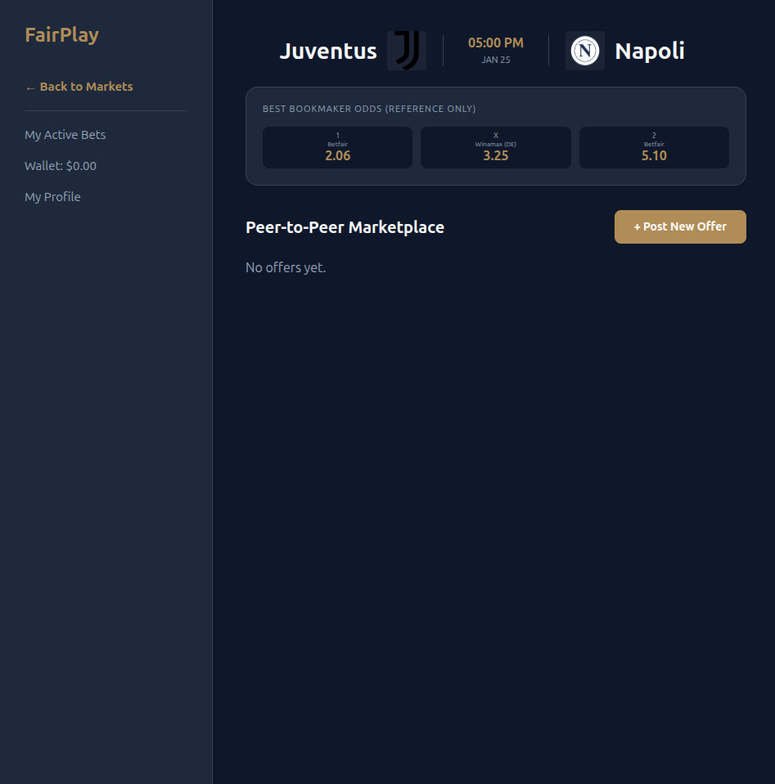
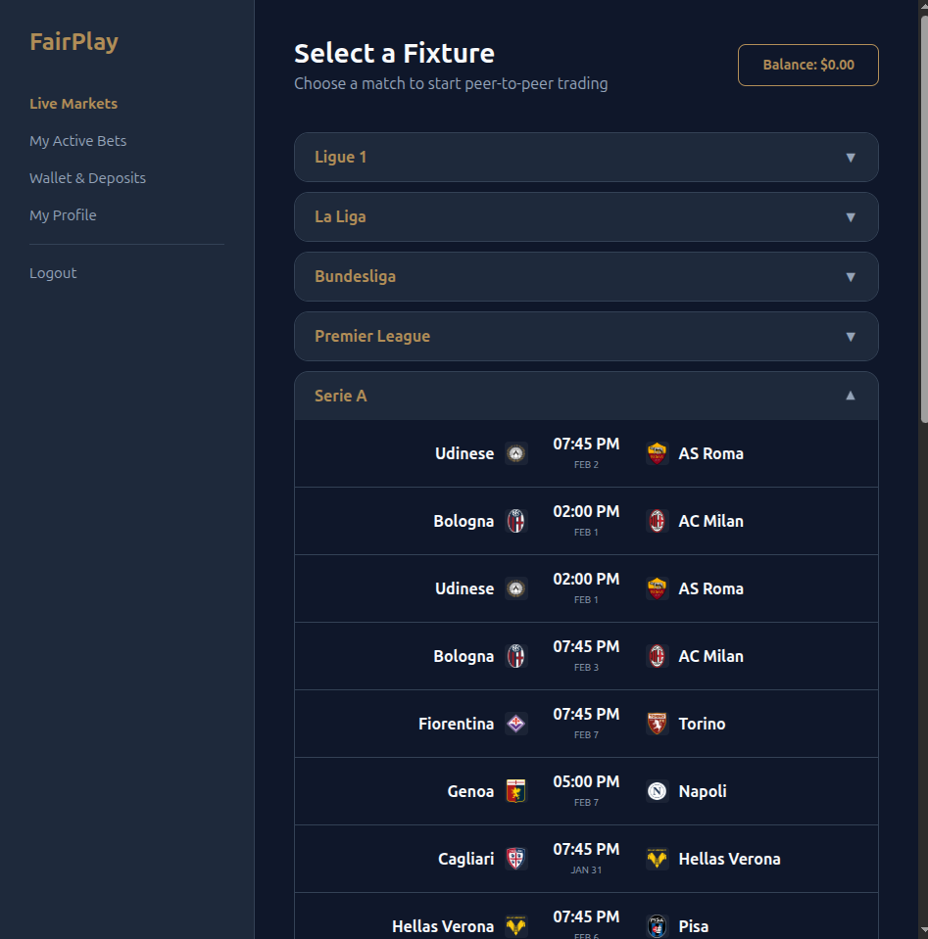

Figure 6-7: Market Odds View showing Data Integration



Figure 8: Admin Dashboard for Orchestrating Market Syncs

