P2P Betting Exchange

OOP Concepts Implementation Report

Introduction
This project uses Object-Oriented Programming to build a peer-to-peer betting exchange. The application is written in pure Java SE 17 with a Java Swing frontend. There are no frameworks, no persistence layers, and no external APIs. The codebase is split into classes and modules so that each component has one business purpose. Encapsulation, inheritance, and polymorphism are used to model bet placement, matching, and post-event settlement.
Avoiding third-party frameworks (Spring, Hibernate, Jackson) is a design choice. It forces every concern (identity, state, dispatch, error reporting) to be modelled in plain OOP terms. The principles stay visible in the code rather than being hidden behind annotations and dependency-injection.

System Overview
The system is built around a central Exchange aggregate that holds in-memory collections of users, wallets, events, offers, and bets. A Swing UI sits above it and dispatches to either a player view or an admin view based on the authenticated user's role.

OOP Concepts Used
The rest of the report walks through each OOP concept used in the codebase, with code drawn directly from the project.

1. Information Hiding - the Three-Step Process
Information hiding stops other parts of the program from depending on details they do not need. It is enforced through three levers: PRIVACY, SCOPE, and CONSTANCY.

1a. PRIVACY - private fields
Every domain class makes its state private and exposes it only through methods that enforce invariants. Wallet's two balances are inaccessible from outside:
public class Wallet {
private final Long id;
private Money totalBalance;
private Money reservedBalance;
...
}
A consumer cannot reach into wallet.totalBalance and overwrite it. They must call deposit(...), withdraw(...), or reserve(...). Each of these enforces the rule that the wallet cannot be made internally inconsistent.

1b. SCOPE - restricted visibility of helpers
Helpers used only inside the class are declared private. Money.normalize is an internal implementation detail and never part of the contract:
private static BigDecimal normalize(BigDecimal v) {
return v.setScale(SCALE, ROUNDING);
}
Password holds its stored value in a private final field with no getter:
public final class Password {
private final String value;
public boolean matches(String rawInput) {
return this.value.equals(rawInput);
}
}
No client class can read Password.value directly. The only operation exposed is matches(rawInput), which answers a yes/no question without ever returning the stored value.

1c. CONSTANCY - final for immutability
Identity fields and value-object internals are declared final. Once a Money value is created, it cannot point to a different BigDecimal. Once a User is created, its id and username are fixed:
public final class Money {
private final BigDecimal value;
}

public abstract class User {
private final Long id;
private final String username;
private final String email;
}
Privacy, restricted scope, and constancy together stop external code from silently breaking domain invariants.

Why we did this
Financial logic is unforgiving. One field mutation in the wrong place can leave a wallet showing money that does not exist or a bet that can never be settled. Information hiding gives us a small surface area through which all state changes flow.

From the Programmer's Perspective
When writing Wallet, you decide which fields are private, which helpers are private static, and which values are final. Each decision is a commitment: future callers cannot depend on what you hide, so you are free to change it without breaking them.

From the User's Perspective
As a caller of Wallet, totalBalance does not appear in your IDE's autocomplete. You call deposit(amount), withdraw(amount), or reserve(amount) and the wallet either succeeds or throws a typed exception. The restricted surface area is an advantage: there are fewer ways to misuse the object.

2. Encapsulation
Encapsulation bundles object state with the operations that can act on it, and stops the object from ever being placed into an invalid state.

How it works
Wallet is the canonical example. It owns two Money fields (totalBalance and reservedBalance) and exposes operations that mutate them together under enforced rules:
public void withdraw(Money amount) throws ExchangeException {
if (amount.isGreaterThan(availableBalance()))
throw new InsufficientFundsException(
"Cannot withdraw " + amount + " - only " + availableBalance() + " available");
this.totalBalance = this.totalBalance.minus(amount);
}

public void reserve(Money amount) throws InsufficientFundsException {
if (amount.isGreaterThan(availableBalance()))
throw new InsufficientFundsException(
"Cannot reserve " + amount + " - only " + availableBalance() + " available");
this.reservedBalance = this.reservedBalance.plus(amount);
}

public void settleWin(Money stakeReleased, Money grossProfit, CommissionPolicy policy)
throws ExchangeException {
this.reservedBalance = this.reservedBalance.minus(stakeReleased);
this.totalBalance = this.totalBalance.plus(policy.apply(grossProfit));
}
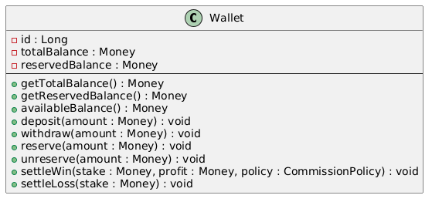
Callers never write wallet.totalBalance -= x. They call wallet.withdraw(x), and the wallet decides whether the operation is allowed.

Rationale
Encapsulation here is a correctness guarantee. The class is the boundary where financial invariants are enforced, and that boundary cannot be bypassed.

From the Programmer's Perspective
When writing Wallet, you bundle the two Money fields with the operations that can legally combine them. settleWin must decrement reservedBalance and increment totalBalance simultaneously. No caller can do half of that — the methods are the only valid entry point into the object's state.

From the User's Perspective
The UI panels (WalletPanel, MarketsPanel) never read or write wallet balances directly. They request high-level operations and the wallet either succeeds or throws a typed exception. The UI deals with presentation; correctness is the wallet's job.

3. Inheritance
Inheritance models an "is-a" relationship and lets a subclass reuse and specialise the parent's contract.

How it works
User is an abstract base class that holds the universal identity fields (id, username, email, password) and the authenticate operation. Two concrete subclasses extend it:
public abstract class User {
private final Long id;
private final String username;
private final String email;
private Password password;

protected User(Long id, String username, String email, Password password) {
this.id = id; this.username = username;
this.email = email; this.password = password;
}

public boolean authenticate(String rawInput) {
return password != null && password.matches(rawInput);
}
public abstract String getRoleName();
}
public class StandardUser extends User implements Tradeable {
private Wallet wallet;
public StandardUser(Long id, String username, String email, Password password) {
super(id, username, email, password);
}
@Override public Wallet getWallet() { return wallet; }
@Override public String getRoleName() { return "PLAYER"; }
}

public class AdminUser extends User {
public AdminUser(Long id, String username, String email, Password password) {
super(id, username, email, password);
}
@Override public String getRoleName() { return "ADMIN"; }
}
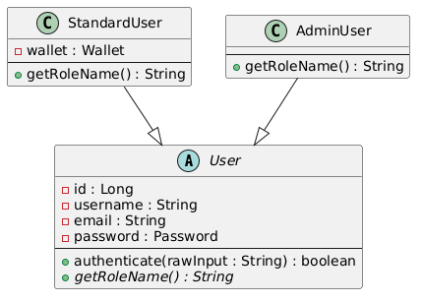

Key design decision - AdminUser has NO wallet
In the current design, getWallet() does not exist on User. It is added to StandardUser by the Tradeable interface (see Section 7). AdminUser has no wallet, no getWallet() method, and no exception to throw. The type system, not runtime conditionals, blocks "deposit money into an admin".

Why we did this
Inheritance must encode genuinely shared behaviour. id, username, email, and authentication are shared between admins and players. Wallet ownership is not. Keeping the base class narrow keeps both subclasses honest.

From the Programmer's Perspective
When designing User, you ask: what is true of every user regardless of role? The answer — id, username, email, and authentication — goes into the abstract class. Writing abstract String getRoleName() is a contract you impose on every future subclass; the compiler will not let the project build if a subclass omits it.

From the User's Perspective
As a caller receiving a User reference, you get getUsername(), authenticate(), and getRoleName() without knowing whether the object is a StandardUser or an AdminUser. The abstract type gives you everything needed for identity and role dispatch.

4. Abstraction
Abstraction expresses *what* a class or interface does without committing to *how*. The codebase uses abstraction at two levels: the abstract base class User, and the interfaces Tradeable and SettlementStrategy.

Abstract class - User
public abstract class User {
public abstract String getRoleName();
...
}
User cannot be instantiated. It declares getRoleName() and forces every concrete subclass to provide an answer. Code that asks "what role is this user?" can do so against the abstract type.

Interface - Tradeable
public interface Tradeable {
Wallet getWallet();
}
Tradeable says nothing about identity, role, or persistence. It only states that the entity has a wallet. Exchange.deposit and Exchange.withdraw depend on this interface, not on User or StandardUser.

Interface - SettlementStrategy
public interface SettlementStrategy {
Outcome determineWinner(int homeScore, int awayScore);
MarketType getMarketType();
}
The strategy interface abstracts the rule that maps a final score to an outcome. The two implementations differ (one allows draws, the other rejects them) but Event does not care which is plugged in.
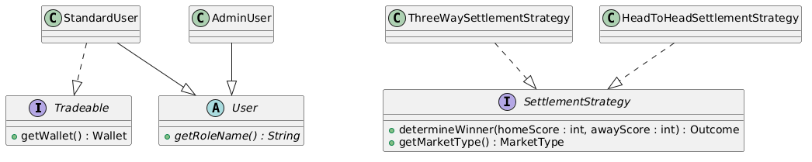

Rationale
Abstraction lets callers depend on contracts rather than concrete types. The Exchange does not know how a Tradeable was constructed. The Event does not know whether a strategy permits draws.

From the Programmer's Perspective
When writing Event.processResult, you declare the parameter as SettlementStrategy, not ThreeWaySettlementStrategy. You commit to depending only on the interface contract, which means you can test Event with a stub strategy and introduce new market types without modifying Event at all.

From the User's Perspective
As a caller of Exchange.processResult, you never interact with a strategy object. The Exchange selects the right strategy by market type internally. Your call is exchange.processResult(admin, eventId, 2, 1) — the dispatch machinery is hidden entirely.

5. Composition
Composition models a "has-a" relationship where the contained object is part of the container's lifecycle.

How it works
The domain is built mostly by composition rather than by inheritance:
public class Offer {
private final Long id;
private final User maker;
private final Event event;
private final Outcome predictedOutcome;
private final Money originalStake;
private Money remainingStake;
private final Odds odds;
private OfferStatus status;
private final List<Bet> bets;
...
}
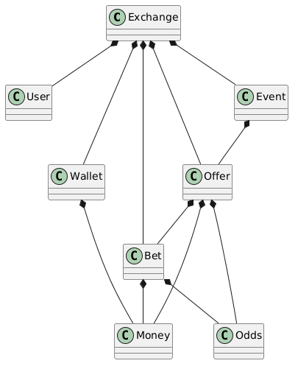

Key design decision - Wallet has no back-reference to User
In the current design, Wallet does not know who owns it, and Bet.resolve() is given the two wallets directly:
public void resolve(Outcome result, Wallet makerWallet, Wallet takerWallet, CommissionPolicy policy)
throws ExchangeException {
if (result == offer.getPredictedOutcome()) {
makerWallet.settleWin(makerStake, takerLiability, policy);
takerWallet.settleLoss(takerLiability);
} else {
makerWallet.settleLoss(makerStake);
takerWallet.settleWin(takerLiability, makerStake, policy);
}
this.status = BetStatus.SETTLED;
}
The user holds the wallet, the bet gets the wallets as parameters when needed, and the wallet stays a pure value-bearing object.

Why we did this
Composition lets us build complex objects from simpler, tested ones. A Wallet does not need to be re-tested every time we use it inside a StandardUser. The same is true of Money, Odds, and Password.

6. Polymorphism
Polymorphism is the most heavily used concept in the codebase. All four classical varieties (ad-hoc, inclusion, coercion, and parametric) are present. Inclusion polymorphism is by far the most important and is covered separately below.

6a. Ad-hoc Polymorphism (Overloading)
Ad-hoc polymorphism gives the same name to multiple methods with different parameter lists. The compiler picks the implementation based on the static argument types.
Money overloads its arithmetic and factory methods:
public Money plus(Money other) {
return new Money(this.value.add(other.value));
}

public Money multiply(BigDecimal factor) {
return new Money(this.value.multiply(factor).setScale(SCALE, ROUNDING));
}

public static Money of(String value) throws IllegalBetException {
return of(new BigDecimal(value));
}

public static Money of(BigDecimal value) throws IllegalBetException {
if (value.compareTo(BigDecimal.ZERO) < 0)
throw new IllegalBetException("Money cannot be negative");
return new Money(value);
}
There are two of(...) factories that differ only by parameter type. There are also two arithmetic methods that accept different operand types: plus(Money) for monetary addition and multiply(BigDecimal) for scaling by a pure factor.

6b. Inclusion Polymorphism (Subtype Polymorphism / Dynamic Dispatch)
Inclusion polymorphism is the heart of OOP. A reference of an abstract or interface type can hold an instance of any concrete implementation, and method calls are dispatched at runtime to the right override. This decouples *what* the program asks for from *who* answers.
The codebase uses inclusion polymorphism in four distinct ways. Each is described below.

6b.i Exchange.login() returns User
Exchange.login() returns the abstract type User, not a specific subclass. The runtime object is either a StandardUser or an AdminUser. A call to getRoleName() on the returned reference is dispatched at runtime to the right override.
public User login(String username, String password) throws ExchangeException {
User found = null;
for (User u : users.values())
if (u.getUsername().equalsIgnoreCase(username)) { found = u; break; }
if (found == null) throw new UserNotFoundException("Invalid username or password");
if (!found.authenticate(password)) throw new UserNotFoundException("Invalid username or password");
return found;
}
At the call site in the Swing login window:
User user = exchange.login(usernameField.getText(), passwordField.getText());
String role = user.getRoleName(); // dispatches to either "PLAYER" or "ADMIN"
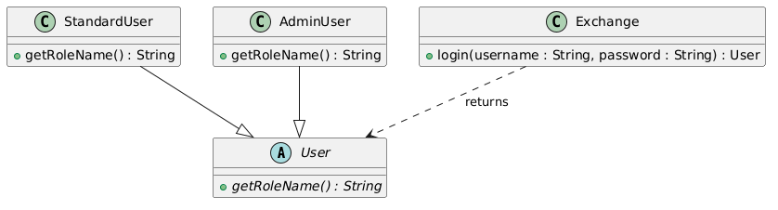
The caller never writes if (user instanceof AdminUser). The polymorphic call user.getRoleName() answers for whichever concrete type is present. The compiler sees the abstract supertype; the JVM resolves the actual implementation.

6b.ii Exchange.deposit / withdraw accept Tradeable
StandardUser lives in three types at once: it is a User, it is a StandardUser, and it is a Tradeable. When the same object is passed to Exchange.deposit(Tradeable, Money), the receiver sees only the Tradeable view, so only getWallet() is visible. The same object gives different facets to different clients.
public void deposit(Tradeable account, Money amount) {
account.getWallet().deposit(amount);
}

public void withdraw(Tradeable account, Money amount) throws ExchangeException {
account.getWallet().withdraw(amount);
}
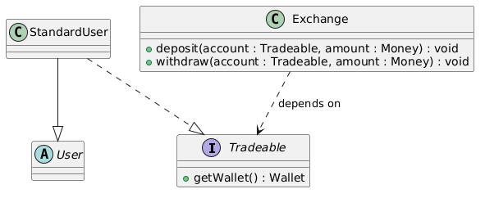
This is the Dependency Inversion Principle in action. Exchange does not depend on the concrete StandardUser class. It depends on the Tradeable abstraction. It also shows the Interface Segregation Principle: the Tradeable contract exposes nothing the depositor does not need. Other parts of the system would access the same object as a User (for identity) or a StandardUser (for full control). Here we see only the financial facet.
If a future requirement introduces an AffiliateAccount that has a wallet but is not a person, it can implement Tradeable and immediately be accepted by deposit and withdraw without any change to Exchange.

6b.iii Event.processResult accepts SettlementStrategy
An Event does not know whether its market type allows draws. It delegates that to whichever SettlementStrategy is passed in. The two strategies behave differently:
public class ThreeWaySettlementStrategy implements SettlementStrategy {
@Override
public Outcome determineWinner(int homeScore, int awayScore) {
if (homeScore > awayScore) return Outcome.HOME_WIN;
if (awayScore > homeScore) return Outcome.AWAY_WIN;
return Outcome.DRAW;
}
@Override public MarketType getMarketType() { return MarketType.THREE_WAY; }
}

public class HeadToHeadSettlementStrategy implements SettlementStrategy {
@Override
public Outcome determineWinner(int homeScore, int awayScore) {
if (homeScore > awayScore) return Outcome.HOME_WIN;
if (awayScore > homeScore) return Outcome.AWAY_WIN;
throw new IllegalStateException("Head-to-head markets cannot end in a draw");
}
@Override public MarketType getMarketType() { return MarketType.HEAD_TO_HEAD; }
}
Event.processResult calls the abstract operation:
public void processResult(int homeScore, int awayScore, SettlementStrategy strategy)
throws ExchangeException {
if (this.status != EventStatus.OPEN)
throw new IllegalBetException("Event is not OPEN - cannot process result");
this.homeScore = homeScore;
this.awayScore = awayScore;
this.result = strategy.determineWinner(homeScore, awayScore);
this.status = EventStatus.COMPLETED;
}
And Exchange.processResult selects the strategy:
public void processResult(AdminUser admin, Long eventId, int homeScore, int awayScore)
throws ExchangeException {
Event event = requireEvent(eventId);
SettlementStrategy strategy = strategies.getOrDefault(
event.getMarketType(), new ThreeWaySettlementStrategy());
event.processResult(homeScore, awayScore, strategy);
}
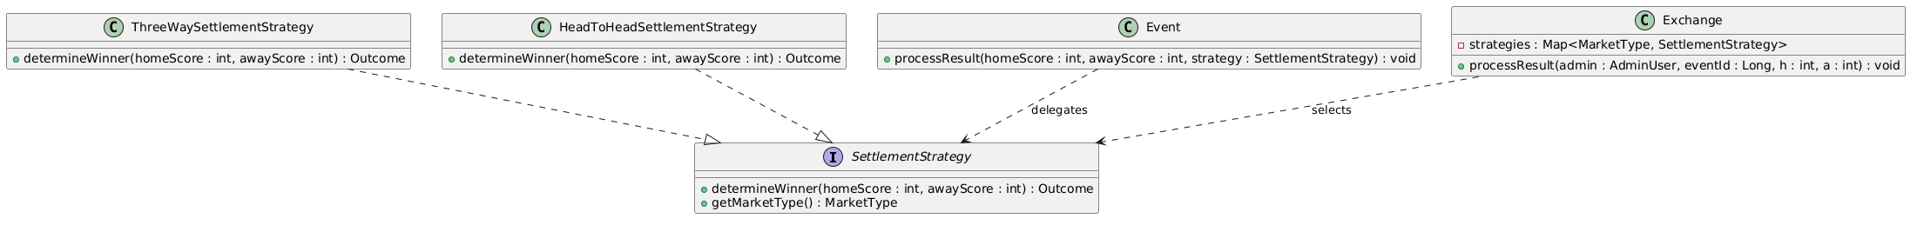
This is the Strategy pattern and a clear case of the Open/Closed Principle. To add an "Asian handicap" market type, write a new class implementing SettlementStrategy and register it in the strategy map. Event does not change. Neither does Exchange.processResult. The polymorphic dispatch absorbs the new behaviour.
The call strategy.determineWinner(...) looks identical regardless of which concrete strategy is bound. The JVM checks the runtime type and dispatches to the correct override. The compiler sees only the interface.

6b.iv UI Role Dispatch via getRoleName()
The Swing main window decides which tabs to show based on the logged-in user's role. It does this without any instanceof checks. The same User reference, which holds either a StandardUser or an AdminUser at runtime, answers getRoleName() differently:
String role = currentUser.getRoleName(); // virtual dispatch
if ("PLAYER".equals(role)) {
tabs.addTab("Wallet", new WalletPanel(exchange, currentUser));
tabs.addTab("Markets", new MarketsPanel(exchange, currentUser));
tabs.addTab("Activity", new ActivityPanel(exchange, currentUser));
} else if ("ADMIN".equals(role)) {
tabs.addTab("Admin", new AdminPanel(exchange, (AdminUser) currentUser));
}
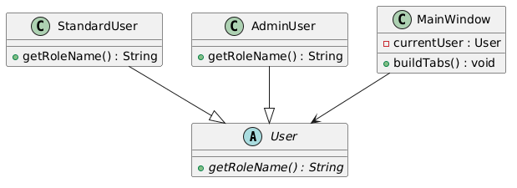
The UI does not ask the JVM "what subclass is this object?". It asks the object "what role do you play?" and lets the object answer. The role string is then a branch key. This is inclusion polymorphism driving the UI branching. A new role means a new User subclass and a new branch. No change to the User base class and no introspection.

6c. Coercion Polymorphism
Coercion polymorphism is the implicit or explicit conversion of one type to another to satisfy an operation. Money.of(String) accepts a string and converts it to a BigDecimal before delegating to the main factory:
public static Money of(String value) throws IllegalBetException {
return of(new BigDecimal(value));
}
The Swing UI reads user input from a JTextField and can write Money.of(field.getText()) directly. The string form is converted into the value space the rest of the system uses. The API user does not need to know whether the underlying type is BigDecimal or double.

6d. Parametric Polymorphism (Generics)
Parametric polymorphism allows a single class or interface definition to operate over many types, with the type fixed at each use site and the compiler enforcing correctness at every interaction.

Money implements Comparable<Money>
Comparable<T> is a parameterised interface from the Java standard library. By implementing it with T = Money, the compareTo method only accepts another Money — not an arbitrary Object:

public final class Money implements Comparable<Money> {
@Override
public int compareTo(Money other) {
return this.value.compareTo(other.value);
}
}
The type parameter pins what counts as a valid comparison. The compiler rejects money.compareTo("100") at compile time. Money is accepted anywhere a sorted or ranked element is expected — Collections.sort, TreeMap, or any generic algorithm bounded by Comparable<T>.

Typed collections in Exchange
Exchange stores every domain aggregate in a typed map:
private final Map<Long, User> users = new HashMap<>();
private final Map<Long, Wallet> wallets = new HashMap<>();
private final Map<Long, Event> events = new HashMap<>();
private final Map<Long, Offer> offers = new HashMap<>();
private final Map<Long, Bet> bets = new HashMap<>();
The same Map class body handles five different value types. The compiler rejects users.put(id, wallet) — a Wallet cannot enter a Map<Long, User>. Without parametric polymorphism, five separate untyped maps would be required, with runtime casts at every lookup.
Event and Offer use parameterised lists for the same reason: List<Offer> in Event and List<Bet> in Offer.

From the Programmer's Perspective
You write Map<Long, User> once and the compiler becomes your gatekeeper. users.get(id) returns a User, not an Object. A type mismatch on insert is caught at the call site, not buried inside a ClassCastException at runtime.

From the User's Perspective
As a caller of Exchange, you receive typed results. getAllUsers() returns List<User> — not a raw list. You iterate and call u.getRoleName() immediately with no casting or guessing about the collection's contents.

7. Subtyping / Multityping
Multityping is when a single concrete class inhabits more than one type at once, and clients see it through whichever type they depend on.

How it works
StandardUser is the clearest case. It is at the same time:
- a StandardUser - the concrete type, used internally for setup such as setWallet(...).
- a User - the abstract identity type, used everywhere identity, authentication, or role is needed.
- a Tradeable - the financial facet type, used everywhere wallet access is needed.
public class StandardUser extends User implements Tradeable {
private Wallet wallet;
@Override public Wallet getWallet() { return wallet; }
@Override public String getRoleName() { return "PLAYER"; }
}
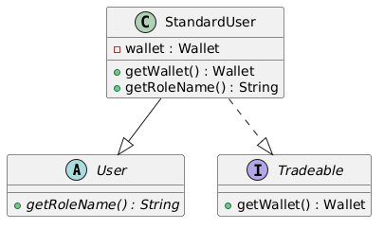
A single StandardUser instance can be passed to:
- exchange.deposit(standardUser, amount) - accepted as Tradeable
- someMethod(user) - accepted as User
- loginWindow.handle(standardUser) - accepted as StandardUser
In each context only the relevant slice of the object is visible to the receiver. That is what the Interface Segregation Principle asks for.

Why we did this
Multityping makes each client of StandardUser depend only on the minimum it needs. The Exchange financial methods need only Tradeable, so they ask for only Tradeable. The UI needs identity, so it depends on User. A future Tradeable implementer that is not a User (a corporate account) would slot into the financial calls without modification.

8. Exception Handling
The codebase models error states as a small hierarchy of checked exceptions rooted at ExchangeException.

The hierarchy
public class ExchangeException extends Exception { ... } // base
public class InsufficientFundsException extends ExchangeException { ... }
public class IllegalBetException extends ExchangeException { ... }
public class UserNotFoundException extends ExchangeException { ... }
public class IdentityConflictException extends ExchangeException { ... }
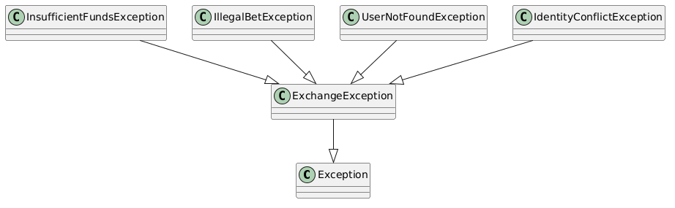

How it works
Each exception name carries a precise meaning:
- InsufficientFundsException - the requested withdrawal or reservation exceeds available balance.
- IllegalBetException - a domain rule is violated: a negative monetary value, settlement of an event not yet open, cancellation of an already-matched offer, and so on.
- UserNotFoundException - login failure or lookup of an absent user.
- IdentityConflictException - registration of a username or email that already exists.
Callers who care only about "any domain error" can catch ExchangeException. Callers that need to react specifically can catch the leaf type:
try {
wallet.withdraw(amount);
} catch (InsufficientFundsException e) {
showWalletShortageDialog(e.getMessage());
} catch (ExchangeException e) {
showGenericErrorDialog(e.getMessage());
}

Inclusion polymorphism in exception handling
Catch clauses rely on inclusion polymorphism. A catch (ExchangeException e) clause catches any subtype (InsufficientFundsException, IllegalBetException, and so on) because the JVM checks the runtime type against the static type of the catch parameter. This is the same dispatch that powers method overrides, applied to exception handlers.

Why we did this
A flat error-code system would force every caller to enumerate every possible failure value. A typed exception hierarchy gives callers an organised vocabulary. Checked exceptions make the failure modes part of each method's contract: the compiler enforces that the caller either handles the failure or propagates it.

Supporting Value Objects
The codebase pairs the major aggregates with small, immutable value objects that carry the invariants of a single concept.

Money
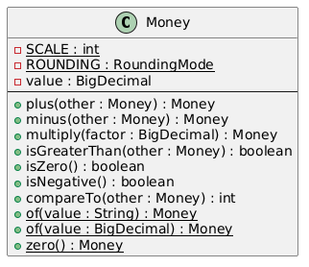
Money enforces non-negativity at construction, fixes precision at 2 decimal places, and uses RoundingMode.HALF_UP. It is immutable, final, and implements Comparable<Money>. Arithmetic methods return new Money instances instead of mutating the receiver.

Odds
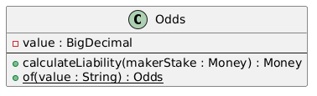
Odds rejects values below 1.0 at construction. Its single behavioural method, calculateLiability(makerStake), applies the formula makerStake * (odds - 1) so callers do not recompute it.

Password
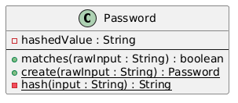
Password holds the stored value in a private final field. Validation — minimum length of six characters — is enforced in create(...). The matches(rawInput) method compares directly without returning the stored value. The only operation a Password exposes is verification; there is no getter for the internal field.

CommissionPolicy
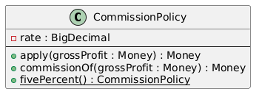
CommissionPolicy is a concrete class, not an interface. There is only one policy across the exchange (currently 5%). Adding an interface for a one-implementation abstraction is over-engineering. If a second policy is ever required (tiered, dynamic), promoting CommissionPolicy to an interface is a mechanical refactor.

The Exchange Aggregate
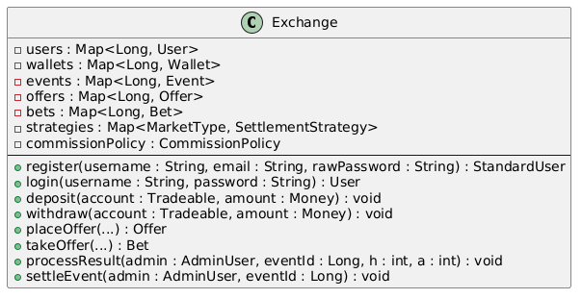

How it works
Exchange is the only entry point for the UI. Every Swing panel takes a reference to the Exchange and a User (or AdminUser) and calls high-level methods that compose the underlying domain operations. The panels never reach into Wallet or Offer directly.
This single-entry design keeps every business operation in one auditable place. It is also the anchor for the polymorphism patterns above: login returns User, deposit/withdraw accept Tradeable, and processResult picks the right SettlementStrategy from its registry.

The Swing UI Layer
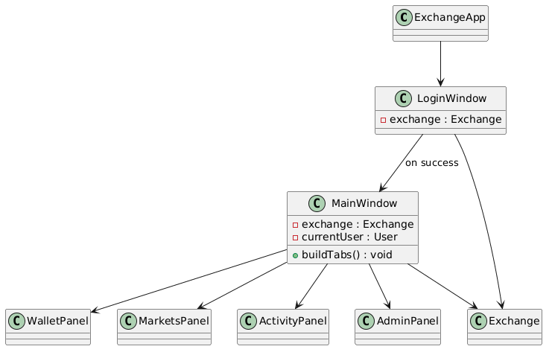
The UI mirrors the domain decomposition: one panel per major use case. MainWindow checks currentUser.getRoleName() to decide which panels to build, using the inclusion polymorphism from Section 6b.iv.

The Client Perspective
From the user's standpoint, the application is a set of tabs. Behind those tabs, every interaction goes to a single domain operation on Exchange, which delegates to the right aggregate. The UI has no business rules. It cannot compute commission, cannot decide outcomes, cannot mutate balances. It can only ask. That separation is the OOP discipline made visible.

Application Screenshots
The following screenshots show the running application. Demo accounts are seeded at startup: admin / admin123 (AdminUser), alice / alice123 (StandardUser, $1000 balance), bob / bob12345 (StandardUser, $1000 balance). Events are created by the admin through the Admin panel.

Login Screen
The login screen is the application entry point. Users sign in with existing credentials or navigate to the registration form to create a new account.
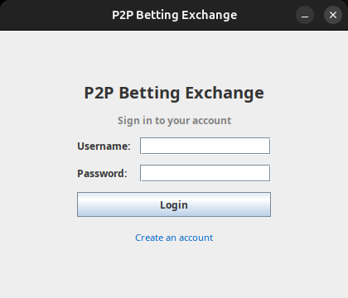

Player View — Markets Tab
After login, a standard user sees the Markets tab listing all events. Each card shows the league, market type, kick-off time, open offer count, and status. Players can view existing offers, place a new offer, or match an open one.
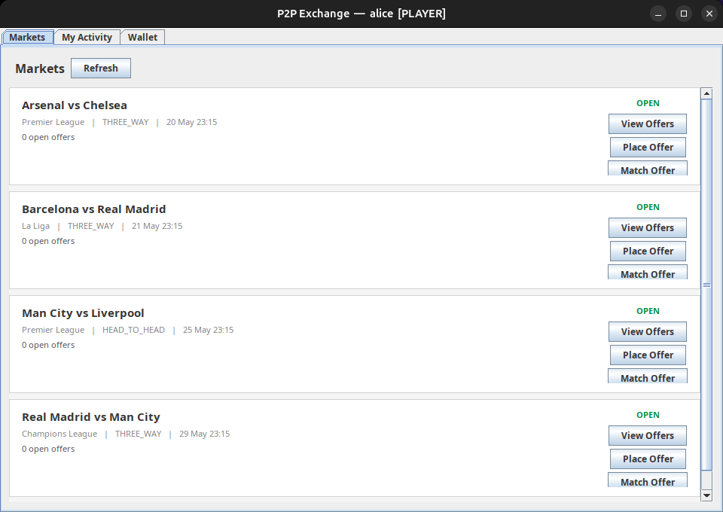

Player View — Wallet Tab
The Wallet tab shows the player's total balance, reserved funds (staked on open bets), and available balance. Deposit and withdraw operations are available here.
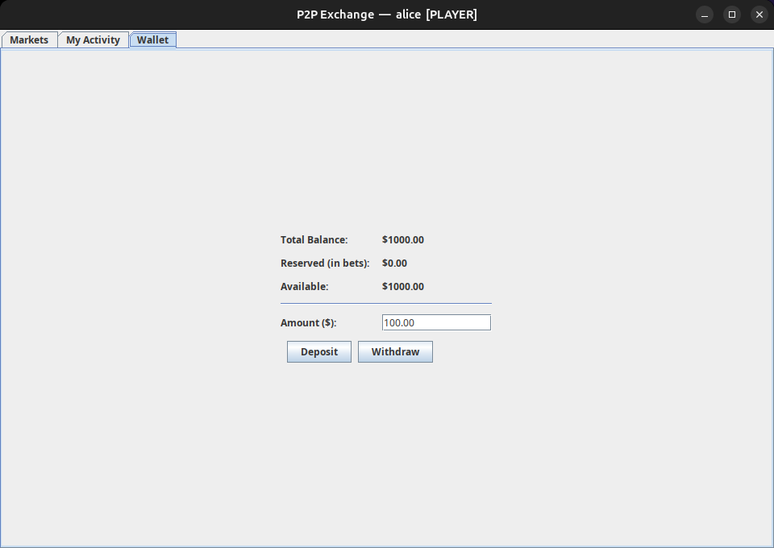

Admin View — Admin Panel
The Admin panel is exclusive to admin accounts. It lists all events in a table with their status and score. Admins can add new events, enter a result for a completed match, and trigger settlement to resolve bets and transfer funds.
